# CXCPayFlex.csproj

Open CXCPayFlex.csproj in edit mode and make following changes as shown below

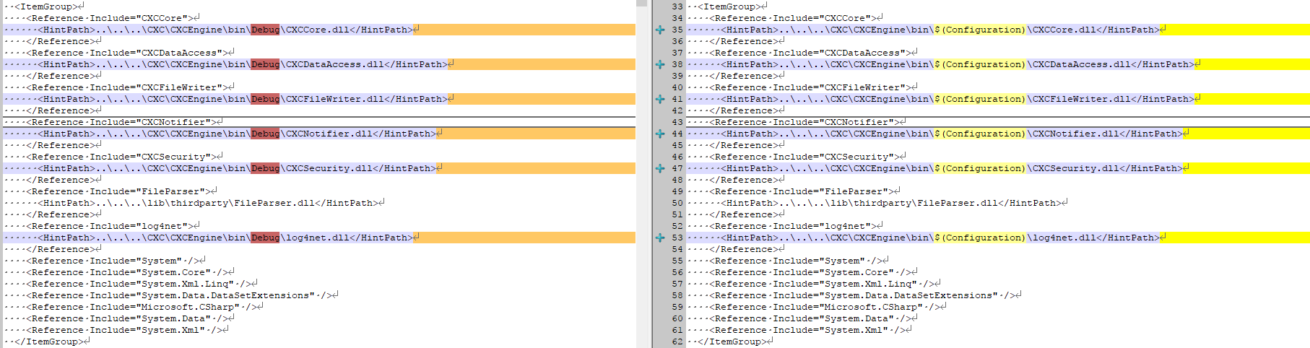

<Reference Include="CXCCore">

<HintPath>..\..\..\CXC\CXCEngine\bin\$(Configuration)\CXCCore.dll</HintPath>

</Reference>

<Reference Include="CXCDataAccess">

<HintPath>..\..\..\CXC\CXCEngine\bin\$(Configuration)\CXCDataAccess.dll</HintPath>

</Reference>

<Reference Include="CXCFileWriter">

<HintPath>..\..\..\CXC\CXCEngine\bin\$(Configuration)\CXCFileWriter.dll</HintPath>

</Reference>

<Reference Include="CXCNotifier">

<HintPath>..\..\..\CXC\CXCEngine\bin\$(Configuration)\CXCNotifier.dll</HintPath>

</Reference>

<Reference Include="CXCSecurity">

<HintPath>..\..\..\CXC\CXCEngine\bin\$(Configuration)\CXCSecurity.dll</HintPath>

</Reference>

<Reference Include="FileParser">

<HintPath>..\..\..\lib\thirdparty\FileParser.dll</HintPath>

</Reference>

<Reference Include="log4net">

<HintPath>..\..\..\CXC\CXCEngine\bin\$(Configuration)\log4net.dll</HintPath>

</Reference>

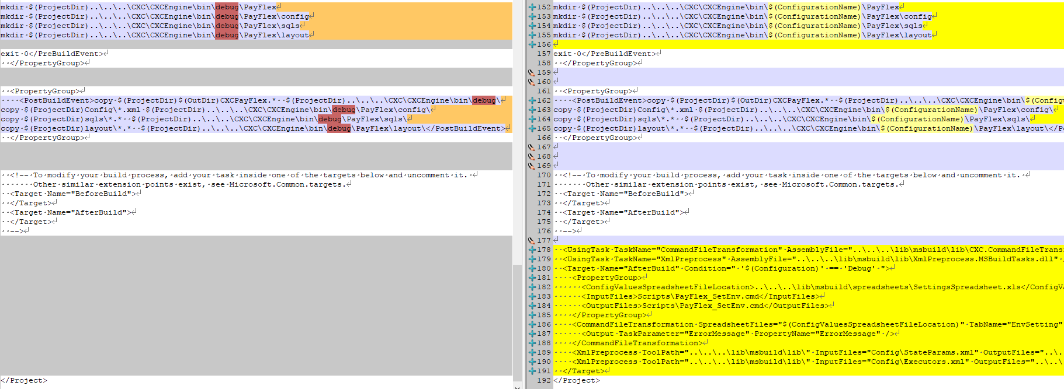

mkdir $(ProjectDir)..\..\..\CXC\CXCEngine\bin\$(ConfigurationName)\PayFlex

mkdir $(ProjectDir)..\..\..\CXC\CXCEngine\bin\$(ConfigurationName)\PayFlex\config

mkdir $(ProjectDir)..\..\..\CXC\CXCEngine\bin\$(ConfigurationName)\PayFlex\sqls

mkdir $(ProjectDir)..\..\..\CXC\CXCEngine\bin\$(ConfigurationName)\PayFlex\layout

================

<PropertyGroup>

<PostBuildEvent>copy $(ProjectDir)$(OutDir)CXCPayFlex.* $(ProjectDir)..\..\..\CXC\CXCEngine\bin\$(ConfigurationName)\

copy $(ProjectDir)Config\*.xml $(ProjectDir)..\..\..\CXC\CXCEngine\bin\$(ConfigurationName)\PayFlex\config\

copy $(ProjectDir)sqls\*.* $(ProjectDir)..\..\..\CXC\CXCEngine\bin\$(ConfigurationName)\PayFlex\sqls\

copy $(ProjectDir)layout\*.* $(ProjectDir)..\..\..\CXC\CXCEngine\bin\$(ConfigurationName)\PayFlex\layout\</PostBuildEvent>

</PropertyGroup>

===========================

<UsingTask TaskName="CommandFileTransformation" AssemblyFile="..\..\..\lib\msbuild\lib\CXC.CommandFileTransformation.dll" />

<UsingTask TaskName="XmlPreprocess" AssemblyFile="..\..\..\lib\msbuild\lib\XmlPreprocess.MSBuildTasks.dll" />

<Target Name="AfterBuild" Condition=" '$(Configuration)' == 'Debug' ">

<PropertyGroup>

<ConfigValuesSpreadsheetFileLocation>..\..\..\lib\msbuild\spreadsheets\SettingsSpreadsheet.xls</ConfigValuesSpreadsheetFileLocation>

<InputFiles>Scripts\PayFlex_SetEnv.cmd</InputFiles>

<OutputFiles>Scripts\PayFlex_SetEnv.cmd</OutputFiles>

</PropertyGroup>

<CommandFileTransformation SpreadsheetFiles="$(ConfigValuesSpreadsheetFileLocation)" TabName="EnvSetting" Environment="$(Configuration)" InputFiles="$(InputFiles)" OutputFiles="$(OutputFiles)" VariableColumnName="Environment Name">

<Output TaskParameter="ErrorMessage" PropertyName="ErrorMessage" />

</CommandFileTransformation>

<XmlPreprocess ToolPath="..\..\..\lib\msbuild\lib\" InputFiles="Config\StateParams.xml" OutputFiles="..\..\..\CXC\CXCEngine\bin\debug\PayFlex\config\StateParams.xml" SpreadsheetFiles="$(ConfigValuesSpreadsheetFileLocation)" Environment="$(Configuration)" Clean="true" Validate="true" />

<XmlPreprocess ToolPath="..\..\..\lib\msbuild\lib\" InputFiles="Config\Executors.xml" OutputFiles="..\..\..\CXC\CXCEngine\bin\debug\PayFlex\config\Executors.xml" SpreadsheetFiles="$(ConfigValuesSpreadsheetFileLocation)" Environment="$(Configuration)" Clean="true" Validate="true" />

</Target>

# CXCGDI.csproj

Open CXCGDI.csproj in edit mode and make following changes as shown below

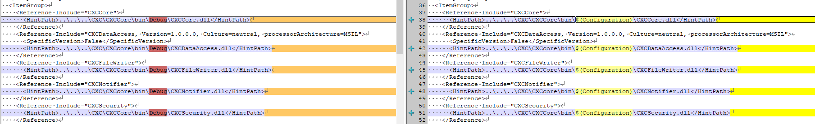

<Reference Include="CXCCore">

<HintPath>..\..\..\CXC\CXCCore\bin\$(Configuration)\CXCCore.dll</HintPath>

</Reference>

<Reference Include="CXCDataAccess, Version=1.0.0.0, Culture=neutral, processorArchitecture=MSIL">

<SpecificVersion>False</SpecificVersion>

<HintPath>..\..\..\CXC\CXCcore\bin\$(Configuration)\CXCDataAccess.dll</HintPath>

</Reference>

<Reference Include="CXCFileWriter">

<HintPath>..\..\..\CXC\CXCCore\bin\$(Configuration)\CXCFileWriter.dll</HintPath>

</Reference>

<Reference Include="CXCNotifier">

<HintPath>..\..\..\CXC\CXCcore\bin\$(Configuration)\CXCNotifier.dll</HintPath>

</Reference>

<Reference Include="CXCSecurity">

<HintPath>..\..\..\CXC\CXCCore\bin\$(Configuration)\CXCSecurity.dll</HintPath>

</Reference>

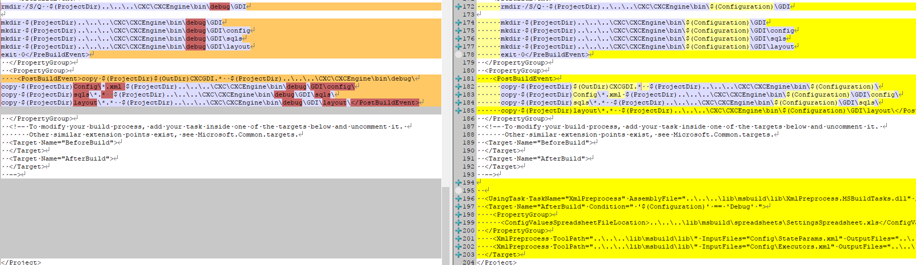

mkdir $(ProjectDir)..\..\..\CXC\CXCEngine\bin\$(Configuration)\GDI

mkdir $(ProjectDir)..\..\..\CXC\CXCEngine\bin\$(Configuration)\GDI\config

mkdir $(ProjectDir)..\..\..\CXC\CXCEngine\bin\$(Configuration)\GDI\sqls

mkdir $(ProjectDir)..\..\..\CXC\CXCEngine\bin\$(Configuration)\GDI\layout

<PropertyGroup>

<PostBuildEvent>

copy $(ProjectDir)$(OutDir)CXCGDI.* $(ProjectDir)..\..\..\CXC\CXCEngine\bin\$(Configuration)\

copy $(ProjectDir)Config\*.xml $(ProjectDir)..\..\..\CXC\CXCEngine\bin\$(Configuration)\GDI\config\

copy $(ProjectDir)sqls\*.* $(ProjectDir)..\..\..\CXC\CXCEngine\bin\$(Configuration)\GDI\sqls\

copy $(ProjectDir)layout\*.* $(ProjectDir)..\..\..\CXC\CXCEngine\bin\$(Configuration)\GDI\layout\</PostBuildEvent>

</PropertyGroup>

<UsingTask TaskName="XmlPreprocess" AssemblyFile="..\..\..\lib\msbuild\lib\XmlPreprocess.MSBuildTasks.dll" />

<Target Name="AfterBuild" Condition=" '$(Configuration)' == 'Debug' ">

<PropertyGroup>

<ConfigValuesSpreadsheetFileLocation>..\..\..\lib\msbuild\spreadsheets\SettingsSpreadsheet.xls</ConfigValuesSpreadsheetFileLocation>

</PropertyGroup>

<XmlPreprocess ToolPath="..\..\..\lib\msbuild\lib\" InputFiles="Config\StateParams.xml" OutputFiles="..\..\..\CXC\CXCEngine\bin\$(Configuration)\GDI\config\StateParams.xml" SpreadsheetFiles="$(ConfigValuesSpreadsheetFileLocation)" Environment="$(Configuration)" Clean="true" Validate="true" />

<XmlPreprocess ToolPath="..\..\..\lib\msbuild\lib\" InputFiles="Config\Executors.xml" OutputFiles="..\..\..\CXC\CXCEngine\bin\$(Configuration)\GDI\config\Executors.xml" SpreadsheetFiles="$(ConfigValuesSpreadsheetFileLocation)" Environment="$(Configuration)" Clean="true" Validate="true" />

</Target>

# CXCPrimePay.csproj

Open CXCPrimePay.csproj in edit mode and make following changes as shown below

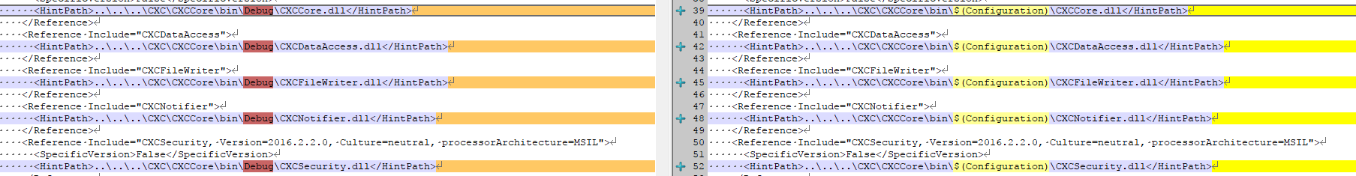

<Reference Include="CXCCore, Version=2016.2.2.0, Culture=neutral, processorArchitecture=MSIL">

<SpecificVersion>False</SpecificVersion>

<HintPath>..\..\..\CXC\CXCCore\bin\$(Configuration)\CXCCore.dll</HintPath>

</Reference>

<Reference Include="CXCDataAccess">

<HintPath>..\..\..\CXC\CXCCore\bin\$(Configuration)\CXCDataAccess.dll</HintPath>

</Reference>

<Reference Include="CXCFileWriter">

<HintPath>..\..\..\CXC\CXCCore\bin\$(Configuration)\CXCFileWriter.dll</HintPath>

</Reference>

<Reference Include="CXCNotifier">

<HintPath>..\..\..\CXC\CXCCore\bin\$(Configuration)\CXCNotifier.dll</HintPath>

</Reference>

<Reference Include="CXCSecurity, Version=2016.2.2.0, Culture=neutral, processorArchitecture=MSIL">

<SpecificVersion>False</SpecificVersion>

<HintPath>..\..\..\CXC\CXCCore\bin\$(Configuration)\CXCSecurity.dll</HintPath>

</Reference>

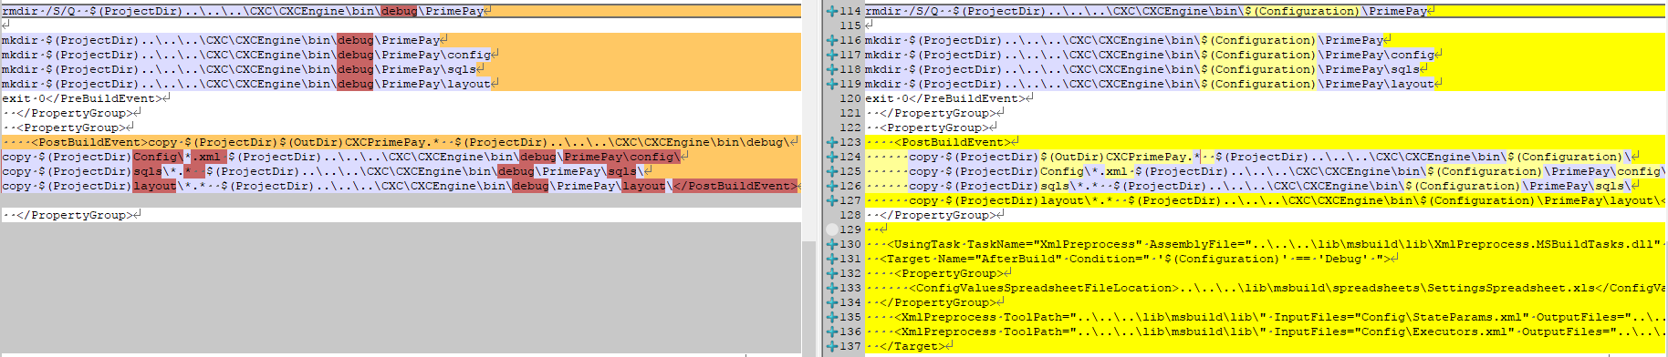

# CXCEngine.csproj

Open CXCEngine.csproj in edit mode, add following code

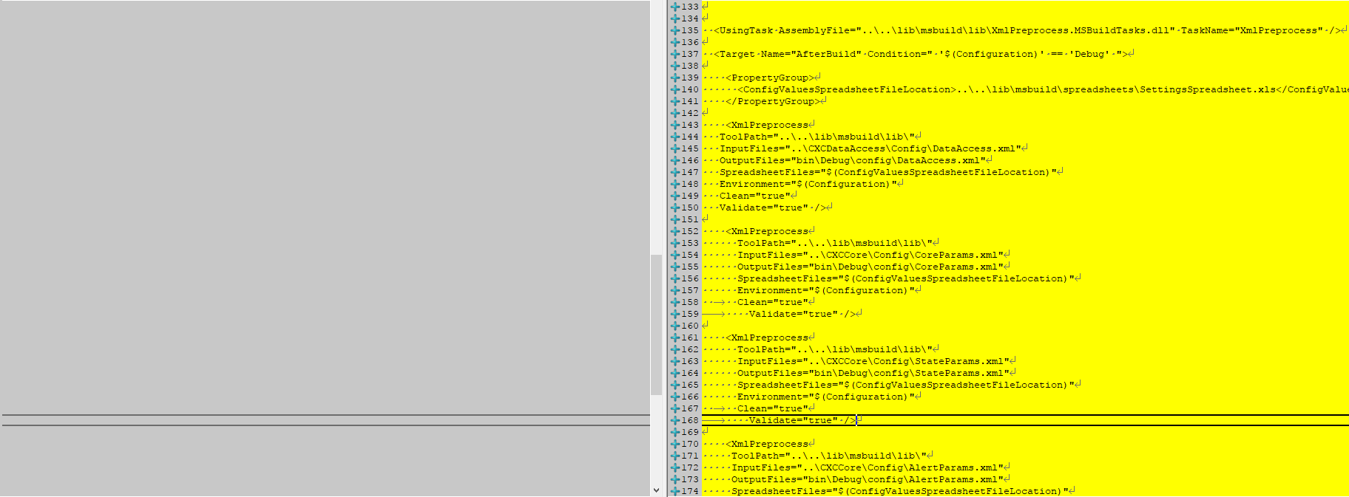

<UsingTask AssemblyFile="..\..\lib\msbuild\lib\XmlPreprocess.MSBuildTasks.dll" TaskName="XmlPreprocess" />

<Target Name="AfterBuild" Condition=" '$(Configuration)' == 'Debug' ">

<PropertyGroup> <ConfigValuesSpreadsheetFileLocation>..\..\lib\msbuild\spreadsheets\SettingsSpreadsheet.xls</ConfigValuesSpreadsheetFileLocation>

</PropertyGroup>

<XmlPreprocess

ToolPath="..\..\lib\msbuild\lib\"

InputFiles="..\CXCDataAccess\Config\DataAccess.xml"

OutputFiles="bin\Debug\config\DataAccess.xml"

SpreadsheetFiles="$(ConfigValuesSpreadsheetFileLocation)"

Environment="$(Configuration)"

Clean="true"

Validate="true" />

<XmlPreprocess

ToolPath="..\..\lib\msbuild\lib\"

InputFiles="..\CXCCore\Config\CoreParams.xml"

OutputFiles="bin\Debug\config\CoreParams.xml"

SpreadsheetFiles="$(ConfigValuesSpreadsheetFileLocation)"

Environment="$(Configuration)" Clean="true" Validate="true" />

<XmlPreprocess

ToolPath="..\..\lib\msbuild\lib\"

InputFiles="..\CXCCore\Config\StateParams.xml"

OutputFiles="bin\Debug\config\StateParams.xml"

SpreadsheetFiles="$(ConfigValuesSpreadsheetFileLocation)"

Environment="$(Configuration)" Clean="true" Validate="true" />

<XmlPreprocess

ToolPath="..\..\lib\msbuild\lib\"

InputFiles="..\CXCCore\Config\AlertParams.xml"

OutputFiles="bin\Debug\config\AlertParams.xml"

SpreadsheetFiles="$(ConfigValuesSpreadsheetFileLocation)"

Environment="$(Configuration)" Clean="true" Validate="true" />

<XmlPreprocess

ToolPath="..\..\lib\msbuild\lib\"

InputFiles="..\CXCArchiver\Config\Archiver.xml"

OutputFiles="bin\Debug\config\Archiver.xml"

SpreadsheetFiles="$(ConfigValuesSpreadsheetFileLocation)"

Environment="$(Configuration)" Clean="true" Validate="true" />

<XmlPreprocess

ToolPath="..\..\lib\msbuild\lib\"

InputFiles="..\CXCNotifier\Config\Notifier.xml"

OutputFiles="bin\Debug\config\Notifier.xml"

SpreadsheetFiles="$(ConfigValuesSpreadsheetFileLocation)"

Environment="$(Configuration)" Clean="true" Validate="true" />

</Target>