MCA ROLL NO :- 16155
Name :- Manoj Devidas Sonje

*TO SHOW YOUR NAME & ROLL NUMBER AT BOOTSECTOR OF SECONDARY DEVICE PLEASE FOLLOW GIVEN INSTRUCTIONS

1 - first step is to make iso image of bootcode i.e- myboot run below command in terminal
" nasm -f bin myboot.asm -o boot.iso "
we can also make boot.img by above command just by replacing boot.iso by boot.img

2 - to check our iso is correct we should run boot.iso with help of qemu(vertual machine). to check
iso first insure that qemu-system-x86_64 is installed .

3 - run below command to test our bootloader
" qemu-system-x86_64 boot.iso "
after running above command you will get screen shown above

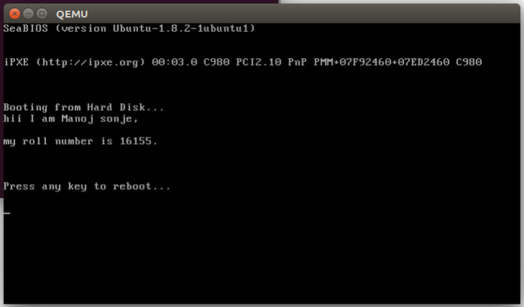
3- also we can use seconadary device to do this – first of all make secondary device bootable.

Commands to make secondary device bootable
sudo umount /dev/sdX
sudo dd if=/path/to/boot.iso of=/dev/sdX bs=4M && sync
where sdX is your usb device (this can be verified with lsblk).
The sync bit is important as dd can return before the write operation finishes.

