**A Project Proposal on**

**Result Management System**

Submitted to:

**Er. Ghan Bahadur Thapa**

By:

**MANOJ SHRESTHA**



**Forth Semester**

**Aadikavi Bhanubhakta Campus**

Vyas-01,Bigyanchaur

**(November 6, 2022)**

# Introduction

This proposal is the solution to ***“Result Management System”.*** This proposal is the reply to the project given by **Er. GHAN BAHADUR THAPA**. The completion of this project will allow the colleges to announce their results technically through the software which is handed to each and every students. A lot of efforts will be reduced after the completion of this project.

# Problem Statement

Recently different colleges of Nepal have been facing a lot problems due to COVID. Students are not able to get the results in proper time as the facilitators cannot meet regularly with the college result section employee/staff. Marks cannot be given in time which makes delay in result.Similarly, extra staffs are required for the result making process and result declaring process which creates financial hit on the college economy.

# Objectives

* Integrates the facilitators to the system for storing the result.
* Make easy for the students to access the result.

# Solution

Thinking about these problems, **MANOJ SHRESTHA, NISHA RANA AND SALMA KHATUN** will develop a desktop online software ***“Result Management System”*** with a solution of every above problems. Now, facilitators must not have to reach out to result section for giving marks. This software allows the facilitators and admins to store marks with their handy laptop or desktop. Similarly, students can also view report of the result through a desktop or laptop. This will decrease the staff required for the exam section to input marks into the system. A little effort of facilitators can make the result work easy and handy.

# Scope and Limitation

## 4.1 Scope

The main intention of this project is to solve the issues encountered in the old result management system where it was based more on paper works. In this project, a desktop software can be used to entry the marks and produce and provide a report ot the students and keep the record in the database for future purpose.

* The targeted groups for the result management system is mainly for the college and students can use it for their own purpose.

## 4.2 Limitations

* It cannot provide the remarks for the students.
* It is based on desktop application so users need a desktop or laptop to use it.
* Teachers cannot use it without a training.

# Methodology

## 5.1 Requirement Identification

**5.1.1 Study of Existing System**

Result Management System is a software to automate the result making process to make it easier and faster. The purpose of this system is to entry the marks of students stored in the database. This project will help to solve all the issues related to the result management system.

**5.1.2 Requirement collection**

There are two types of requirement collection i.e functional and non-functional requirement.

1. **Functional Requirement**

* **Student details storage:**  Admin can store some required detail of the student.
* **Facilitator details storage:** Admin can store some required detail of the facilitator.
* **Marks entry:** Admin and facilitators can enter the marks according to their role.
* **Views marks:** Students can view the marks entered by the students.
* **Authentication and Authorization:** System can validate the users through the id and password.

1. **Non-functional Requirement**

* **Performance:** The performance of the application depends upon the system specification.
* **Usability:** There is navigation bar at the top so navigate through the pages easily.
* **Security:** Some detaila of the students will be hidden.
* **Maintainability:** The system is easy to maintain.
* **Supportability:** System is supported by any OS having JVM.

## 5.2 Feasibility Study

### 5.2.1 Economic Feasibility

Since our system donot use any kind of other extra hardware component, it will be cheap means of result management system application.

|  |  |  |
| --- | --- | --- |
| **S.N** | **Particulars** | **Amount** |
| 1. | Software | 1000 |
| 2. | Paper print cost | 1000 |
|  | Internet cost | 3000 |
|  | Per person cost | 3000*3=9000 |
|  | Total cost | 14000 |

### 5.2.2 Technical Feasibility

Our system is built for any kind of OS. It has object oriented programming languages so the addition of new modules and editing modules will be easier as per requirement.

### 5.2.3 Operational Feasibilty

This system has a simple UI. Anyone with a little training can be able to handle the system well. The system will be maintainable, friendly and affordable. The system is tested under different circumstances with changing inputs in unit approach of testing to integrated approach of testing.

## 5.3 Tools Used

### 5.3.1 Front end Tools

#### Draw.io

Draw.io is a useful, free diagramming service with strong collaboration featuers via Google. It’s handy if your only occasionally need to make diagrams, but for functionality and more templated you’ll want a premium services.

### 5.3.2 Back end Tools

#### Language : Java

Java is a platform independent language as different devices have JVM(virtual machine) in which Java runs. Java is object oriented and it has proper memory management.

#### Framework: Swing

Java Swing is used to create window based applications. It provides lightweight GUI components for desktop software development.

#### Framework: JDBC

JDBC stands for Java Database Connectivity. JDBC is a Java API to connect and execute the query with the database. It is a part of JavaSE (Java Standard Edition). JDBC API uses JDBC drivers to connect with the database.

#### Database: MySQL

We use MySQL as our database. It is very simple to use. Little knowledge of SQL is enough. We can interact with the database through some simple SQL statements. It is free to use and we can download it from MySQL official website without any cost.

#### IDE: IntelliJ IDEA Community Edition 2022.2.3

IntelliJ IDEA Community Edition 2022.2.3 is an integrated development environment used in computer programming, specially for the python language. It is specially designed for the Java programming language providing a wide range of tools for providing environment for productive development.

#### Version Control: Git and Github

Github is a web based collaboration tools for the developers and version control tool too.

# High Level Design of Proposed System(ER Diagram, use cases or other appropriate diagrams)

## 5.1 Data Modelling (ER Diagram)

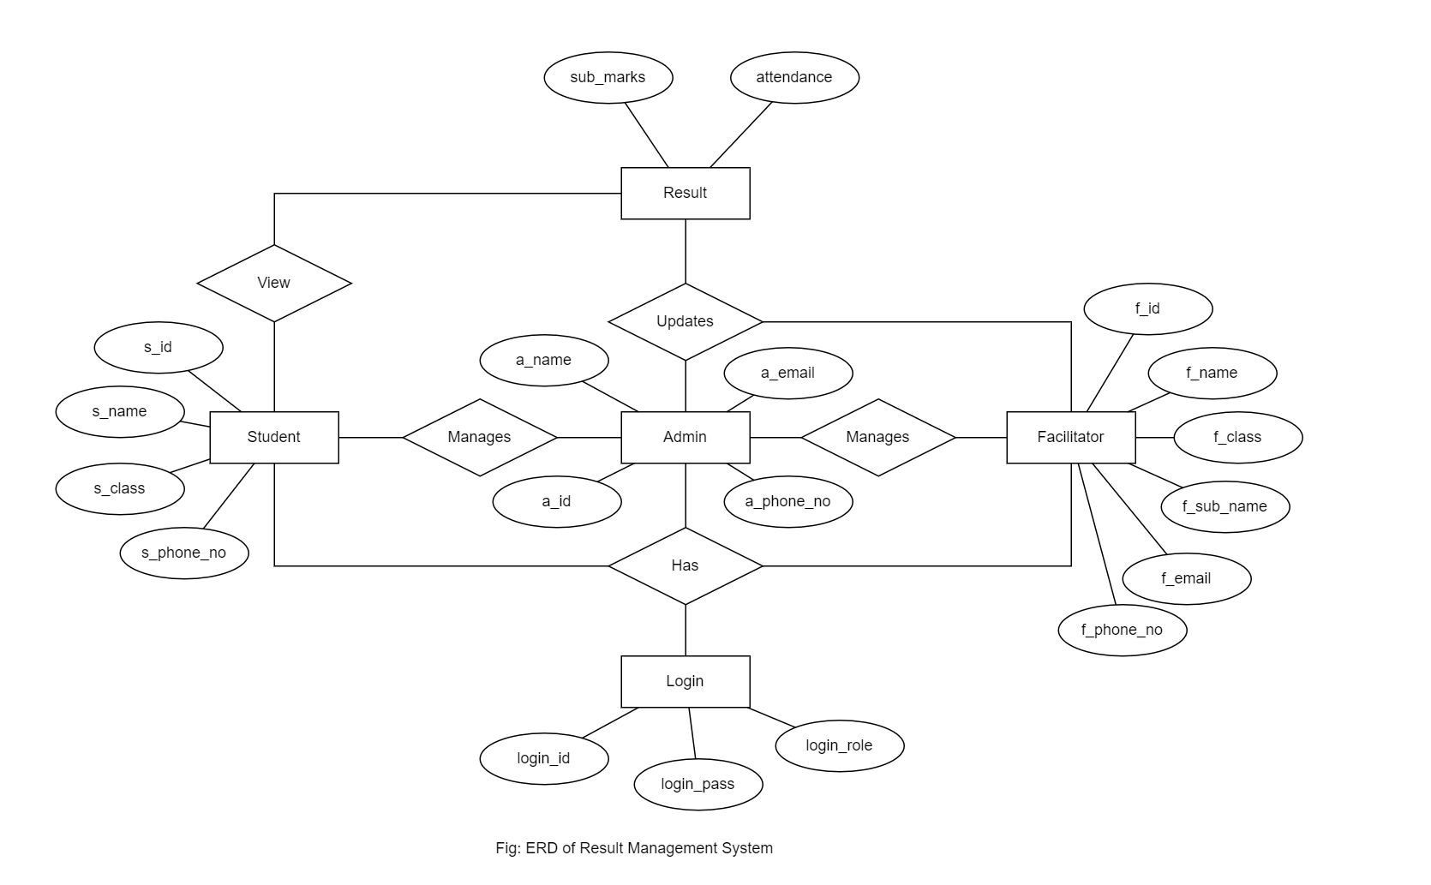

## 5.2 Use Case Diagrams

### 5.2.1 Use Case: Admin

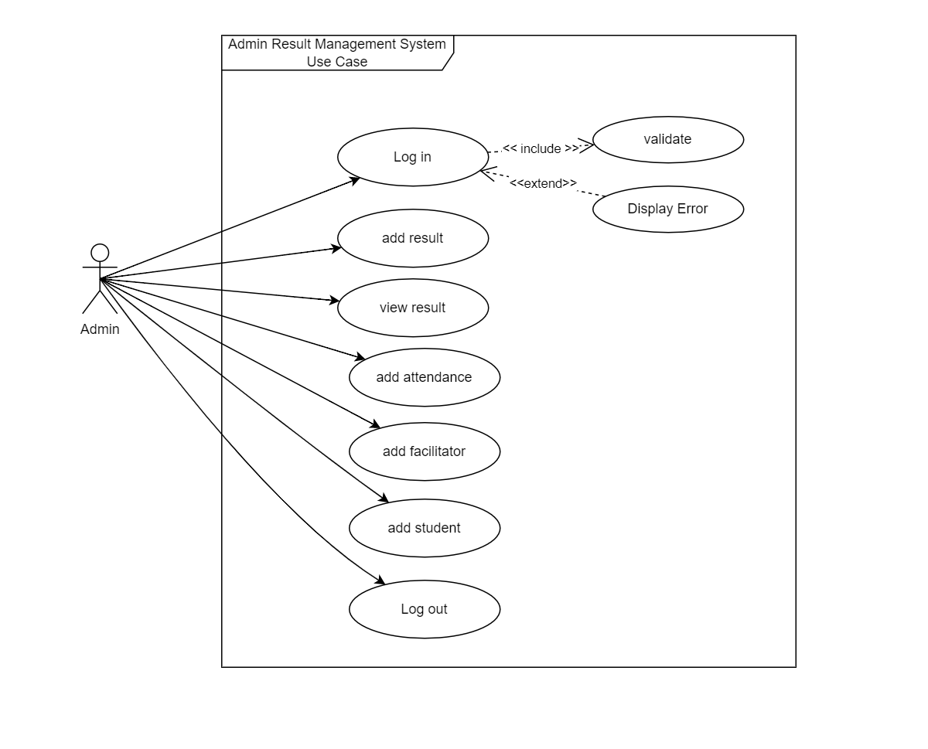

**5.2.2 Use Case: Facilitator**

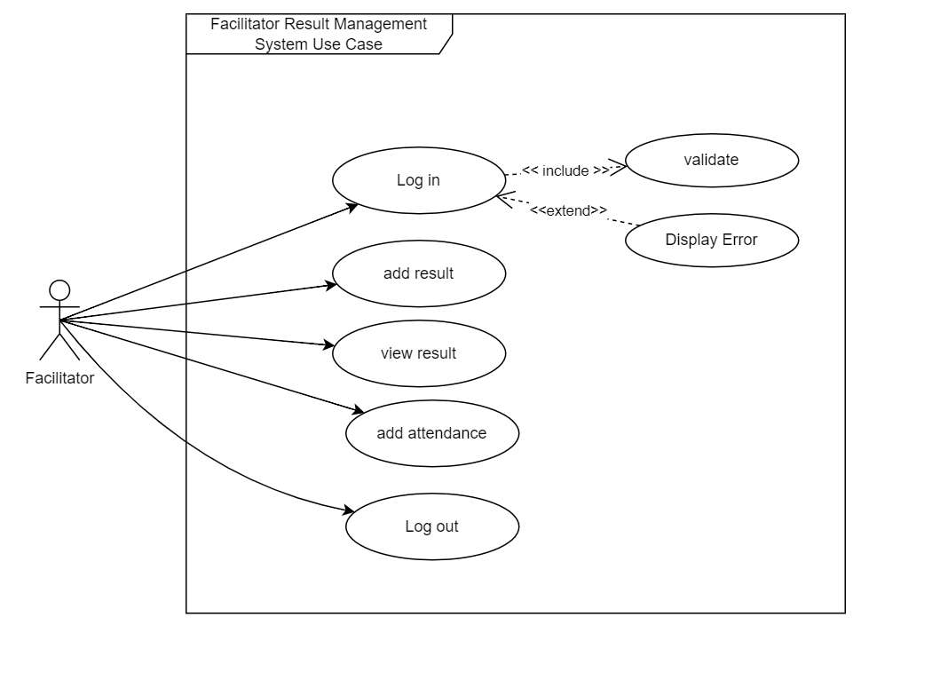

**5.2.3 Use Case: Student**

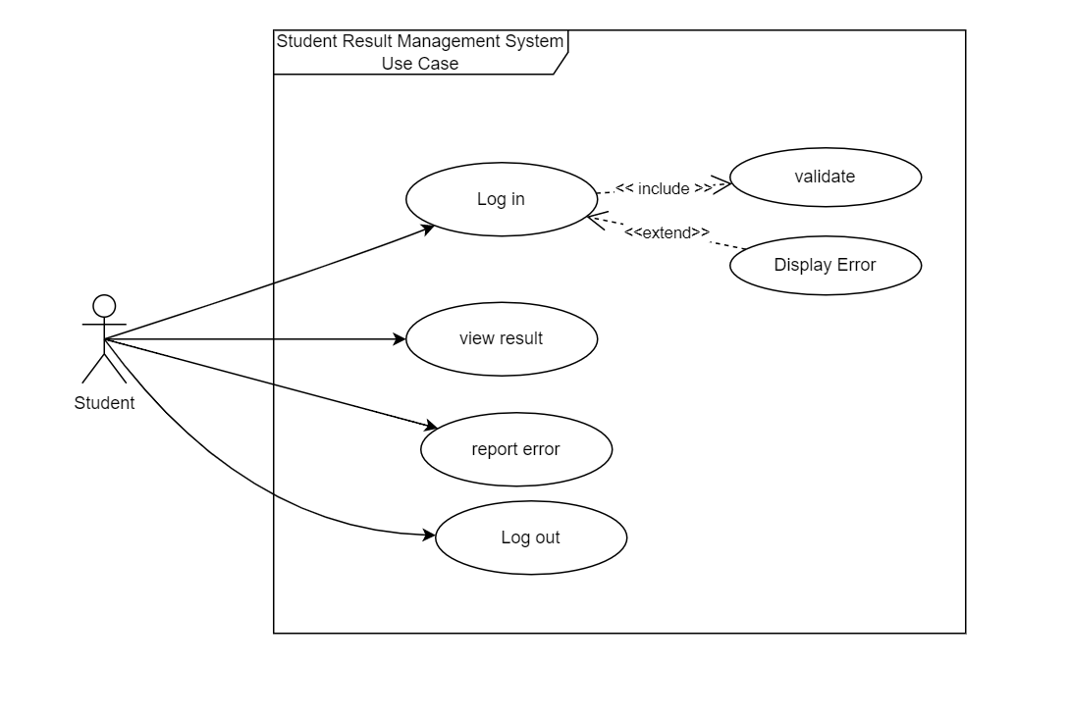

## 5.3 Process Modelling

### 5.3.1 DFD: Level 0

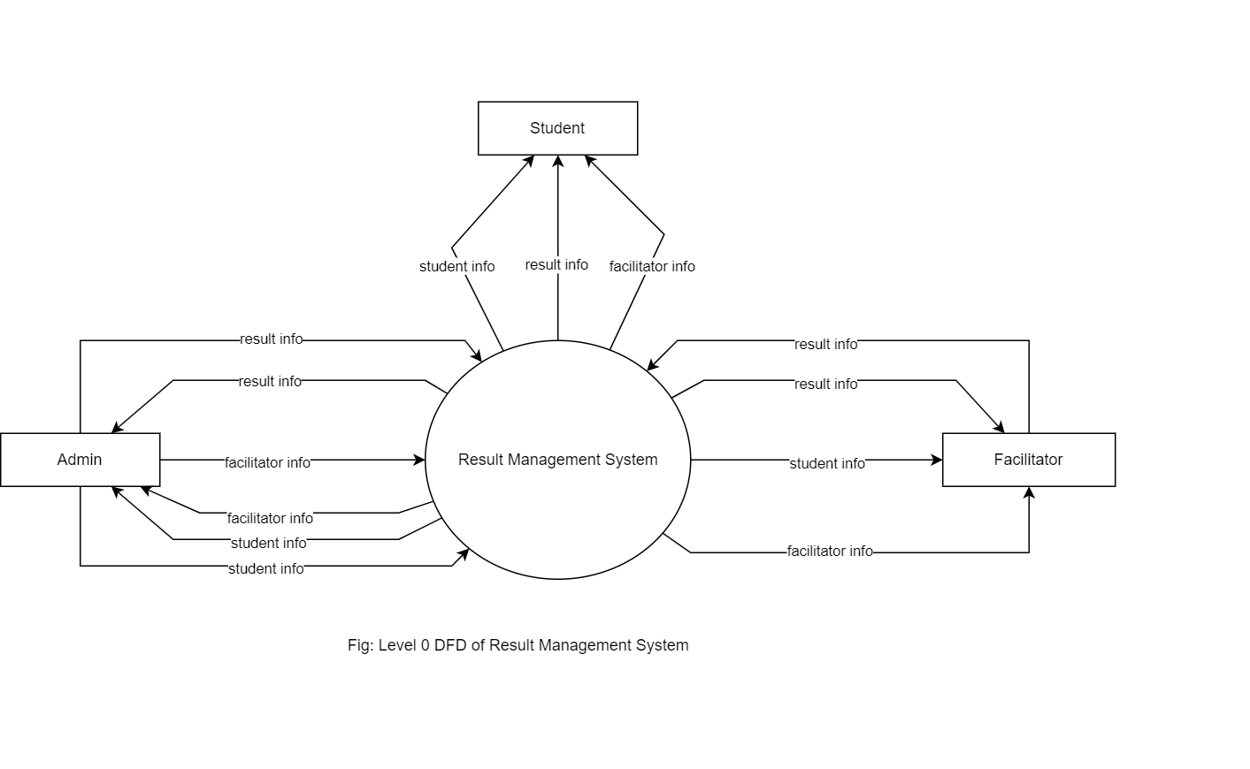

### 5.3.2 DFD: Level 1

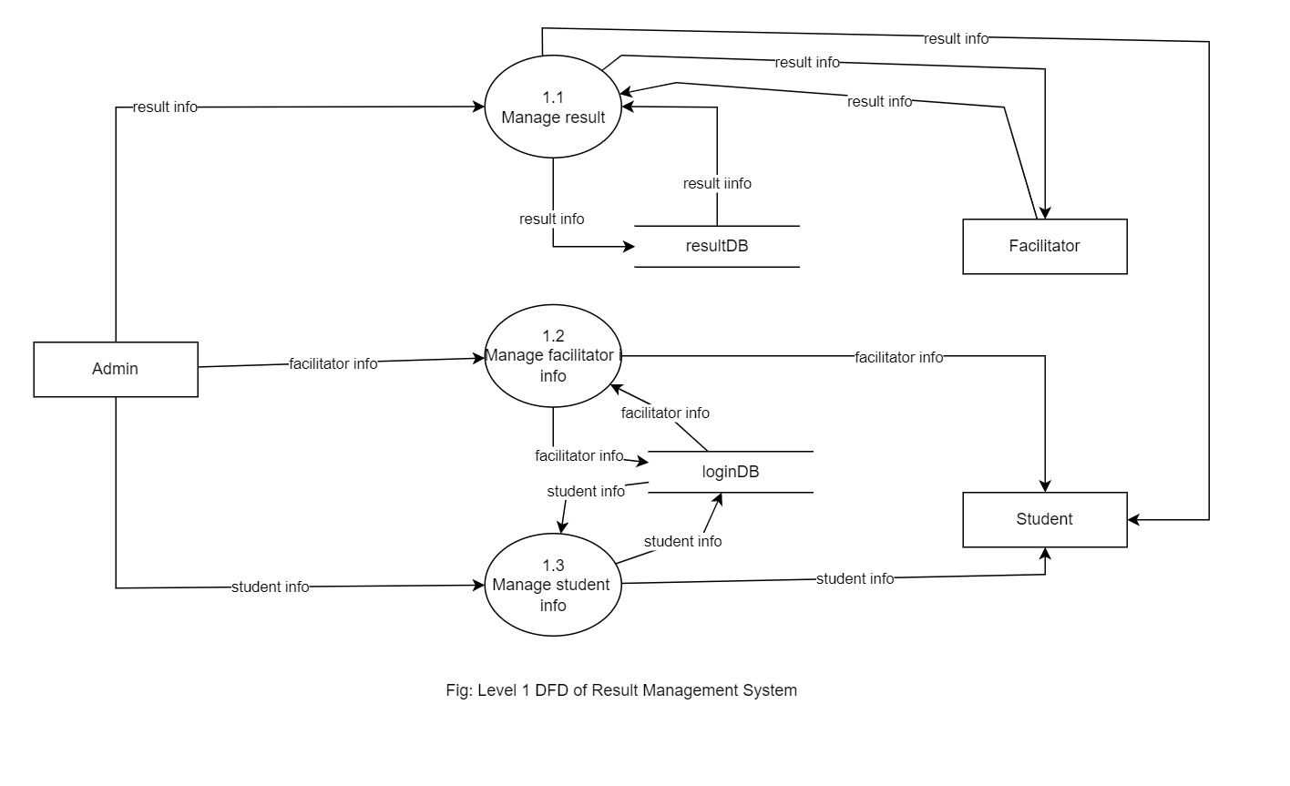

## 5.4 UML Class Diagram

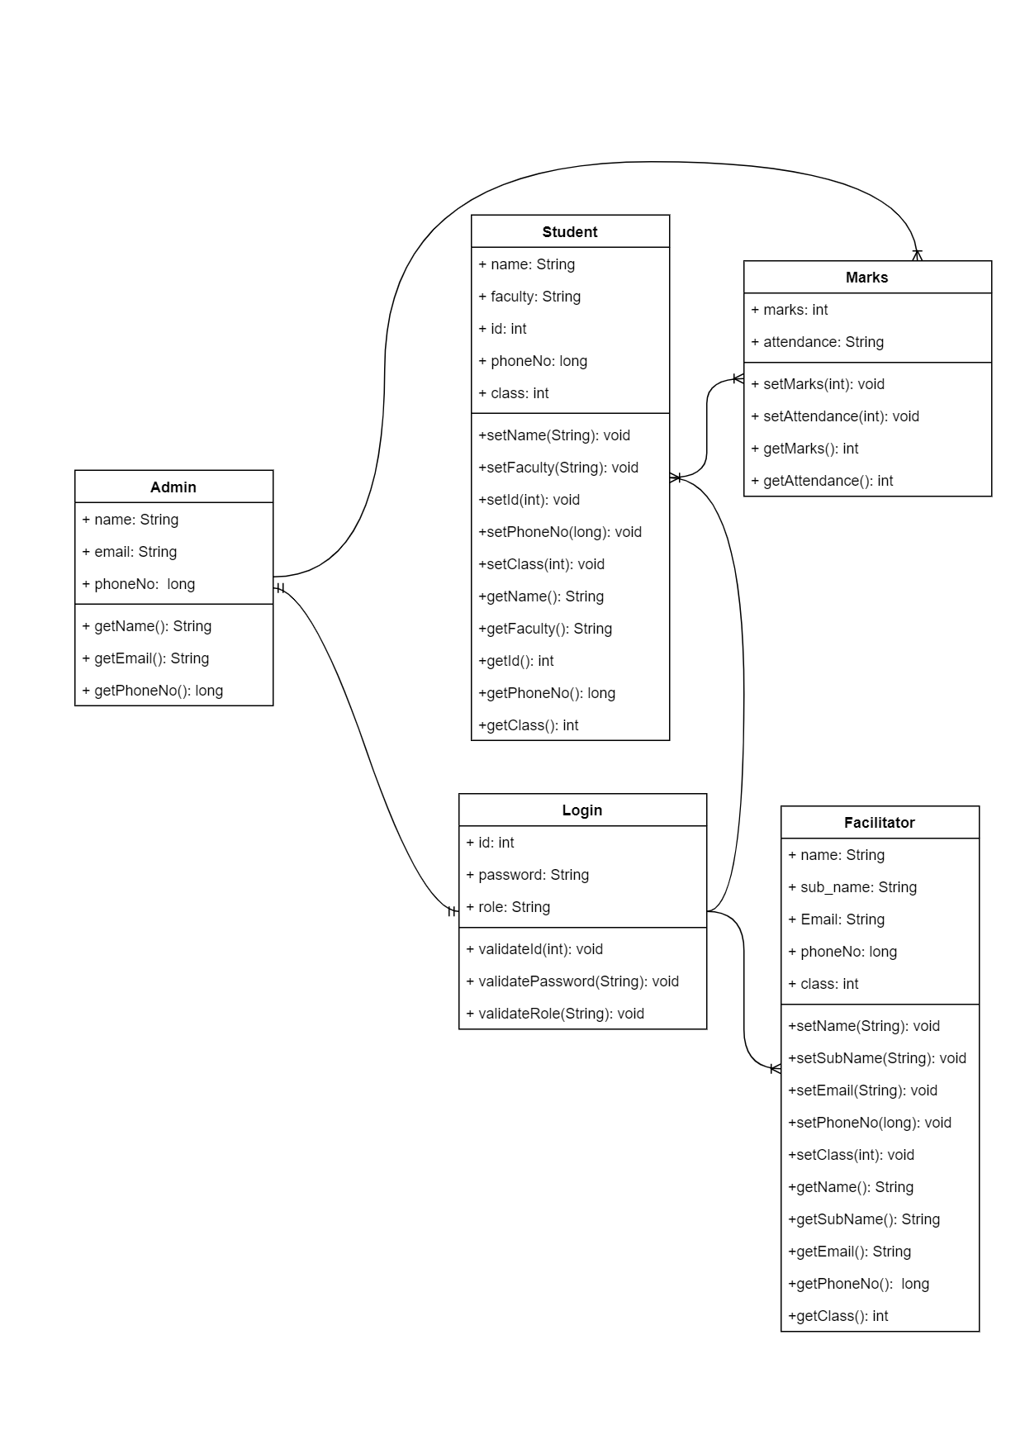

# Gantt chart to show project time planning

Time planning deals with the measures to plan the available time within the time frame.If a project takes more time that the time frame it is likely to get rejected.

|  |  |  |  |  |  |  |  |  |
| --- | --- | --- | --- | --- | --- | --- | --- | --- |
|  | Requirement  Gathering and  Feasibility study | System  analysis | System  design | coding | Testing | Debugging | Implementaion  And  Maintenance | Documentation |
| Start Date | 25 Oct | 25 Nov | 17 Dec | 9 Jan | 28 Jan | 16 Feb | 25 Feb | 15 Mar |
| Days To complete | 30 | 22 | 22 | 37 | 9 | 9 | 15 | 21 |

# Expected Output

When the software is completed, it will able to automate the result making process more easier. Now manual result management system will be automated and students can get their results during their holidays too. Teachers can directly fill the marks online at real time.