# **SUPERVISOR’S RECOMMENDATION**

It is my pleasure that a recommend on a “***School Management System***” has been prepared under my supervision by, **Miss. Dil Maya Ale,** **Mr. Manoj Shrestha**, **Miss. Nisha Rana**, **Mr. Bishal Ruchal** in partial fulfillment of the requirement of the Degree of Bachelor of Information and Communication Technology (BICTE). This report is satisfactory and is and original work done by us to process in further evaluation.

……………………………

Er. Ghan Bahadur Thapa

Project supervisor/coordinator

# **ACKNOWLEDGEMENT**

We would like to acknowledge and special thanks to our project supervisor **Mr. Ghan Bdr. Thapa** sir, who took interest on our project and guide us throughout the project by providing all the necessary ideas, information and knowledge for the project. His proper guidance and advice carried us through all the stage of writing this project. We would also like to thanks to our project members for letting this project more enjoyable moments, and for a proper comments and suggestions.

We would also express our thanks to Aadikavi Bhanubhakta Campus for constant guidance and supervision, as well as for providing all the necessary infrastructures and friendly environment for the successful completion of the project.

Finally, we would like to thanks to our classmate for letting us through all the difficulties and for providing much valuable suggestion to complete this project successful.

**Mr. Manoj Shrestha (73288013)**

**Miss. Nisha Rana (76288016)**

**Mr. Bishal Ruchal (76288006)**

**Miss. Dil Maya Ale (76288008)**

# **ABSTRACTS**

We proposed a web-based ***School Management System*** which will use as a platform for interaction between student, facilitators and admins. While the main objective of this project is to computerize the paperwork in the system and automate the work. The computerization is done so that the storage of all the details regarding students and facilitators will be stored in the system which makes system centralized and the chance of duplication of any data is minimized. Because of doing automation to the system that reduce the time for storing any data in the system. Similarly, it helps to stores, retrieves and detect the mistakes while entering the data.

This system uses **Php, CSS** and **MYSQL** as aprogramming language. Thus, the main purpose of this system is to provide more reliable to reduce a time, cost and minimize the duplication of data in the system. This system also reduces the amount of paper and time to search for the students details.

**Keywords used: CSS, computerization, centralized.**

Table of Content

**SUPERVISOR’S RECOMMENDATION** 1

**ACKNOWLEDGEMENT** 2

**ABSTRACTS** 3

**LIST OF FIGURES** 6

**LIST OF ABBREVIATIONS** 7

**CHAPTER 1: - INTRODUCTION** 8

**1.1 Problem Statement** 8

**1.2 Motivation** 8

**1.3 Objectives** 9

**1.4 Project Scope** 9

**1.5 Limitations: -** 9

**1.4 Report Organization** 10

**CHAPTER: -2 REQUIREMENTS ANALYSIS** 11

**2.1. Literature Review** 11

**2.2 Problem Definition** 11

**2.3 Requirement Analysis** 12

**2.3.1 Functional Requirement** 12

**2.4 Feasibility Study: -** 21

**2.4.1Economic feasibility:** 21

**2.4.2Technical feasibility:** 21

**2.4.3Legal feasibility:** 22

**2.4.4 Operational feasibility:** 22

**2.5** **Structuring System Requirements:** 23

**2.5.1 Data Modeling (ER Diagram)** 23

**2.5.2** **Process Modeling (DFD Level-0)** 23

**2.5.3 Process Modeling (DFD level-1)** 24

**CHAPTER: - 3 SYSTEM DESIGN** 24

**1.1.** **System Architecture and overview.** 24

**1.2.** **System Design** 25

**1.2.1** **Database Schema** 25

***Fig:- Database schema*** 26

**3.2.2 Data Dictionary** 26

**1.2.2** **UML Class Diagram** 29

**1.3** **Interface Design** 29

**CHAPTER: - 4 SYSTEM IMPLEMENTATION AND TESTING** 30

**4.1 Implementation and Overview** 30

**4.2 Technology used in my system** 30

**4.2.1 HTML:** 30

**4.2.2 CSS:** 31

**4.2.3 PHP:** 31

**4.2.3 MySQL Database:** 31

**4.3 Testing** 31

**4.3.1 Integrate Testing** 31

**4.3.2 Unit Testing** 32

**4.3.3 System Testing** 35

**CHAPTER: - 5 CONCLUSION AND RECOMMENDATION** 36

**5.1 Conclusion** 36

**5.2. Recommendation** 36

**5.2.1**  **Recommendation** 36

# **LIST OF FIGURES**

Figure 1: Use case diagram

Figure 2: Use case Template

Figure 3: Entity Relationship Diagram

Figure 4: Data Flow Diagram level-0

Figure 5: Data Flow Diagram level-1

Figure 6: Activity Diagram

Figure 7: UML Class Diagram

Figure 8: Data Dictionary

# **LIST OF ABBREVIATIONS**

|  |  |
| --- | --- |
| **ABBREVIATION** | **DESCRIPTION** |
| CSS | Cascading Style Sheet |
| MYSQL | Structured Query Language (MySQL in database engine) |
| DFD | Data Flow Diagram |
| ERD | Entity Relationship Diagram |
| SDLC | Software Development Life Cycle |
| RDBMS | Relational Database Management System |
| SMS | School Management System |

# **CHAPTER 1: - INTRODUCTION**

## **1.1 Problem Statement**

Most of the schools, college and universities are depends on paper-based processes. Due to this process many Headmasters and facilitators are facing many problems at the start of every new academic year, because of unmanaged information of students and facilitators. It became tedious to collect the information of all the students and teachers and manage them while the searching of information in just papers will be difficult.

The academic achievement for many students has decline, because of lake of care of them from their parents, and this refer to that their parents do not have a free time to come to school. Lack of communication and collaboration after a school day between Admin, Facilitators, Students and Parents, which had a bad reflection on a modern educational system.

## **1.2 Motivation**

The importance of school education lies in the fact that the children of today will become adult citizens of tomorrow. The growth and future of our country highly depends upon the quality of the present school education system. And in a good school the chief objective is to stimulate interest and curiosity in the students and provide all possible facilities for students, headmasters, facilitators and parents to achieve the desired goal which is a better and easier educational way for students so the motivation for our project came from that it has been made for that purpose, and for trying hardly to achieve all the previous goals.

## **1.3 Objectives**

* To make a virtual community between the members of educational process.
* To manage all the information about the schools, facilitators, students.
* To update the information of students and teachers easily.
* To create the communications between students, teachers and parents.
* To minimize the time.
* To reduce the duplication of data.
* To build a website for the management of schools.
* To facilitate remarks entry process for students by teachers.
* To computerize the paperwork in the system and automate the work.

## **1.4 Project Scope**

In this era of technology school facilities are not base on paper work, but rather, the administrators have been hoping for an advanced system. This model is purpose for the full, **user friendly**, **fast** and **effective management** for various task. The school management system manages the administration of managing the information of students and facilitators **and provides communications between students, facilitator, admin and parents.**

## **1.5 Limitations: -**

* Student info doesn’t contain result, attendance, account.
* Admin cannot create account for facilitator and students.
* Requires a skills and knowledge of technology.
* School management system can entry data 1 person at a single time.
* Cannot enter the data without internet.
* Cost of this system will be expensive.

## **1.4 Report Organization**

**Chapter 1**: This chapter explains the overview, introduction, problem statement, motivations, project scope and limitation of the system.

**Chapter 2**: This chapter covers all the history, methods, requirement specification and feasibility analysis and structured system requirements.

**Chapter 3**: Design of school management project is explained in detail with all the necessary diagrams and brief functionality.

**Chapter 4**: Process of implementation and testing is described along with all the tools used for the development.

**Chapter 5**: Conclusion and future scope of the application are explained.

# **CHAPTER: -2 REQUIREMENTS ANALYSIS**

## **2.1. Literature Review**

In ancient school management system were done by paper based, which are very time consuming and often leads to human error. Right now, there are numbers of school that have implemented computer base school management system, which are very essential for human life. In general, **School Management System**has managed to ease the task of admins, facilitators, staffs, students and others through a multi-function platform. Not only limited to internal management, but the school system management also manages the school’s interaction with the students and parents and community about different topics. In this era of technology, we need to manage all information in secure than ever before.

Without a solid internal infrastructure for **admins, headmasters and departments** to share data, critical school and student information can be lost that can be effect of a school's image.

## **2.2 Problem Definition**

Manual school managements system can take up a significant amount of space, and the quantity of paper will increase day by day. Furthermore, documents will typically need to be stored close to hand so that they can be accessed as quickly as possible.

Manual documents can be easily damaged, lost, misplaced or stolen. A fire or natural disaster could mean the loss of essential information. If you don’t have any copies, once the files are gone, there is no way of getting the information back.

The paper-based system is quite complicated, slow and inefficient. With a digital document management system in place, you can simply add attachments to an email and send information instantly.

If you want to change the information, you need to write all the contain again. This will need to be repeated every time you want to make more corrections.

To solve these issues, we aimed to design and implement web base school management system where the students can add their data and this information are store in software and can search all the information whatever we need.

## **2.3 Requirement Analysis**

In our project, we have collected list of documents with sufficient and necessary requirements for the project development.

To derive the requirements, we have done better understanding of the products under development which we achieved through detailed and continuous communications with the project team throughout the software development process.

### **2.3.1 Functional Requirement**

**1. Admin**: - Admin can update facilitator and student info in the system.

**2. Student**: - Students can view facilitator and student info provided by the database.

**3.** **View Instructor Info: -** Admins, facilitators and students can view facilitator info provided by the admin the instructor section.

**4. Auto management**: - System verifies login-id and provides all information automatically.

**5. Show management system**: - If the system is validated it then the system displays homepage.

**6. Update Instructor Info: -** Admins and facilitators can update facilitator info in the system.

**7. Update Student Info: -** Admins and facilitators can update student info in the system.

**8. View Student Info: -** Admin, facilitators and students can view student info in the system.

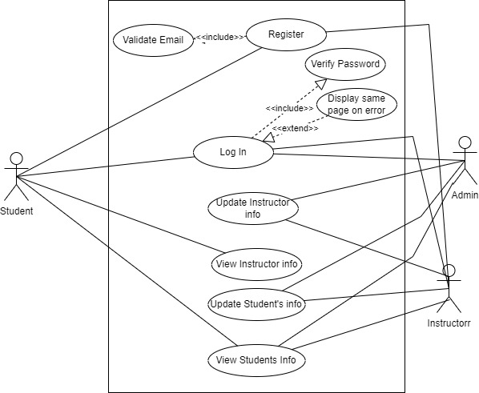

**Fig: Use Case Diagram.**

| Use Case Id: | 1.0 |
| --- | --- |
| Use Case Name: | Register |
| Created By: | Nisha, Bishal, Dilu Maya, Manoj Last updated by: |
| Date Created: | April 26, 2023 Date last updated: |
| Actor(s): | Student, Facilitator |
| Description: | Users register themselves into the system using their email id. Users select a unique username and password to register with some details for registration. Users have to include their roles to get different facilities according to roles. |
| Precondition: | 1. Users have to validate their email. |
| Postcondition: | 1. System displays the login page. |
| Normal Courses: | 1. Users validate their email. 2. Users select a unique username and password. 3. System checks for the username and password in the database. 4. Users choose the roles. 5. Users submit the email, username, password, date of birth and roles. 6. The use case ends. |
| Alternative Courses: | 1a. Upon missing email:   * System prompts for email. * The use case resumes at step 1.   5a. Upon not unique username and password:   * System prompts a message. * The use case resumes at step 2. |
| Exceptions: | Nil |
| Includes: |  |
| Priority: | High |
| Frequency of use: | 24 hours a day |
| Business Rule: | User must register through a email id. |
| Special Requirement: |  |
| Assumptions: | Nil |

|  |  |
| --- | --- |
| Use Case Id: | 2.0 |
| Use Case Name: | Log In |
| Created By: | Nisha, Bishal, Dilu Maya, Manoj Last updated by: |
| Date Created: | April 26, 2023 Date last updated: |
| Actor(s): | Student,Admin,Facilitator |
| Description: | This use case allows users to login into the system and perform different functions according to the user roles. All the users have to enter a unique username and password. |
| Precondition: | 1. Users have to validate their account. |
| Postcondition: | 1. System displays the relevant homepage. |
| Normal Courses: | 1. Users enter the username and password. 2. User submits the username and password. 3. System validates the username and password. 4. System verifies the username and password. 5. System detects the usertype. 6. System displays the home page. 7. This use case ends. |
| Alternative Courses: | 3a. Upon missing username and password:   1. the system prompts for username and password. 2. the use case resumes at step 1.   4a. Upon invalid username and password:   1. the system displays invalid messages. 2. the system prompts for username and password. 3. The system resumes at step 1. |
| Exceptions: | Nil |
| Includes: |  |
| Priority: | High |
| Frequency of use: | 24 hours a day |
| Business Rule: | User must login through a registered and verified account. |
| Special Requirement: |  |
| Assumptions: | Nil |
| Notes and Issues: |  |
| Use Case graphics: |  |

|  |  |
| --- | --- |
| Use Case Id: | 3.0 |
| Use Case Name: | Update Facilitator Info |
| Created By: | Nisha, Bishal, Dilu Maya, Manoj Last updated by: |
| Date Created: | April 26, 2023 Date last updated: |
| Actor(s): | Admin,Facilitator |
| Description: | Admin,facilitator can update facilitator and info into the update facilitator section. |
| Precondition: | 1. Admin,facilitator login into the system. 2. Admin,facilitator opens the update facilitator section. |
| Postcondition: | 1. New facilitator is seen in the facilitator section. |
| Normal Courses: | 1. Admin,facilitator gives the facilitator name and details. 2. Admin,facilitaor submits the facilitator name and details. 3. This use case ends. |
| Alternative Courses: | 1a. Upon missing course name:   * The system displays missing courses. * The use case resumes at step 1. |
| Exceptions: | 1. Admin do not fill up the details. |
| Includes: |  |
| Priority: | Medium |
| Frequency of use: | 24 hours a day |
| Business Rule: |  |
| Special Requirement: |  |
| Assumptions: | Nil |
| Notes and Issues: |  |
| Use Case graphics: |  |

|  |  |
| --- | --- |
| Use Case Id: | 4.1 |
| Use Case Name: | View Facilitator Info |
| Created By: | Nisha, Bishal, Dilu Maya, Manoj Last updated by: |
| Date Created: | April 26, 2023 Date last updated: |
| Actor(s): | Student,Facilitator |
| Description: | Students can view facilitator info provided by the admin in the view facilitator section. |
| Precondition: | 1. Students login into the system. 2. Student opens the view facilitator section. |
| Postcondition: | 1. Students can view the facilitator info. |
| Normal Courses: | 1. Students get the facilitator details. 2. Students download the facilitator details. 3. The use case ends. |
| Alternative Courses: | 2a. Upon not downloading facilitator info:   * System exits to homepage. |
| Exceptions: | 1. Student’s don’t view the facilitator info. |
| Includes: |  |
| Priority: | Low |
| Frequency of use: | 24 hours a day |
| Business Rule: |  |
| Special Requirement: |  |
| Assumptions: | Nil |
| Notes and Issues: |  |
| Use Case graphics: |  |

|  |  |
| --- | --- |
| Use Case Id: | 5.0 |
| Use Case Name: | Update Student’s Info |
| Created By: | Nisha, Bishal, Dilu Maya, Manoj Last updated by: |
| Date Created: | April 26, 2023 Date last updated: |
| Actor(s): | Admin,Facilitator |
| Description: | Users can check the student details and edit the students details. Admin and facilitators can update the status of students on the basis of marks and results. Students can only update their profile status. |
| Precondition: | 1. Users must login into the system 2. Users open the update student section. |
| Postcondition: | 1. Data about the student is updated. |
| Normal Courses: | 1. Users update the students' details. 2. Users submit the students' details. 3. This use case ends. |
| Alternative Courses: | 1a. Upon missing students info.   * System gives a message to the user. |
| Exceptions: | User do not update the students details. |
| Includes: |  |
| Priority: | High |
| Frequency of use: | 24 hours a day |
| Business Rule: |  |
| Special Requirement: |  |
| Assumptions: | Nil |
| Notes and Issues: |  |
| Use Case graphics: |  |

|  |  |
| --- | --- |
| Use Case Id: | 6.0 |
| Use Case Name: | View Student’s Info |
| Created By: | Nisha, Bishal, Dilu Maya, Manoj Last updated by: |
| Date Created: | April 26, 2023 Date last updated: |
| Actor(s): | Admin,Facilitator,Students |
| Description: | Users can view students info provided by the database in the view student section. |
| Precondition: | 1. Users login into the system. 2. Student opens the view student section. |
| Postcondition: | * + - 1. Students can view the student info. |
| Normal Courses: | * + - 1. Students get the student details.       2. Students download the student details.       3. The use case ends. |
| Alternative Courses: | 2a. Upon not downloading facilitator info:   * System exits to homepage. |
| Exceptions: | Student’s don’t view the students info. |
| Includes: |  |
| Priority: | High |
| Frequency of use: | 24 hours a day |
| Business Rule: |  |
| Special Requirement: |  |
| Assumptions: | Nil |
| Notes and Issues: |  |
| Use Case graphics: |  |

**Use case diagram description.**

**2.3.2 Non-functional Requirement**

1. **Security: -** Only authorize users can access the system with username and password
2. **Performance:** - Easy tracking of records and update can be done.
3. **User Friendly:** - The system is very interactive.
4. **Availability**: The system is available all the time, no time constraint

## **2.4 Feasibility Study: -**

Feasibility study is an analysis of how successfully a project can be completed, accounting for factors that effect it such as economic, technical, legal and other factors. Similarly, we use feasibility studies to determine potential positive and negative outcomes of a project before investing a considerable amount of time and money into it.

### **2.4.1Economic feasibility:**

Since, our system uses simple hardware components which are easily available in market. The overall system is economically feasible to be implemented by educational sectors. But to get the system more efficient it requires GPU so it can be expensive.

### **2.4.2Technical feasibility:**

Our system is built for any type of operating system. It can adopt the technological upgrades as it is developed under the considerations of software engineering principles. Moreover, it uses hypertext markup language, cascading style sheet and php approach of programming which can enhance the upgrading with new classes and modules as per requirement.

**Hardware specification**

* Laptop / Desktop

**Software specification**

* XAMPP web server
* Apache Server
* MySQL Server
* Visual Studio Code

### **2.4.3 Legal feasibility:**

This system follows the legal policy and all the requirements. Also, it has a privacy, nepotism and accountability.

### **2.4.4 Operational feasibility:**

This system has a simple UI. Anyone with the basic knowledge of application can easily go to the home page of the application to perform the various task and perform actions easily by clicking bottoms. The developed application will be reliable, maintainable, usable, user friendly, sustainable and affordable. The system is tested under several circumstances with varying inputs in unit approach of testing to integrated approach of testing.

## **Structuring System Requirements:**

### **2.5.1 Data Modeling (ER Diagram)**

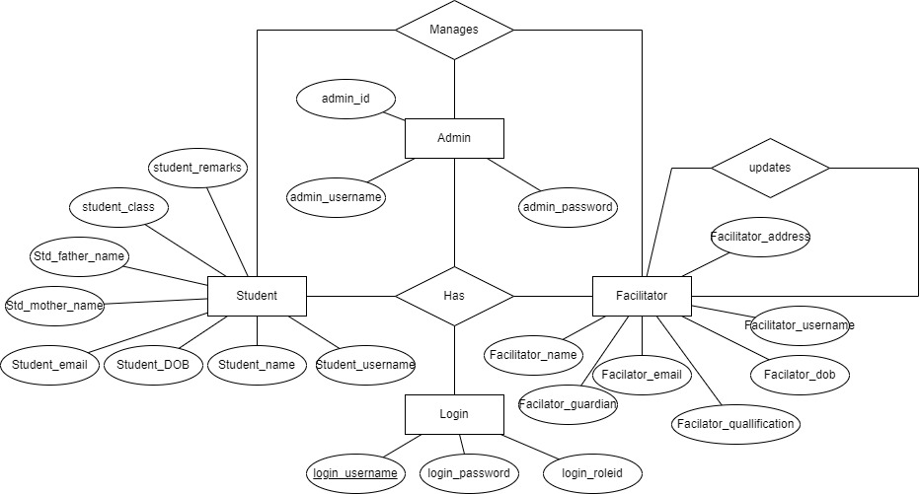

The above diagram explains the relationship between the database where rectangle represents entity, oval represents attributes and Diamond represents relation. There are three entities with their respective attributes. Admin acts as one of the entities and has attributes like admin_ id, admin_ username, admin_ password. And another attributes Facilitator acts as another entity and it has attributes like facilitator_ name, facilitator_ username, facilitator_dob, facilitator_ email,facilitator_qualification, facilitator_guardian . The student is another entity and it has attributes like student_ email, students_ DOB, students_ name, students_ username, std_mother_name, std_father_name, student_class, and student_remarks.

### **Process Modeling (DFD Level-0)**

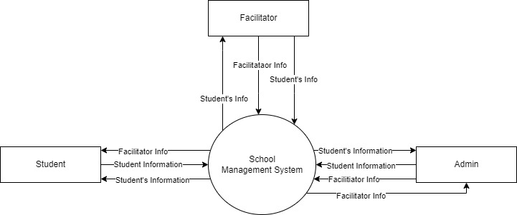

The above diagram shows the DFD zero level where system manages the students Information. It’s a basic overview of the whole school Management system where student’s login to the system. System takes the students information and sends data to students database. Admin performs updating database and adding new students records in addition admin manages student’s data, facilitators data and courses information and update report.

### **2.5.3 Process Modeling (DFD level-1)**

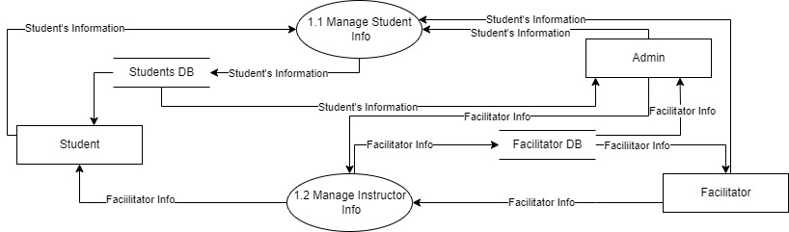

The above diagram is the DFD level-1, where it explains the working process of system. These procedures require information such as record of students, enrollees, transactions and instructors from which served as the bases for the School Management System. There is login process in the system which is authenticated and authorized by admin. Students’ login to the system via email_ id then system verify it. If student_ id is validated then the system opens the home page, if the id is invalidated then the system notifies unauthorize.

# **CHAPTER: - 3 SYSTEM DESIGN**

## **System Architecture and overview.**

**System Design** is the process of designing the architecture, components, and interfaces for a system so that it meets the end-user requirements. The designs can be defined in graphical or textual modelling languages. Also, it is the process of creating or altering systems, along with the processes, practices, models. And methodologies used to develop them.

We have developed “School Management System” which require MySQL-server for its functioning. To use this system we need a database, laptop / desktop and the users.

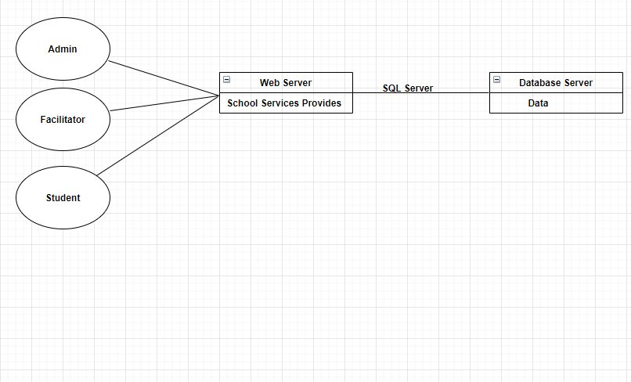

***Fig: - System architecture***

## **System Design**

### **Database Schema**

There are three tables in our system as database which are student, facilitator and admin. In below diagram the tables cover their respective primary key and their fields.

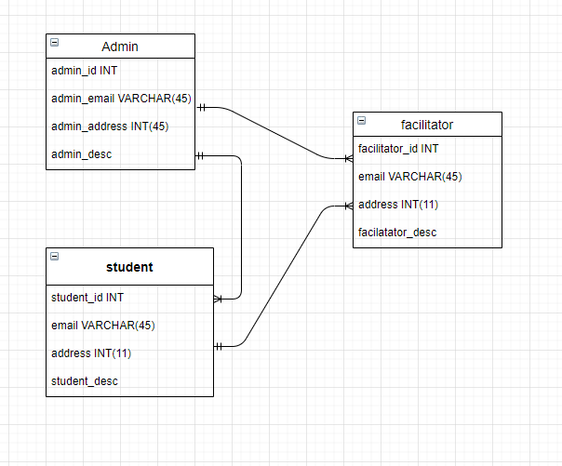

### ***Fig:- Database schema***

### **3.2.2 Data Dictionary**

A data dictionary describes the data stored in a database. In simple terms, it provides information and insights about your database, in other words, a data dictionary is a documentation for all the data assets in a database. So, we also provide a data dictionary of our project which is illustrate below: -

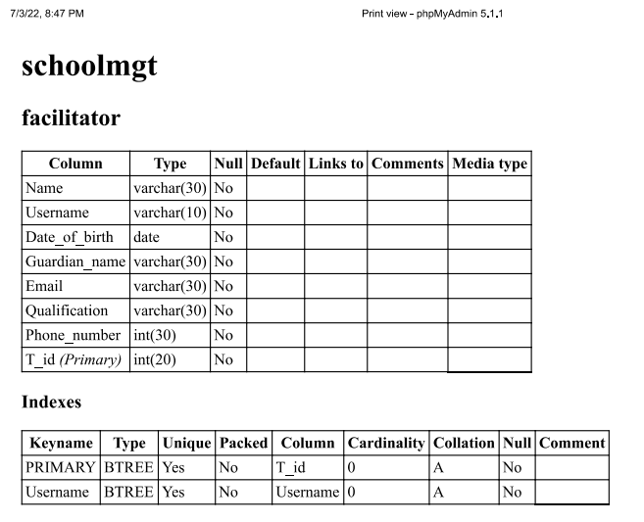

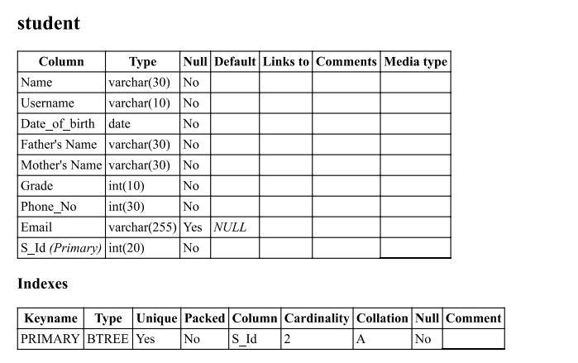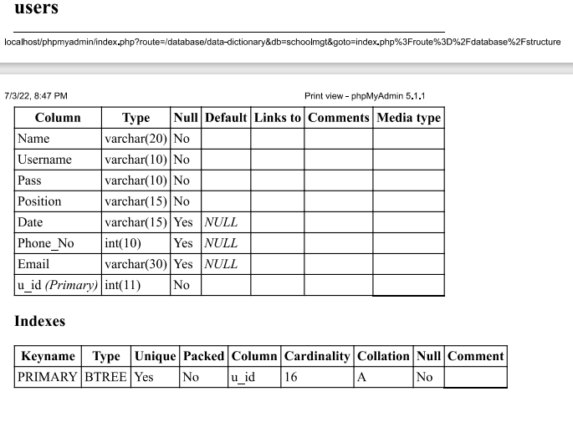

### **UML Class Diagram**

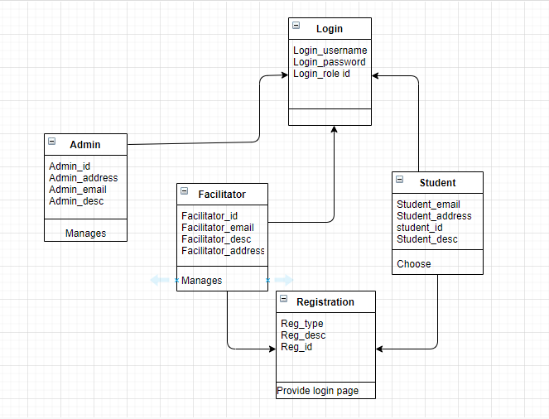

***Fig: - UML Class diagram***

Our system has four entities: admin, facilitator, students, login which have their own data members and methods. Above diagram shows the flow of the functionality from entity to entity.

### **Interface Design**

# **CHAPTER: - 4 SYSTEM IMPLEMENTATION AND TESTING**

## **4.1 Implementation and Overview**

Prototyping Model has been used to develop this application. The Prototyping model is a technique for quickly building a function but incomplete model of the information system. There are several kinds of prototypes but they all intend to reduce risk by building a quick and dirty replica or mockup of the intended system. It can be used to demonstrate technical feasibility when the technical risk is high. It can also be used to better understand and elicit user requirements. In either case, the goal is to reduce risk and limit costs by increasing understanding of proposed solutions before committing more resources. The figure is illustrates given below: -

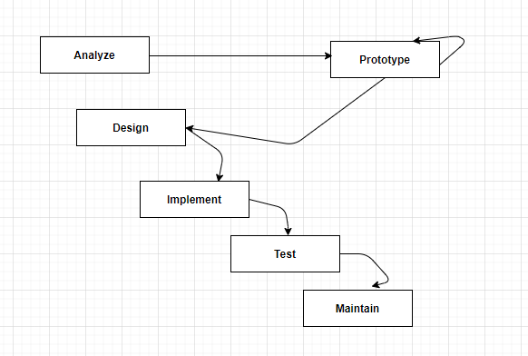 ***Fig: - Prototype model***

## **4.2 Technology used in my system**

**4.2.1 HTML:** Is the standard markup language used to create web pages. Web browsers can read HTML files and render them into visible or audible web pages. HTML elements form the building blocks of all websites. HTML allows images and objects to be embedded and can be used to create interactive forms. It provides a means to create structured documents by denoting structural semantics for text such as headings, paragraphs, lists, links, quotes and other items.

**4.2.2 CSS:** Is a Web page derived from multiple sources with a defined order of precedence where the definitions of any style element conflict. The Cascading Style Sheet, level 1 recommendation from the World Wide Web Consortium (W3C), which is implemented in the latest versions of the Netscape and Microsoft Web browsers, specifies the possible style sheets or statements that may determine how a given element is presented in a Web 9 page. And describes how HTML elements are to be displayed on screen, paper, or in other media .

**4.2.3 PHP:** Is an open sources server-side language which is used for creating dynamic web pages. It can be embedded into HTML. PHP is usually used in conjunction with a MySQL database on Linux/UNIX web servers. It is probably the most popular scripting language. And it is a widely-used general-purpose scripting language and interpreter that is freely available. A full explanation of all the PHP tags.

**4.2.3 MySQL Database:** MySQL is the world's most popular open sources database. With its proven performance, reliability and ease-of-use, MySQL has become the leading database choice for web-based applications, used by high profile web properties including Facebook, Twitter, YouTube, Yahoo! and many more.

## **4.3 Testing**

### **4.3.1 Integrate Testing**

|  |  |  |
| --- | --- | --- |
| **Test suite plan** | **Test Case Id** | Test Case Description |
| Admin | T-01 | Log In |
| T-02 | Edit Facilitator |
| T-03 | Edit Student |
| T-04 | Delete Facilitator |
| T-05 | Delete Student |
| Facilitator | T-06 | Register |
| T-07 | Log In |
| T-08 | Edit Facilitator |
| T-09 | Edit Student |
| T-10 | Delete Facilitator |
| T-11 | Delete Student |
| Student | T-12 | Register |
| T-13 | Log In |

### **4.3.2 Unit Testing**

|  |  |  |  |  |  |  |
| --- | --- | --- | --- | --- | --- | --- |
| S. N | Test Case Id | Test Case Description | Input Test Data | Expected Result | Actual Result | Remarks |
| 1. | T-01 | Enter username and password | admin  admin | Display homepage | Successful | Pass |
| Enter username and password | Admin 1  admin | Display the login page again | Successful | Failed |
| Enter username and password | admin  admin 1 | Displays the login page again | Successful | Failed |
| 2. | T-02 | Enter  Name, Date of Birth, Guardian’s Name, Email, Phone Number, Qualification  For edit | Hompal Prasad Rao  2021-11-05  Gopal Rao  [ghan@gmail.com](mailto:ghan@gmail.com)  9813832874  BSc. CSIT | Edit the data where details is viewed for given username | Successful | Pass |
| 3. | T-03 | Enter Name,  Date of Birth,  Father’s Name, Mother’s Name, Phone Number, Email, Class, Remarks | Manoj Shrestha  2001-09-04  Hari Kumar Shrestha  Pabitra Shrestha  9816683613  [student@gmail.com](mailto:student@gmail.com)  10  80 | Edit the data where details are viewed for given username | Successful | Pass |
| 4. | T-04 | Delete the Facilitator | Press Delete | Delete the Facilitator for given username | Successful | Pass |
| 5. | T-05 | Delete the Student | Press Delete | Delete the student for given username | Successful | Pass |
| 6. | T-06 | Enter Full Name, Date of Birth, Position,  Phone Number,  Username,  Email,  Password,  Confirm  Password | Remon Shrestha  9861110801  [shresthanewar678@gmail.com](mailto:shresthanewar678@gmail.com) | Shows the screen with message “Data is Empty” | Successful | Failed |
| Enter Full Name, Date of Birth, Position,  Phone Number,  Username,  Email,  Password,  Confirm  Password | Remon Shrestha  2007-05-08  Facilitator  9861110801  remon1  @gmail.com  remon1  remon1 | Shows the screen with message “Email is not valid” | Successful | Failed |
| Enter Full Name, Date of Birth, Position,  Phone Number,  Username,  Email,  Password,  Confirm  Password | Remon Shrestha  2007-05-08  Facilitator  9861110801  remon1  shresthanewar678@gmail.com  remon1  remon2 | Shows the screen with message “Both Password are not same” | Successful | Failed |
| Enter Full Name, Date of Birth, Position,  Phone Number,  Username,  Email,  Password,  Confirm  Password | Remon Shrestha  2007-05-08  Facilitator  9861110801  remon1  shresthanewar678@gmail.com  remon1  remon1 | Redirect to the login page | Successful | Pass |
| 7. | T-07 | Enters the username and password | remon1  remon | Display the login page again | Successful | Failed |
| Enter the username and password | remon  remon1 | Display the login page again | Successful | Failed |
| Enters the username and password | remon1  remon1 | Display home page | Successful | Pass |
| 8. | T-08 | Enter  Name, Date of Birth, Guardian’s Name, Email, Phone Number, Qualification  For edit | Hompal Prasad Rao  2021-11-05  Gopal Rao  [ghan@gmail.com](mailto:ghan@gmail.com)  9813832874  BSc. CSIT | Edit the data where details are viewed for given username | Successful | Pass |
| 9. | T-09 | Enter Name,  Date of Birth,  Father’s Name, Mother’s Name, Phone Number, Email, Class, Remarks | Manoj Shrestha  2001-09-04  Hari Kumar Shrestha  Pabitra Shrestha  9816683613  [student@gmail.com](mailto:student@gmail.com)  10  80 | Edit the data where details is viewed for given username | Successful | Pass |
| 10. | T-10 | Delete the Facilitator | Press Delete | Delete the Facilitator for given username | Successful | Pass |
| 11. | T-11 | Delete the Student | Press Delete | Delete the student for given username | Successful | Pass |
| 12. | T-12 | Enter Full Name, Date of Birth, Position,  Phone Number,  Username,  Email,  Password,  Confirm  Password | Manipal Shrestha  9861110801  manojbicte@gmail.com | Shows the screen with message “Data is Empty” | Successful | Failed |
|  |  | Enter Full Name, Date of Birth, Position,  Phone Number,  Username,  Email,  Password,  Confirm  Password | Manipal Shrestha  2008-05-08  Student  9861110801  manipal  manipal.com  manipal1  manipal1 | Shows the screen with message “Email is not valid” | Successful | Failed |
|  |  | Enter Full Name, Date of Birth, Position,  Phone Number,  Username,  Email,  Password,  Confirm  Password | Manipal Shrestha  2008-05-08  Student  9861110801  manipal  manipal.com  manipal1  manipal2 | Shows the screen with message “Both Password are not same” | Successful | Failed |
|  |  | Enter Full Name, Date of Birth, Position,  Phone Number,  Username,  Email,  Password,  Confirm  Password | Manipal Shrestha  2008-05-08  Student  9861110801  manipal  manipal@gmail.com  manipal1  manipal1 | Redirect to the login page | Successful | Pass |
|  |  | Enters the username and password | manipal  manipal | Display the login page again | Successful | Failed |
|  |  | Enter the username and password | manipal1  manipal1 | Display the login page again | Successful | Failed |
|  |  | Enters the username and password | manipal  manipal1 | Display home page | Successful | Pass |

### **4.3.3 System Testing**

|  |  |  |  |  |  |  |
| --- | --- | --- | --- | --- | --- | --- |
| S. N | Test case id | Test  Description | Input Test Data | Expected result | Actual result | Remarks |
| 8 | T-  08 | System test | Registered  data | Data Stored Successfully and can login Successfully | Successful | Pass |

# **CHAPTER: - 5 CONCLUSION AND RECOMMENDATION**

# **5.1 Conclusion**

School management system are being as identified as an appropriate method for managing data, information in schools. The purpose of computerize the paperwork in the system and automate the work, has been achieved by implementing this school management system.

It was a wonderful and learning experience for us while working on this project. This software is very easy to use so all educational institute can use this frequently. So, we can hope our software will be very popular and get sponsors to develop in future.

## **5.2. Recommendation**

The school management system is based on website, is highly referable to the educational institution in modern days. This system is further enhanced with the benefitable features for upgrading in future. The methodology of enhancement in the smart attendance are done by integrating True Depth camera system that scans the shape of the face with near-infrared light.

### **5.2.1 Recommendation**

<https://core.ac.uk/download/pdf/84656452.pdf>