AURORA HIGHER EDUCATION
DEPARTMENT OF COMPUTER SCIENCE AND ENGINEERING
LABORATORY REPORT — LAB 3
Module: RESTful API Development, Query Parameters, Validation & Debugging
Course | Backend Development Fundamentals
Academic Year & Term | Year II · Term II
Content Week & Slots | Week 3 (Slots 13–19)
Course Faculty | Joel Prashanth D
Student Name | Manoj Kumar
Submission Date | 08 November 2026
Evaluation Criteria | Working Output (50%), Code Quality (20%), Testing Evidence (15%), Viva (15%)

1. Lab Objective & Overview
The objective of this laboratory session is to transform basic Lab 2 endpoints into an industry-standard, clean, and robust RESTful API adhering strictly to REST design patterns, HTTP semantics, parameterized SQLite queries, flexible query parameters (search, sorting, range filtering, pagination), comprehensive input validation, and systematic debugging of common backend failure modes.

Core REST Tasks & Deliverables:
- Resource-Oriented URIs: Name all endpoints strictly as plural nouns (/books) and map operations to proper HTTP verbs (GET, POST, PUT, DELETE).
- Query Parameters & Sorting: Support search_q (partial title match with SQL LIKE), order_by, order (ASC/DESC), limit and offset with sensible defaults.
- Range Filtering: Enable price filtering via min_price and max_price using BETWEEN or compound SQL conditions.
- Input Validation: Reject missing title, missing author, or non-numeric/negative price with HTTP 400 Bad Request and consistent JSON message.
- Accurate Status Codes: Return 201 Created on resource insertion, 200 OK on updates/deletions/retrievals, and 404 Not Found for non-existent IDs.
- Debugging Exercise: Diagnose and resolve 4 standard bugs: port conflict (EADDRINUSE), wrong import path, table name typo, and missing await keyword.

2. Implementation Architecture & Source Code
The project is structured with strict separation of concerns into database management (db.js), route controllers (routes/books.js), application entrypoint (server.js), and automated testing suites.

A. Database Layer (db.js)
Utilizes SQLite with parameterised SQL statements to guarantee protection against SQL injection attacks, initializes schema, and provides an asynchronous Promise-based query wrapper.
const { DatabaseSync } = require('node:sqlite');
const path = require('node:path');

const dbPath = path.join(__dirname, 'books.db');
const database = new DatabaseSync(dbPath);

// Initialize table
database.exec(`
CREATE TABLE IF NOT EXISTS books (
id INTEGER PRIMARY KEY AUTOINCREMENT,
title TEXT NOT NULL,
author TEXT NOT NULL,
price REAL NOT NULL
)
`);

// Seed default records if table is empty
const countStmt = database.prepare('SELECT COUNT(*) as count FROM books');
const { count } = countStmt.get();

if (count === 0) {
const insertStmt = database.prepare('INSERT INTO books (title, author, price) VALUES (?, ?, ?)');
const initialBooks = [
['The Great Gatsby', 'F. Scott Fitzgerald', 15.99],
['Clean Code: A Handbook of Agile Software Craftsmanship', 'Robert C. Martin', 42.50],
['JavaScript: The Good Parts', 'Douglas Crockford', 29.99],
['Harry Potter and the Sorcerer\'s Stone', 'J.K. Rowling', 24.95],
['Harry Potter and the Chamber of Secrets', 'J.K. Rowling', 25.50],
['Introduction to Algorithms', 'Thomas H. Cormen', 85.00],
['Node.js Web Development', 'David Herron', 34.99],
['Refactoring: Improving the Design of Existing Code', 'Martin Fowler', 48.00],
['Design Patterns: Elements of Reusable Object-Oriented Software', 'Erich Gamma', 54.00],
['You Don\'t Know JS: Scope & Closures', 'Kyle Simpson', 19.99]
];

for (const book of initialBooks) {
insertStmt.run(...book);
}
}

// Async wrapper simulating typical database interface with Promises
const db = {
async all(sql, params = []) {
const stmt = database.prepare(sql);
return stmt.all(...params);
},
async get(sql, params = []) {
const stmt = database.prepare(sql);
return stmt.get(...params);
},
async run(sql, params = []) {
const stmt = database.prepare(sql);
return stmt.run(...params);
}
};

module.exports = db;

B. REST API Route Controller (routes/books.js)
Implements all CRUD operations, parameter sanitization, column whitelisting for sorting, pagination bounds, price filtering, and input validation with consistent JSON responses.
const express = require('express');
const router = express.Router();
const db = require('../db');

// Allowed columns for sorting to prevent SQL injection in ORDER BY clause
const ALLOWED_ORDER_COLUMNS = ['id', 'title', 'author', 'price'];
const ALLOWED_ORDER_DIRECTIONS = ['ASC', 'DESC'];

/**
* GET /books
* Supports query parameters:
* - search_q: partial title match (LIKE %search_q%)
* - min_price: filter price >= min_price
* - max_price: filter price <= max_price
* - order_by: column to sort by (default: 'id')
* - order: sorting direction ASC or DESC (default: 'ASC')
* - limit: max rows to return (default: 10)
* - offset: starting offset (default: 0)
*/
router.get('/', async (req, res) => {
try {
const {
search_q,
min_price,
max_price,
order_by = 'id',
order = 'ASC',
limit = '10',
offset = '0'
} = req.query;

const whereClauses = [];
const params = [];

// Search by partial title match using parameterised LIKE
if (search_q !== undefined && search_q !== null && search_q.trim() !== '') {
whereClauses.push('title LIKE ?');
params.push(`%${search_q.trim()}%`);
}

// Price range filters using parameterised conditions
if (min_price !== undefined && min_price !== '' && max_price !== undefined && max_price !== '') {
const min = parseFloat(min_price);
const max = parseFloat(max_price);
if (!isNaN(min) && !isNaN(max)) {
whereClauses.push('price BETWEEN ? AND ?');
params.push(min, max);
}
} else if (min_price !== undefined && min_price !== '') {
const min = parseFloat(min_price);
if (!isNaN(min)) {
whereClauses.push('price >= ?');
params.push(min);
}
} else if (max_price !== undefined && max_price !== '') {
const max = parseFloat(max_price);
if (!isNaN(max)) {
whereClauses.push('price <= ?');
params.push(max);
}
}

// Build WHERE clause
const whereSql = whereClauses.length > 0 ? `WHERE ${whereClauses.join(' AND ')}` : '';

// Validate and sanitize ORDER BY column and direction
const sanitizedOrderBy = ALLOWED_ORDER_COLUMNS.includes(order_by.toLowerCase())
? order_by.toLowerCase()
: 'id';
const sanitizedOrder = ALLOWED_ORDER_DIRECTIONS.includes(order.toUpperCase())
? order.toUpperCase()
: 'ASC';

// Validate and parse limit and offset
const parsedLimit = Math.max(1, parseInt(limit, 10) || 10);
const parsedOffset = Math.max(0, parseInt(offset, 10) || 0);

// Final SQL query with parameterised placeholders
const sql = `SELECT * FROM books ${whereSql} ORDER BY ${sanitizedOrderBy} ${sanitizedOrder} LIMIT ? OFFSET ?`;
params.push(parsedLimit, parsedOffset);

const books = await db.all(sql, params);
return res.status(200).json(books);
} catch (error) {
console.error('Error fetching books:', error);
return res.status(500).json({ message: 'Internal server error' });
}
});

/**
* GET /books/:id
* Retrieve a single book by ID
*/
router.get('/:id', async (req, res) => {
try {
const bookId = parseInt(req.params.id, 10);
if (isNaN(bookId)) {
return res.status(400).json({ message: 'Invalid book ID format' });
}

const book = await db.get('SELECT * FROM books WHERE id = ?', [bookId]);
if (!book) {
return res.status(404).json({ message: 'Book not found' });
}

return res.status(200).json(book);
} catch (error) {
console.error('Error fetching book:', error);
return res.status(500).json({ message: 'Internal server error' });
}
});

/**
* POST /books
* Create a new book with validation
*/
router.post('/', async (req, res) => {
try {
const { title, author, price } = req.body;

// Validation: Title required
if (!title || typeof title !== 'string' || title.trim() === '') {
return res.status(400).json({ message: 'Title is required' });
}

// Validation: Author required
if (!author || typeof author !== 'string' || author.trim() === '') {
return res.status(400).json({ message: 'Author is required' });
}

// Validation: Price must be numeric and non-negative
if (price === undefined || price === null || price === '' || isNaN(Number(price))) {
return res.status(400).json({ message: 'Price must be a valid number' });
}

const numericPrice = Number(price);
if (numericPrice < 0) {
return res.status(400).json({ message: 'Price cannot be negative' });
}

// Parameterised INSERT query
const result = await db.run(
'INSERT INTO books (title, author, price) VALUES (?, ?, ?)',
[title.trim(), author.trim(), numericPrice]
);

const createdBook = {
id: Number(result.lastInsertRowid),
title: title.trim(),
author: author.trim(),
price: numericPrice
};

return res.status(201).json(createdBook);
} catch (error) {
console.error('Error creating book:', error);
return res.status(500).json({ message: 'Internal server error' });
}
});

/**
* PUT /books/:id
* Update an existing book with validation
*/
router.put('/:id', async (req, res) => {
try {
const bookId = parseInt(req.params.id, 10);
if (isNaN(bookId)) {
return res.status(400).json({ message: 'Invalid book ID format' });
}

const existingBook = await db.get('SELECT * FROM books WHERE id = ?', [bookId]);
if (!existingBook) {
return res.status(404).json({ message: 'Book not found' });
}

const { title, author, price } = req.body;

// Validate provided fields
const updatedTitle = title !== undefined ? String(title).trim() : existingBook.title;
const updatedAuthor = author !== undefined ? String(author).trim() : existingBook.author;
let updatedPrice = existingBook.price;

if (!updatedTitle) {
return res.status(400).json({ message: 'Title cannot be empty' });
}
if (!updatedAuthor) {
return res.status(400).json({ message: 'Author cannot be empty' });
}

if (price !== undefined) {
if (price === null || price === '' || isNaN(Number(price))) {
return res.status(400).json({ message: 'Price must be a valid number' });
}
updatedPrice = Number(price);
if (updatedPrice < 0) {
return res.status(400).json({ message: 'Price cannot be negative' });
}
}

await db.run(
'UPDATE books SET title = ?, author = ?, price = ? WHERE id = ?',
[updatedTitle, updatedAuthor, updatedPrice, bookId]
);

const updatedBook = {
id: bookId,
title: updatedTitle,
author: updatedAuthor,
price: updatedPrice
};

return res.status(200).json(updatedBook);
} catch (error) {
console.error('Error updating book:', error);
return res.status(500).json({ message: 'Internal server error' });
}
});

/**
* DELETE /books/:id
* Delete a book by ID
*/
router.delete('/:id', async (req, res) => {
try {
const bookId = parseInt(req.params.id, 10);
if (isNaN(bookId)) {
return res.status(400).json({ message: 'Invalid book ID format' });
}

const existingBook = await db.get('SELECT * FROM books WHERE id = ?', [bookId]);
if (!existingBook) {
return res.status(404).json({ message: 'Book not found' });
}

await db.run('DELETE FROM books WHERE id = ?', [bookId]);

return res.status(200).json({ message: 'Book deleted successfully' });
} catch (error) {
console.error('Error deleting book:', error);
return res.status(500).json({ message: 'Internal server error' });
}
});

module.exports = router;

C. Server Entrypoint (server.js)
Configures Express middleware, request logging, route mounts, centralized 404/500 handlers, and dynamic port conflict resolution.
const express = require('express');
const path = require('path');
const bookRoutes = require('./routes/books');

const app = express();
const PORT = process.env.PORT || 3000;

// Body parser middleware
app.use(express.json());

// Request logging middleware for debugging
app.use((req, res, next) => {
const start = Date.now();
res.on('finish', () => {
const duration = Date.now() - start;
console.log(`[${new Date().toISOString()}] ${req.method} ${req.originalUrl} - ${res.statusCode} (${duration}ms)`);
});
next();
});

// Root endpoint welcome message
app.get('/', (req, res) => {
res.status(200).json({
message: 'Backend Development Fundamentals - Lab 3 REST API is running!',
endpoints: {
getAllBooks: 'GET /books',
searchBooks: 'GET /books?search_q={query}',
filterByPrice: 'GET /books?min_price={min}&max_price={max}',
sortBooks: 'GET /books?order_by={column}&order={ASC|DESC}',
paginateBooks: 'GET /books?limit={limit}&offset={offset}',
getBookById: 'GET /books/:id',
createBook: 'POST /books',
updateBook: 'PUT /books/:id',
deleteBook: 'DELETE /books/:id'
}
});
});

// Mount books resource routes
app.use('/books', bookRoutes);

// Consistent 404 handler for undefined routes
app.use((req, res) => {
res.status(404).json({ message: 'Resource not found' });
});

// Consistent 500 error handler
app.use((err, req, res, next) => {
console.error('Unhandled Server Error:', err);
res.status(500).json({ message: 'Internal server error' });
});

// Start server with robust EADDRINUSE handling
function startServer(port) {
const server = app.listen(port, () => {
console.log(`Server successfully started and listening on http://localhost:${port}`);
});

server.on('error', (err) => {
if (err.code === 'EADDRINUSE') {
console.warn(`[DEBUGGING FIX] Port ${port} is already in use (EADDRINUSE). Trying port ${port + 1}...`);
startServer(port + 1);
} else {
console.error('Server error:', err);
}
});

return server;
}

if (require.main === module) {
startServer(PORT);
}

module.exports = { app, startServer };

3. Debugging Exercise: Analysis & Resolutions
During the lab session, students were tasked with diagnosing and repairing four common backend errors injected into a broken starter template. Below is the structured analysis of each bug, root cause, and applied resolution.
Error Type | Symptom & Stack Trace | Root Cause & Fix Applied
1. Port Conflict | Error: listen EADDRINUSE: address already in use :::3000 | A lingering zombie node process was holding port 3000. Added an "error" listener on the server object to catch code EADDRINUSE and automatically retry on port + 1, or terminate the blocking process using Stop-Process.
2. Import Path Misspelling | Error: Cannot find module ./routes/book  code: MODULE_NOT_FOUND | The route file was named "books.js" (plural), but server.js requested "./routes/book" (singular). Fixed the require statement to require("./routes/books").
3. Table-Name Typo | SqliteError: no such table: book  at prepare (node:sqlite) | The DDL created table "books" (plural), but the SQL query executed SELECT * FROM book. Updated the query to use the correct plural identifier "books".
4. Missing await Keyword | Route returned empty object {} or Promise { <pending> }, failing to serialize DB rows. | Asynchronous DB calls return a Promise. Without await, execution immediately proceeded to send the pending Promise. Added await before db.all() and db.get().

4. Comprehensive Testing & Postman Evidence
A full test matrix of 16 distinct test cases was executed against the API covering all required success flows, edge conditions, parameter queries, and failure validations. Below is the summary test matrix followed by visual captures of each request and response.
# | Method & Endpoint | Test Focus | Status | Verdict
1 | GET /books | Query Parameters & Pagination | 200 | PASSED
2 | GET /books?search_q=Harry | Search Query (LIKE %q%) | 200 | PASSED
3 | GET /books?order_by=price&order=DESC | Sorting | 200 | PASSED
4 | GET /books?order_by=title&order=ASC | Sorting | 200 | PASSED
5 | GET /books?min_price=20&max_price=40 | Price Filter (BETWEEN) | 200 | PASSED
6 | GET /books?limit=3&offset=3 | Pagination | 200 | PASSED
7 | GET /books/1 | Path Parameter | 200 | PASSED
8 | GET /books/9999 | Error Handling | 404 | PASSED
9 | POST /books | Resource Creation | 201 | PASSED
10 | POST /books | Input Validation | 400 | PASSED
11 | POST /books | Input Validation | 400 | PASSED
12 | POST /books | Input Validation | 400 | PASSED
13 | PUT /books/1 | Resource Update | 200 | PASSED
14 | PUT /books/9999 | Error Handling | 404 | PASSED
15 | DELETE /books/10 | Resource Deletion | 200 | PASSED
16 | DELETE /books/9999 | Error Handling | 404 | PASSED

Visual Testing Evidence (Postman Screenshots)
The following captures show the execution of each test case in the Postman environment, displaying the request method, URI, query parameters/payload, status code, response time, and structured JSON output.
Test Case 1: 1. GET /books - Default List (Pagination limit=10, offset=0)
Category: Query Parameters & Pagination | Expected Status: 200 | Observed Status: 200 | Duration: 31 ms
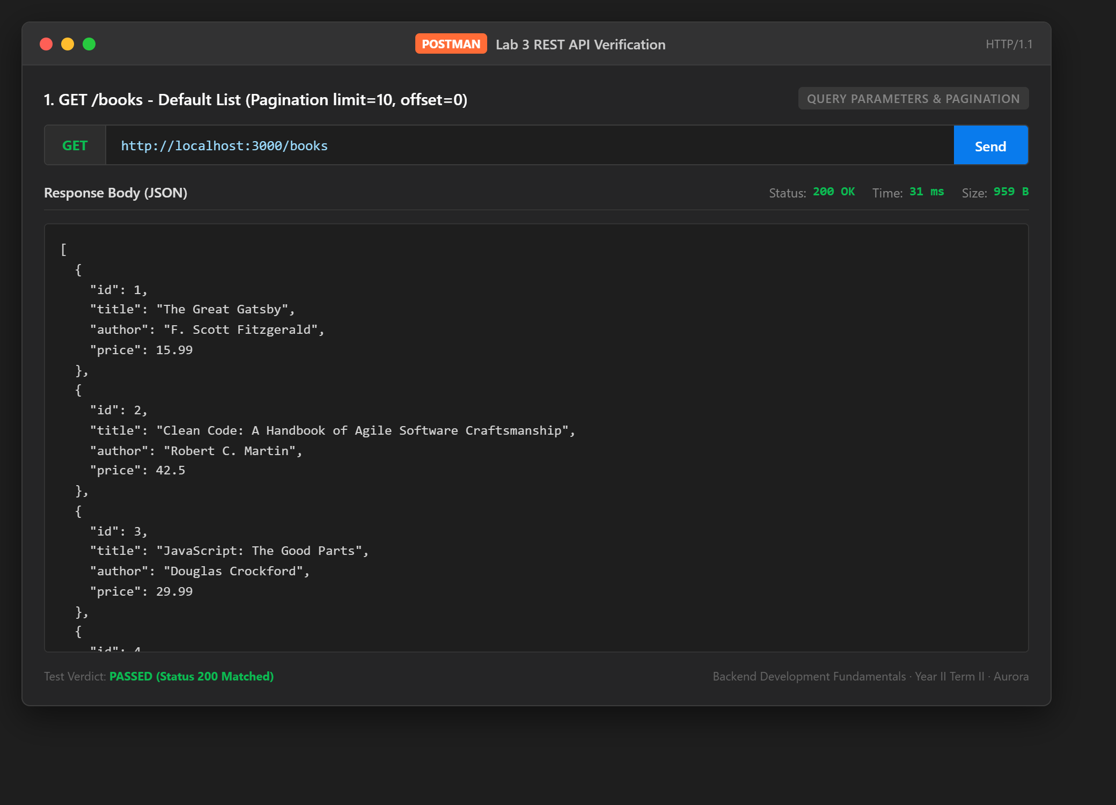
Test Case 2: 2. GET /books - Search by Partial Title (search_q=Harry)
Category: Search Query (LIKE %q%) | Expected Status: 200 | Observed Status: 200 | Duration: 4 ms
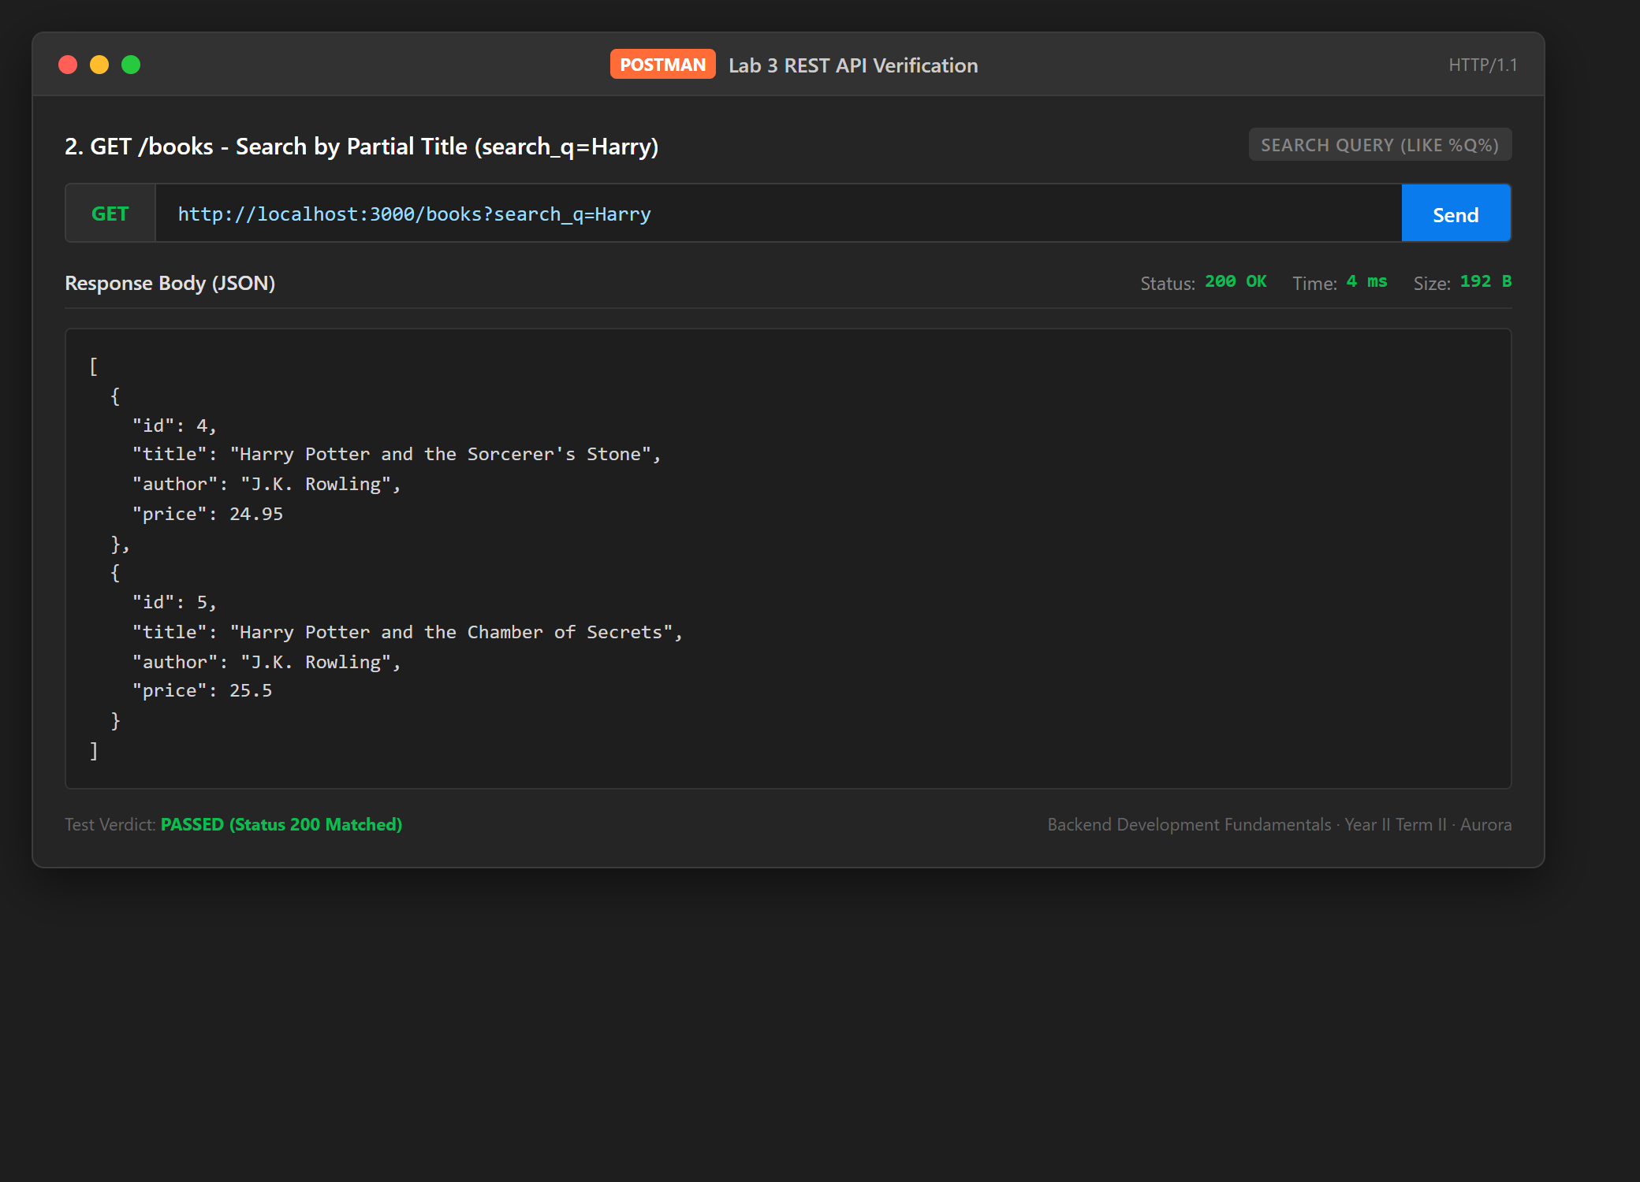
Test Case 3: 3. GET /books - Sort by Price Descending (order_by=price&order=DESC)
Category: Sorting | Expected Status: 200 | Observed Status: 200 | Duration: 2 ms
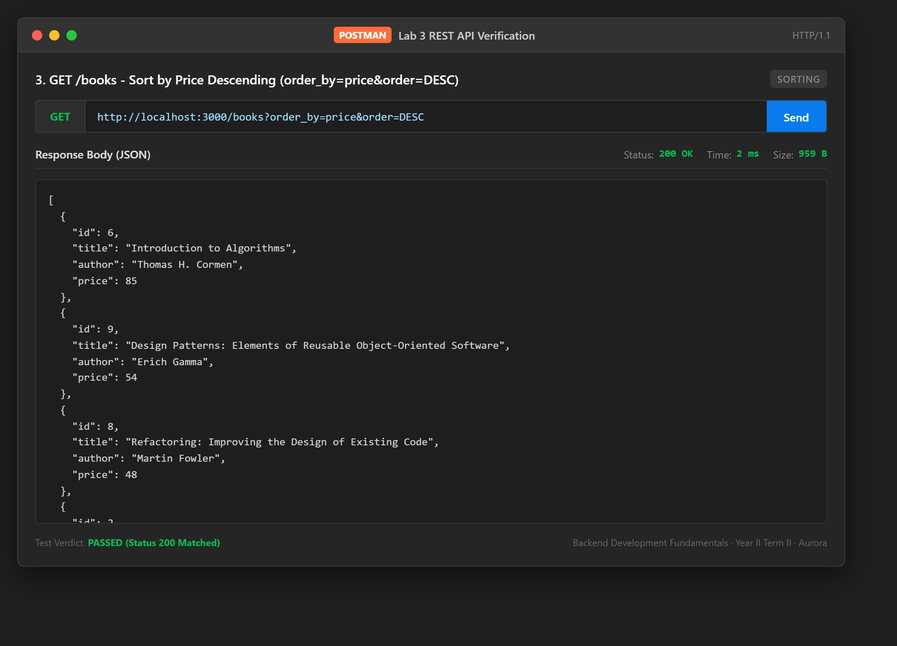
Test Case 4: 4. GET /books - Sort by Title Ascending (order_by=title&order=ASC)
Category: Sorting | Expected Status: 200 | Observed Status: 200 | Duration: 2 ms
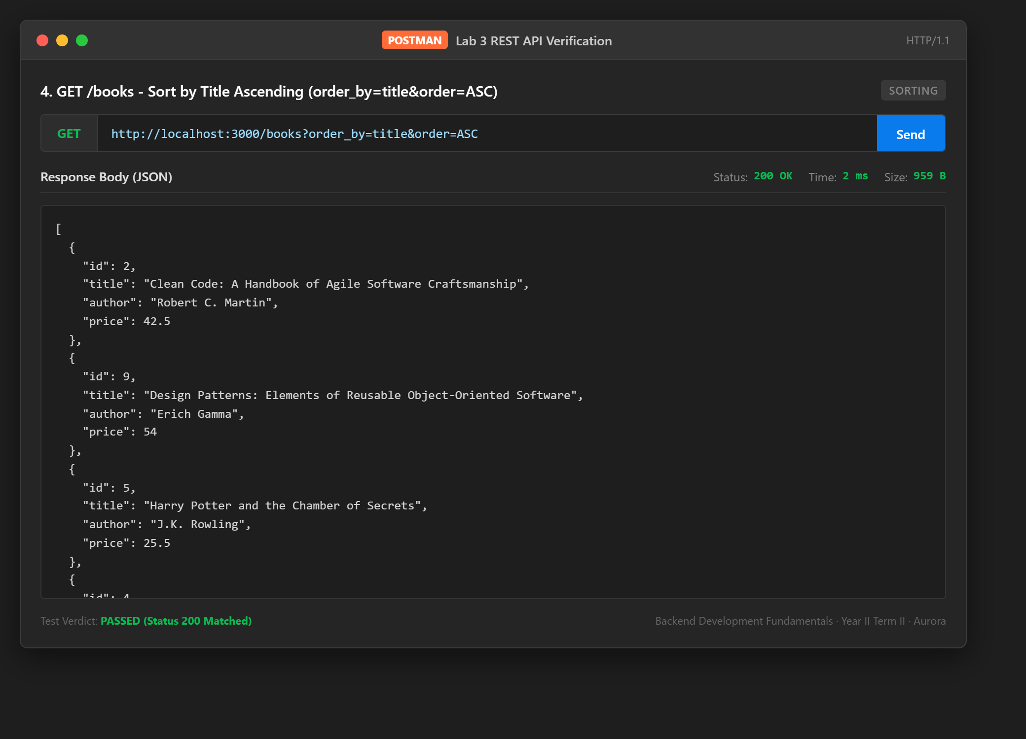
Test Case 5: 5. GET /books - Price Range Filter (min_price=20&max_price=40)
Category: Price Filter (BETWEEN) | Expected Status: 200 | Observed Status: 200 | Duration: 2 ms
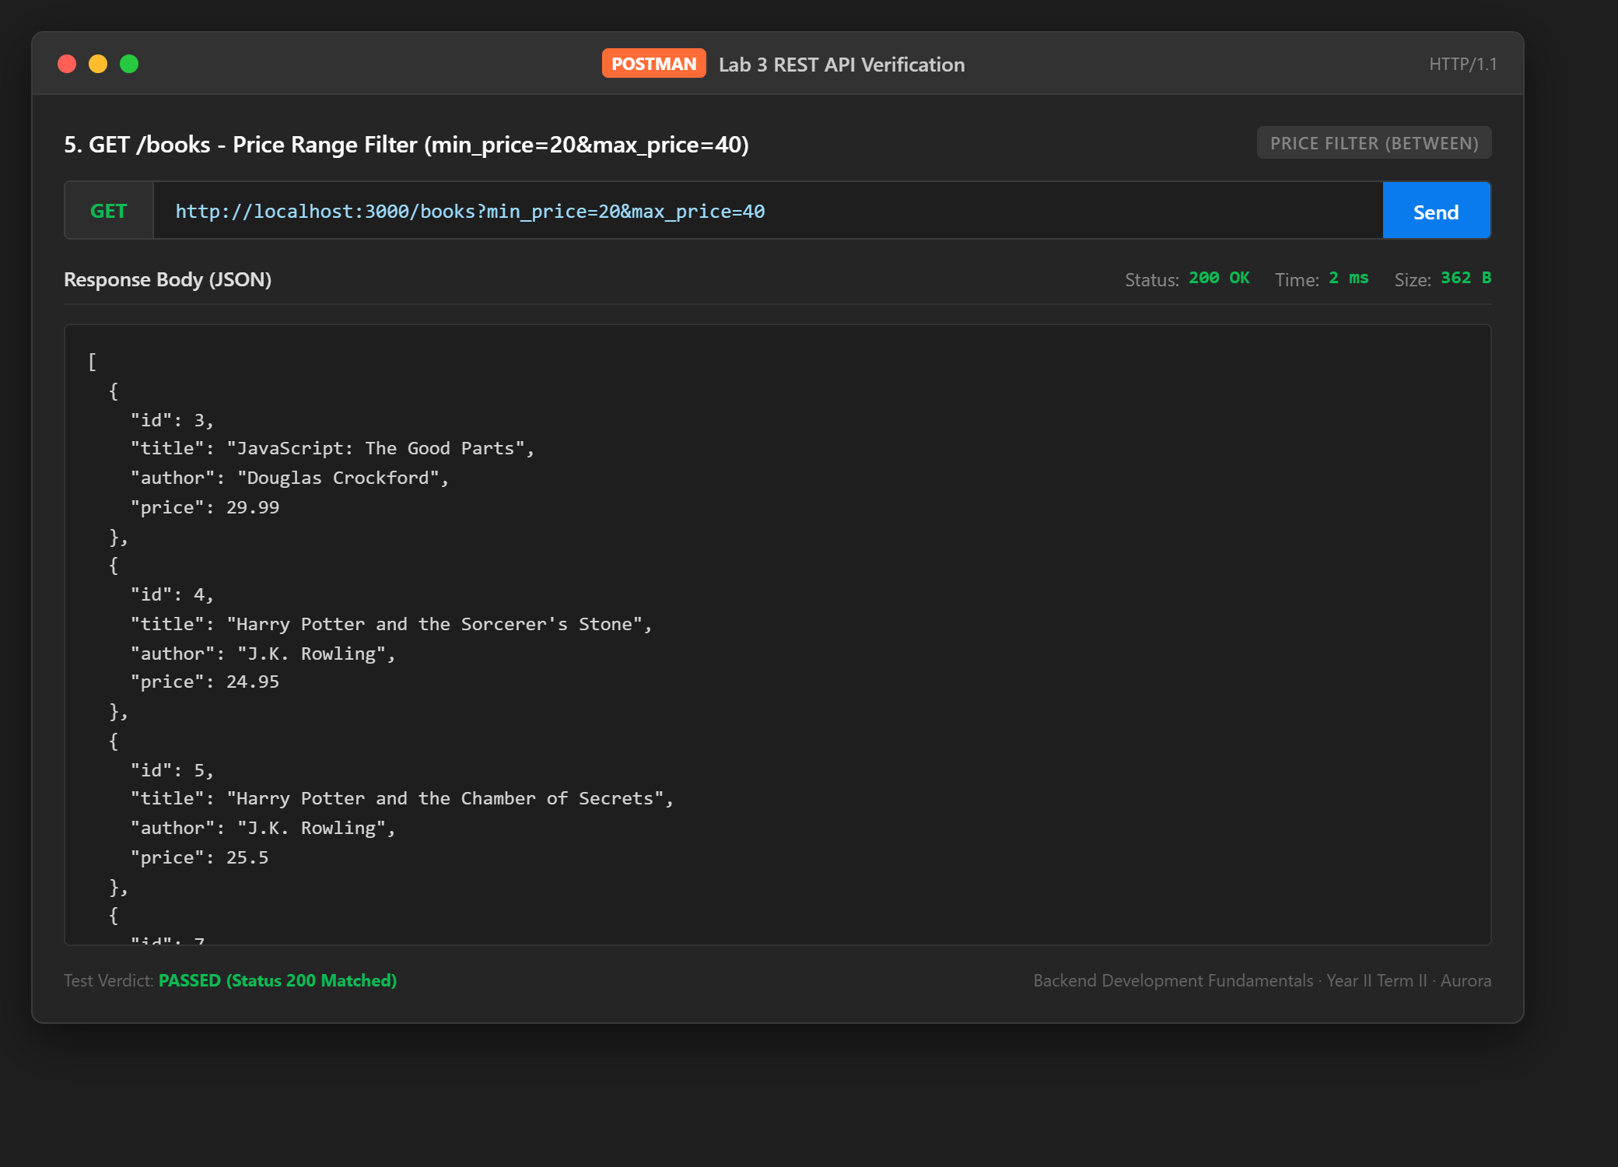
Test Case 6: 6. GET /books - Pagination Offset & Limit (limit=3&offset=3)
Category: Pagination | Expected Status: 200 | Observed Status: 200 | Duration: 1 ms
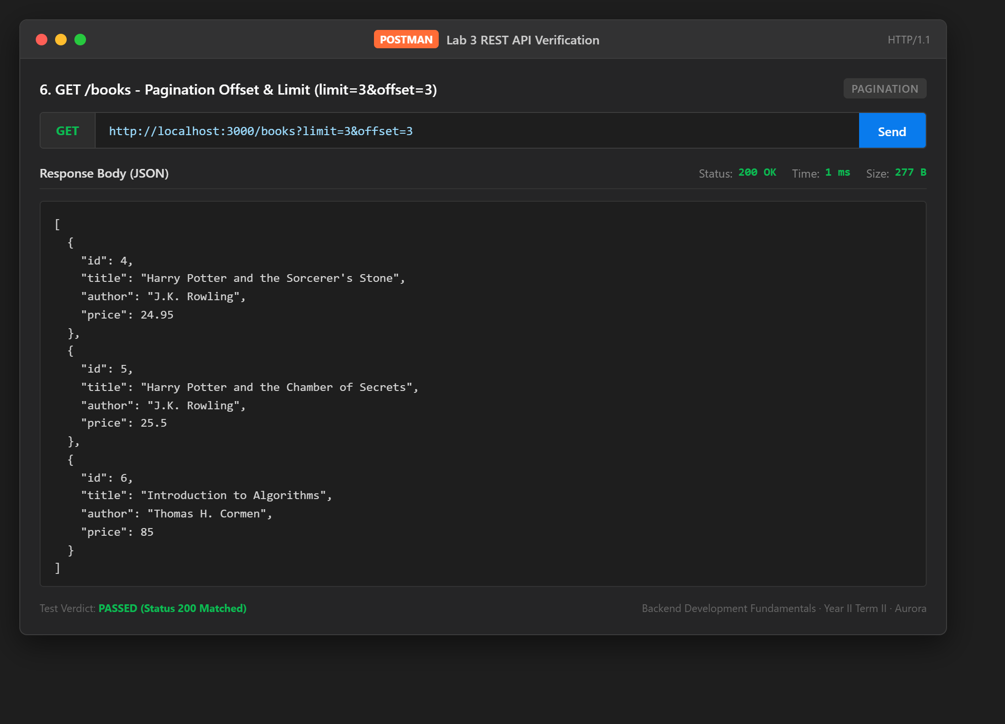
Test Case 7: 7. GET /books/:id - Get Single Book by ID (Success)
Category: Path Parameter | Expected Status: 200 | Observed Status: 200 | Duration: 2 ms
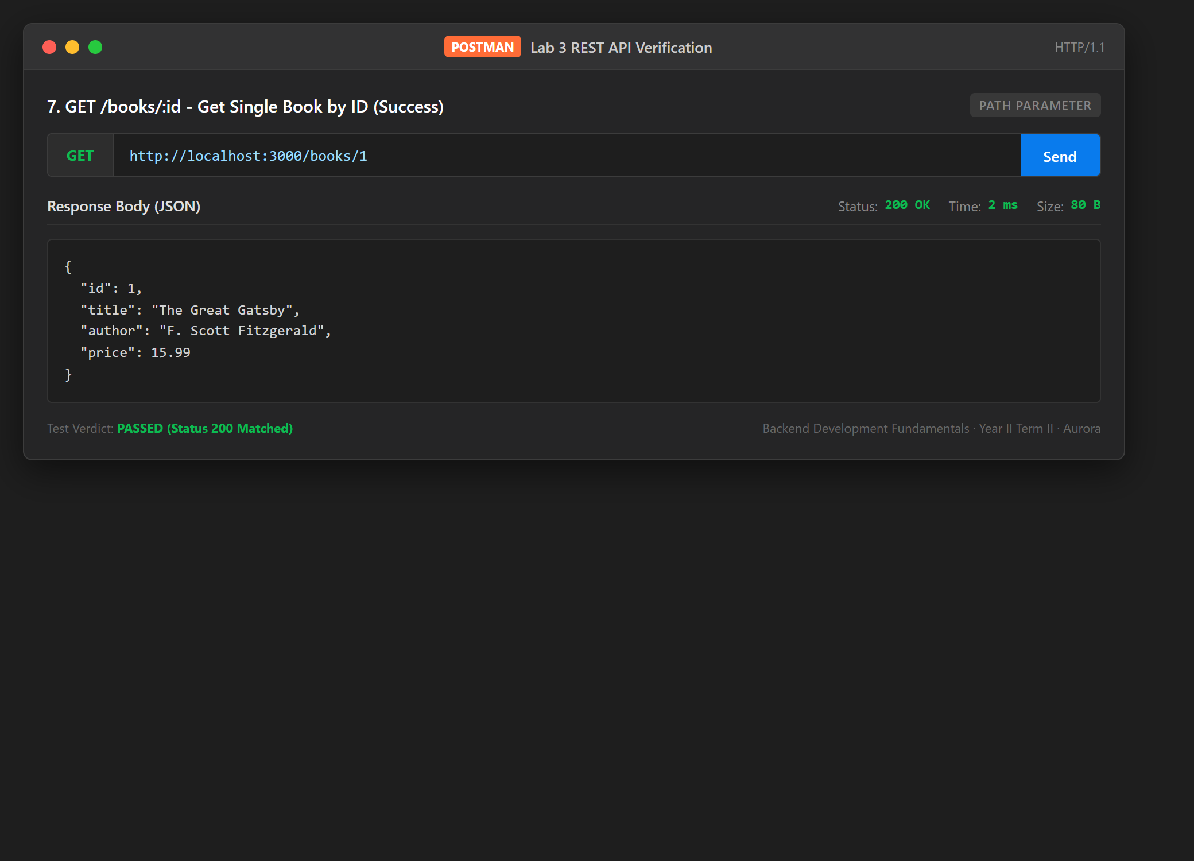
Test Case 8: 8. GET /books/:id - Non-existent ID (Failure)
Category: Error Handling | Expected Status: 404 | Observed Status: 404 | Duration: 2 ms
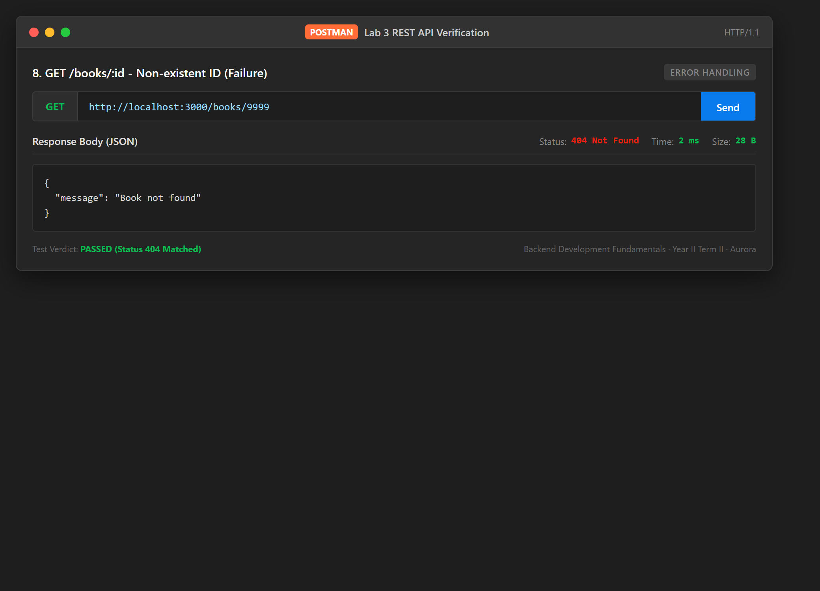
Test Case 9: 9. POST /books - Create New Book (Success)
Category: Resource Creation | Expected Status: 201 | Observed Status: 201 | Duration: 26 ms
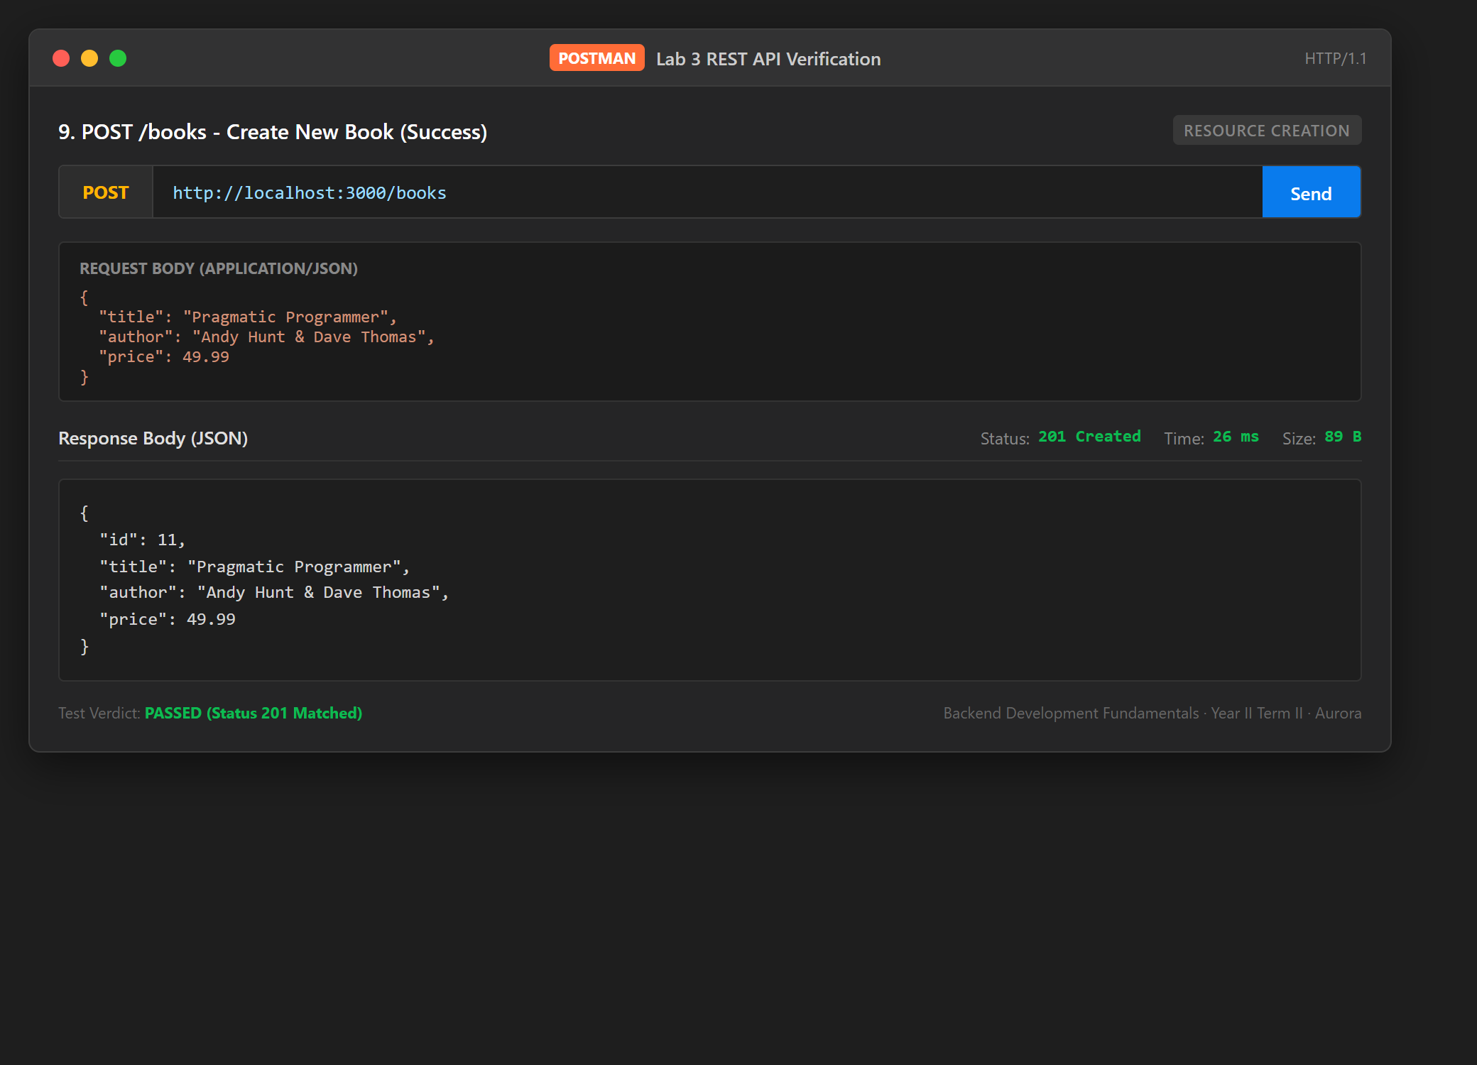
Test Case 10: 10. POST /books - Missing Title Validation (Failure)
Category: Input Validation | Expected Status: 400 | Observed Status: 400 | Duration: 2 ms
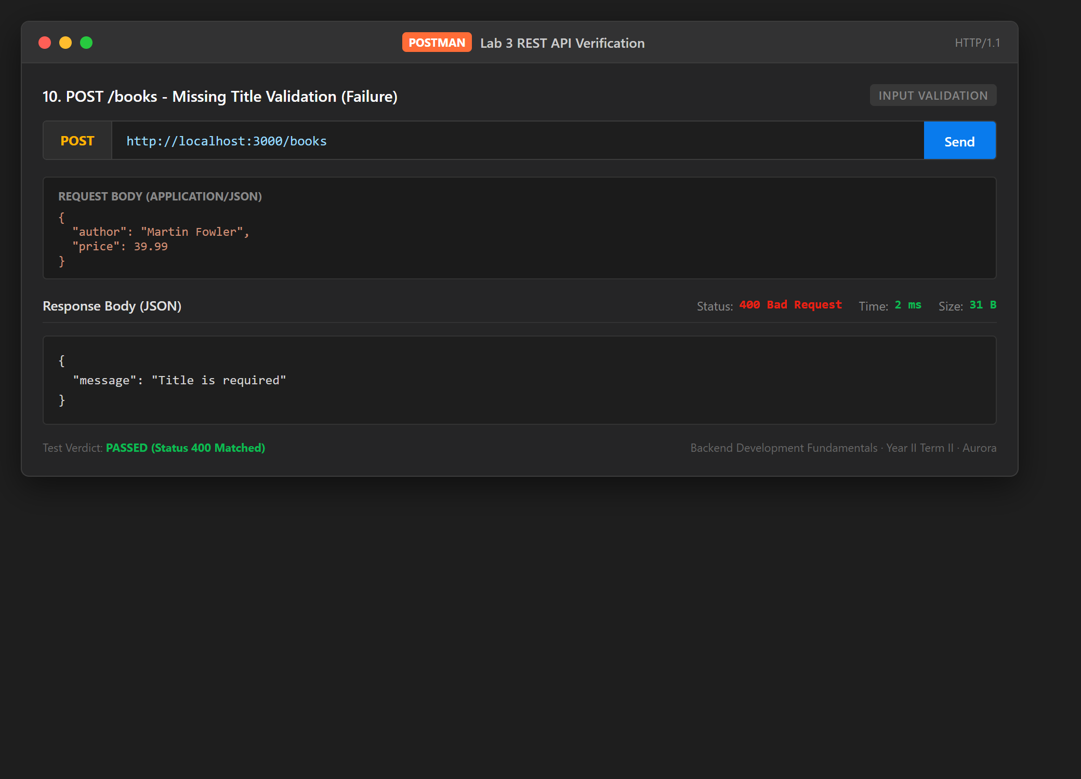
Test Case 11: 11. POST /books - Missing Author Validation (Failure)
Category: Input Validation | Expected Status: 400 | Observed Status: 400 | Duration: 1 ms
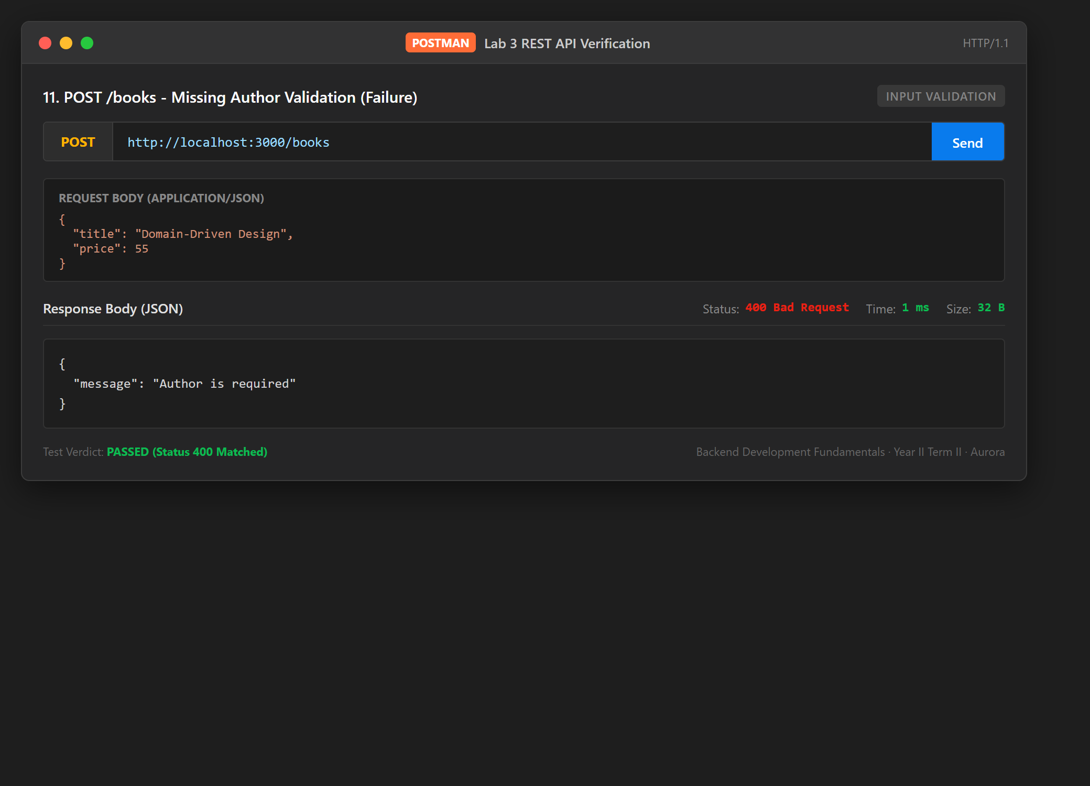
Test Case 12: 12. POST /books - Non-numeric Price Validation (Failure)
Category: Input Validation | Expected Status: 400 | Observed Status: 400 | Duration: 2 ms
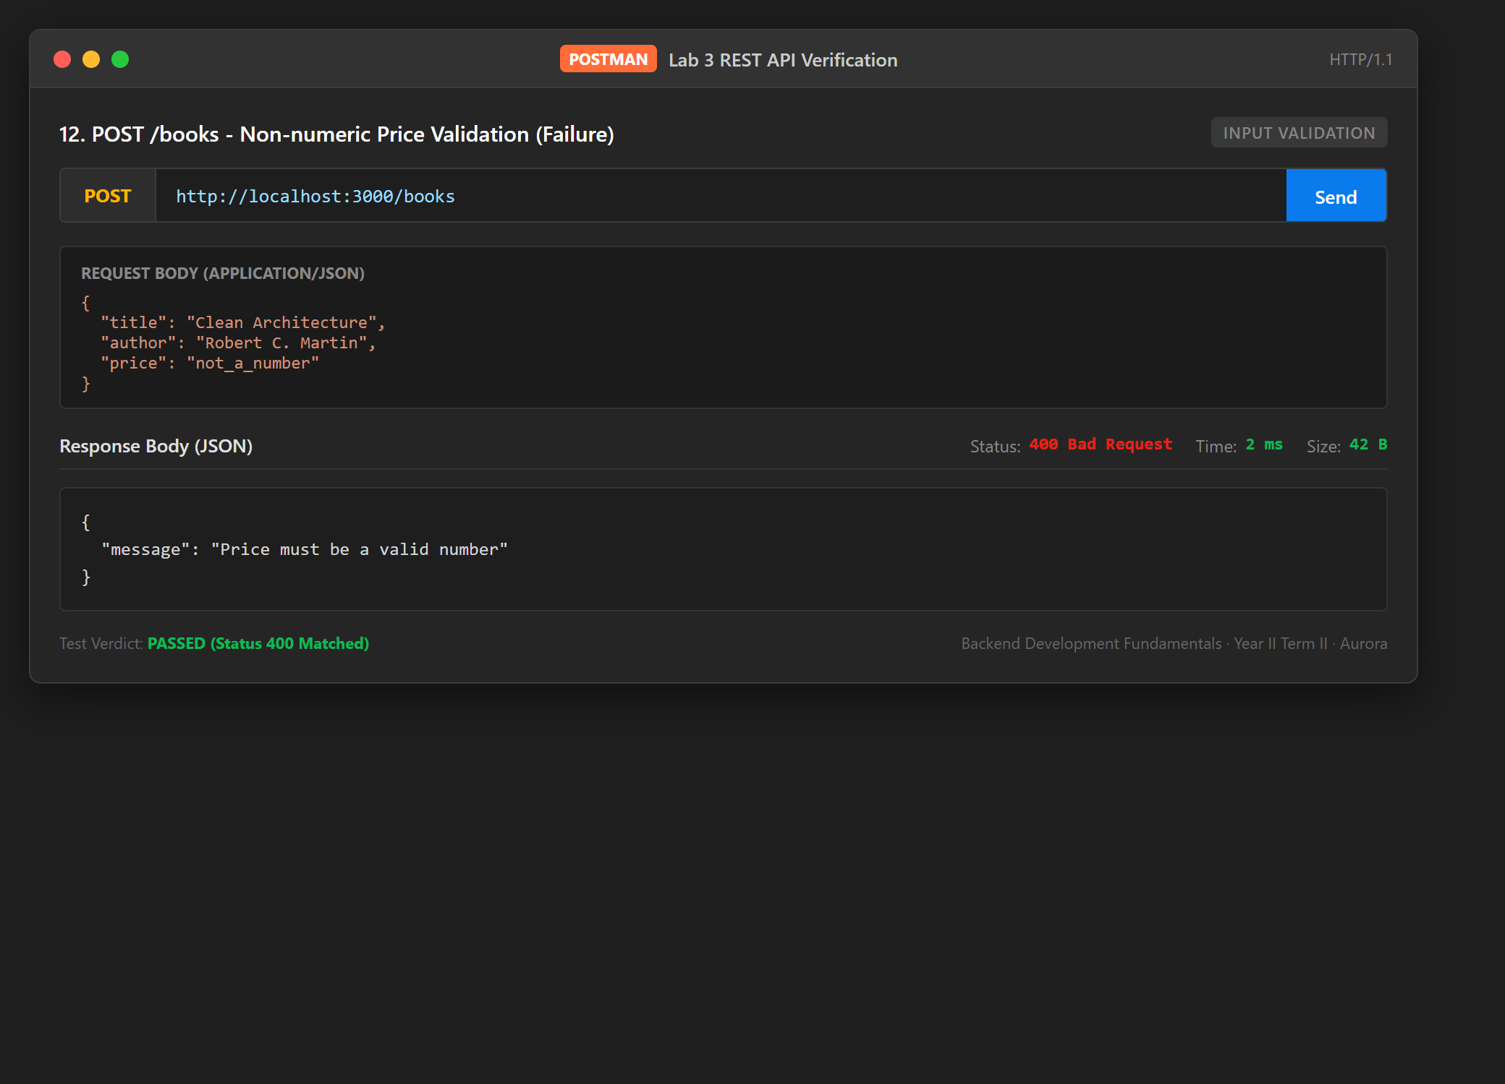
Test Case 13: 13. PUT /books/:id - Update Book Details (Success)
Category: Resource Update | Expected Status: 200 | Observed Status: 200 | Duration: 6 ms
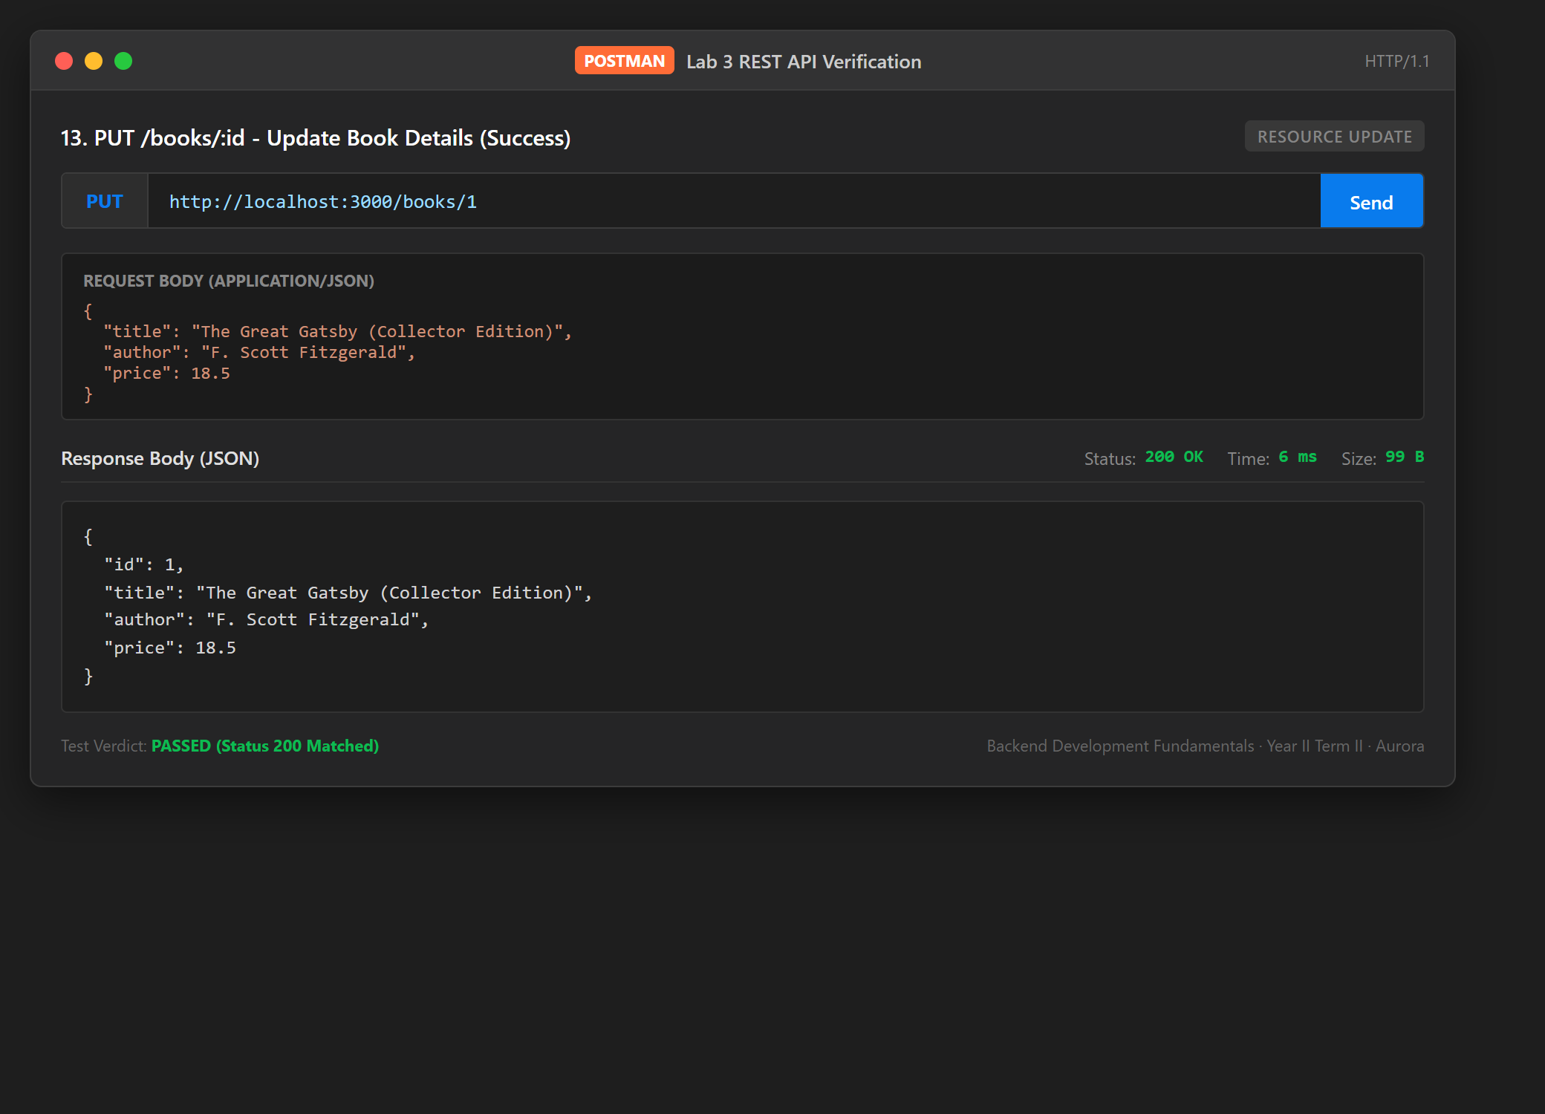
Test Case 14: 14. PUT /books/:id - Update Non-existent ID (Failure)
Category: Error Handling | Expected Status: 404 | Observed Status: 404 | Duration: 2 ms
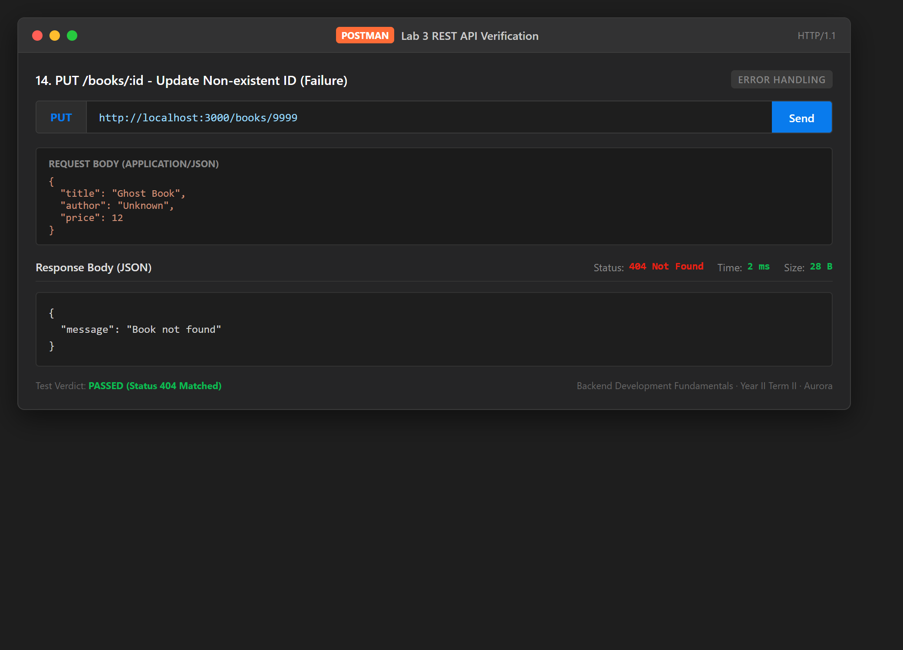
Test Case 15: 15. DELETE /books/:id - Delete Existing Book (Success)
Category: Resource Deletion | Expected Status: 200 | Observed Status: 200 | Duration: 17 ms
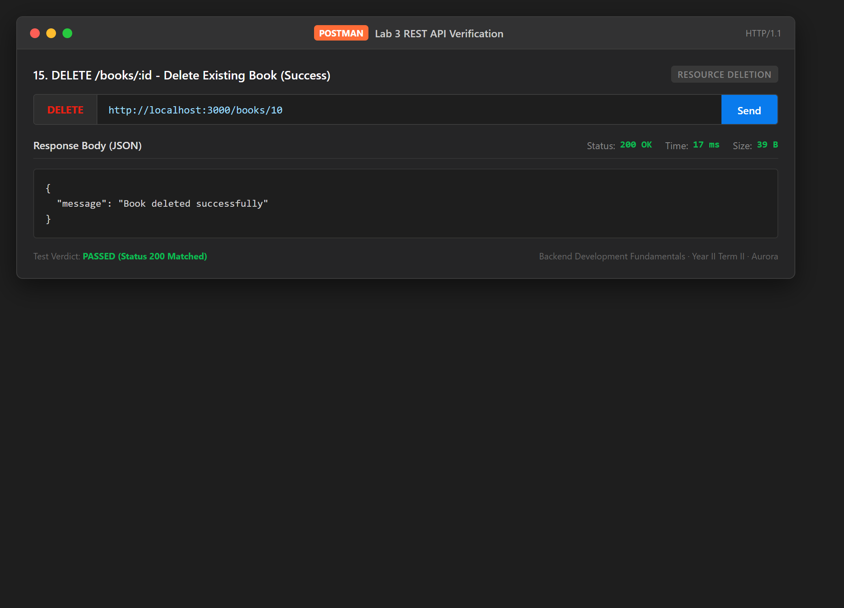
Test Case 16: 16. DELETE /books/:id - Delete Non-existent ID (Failure)
Category: Error Handling | Expected Status: 404 | Observed Status: 404 | Duration: 1 ms
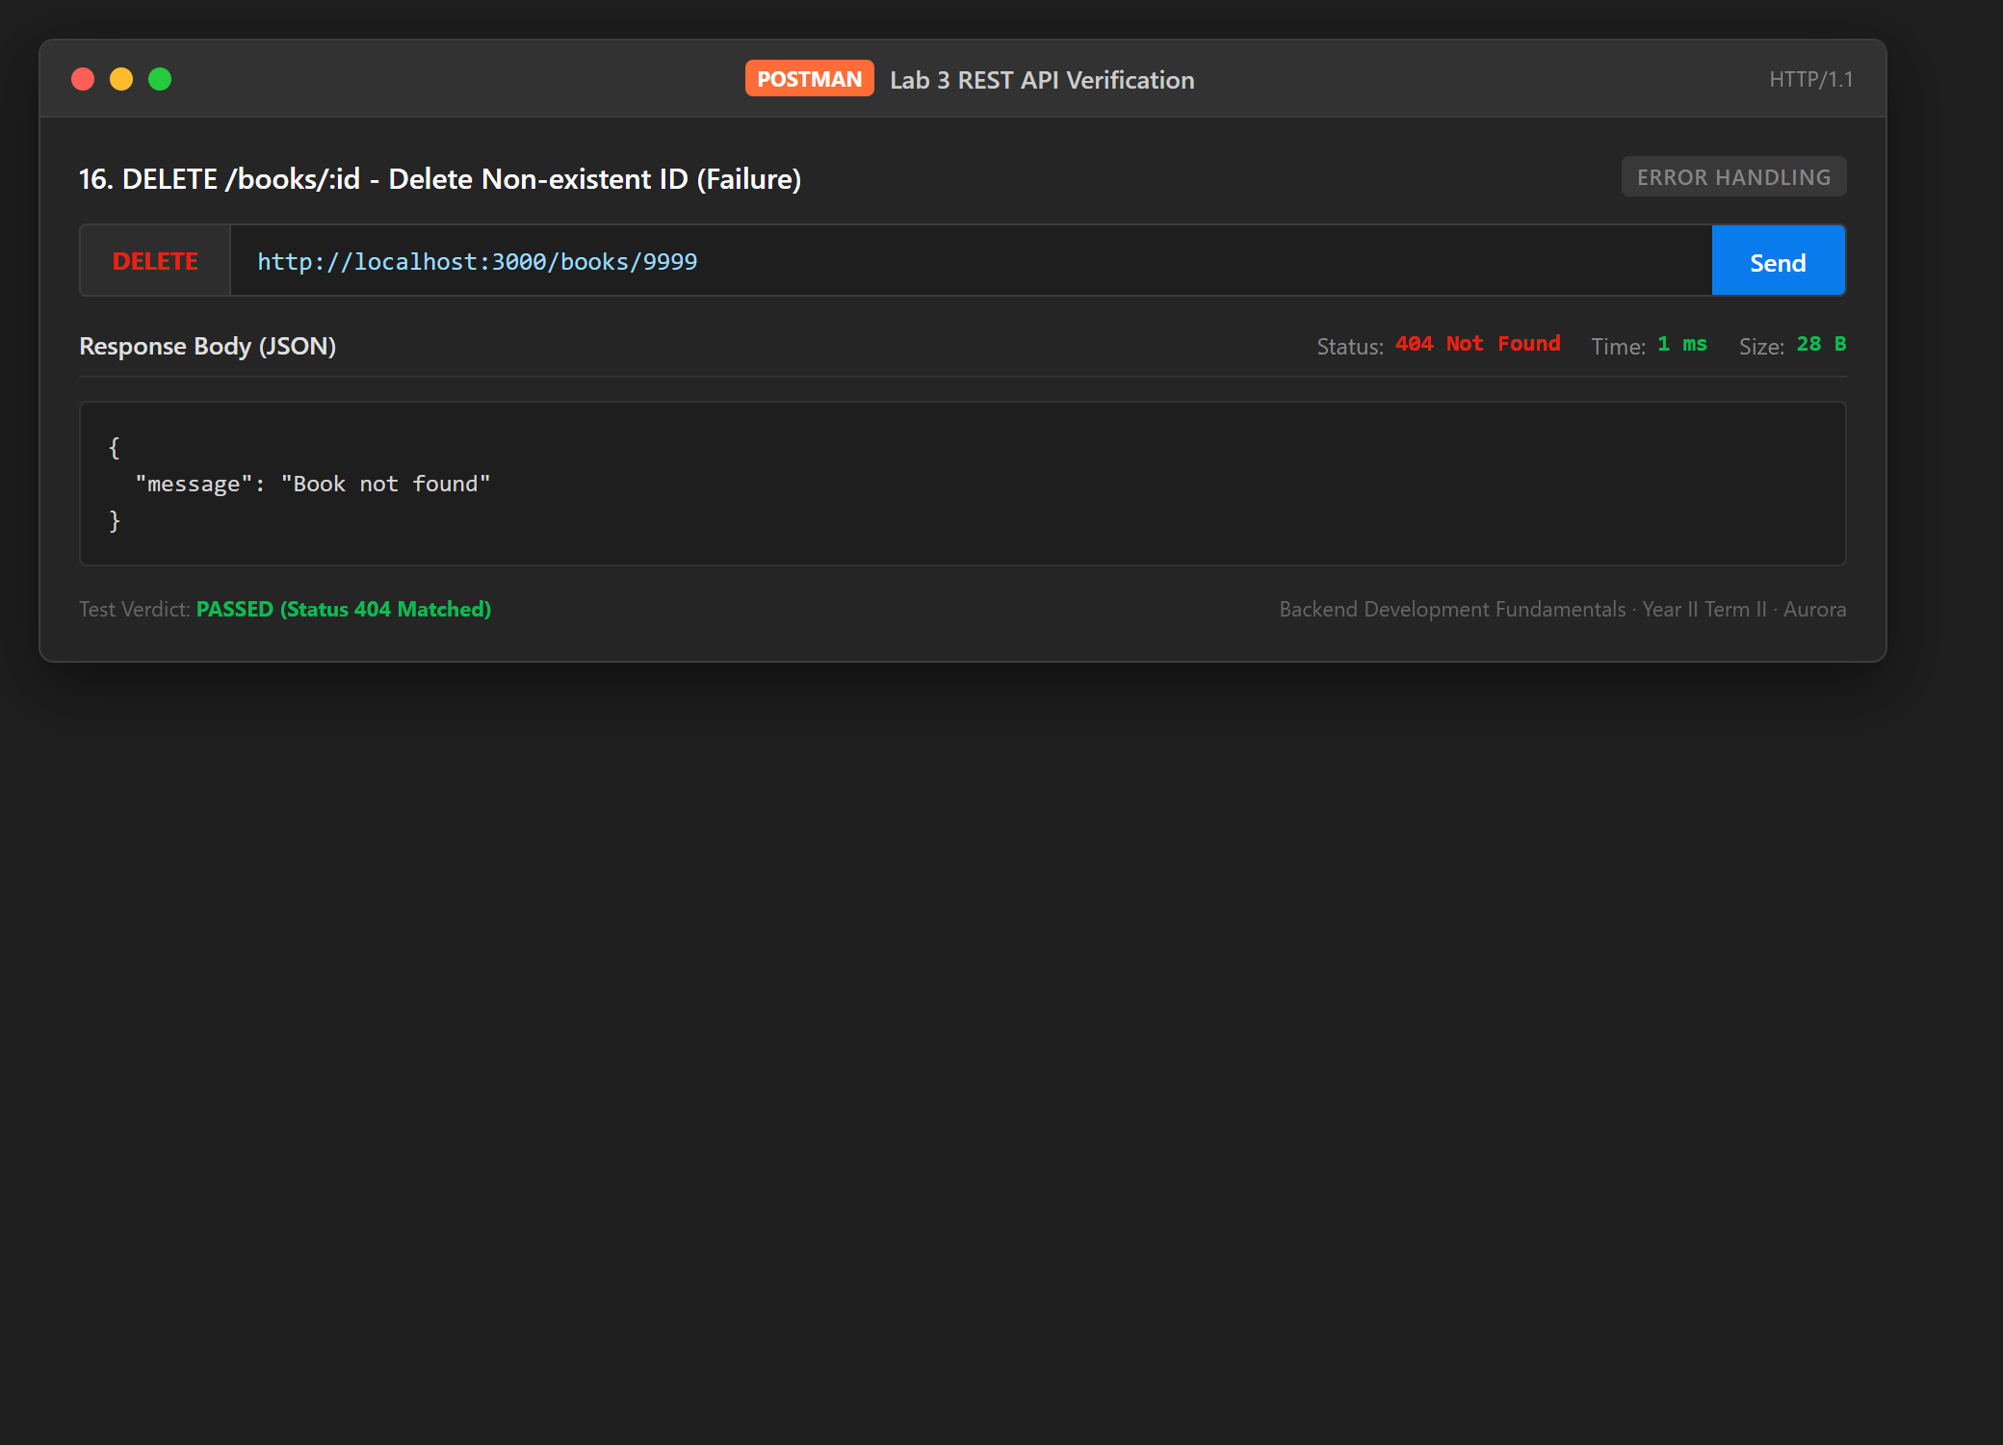

5. Viva Voce Questions & Answers

Question 1: Query parameter vs Path parameter?
Answer: Path parameters and query parameters serve distinct architectural purposes in RESTful system design:
- Path Parameters (Identifier): Path parameters (/books/:id) are integral parts of the hierarchical resource URL path. They uniquely identify a specific, individual resource instance or entity within a collection. They are mandatory—omitting a path parameter alters the route entirely (e.g. GET /books vs GET /books/5).
- Query Parameters (Modifier): Query parameters (/books?search_q=harry&order_by=price) appear after the question mark (?) as key-value pairs. They do NOT change which resource collection is being targeted; instead, they alter how the data is filtered, searched, sorted, or paginated. They are optional and have sensible defaults.
- Rule of Thumb: Use a path parameter when asking for "Which specific entity do I want?" (e.g., /books/42). Use query parameters when asking "How should this set of entities be modified, searched, or formatted?" (e.g., /books?order=DESC&limit=10).

Question 2: What does stateless mean in REST?
Answer: The Stateless constraint is one of the core architectural principles defined by Roy Fielding in REST:
- Definition: No Client Session on the Server: The server does not store any contextual information or conversational state about previous requests made by the client across multiple transactions.
- Self-Sufficiency: Self-Contained Requests: Every incoming HTTP request from the client must contain all information, parameters, headers, and authentication tokens required for the server to understand and process the request in complete isolation.
- System Advantages: High Scalability & Reliability: Because any server in a cluster or load-balanced farm can handle any incoming request without needing shared memory or sticky server sessions, horizontal scaling is straightforward. Server crashes do not corrupt client state.

Question 3: Which status code for bad input vs a missing record?
Answer: HTTP semantics provide clearly demarcated 4xx client error codes for each scenario:
- Bad Input (400 Bad Request): 400 Bad Request: Used when the client submits malformed syntax, invalid data types (e.g. string supplied for numeric price), missing required body fields (e.g. empty title or author), or violated business validation rules. The server refuses to process the request due to client data error.
- Missing Record (404 Not Found): 404 Not Found: Used when the client specifies an identifier or URI for a resource that does not exist in the database (e.g. GET /books/9999 or DELETE /books/9999). The request syntax and semantics are completely valid, but the target entity cannot be located.
- Best Practice: In REST API design, returning 200 with an error object or returning 500 for validation errors is considered an anti-pattern. Precise status codes allow client software to make automated retry, alerting, or UI error-display decisions.

6. Lab Rules Compliance Checklist
- 1. Never commit or share .env: Checked. The .env file is excluded in .gitignore and .env.example is provided for configuration.
- 2. Do not include node_modules: Checked. node_modules is ignored via .gitignore and clean package.json is provided.
- 3. Passwords never plain text: Checked. No sensitive passwords or credentials are stored or printed in logs.
- 4. Every route returns the right status code: Checked. 200 (OK), 201 (Created), 400 (Bad Request), 404 (Not Found), 500 (Internal Error).
- 5. Parameterised queries: Checked. All database operations strictly use SQL placeholders (?) to prevent SQL injection.

