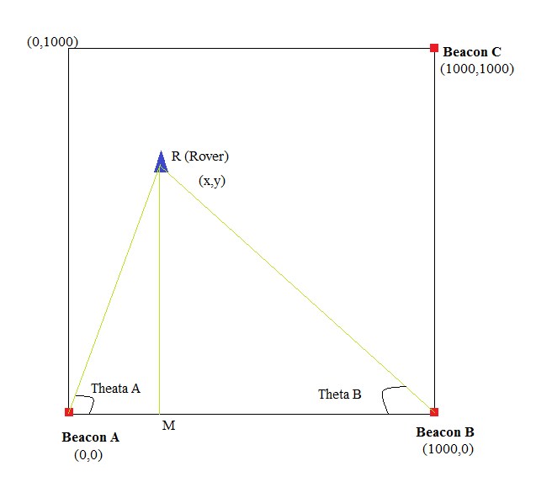

Triangle ARM and Triangle BRM both are right triangles

The have RM side common

In Triangle ARM,

$$RM=AM*\tan{θ_{A}}$$

In Triangle ARM,

$$RM=BM*\tan{θ_{B}}$$

So ,

$$AM*\tan{θ_{A }=BM* \tan{θ_{B}}}$$

$$AM=\frac{BM*\tan{θ_{B}}}{\tan{θ_{A}}}$$

We know the AB distance,

So,

$$AB=AM+BM$$

$$AB=\frac{BM* \tan{θ_{B}}}{\tan{θ_{A}}} + BM$$

$$BM=\frac{AB}{(1+\left(\frac{\tan{θ_{B}}}{\tan{θ_{A}}}\right))}$$

$$x=1000-BM$$

$$y=0+BM*\tan{θ_{B}}$$