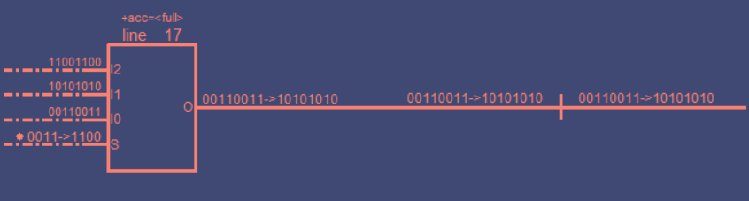
MicroProcessor Decoder Data Flow:

