Results and Limitations Memo
Calibrated Multi-Factor Case Routing for RescueNet
Instructor: Majid Shaalan, Ph.D. Course: CISC 699 Applied Project in Computer Information Sciences Student: Manoj Venkatachalaiah
Assignment: 09 Results and Limitations Memo (due Nov 1, 2026, 11:59 PM EDT) Prepared: October 31, 2026
Repository: https://github.com/manojvprimary/rescuenet Branch: sprint-5/results-memo
What this memo is for. It organizes the strongest results so far by question, states what they do and do not support, analyzes one failure class in detail, and lists the limitations the final report must carry. Every number below comes from a committed result file (Section 9 lists them). The one new analysis this week is the error analysis in Section 5; everything else restates earlier evidence with its denominators.

1. AI Usage Log and Academic Integrity
As in earlier submissions, this section leads. Claude (Anthropic, Claude Sonnet 5.5) wrote the error-analysis script, produced the two figures, and drafted this memo from the repository's own files. The student directed the topic, chose which evidence to include, and is responsible for every claim. The full cumulative log is in docs/AI_USE_LOG.md; Appendix A indexes it.
Entry 26: Results and Limitations Memo and Error Analysis
Field | Detail
Tool | Claude (Anthropic, Claude Sonnet 5.5)
Date / Phase | Week 9 (2026-10-31), Results and Limitations Memo
Purpose | Turn the Hard Stop 4 ablation into a results-and-limitations argument, and find out why the production formula misses the cases it misses.
Prompt / Task Summary | Write scripts/error-analysis.ts (per-case score gaps for every formula under the v2 blend weights); render Figures 1 and 2; draft this memo from eval/results/, KNOWN_ISSUES.md, docs/RISK_LOG.md, and the Hard Stop 3 and 4 documents.
Output Used | The script, docs/evidence/sprint-5/error-analysis.json, the two figures, and this document.
Affected Section / Artifact | Section 5 (error analysis) is new analysis; Sections 3, 4, 6 and 7 restate earlier evidence. KI-11 and KI-22 are referenced, not changed.
Human Verification | The error-analysis output was checked against eval/results/ablation.json: the five missed cases and their winners match the pre-registered run exactly. Headline counts were recomputed from the result files by the document generator rather than typed.
Final Student Revisions | The student chose the topic and the order of the sections. Supervisor feedback on this memo has not been obtained (see Section 8).

Two things the reader should know about the evidence itself. The second evaluation set (SYN-09 to SYN-16) and the formula variants F1 to F3 were written by the AI assistant, and the student approved the set but did not author it (KI-20, R-12). So a good score under those variants is a lead, not independent validation.

2. Summary of What the Evidence Supports
- The weighting method did not limit routing correctness; the scoring formula did. Under the production formula all four weighting methods, including equal weights, get the same 7 of 12 informative cases right (95% interval 0.32 to 0.81).
- All 5 production-formula misses share one pattern: a shelter that is farther away but has more open slots outranks the nearer annotated best. The cause is traceable to one component, because open slots enter the score twice (Figure 1).
- Counting capacity once helps only when weights are case-specific (9 to 10 of 12 versus 7 with equal weights); combined with a 10 km distance scale the best cells reach 11 of 12.
- The evidence is still incomplete on the claim that matters most, that v2 routes better than v1. On these cases they tie. The honest statement is that v2 is auditable and reproducible, not that it is more accurate.

3. Results by Question
Table 1. Strongest results to date, organized by question
Question | Result (with denominator) | Strength | Source
Q1. Does the weighting method or the scoring formula limit correct routing? | Production formula: 7/12 under all four methods. A one-factor swap changes the winner in 11.1% of 288 pairs for weights, 20.8% of 288 for formulas. | Directional; no contrast is significant | eval/results/ablation.json
Q2. Does counting capacity once help? | F1 vs F0: 3 cases gained, 0 lost under blend and top (p = 0.25), 2 gained under v1 (p = 0.50), none under equal weights. Best pre-registered cell: 11/12. | Directional; 12 cases | same
Q3. Is v2 at least as good as v1? | Tie under the production formula (7/12 each); differs by one case (SYN-12) under F1. | Weak: a tie | same
Q4. Does the classifier read cases the way the annotator does? | 7 of 7 agree with the annotated archetype (SYN-08 is the fault case, not classified); max probability spread 0.05 over 5 repeats; 0 invalid outputs in 35 set-1 calls and in the 59 later temperature-0 batch calls. | Reasonable for n = 7; probabilities are near one-hot (KI-13) | eval/results/classifier-*.json
Q5. Is the result sensitive to one judgment in the AHP matrices? | 60 one-step perturbations of the 30 judgments; the largest flip count was 1 case, for both classifiers. | Met a provisional threshold | eval/results/sensitivity-*.json
Q6. Does the deployed pipeline work end to end? | 13 of 13 cases ASSIGNED in both weighting modes; 0 error lines across nine functions; median 24.1 to 24.7 s to a scored assignment; rollback 7.3 s and verified. | Indicative only (KI-17, KI-18) | docs/evidence/sprint-3/measure-v2.json
Q7. Can another reader reproduce the numbers? | Identical result hashes across three repeated runs for each evaluation, and for the ablation on a clean clone under Node 20. | Strong for the offline code | docs/evidence/sprint-4/node20-ablation.txt

Table 2. Informative cases routed to the annotated best shelter, by formula and weighting method (95% Wilson interval)
Formula | equal | v1 (LLM-written) | v2 blend | v2 top
F0 production formula | 7/12 (0.32 to 0.81) | 7/12 (0.32 to 0.81) | 7/12 (0.32 to 0.81) | 7/12 (0.32 to 0.81)
F1 capacity counted once | 7/12 (0.32 to 0.81) | 9/12 (0.47 to 0.91) | 10/12 (0.55 to 0.95) | 10/12 (0.55 to 0.95)
F2 distance scale 10 km | 7/12 (0.32 to 0.81) | 8/12 (0.39 to 0.86) | 8/12 (0.39 to 0.86) | 9/12 (0.47 to 0.91)
F3 capacity once + 10 km | 8/12 (0.39 to 0.86) | 10/12 (0.55 to 0.95) | 11/12 (0.65 to 0.99) | 11/12 (0.65 to 0.99)
Pre-registered run, 12 informative non-control cases from two sets of eight (four excluded as near-tie, fault injection, or decided by a hard constraint; the control SYN-16 was right in all 16 cells). Source: eval/results/ablation.json.
Reading Table 2. The first row is flat: under the production formula the weighting methods are indistinguishable. The columns separate only once the formula changes, which is the interaction the memo is built around. Intervals overlap everywhere, so none of these differences is statistically established.

4. Limitations
Table 3. Limitations, what each means for claims, and how it is handled
Area | Limitation | Consequence for what can be claimed
Data | The evaluation has 16 synthetic cases (12 informative) and no real case (KI-16). One annotator wrote set 1; set 2 was drafted by the AI and approved by the student (KI-20). | Every number is a count on a small set. Nothing supports an estimate of real-world accuracy.
Sample bias | Both sets were designed around capacity, distance and vet trade-offs, the same trade-offs the formula variants address (R-12). The seeded live roster has one dominant shelter that won all 13 measured cases (KI-17). | The ablation measures the variants on cases that probe them; live runs cannot tell weighting modes apart.
Implementation shortcuts | Capacity is counted twice (KI-11) and is a score term, not an eligibility rule (KI-22). Ties resolve alphabetically. Injury detection in the rule-based paths ignores the free-text report (KI-23). The classifier's probabilities are near one-hot, so blend behaves like top (KI-13). | Results describe the current prototype formula, not the design; the double count is a known defect, not a design choice.
Runtime and integration | Median 24 s to a scored assignment in a demo account on cold functions (KI-18). Slack-based shelters carry a freshness penalty of roughly 30%. Single model and region (Bedrock, us-east-1). | Latency is indicative. Whether the freshness penalty is fair is untested.
API and model variability | v1 weights come from one live call per case at default temperature, frozen for repeatability; classifier probabilities are the first valid response of repeated temperature-0 calls. About 100 live calls in total, none throttled. | Another day's model output could differ. Recorded outputs are replayed, so the offline results are repeatable but not independent of that one sample.
Validity threats | Internal: a post-hoc variant (zero-slot bids removed) was run after the pre-registered result, and p-values are uncorrected. Construct: "annotated best" is one person's judgment. External: no real cases, no shelter-expert review. | The 12/12 post-hoc cell is a lead. No claim of generalization.

Table 4. "The system failed" versus "the evidence is still incomplete"
The system failed (observed) | The evidence is incomplete (not yet known)
The production formula routes 5 of 12 informative cases to a shelter other than the annotated best, under every weighting method.  A zero-capacity bid beats the annotated best in SYN-04 under capacity-once formulas, because capacity is only a score term (KI-22). | Whether case-specific weights are worth having once the formula is fixed (the interaction was seen on 12 cases).  Whether v2 beats v1 on anything but auditability.  Whether the three near-tie misses (gap under 0.025) reflect the formula or the annotator's judgment.  Whether agent-generated weights reproduce across days.

5. Error Analysis: Capacity Outranks Proximity
Failure class. Of the 12 informative cases, the production formula (F0) misses 5 under every weighting method: SYN-01, SYN-04, SYN-05, SYN-11, SYN-12. The weights are not the cause, because four different weighting methods produce the same winners. I therefore compared, for each miss, the annotated best shelter with the shelter that won (Table 5) and traced the difference to the formula (Figure 1).
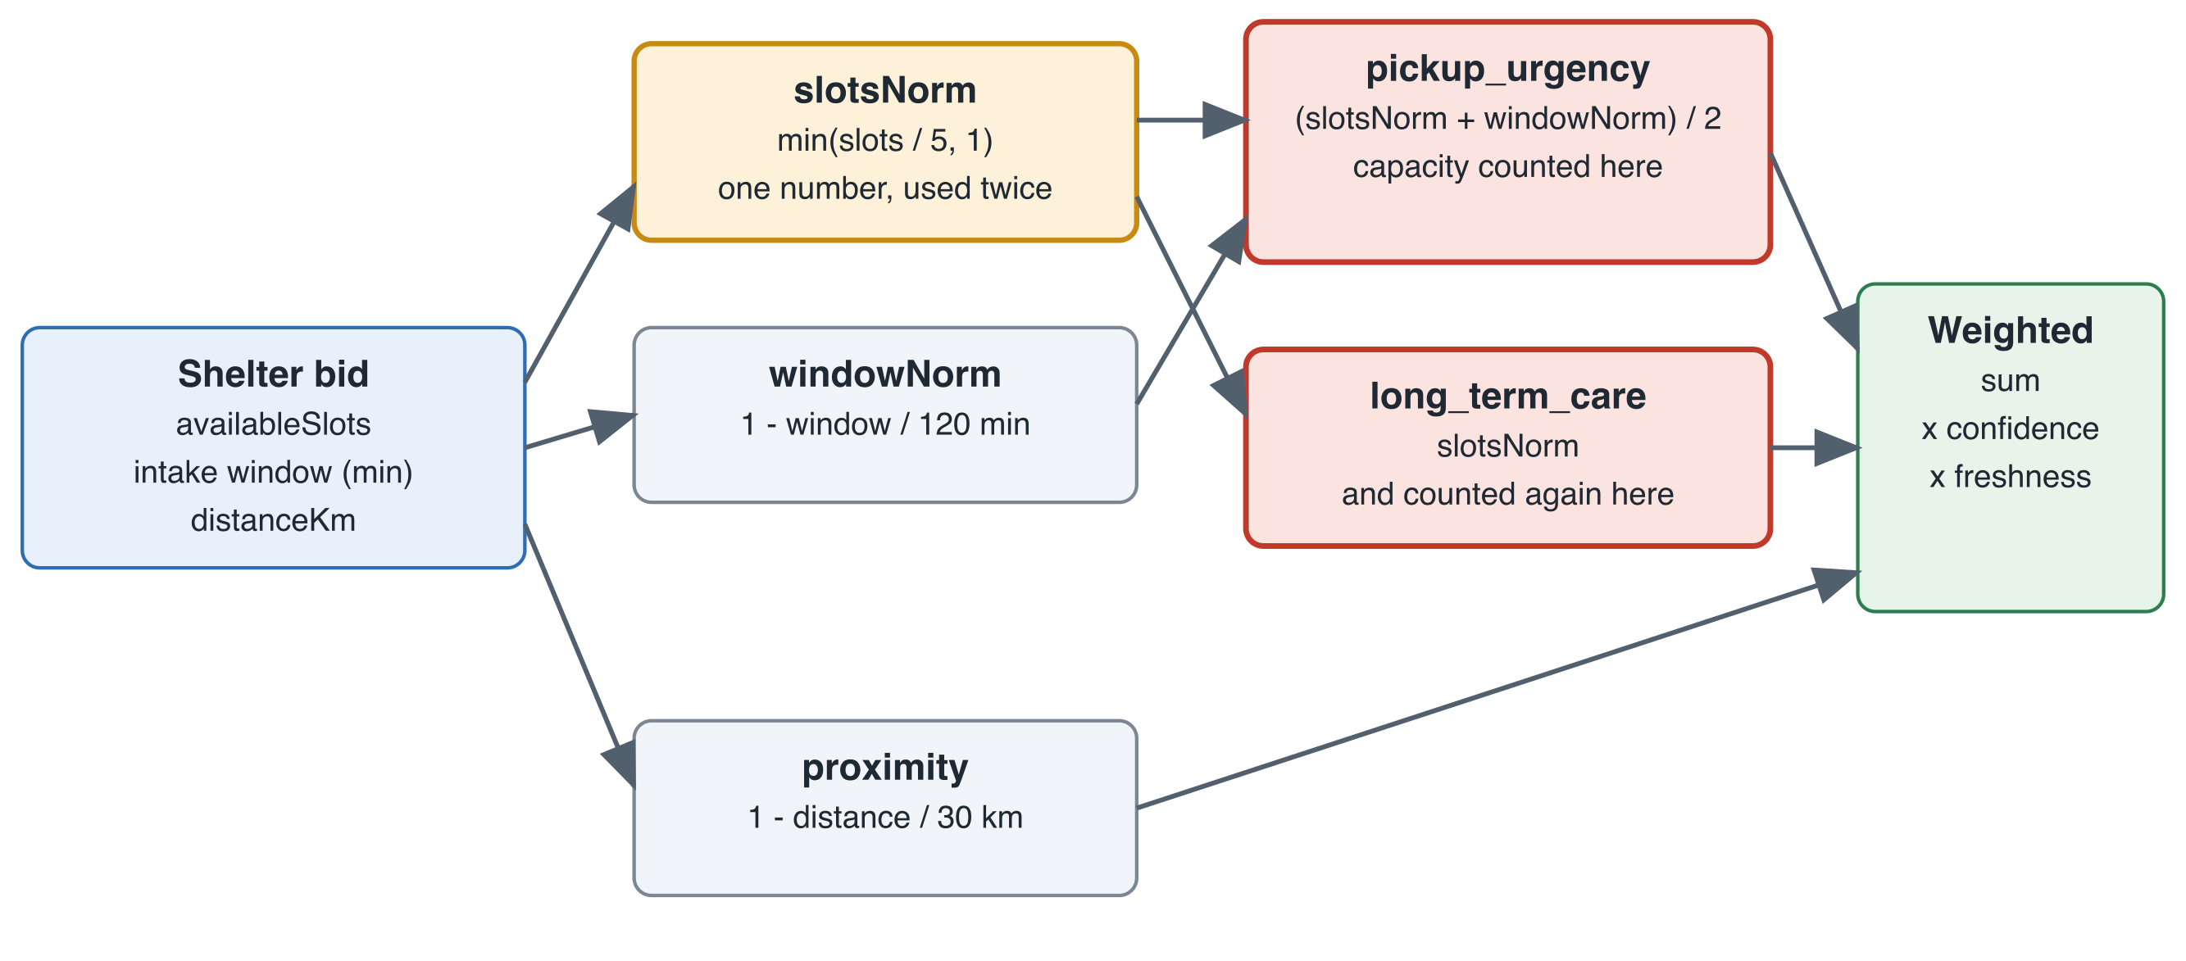
Figure 1. Failure path inside computeMatchScore (lambda/shared/match.ts). Open slots (amber) feed both pickup_urgency and long_term_care (red), so a roomier shelter gains twice while distance enters once. No term measures how urgent the case itself is. All five production-formula misses follow this pattern.
Table 5. The five production-formula misses (v2 blend weights; gap = annotated best minus strongest rival)
Case | Annotated best | Won under F0 | Gap F0 | Gap F3 | Which change fixes it
SYN-01 | A: 2 km, 3 slots, vet | B: 9 km, 5 slots, vet | -0.024 | 0.067 | F1, F2, F3
SYN-04 | B: 4 km, 3 slots, no vet | C: 12 km, 5 slots, vet | -0.018 | -0.149 | none (fixture artifact)
SYN-05 | B: 6 km, 3 slots, vet | C: 14 km, 6 slots, vet | -0.019 | 0.027 | F1, F3
SYN-11 | A: 1.5 km, 2 slots, no vet | B: 6 km, 6 slots, vet | -0.147 | 0.055 | F3
SYN-12 | A: 1 km, 1 slots, no vet | B: 3 km, 6 slots, vet | -0.169 | 0.060 | F1, F3

What the analysis shows.
- In 5 of 5 misses the winner is farther away and has more open slots than the annotated best. No miss goes the other way.
- Three misses are near-ties (SYN-01, SYN-04, SYN-05; gap under 0.025) and two are clear misses (SYN-11 and SYN-12; gap about 0.15 to 0.17). The clear misses are the ones where the nearer shelter has one or two slots, which the formula treats as poor capacity even though one slot is enough for one animal.
- Counting capacity once (F1) flips SYN-01, SYN-05 and SYN-12; adding the 10 km distance scale (F3) also flips SYN-11. SYN-04 is not fixed by any variant, because its nearest shelter has zero open slots and the production tier-1 agent never submits such a bid (KI-21).
- F1 alone is not safe: in SYN-04 and SYN-11 it leaves the annotated best behind, and without a minimum-capacity eligibility rule an empty shelter can win (KI-22).
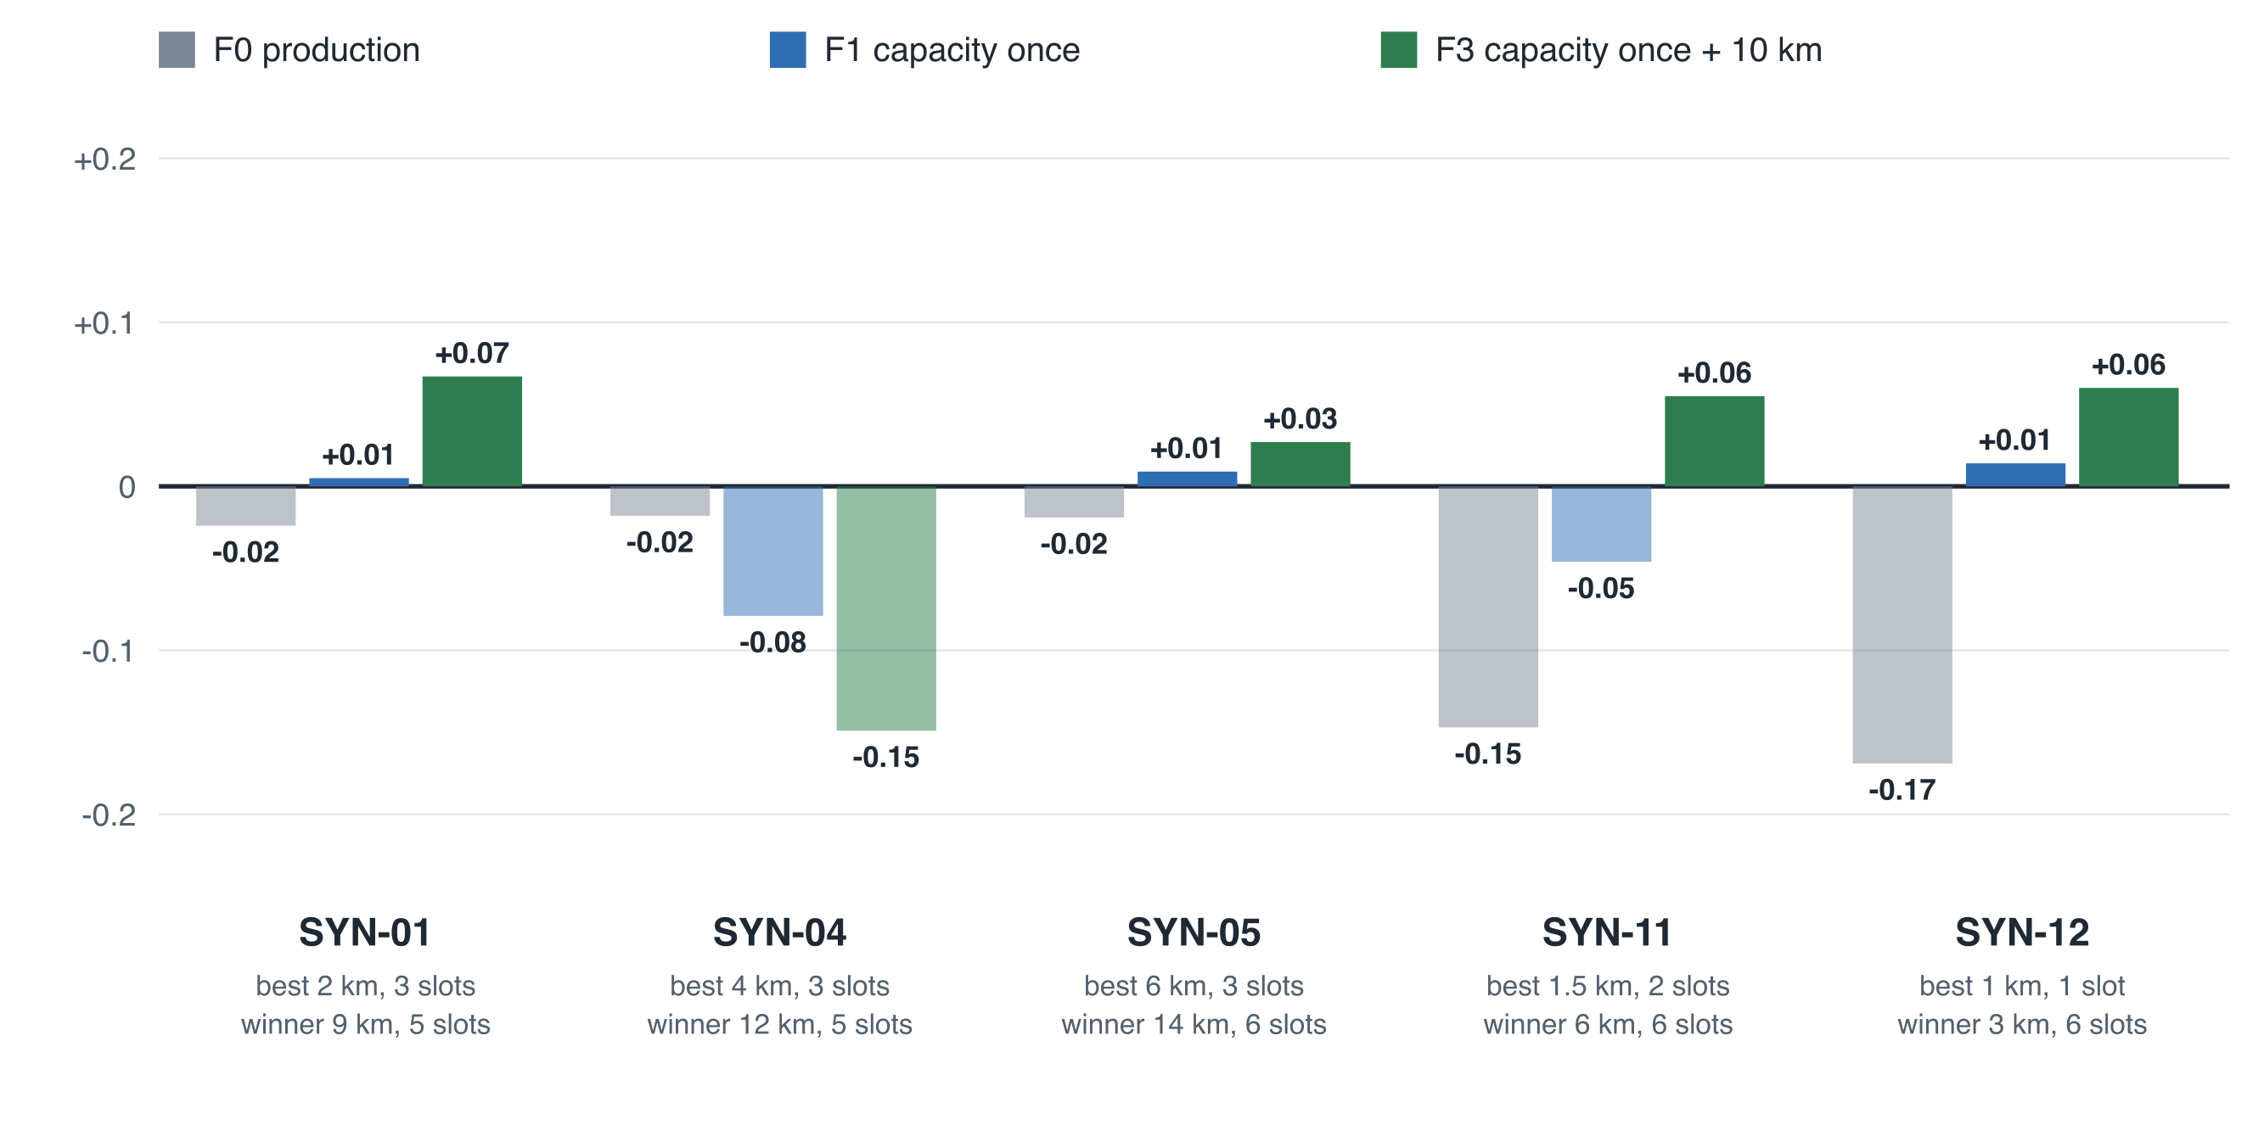
Figure 2. Score gap between the annotated best shelter and its strongest rival, per miss, under v2 blend weights. Above zero the annotated best wins; below zero (faded) it loses. SYN-04 is never fixed because its nearest shelter has zero slots (KI-21). Source: docs/evidence/sprint-5/error-analysis.json.
What I checked, and what I have not. Checked: that the pattern holds for all four weighting methods, not only the blend; that the five misses match the pre-registered run exactly; and that a post-hoc variant without zero-slot bids leaves F0 at 7 of 12. Not checked: whether the three near-tie misses are errors of the formula or of the annotation, which needs a second annotator; and whether the fix generalizes to cases written by someone else.

6. Broader-Impact Considerations
Safety. A misrouted injured animal loses treatment time. The current fallback sends an unusable classifier result to the least severe profile; the student's review decided it should default to the highest severity (better safe than sorry), but that change is not yet implemented, so the deployed behavior still has the less safe default. The free-text gap (KI-23) is the same kind of risk: a report that describes an injury in words but has no photo evidence is not treated as injured by the rule-based paths.
Fairness. Treating capacity as a score term favors large shelters, and the freshness penalty (about 30% for Slack-based shelters) favors shelters that publish live data over those that do not. Both can disadvantage small or low-resource shelters for reasons unrelated to whether they can care for the animal. The Hard Stop 3 won-share check was too small to detect bias, so this is a design concern, not a measured finding.
Privacy. A report carries the reporter's location, photos and free text, which are sent to a hosted model and posted to shelter Slack channels. No real reporters were involved in this project, but a real deployment would need retention limits and consent wording.
Cost and sustainability. About 100 live model calls were made across the project; the 42-call Hard Stop 3 batch cost about $0.25. A real deployment would pay per case for the classifier call, so repeated or duplicate reports would need caching.
Maintainability and organizational impact. The WEIGHTING_MODE flag allowed a measured rollback in 7.3 s, and pre-registration plus recorded model outputs make results auditable. The routing is a recommendation: shelters keep their autonomy preference, and the evidence here does not justify removing a human from the loop.

7. The Limitation the Final Report Must State
Supervisor prompt: which one limitation must be stated explicitly to preserve credibility? That every routing result comes from 12 informative synthetic cases annotated by one person, with half of them drafted by the AI assistant and the formula variants designed around the same trade-offs. The results show how much the formula and the weights each change the winner on those cases. They are not an estimate of how well RescueNet routes real animals, and the best cell (12 of 12) is a lead, not a validation.

8. Next Steps and Supervisor Review
Supervisor review. The assignment asks for the memo to be shared with the supervisor before submission. That has not happened: no feedback has been obtained on this memo, and the supervisor review from earlier hard stops (backlog item B-04) is still open. I am recording that here rather than implying review took place. The relevant approval on file remains the supervisor's September 27 response on the archetype design.
Next, in order:
- Implement counting capacity once together with a minimum-capacity eligibility rule (availableSlots > 0), and re-run the same pre-registered grid on a fresh case set.
- Obtain an independent annotator for set 2 and shelter-expert-proposed formula variants, so the evidence stops depending on one author.
- Apply the student's review decisions: default to the highest severity when the classifier is unusable, and read the free-text report for injury cues (KI-23).
- Test whether agent-generated weights reproduce across days (needs live calls; the count and cost will be agreed first).
- Only after the formula is fixed, revisit promoting WEIGHTING_MODE and classifier calibration.

9. Where Each Number Comes From
Result | How to regenerate
Table 2, Table 1 rows Q1 to Q3 | npx ts-node scripts/run-ablation.ts (writes eval/results/ablation.json)
Table 5, Figure 2, Figure 1 evidence box | npx ts-node scripts/error-analysis.ts (writes docs/evidence/sprint-5/error-analysis.json)
Q4, Q5 | scripts/run-eval.ts and scripts/run-sensitivity.ts against the recorded classifier output in eval/results/
Q6 | docs/evidence/sprint-3/measure-v2.json (live measurement; cannot be regenerated offline)

Another reader can reproduce everything except the live model outputs (replayed from committed recordings) and the annotations (judgments). Both are stated above.

Appendix A. Cumulative AI Use Log (index)
Full entries with purpose, verification and student revisions are in docs/AI_USE_LOG.md in the repository. This index lists every entry.
Entry | Title
1 | Code Audit
2 | Literature Research
3 | Charter, Feasibility, and Revision Drafting
4 | Feedback Triage and Gap Analysis
5 | Proposal Drafting (Background, Objectives, Success Criteria, MACP Framing, Project Plan)
6 | Work Breakdown, Risk/Ethics Section, and Approval Brief
7 | Literature Verification and Synthesis
8 | Requirements and Use Case Drafting
9 | Domain Constraints and Data Source Inventory
10 | Citation Re-Verification and Correction (Post-Feedback)
11 | Architecture, Data Flow, and Computational Method Drafting
12 | Test and Evaluation Plan, Traceability Matrix
13 | Environment, API Contracts, and Supervisor Review Drafting
14 | Design Revision: Dynamic Archetype-Blended Weighting
15 | Rubric Audit and Corrections
16 | Incorporating the Supervisor's Response
17 | Fairness-by-Shelter-Characteristic Check
18 | Implementation Sprint I: Code, Tests, and Engineering Documentation
19 | Implementation Sprint II: Evaluation Harness, Classifier Wiring, and Evidence
20 | Evidence-Informed AHP Judgments (Proposed by AI, Adopted by the Student)
21 | Hard Stop 3 Validation Package
22 | Midpoint: Non-Production Deployment, Measurement, and Demo Scripts
23 | Midpoint Package (Memo and Slide-Supported Demo)
24 | Hard Stop 4: Pre-Registered Ablation, Second Case Set, and Live Calls
25 | Hard Stop 4 Technical Evidence Review
26 | Results and Limitations Memo and Error Analysis
27 | Discussion 09 Post Draft (Unexpected Result)

