**Software Name:**

**Fitness Center Customer Registration System**

**PREPARED BY:**

* **Mr. Jayasinghe D C P**
  + DO141053
* **Mr. Kularathna E K M W**
  + DO141067
* **Ms. Niroshima G D**
  + DO141088
* **Ms. Jayawardena K S**
  + DO141057

**NIBM**

**August – 2014**

**Diploma in Computer System Design**

**NATIONAL INSTITUTE OF BUSINESS MANAGEMENT**

**ACKNOWLEDGMENT**

With our heartfelt thanks,

* To our most beloved lectures

Mr. Thisara

guiding us for this assignment.

* + - To National Institute of Business Management.
    - To our colleagues of NIBM.

**CONTENTS**

**INTRODUCTION**

**PROBLEM DEFINITION**

**SOFTWARE REQUIREMENTS**

**PROPOSED SOLUTION**

* UML Diagrams
  + - * + Use Case Diagram
        + Class Diagram
        + State Diagrams
        + Sequence Diagrams
        + Activity Diagrams

**BENEFITS**

**INTRODUCTION**

* Firstly system records GYM instructor, manager, physician, proteins, drugs, and physiotherapy, supplier and agent details.
* The customers will come and give their details in order to get them registered, after registering the customers have to pay membership payment and system records customer data.
* Then GYM instructor checks details of customer and prescribe suitable proteins for the customer. After prescribing proteins check whether the related proteins are available or not.
* If proteins are available customer gets proteins and records details of sold proteins.
* Accidently if any customer gets injured in Fitness Center physician provides physiotherapy for the injured customer based on his injury and record details. And also GYM instructor prescribes drugs for the customer and check whether the related drugs are available or not.
* If drugs are available customer gets drugs and records details of sold drugs.
* If proteins or drugs are not available record details of not available proteins and drugs.
* End of the day the System sends reports of sold proteins, drugs and not available proteins, drugs to the manager.
* Manager sends purchase report order for not available proteins and drugs to the supplier.
* Then supplier has the proteins and drugs the supplier will supply, if not the supplier will make an order for the agent.
* After supplier supplied proteins and drugs records details of supplied proteins and drugs.
* End of the day customer have to do the payments acquired proteins and drugs (if only customer gets injured).

**PROBLEM DEFINITION**

**The reasons to propose the Fitness Center customer Registration system**

* The above process currently happens manually. So,
  + - * It is difficult to keep track of the customer details.
      * It is difficult to check whether proteins and drugs are available or not.
      * When generating reports of sold proteins, drugs and not available proteins, drugs errors may occur. (E.g.: sales report might not be balanced.)
      * When manager generate purchase order it’s hard to find what are the proteins and drugs they need.
      * After supplier sends proteins and drugs when record details of purchased proteins and drugs errors may occur.
      * When calculate charges and collect payments for the service errors may occur.

**SOFTWARE REQUIREMENTS**

* Register new member.
* Receiving membership payments.
* Stocks monitoring.
* Maintaining a record of the GYM instructors.
* Sends a report at the end of the day to the manager.
* Keeping a record of suppliers and ordering medicine that are low in stocks.
* Generating a sales report.
* Receiving customer payment information.

**PROPOSED SOLUTION**

* UML Diagrams
  + - * + Use Case Diagram

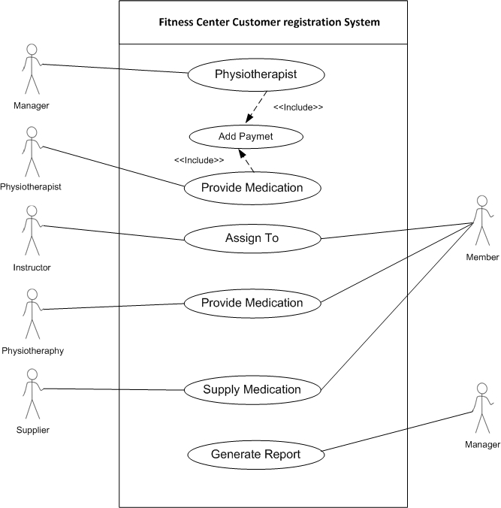

* + - * + Class Diagram

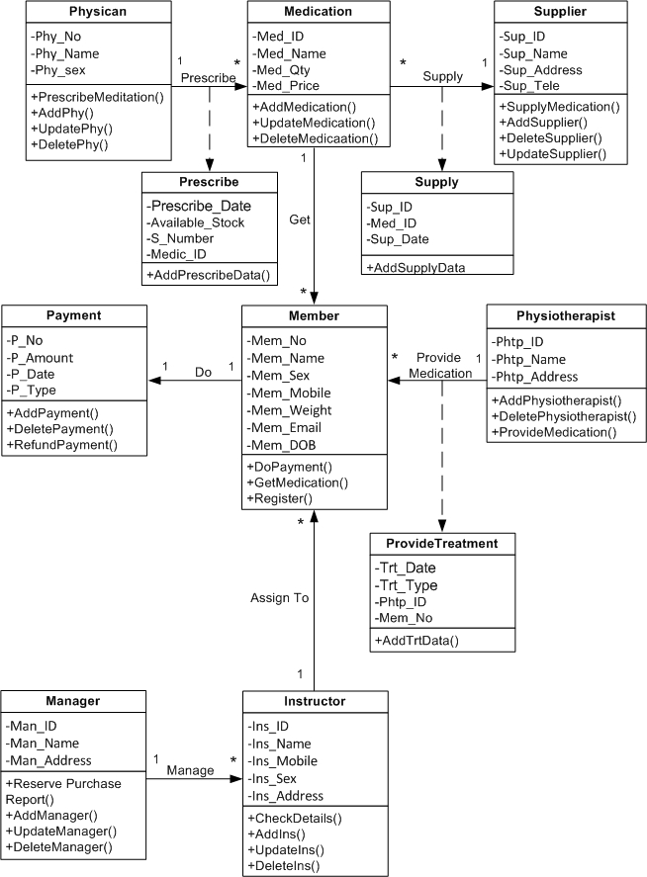

* + - * + State Diagrams

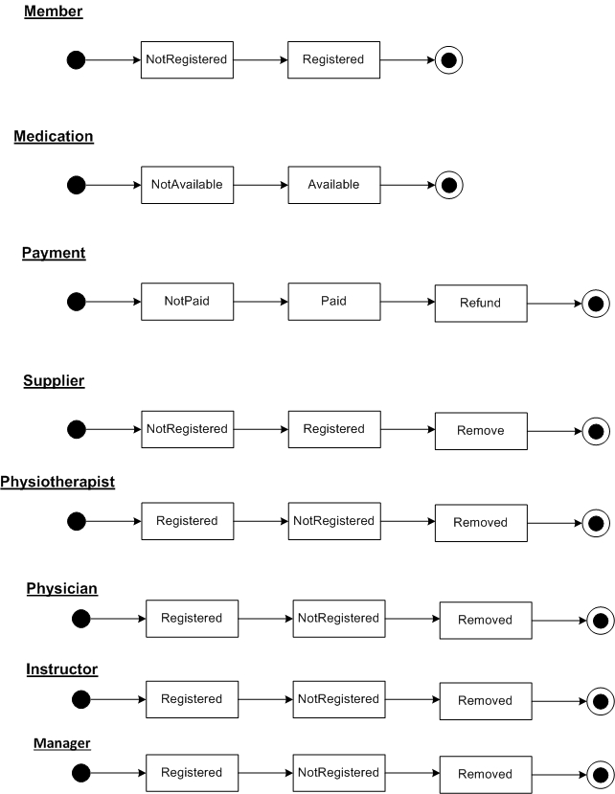

* + - * + Sequence Diagrams

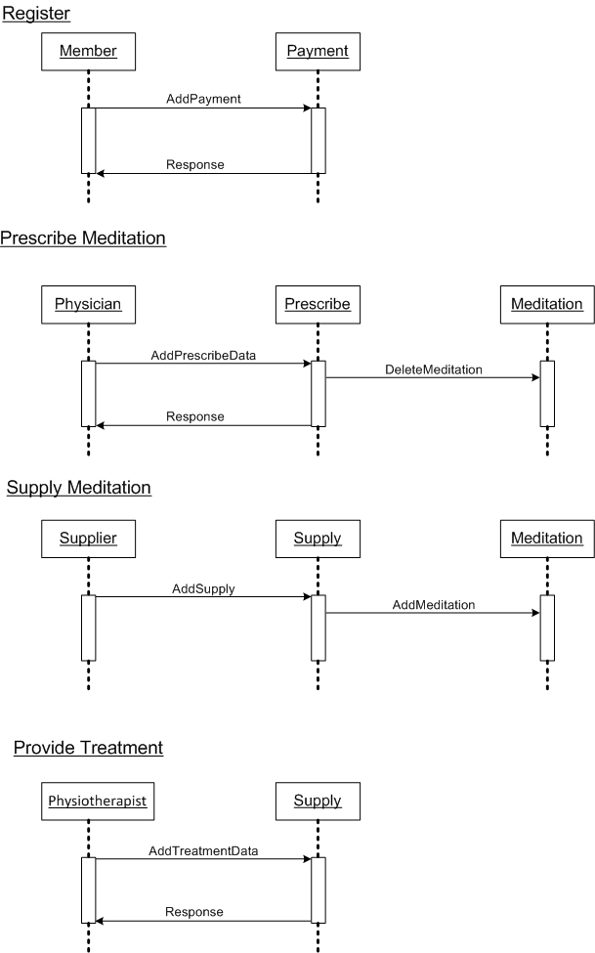

* + - * + Activity Diagrams
        + Activity Diagrams

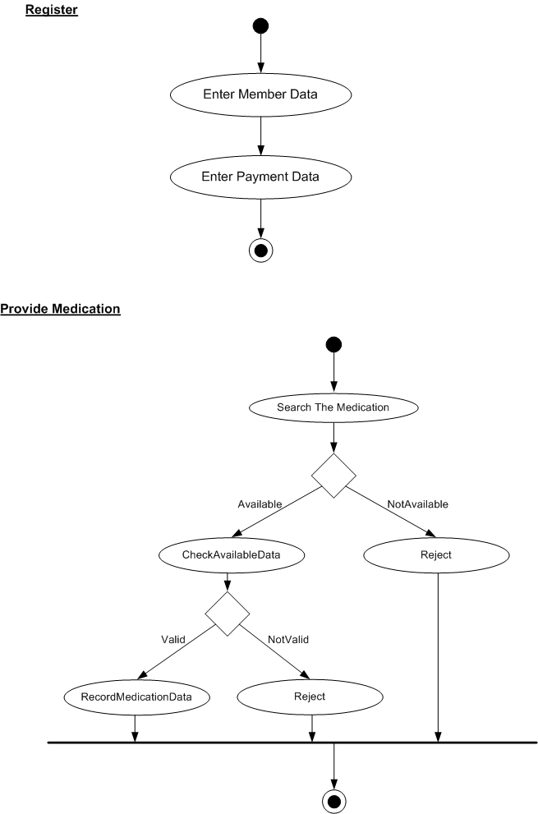

**PROPOSED SOLUTION**

* When the customers give their details to get register the system records customer data and it is easy to keep track of the customer details.
* When customer gets proteins or drugs system records the data. So it is easy to check whether proteins and drugs are available or not and also when generating reports of sold proteins, drugs and not available proteins, drugs errors may not occur.
* When customer gets proteins or drugs system records sold data. Therefore manager has correct details about not available proteins and drugs. So supplier gets an accurate purchase order.
* After supplier sends proteins and drugs system record data. Therefore errors may not occur about available proteins or drugs.
* If customer gets proteins, drugs or physical therapy all the charges are recorded by system. So when calculate charges and collect payments errors may not occur.