 | BUILDING CONSTRUCTION MANAGEMENT SYSTEM | 

A MINIPROJECT REPORT

Submitted by

MANOJ K (73772221156)
FIZUR RAHMAN S (73772221123)

in partial fulfillment of the requirement
for the award of the degree
of
B.TECH
in
INFORMATION TECHNOLOGY

K.S. RANGASAMY COLLEGE OF TECHNOLOGY
(An Autonomous Institution, affiliated to Anna University Chennai and Approved by AICTE, New Delhi)
TIRUCHENGODE – 637 215

AUGUST 2023

K.S. RANGASAMY COLLEGE OF TECHNOLOGY
TIRUCHENGODE - 637 215
BONAFIDE CERTIFICATE
Certified that this project report titled “BUILDING CONSTRUCTION MANAGEMENT SYSTEM” is the bonafide work of MANOJ K (73772221156) and FIZUR RAHMAN S (73772221123) who carried out the project under my supervision. Certified further, that to the best of my knowledge the work reported herein does not form part of any other project report or dissertation on the basis of which a degree or award was conferred on an earlier occasion on this or any other candidate.

SIGNATURE  Dr.R.POONKUZHALI M.E., Ph.D  HEAD OF THE DEPARTMENT  Professor  Department of Information Technology  K.S. Rangasamy College of Technology  Tiruchengode - 637 215 | SIGNATURE  Mr.k.SARAVANAN,B.TECH., M.E.  FACULATY INCHARGE  Associate Professor  Department of Information Technology  K.S. Rangasamy College of Technology  Tiruchengode - 637 215

DECLARATION
We jointly declare that the project report on “BUILDING CONSTRUCTION MANAGEMENT SYSTEM” is the result of original work done by us and best of our knowledge, similar work has not been submitted to “ANNA UNIVERSITY CHENNAI” for the requirement of Degree of B.Tech. This project report is submitted on the partial fulfilment of the requirement of the award of Degree of B.Tech.

Signature
____________________
MANOJ K
____________________
FIZUR RAHMAN S

Place : Tiruchengode
Date :

LIST OF FIGURES
FIG No. | TITLE | PAGE NO.
5.1 | MF CONSTRUCTIONS | 8
5.2 | MATERIALS REQUIRED | 8
5. 3 | MF CONSTRUCTIONS | 9

ABSTRACT
The provided program seems to represent an interactive system for construction management, aimed at simplifying the process of gathering project details, estimating required construction materials, and calculating the total cost. The first part of the application captures essential information about the construction project, ensuring all necessary parameters are considered, including property details, number of bedrooms, parking, and more. The second part focuses on estimating the quantity of materials needed for the construction, such as bricks, cement, iron bars, aggregate, and sand. This estimation aims to provide an initial cost calculation for the project, helping users get an idea of the resources required. The program's intuitive GUI design makes it user-friendly, facilitating easy data entry and understanding of material quantities and costs, making it potentially valuable for individuals or small businesses involved in the construction industry

TABLE OF CONTENTS
CHAPTER | TITLE | PAGE NO.
 | LIST OF FIGURES | iv
 | ABSTRACT | v
1 | INTRODUCTION | 1
2 | TOOL USED – TKINTER | 2
3 | FORM DESIGN | 4
4 | CODING | 6
5 | SAMPLE INPUT OUTPUT | 9
 | CONCLUSION | 12

CHAPTER 1

INTRODUCTION
The provided code is a Python script that utilizes the Tkinter library to create a graphical user interface (GUI) application. The application appears to be related to construction and real estate. It presents a window with various input fields for collecting information about a construction project, such as name, address, phone number, email, area of land, number of floors, etc. The user can choose between different options for the area measurement and parking availability. After filling in the details, the user can click the "NEXT" button, which opens a new window with more input fields for various construction materials (bricks, cement, iron bars, aggregate, sand) required for the project. Additionally, there are entry fields for the price of these materials. An "APPLY" button is provided to calculate and display the total price of the materials. The code concludes by using the mainloop() function to start the Tkinter event loop and keep the application running.
CHAPTER 2
TOOL USED - TKINTER
The Python script that uses the "TKINTER " library to create a graphical user interface (GUI) for collecting information related to construction details. Here's a breakdown of the code and the key components used.
1.Importing tkinter Library:
The code starts with importing the 'TKINTER' library, which is a standard GUI library for creating GUI applications.
2 .Creating a Main Window:
• 'Tk()' function is used to create the main window (w) for the GUI application.
• 'w.title("window")' sets the title of the window to "window".
3 .Labels and Entries:
The code creates labels and entry fields for various details like name, address, phone number, email, area of land, BHK (Bedroom, Hall, Kitchen) type, parking area, and number of floors.
4 .Option Menu:
• The 'optionmenu' widget is used to create a dropdown menu to select the unit for the area of land.
• The 'menu' variable is used to store the created dropdown menu.
5 .Radio Buttons:
• Radio buttons are used to select the number of bedrooms in the construction.
• Each radio button is associated with a bhk variable that stores the selected value (1BHK, 2BHK, 3BHK, 4BHK).
6 .Defining Functions:
• 'pk()' function is defined, which creates a new top-level window (‘sm’) to display construction details and calculations.
• 'cc()' function is defined, which displays a messagebox indicating that the application has been applied successfully.
7 .Button:
• A "NEXT" button ('sub') is created, which when clicked, calls the 'pk()' function to open the new top-level window.
8 .Main Loop:
The 'w.mainloop()' function starts the main event loop, allowing the GUI application to handle user interactions and events.

CHAPTER 3

FORM DESIGN

This code snippet uses various tkinter widgets like 'Label', 'Entry', 'OptionMenu', and 'Radiobutton' to create a basic GUI for capturing construction-related information. The provided functions 'pk()' and 'cc()' are placeholders and seem to be incomplete. It seems like the intended functionality is to calculate construction materials and prices based on the provided information and display the results in the top-level window ('sm').
Please note that the code snippet provided may not be complete, and the actual implementation of the 'pk()' and 'cc()' functions is missing. Additionally, the radio button variable bhk is overwritten multiple times, which could cause issues in the functionality related to selecting the number of bedrooms.

1 .Importing tkinter:

• 'From tkinter import *': This imports all symbols from the 'TKINTER' library, allowing you to use its functions and classes without prefixing them with 'tkinter'.

2 .Creating the Main Window:

• 'w = Tk()': Creates the main application window.
'w.title("window")': Sets the title of the window to "window"

3 .Labels and Entries:

• Label widgets are used to display text, and 'Entry' widgets are used to provide text input fields.
• Labels for various fields like "NAME", "ADDRESS", "PHONE NUMBER", etc., are created using Label with specified text, background color, and font settings.
• Entry fields for user input are created using Entry.

4 .OptionMenu and Radiobuttons:

• 'OptionMenu' and 'Radiobutton' widgets are used for dropdown menus and radio button groups, respectively.
•OptionMenu is used for "AREA OF LAND" with options "FEET" and "METER".
Radiobutton widgets are used for selecting the number of bedrooms (BHK), parking area options, and the number of floors.

4 .Button Actions:

• The 'pk' function is defined to create a new top-level window when the "NEXT" button is clicked. This window seems to be for displaying construction details.
• In the 'pk' window, labels and entry fields are used to show and input various construction material details.
•The 'cc' function is defined to show a message box when the "APPLY" button is clicked, indicating that the application has been successfully.

5 .Execution of the GUI:

• 'w.mainloop()': Starts the event loop, allowing the GUI to respond to user interactions.

Overall, the code creates a GUI form that captures user information related to construction details and provides options for selecting various attributes. When the user clicks the "NEXT" button, a new window pops up to display construction material details and provides an "APPLY" button to acknowledge the application.

CHAPTER 4

CODING

from tkinter import *
from tkinter import messagebox
w=Tk()
w.maxsize(1500,1400)
w.minsize(1500,1400)
w.title("window")
l=Label(w,text="MF CONSRUCTIONS",bg="red",font="time 25 bold").place(x=580,y=25)
l1=Label(w,text="NAME",bg="blue",font="time 12 bold").place(x=500,y=85)
ln1=Entry(w).place(x=700,y=85)
l2=Label(w,text="ADDRESS",bg="blue",font="time 12 bold").place(x=500,y=125)
ln2=Entry(w).place(x=700,y=125)
l3=Label(w,text="PHONE NUMBER",bg="blue",font="time 12 bold").place(x=500,y=165)
ln3=Entry(w).place(x=700,y=165)
l4=Label(w,text="EMAIL",bg="blue",font="time 12 bold").place(x=500,y=205)
ln4=Entry(w).place(x=700,y=205)
l5=Label(w,text="AREA OF LAND",bg="blue",font="time 12 bold").place(x=500,y=245)
lists=["FEET","METER"]
listroom=StringVar(w)
listroom.set("CHOOSE")
menu=OptionMenu(w,listroom,*lists)
menu.place(x=700,y=245)
ln5=Entry(w).place(x=810,y=250)
l6=Label(w,text="BHK",bg="blue",font="time 12 bold").place(x=500,y=310)
bhk=StringVar()
l7=Radiobutton(w,text="1BHK",variable=bhk,value='0',font="time 12 bold").place(x=700,y=310)
bhk=StringVar()
l7=Radiobutton(w,text="2BHK",variable=bhk,value="1",font="time 12 bold").place(x=800,y=310)
bhk=StringVar()
l7=Radiobutton(w,text="3BHK",variable=bhk,value="2",font="time 12 bold").place(x=700,y=350)
bhk=StringVar()
l7=Radiobutton(w,text="4BHK",variable=bhk,value="3",font="time 12 bold").place(x=800,y=350)
l8=Label(w,text="PARKING AREA",bg="blue",font="time 12 bold").place(x=500,y=400)
bhk=StringVar()
l7=Radiobutton(w,text="WITH",variable=bhk,value="WITH",font="time 12 bold").place(x=700,y=400)
bhk=StringVar()
l7=Radiobutton(w,text="WITHOUT",variable=bhk,value="WITHOUT",font="time 12 bold").place(x=800,y=400)
l8=Label(w,text="NO.OF.FLOORS",bg="blue",font="time 12 bold").place(x=500,y=440)
lists=["1","2","3"]
listroom=StringVar(w)
listroom.set("CHOOSE")
menu=OptionMenu(w,listroom,*lists)
menu.place(x=700,y=440)
def pk():
sm=Toplevel()
sm.maxsize(1500,1400)
sm.minsize(1500,1400)
l=Label(sm,text="MATERIALS REQUIRED ",bg="red",font="time 20 bold").place(x=580,y=25)
l=Label(sm,text="DETAILS",bg="red",font="time 14 bold").place(x=400,y=150)
l1=Label(sm,text="BRICKS REQUIRED(IN NO.OF)",bg="white",font="time 12 bold").place(x=345,y=200)
l2=Label(sm,text="CEMENT REQUIRED(IN KG)",bg="white",font="time 12 bold").place(x=345,y=250)
l3=Label(sm,text="IRON BAR REQUIRED(IN NO.OF)",bg="white",font="time 12 bold").place(x=345,y=300)
l4=Label(sm,text="AGGREGATE REQUIRED(IN KG)",bg="white",font="time 12 bold").place(x=345,y=350)
l5=Label(sm,text="SAND REQUIRED(IN NO.OF)",bg="white",font="time 12 bold").place(x=345,y=400)
l6=Label(sm,text="AMOUNT",bg="RED",font="time 15 bold").place(x=700,y=150)
l6=Label(sm,text="PRICE",bg="RED",font="time 15 bold").place(x=950,y=150)
ln=Entry(sm).place(x=680,y=200)
ln1=Entry(sm).place(x=680,y=250)
ln2=Entry(sm).place(x=680,y=300)
ln3=Entry(sm).place(x=680,y=350)
ln4=Entry(sm).place(x=680,y=400)
ln=Entry(sm).place(x=920,y=200)
ln1=Entry(sm).place(x=920,y=250)
ln2=Entry(sm).place(x=920,y=300)
ln3=Entry(sm).place(x=920,y=350)
ln4=Entry(sm).place(x=920,y=400)
ln4=Entry(sm).place(x=920,y=450)
l6=Label(sm,text="TOTAL PRICE=" ,font="time 12 bold").place(x=800,y=450)
m=Button(sm,text="APPLY",background="green",fg="black",command=cc).place(x=700,y=500)
def cc():
messagebox.showinfo("APPLY","APPLIED SUCCESSFULLY")
sub=Button(w,text="NEXT",bg="GREEN",command=pk).place(x=850,y=510)
w.mainloop()

CHAPTER 5
SAMPLE I/O
PAGE 1:
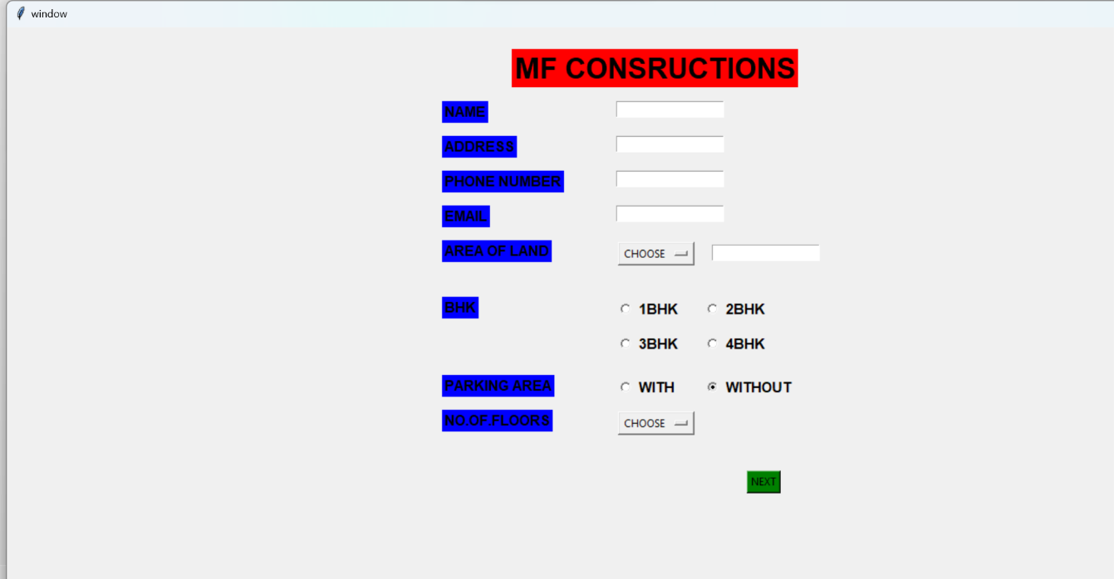
Fig 5.1MF CONSTRUCTION

PAGE 2:
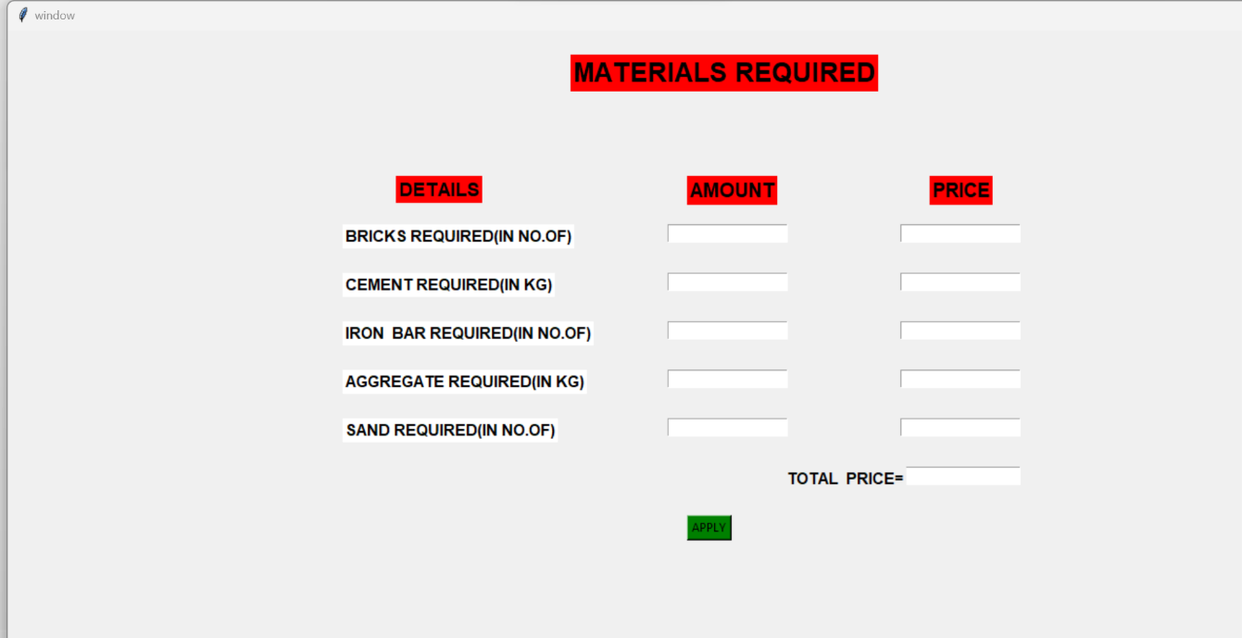
Fig 5.2 MATERIALS REQUIRED

PAGE 3:
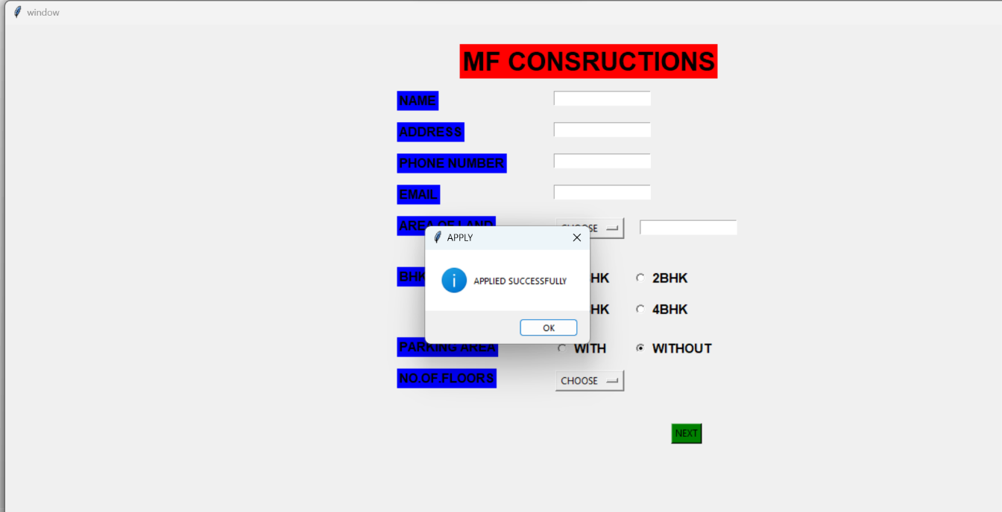

Fig 5.3 MF CONSTRUCTION

CONCLUSION
In conclusion "The BUILDING CONSTRUCTION MANAGEMENT SYSTEM" program is written using the tkinter library in Python to create a graphical user interface for a construction-related application. It involves entering various details about a construction project and calculating the required materials and pricing. The program includes labels, entry fields, radio buttons, and buttons to navigate through the interface. Upon running the program, a main window will appear with fields to input the user's details such as name, address, phone number, email, area of land, number of rooms (BHK), parking area preference, and number of floors. Once the user fills in these details and clicks the "NEXT" button, a new window (Toplevel) called "sm" will open, displaying a summary of the materials and their estimated prices required for the construction project. There is also an "APPLY" button that, when clicked, will show a message box confirming that the application was successful. the provided program is an interface for entering construction-related details and obtaining an estimate of required materials and pricing for a project. It's a basic example of using tkinter to create a user-friendly application for managing construction information.

