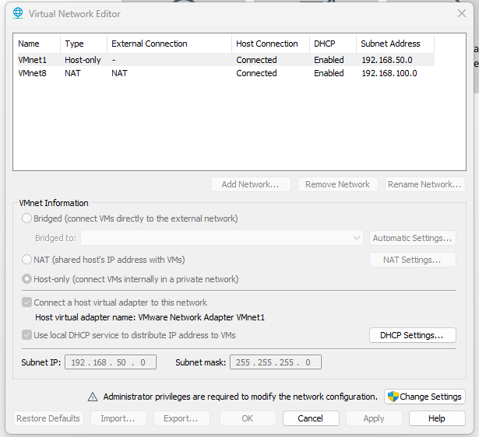
The existing VMware virtual network configuration was reviewed. Default networks (Bridged, Host-Only, and NAT) were identified, and administrative access was enabled to create custom virtual networks for the cyber range.

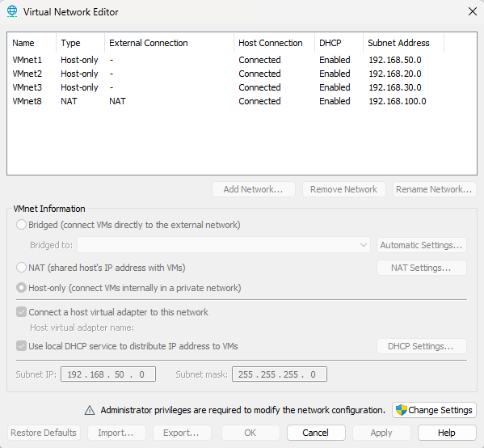

Title
VMware Virtual Network Configuration
Description
Custom virtual networks were configured in VMware Workstation Pro to support the isolated cybersecurity lab. VMnet2 was designated as the Target Network for servers and client systems, VMnet3 was configured as the Monitoring Network for centralized security monitoring, and VMnet8 was retained as the NAT network to provide controlled internet connectivity for software installation and updates. This segmented network design improves security, organization, and realistic attack–defense simulation.

Today's Progress
You can report the following to your mentor:
- ✔ VMware project workspace created.
- ✔ Default VM storage location configured.
- ✔ VMware networking reviewed.
- ✔ Custom virtual networks (VMnet2 & VMnet3) created.
- ✔ Network architecture finalized for the project.
This is a meaningful infrastructure milestone.

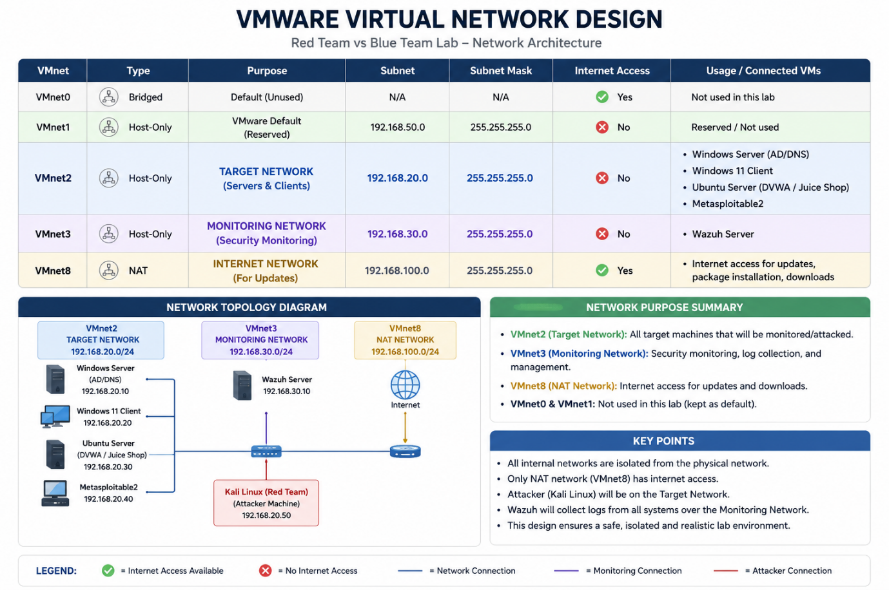
Two dedicated Host-Only virtual networks were created using VMware Virtual Network Editor. The Target Network was designated for servers and client systems, while the Monitoring Network was reserved for centralized security monitoring. Network segmentation improves isolation, simplifies traffic management, and supports realistic attack-and-defense simulations.

3. Creation of Wazuh Server Virtual Machine
Objective
To create the first virtual machine that will serve as the centralized Security Information and Event Management (SIEM) server for the Blue Team infrastructure. This server will later host the Wazuh platform for log collection, monitoring, threat detection, and security analysis.

Step 10 – Creating a New Virtual Machine
A new virtual machine was created in VMware Workstation Pro by selecting File → New Virtual Machine. The Custom (Advanced) configuration option was chosen instead of the Typical configuration to allow complete control over the virtual hardware settings, networking configuration, storage allocation, and future scalability.

Step 11 – Hardware Compatibility
The latest available VMware Hardware Compatibility Version was selected to ensure compatibility with the latest virtualization features and improved hardware support. Using the latest compatibility level also enhances performance and simplifies future upgrades.

Step 12 – Installation Method
The option "I will install the operating system later" was selected. This approach allows the virtual hardware to be configured before installing the operating system, ensuring that processor, memory, storage, and networking resources are properly allocated according to the project requirements.

Step 13 – Guest Operating System Selection
The guest operating system type was configured as:
- Operating System: Linux
- Version: Ubuntu 64-bit
Ubuntu Server was selected because it is officially supported by Wazuh and provides a stable, lightweight, and secure environment for deploying security monitoring services.

Step 14 – Virtual Machine Naming and Resource Allocation
The virtual machine was named Wazuh-Server and stored inside the centralized project directory (RedTeam-BlueTeam-Lab\VMs) to maintain an organized infrastructure.
The initial hardware configuration was planned as follows:
Parameter | Configuration
VM Name | Wazuh-Server
Guest OS | Ubuntu 64-bit
Processors | 1
Cores per Processor | 4
Total vCPUs | 4
Memory | 8 GB (8192 MB)
Virtual Disk | 80 GB (Thin Provisioned)
Configuration Type | Custom (Advanced)
This hardware allocation provides sufficient computing resources for the Wazuh Manager, Dashboard, and Indexer while ensuring efficient utilization of the host system.

Outcome
- Successfully initiated the creation of the Wazuh Server virtual machine.
- Selected the Custom (Advanced) configuration for greater flexibility.
- Chose Ubuntu 64-bit as the guest operating system.
- Planned the virtual hardware resources according to the requirements of the Blue Team monitoring infrastructure.
- Organized the virtual machine within the centralized project workspace to maintain consistency across the cyber range.
- ------------------------------------------------------------
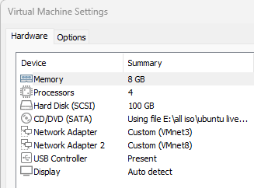
Documentation – Hardware Customization
The Wazuh Server virtual machine hardware was configured with 8 GB RAM, 4 vCPUs, and a 100 GB SCSI virtual disk. The Ubuntu Server ISO was attached to the virtual CD/DVD drive. Two network adapters were configured: VMnet3 for the dedicated monitoring network and VMnet8 for NAT-based internet access. Unnecessary hardware components were omitted, keeping the virtual machine optimized and ready for Ubuntu Server installation.
Outcome
- Wazuh Server VM successfully configured.
- Hardware resources allocated.
- Ubuntu Server ISO attached.
- Monitoring and internet network interfaces configured.
- VM ready for operating system installation.

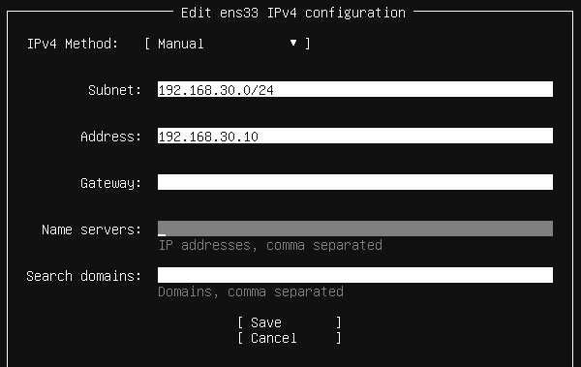
Edit Network settings of ens33(host only- vmnet3)
Edit Network settings of ens34(NAT- vmnet8) keep it as it is

Proxy and Repository Configuration
The proxy configuration was left blank as no proxy server was required. The default Ubuntu package repository mirror was retained for software installation and future updates.
Storage Configuration
The operating system was installed using the Guided Storage option with the entire 100 GB virtual disk. The default LVM (Logical Volume Manager) layout was selected without disk encryption, providing flexible storage management for the server.
User and Server Profile
The server profile was configured by assigning the hostname wazuh-server, creating an administrative user account, and setting a secure password for system administration.
SSH Configuration
The OpenSSH Server package was installed to enable secure remote administration of the Wazuh Server. Password-based SSH authentication was enabled for the lab environment, while SSH key import was skipped.

Outcome
- Configured a static IP for the monitoring interface (192.168.30.10/24).
- Configured NAT interface with DHCP for internet connectivity.
- Retained the default Ubuntu repository and skipped proxy configuration.
- Installed Ubuntu using Guided Storage with LVM on a 100 GB virtual disk.
- Created the server profile and administrator account.
- Enabled OpenSSH Server for secure remote access.
- Began the Ubuntu Server installation process, preparing the VM for Wazuh installation.

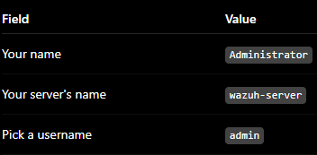
Username is admin1 (enter this at login page of wazuh-server)
D!t!$$@007

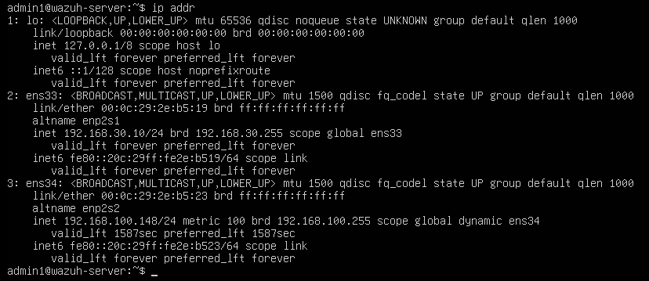
Verify network
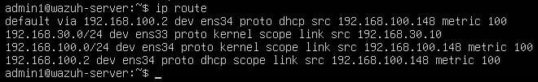
Ip route
--
Installation Completion and Initial Verification
The Ubuntu Server installation was completed successfully, and the virtual machine was rebooted using the installed operating system. The administrator logged into the server using the configured credentials. Network connectivity was verified by confirming the static IP address on the monitoring interface and the DHCP-assigned IP address on the NAT interface. Internet and DNS connectivity were tested to ensure the server was ready for software installation and Wazuh deployment.

Next Phase
Once you've confirmed:
- You can log in,
- ip addr shows the expected IP addresses,
- ping 8.8.8.8 and ping google.com work,
wazuh login
admin
dze9t+8vS+Y9ZqGpIf813v9l5c7Sy7x3
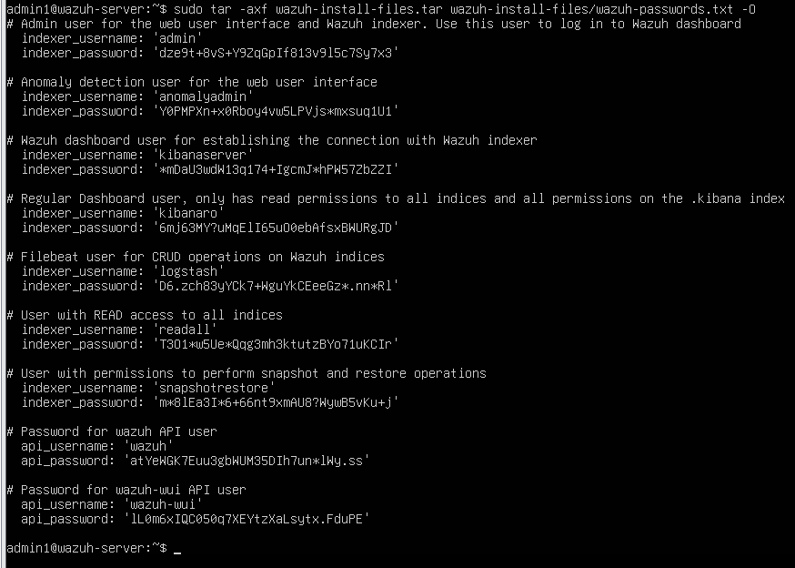

Added a script project file for later use

Wazuh Deployment Verification
The Wazuh deployment was successfully verified. The Wazuh Manager, Wazuh Indexer, and Wazuh Dashboard services were confirmed to be in the active (running) state. The Wazuh web dashboard was successfully accessed using the generated administrator credentials, confirming that the centralized SIEM platform is operational and ready to receive security events from managed endpoints.
