Now Windows server 2022 setup
Documentation (Steps 1–13)
Windows Server Virtual Machine Creation
A new virtual machine was created in VMware Workstation Pro using the Custom (Advanced) configuration. The guest operating system was configured as Microsoft Windows Server 2022 (64-bit). The virtual machine was allocated 4 GB RAM, 4 vCPUs, and a 60 GB SCSI virtual disk. The VM was connected to the VMnet3 Monitoring Network to support communication with the Wazuh Server and future lab systems.

Documentation (Steps 16–26)
Hardware Customization
The Windows Server 2022 virtual machine was configured by attaching the Windows Server installation ISO, allocating 4 GB RAM, 4 vCPUs, and a 60 GB SCSI virtual disk. The VM was connected to the VMnet3 monitoring network and unnecessary virtual hardware such as the sound card and printer was removed to optimize resource utilization. The virtual machine was then finalized and prepared for operating system installation.

Documentation (Steps 27–35)
Windows Server Installation
Windows Server 2022 Standard Evaluation (Desktop Experience) was installed on the virtual machine using the default partitioning scheme on the 60 GB virtual disk. After installation, an Administrator account password was configured, and the operating system was successfully booted, completing the initial server deployment.

Phase 2 – Basic Server Configuration
Step 36 – Rename the Server
Open Server Manager.
Go to:
Local Server → Computer Name → Click the current name → Change
Rename it to:
DC01
Click OK.
Do not restart yet.

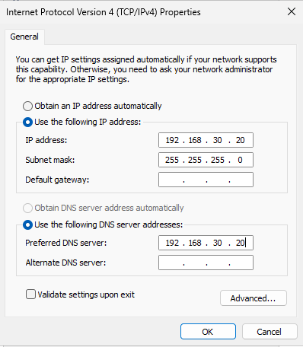
Step 37 – Configure Static IP
Open:
Control Panel → Network and Sharing Center → Change adapter settings
Right-click Ethernet → Properties.
Open:
Internet Protocol Version 4 (TCP/IPv4)
Configure:
Setting | Value
IP Address | 192.168.30.20
Subnet Mask | 255.255.255.0
Default Gateway | (Leave blank)
Preferred DNS | 192.168.30.20
We point DNS to itself because this server will become the Domain Controller.
Click OK.

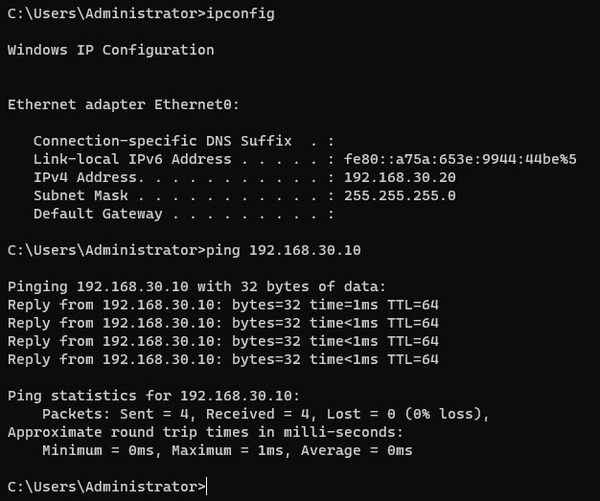
Now verified with ping to wazuh-server using ping

Documentation (Steps 36–39)
Initial Windows Server Configuration
The Windows Server was renamed to DC01 to align with enterprise naming conventions. A static IPv4 address (192.168.30.20/24) was assigned to the server, and the DNS server was configured to point to itself in preparation for Active Directory Domain Services (AD DS). Network connectivity with the Wazuh server was verified, and the server was restarted to apply the hostname change.

Phase 3 – Active Directory Installation
Step 40 – Open Server Manager
- Open Server Manager.
- Click Manage → Add Roles and Features.

Step 41 – Installation Type
Select:
- Role-based or feature-based installation
Click Next.

Step 42 – Server Selection
Select:
- DC01
Click Next.

Step 43 – Server Roles
Check:
- ✅ Active Directory Domain Services
When prompted:
- Click Add Features
Click Next.

Step 44 – Features
Leave the default features selected.
Click Next.

Step 45 – Active Directory Domain Services
Read the information.
Click Next.

Step 46 – Confirmation
- ✅ Check Restart the destination server automatically if required.
- Click Install.
Wait for the installation to complete.
Do not close Server Manager.

Step 47 – Promote to Domain Controller
After installation finishes, you'll see a notification flag in Server Manager.
Click:
Promote this server to a domain controller

Step 48 – Deployment Configuration
Select:
- Add a new forest
Root domain name:
cyberlab.local
Click Next.

Step 49 – Domain Controller Options
Configure:
Setting | Value
Forest Functional Level | Windows Server 2022
Domain Functional Level | Windows Server 2022
DNS Server | ✅ Checked
Global Catalog | ✅ Checked
Read-only Domain Controller | ❌ Unchecked
DSRM Password | Set a strong password and save it
Click Next.

Step 50 – DNS Options
Ignore the delegation warning.
Click Next.

Step 51 – NetBIOS Name
Leave the default:
CYBERLAB
Click Next.

Step 52 – Paths
Leave the default paths.
Click Next until you reach Prerequisites Check.

Step 53 – Install
When the prerequisites check passes:
Click Install.
The server will automatically restart.

Documentation (Steps 40–53)
Active Directory Domain Services Installation
Active Directory Domain Services (AD DS) was installed on DC01 using the Server Manager wizard. The server was promoted to a Domain Controller by creating a new Active Directory forest named cyberlab.local. The DNS Server and Global Catalog roles were enabled, and the default database, log, and SYSVOL paths were retained. After passing prerequisite validation, the domain controller installation was completed and the server restarted automatically.

Looking at your screenshot, the important part is this:
Name: dc01.cyberlab.local
Address: 192.168.30.20
This means DNS resolution is working. The domain controller can resolve its own name.
The message:
DNS request timed out.
Server: UnKnown
Address: ::1
is related to IPv6 loopback (::1) and is common on some Windows Domain Controllers. By itself, it is not a sign that Active Directory is broken, especially since the lookup succeeded.
Let's verify everything before proceeding
Please run these commands one by one and share the outputs:
1. Check IP and DNS
ipconfig /all
I want to verify that the DNS server is configured correctly.

2. Check domain
echo %USERDOMAIN%
Expected:
CYBERLAB

3. Check domain controller
echo %LOGONSERVER%
Expected:
\\DC01

4. Verify Active Directory health
dcdiag /test:dns
This is the most important test. It will tell us if there are any actual DNS issues.

Don't change anything yet
Do not modify IPv6 settings or DNS configuration until we see the outputs. Since nslookup already returned 192.168.30.20, your AD DS installation may already be functioning correctly, and we don't want to introduce unnecessary changes.
Please send the output of ipconfig /all first.

Your configuration looks correct.
From your screenshot:
- ✅ Host Name: DC01
- ✅ Primary DNS Suffix: cyberlab.local
- ✅ IPv4 Address: 192.168.30.20
- ✅ DNS Server: 127.0.0.1 (localhost)
- ✅ DNS Suffix Search List: cyberlab.local
The DNS server being 127.0.0.1 is perfectly valid on a Domain Controller because the DNS service is running locally. The ::1 (IPv6 loopback) you saw with nslookup is also local.
Why did nslookup show "DNS request timed out"?
This usually happens because nslookup first tries to query the DNS server over IPv6 (::1). If the IPv6 listener doesn't respond quickly, it times out, then falls back and successfully resolves the name. Since it ultimately returned:
dc01.cyberlab.local
192.168.30.20
DNS resolution is working.
One final health check
Please run:
dcdiag /test:dns
If it passes (or only shows minor warnings), your Domain Controller and DNS are ready.

If dcdiag passes
We can move on to the next VM:
Windows 11
We'll:
- Create the Windows 11 VM.
- Assign it a static IP (192.168.30.30).
- Set its DNS server to 192.168.30.20.
- Join it to the CYBERLAB.LOCAL domain.
- Install the Wazuh Agent and Sysmon.

Phase 9 – Monitor the Domain Controller
Your Domain Controller is the most critical Windows system. It should also be monitored.
Step 95 – Install the Wazuh Agent on DC01
On DC01:
- Open the Wazuh Dashboard.
- Go to Deploy New Agent.
- Select:
  - OS: Windows
  - Server: 192.168.30.10
  - Agent Name: DC01
- Copy the generated installation command.
- Run it in PowerShell as Administrator on DC01.
Verify that DC01 appears as an Active agent.

Step 96 – Install Sysmon on DC01
Use the same files you used on Windows 11:
- Sysmon64.exe
- sysmonconfig-export.xml
Run:
.\Sysmon64.exe -accepteula -i .\sysmonconfig-export.xml
Then verify that Sysmon events from DC01 appear in Wazuh.
Some other codeshare info to add
Invoke-WebRequest -Uri https://packages.wazuh.com/4.x/windows/wazuh-agent-4.12.0-1.msi -OutFile $env:tmp\wazuh-agent; msiexec.exe /i $env:tmp\wazuh-agent /q WAZUH_MANAGER='192.168.30.10' WAZUH_AGENT_NAME='WIN11-01'

NET START WazuhSvc
cd "C:\Users\<your-user>\Downloads\Sysmon"
.\Sysmon64.exe -accepteula -i .\sysmonconfig-export.xml

C:\Program Files (x86)\ossec-agent\ossec.conf

<localfile>
<location>Microsoft-Windows-Sysmon/Operational</location>
<log_format>eventchannel</log_format>
</localfile>

Restart-Service WazuhSvc

Get-Service WazuhSvc

------------
Invoke-WebRequest -Uri https://packages.wazuh.com/4.x/windows/wazuh-agent-4.12.0-1.msi -OutFile $env:tmp\wazuh-agent; msiexec.exe /i $env:tmp\wazuh-agent /q WAZUH_MANAGER='192.168.30.10' WAZUH_AGENT_NAME='DC01'

NET START WazuhSvc

Threat hunting--events (for looking into sysmon logs of any endpoint)
-----

