**NODE-REACT ASSESSMENT**

1. Installation of MySql
2. Configuration and Adding database(Database Name:wfm)
3. Api call for Listing Employee data from employee table,skill table and skillmap table in Manager Home Screen.

**Node:**

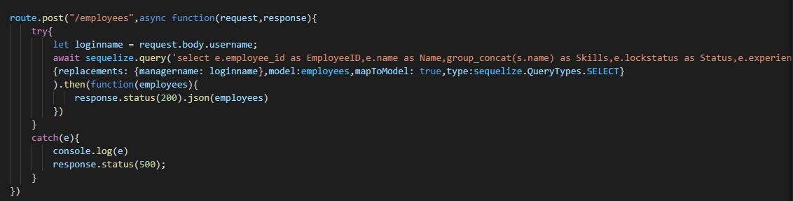

**React:**

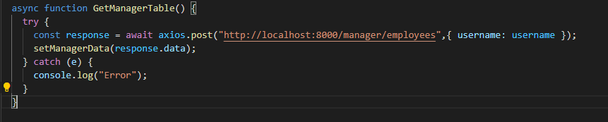

1. Api call for listing Requested employee data from softlock table in wfm Manager Home Screen.

**Node:**

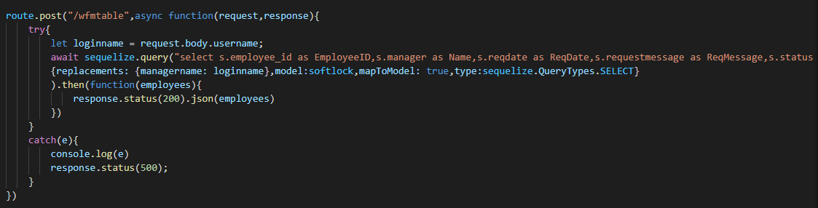

**React:**

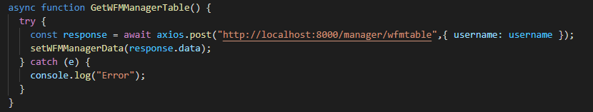

1. Api call for getting the value from the manager page popup for updating the status and to insert the message in the softlock(table).

**Node:**

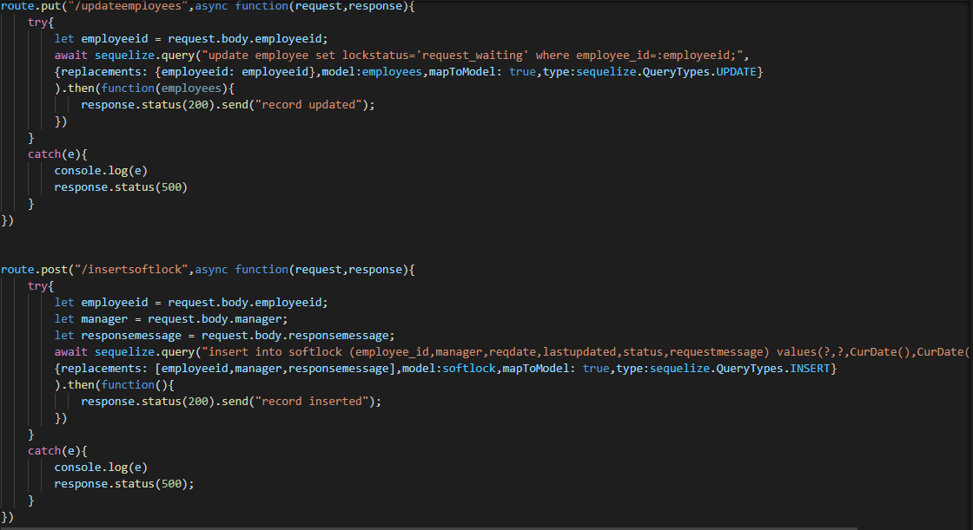

**React:**

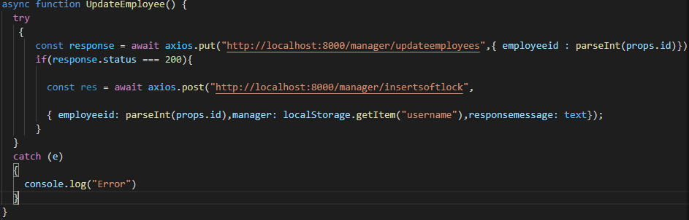

6.Api call for updating status in employee and softlock table

**Node:**

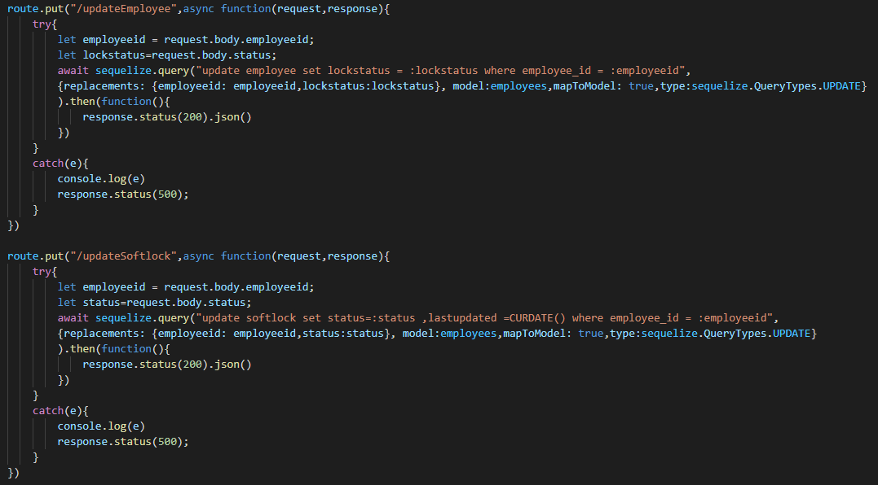

**React:**

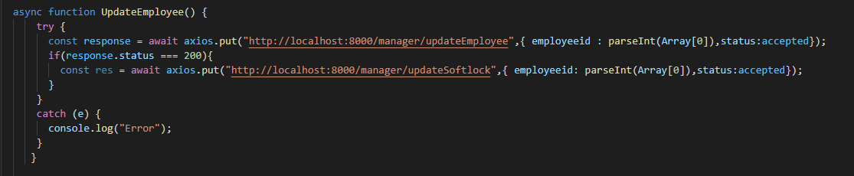

**OUTPUT SCREENS**

**Manager Home Screen:**

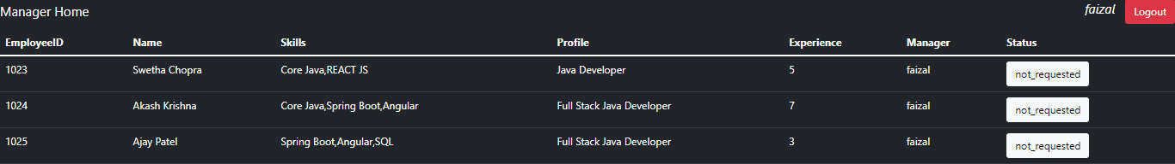

**Request Popup in Manager Screen:**

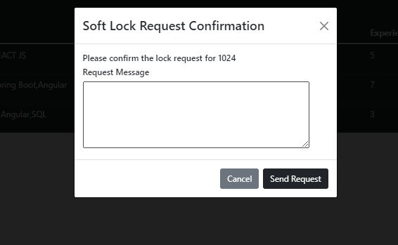

**Wfm Manager Home Screen:**



**Approval Popup In wfm Manager Screen:**

