**NODE-REACT ASSESSMENT**

1. Installation of MySql
2. Configuration and Adding database(Database Name:wfm)
3. Api call for Listing Employee data from employee table,skill table and skillmap table in Manager Home Screen.

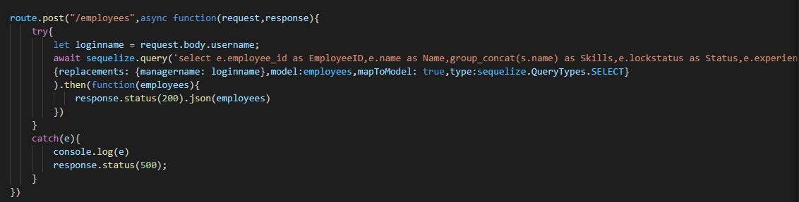

1. Api call for listing Requested employee data from softlock table in wfm Manager Home Screen.

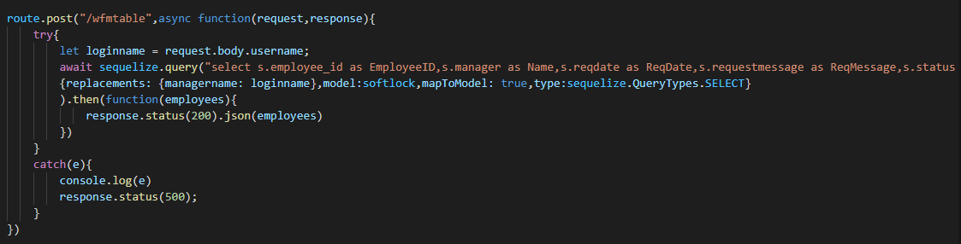

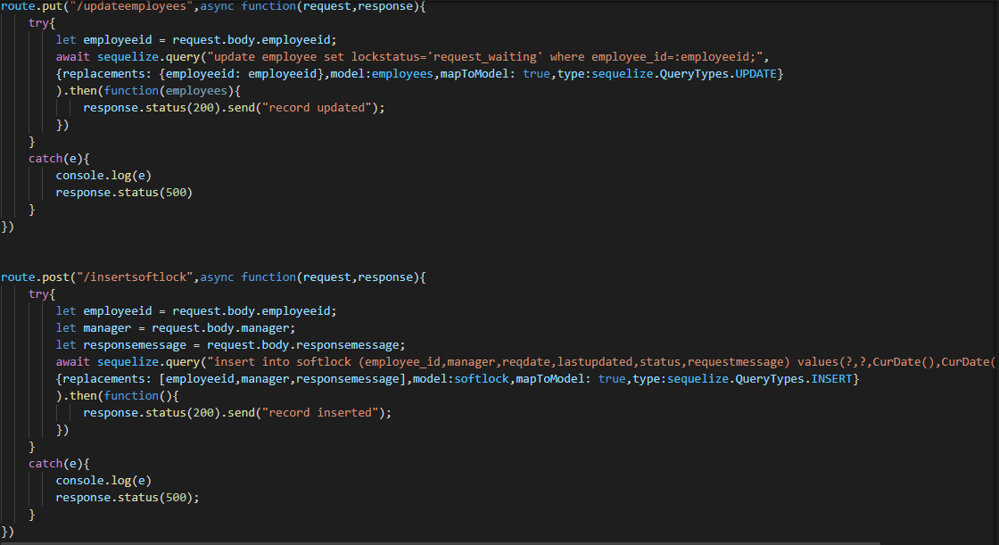

6.Api call for updating status in employee and softlock table

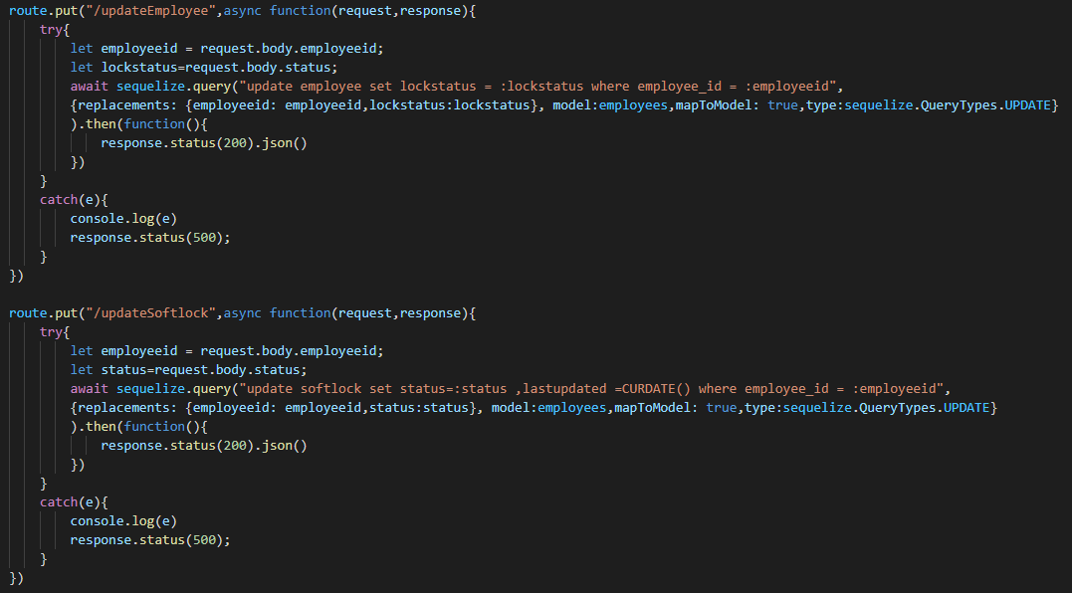

**OUTPUT SCREENS**

**Manager Home Screen:**

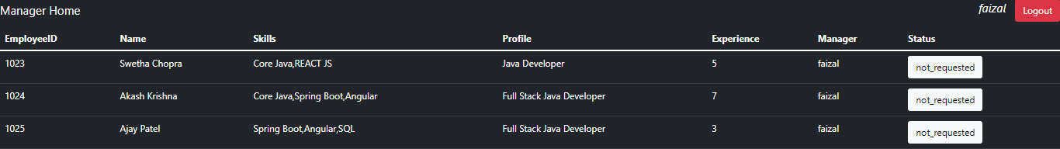

**Request Popup in Manager Screen:**

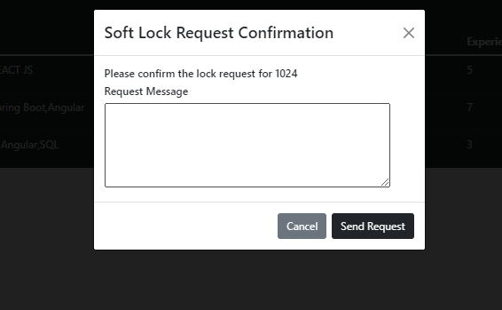

**Wfm Manager Home Screen:**



**Approval Popup In wfm Manager Screen:**

