

Step 1: creating a script file

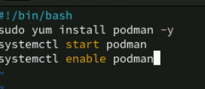

Step 2: Installing , starting and enabling the docker

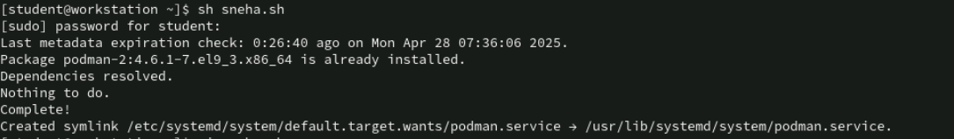

Step 3: Output