Streamlined Library Services for an Improved User Experience

Date: August 11, 2017; revised August 22, 2017

To: Oya Rieger and Xin Li

From: CUL Usability Working Group 2016- 2017: Darcy Branchini, Gabriela Castro Gessner, Adam Chandler, Matt Connolly, Erica Johns, Wendy Kozlowski, Mary Beth Martini-Lyons, Melissa Wallace, Sarah J. Wright[1]

Introduction and recommendations

The idea for a user-centric study of how we present equipment loans to our patrons was stimulated by two events in the spring of 2016.  The first was a report conducted here at Cornell, A day in the Life of a (Serious) Researcher: Envisioning the Future of the Research Library.[2]  That report argues for a more modular, app-focused, design and service approach.  Around the same time, a cognitive walkthrough by the Usability group of the new Olin Uris website revealed some of the challenges patrons encountered  handling equipment loans on the website, an observation supported by members of the student library advisory council (SLAC), who indicated that "equipment pages were not unified."

Our investigations took us to understand the current equipment lending environment in four areas: user perspective (patrons), staff, CUL systems and national environmental landscape.  Our key findings prompt us to recommend suggestions for modifications in five areas that would provide a better user experience:

1. Systems: The core of the problem is our library management system is optimized for books and journals, not equipment. We have a golden opportunity with FOLIO to design in robust support for non-book, "equipment" types of physical materials. Development should include consideration of both staff needs and how the system API should be designed so that patron facing services can be improved over what is possible today. FOLIO has the potential to be best in class. To make this a reality, effort needs to put into educating the people designing the system so they understand how managing equipment differs from managing books, journals, and other traditional formats.
2. Web presence: Streamlining the online presence and ease of discovery of shared services, such as equipment loans, would not only benefit users, but also create more efficient workflows for staff at public service desks and developers behind the scenes.
3. Metadata normalization: The decentralized "cataloging" of equipment in a system that is not really made to support it has led to a lack of controlled vocabulary.  With sufficient buy-in from Access Services staff, support from Library Technical Services, and encouragement from library administration, we can do better. However, there is only so much staff can do in the current Voyager environment.
4. Policies: In 2017, we appear to be caught between a decentralized past and an "app-centric" future (by "app centric" we are referring to the vision expressed in the A day in the Life of a (Serious) Researcher study). To minimize confusion for patrons, CUL should make an effort to harmonize circulation and reserve policies across all library service points.  With that said, we still need to empower staff at service points with sufficient agency to make exceptions.
5. Inventory management: Our data analysis suggests places where equipment could be shifted between units to better meet demand. Routine data analysis would help to optimize our assets. The figure at the end of this document, "CUL Equipment Circulation, September/October 2016," may help to illustrate the differences in demand across service points. The figure shows number of items on the x axis, and number of charges per items on the y axis. It was created with a combination of SQL queries of the Voyager database and R code.

Methods and findings

The recommendations outlined above, are a result of the following approaches and the results of those investigations.

|  |  |
| --- | --- |
| Environment | Method Used |
| Patrons | Collected and reviewed recent circulation data for the various equipment types that CUL collects and loans. We also have the results of a survey of patrons that was conducted in the Uris Library over the Fall 2016 semester. |
| Staff | Held multiple conversations with Access Services staff. |
| CUL systems review | Conducted a systematic review of patron-facing CUL websites to understand better what patrons see. |
| Literature review | Conducted a literature review to better understand how other libraries are managing and presenting equipment inventory. |

**Findings**

1. Patrons cannot go to one website to get equipment information and availability. They need to visit (and learn to use) over a dozen different sites to see what each library individually holds.
2. Only two libraries (Olin/Uris, Mann) appear to have a large amount of equipment represented on their website. It is unknown if other libraries don’t include more equipment information because of scale, lack of use or demand, or due to challenges around providing and maintaining this information.
3. There is a great deal of inconsistency between sites with respect to equipment offered, policies, terminology for both the equipment and how the service is named, navigating to the service information, and level of detail provided.
4. Most sites did not offer information about availability.
5. Like Cornell, other libraries are struggling with how to manage and promote an ever changing array of equipment, though there do exist interesting examples from which we can learn.

We look forward to working with CUL leadership on appropriate next steps, given available resources and enthusiasm.

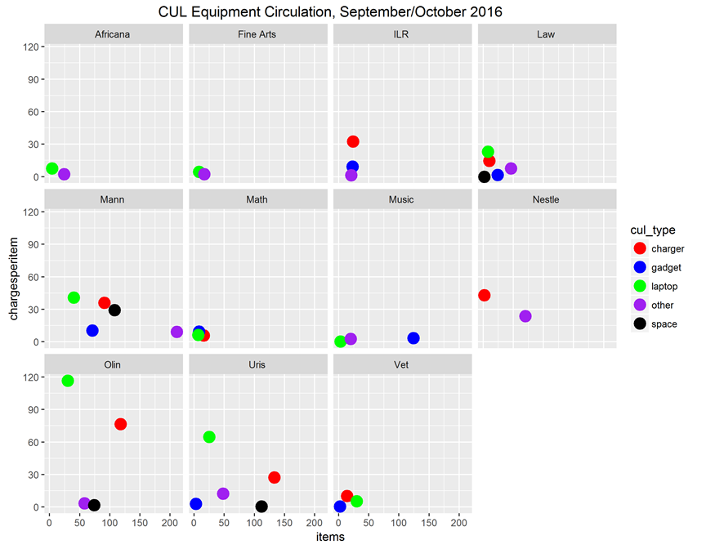

1. We would also like to acknowledge the contributions of Tobi Hines and Wendy Wilcox, for sharing their insights about Access Services workflows.
2. Tancheva, Kornelia, Gabriela Castro Gessner, Neely Tang, Erin Eldermire, Heather Furnas, Darcy Branchini, Gail Steinhart, and Nancy Fried Foster. 2016. “A Day in the Life of a (Serious) Researcher.” Ithaka S+R. <http://www.sr.ithaka.org/publications/a-day-in-the-life-of-a-serious-researcher/>.