**DEEP LEARNING METHODS IN POPULATION GENOMICS AND PHYLOGEOGRAPHY**

Welcome to the course Deep Learning methods for population genetics and phylogeography. Before we start, please follow the next steps to have everything ready for our practice on using Convolutional Neural Networks for demographic model selection.

1. Download the contents of the SharedFolder **to your computer**.
2. Upload the contents of the downloaded SharedFolder folder **to your Google Drive,** to make it editable (the original shared folder is read only).
3. Find the file **simulate_Esegueriana.ipynb**, located inside the folder scripts/Day1.
4. Right click on the file and select **Open with -> Connect more apps**.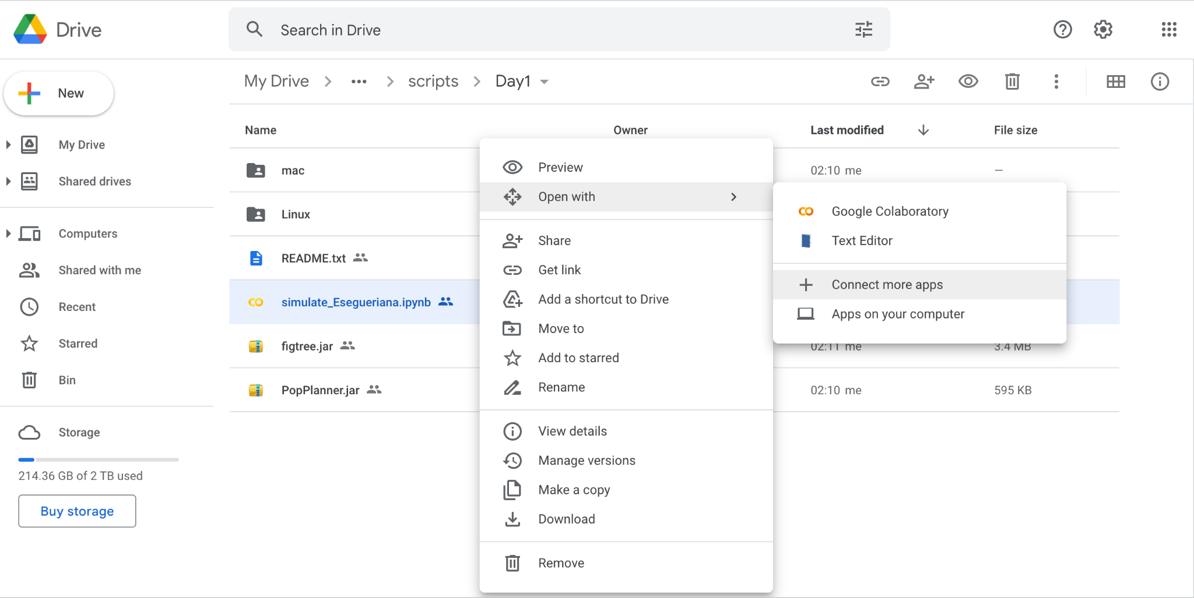
5. Search for the app **Colaboratory** and install it.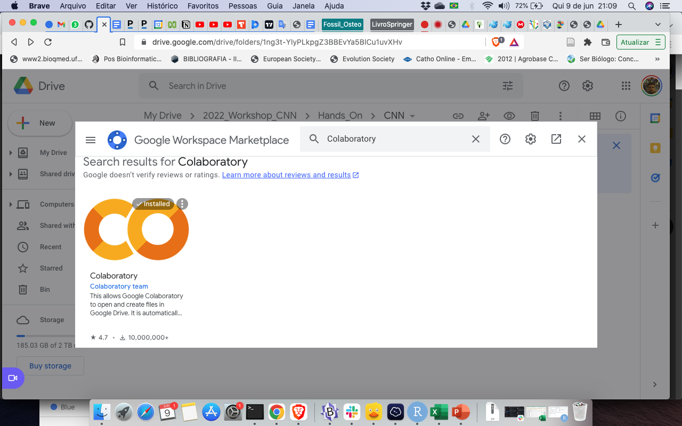
6. Now open the file **simulate_Esegueriana.ipynb** with the Colaboratory. You should see text and code in a nice graphical interface, similar to in the image below:

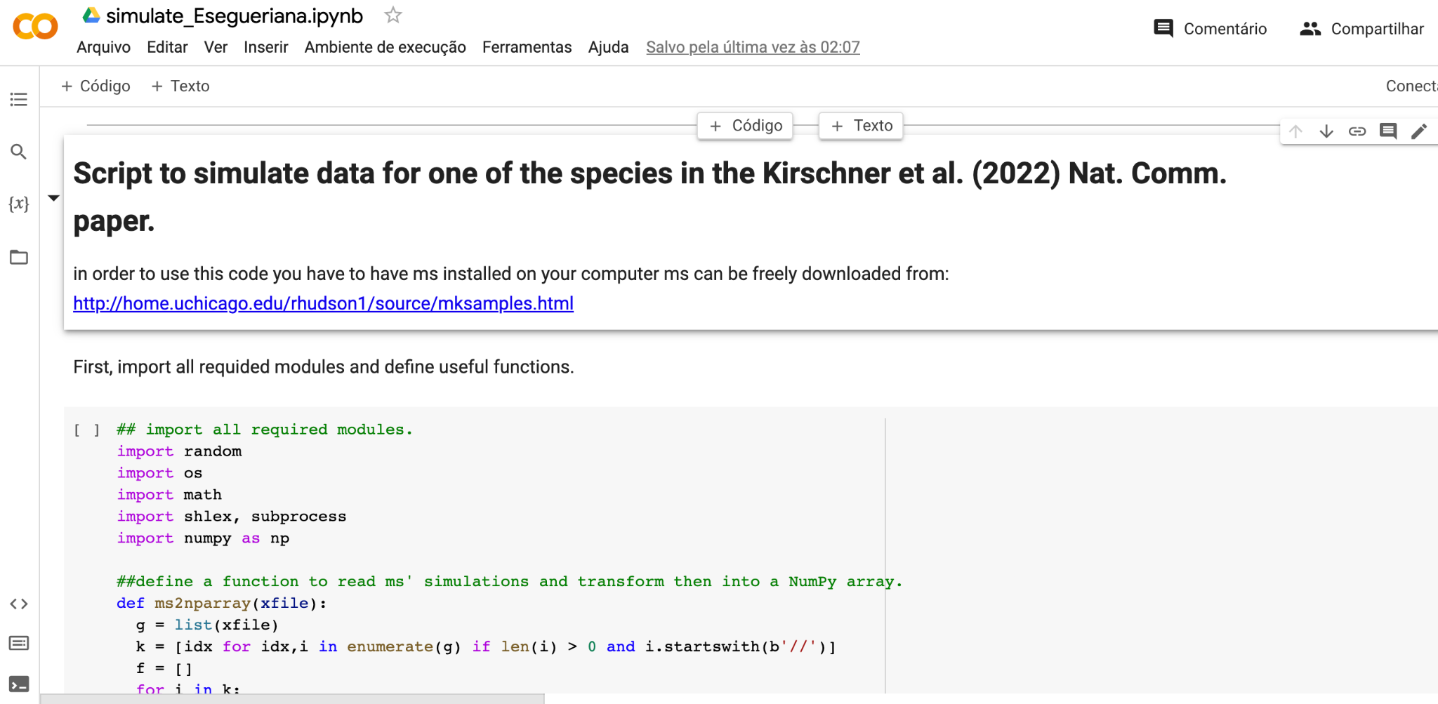

1. Now you are good to go!

Please do not hesitate to contact me at [manolofperez@gmail.com](mailto:manolofperez@gmail.com) if you have any questions.

All the Best,

Manolo and Matteo