Software Design
Specification

Takami
Revision 1.0

Table of Contents
Table of Contents ii
Revision History iii
Approved By iii
1. Introduction 1
1.1 Purpose 1
1.2 System Overview 1
2. Design Considerations 1
2.1 Constraints 2
2.2 System Environment 2
3. Architecture 2
4. Database Schema 3
4.1 Tables, Fields and Relationships 3
4.1.1 Databases 3
4.1.2 New Tables 3
4.1.3 New Fields(s) 3
4.1.4 Fields Change(s) 3
4.1.5 All Other Changes 3
4.2 Data Migration 4
5. High Level Design 4
6. Low Level Design 4
7. User Interface Design 4
Wireframes
Appendix A: Project Timeline 5

Revision History
Version | Name | Reason For Changes | Date
1.0 | Moni | Writing the design document | 09/10/2020
2.0 | Moni | Filling the database part and adding user stories | 06/11/2020

Approved By
Approvals should be obtained for project manager, and all developers working on the project.

Name | Signature | Department | Date

Introduction

Purpose
The design will show the implementation of requirements, which are in Software Requirements Specification.

System Overview
The project is website, which provides functionalities to both staff and clients of fishing gear shop. Customers will be able to buy products. The staff will be able to modify, delete, add product and also to vie orders of a customer.

Design Considerations

Constraints
I can’t come up with any constraint.

System Environment
The restful services of the app will be developed in the Java’s framework Spring boot. For the database I will use MySQL. For the frontend I will use ReactJS.

Risks and Volatile Areas
I haven’t identified any risks yet.

Architecture

The C4 diagrams are in this folder and they explain about the architecture of the project.

Database Schema

Tables, Fields and Relationships

Databases

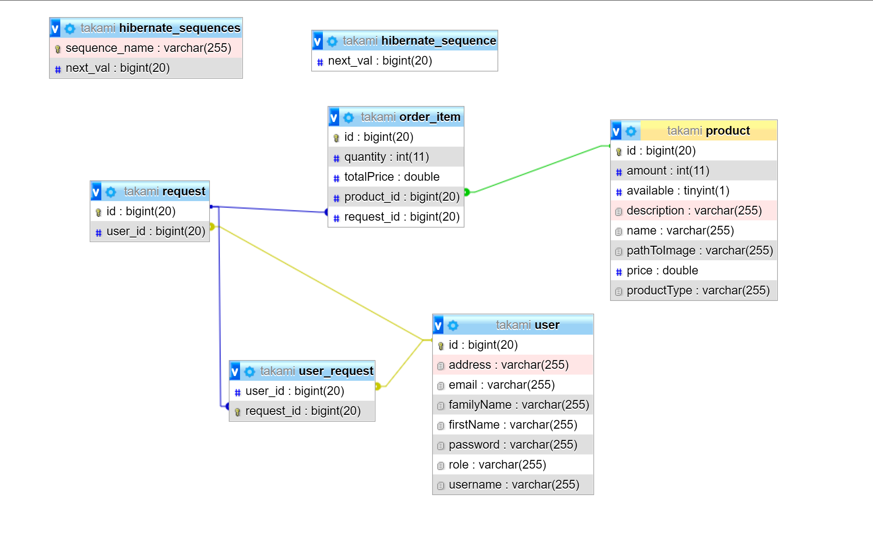

These are my databases. If the user is not an admin, he can make requests. The requests are made with order item object which contains a product and its quantity.

New Tables

New Fields(s)

Fields Change(s)

All Other Changes

Data Migration
I have used the “create-drop” strategy, which is means that every time the application starts the database schema is deleted and set up again automatically.

High Level Design

Low Level Design
Front end:
For the front end I have chosen one of the most popular Javascript’s frameworks ReactJS. Of course as all of them it has his pros and cons. I have chosen it because it is easy to learn, because of the big community it has. This framework is fast and flexible.

Back end:
For the back end I have chosen the Java’s frameworks Spring, because it is really famous and they are a lot of tutorials in internet. This framework has minimum configuration and easy to deployment.

Database:
I have chosen to implement my database in MySQL because I have one provided from Fontys.

User Interface Design

The wireframes are in this folder.

User stories
As a customer I want database with security so I can give my credentials securely.
As a customer I want to see the products separated by their type so I can find the product I want to buy easily.
As a customer I want to have shopping cart so I can store the products I want to buy there.
As a customer I want to see all the products so I can buy them.

As a manager I want a database with security so I can login secure.
As a manager I want a database with all products so I wan see all the products in the website.
As a manager I want database with all the products in there so I can delete existing product.
As a manager I want a database with all the products so I can update existing product.
As a manager I want a database with all products so I can add new product.

Functional requirements

User should see as detailed as possible information about a product.
User should be able to add product in his cart.

Manager should be able to add new product.
Manager should be able to delete existing product.
Manager should be able to modify existing product.

Non- functional requirements
The front end should interact with backend as fast as possible.
The code should be finished but it should be opened for improvements, which can be done in the future.
The app will have 3 types of testing: System testing, Integration testing and Unit testing
Everything in the app will be described in its documentation.
The app should be as secure as possible.

Architecture

System context diagram

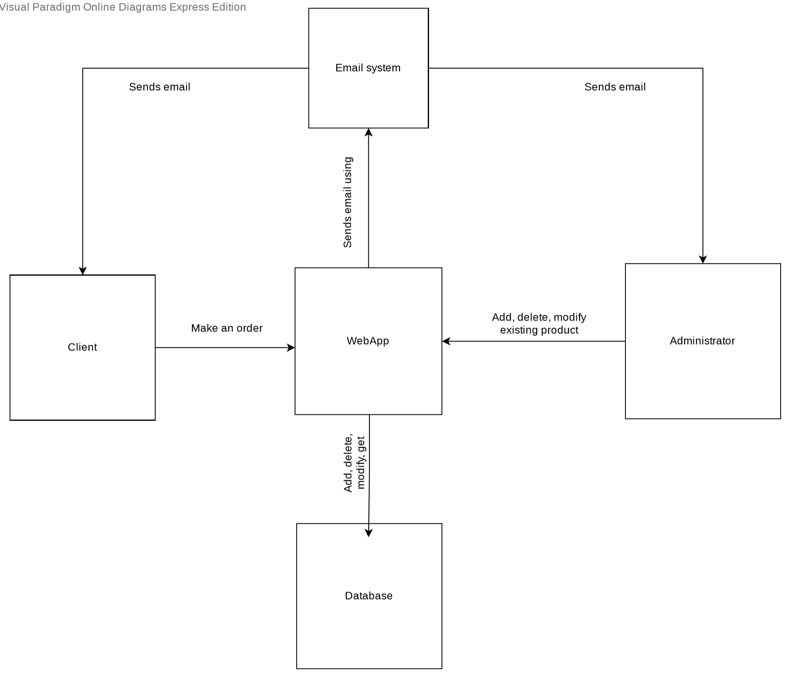

Container diagram
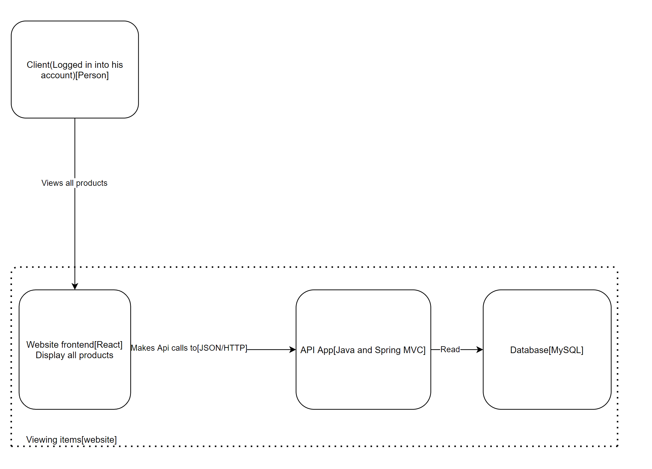

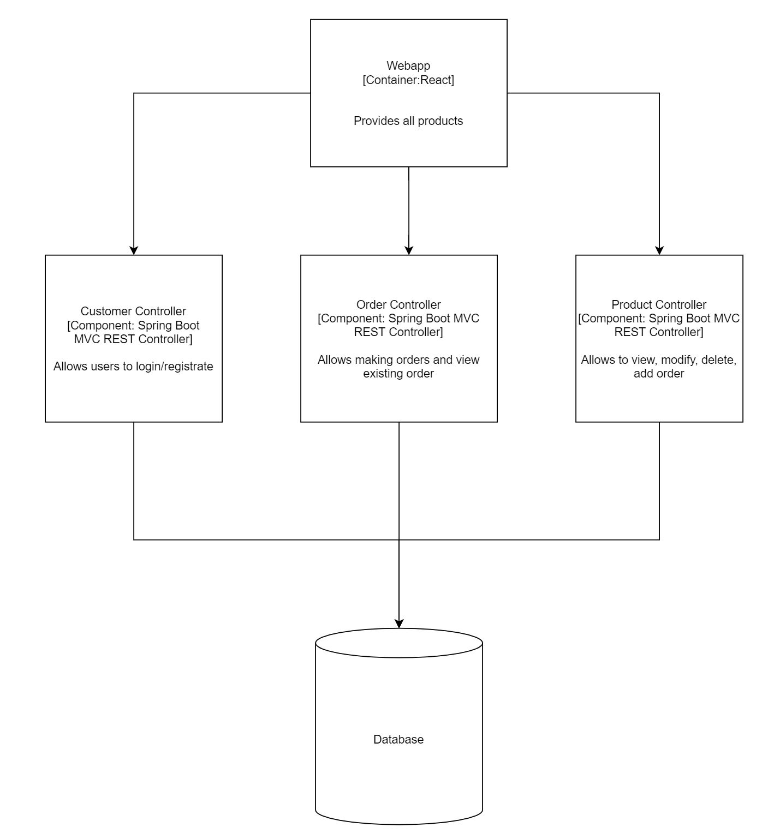

Component diagram

UML Class diagram

