

# 02 May, 2018

# test assignment 4 2

### General condition as of 02 May, 2018

# General Details:

**Survey Report No. :** DLS-18

**Requested by :** asdfa

**Account of :** fasdf

**Location of Survey :** sdadas

**Owner :** fasdf

**Operator :** fas

**Type of Vessel :** Jackup/Liftboat

# General Description:

sadasdasdasdasd

# Vessel Drafts:

**Port Bow :** 1212'1212"

**Port Stern :** 1212'1212"

**Starboard Bow :** 1212'1212"

**Starboard Stern :** 1212'2323"

# Vessel Particulars:

**Built :** ,

**Official Number :**

**IMO Number :**

**Previous Name :**

**Flag :**

**Dimensions :** ' X ' X '

**Length Overall :** '

**GRT/NRT :** /

**GRT/NRT :** /

**Classed As :**

**Cargo Deck :** ' X ' with clear deck size of ' X '

**Deck Cargo Rating :**  Long Tons

**Engines:**

**Total Horsepower :**  @ - RPM

**Drive :**

# General Outfitting:

## Fendering:

* **Fixed Hull Fendering:** 12 courses of 1212" X 1212" Split Pipe, located Stern transom
* **Rubber Fendering:** 121212 courses of 121212" Double sasddasdasdasd, located Port and Starboard
* **Tire Fendering:** 1212 courses of Large Wire Rope Hung with appropriate hardware located Port and Starboard

**Additional Commentary:** sadasdasdasd

**The following condition grading scale applies all condition assessments:**

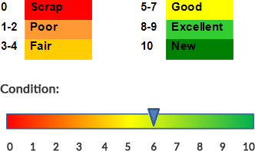

**Condition Description:** sadasdasdasd

**Fendering Gallery:**

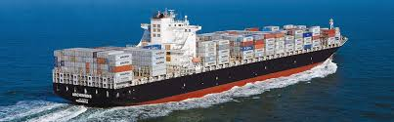

## Bulwarks:

* **Cargo Deck:** 1212" high, Type: Open, Material: Aluminum, Cap: Pipe, Cap Dimensions: 2" - 12", Stiffeners: Bulbed plate

**Additional Commentary:** Nonesasds

**The following condition grading scale applies all condition assessments:**



**Condition Description:** None

**Bulwarks Gallery:**



## Cargo Rails:

* **Cargo Deck:** 1212” high, Material: Aluminum, Construction: Square Tubing, Cap: Pipe, Cap Dimensions: 2" - 12", Stiffeners: I-beam

**Additional Commentary:** None

**The following condition grading scale applies all condition assessments:**



**Condition Description:** None

**Cargo Rails Gallery:**



## Deck Fittings:

**Additional Commentary:**

**The following condition grading scale applies all condition assessments:**

**Condition Description:**

**Deck Fittings Gallery:**



## Ground Tackle:

**Additional Commentary:** None

**The following condition grading scale applies all condition assessments:**



**Condition Description:** None

**Ground Tackle Gallery:**



# Hull Compartmentation:

**Hull Compartmentation Details:**

* **sadasdasdasd**
* sadsadasdasd

### Tank Type

* **Liquid Mud Tanks:** Filling Lines:dsfsdfsdfs, Vents: sdfsdfsdfs

### Tank Capacities

* **Capacities**
* Ballast Water: 1212 Units1

**Additional Commentary:** None