EKalusugan User Manual
  - Summarized visual guide
Use this guide to sign in, recover access, and work with the dental queue. Red numbers match the controls described below each figure. The figures show sample records.

Log in
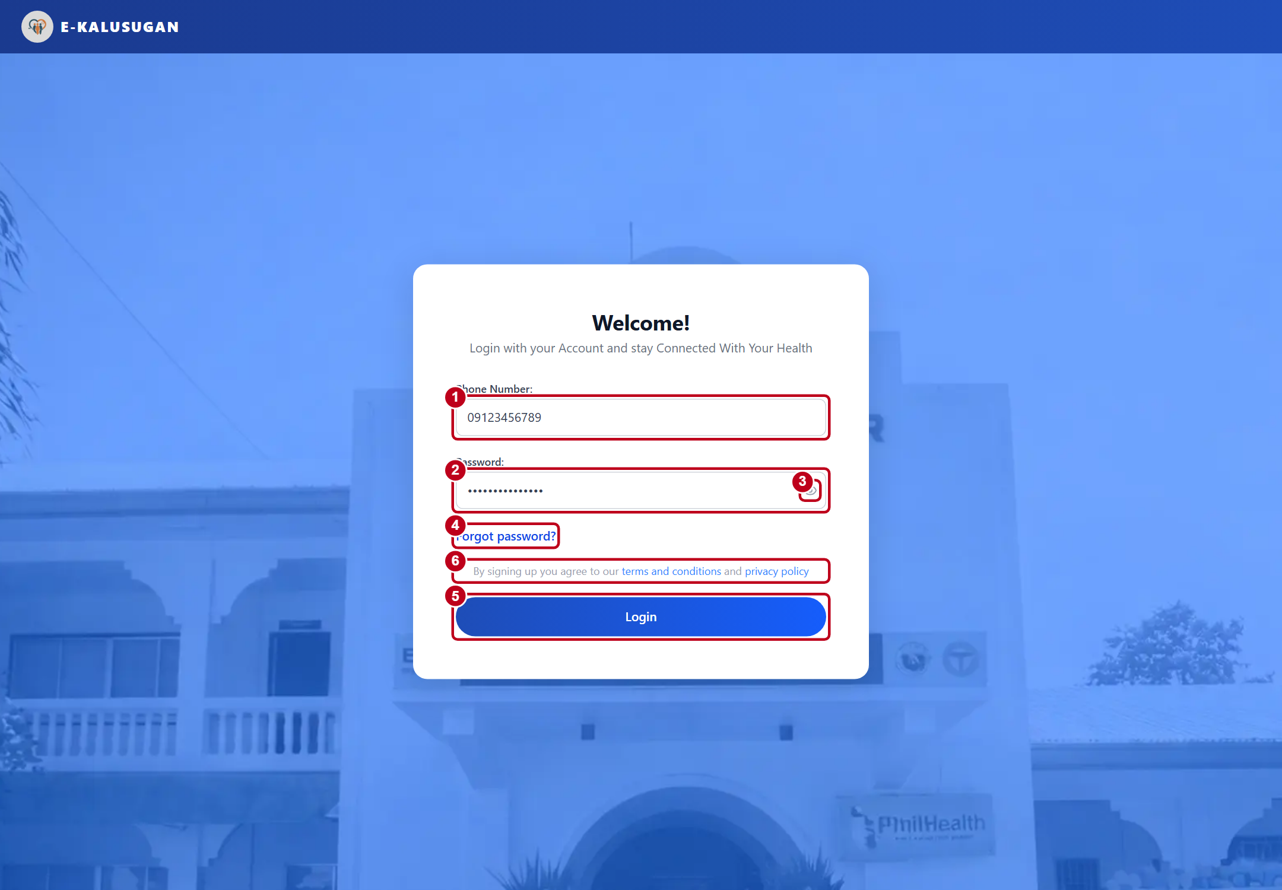
Figure 1. EKalusugan sign-in screen
1 Open the clinic website, choose Patient Portal, and enter your registered Phone Number. Use the account issued by the clinic.
2–3 Enter your Password. Use the eye icon if you need to check what you typed.
4 Select Forgot password? to recover a patient account. For a new account, ask clinic reception.
5 Select Login. The system opens the dashboard for your role.
6 Use the terms and conditions and privacy policy links to read the clinic’s policies.
When you finish, open your name or profile menu and select Log Out. Keep your password private.
ACCOUNT ACCESS

Change your password
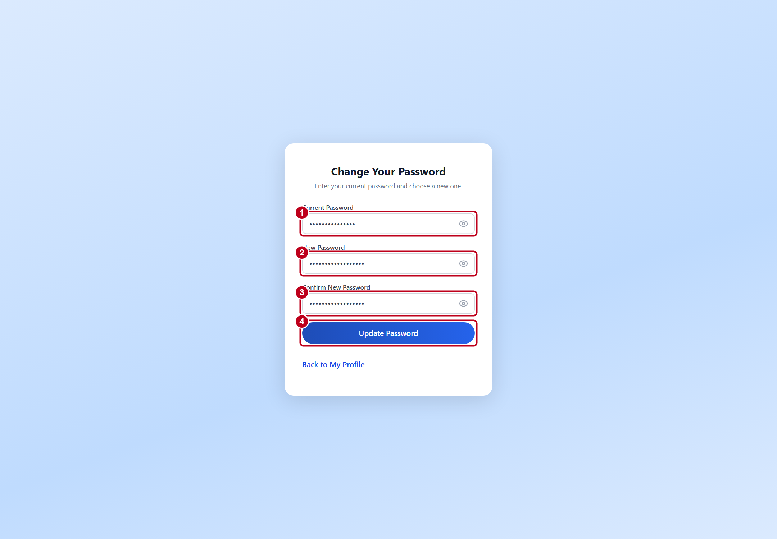
Figure 2. Password change screen
1 For a normal password change, open My Profile and select Change password. Enter your Current Password.
2 Enter a New Password with at least eight characters and one number.
3 Enter it again in Confirm New Password.
4 Select Update Password. After signing in with a temporary password, the setup screen asks for the new password and its confirmation.
ACCOUNT RECOVERY

Request a recovery code
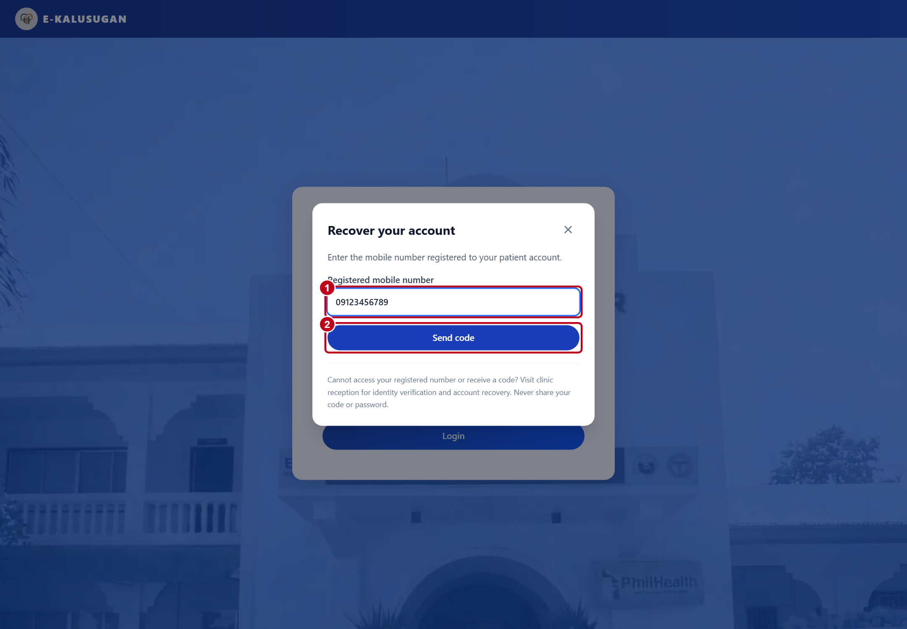
Figure 3. Patient recovery on the sign-in screen
1 On the sign-in screen, select Forgot password? and enter the mobile number registered to your patient account.
2 Select Send code. The system sends a four-digit code by SMS.
Visit clinic reception if you cannot access the registered number or receive a code. Doctors, staff, and administrators should contact the system administrator for login assistance.
ACCOUNT RECOVERY

Verify the SMS code
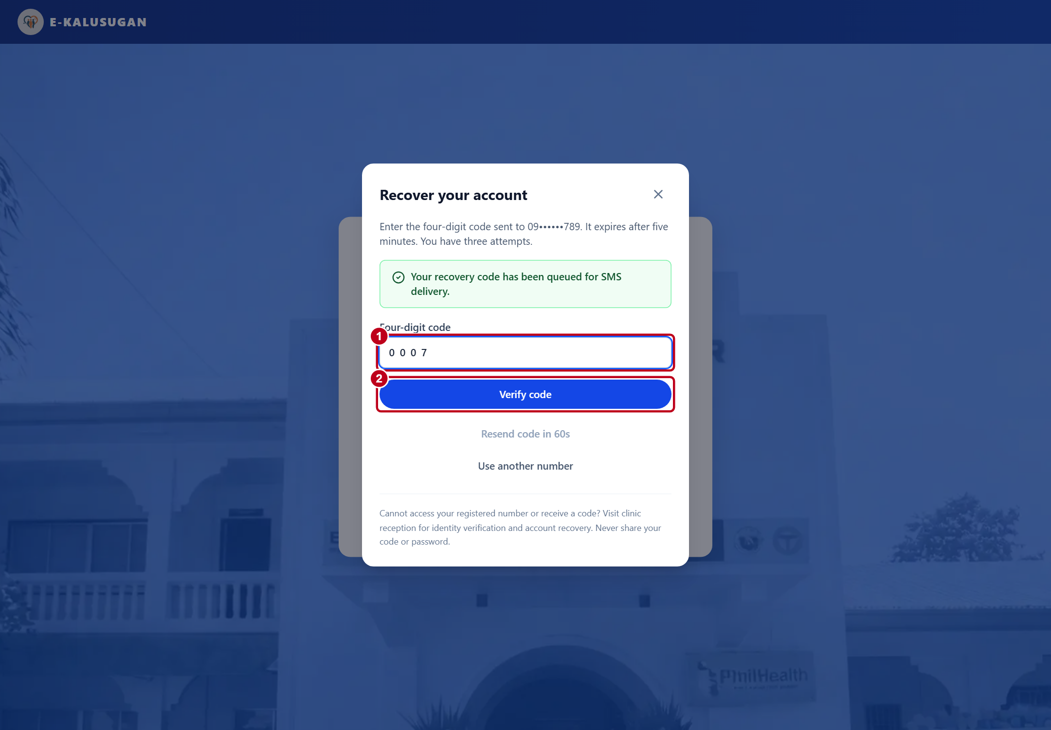
Figure 4. SMS code entry
1 Enter the four-digit code, including any leading zero. The code expires after five minutes and allows up to three incorrect attempts.
2 Select Verify code. Set and confirm a new password within five minutes of verification. Select Save new password, then return to Login.
If you need another code, select Resend code after 60 seconds and use the newest code. Keep recovery codes private.
ACCOUNT RECOVERY

Verify identity at reception
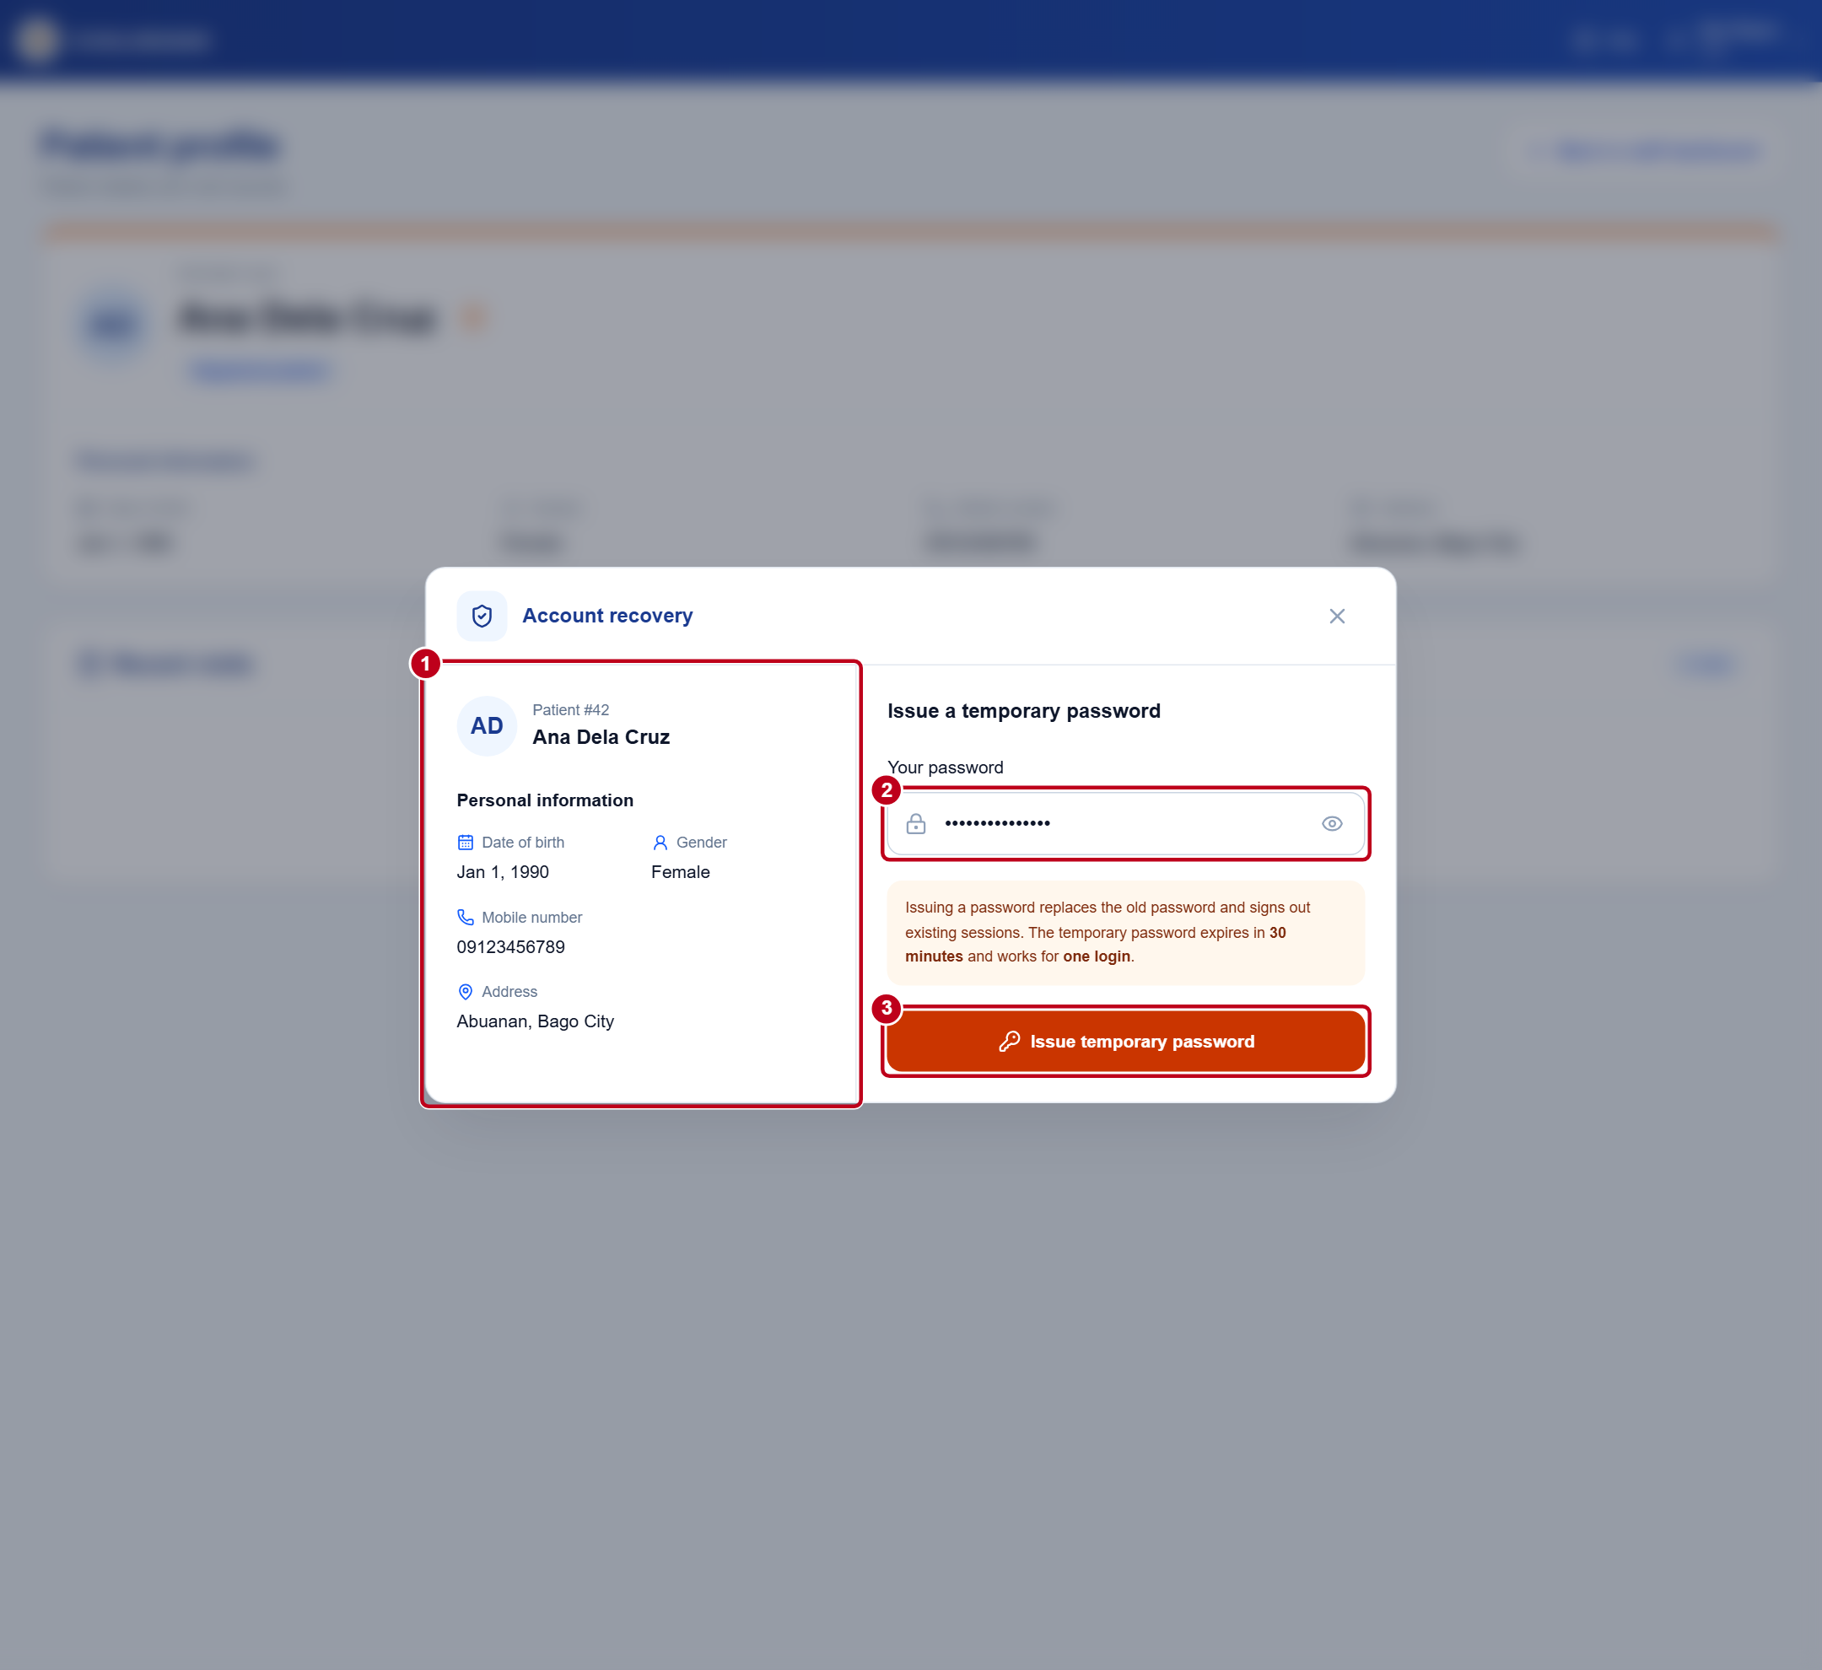
Figure 5. Staff recovery dialog on the patient profile
1 Staff opens Account recovery, searches for the patient, and opens the matching profile. Admin opens Management → Accounts → Patients and selects Account recovery for the patient. Open Start account recovery and verify the patient in person using the displayed identity and contact details.
2 Confirm the registered phone number. If the account is active and eligible and the details match, enter your own staff or admin password.
3 Select Issue temporary password. Give the displayed password directly to the patient, then close the dialog with ×. Issuing it replaces the old password and signs out existing sessions.
The temporary password works for one login within 30 minutes. The patient must set a new password within 15 minutes after signing in.
PATIENT

Find your way around Home
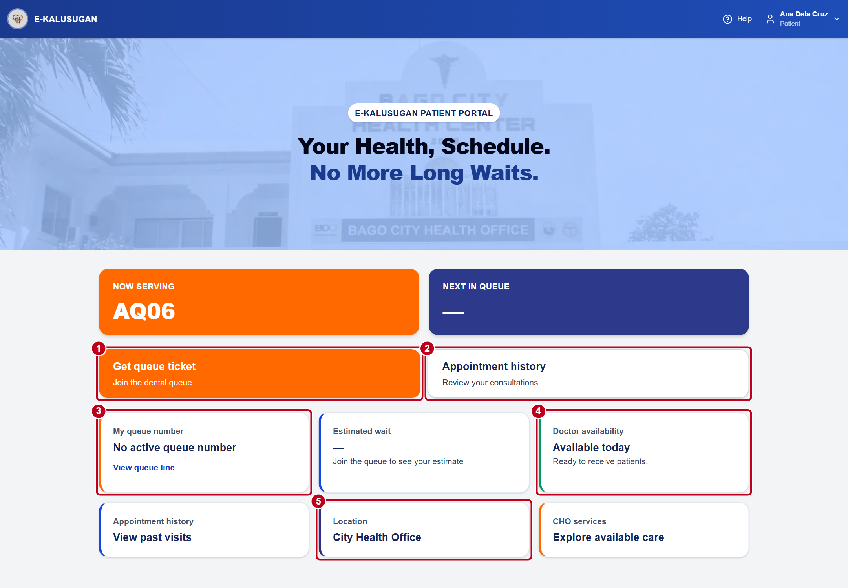
Figure 6. Patient Home and its main actions
1 Select Get queue ticket to request a ticket for today’s dental queue.
2 Use Appointment history to review past visits.
3 Use My queue number or View queue line to check the dental queue.
4 Check Doctor availability before you request a ticket.
5 Select Location, then Open in Google Maps, for directions to the clinic.
PATIENT

Get a dental queue ticket
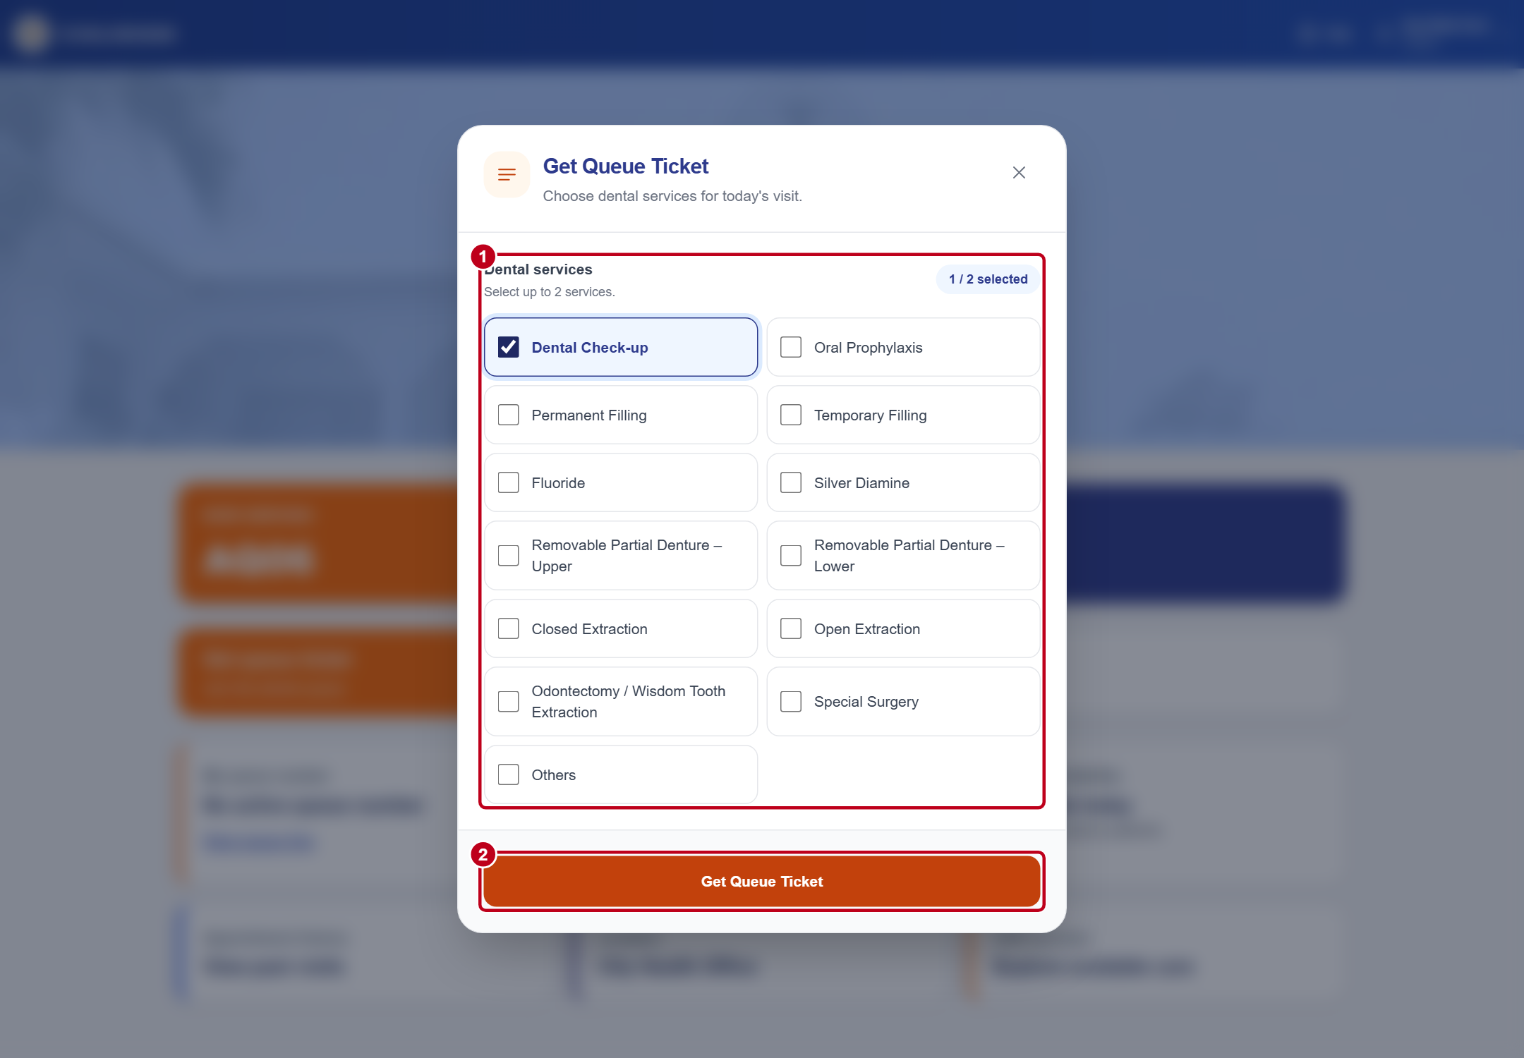
Figure 7. Service selection on Patient Home
1 Select one or two dental services in the Get Queue Ticket window.
2 Select Get Queue Ticket to submit. Check the assigned ticket number, services, and status.
You can hold one active ticket and register up to twice per day, subject to availability. If registration is closed or full, read the on-screen message and ask reception for help. Use the portal for today’s dental queue.
PATIENT

Follow a waiting ticket
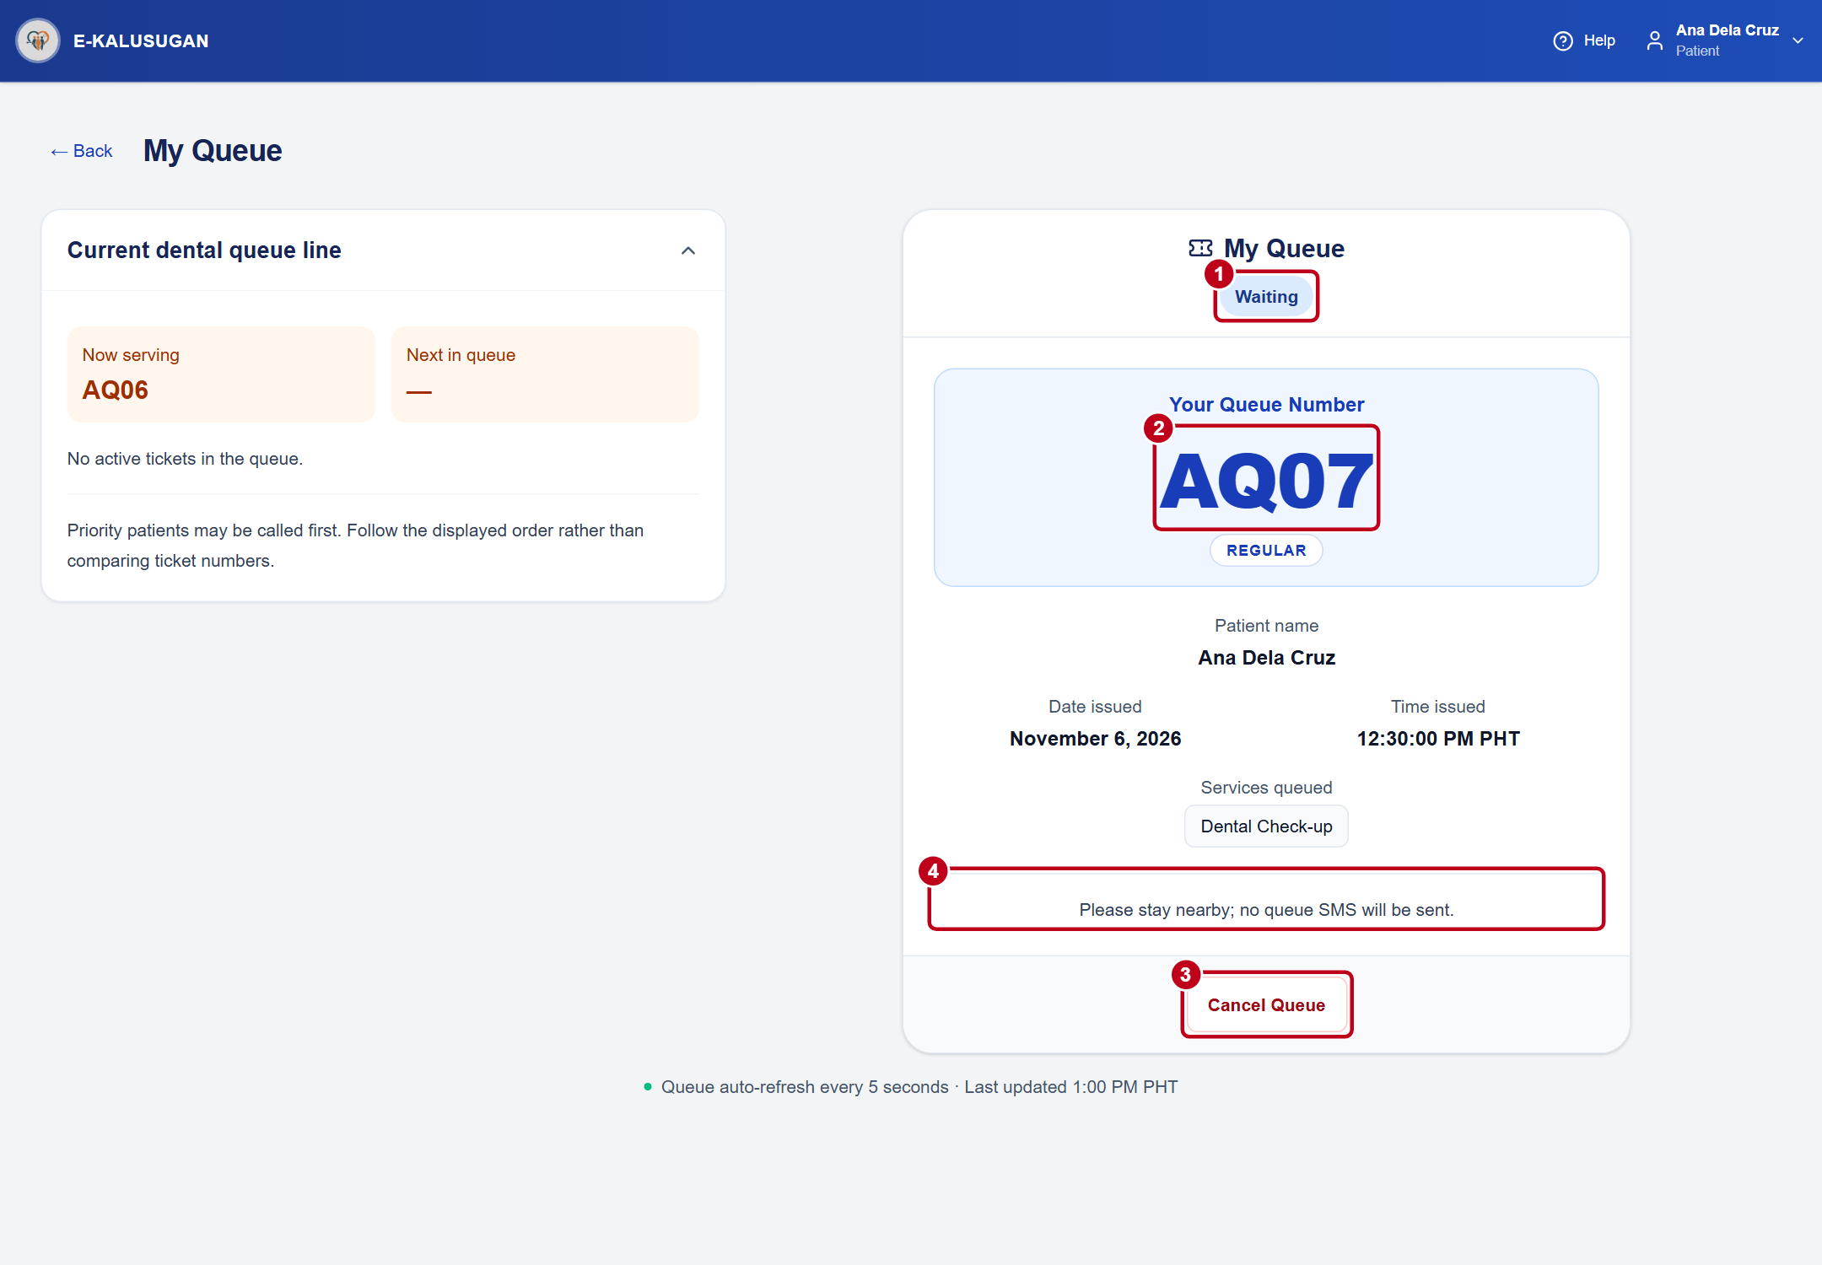
Figure 8. Waiting ticket AQ07 beside the current dental queue line
1 While Waiting, follow the queue on-screen. The order and estimated waiting time can change. Report immediately when the ticket says It’s your turn! Receiving care means staff has confirmed your arrival.
2 Keep your queue number ready when speaking with staff.
3 To cancel a waiting ticket, select Cancel Queue, choose a reason, and select Continue.
4 Read the SMS or stay-nearby instruction on the ticket. Follow the screen even if you expect a text message.
PATIENT

Respond to a missed call
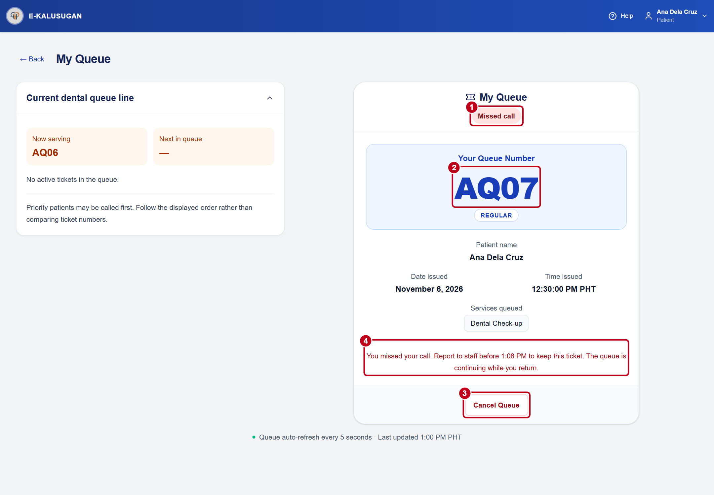
Figure 9. Missed call on ticket AQ07
1 If your status changes to Missed call, go directly to reception.
2 Give staff your ticket number. Staff must select Patient returned after confirming you are present.
3 Use Cancel Queue if you need to leave. For a called or serving ticket, speak to staff.
4 Return before the exact deadline shown on the ticket. The return window lasts 10 minutes.
DOCTOR

Call and receive a patient
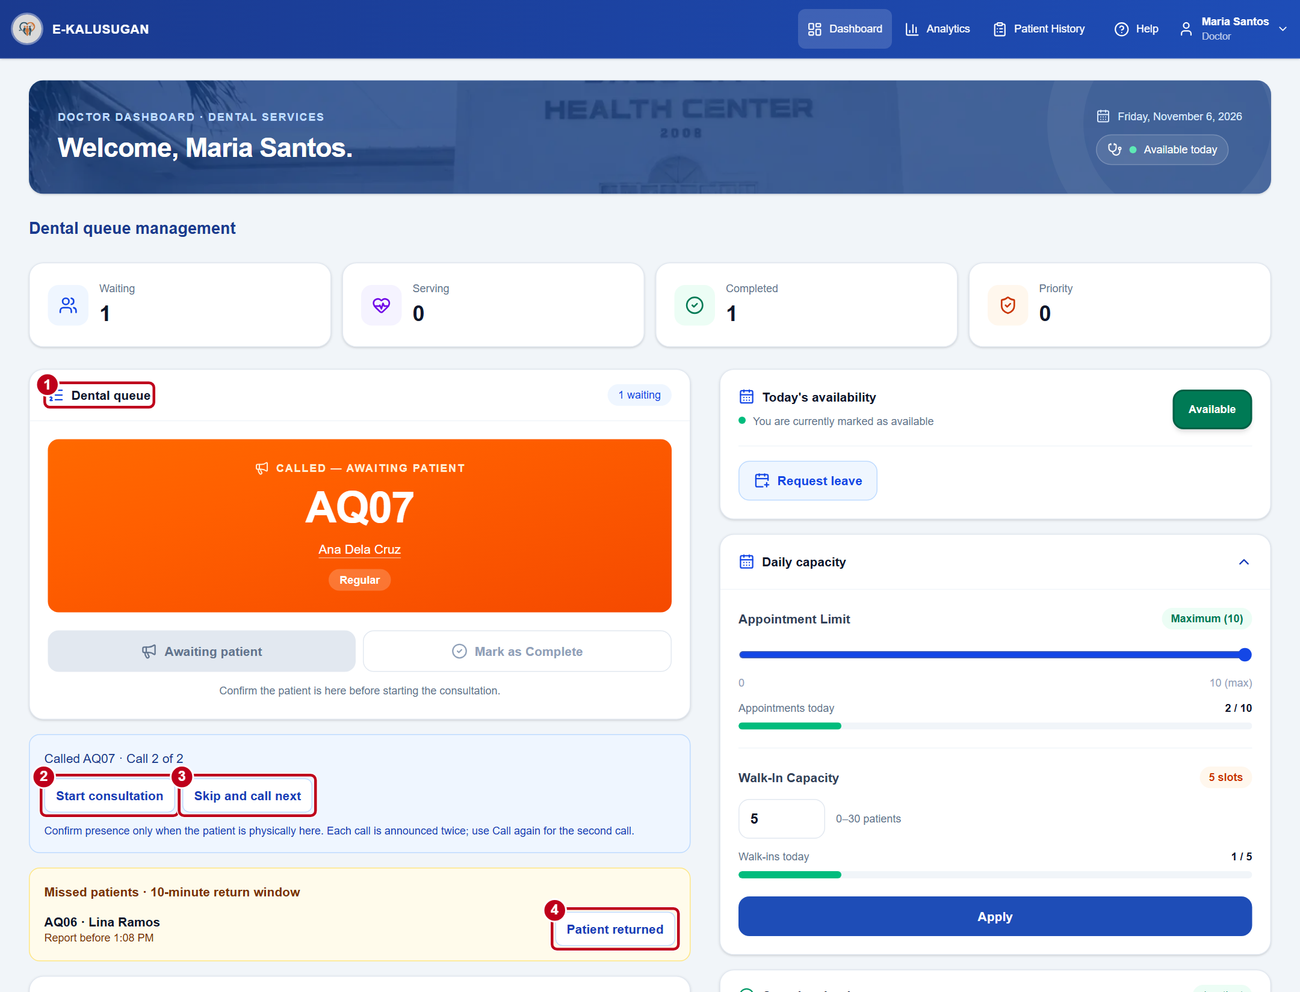
Figure 10. Doctor dashboard with a called ticket and return controls
1 Select Next when ready to call a waiting patient. Check the ticket number and patient name.
2 Select Start consultation when the patient is physically present. Select Consult to reopen notes for a serving visit.
3 If the patient is absent, wait 15 seconds before selecting Call again. Wait another 15 seconds after the second call before selecting Skip and call next.
4 Select Patient returned only when the patient arrives before the displayed deadline.
DOCTOR

Save consultation notes
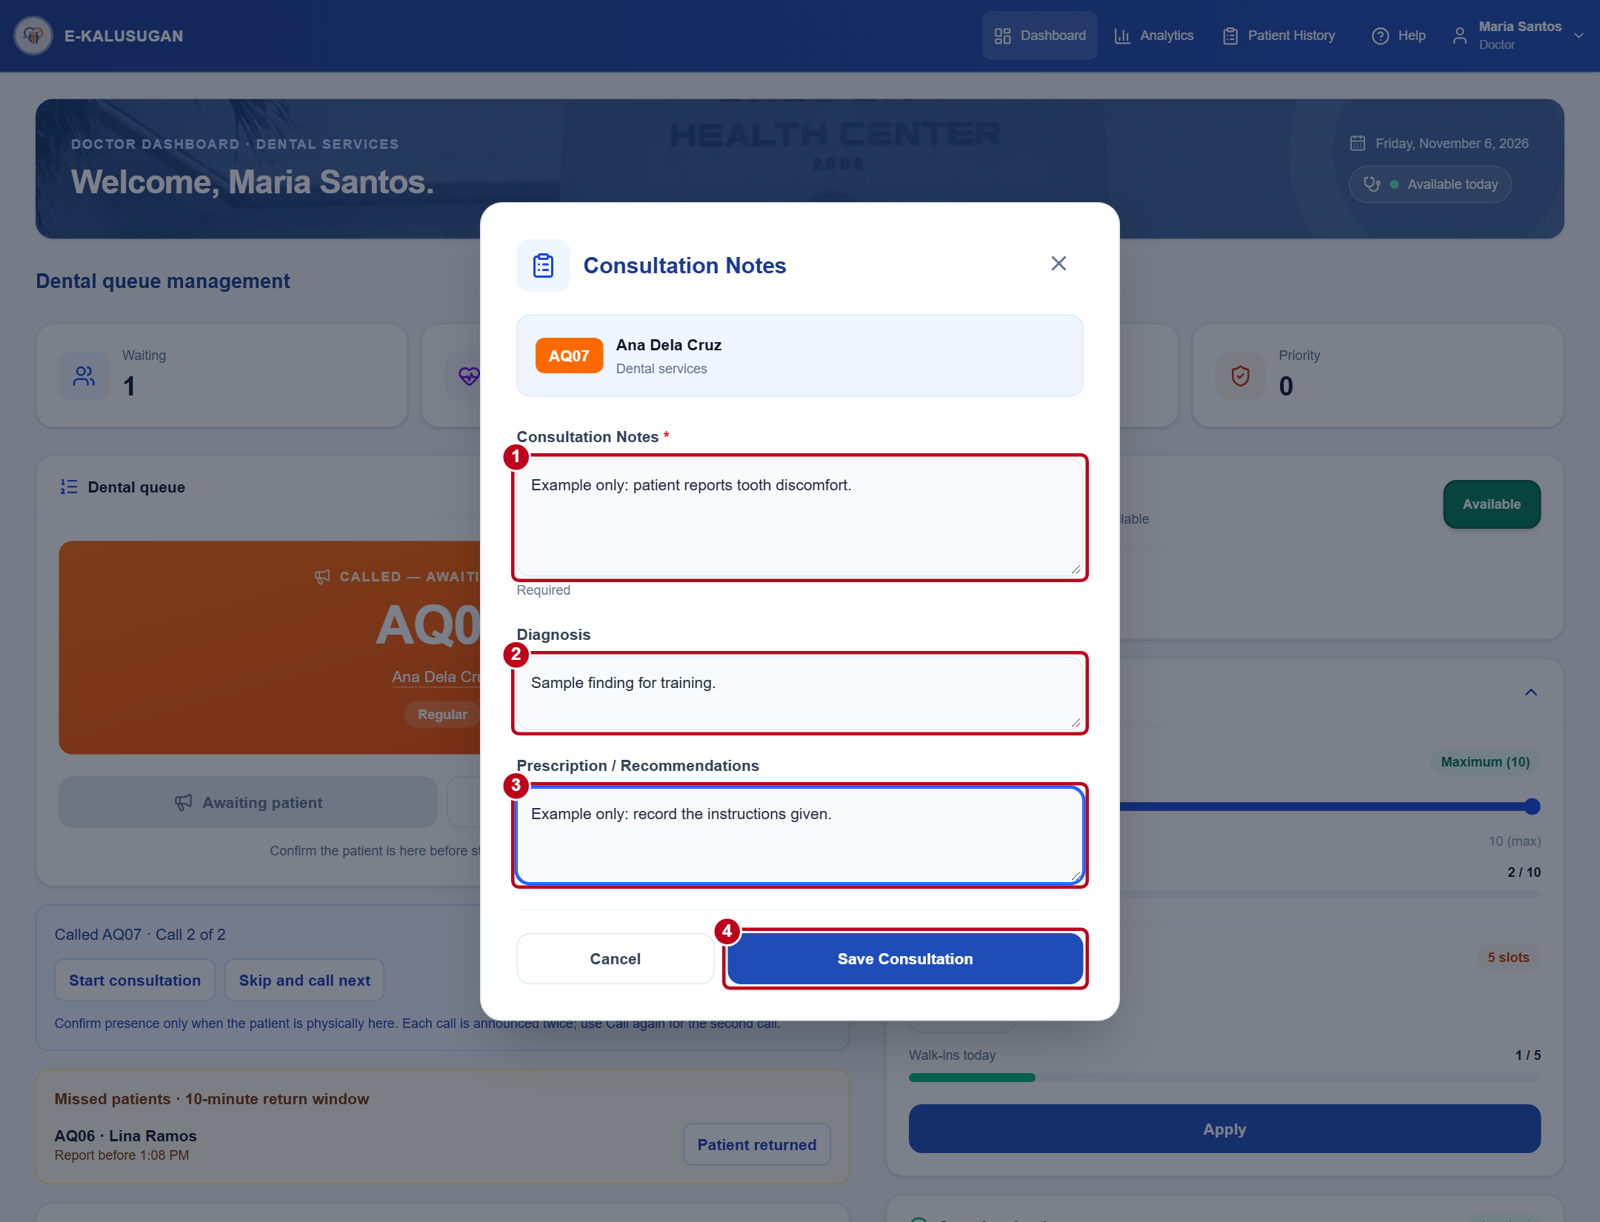
Figure 11. Consultation Notes dialog on the doctor dashboard
1 Confirm the patient and ticket number, then enter the required Consultation Notes.
2 Add the Diagnosis as appropriate.
3 Enter Prescription / Recommendations as appropriate.
4 Review the entries and select Save Consultation. A successful save stores the notes and completes the serving visit.
DOCTOR

Set daily availability and capacity
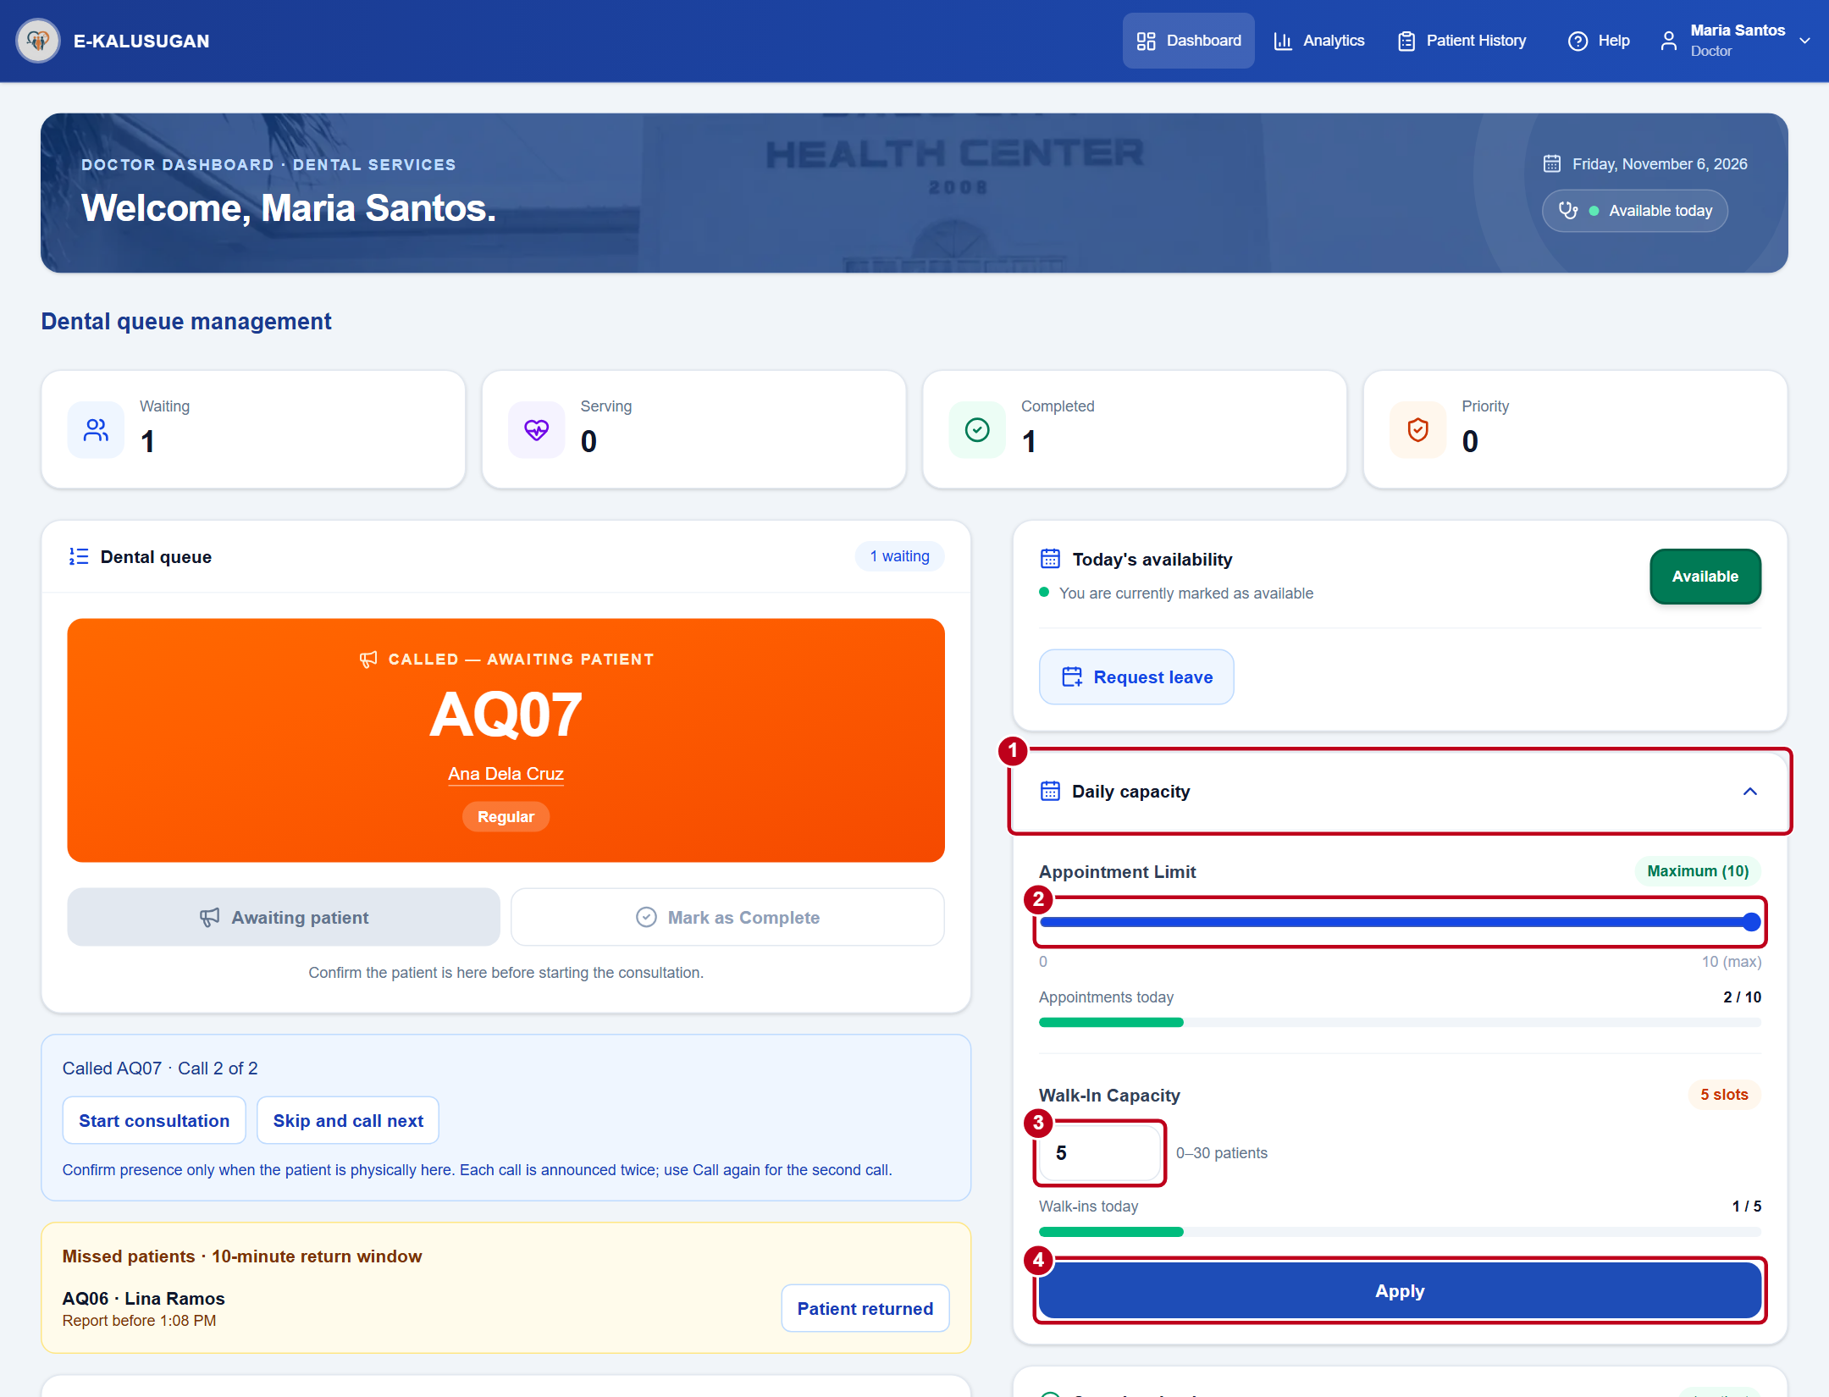
Figure 12. Daily capacity controls on the doctor dashboard
1 On Home, check Today’s availability and select the current status to switch between Available and Unavailable. Then expand Daily capacity.
2 Set Appointment Limit from 0 to 10.
3 Set Walk-In Capacity from 0 to 30. A value of 0 appears as Not set.
4 Select Apply and wait for Saved. Recheck the limits when starting a new day.
DOCTOR

Review and export reports
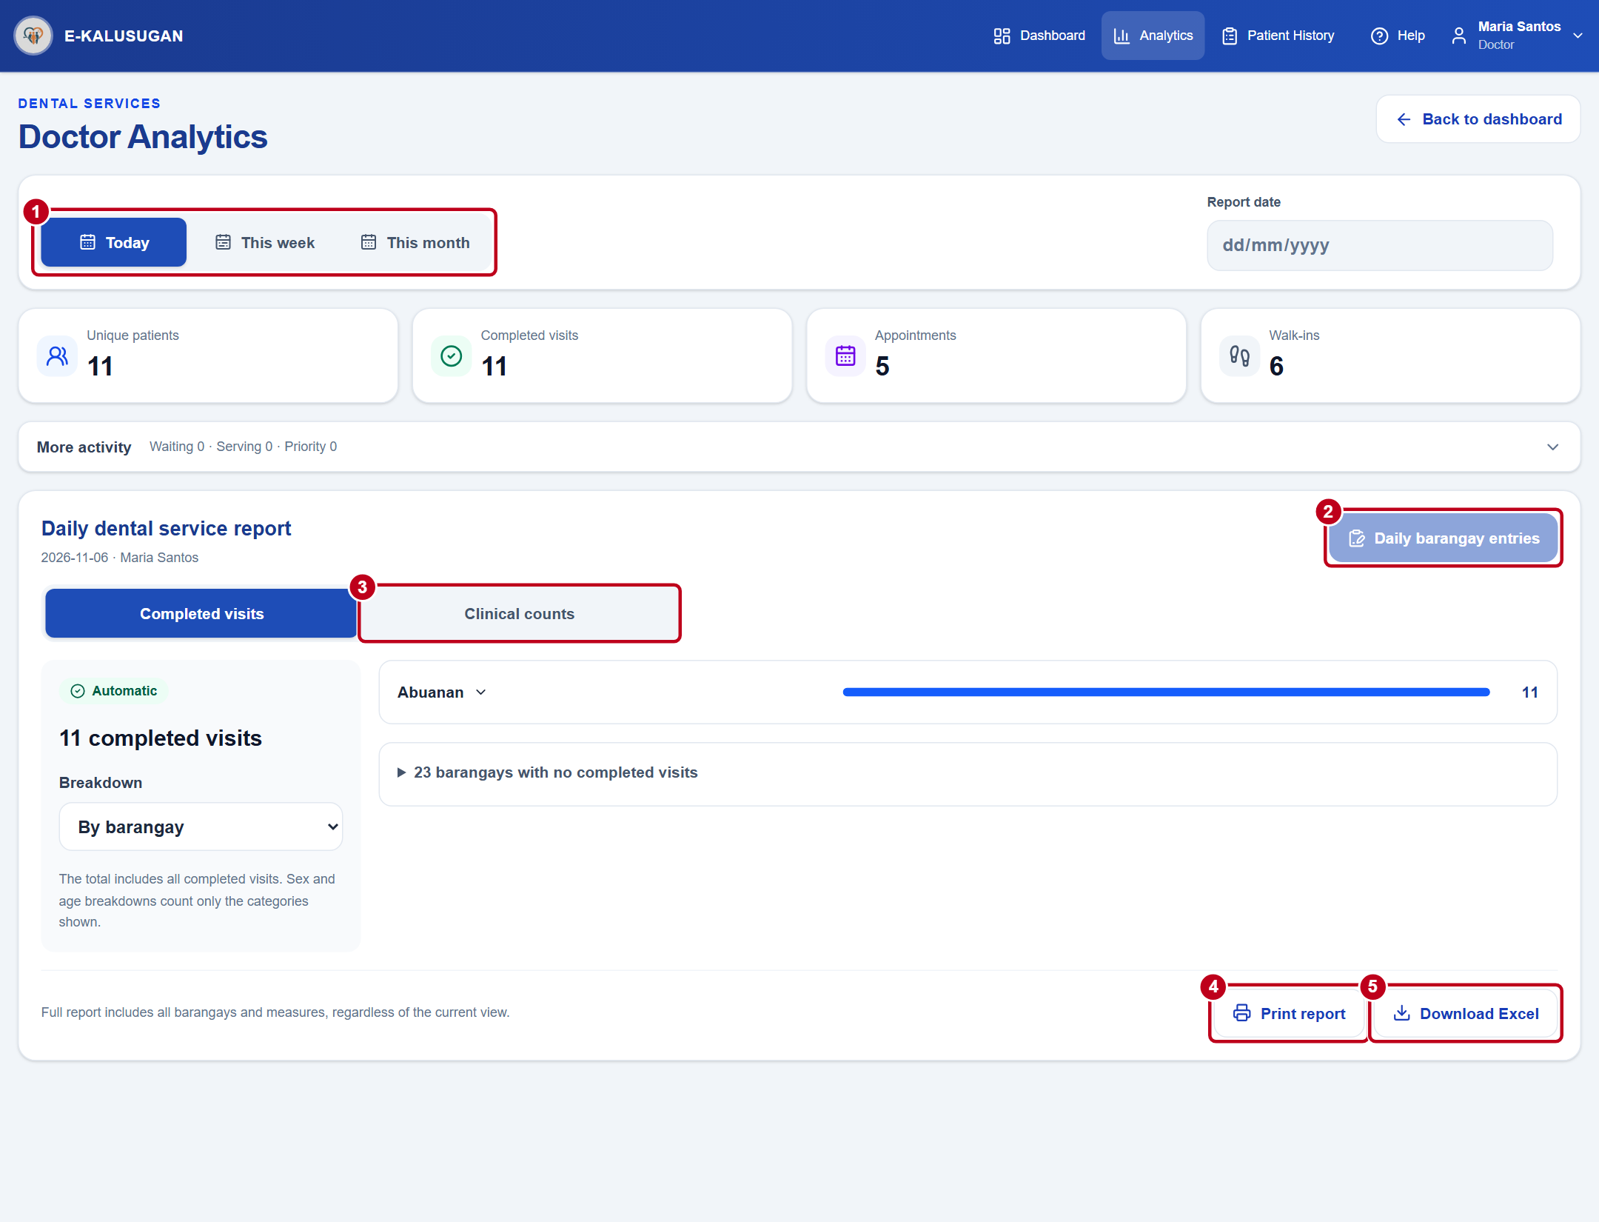
Figure 13. Report period, entries, and export controls in Analytics
1 Open Analytics. Choose Today, This week, or This month and the corresponding date.
2 Open Daily barangay entries. Choose Entry date, Barangay, and Clinical measure. Enter verified counts and select Save entries. Leave unknown counts blank. Enter 0 for a confirmed zero.
3 Return to Analytics and use Clinical counts to review saved clinical data. Completed visits are recorded separately.
4–5 After data loads and all changes are saved, choose Print report or Download Excel. Use Appointment History to review Today or All appointments.
STAFF

Find and verify a patient
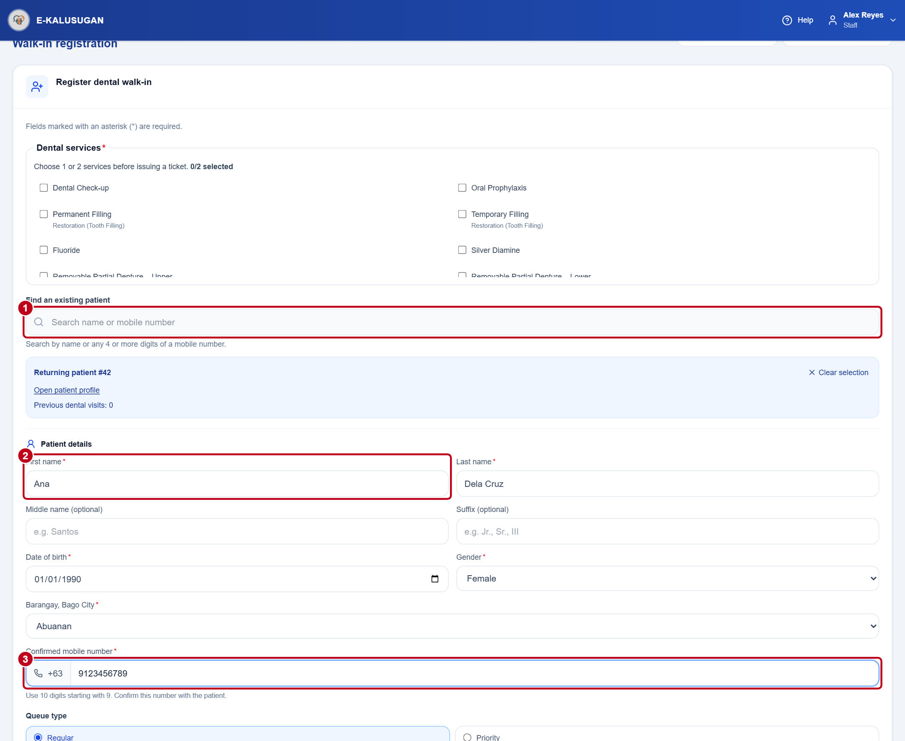
Figure 14. Patient search and confirmed mobile number in walk-in registration
1 In Register dental walk-in, search by name or at least four consecutive mobile digits. Check the matches and select the correct record before creating a new patient.
2 Confirm the patient’s full name, date of birth, gender, and barangay.
3 Confirm the mobile number. Beside +63, enter ten digits starting with 9. The figure uses 9123456789 as the example.
STAFF

Assign a walk-in ticket
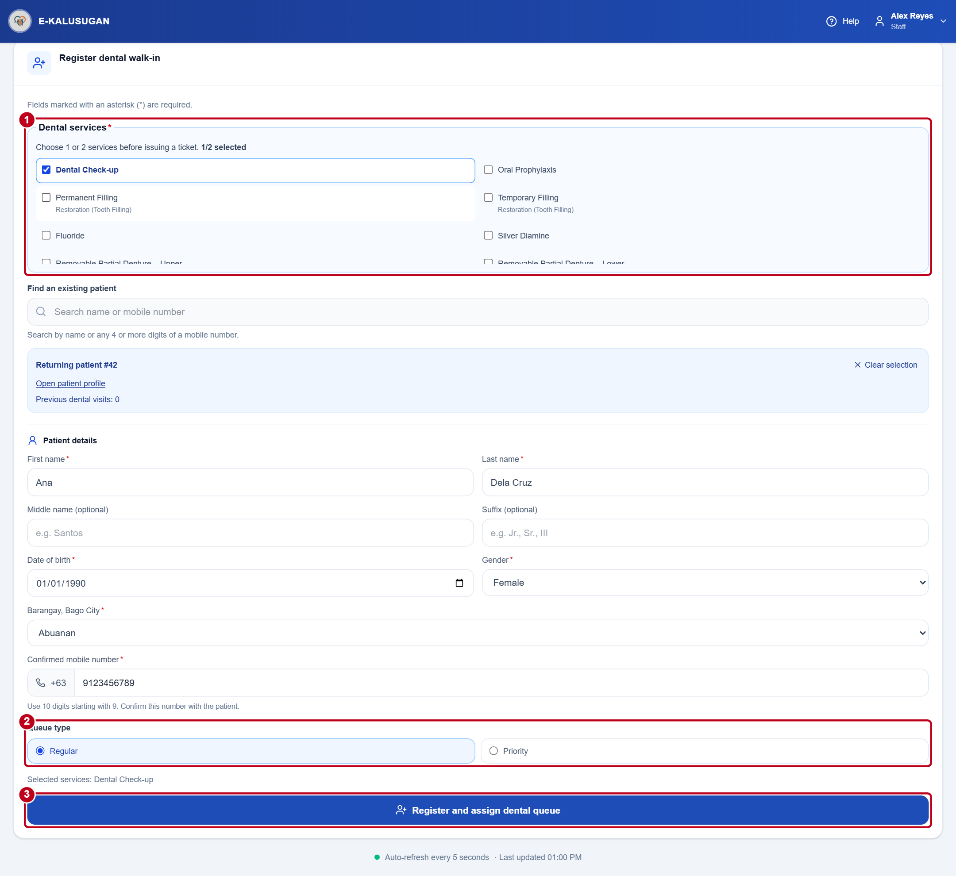
Figure 15. Services, queue type, and registration on the walk-in screen
1 Choose one or two Dental services and complete the required patient details.
2 Use Regular or select a verified Priority category. Senior Citizen priority is assigned from age 60. For other eligible patients, choose PWD or Pregnant.
3 Select Register and assign dental queue. Give the patient the ticket number and relay the exact SMS or stay-nearby instruction in the confirmation.
If the patient needs a portal login, ask an administrator to create the account separately.
STAFF

Manage the dental queue
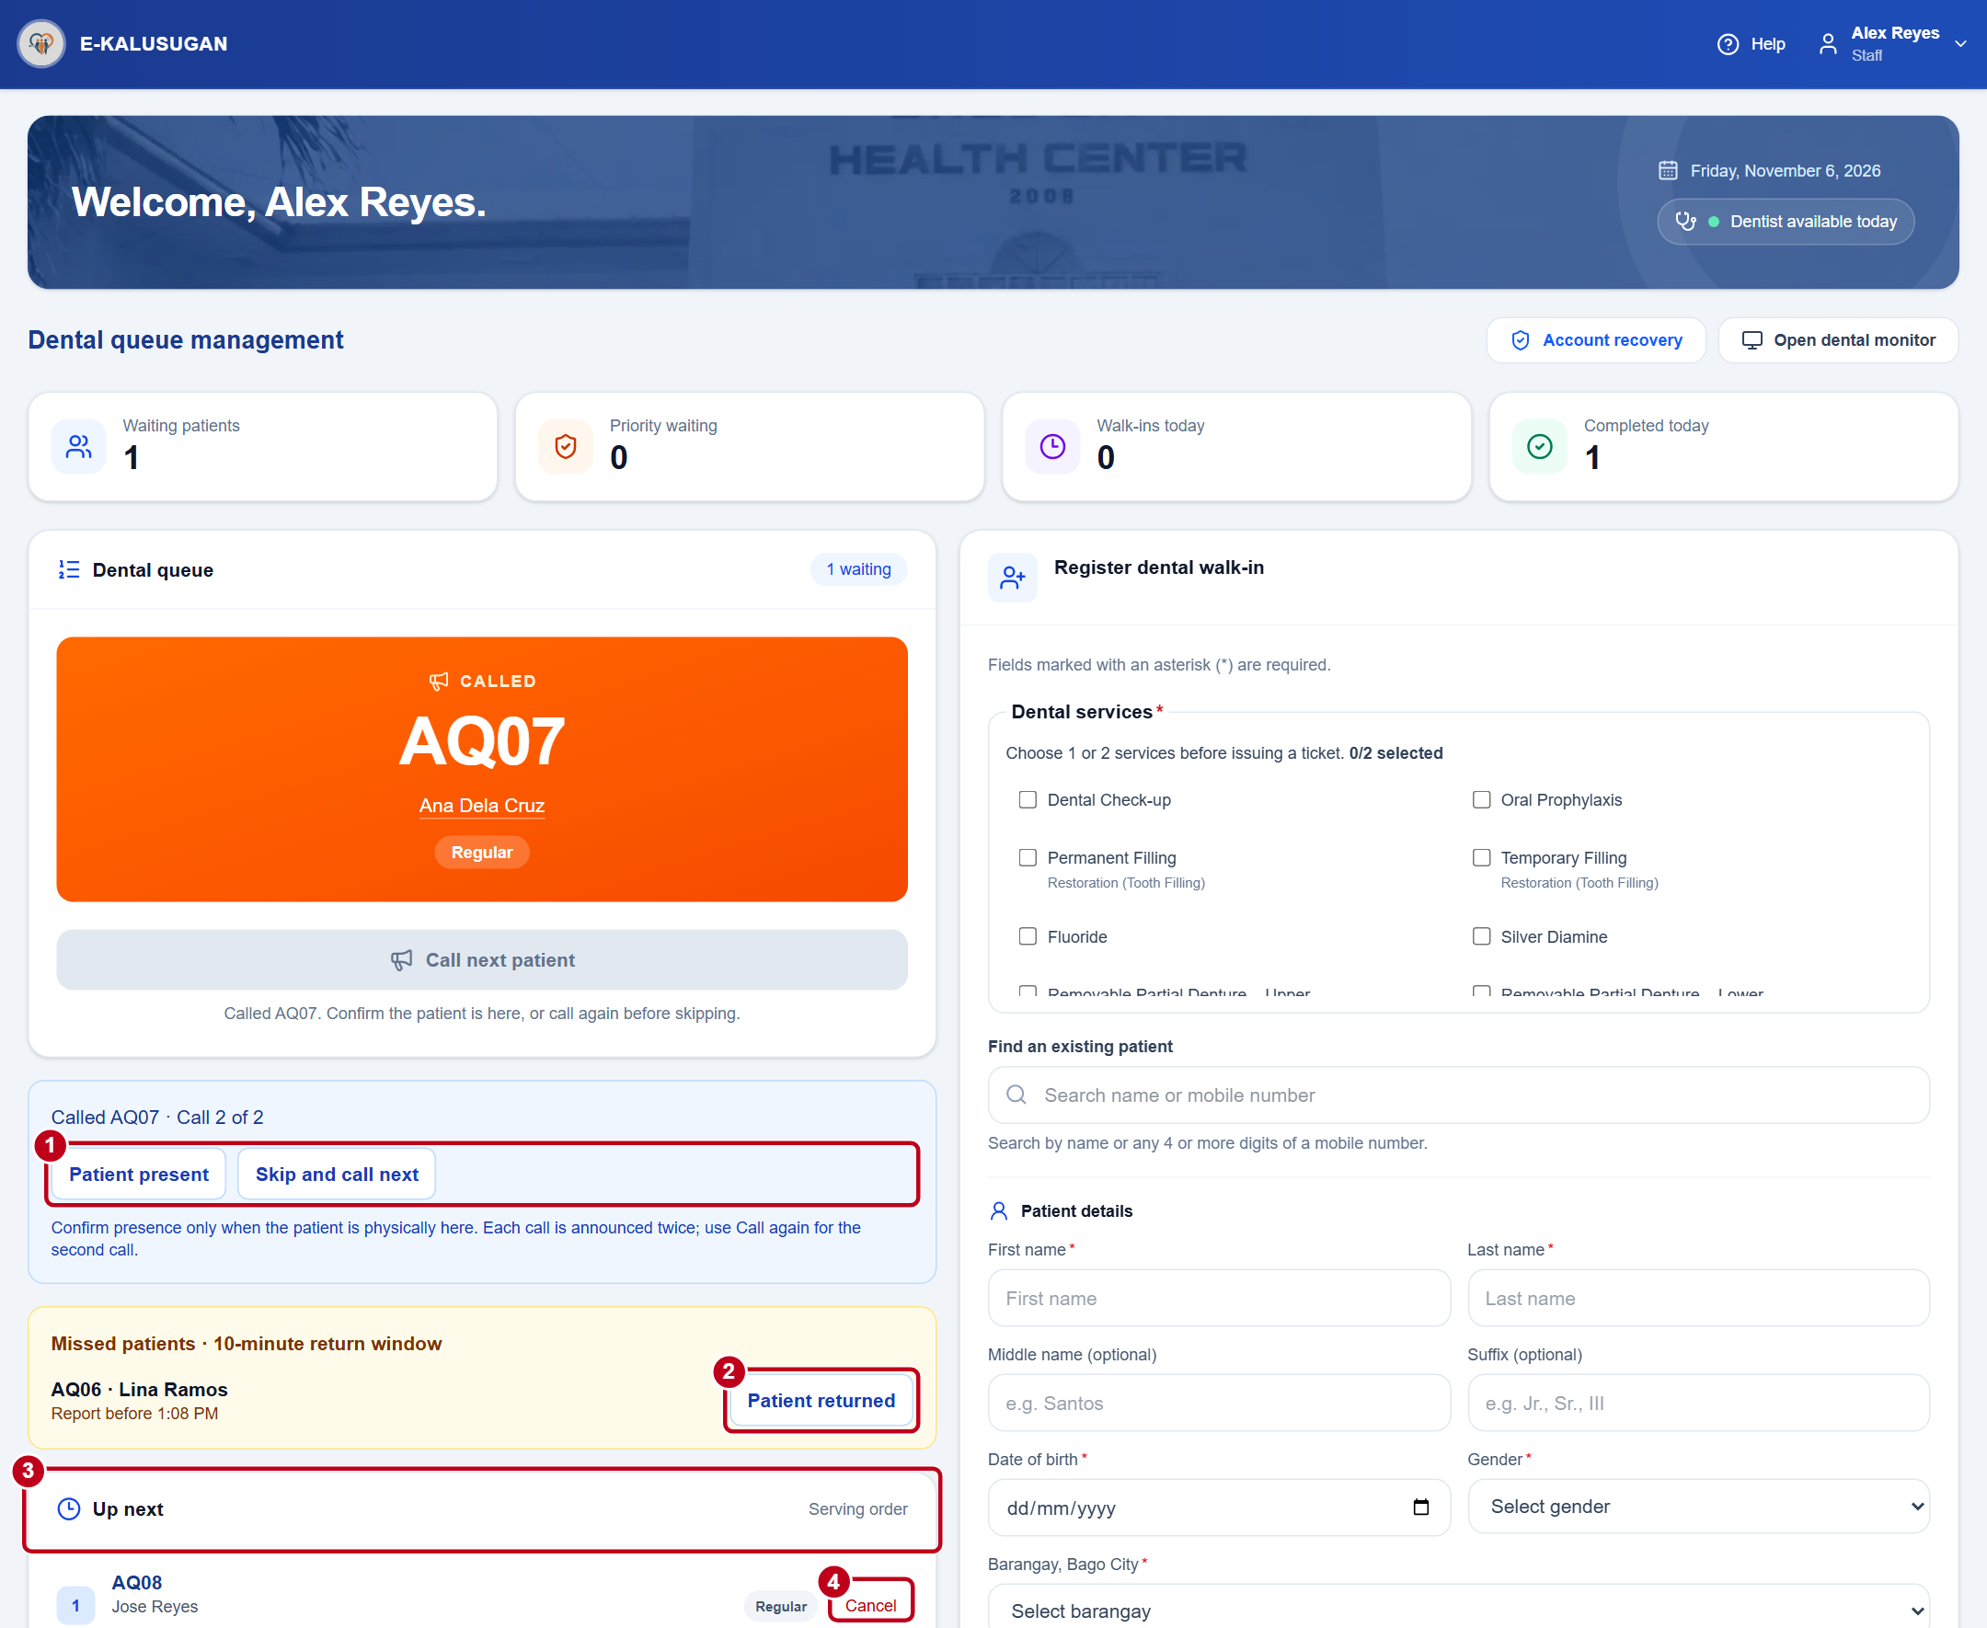
Figure 16. Called and missed tickets with the Up next list
1 When the chair is free, select Call next patient. Select Patient present when the patient arrives. After treatment, use Call next patient or Finish check-up for the last patient. For an absent patient, wait 15 seconds before Call again and another 15 seconds before Skip and call next.
2 Confirm a return with Patient returned before the listed deadline.
3 Follow Up next for the current serving order. Open a linked patient name to see identity details and queue history.
4 To cancel a waiting ticket, verify the name and number, select Cancel, choose a reason, and select Continue.
Use the dental monitor for the waiting-room display. Refresh the queue if another user has changed it.
ADMINISTRATOR

Review the dashboard and live queue
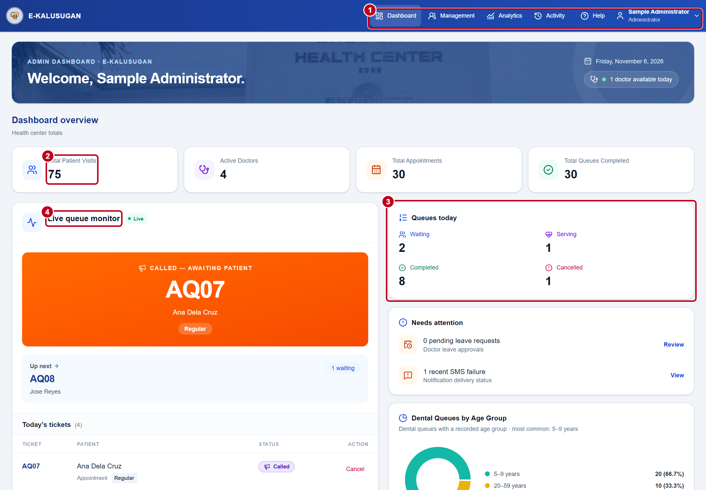
Figure 17. Administrator navigation, totals, and live queue
1 Use the top navigation. In Management, choose Doctors & leave for availability or Patient history for visit records. In Analytics, choose a year to inspect the charts.
2 Review the dashboard totals.
3 Use Queues today for waiting, serving, completed, and cancelled counts.
4 Use Live queue monitor to inspect current tickets. To cancel an eligible ticket, verify it, select Cancel, choose a reason, and select Continue.
The demonstration forecast uses synthetic historical values. Its predictions and accuracy scores are illustrative.
ADMINISTRATOR

Set and review SMS notifications
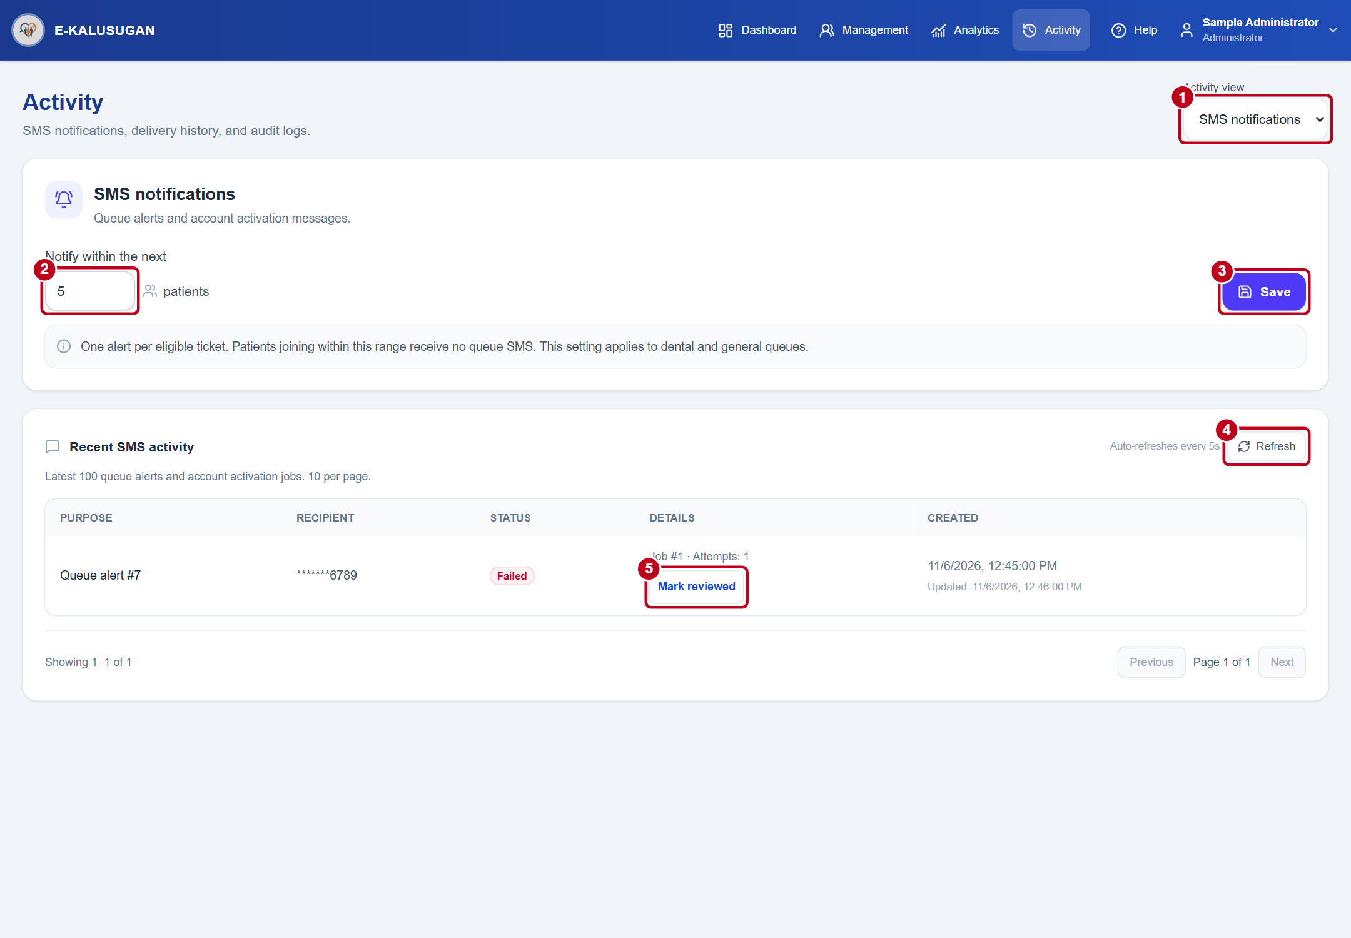
Figure 18. SMS notification settings and recent activity
1 Open Activity and choose SMS notifications in Activity view.
2–3 Enter a whole number from 1 to 100 in Notify within the next, then select Save. Patients who join already within range follow the stay-nearby instruction on their ticket.
4 Use Refresh in Recent SMS activity to review message status. If submission is uncertain, follow the displayed provider-check instruction.
5 After checking a failed message, use Mark reviewed to record your review. One queue alert is sent per eligible ticket. A sent status does not confirm that the patient read it.
ADMINISTRATOR

Create a staff account
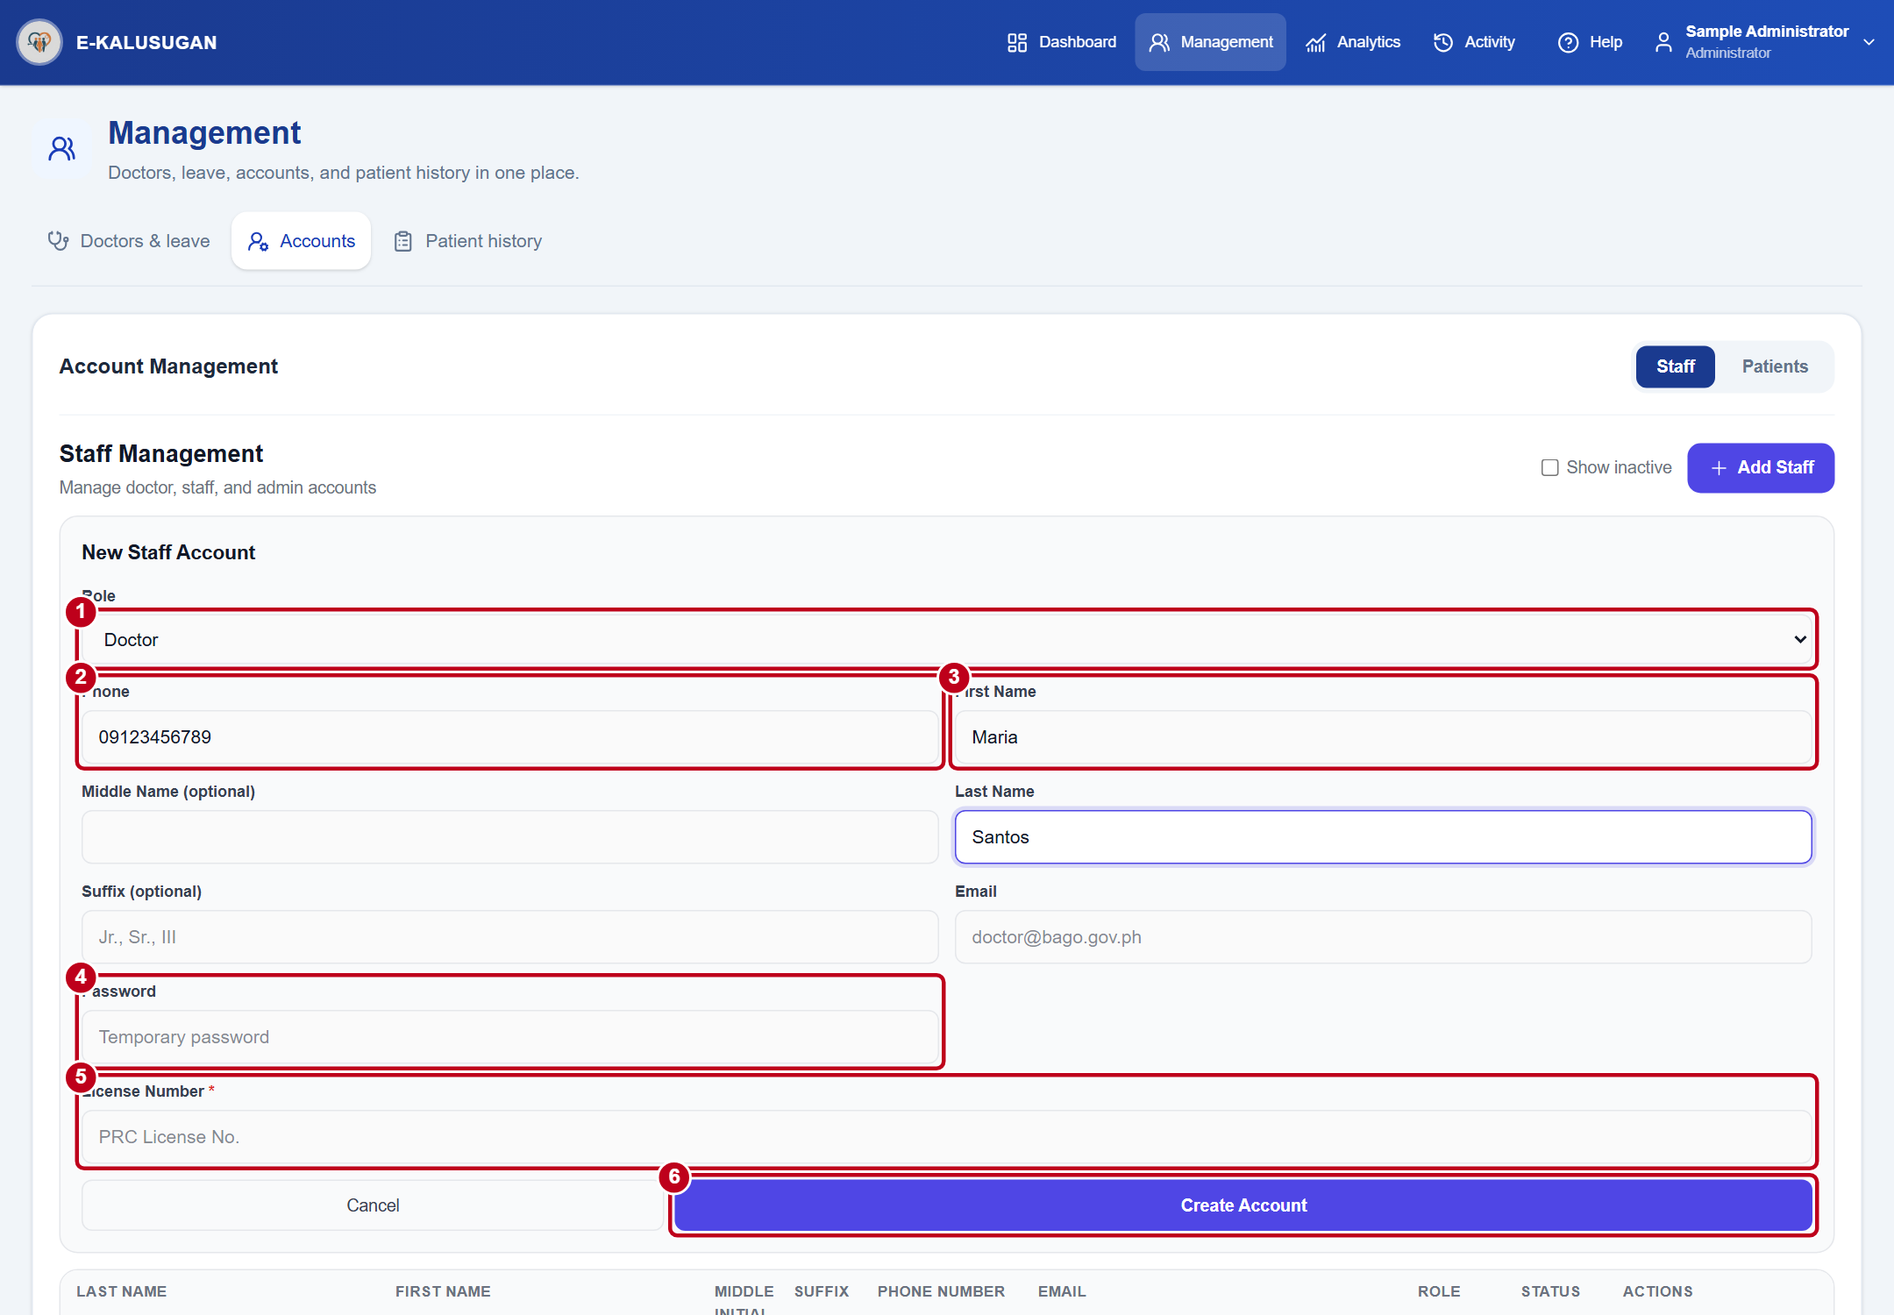
Figure 19. New Staff Account form with Doctor selected
1 Open Management → Accounts → Staff and select Add Staff. Choose Doctor, Staff, or Admin under Role.
2–4 Enter the phone number, name, email, and password.
5 Enter License Number for Doctor or Position for Staff.
6 Review the details and select Create Account.
Use Edit to correct account details. To remove access, select Deactivate and confirm. To restore it, enable Show inactive and select Reactivate.
ADMINISTRATOR

Create a patient account
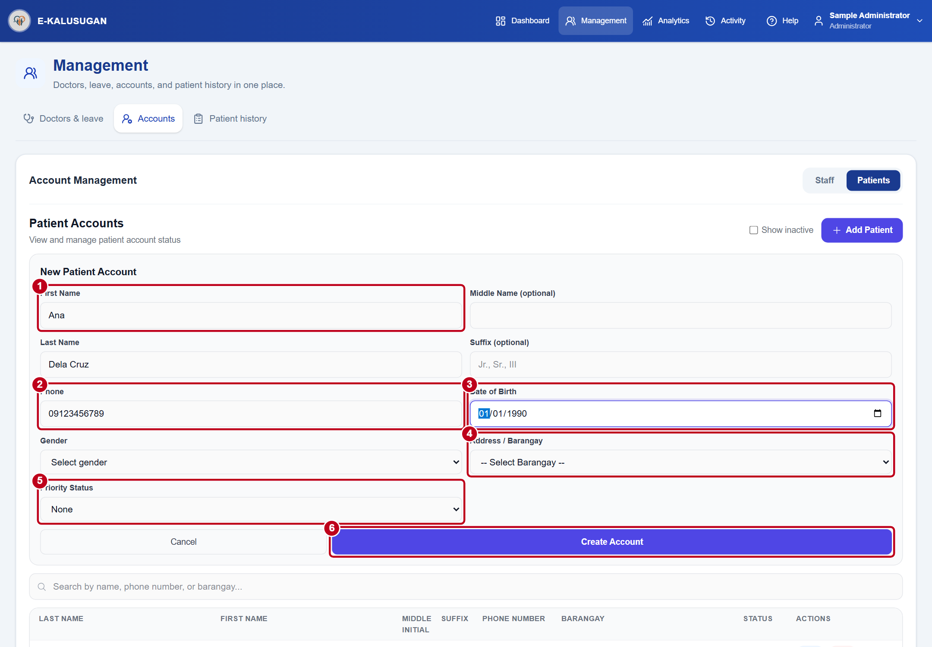
Figure 20. New Patient Account form with a sample mobile number
1 Open Management → Accounts → Patients and search for the patient first. Select Add Patient and enter the patient’s name.
2–4 Enter the verified phone number, date of birth, gender, and barangay.
5 Select Priority Status when applicable.
6 Select Create Account and check the temporary-password SMS status.
For pending activation, verify the patient and phone number before using Issue replacement password. For forgotten access, follow the in-person steps under Account recovery.

