EKalusugan User Manual
  - Patient Dentist Staff and Administrator instructions
Version 1.0 | 18 October 2026
Use this manual to sign in, understand your dashboard, and complete the tasks assigned to your role. It covers the current dental queue, walk-in registration, patient records, clinical documentation, reports, account management, and SMS notifications.
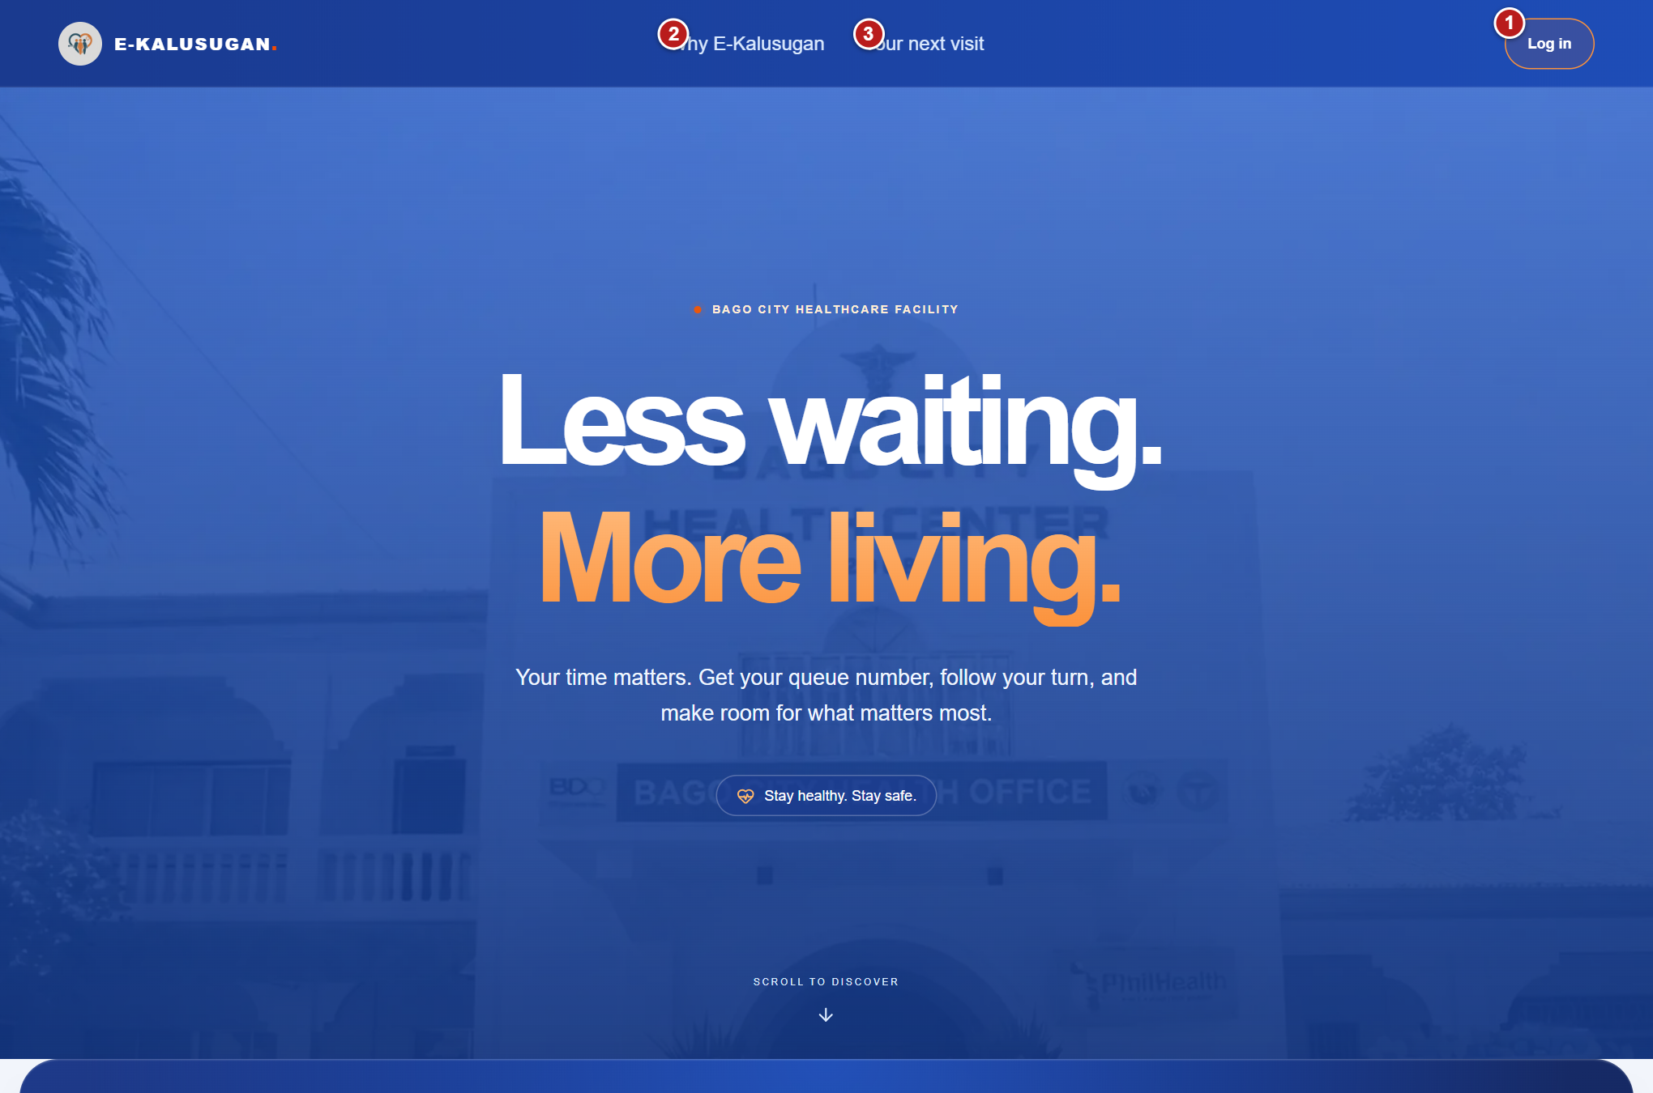
Figure 1 EKalusugan homepage
1 Log in opens the sign in page. 2 Why E Kalusugan jumps to the feature overview. 3 Your next visit jumps to the sign in invitation.
Read the access instructions first, then follow the chapter for your role. Red numbered labels identify the controls explained below each screenshot. Names, contact details, and account identities in the screenshots are anonymized. Example queue and clinical records illustrate actions in the actual running interface.
The patient portal currently handles same-day dental queue tickets and appointment history. Clinic administrators provide accounts; public self-registration and future-date patient booking are not available in this version.

Using this manual
Before you start, obtain the EKalusugan website address and an active account from the clinic. Use a browser with an internet connection. Keep your registered mobile phone available if the clinic sends your first temporary password by SMS.
A button name in these instructions matches the system text. A disabled button appears faded and cannot be used until its requirements are met. Read any message near the button before retrying. Close or Cancel in a dialog generally returns to the previous screen; Continue or a save button confirms the described action.

Choose your role
Role | Main responsibilities | Begin with
Patient | Request and follow your own dental ticket, review appointment history, and find the clinic. | Chapter 2
Dentist or Doctor | Set availability and daily limits, manage the dental queue, save consultation notes, enter clinical counts, and export reports. | Chapter 4
Staff | Find patients, register dental walk-ins, manage arrival and queue actions, review records, and verify in-person recovery. | Chapter 3
Administrator | Oversee queues and activity, manage accounts, view history and forecasts, and configure SMS alerts. | Chapter 5

Read the screen correctly
The system uses Doctor as the account role and Dentist for the dental service. A ticket number identifies a queue visit. An appointment record and a clinical report are separate records. A blank, dash, or loading indicator does not confirm that a count is zero.
Dates and queue return times use Philippine time. Patient and Staff screens refresh about every 15 seconds; Dentist screens refresh about every 30 seconds. Read the latest state before acting because another authorized user may have updated the same ticket.

Protect patient information
Use your own account. Verify the selected patient before opening or changing records. Keep passwords private, share a recovery password only with the verified patient, and use Log Out when finished. Keep the public queue monitor on the dedicated display and keep account and clinical screens at the staff workstation.

Contents
Using this manual 2
Choose your role 2
Read the screen correctly 2
Protect patient information 2
Contents 3
1 Access and sign in 5
Open the homepage 5
Sign in to your account 6
Recover access through reception 7
Set or change your password 8
Read terms and end your session 9
2 Patient instructions 10
Understand the patient dashboard 10
Request a dental queue ticket 11
Dental service choices 12
Read your active ticket 12
Ticket statuses and the next action 13
Cancel a waiting or missed ticket 14
Return after a missed call 15
Review history and find the clinic 16
3 Staff instructions 17
Understand the staff dashboard 17
Find an existing patient 18
Register a dental walk in 19
Call and serve dental patients 20
Handle missed calls and returning patients 21
Cancel a ticket with a reason 21
Use the dental queue monitor 22
Review the patient profile 23
Merge a duplicate walk in record 24
Find a patient for account recovery 25
Verify identity and issue recovery access 26
4 Dentist instructions 27
Understand the dentist dashboard 27
Set availability and daily capacity 28
Call patients and confirm arrival 29
Document and complete the consultation 30
Review appointment history 31
Read dentist analytics 32
Enter daily barangay clinical counts 33
Save and check clinical counts 34
Print or download reports 35
5 Administrator instructions 36
Navigate the administrator dashboard 36
Monitor and cancel queue tickets 37
Choose a cancellation reason 37
Review statistics and forecasts 38
Check doctor availability 39
Review patient appointment history 40
Configure and monitor SMS notifications 41
Manage staff doctor and admin accounts 42
Create a staff doctor or admin account 43
Find and manage patient accounts 44
Create a patient account 45
Assist a verified patient with recovery 46
6 Common problems and routine checks 47
Sign in and account access 47
Queue and walk in problems 47
Reports notifications and records 48
Daily routine by role 48
Get help from the clinic 48

1 Access and sign in

Open the homepage
Figure 2 Homepage navigation
1 Log in opens the sign in page. 2 Why E Kalusugan jumps to the feature overview. 3 Your next visit jumps to the sign in invitation.
- Open the EKalusugan address supplied by the clinic.
- Select Log in in the upper right. Why E-Kalusugan scrolls to the feature overview; Your next visit scrolls to the invitation to sign in.
- The homepage preview is an introduction to the portal. Sign in with your clinic-issued account to reach your role dashboard.
Note There is no active public registration page. Contact clinic reception if you do not yet have an account.

Sign in to your account
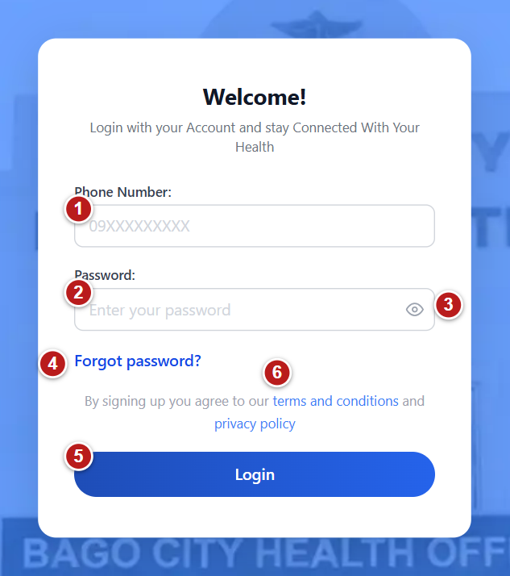
Figure 3 Sign in to your account
1 Phone Number enter your registered login phone. 2 Password enter your password. 3 Eye icon shows or hides the password. 4 Forgot password opens reception recovery instructions. 5 Login opens the dashboard assigned to your role. 6 Terms and privacy links open the policy dialog.
1. Enter your registered mobile number in Phone Number. Use the Philippine mobile format shown in the field, such as 09 followed by nine digits.
2. Enter your password. Use the eye icon only when it is safe to display the password on screen.
3. Select Login once and wait while Logging in is displayed.
4. A Patient, Doctor, Staff, or Administrator account opens its assigned dashboard automatically. You do not choose a role on the login form.
5. If the system requires a new password, complete Change Your Password before continuing.
Note If Please fill in all fields appears, complete both fields. If Invalid phone or password appears, check the registered phone and password. Ask reception for recovery assistance if access still fails.

Recover access through reception
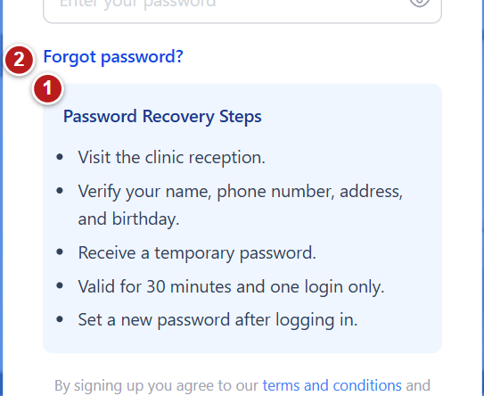
Figure 4 Recover access through reception
1 Reception recovery steps verify your identity in person. 2 Forgot password expands or collapses these instructions.
1. On the login form, select Forgot password? to expand Password Recovery Steps.
2. Visit clinic reception. Verify your name, registered login phone number, address, and birthday with authorized staff.
3. Receive the temporary recovery password privately. It is valid for 30 minutes and one login.
4. Sign in with the same registered phone and the recovery password. Set a permanent password when prompted.
Note Forgot password? displays instructions for in-person recovery. It does not send a reset link or change your password.
Note The first activation password sent by SMS is a different workflow. Follow the activation message and complete password setup promptly; ask the clinic if it expires or cannot be used.

Set or change your password
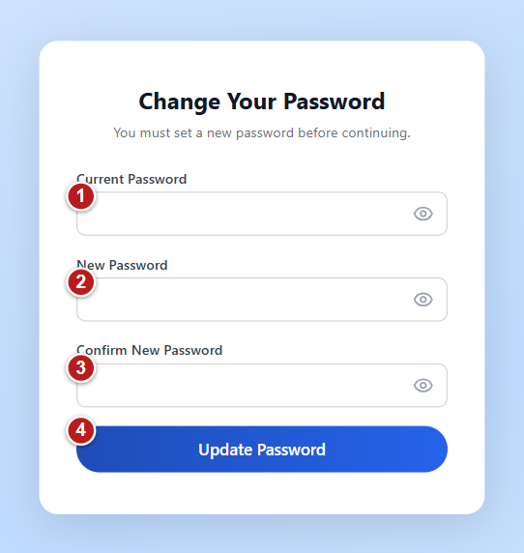
Figure 5 Set or change your password
1 Current Password enter the password you currently use. 2 New Password use at least eight characters including a number. 3 Confirm New Password enter the same new password again. 4 Update Password saves the new password.
1. At first activation or recovery login, the system opens Change Your Password. In this setup flow, the form asks for New Password and Confirm New Password.
2. For a normal password change, enter Current Password as well, as shown in the screenshot.
3. Create a password with at least eight characters and at least one number. The maximum is 72 bytes, equivalent to 72 plain English characters and fewer for accented characters or emoji.
4. Enter the same new password in Confirm New Password. Use the eye controls to check the fields when appropriate.
5. Select Update Password. Wait for the assigned dashboard to open. If Passwords do not match appears, enter matching values and try again.
Note A temporary-password setup session is time limited. If it expires, return to reception or request the appropriate activation assistance.
Note You can open the normal password-change page from the website address ending in /change-password while signed in.

Read terms and end your session
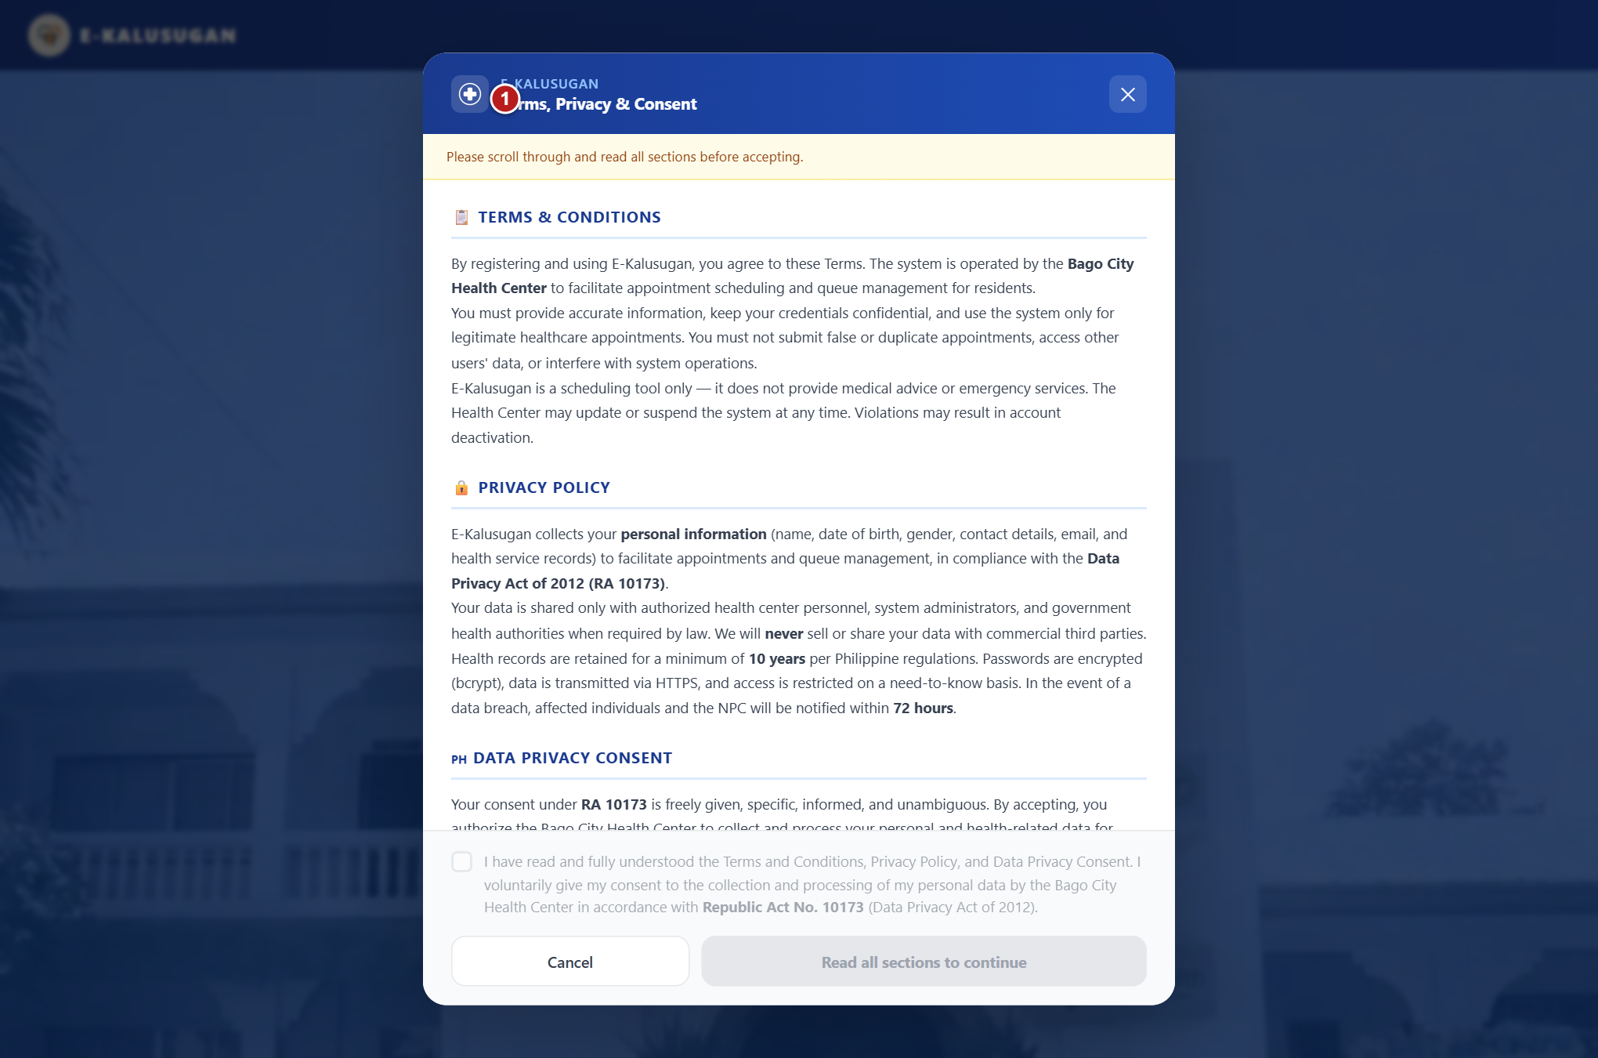
Figure 6 Read terms and end your session
1 Terms and privacy dialog read the displayed policy.
1. Select terms and conditions or privacy policy on the login page to open Terms, Privacy & Consent.
2. Read the policy and scroll through the policy area. The consent controls become available after reaching the bottom.
3. Select the consent checkbox if you agree, then select Accept & Continue. Use Cancel or the X to close the dialog when you only need to return to sign in.
4. When finished with a dashboard, open your name or profile chip at the upper right and select Log Out. On a phone, open the menu first if the profile control is hidden.
Note Closing the browser tab ends that tab session. Sign in again if you return to the login page or see an expired-session message.

2 Patient instructions
Request a same-day dental queue ticket, follow the live queue, and review your own appointment history.

Understand the patient dashboard
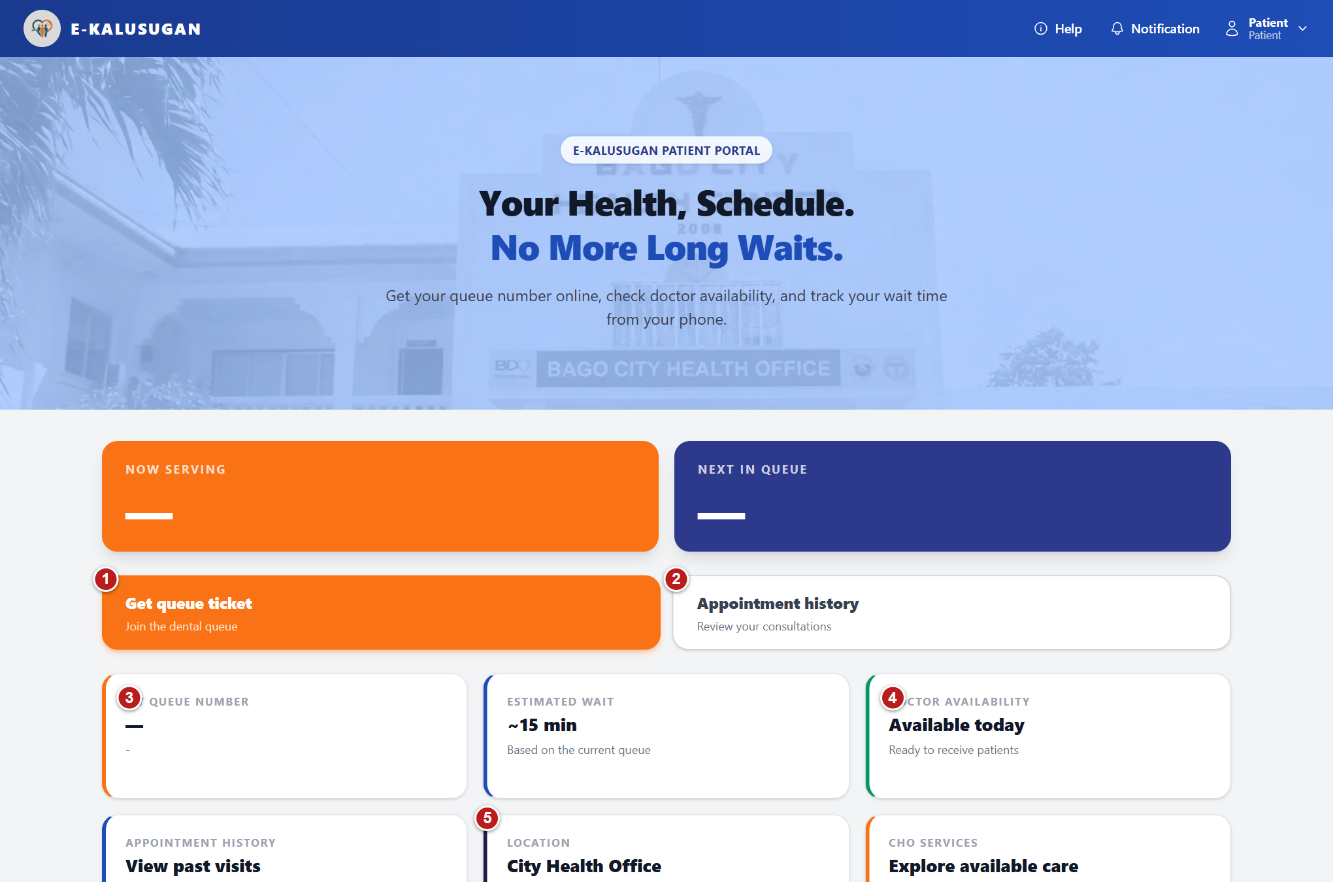
Figure 7 Patient dashboard
1 Get queue ticket opens the dental service selection. 2 Appointment history displays earlier appointments. 3 My queue number shows your active ticket. 4 Doctor availability shows the current availability status. 5 Location opens the clinic map.
After signing in with a patient account, E-KALUSUGAN opens the patient portal. The home screen brings together today's dental queue, your own ticket, dentist availability, and appointment history.
1. Read the large Now serving and Next in queue cards. When a patient has been called and is awaiting arrival confirmation, the first card reads Called - report to staff.
2. Check My queue number for your active ticket number and selected dental sub-services. A dash means there is no active ticket to show.
3. Read Doctor availability. The card may show Checking availability, Available today, or Unavailable today. Availability alone does not guarantee that registration or daily slots remain open.
4. Use Get queue ticket to join today's dental queue when the button is enabled. Use Appointment history to review your visits.
5. On a narrow phone screen, use the Toggle menu button at the top to show the navigation controls. Tap your name to reveal Log Out when you finish using the portal.
Note The queue and dentist availability refresh automatically every 15 seconds while the portal remains open.
Note The Estimated wait card displays ~15 min. Treat this as an indicative display; keep watching the queue and respond when called.
Note An existing waiting, called, serving, or missed ticket counts as an active queue. You cannot request another active ticket.
Note Help, Notification, and CHO services are visible on the current home screen. There is no additional help, notification list, or services action to complete from those controls in this version.

Request a dental queue ticket
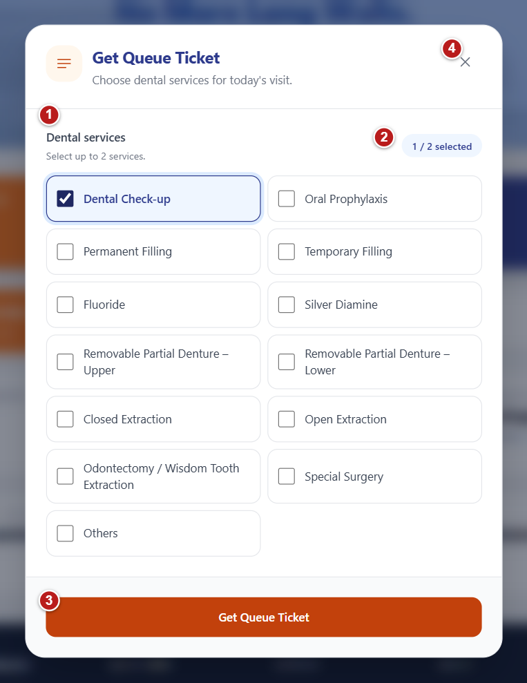
Figure 8 Request a dental queue ticket
1 Dental services choose one or two services. 2 Selection counter shows the two service limit. 3 Get Queue Ticket submits the request. 4 Close returns to the dashboard.
Use this process for a dental visit on the current day. Choose the services you need, then let the system assign the ticket number.
1. From the patient home screen, select Get queue ticket.
2. In Get Queue Ticket, read any registration message shown above the service list.
3. Select one or two checkboxes under Dental services. The counter shows how many services you have selected. Once two are checked, the other checkboxes are disabled; uncheck one before choosing a replacement.
4. Select Get Queue Ticket at the bottom. The button reads Getting your ticket... while the request is being processed.
5. When the request succeeds, the window closes and your ticket appears on the dashboard. Check the queue number, your name, selected services, and current status.
6. Keep the portal open or check it again while waiting. Follow the displayed queue and report to staff when your status says It's your turn!
Note At least one service is required. No more than two services can be selected.
Note Close queue ticket (the X icon), the Escape key, or clicking outside the dialog closes it without issuing a ticket.
Note A valid priority category on your patient record is applied automatically. Ask clinic staff if your recorded priority details need review.
Note The system refuses a new request when you already have an active queue today. Patient self-service is limited to two queue registrations per day, including earlier registrations that ended.
Note Registration can be refused if there is no dentist, the dentist is unavailable, or today's appointment slots are full.
Note After today's dental queue has started, new same-day appointment registration closes. The displayed message directs patients to approach staff for walk-in registration. A patient who already has an active appointment for today may still be eligible to request a ticket.

Dental service choices
Choose one or two services for one dental visit. Both the patient ticket form and staff walk-in form use these choices.
Service group | Choices shown in the forms
General dental care | Dental Check-up; Oral Prophylaxis; Fluoride; Silver Diamine; Special Surgery; Others
Restoration or tooth filling | Permanent Filling; Temporary Filling
Removable partial denture | Removable Partial Denture - Upper; Removable Partial Denture - Lower
Dental surgery | Closed Extraction; Open Extraction; Odontectomy / Wisdom Tooth Extraction

Read your active ticket
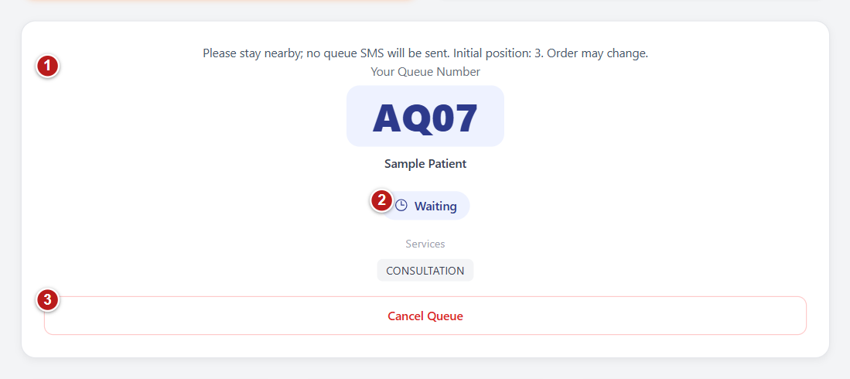
Figure 9 Active patient ticket Example records
1 Your Queue Number identify yourself to staff using this ticket. 2 Waiting read this status and follow the instructions above. 3 Cancel Queue opens the required cancellation reason.
1. Read Your Queue Number and the service labels. Use the ticket number when reporting to staff.
2. Read the status and the instruction above the ticket. If no SMS will be sent, stay nearby. If one alert is expected, also follow the queue display.
3. When called, report to staff immediately so they can confirm your presence.
Note Queue order may change. Initial position is not a fixed place, and the displayed estimated wait is indicative.

Ticket statuses and the next action
Your ticket status tells you what to do next. Keep your queue number available when speaking with staff.
Ticket display | What it means | What you should do
Waiting | Your ticket is in the waiting queue. | Stay nearby, watch the current queue number, and follow the SMS instruction shown on your ticket.
It's your turn! | Your number has been called; staff have not yet confirmed your arrival. | Report to staff now so they can confirm you are here.
Receiving care | Your presence has been confirmed and your visit is in service. | Follow the dental team's instructions.
Missed call | You did not respond to the calls. The ticket is temporarily recoverable. | Report to staff before the exact deadline displayed on the ticket. Other patients continue to be called while you return.
Waiting after return | Staff have confirmed your return within the allowed time. | Stay nearby. The ticket says that you will be called at the next opening.
No-show | The ticket has ended because the return period expired or the returning patient missed the next turn. | Read the reason. A new ticket is subject to today's availability and the daily queue limit.
Completed | The visit has finished. | Review your appointment history for the visit record.
Cancelled | The queue visit was cancelled with a recorded reason. | Check with staff if you still need care; another request is subject to the current registration rules.

Note For some waiting tickets, the portal says: Please stay nearby; no queue SMS will be sent. Follow that instruction.
Note For tickets eligible for an approach alert, the portal says that one SMS will be sent when your turn approaches. Delivery may be delayed, so follow the queue display as well.
Note An initial position is a starting position, not a fixed place. Order may change because the queue combines online registrations, walk-ins, priority patients, and patients whose return has been confirmed.
Note A missed ticket has a 10-minute return window. Staff must confirm the return before the displayed deadline; merely refreshing your patient portal does not restore the ticket.
Note Your home screen shows the active ticket or the latest no-show ticket. A finished or cancelled ticket may no longer be displayed as your current ticket.

Cancel a waiting or missed ticket
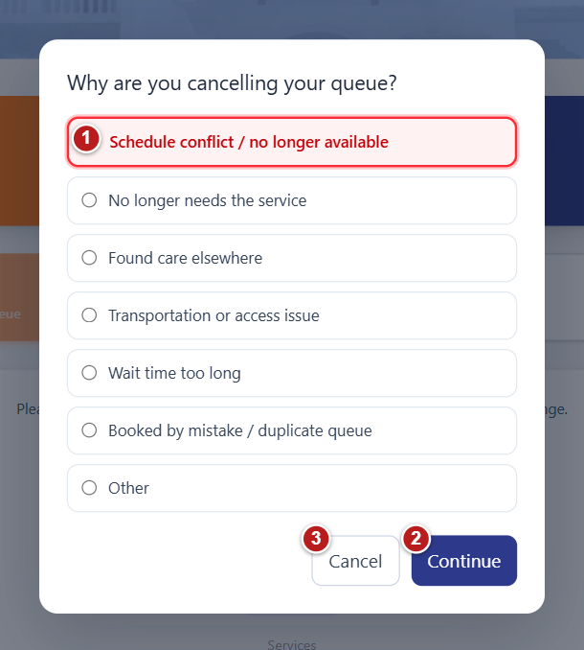
Figure 10 Cancel a waiting or missed ticket Example records
1 Reason select the reason that applies. 2 Continue confirms cancellation with the selected reason. 3 Cancel closes the dialog and keeps your ticket.
Use cancellation when you no longer need the current queue ticket. A reason is required.
1. On your active ticket, select Cancel Queue. This button is available only while your ticket is Waiting or Missed call.
2. In Why are you cancelling your queue?, select the reason that best describes the cancellation.
3. Select Continue to submit the cancellation. The dialog closes and the portal refreshes your ticket information.
4. To keep the ticket, select Cancel in the reason window or click outside it before continuing.
- Schedule conflict / no longer available
- No longer needs the service
- Found care elsewhere
- Transportation or access issue
- Wait time too long
- Booked by mistake / duplicate queue
- Other
Note Continue remains disabled until a reason is selected.
Note If your ticket has already been called or is receiving care, speak to staff because the patient cancellation button is no longer available.
Note Cancelling does not undo the fact that a queue registration was made today. Any later ticket request remains subject to the daily limit and registration rules.

Return after a missed call
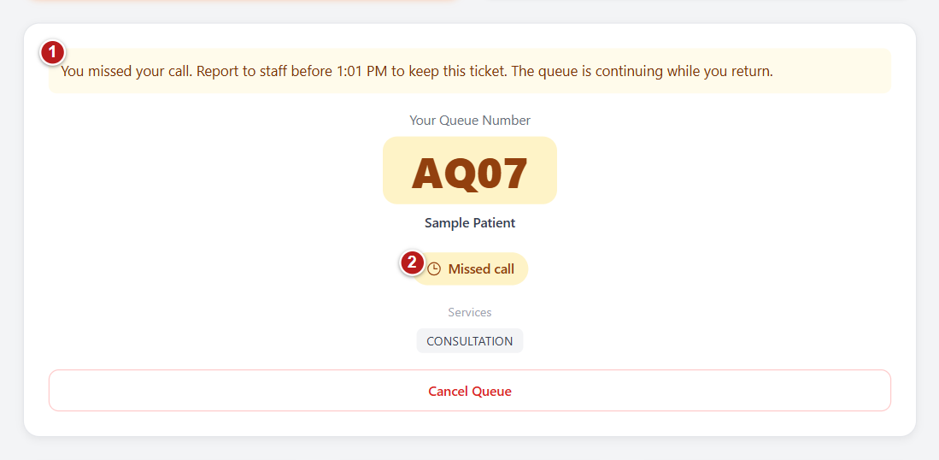
Figure 11 Return after a missed call Example records
1 Return deadline report to staff before the displayed time. 2 Missed call staff must confirm your return.
1. Read the deadline shown above the ticket after Missed call appears.
2. Report to Staff before that exact time. Staff must select Patient returned to confirm your return.
3. Stay nearby after confirmation. The queue continues while you return, and the restored ticket is called at the next opening.
4. If the deadline expires or a returning patient misses the next call, the ticket ends as No-show. A new request depends on current availability and daily limits.
Note Refreshing the patient screen does not confirm a return. Do not wait for an SMS to report to reception.

Review history and find the clinic
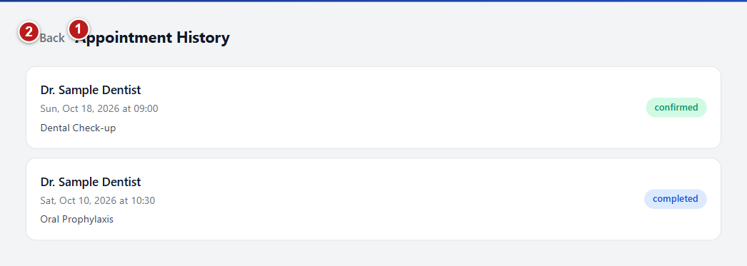
Figure 12 Review history and find the clinic Example records
1 Appointment history lists your recorded appointments. 2 Back returns to the patient dashboard.
1. Select Appointment history from the home screen. The Appointment History page loads your own appointment records.
2. Read the dentist name, appointment date, time when recorded, service or reason, and status on each card. Status may be confirmed, completed, or cancelled.
3. If the page says No appointments found., there are no appointment entries to show for your account. Use Back to return home.
4. From home, select Location. The City Health Office of Bago map window opens.
5. Select Open in Google Maps to open a separate map tab. Use Close map (X), Escape, or click outside the map window to close the portal's map.
Note Appointment History is a viewing page. It has no date picker, booking button, or editing action in the current patient portal.

3 Staff instructions
Register dental walk-ins, keep the serving queue moving, confirm patient arrival, and help patients recover account access after in-person verification.

Understand the staff dashboard
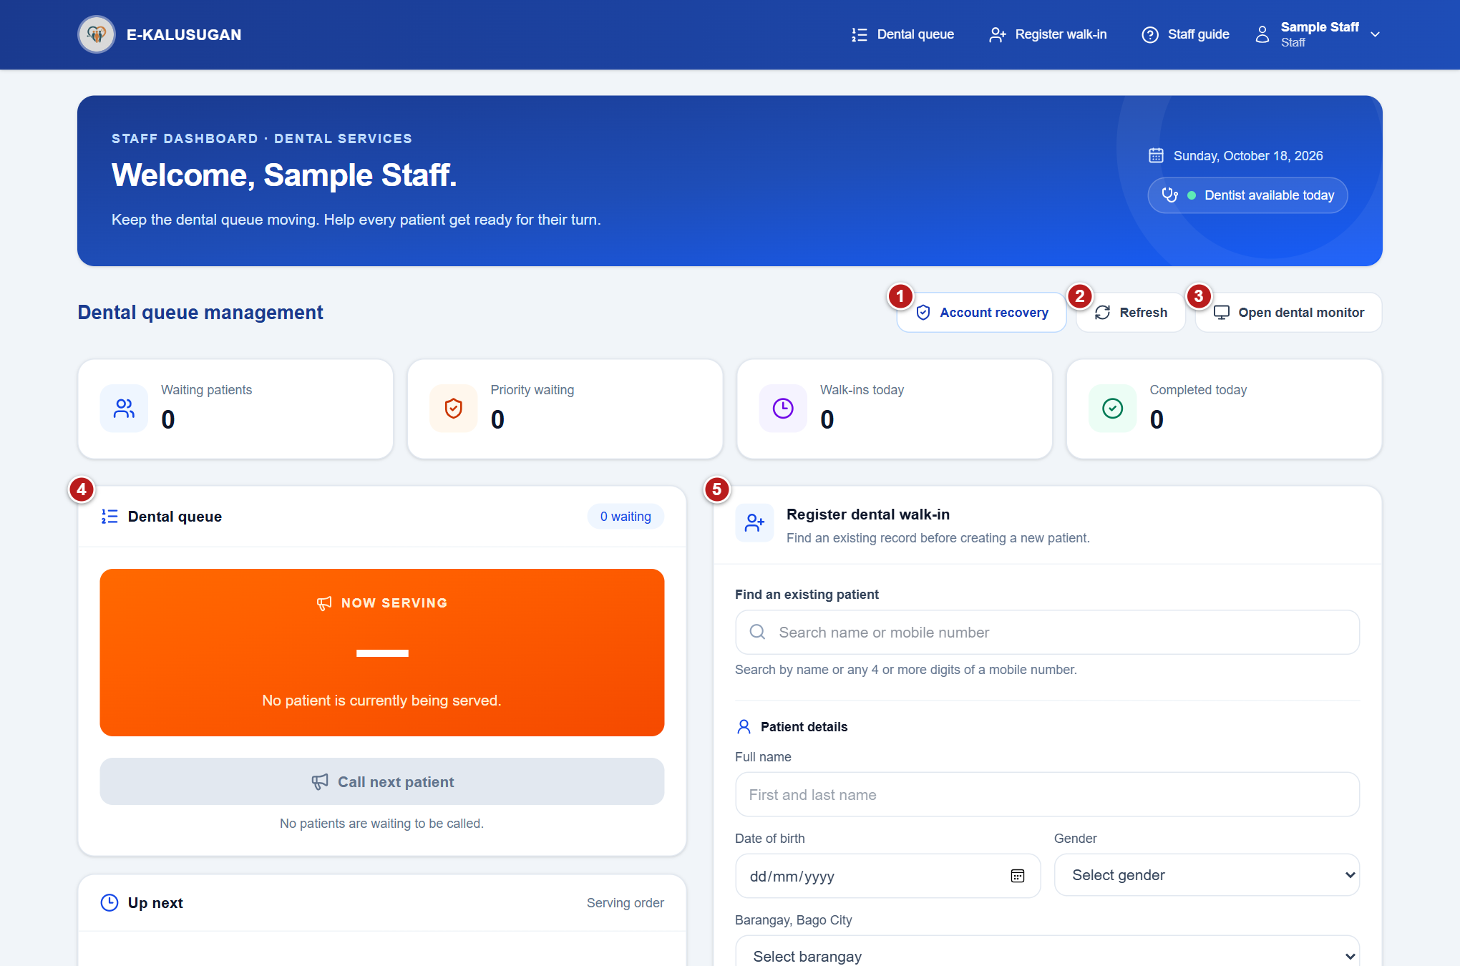
Figure 13 Staff dashboard
1 Account recovery opens the patient lookup. 2 Refresh reloads the current queue. 3 Open dental monitor displays the queue in a new tab. 4 Dental queue contains the calling and ticket controls. 5 Register dental walk in finds or creates a patient and ticket.
After a staff member signs in, the Staff Dashboard | Dental Services screen opens. It combines queue operations and walk-in registration on one page.
1. Read the welcome panel for today's date and dentist availability. The display may show Dentist available today, Dentist unavailable today, or Dentist availability unknown.
2. Read the summary cards: Waiting patients, Priority waiting, Walk-ins today, and Completed today.
3. Use Dental queue in the top navigation to move to the queue panel, or Register walk-in to move to the registration form.
4. Use Refresh to load the latest queue and dentist availability immediately. The page also refreshes automatically every 15 seconds, and the bottom of the page shows the last update time.
5. Select Staff guide in the top navigation for the built-in dental queue reminders.
6. Select Open dental monitor to open the queue monitor in a new tab. Keep the staff dashboard available for operational actions.
7. Select your name and then Log Out at the end of your session.
Note If a red warning says the displayed queue information may be outdated, refresh again before relying on it.
Note The Up next list shows the first five waiting tickets and a count of additional waiting patients. Its displayed serving order should guide operations; queue numbers alone do not define the order.

Find an existing patient
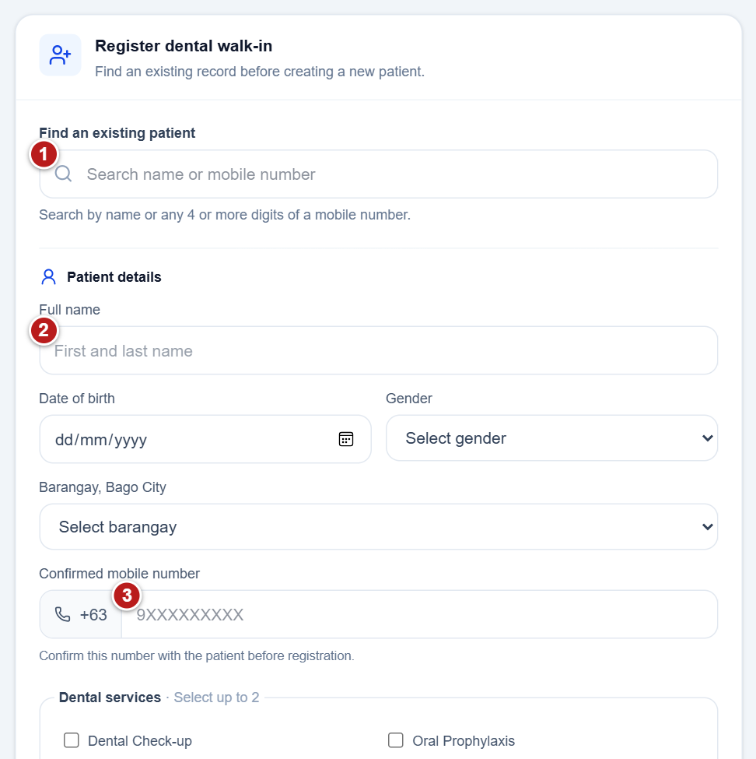
Figure 14 Find an existing patient
1 Find an existing patient search before creating a new record. 2 Full name enter or confirm the patient name. 3 Confirmed mobile number verify the number with the patient.
Always check whether the person already has a record. Reusing the correct record keeps the person's visits together and helps prevent duplicates.
1. In Register dental walk-in, enter the patient's name or mobile digits in Find an existing patient. A name search needs at least two characters; mobile searches can use any four or more digits.
2. Wait for Searching patient records… to finish. The form can also look for matches as you enter Full name, Date of birth, or Confirmed mobile number.
3. Compare each Possible existing patients result with the person in front of you. Results show a name, birthday, and masked mobile number.
4. Select the correct result. The form shows Returning patient, fills the patient details, and lists the number of Previous dental visits with up to three recent entries.
5. Review and confirm the patient's current details and mobile number before submitting. If you selected the wrong record, select Clear selection and search again.
6. Use Open patient profile when you need to see the identity details and full queue history before proceeding.
7. If the results are different people, check I checked these records; create a new patient. only after checking them. Then complete the new patient's details.
Note The form will stop registration if likely matches exist and neither a patient nor the explicit new-record confirmation has been selected.
Note Changes made to a selected patient's name, birthday, gender, mobile number, barangay, or priority category are saved with walk-in registration. Check these fields carefully; they are not just temporary ticket labels.
Note The selected patient's queue must not already be active today.

Register a dental walk in
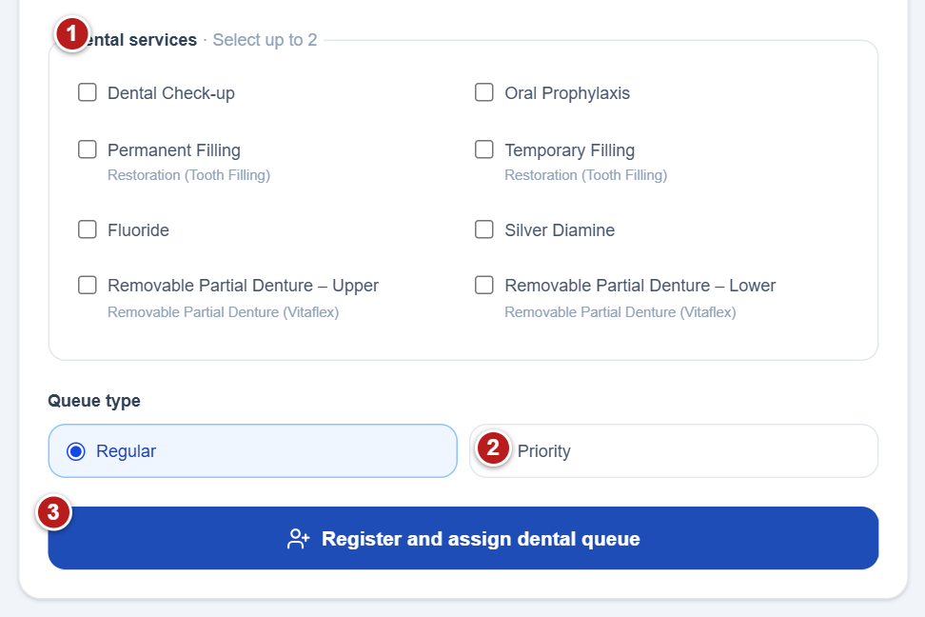
Figure 15 Register a dental walk in
1 Dental services select one or two required services. 2 Priority use only for a verified eligible patient. 3 Register and assign dental queue creates the visit and issues a number.
This process assigns a same-day dental queue ticket to an existing or newly recorded walk-in patient.
1. Find and select the existing patient first, or confirm that a new record is needed.
2. Enter or confirm Full name, Date of birth, Gender, Barangay, Bago City, and Confirmed mobile number. The full name must include first and last names. Birthday cannot be in the future.
3. For Confirmed mobile number, enter the ten digits beginning with 9 in the field beside +63. Confirm the number directly with the patient before registration.
4. Under Dental services, select one or two services. Scroll within the service list when necessary to see all choices.
5. Under Queue type, choose Regular or Priority. When selecting Priority, select a Priority category: Senior citizen (60+), PWD (Person with Disability), or Pregnant.
6. Select Register and assign dental queue. While the request is processing, the button reads Registering patient… and the form is disabled.
7. Read the green registration message. Tell the patient the assigned queue number and initial position, and relay the exact SMS instruction shown.
8. Check that the new ticket appears in the dental queue. The form clears after a successful registration so it is ready for the next patient.
Note The form requires all patient-detail fields, a valid ten-digit mobile entry beginning with 9, one or two services, and a category when Priority is chosen.
Note The service can refuse registration when the dentist is unavailable, walk-in slots are full, a record is archived, or that patient already has an active queue today. Read the displayed error, correct the issue, and retry only when appropriate.
Note The success message may say no queue SMS will be sent. In that case, tell the patient to stay nearby. Otherwise explain that one SMS will be sent as the turn approaches and that serving order may change.
Note Registration creates or reuses a patient record and assigns a queue ticket. A new walk-in does not automatically receive a portal login account.

Call and serve dental patients
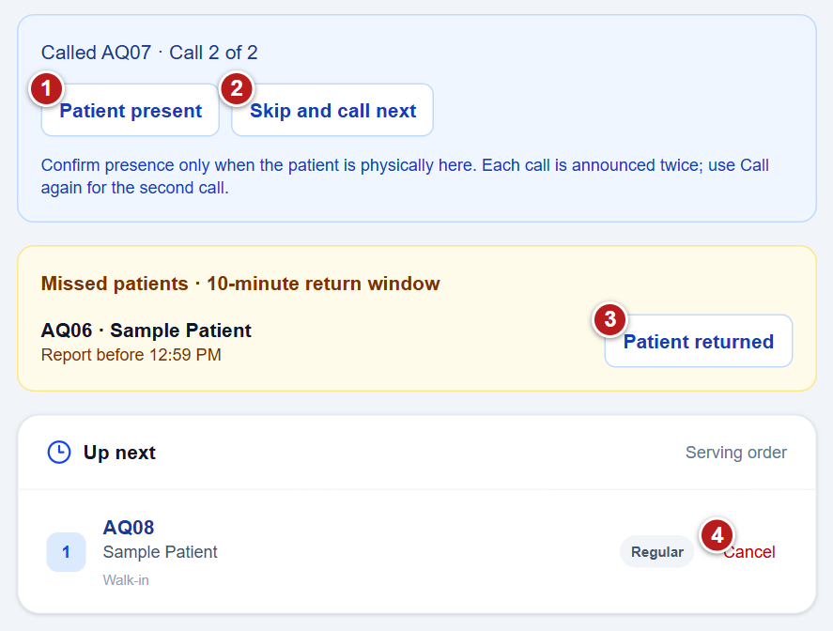
Figure 16 Call and serve dental patients Example records
1 Patient present confirms physical presence and starts service. 2 Skip and call next moves an absent ticket into the return window. 3 Patient returned confirms a missed patient before the deadline. 4 Cancel opens the required cancellation reason.
Use the queue panel when the dental team is ready to receive the next patient. A called ticket must be acknowledged before the visit can be completed.
1. Check Up next and the message under Call next patient. If the queue has no current patient, the hint identifies the next ticket ready to be called.
2. Select Call next patient when the chair is free. The orange panel changes to Called and shows the ticket number and patient name.
3. When the patient is physically at the clinic, select Patient present in Called patient controls. This changes the visit to receiving service.
4. Allow the dental team to finish the check-up. If other patients are waiting, select Call next patient only when the check-up has finished. This marks the current visit complete and calls the next ticket.
5. If this is the last patient and nobody is waiting, the main button reads Finish check-up. Select it when the visit is finished to mark it complete.
6. Check the refreshed queue and Completed today summary after the action.
Note While a ticket is only Called, the main Call next patient button remains disabled. Confirm physical presence, or use the recall and missed-patient process.
Note Patient names in the current queue and Up next list are links to Patient profile when a patient record is attached.
Note The queue list may change when another authorized user acts. If an error appears, read it and refresh; confirm the current state before taking another action.

Handle missed calls and returning patients
The interface enforces two calls and waiting intervals before a missing patient is skipped. A first missed turn gives the patient a short return period.
1. After the first call, check Called patient controls. It shows Call 1 of 2 and a Wait countdown.
2. If the patient has not arrived, wait at least 30 seconds until Call again is enabled. Select Call again to make the second call.
3. After the second call, wait another 30 seconds. If the patient is still absent, select Skip and call next when enabled.
4. The absent patient's first missed turn moves to Missed patients | 10-minute return window. The next waiting patient is called as part of the skip action.
5. If the patient reports back before the listed Report before time, select Patient returned for that exact ticket. The ticket re-enters Waiting and will be called at the next opening.
6. If the window expires, Patient returned becomes disabled and the ticket ends as a no-show. If a patient returns but misses the next called turn as well, the ticket also ends as a no-show.
Note Use Patient present only for someone physically here. Use Patient returned only after the missed patient has reported back.
Note Each call is announced twice; Call again is the separate second call controlled by the 30-second wait.
Note The return period begins when the ticket is skipped. Continue serving the queue while the missed patient has time to return.
Note A missed ticket remains an active ticket during its return period, so the patient cannot hold another active ticket at the same time.

Cancel a ticket with a reason
1. Find the correct ticket in Up next. Confirm the queue number and patient name.
2. Select Cancel at the right of that ticket.
3. In Reason for cancellation, select a reason from the list, then select Continue.
4. Review the refreshed queue. If the cancellation was not intended, select Cancel in the reason window before submitting.
Note A reason is required; Continue is disabled until one is selected.
Note The staff dashboard's visible Cancel action appears on waiting rows in Up next. It is not shown as a separate button on the current-serving or missed-patient cards.
Note Cancellation reasons are the same choices listed in the patient cancellation section. They are recorded with the visit and may appear in queue history.

Use the dental queue monitor
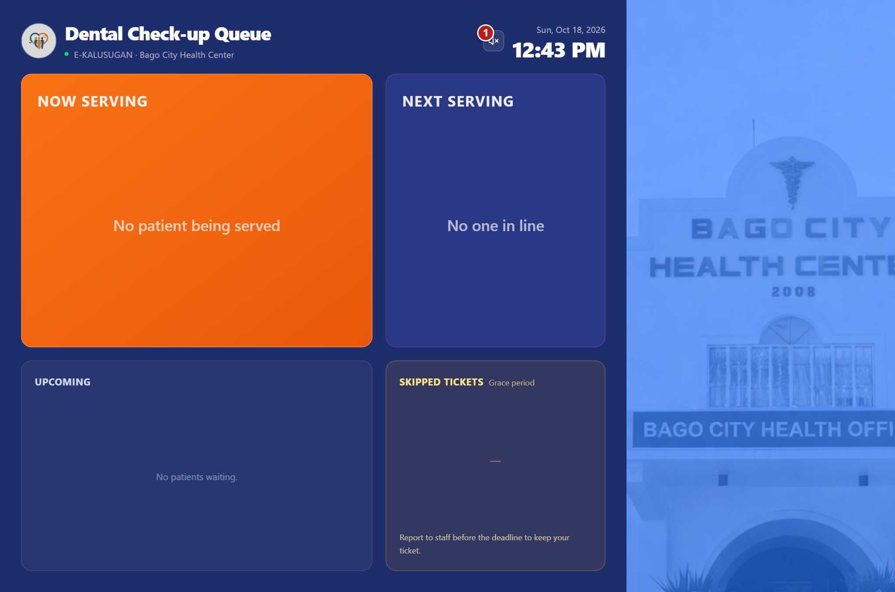
Figure 17 Use the dental queue monitor
1 Enable announcements speaker control turns on queue audio.
1. From the staff dashboard, select Open dental monitor. The monitor opens in another browser tab.
2. Keep this display visible to waiting patients. Read the current and next dental queue numbers and the waiting list.
3. Select Enable announcements using the speaker control if audio announcements are needed, and allow audio through the browser.
4. Keep the staff dashboard available in its own tab for calling, confirming arrival, and handling returns.
Note The monitor requires a Staff or Administrator session. If the tab returns to sign in, sign in with an authorized account and reopen it.

Review the patient profile
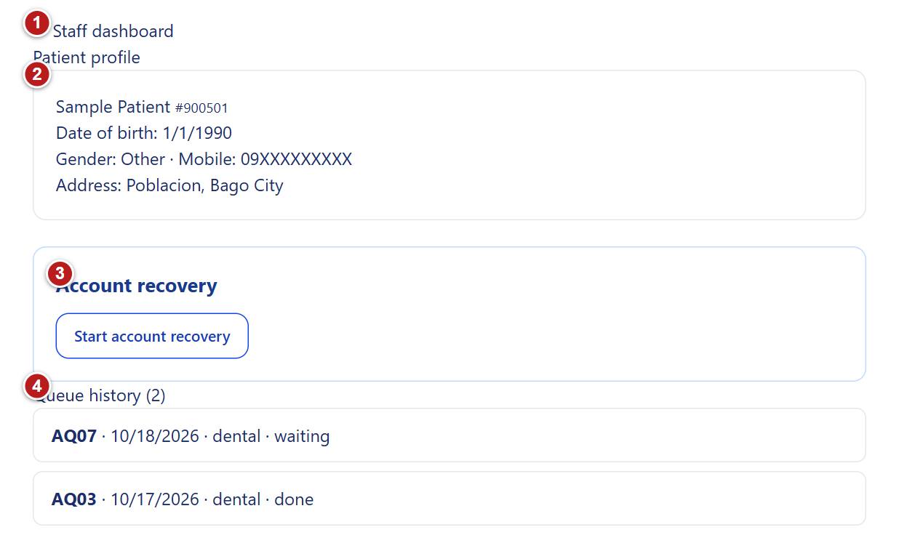
Figure 18 Review the patient profile Example records
1 Staff dashboard returns to dental queue management. 2 Patient identity verify the record before acting. 3 Account recovery requires an active eligible login. 4 Queue history lists recorded visits and statuses.
Patient profile combines the person's identity details, account-recovery controls, and queue visits. It can be opened from queue-name links, a selected walk-in, or account-recovery search results.
1. Select the patient's linked name, Open patient profile, or a patient search result.
2. At the top of Patient profile, confirm the patient name and record number. Read date of birth, gender, mobile number, barangay, and city.
3. Under Queue history, review each visit's queue number, date, category, and status. A recorded status reason is shown beneath the visit.
4. If the record was merged, use the linked patient number in the merged-record notice to open its destination record.
5. Use Staff dashboard or Admin dashboard to return to your dashboard.
Note No queue visits yet. means the record has no queue history to display.
Note The patient profile itself is a viewing and account-recovery screen. The ordinary patient details do not have an Edit button on this page.

Merge a duplicate walk in record
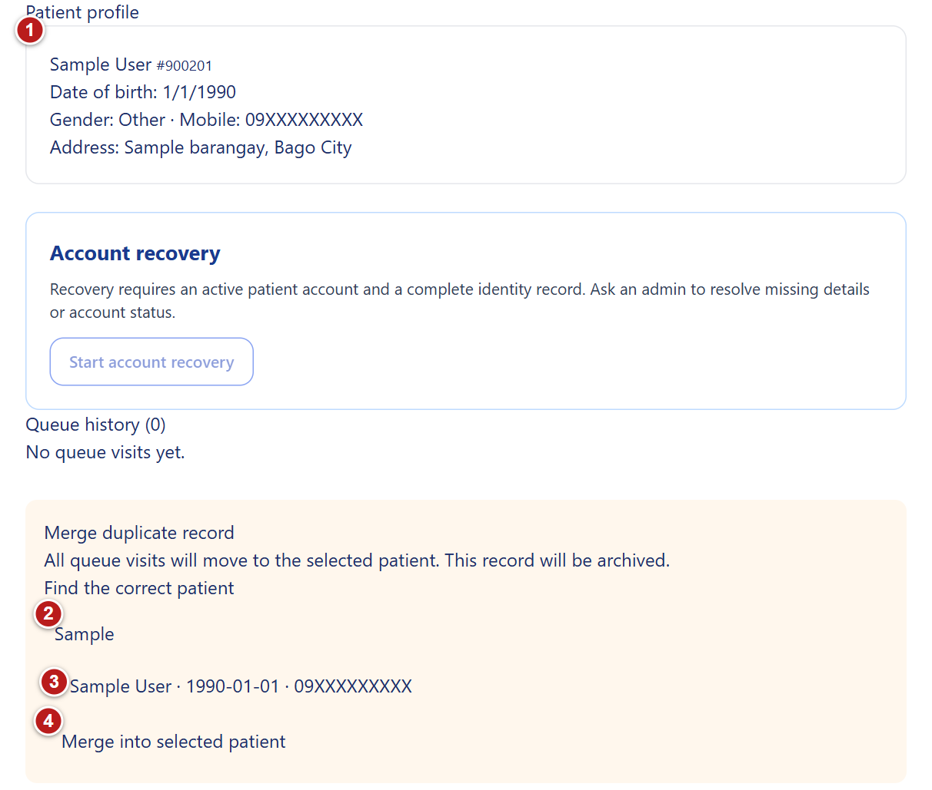
Figure 19 Merge a duplicate walk in record Example records
1 Source walk-in record verify that this is the duplicate whose visits should move. 2 Find the correct patient searches the destination by name or mobile number. 3 Destination patient compare the record carefully before selecting it. 4 Merge moves every queue visit and archives the source after confirmation.
Merge duplicate record appears only for an unarchived walk-in record that is not linked to a login account. Merging moves every queue visit to the selected patient and archives the duplicate record.
1. Open the duplicate walk-in's Patient profile and verify that it is the record whose visits should be moved.
2. Under Merge duplicate record, use Find the correct patient to enter a name or mobile number.
3. Compare the search results by name, date of birth, and masked contact number. Select the radio button for the correct destination patient.
4. Select Merge into selected patient. The button is enabled only after a destination is selected.
5. Read the confirmation: Move every queue visit to the selected patient and archive this record? Confirm only after checking both records.
6. After a successful merge, the destination Patient profile opens. Check the resulting queue history.
Note The source must be an active, unarchived walk-in record. An account-linked source or an archived destination cannot be used.
Note If both records have separate active queues today, resolve the active queues first. The merge is refused while more than one active queue exists across the two records.
Note This action changes which patient owns the visits and archives the source record. Check the destination carefully before confirming.

Find a patient for account recovery
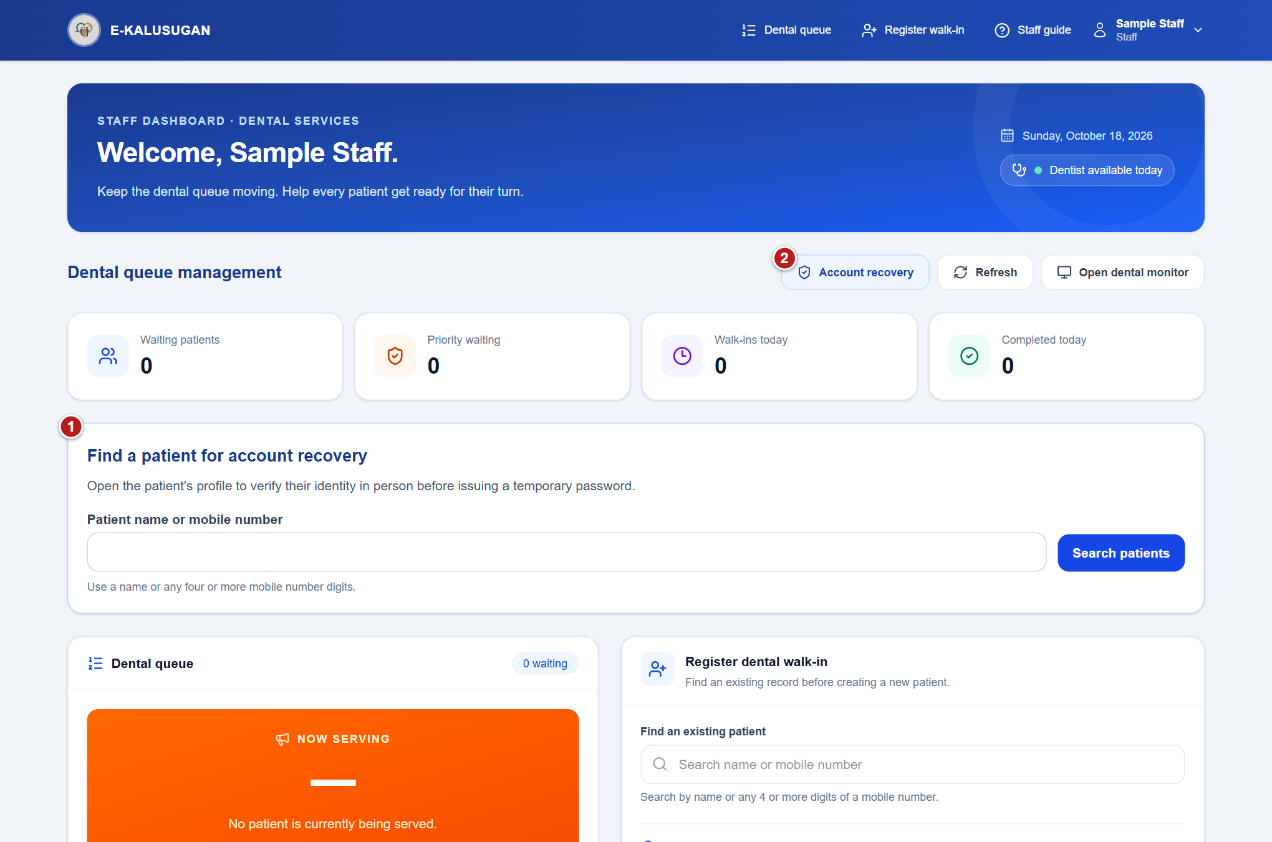
Figure 20 Find a patient for account recovery
1 Account recovery search finds the patient before identity checks. 2 Account recovery opens or closes the search panel.
1. On the staff dashboard, select Account recovery to show Find a patient for account recovery.
2. Enter Patient name or mobile number, using at least two name characters or four mobile digits, and select Search patients.
3. Choose the matching result to open Patient profile. If no record matches, the search displays No matching patient records.
Note Account recovery is for a patient who is physically present. Search for the correct record and open the profile before starting the verification checklist.

Verify identity and issue recovery access
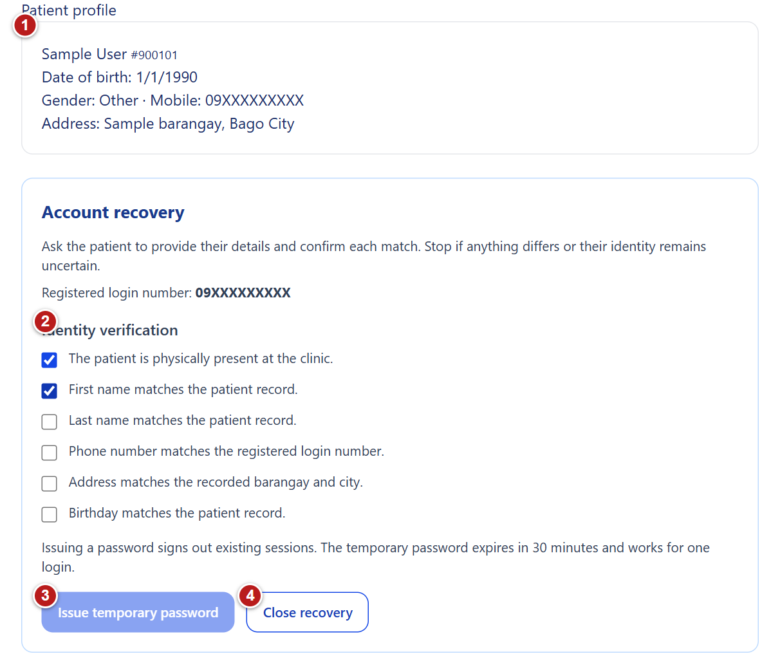
Figure 21 Verify identity and issue recovery access Example records
1 Selected patient details compare these against what the patient provides. 2 Verify physical presence and every identity item before checking each box. 3 Issue temporary password stays disabled until all six checks are complete; issuance replaces old access. 4 Close recovery stops without issuing a password.
Use this process when a patient cannot access an existing account. The patient must be physically at the clinic and every identity check must match before a temporary password is issued.
1. In Account recovery, select Start account recovery. If the button is disabled, read the message and ask an administrator to resolve the account status or missing identity details.
2. Ask the patient to provide their details. Check each statement only after confirming it: the patient is physically present; first name matches; last name matches; phone number matches the registered login number; address matches barangay and city; and birthday matches.
3. If any detail differs or identity remains uncertain, stop. Use Close recovery without issuing a password.
4. When all six boxes are checked, select Issue temporary password. Read and accept the confirmation only after identity has been verified in person.
5. Hand the displayed temporary password directly to the verified patient together with the Registered login number. Read the expiration time, which is shown in Philippine time.
6. Tell the patient to log in before the 30-minute expiry. The password works for one login, after which the patient must choose a new password within 15 minutes.
7. Select Hide temporary password after handing it to the patient. Closing the section hides this displayed password permanently.
Note Recovery is available only for an active patient login account linked to an unarchived patient record, with a registered phone number, birthday, first and last names, barangay, and city.
Note Issuing the temporary password replaces the old password and signs out existing sessions. It also invalidates any earlier temporary password.
Note The password is handed to the patient on this page; this recovery process does not promise an SMS containing it.
Note If another authorized person has changed the account, refresh the patient profile and perform all identity checks again.
Note The system limits recovery requests. If the page says Too many recovery requests. Please try again in 15 minutes., wait for that period before another request.

4 Dentist instructions
Manage today's dental service, document consultations, and prepare clinical reports from the Doctor account.

Understand the dentist dashboard
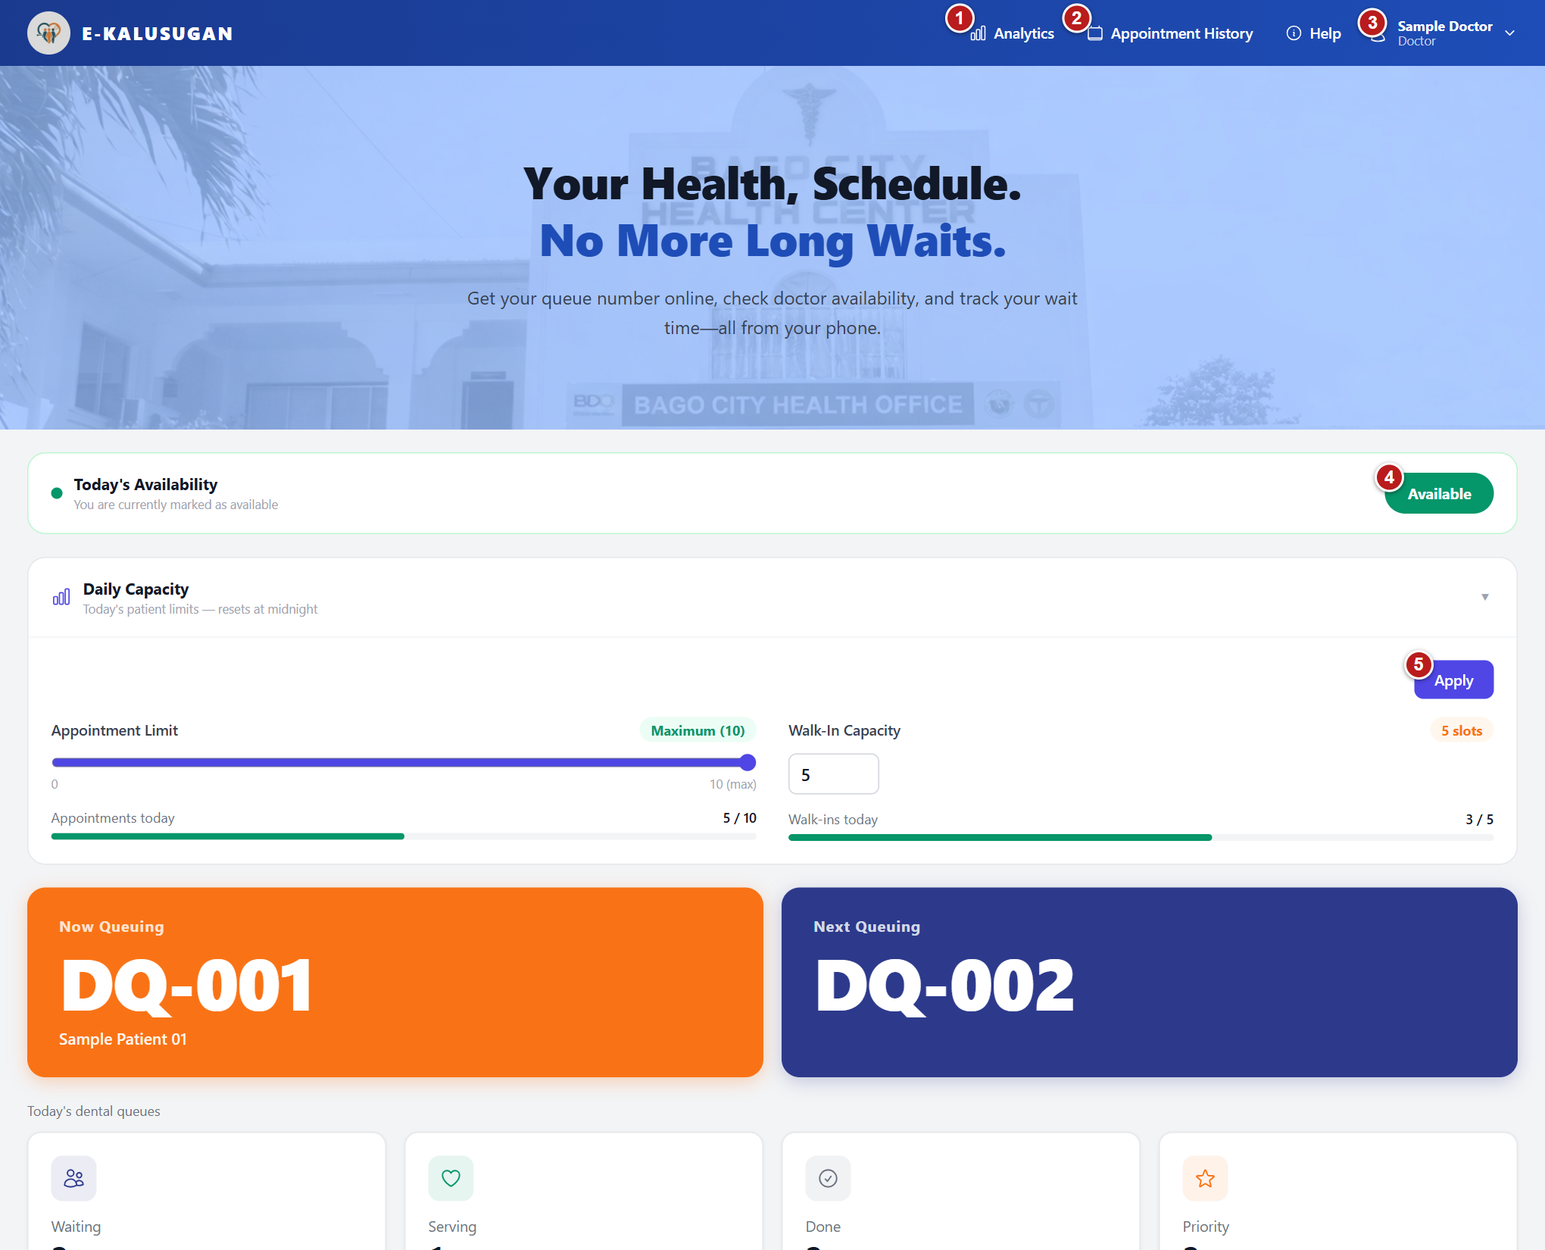
Figure 22 Dentist dashboard Example records
1 Analytics - view dental activity, clinical entries, and reports. 2 Appointment History - review your appointments. 3 Account menu - check your identity or Log Out. 4 Availability - select the current status to change it. 5 Apply - save daily capacity settings.
Use the dashboard as the starting point for today's dental queue and service settings.
1. Sign in using an active Doctor account. The Doctor dashboard opens on its home view.
2. Read Today's Availability and Daily Capacity before receiving patients.
3. Use Now Queuing to identify the current called or serving ticket and Next Queuing to see the next waiting ticket.
4. Read Waiting, Serving, Done, and Priority cards for today's dental queues. Priority is the number of priority tickets in today's dental queue data, including tickets in other states; it is not solely the number still waiting.
5. Use Analytics for activity summaries, clinical entries, and reports. Use Appointment History for the signed-in doctor's appointment list.
6. Open the account menu at the upper right to view the signed-in identity and use Log Out when finished. On a narrow screen, use Toggle menu to reveal navigation.

Set availability and daily capacity
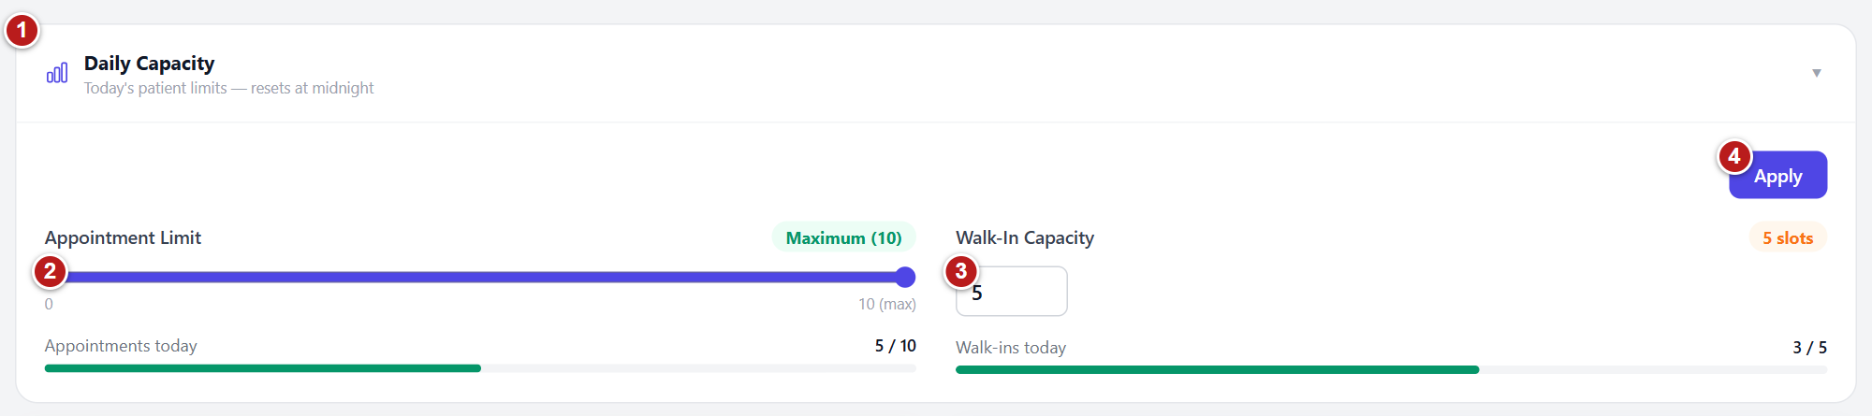
Figure 23 Set availability and daily capacity Example records
1 Daily Capacity - expand or collapse this panel. 2 Appointment Limit - choose 0 to 10 appointments. 3 Walk-In Capacity - enter 0 to 30 slots. 4 Apply - save both limits; wait for Saved.

Set availability
Tell users whether the doctor is available for today's service.
1. Find Today's Availability near the top of the home view.
2. Read the current state: Available or Unavailable.
3. Select the status button to switch to the opposite state.
4. Wait while the button shows Saving.... Check that the displayed state changes successfully. If an error appears, address it before assuming availability was updated.
Note The button displays its current state: selecting Available marks the doctor unavailable; selecting Unavailable marks the doctor available.
Note Availability saves immediately. Capacity changes use the separate Apply button.

Set patient limits
Control the number of patients accepted for the day.
1. Open Daily Capacity if the panel is collapsed.
2. Move the Appointment Limit slider to the required value from 0 to 10.
3. Enter Walk-In Capacity from 0 to 30. A blank field represents zero and the badge shows Not set.
4. Compare Appointments today and Walk-ins today with the selected limits. The progress bars show the proportion already used.
5. Select Apply and wait for Saved .
6. If Lower Appointment Limit? appears because the new appointment limit is below the number already booked, review the existing count. Select Continue to save the lower limit, or Cancel to restore the saved settings.
Note Lowering the appointment limit prevents additional bookings beyond that limit and does not cancel existing appointments.
Note SLOTS FULL appears when the existing count reaches the relevant positive limit.
Note Daily Capacity is labeled Today's patient limits - resets at midnight. Recheck the settings each service day.
Note A zero walk-in value is shown as Not set; set the intended allowance before accepting walk-ins.

Call patients and confirm arrival
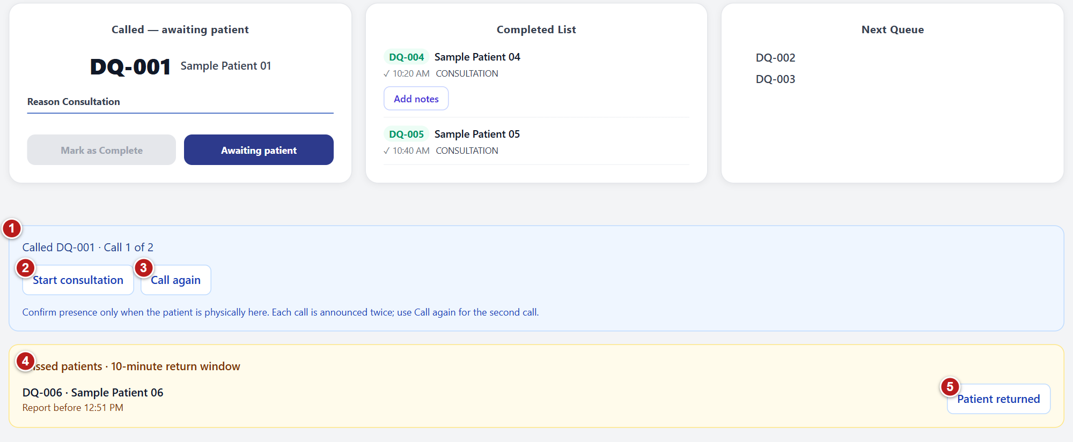
Figure 24 Call patients and confirm arrival Example records
1 Called patient controls - read the call number and wait time. 2 Start consultation - confirm that the patient is physically present. 3 Call again - second call after the 30-second countdown. 4 Missed patients - return deadline for a skipped ticket. 5 Patient returned - restore a missed ticket before its deadline.
Advance the dental queue after confirming the patient's presence.
1. Check that no patient is already called and waiting for a response. In Currently Serving, select Next to call the next waiting dental ticket.
2. The ticket becomes Called - awaiting patient. Review the ticket and patient name in the current queue card.
3. When the patient is physically present, select Start consultation in Called patient controls. The ticket changes to serving and Consultation Notes opens.
4. If the ticket is already serving and the notes dialog is closed, select Consult to reopen it.
5. If the patient does not respond, wait until the displayed 30-second countdown ends. Select Call again for the second call.
6. After the second call, wait for the next countdown to end, then select Skip and call next if the patient is still absent.
7. A skipped ticket appears under Missed patients | 10-minute return window. If the patient returns before the shown deadline, select Patient returned. After the return window expires, that button is disabled.
Note Each call is announced twice, according to the interface instruction.
Note Next is disabled when there is no waiting ticket, while a call is already pending, or while an action is processing.
Note Presence must be confirmed only when the patient is physically at the clinic.

Document and complete the consultation
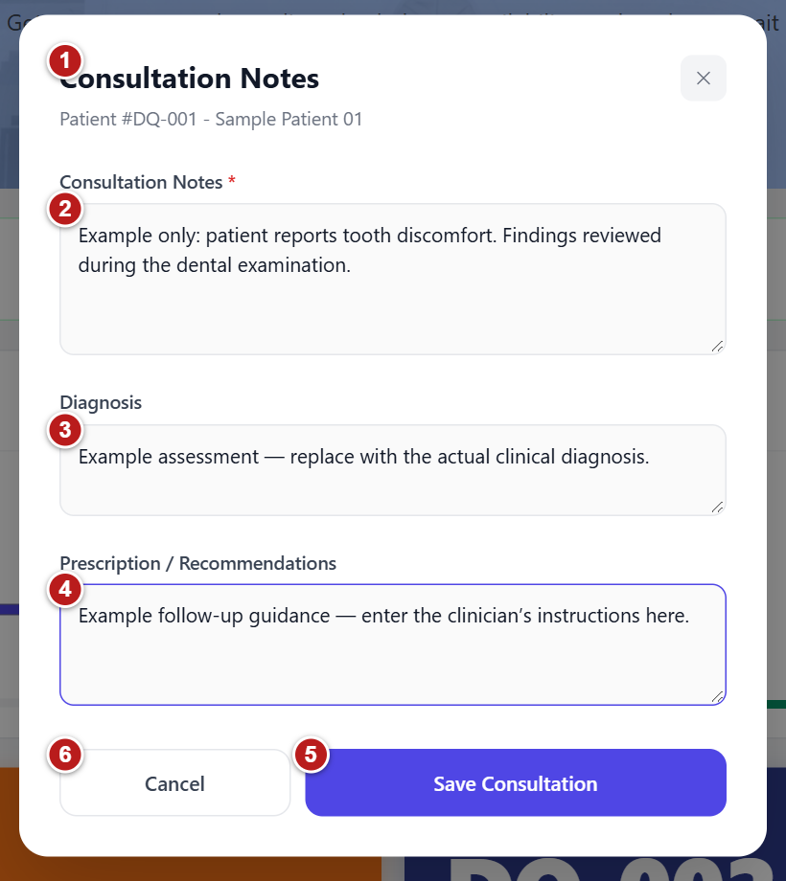
Figure 25 Document and complete the consultation Example records
1 Consultation Notes - verify the patient and queue number. 2 Consultation Notes - required clinical findings. 3 Diagnosis - enter the clinical assessment. 4 Prescription / Recommendations - treatment and follow-up. 5 Save Consultation - save documentation and finish the serving visit. 6 Cancel - close without saving.
Record the clinical encounter against the correct dental queue visit.
1. Open Consultation Notes through Start consultation or Consult and verify the patient name and queue number at the top.
2. Enter the required Consultation Notes, for example the chief complaint, history, and examination findings.
3. Enter Diagnosis when appropriate.
4. Enter Prescription / Recommendations when appropriate, including medication instructions or follow-up guidance.
5. Review all entries and select Save Consultation. It remains disabled until the required notes contain text.
6. Wait while Saving... is shown. A successful save closes the dialog and moves a serving ticket to the completed list.
7. If a visit was completed through Mark as Complete before notes were saved, find it in Completed List and use Add notes. Add notes is shown only for completed tickets without a saved consultation.
Note Mark as Complete is available only when a patient is serving. Prefer Save Consultation when clinical documentation is ready.
Note The system permits one saved consultation per queue visit. It rejects saving when the ticket is not serving or done, when it has expired, or when a consultation already exists.
Note If an error appears, leave the dialog open, review the message, and check the ticket state before trying again.
Note The current dialog retains its field state during the dashboard session; always review every field and the patient heading when opening notes for another patient.

Review appointment history
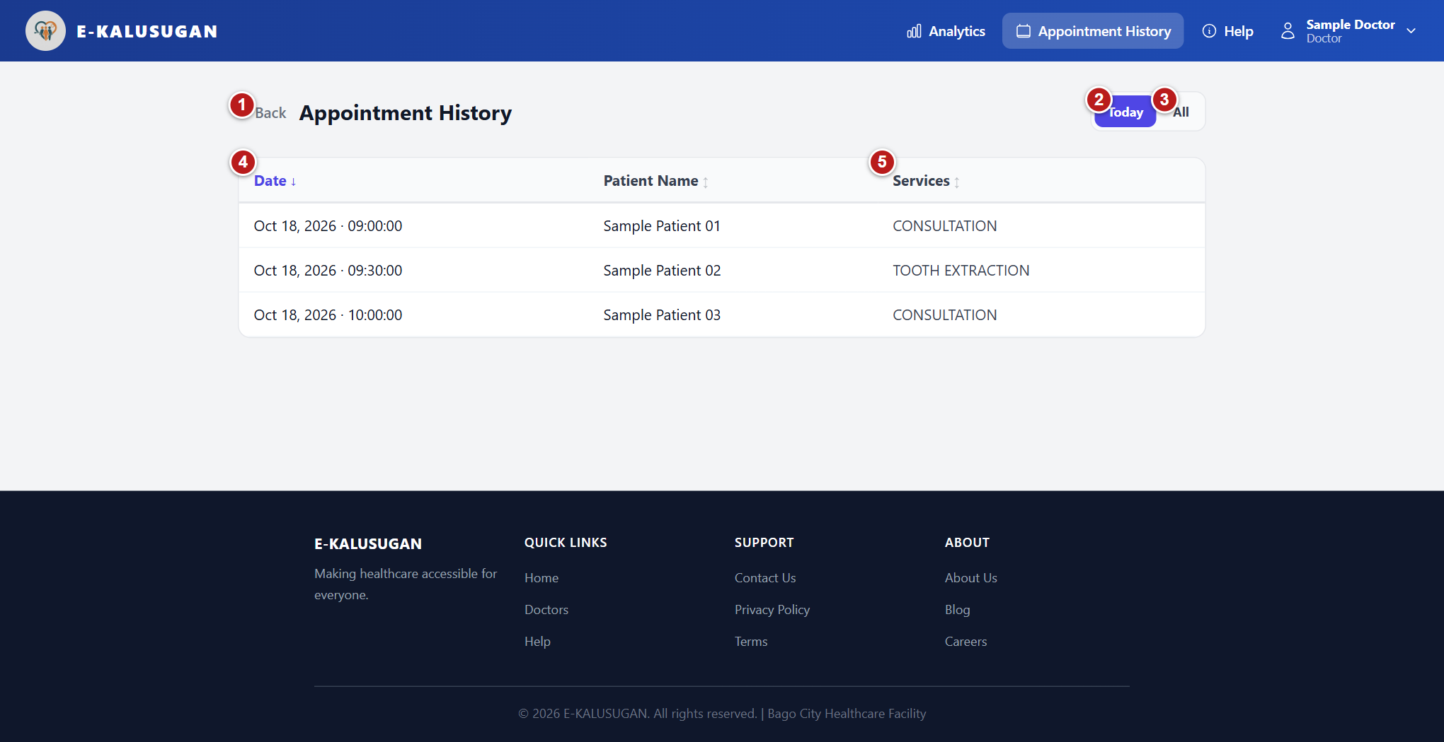
Figure 26 Review appointment history Example records
1 Back - return to the Doctor dashboard. 2 Today - show appointments for the current day. 3 All - show the full loaded appointment history. 4 Date - select a heading to sort; select again to reverse. 5 Services - review the appointment's service details.
1. Select Appointment History in the top navigation.
2. Select Today for appointments on the current day, or All for the complete loaded appointment history.
3. On a desktop, select Date, Patient Name, or Services to sort by that column. Select the same heading again to reverse the order; an arrow shows the direction.
4. Read the Date, Patient Name, and Services values. On a phone, the records are displayed as cards.
5. Select Back to return to the Doctor dashboard.
Note No appointments for today. and No appointments yet. are valid empty states.
Note This view is for review; no appointment-edit or cancellation control is implemented here.

Read dentist analytics
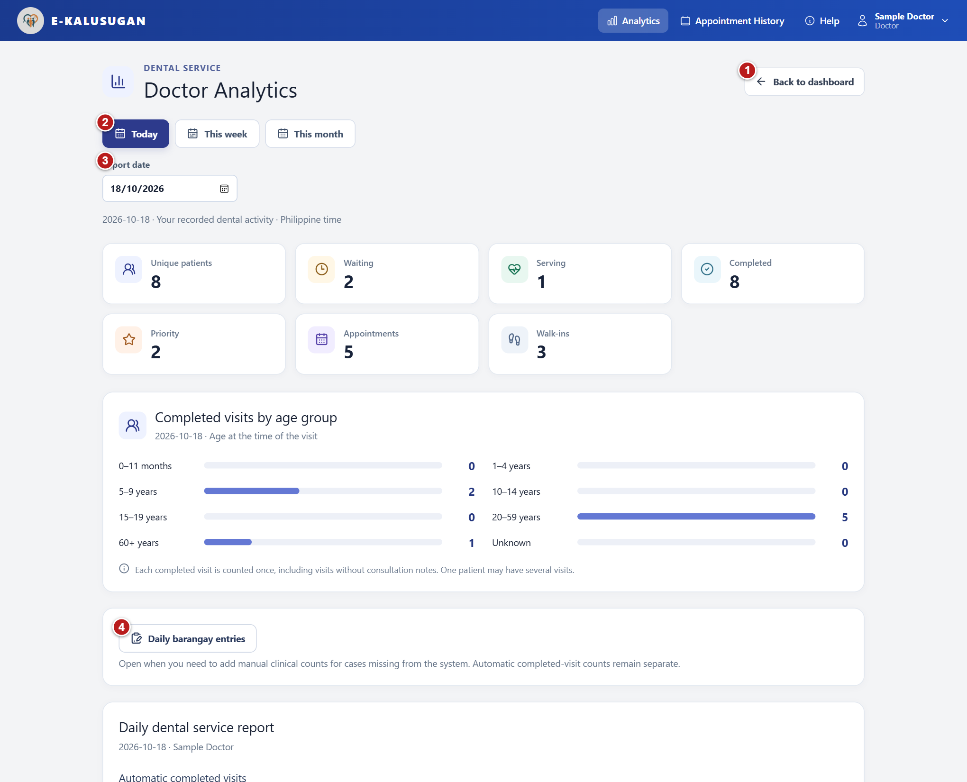
Figure 27 Read dentist analytics Example records
1 Back to dashboard - return to the dental queue. 2 Today / This week / This month - choose the report period. 3 Report date - select an earlier date or period. 4 Daily barangay entries - open manual clinical counts.
1. Select Analytics to open Doctor Analytics.
2. Select Today, This week, or This month. For an earlier period, use Report date, Week containing, or Report month.
3. Read the displayed date range, which uses Philippine time. Weekly periods run Monday-Sunday.
4. Review Unique patients, Completed, Priority, Appointments, and Walk-ins. Waiting and Serving are additionally shown in the daily view.
5. Review Completed visits by age group. These counts use the patient's age at the time of the visit.
6. Scroll to Automatic completed visits to review the barangay, sex, and age-group breakdown. Review any notice for missing demographics or barangays outside the report list.
7. If a data request fails, use the Retry button beside that error. Use Back to dashboard when finished.
Note Unique patients and completed visits are different measures. A patient can have several completed visits.
Note Each completed visit is counted once, including a completed visit without saved consultation notes.
Note Automatic completed visits and manual clinical counts remain separate; a completed ticket does not by itself establish BOHC or another clinical outcome.
Note Analytics and reports refresh approximately every 30 seconds. Future dates are unavailable in the date selectors.

Enter daily barangay clinical counts
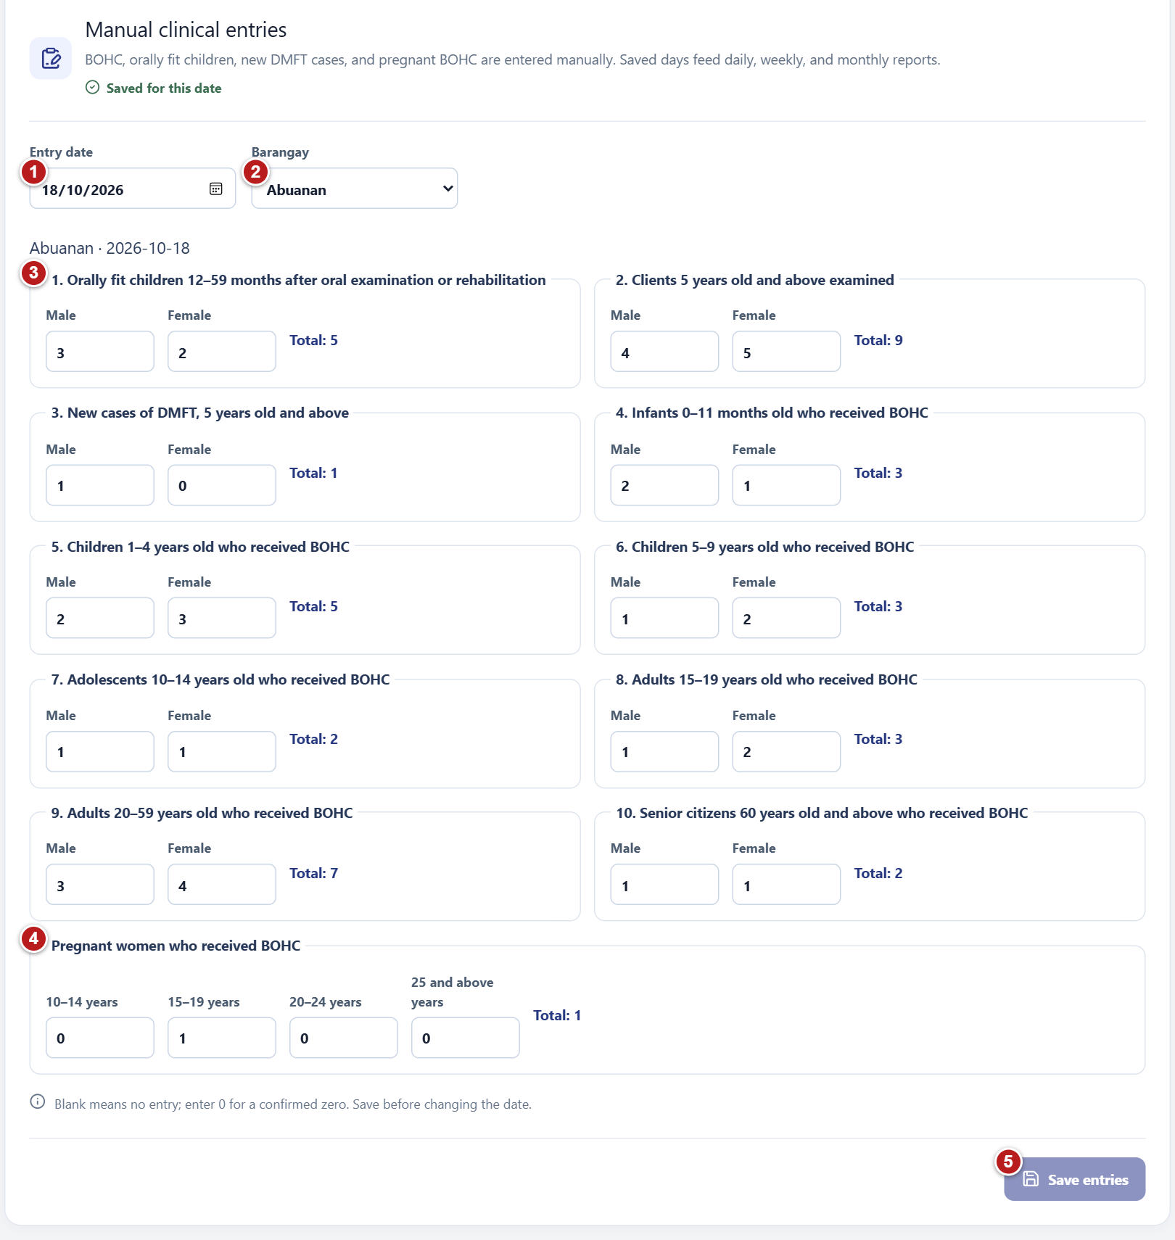
Figure 28 Enter daily barangay clinical counts Example records
1 Entry date - choose the clinical reporting day. 2 Barangay - choose the area for these clinical counts. 3 Clinical measures - enter verified Male and Female counts. 4 Pregnant BOHC - record counts by the displayed age groups. 5 Save entries - save changes before changing the date.
Record verified clinical totals that are not automatically established by queue completion.
1. In Analytics, select Daily barangay entries.
2. Choose Entry date and wait for the saved values to load. Ready for entries indicates that no saved record exists yet; Saved for this date indicates existing saved values.
3. Choose the Barangay.
4. Enter Male and Female counts for each applicable clinical measure. The form calculates the Total beside each group.

Save and check clinical counts
1. Enter applicable counts in Pregnant women who received BOHC for 10-14 years, 15-19 years, 20-24 years, and 25 and above years.
2. Select other barangays as needed and enter their counts for the same date.
3. Review the date, barangays and counts, then select Save entries. Wait for Saved for this date before changing the date or report period.
4. If Earlier unassigned totals for this date appears, review those legacy values and assign them to the correct barangays manually only when their source is known.

Clinical measures in the entry form
- Orally fit children 12-59 months after oral examination or rehabilitation
- Clients 5 years old and above examined
- New cases of DMFT, 5 years old and above
- Infants 0-11 months old who received BOHC
- Children 1-4 years old who received BOHC
- Children 5-9 years old who received BOHC
- Adolescents 10-14 years old who received BOHC
- Adults 15-19 years old who received BOHC
- Adults 20-59 years old who received BOHC
- Senior citizens 60 years old and above who received BOHC
Note BOHC means Basic Oral Health Care. DMFT is shown as a clinical measure in the form; enter verified clinical counts according to the facility's reporting definitions.
Note Blank means no entry; enter 0 only for a confirmed zero.
Note The count fields accept non-negative whole numbers up to nine digits. Totals are automatic.
Note Unsaved changes disables the date, period and report export controls. Save before changing the date. Back to dashboard asks whether to discard unsaved barangay entries.
Note Saved daily entries are added together for weekly and monthly clinical reports.

Print or download reports
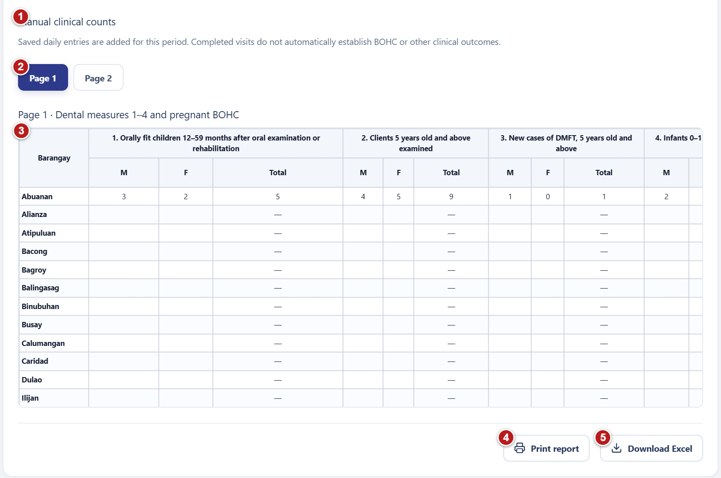
Figure 29 Print or download reports Example records
1 Manual clinical counts - saved daily clinical measures. 2 Page 1 / Page 2 - switch the clinical measure table. 3 Clinical report table - barangay totals and clinical measures. 4 Print report - opens the browser print dialog when data is ready. 5 Download Excel - saves the period report when data is ready.
1. Select the required period and date in Analytics.
2. Scroll to Daily dental service report, Weekly dental service report, or Monthly dental service report.
3. Review Automatic completed visits and the separate Manual clinical counts.
4. Use Page 1 to review dental measures 1-4 and pregnant BOHC. Use Page 2 to review BOHC age groups 5-10.
5. Save any unsaved clinical entries and wait until report data finishes loading.
6. Select Print report to open the browser print dialog, or Download Excel to save the report workbook.
7. Review the downloaded file or print preview for the selected doctor, period and date range.
Note Print report and Download Excel remain disabled while requests are loading, errors are unresolved, entries are unsaved, or the selected period has neither completed visits nor manual entries.
Note The Excel filename follows dental-report-[period]-[start-date].xlsx.
Note The print version includes both clinical report pages.

5 Administrator instructions
Oversee service activity, manage accounts, review patient history, and configure SMS notifications.

Navigate the administrator dashboard
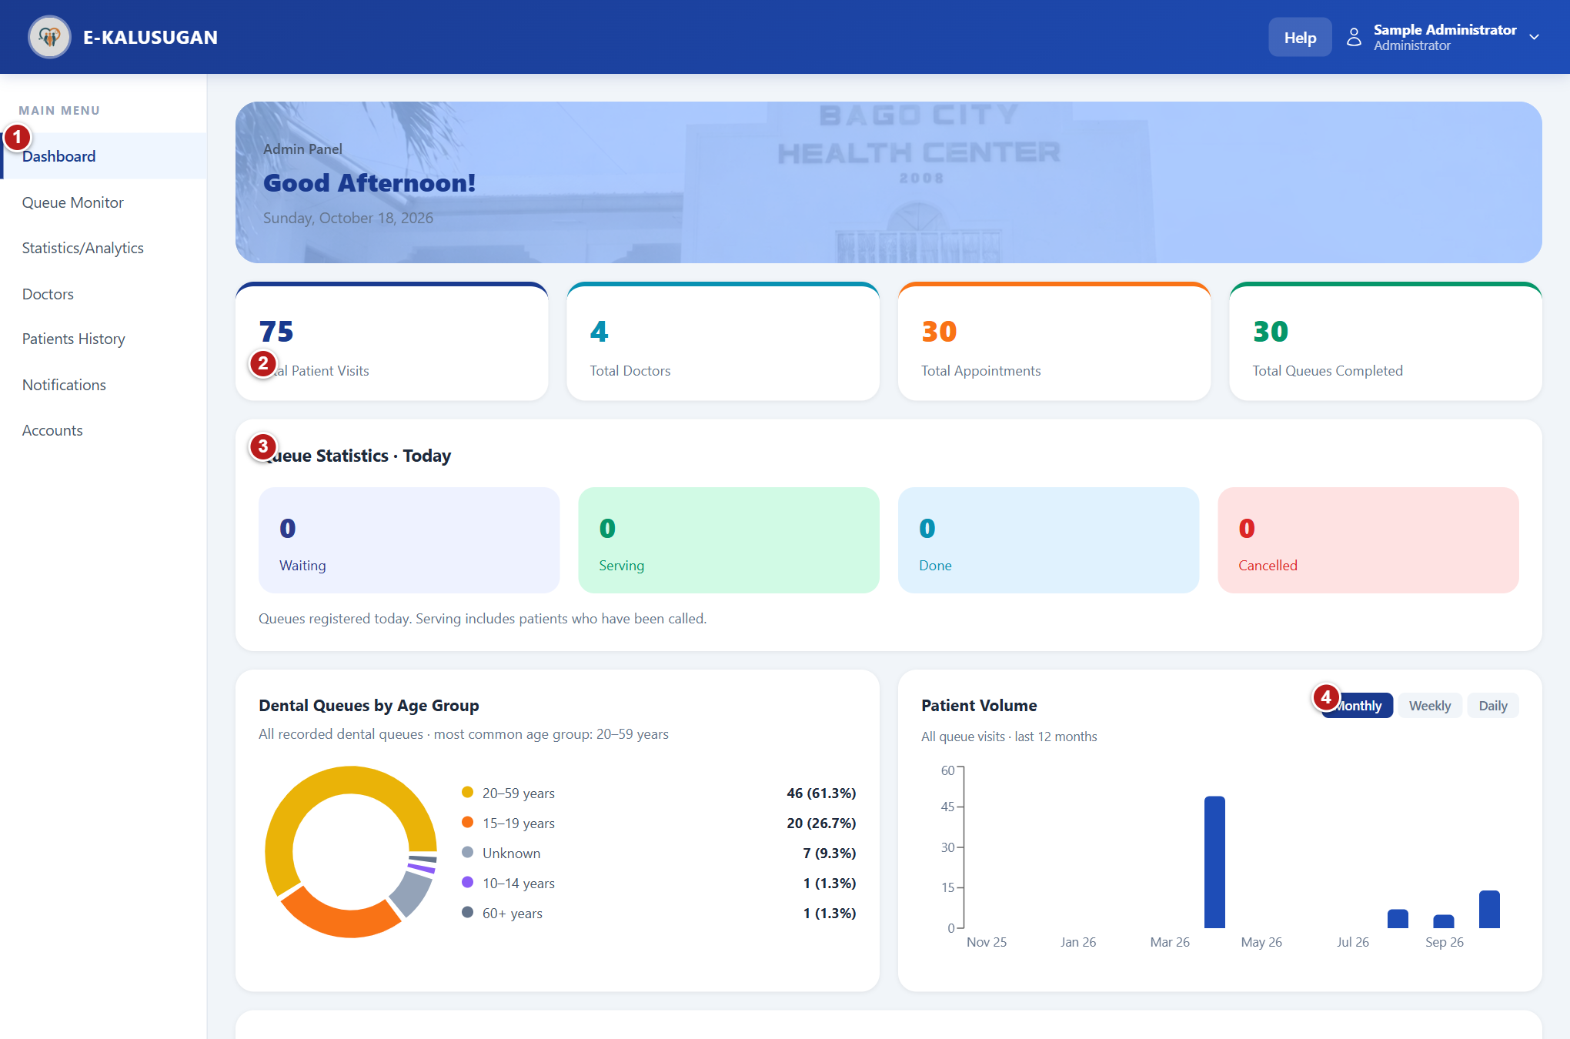
Figure 30 Administrator dashboard
1 Dashboard - return to the administrator overview. 2 Overview cards - review recorded visits, doctors, appointments and completed queues. 3 Queue Statistics - check today's waiting, serving, done and cancelled totals. 4 Monthly / Weekly / Daily - change the patient-volume chart period.
1. Sign in using an active Administrator account. The Dashboard overview opens first.
2. Use the left MAIN MENU to switch between Dashboard, Queue Monitor, Statistics/Analytics, Doctors, Patients History, Notifications, and Accounts.
3. On a narrow screen, select Open menu to display the navigation drawer. Select a page to close it, or select Close menu, press Escape, or select the shaded area outside the drawer.
4. Use the account menu at the upper right and select Log Out when finished.

Review activity and volume
Check overall service activity and today's queue before opening a specialist page.
1. Select Dashboard.
2. Review Total Patient Visits, Total Doctors, Total Appointments, and Total Queues Completed.
3. Read Queue Statistics | Today: Waiting, Serving, Done, and Cancelled. Serving includes patients who have been called.
4. Review Dental Queues by Age Group for the displayed age breakdown.
5. In Patient Volume, select Monthly for the last 12 months, Weekly for the last 8 weeks, or Daily for the last 7 days.
6. Review Doctors Profile and Recent Patient History for the available summary details. Open Doctors or Patients History for the dedicated lists.

Monitor and cancel queue tickets
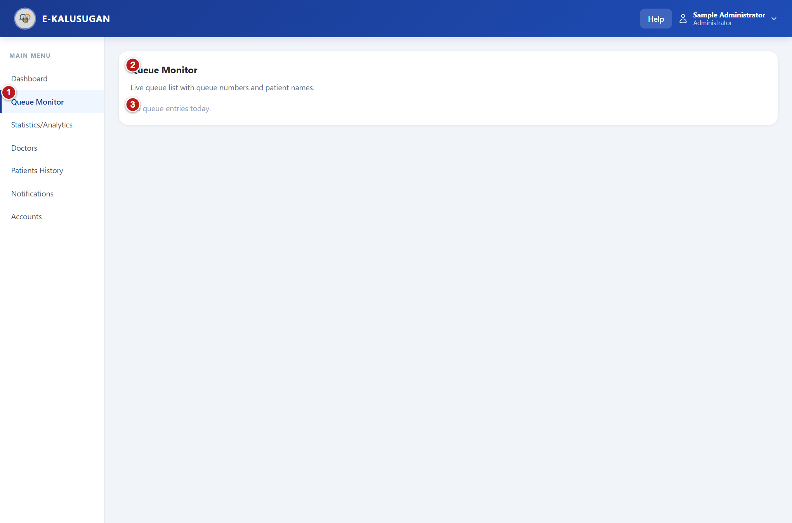
Figure 31 Monitor and cancel queue tickets
1 Queue Monitor - open the live queue list. 2 Live queue - view ticket numbers, patient names, priority and status; the list refreshes automatically. 3 Empty queue - this message appears when today has no tickets.
1. Select Queue Monitor. The list refreshes approximately every 15 seconds while this page is open.
2. Identify the ticket by queue number and patient name. Read its Regular or Priority badge and status badge.
3. If a ticket is missed, review Missed call | Return before and the shown deadline.
4. When an active ticket needs to be cancelled, select its Cancel button.
5. In Reason for cancellation, choose one reason: Schedule conflict / no longer available; No longer needs the service; Found care elsewhere; Transportation or access issue; Wait time too long; Booked by mistake / duplicate queue; or Other.
6. Select Continue to submit, or Cancel to leave the ticket unchanged.
7. Check that the list refreshes to show the Cancelled state and the recorded Reason.
Note Cancel is available for waiting, called, serving and missed tickets; the monitor does not offer it for completed or already cancelled tickets.
Note Continue stays disabled until a reason is selected.
Note The Administrator's monitor does not expose the Doctor's consultation form or call-next controls.

Choose a cancellation reason
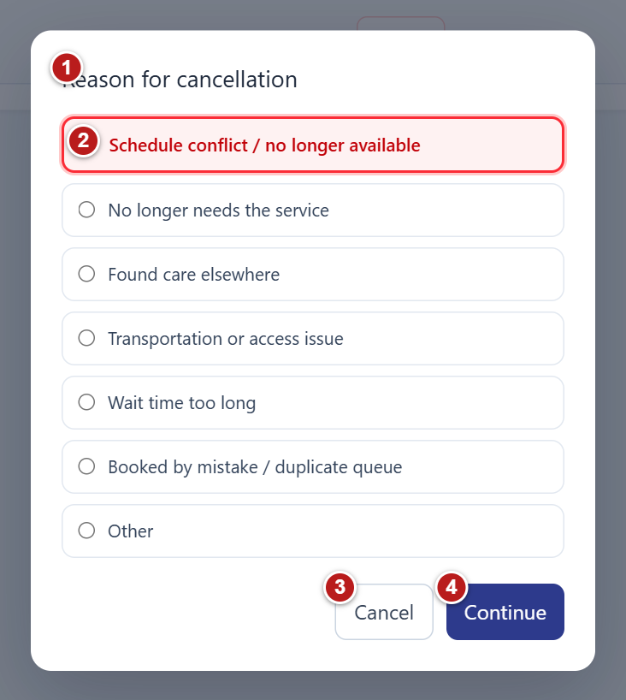
Figure 32 Administrator cancellation reason Example records
1 Reason for cancellation - confirm that you opened the cancellation dialog for the intended ticket. 2 Reason - select the reason that applies; a reason is required. 3 Cancel - close the dialog and leave the ticket unchanged. 4 Continue - cancel the selected ticket using the chosen reason.
Select one reason and then Continue to confirm. Select Cancel to keep the ticket. The reason is stored with the cancelled visit.

Review statistics and forecasts
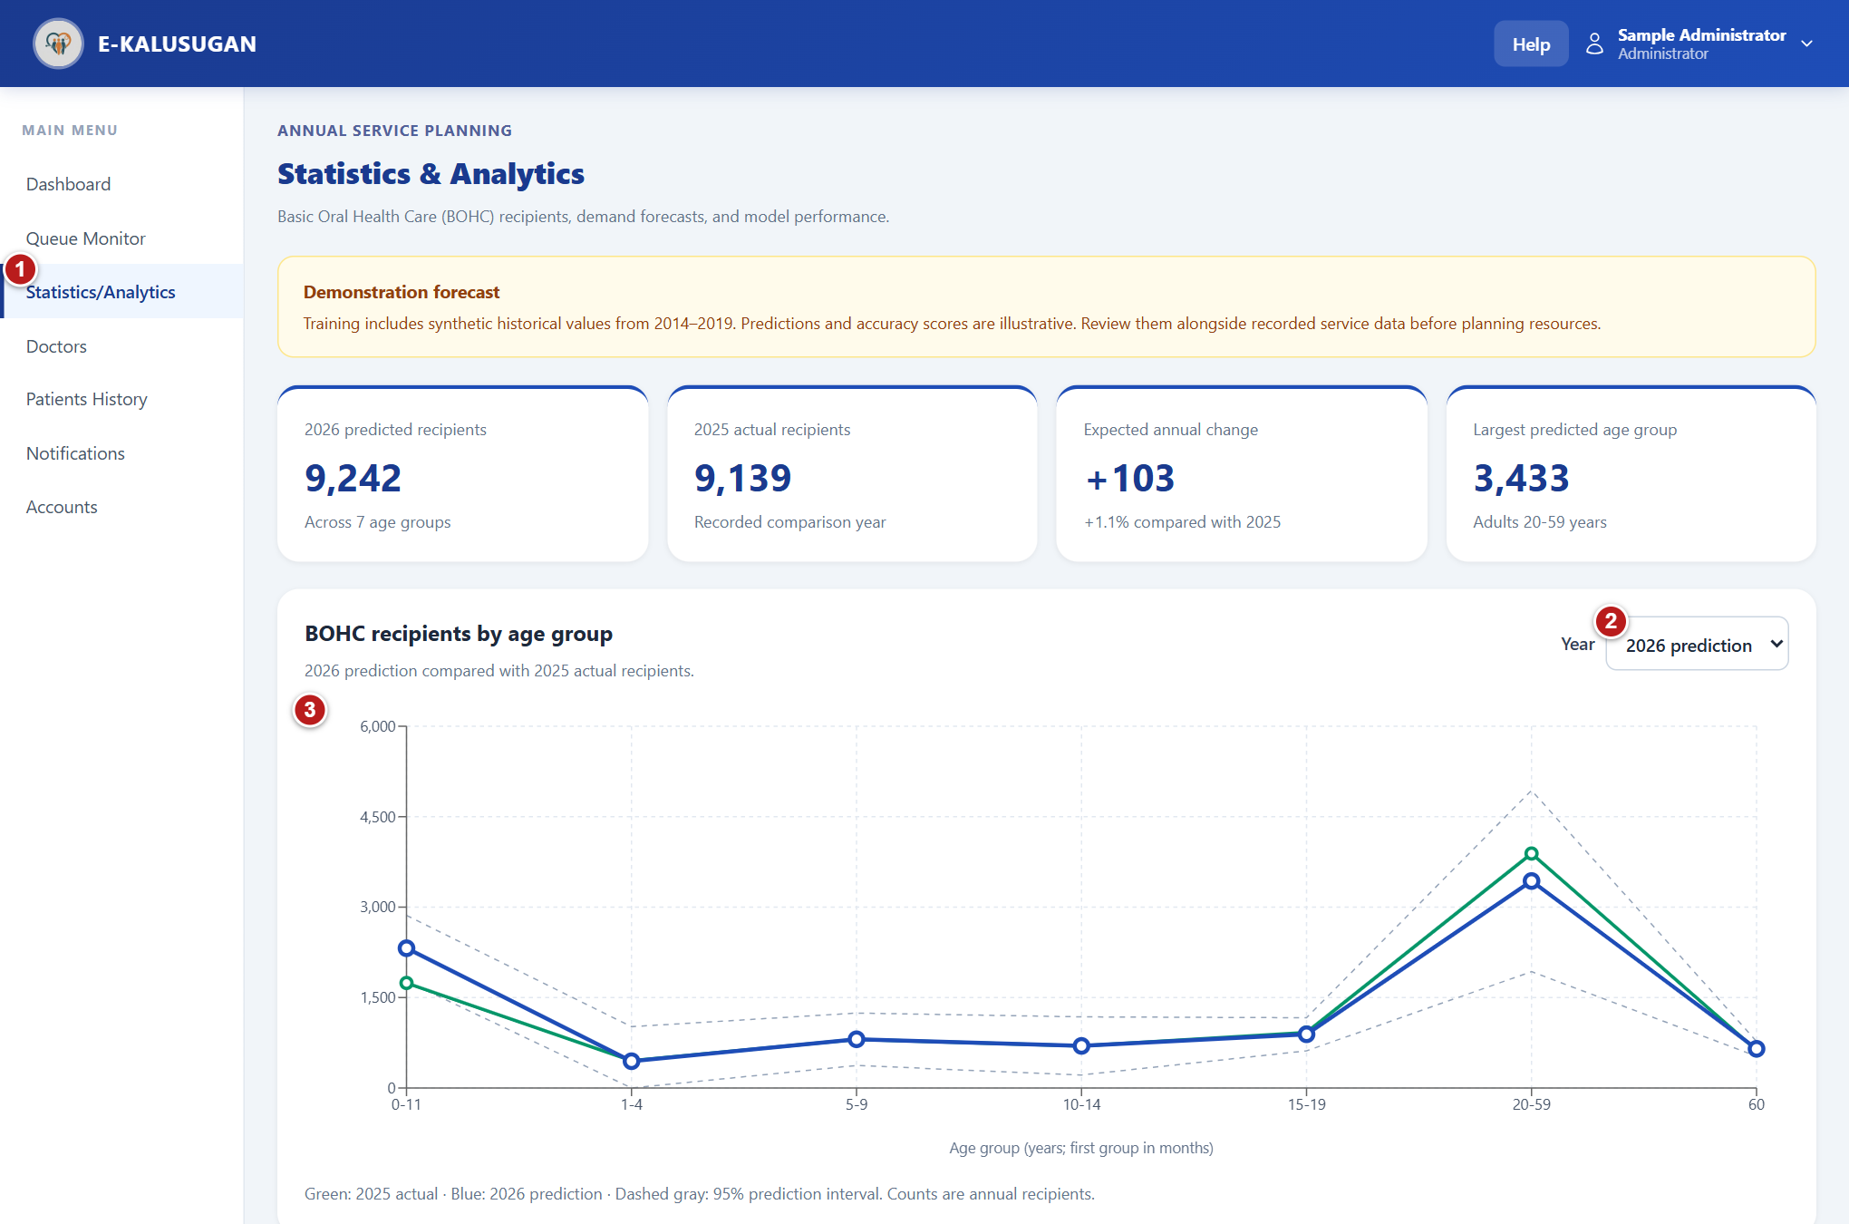
Figure 33 Review statistics and forecasts
1 Statistics/Analytics - open oral health statistics and forecasting. 2 Year - choose recorded historical figures or the 2026 prediction. 3 Recipient chart - compare age groups and, for 2026, predictions with the 2025 actual figures.
Review annual BOHC data and the system's demonstration forecast.
1. Select Statistics/Analytics to open Statistics & Analytics.
2. Read Demonstration forecast and its data limitations before using the numbers for planning. The page states that training includes synthetic historical values and that predictions and accuracy scores are illustrative.
3. Review 2026 predicted recipients, 2025 actual recipients, Expected annual change, and Largest predicted age group.
4. In BOHC recipients by age group, choose Year. Select 2026 prediction to compare the forecast with 2025 actual recipients, or select an available historical year.
5. Hover over or tap a chart point to inspect the full age group and count. Historical-year detail tables identify records as Synthetic, Recorded, or Unavailable.
6. Review 2026 forecast breakdown for age-group counts, change, forecast share, and the 95% prediction interval.
7. Review Model performance by age group and How to read these predictions for definitions and methodology.
Note Green represents 2025 actual counts in the forecast view; blue represents 2026 predictions; dashed gray lines represent lower and upper prediction interval bounds.
Note Change is prediction minus 2025 actual. A dash for Change (%) means the 2025 baseline is zero.
Note Lower MAE, RMSE, and MAPE values indicate smaller historical prediction errors. MAE vs. baseline compares the model to repeating the previous year's count.
Note Prediction intervals are not guarantees or accuracy scores. Per-age-group intervals are not added into a total interval.
Note The current forecast covers 2026 only. Refresh the page to retry if Predictive analytics are unavailable appears.

Check doctor availability
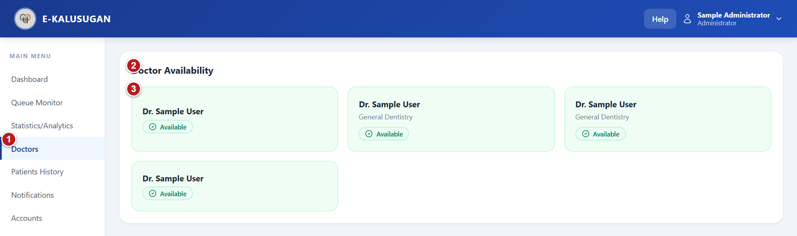
Figure 34 Check doctor availability
1 Doctors - view registered doctors and their availability. 2 Doctor Availability - read each doctor's name and service. 3 Availability badges - identify available and on-leave doctors.
1. Select Doctors to open Doctor Availability.
2. Read each doctor's name, specialization when available, and availability badge.
3. Use Accounts > Staff when you need to create or edit a doctor account. Today's availability itself is maintained in the Doctor dashboard.
Note No doctors registered yet. indicates an empty doctor list. There is no edit or availability-toggle action on this page.

Review patient appointment history
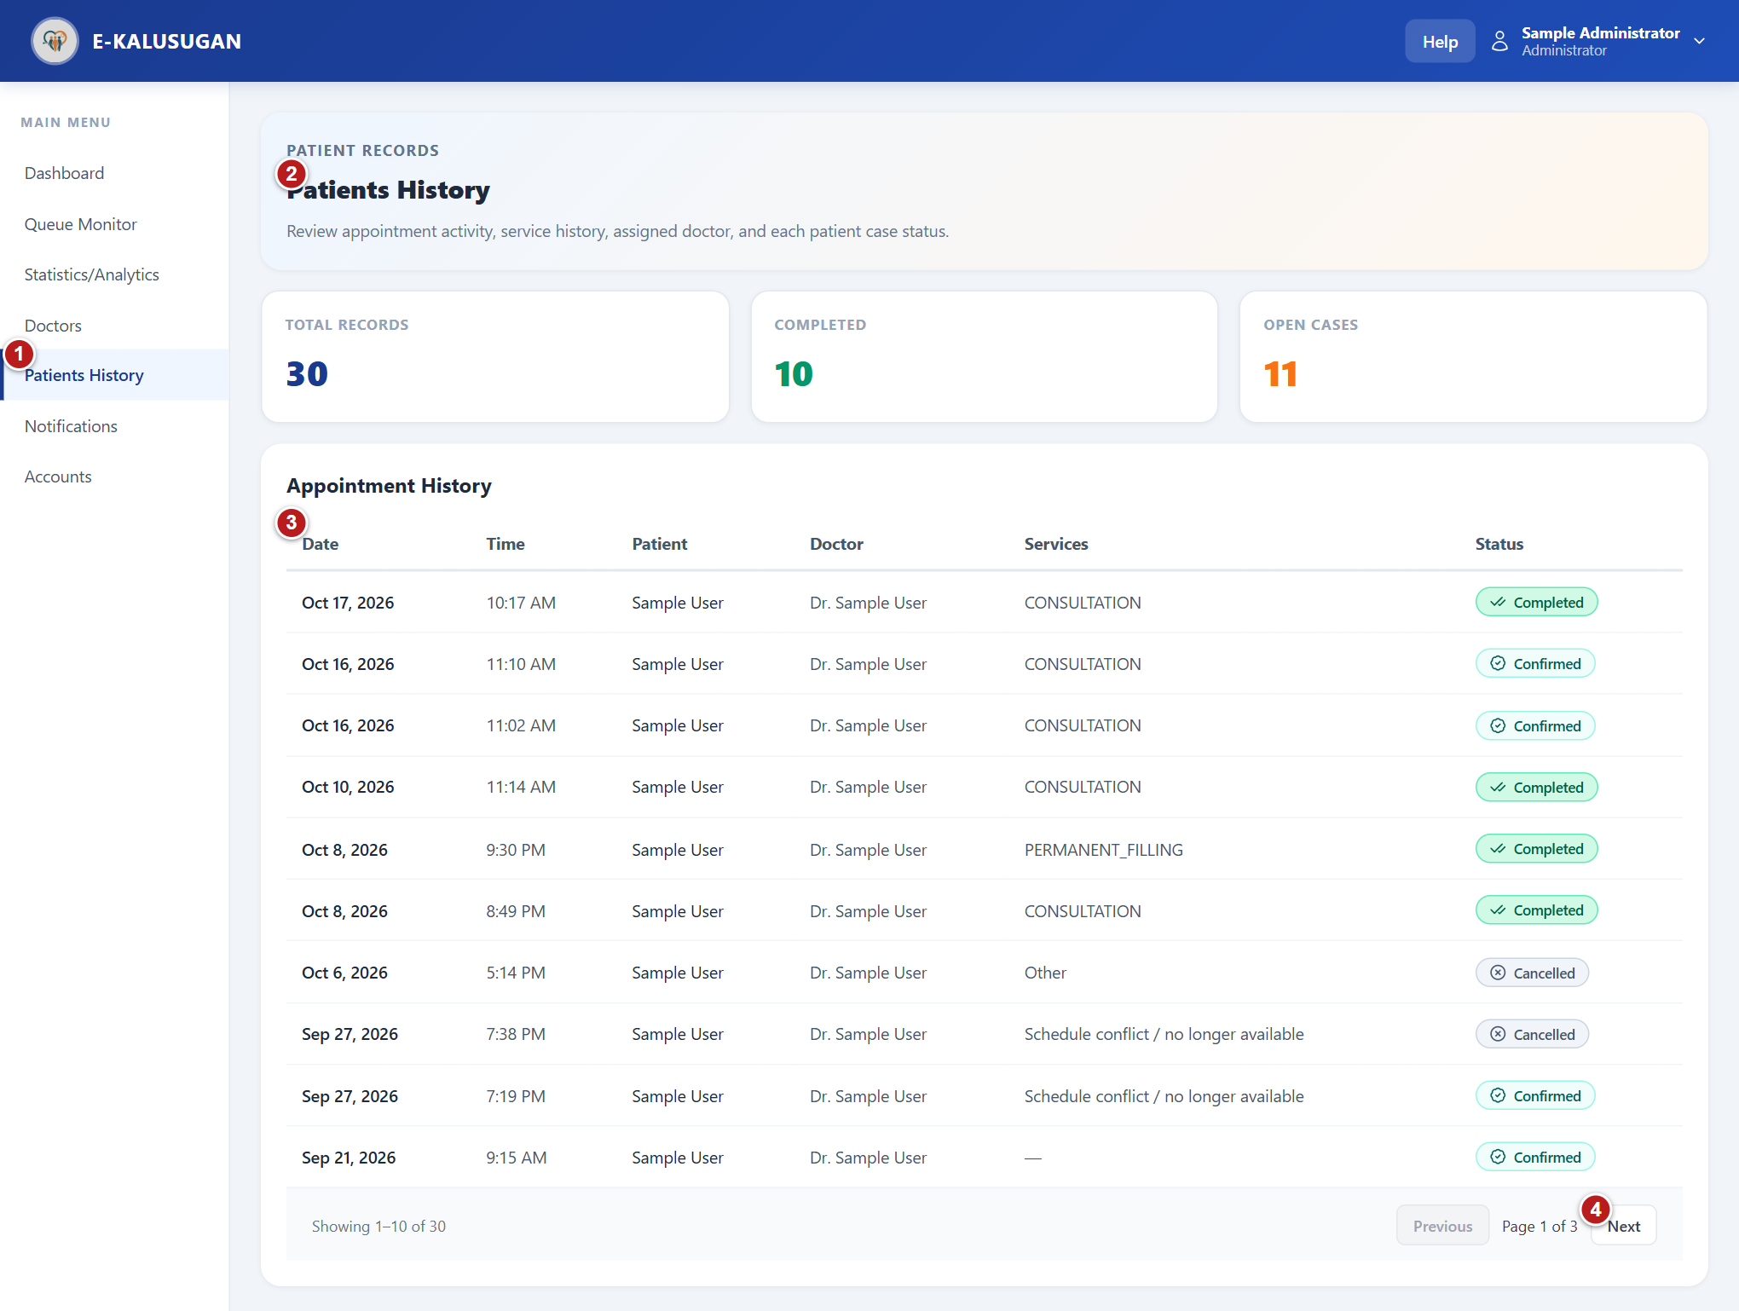
Figure 35 Review patient appointment history
1 Patients History - open appointment and patient history records. 2 History table - review appointment date, patient, doctor and status. 3 Recorded appointments - inspect each row and use the page controls below the table for more records. 4 Previous / Next - move through the appointment history pages.
1. Select Patients History.
2. Review Total Records, Completed, and Open Cases. Open Cases combines pending and confirmed appointments.
3. In Appointment History, read Date, Time, Patient, Doctor, Services, and Status for each appointment.
4. Use Previous and Next below the list to move through pages of 10 records. Check the Showing range and Page number.
5. On a phone, read the patient cards instead of the desktop table.
Note This page reviews appointment and service history; no clinical-note editor is provided.
Note No appointments recorded yet. is the empty state.

Configure and monitor SMS notifications
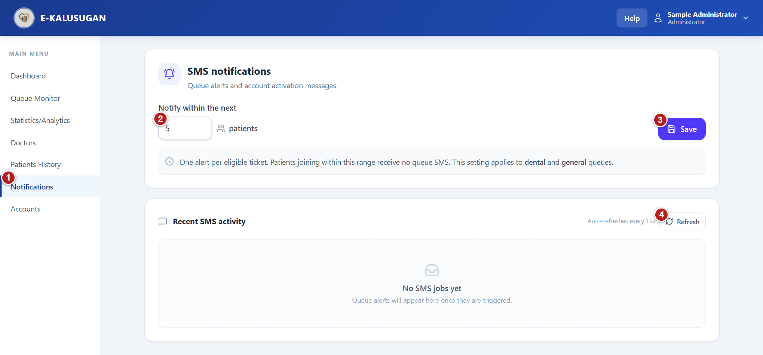
Figure 36 Configure and monitor SMS notifications
1 Notifications - manage queue SMS settings and review SMS activity. 2 Notify within the next - enter a whole-number queue threshold from 1 to 100. 3 Save - apply the notification threshold. 4 Refresh - reload SMS delivery activity immediately.
1. Select Notifications to open SMS notifications.
2. In Notify within the next, enter the desired whole number of patients from 1 to 100.
3. Select Save and wait for SMS threshold saved. Existing suppressed tickets stay suppressed.
4. Read Recent SMS activity. Each row shows Purpose, a masked Recipient, Status, Details, and Created time in Philippine time.
5. Use Refresh to update the list immediately. Otherwise, the list refreshes approximately every 15 seconds.
6. If the status is unknown, follow the displayed instruction: Submission uncertain; check Semaphore before replacing. Review the provider state before issuing another activation password.
Note The threshold applies to dental and general queues.
Note One alert is sent per eligible ticket. Patients who join when already inside the configured range receive no queue SMS.
Note Changing the threshold does not make previously suppressed tickets eligible.
Note A submitted, queued, accepted or sent status should be read as the displayed job/provider state; it does not by itself establish that the patient has read the message.
Note No SMS jobs yet means no jobs are shown in the activity list; queue jobs appear when triggered.

Manage staff doctor and admin accounts
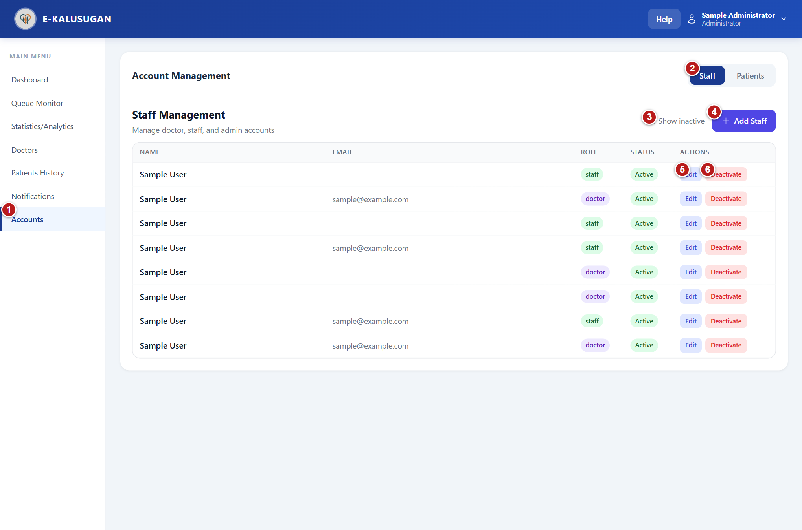
Figure 37 Manage staff doctor and admin accounts
1 Accounts - open account management. 2 Staff / Patients - switch the account list. 3 Show inactive - include deactivated staff accounts in the list. 4 Add Staff - open a form for a doctor, staff or administrator account. 5 Edit - update an existing staff member's account details. 6 Deactivate - open the confirmation that removes this account's system access.
1. Select Accounts in the sidebar, then select Staff. The Staff Management list includes staff, doctor, and administrator accounts.
2. Use Name, Email, Role, and Status in the list to identify the correct person before choosing an action.
3. Select Add Staff to open a new account form. Use Edit on an existing account to update it.

Edit and manage account status
1. Open Accounts > Staff and identify the account using Name, Email, Role, and Status.
2. Select Edit for an active account. In Edit Staff Account, update First Name, Last Name, Email, Phone, and the applicable License Number or Position.
3. Select Save Changes. First and last name are required. Select Cancel or the close icon to leave without saving.
4. To remove access, select Deactivate for the account. Review the named account in Deactivate Account, then select Deactivate to confirm or Cancel to stop.
5. To restore access, enable Show inactive, locate the account, select Reactivate, and confirm Reactivate in the dialog.
6. Confirm that the refreshed list displays the intended Active or Inactive state.
Note Deactivation removes account access; reactivation restores it.
Note Administrators cannot deactivate their own account. The system displays You cannot deactivate your own account.
Note The current edit modal does not change the account's role or password.
Note Use Retry if the account list could not be loaded.

Create a staff doctor or admin account
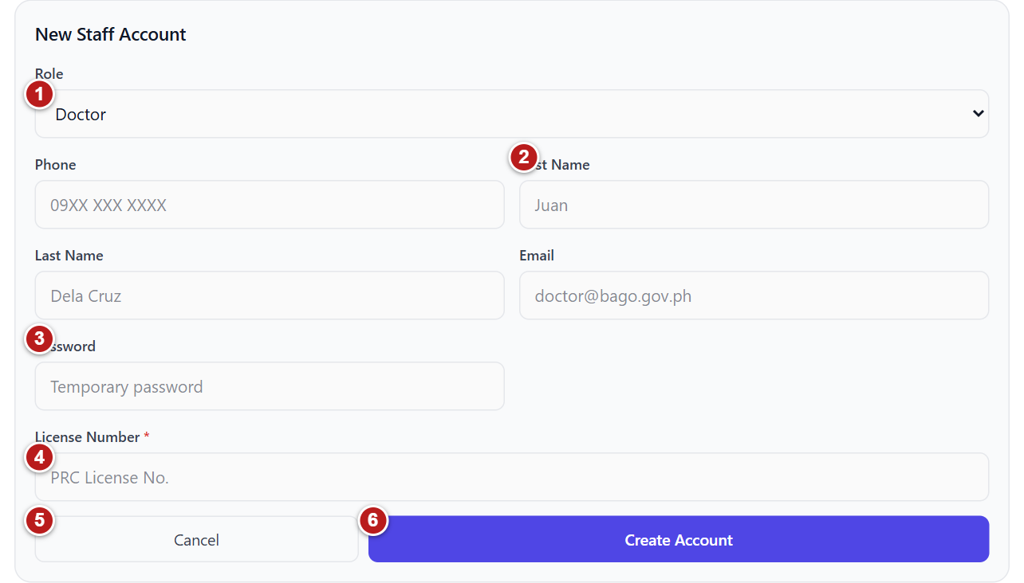
Figure 38 Create a staff doctor or admin account
1 Role - choose Doctor, Staff or Admin. 2 Identity and contact fields - enter the account holder's first name, last name, email and phone. 3 Password - set the initial password for the staff account. 4 Role-specific field - enter the doctor's license number; Staff uses Position. 5 Cancel - close the new-account form. 6 Create Account - validate and create the staff account.
1. Select Accounts, then Staff. Staff Management includes doctor, staff and admin accounts.
2. Select Add Staff to open New Staff Account.
3. Choose Role: Doctor, Staff, or Admin.
4. Enter Phone, First Name, Last Name, Email, and Password. The form requires these entries.
5. For Doctor, also enter License Number. For Staff, enter Position. Changing Role clears the role-specific license and position fields.
6. Review the account details and role, then select Create Account. Wait while Creating... appears.
7. Check that the form closes and the new account appears in the refreshed account list. Resolve any validation error before submitting again.
Note Use a valid Philippine mobile number. The system checks for duplicate phone numbers and duplicate email addresses.
Note The account role determines access. Select it carefully; the edit form does not include a role selector.
Note A doctor license number and staff position are required for their respective roles. The backend can also reject duplicate license values.
Note Cancel closes the new-account form without creating an account.

Find and manage patient accounts
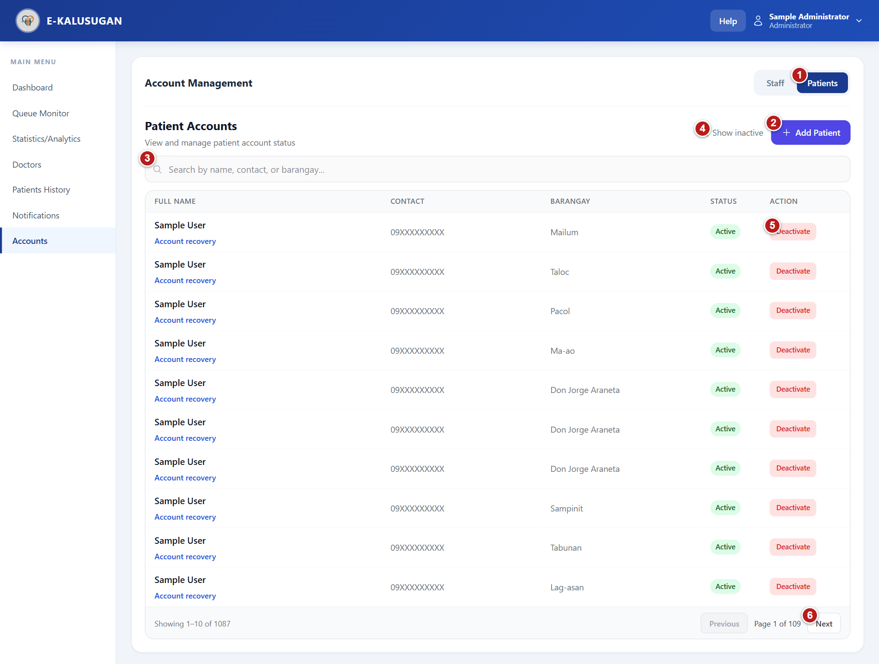
Figure 39 Find and manage patient accounts
1 Patients - switch to patient account management. 2 Add Patient - open the assisted patient-account form. 3 Search - filter the patient list by name, contact or barangay. 4 Show inactive - include deactivated patient accounts. 5 Deactivate - open the account-access confirmation. 6 Previous / Next - move through the patient-account pages.
1. Select Accounts, then Patients to open Patient Accounts.
2. Find the patient using the search and filters. Check account state, activation or password SMS status, and the matching identity.
3. Use Previous and Next to move through pages. Select Add Patient only after checking for an existing account.

Manage activation and access
1. Open Accounts > Patients and find the correct patient.
2. Read Activation SMS below the patient name when first-time password setup is still required.
3. If an activation replacement is required, verify the patient's identity and registered mobile number, then select Issue replacement password.
4. Read the confirmation. Issuing a replacement invalidates the old temporary password and setup session. Confirm only after verifying the person and number.
5. Review the replacement-password SMS status notification and the refreshed Activation SMS value.
6. To suspend a patient's access, use Deactivate and confirm the named account. To restore it, enable Show inactive, select Reactivate and confirm.
7. For a forgotten-password case requiring in-person recovery, use the patient's Account recovery link and follow the identity checks on the patient profile.
Note Issue replacement password is shown for active accounts that still require password setup.
Note Activation replacement by SMS and in-person Account recovery are separate actions with different delivery methods.

Create a patient account
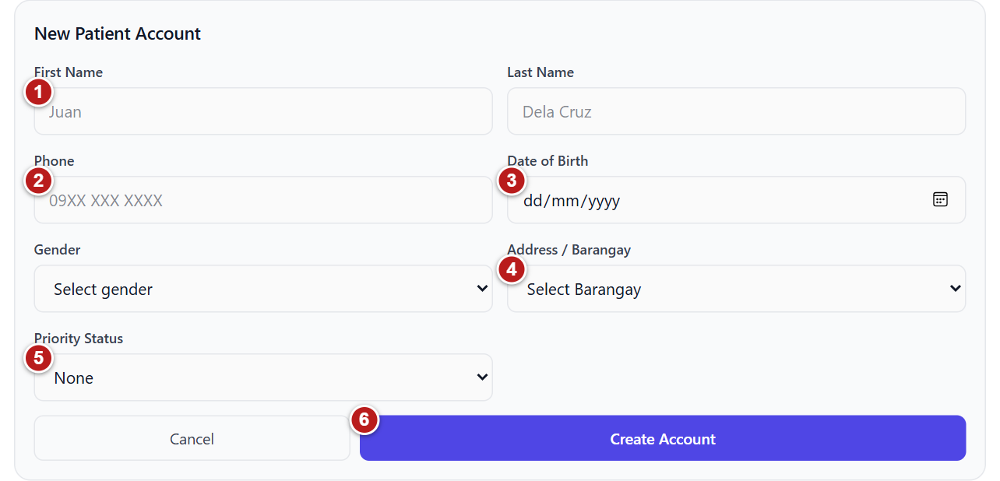
Figure 40 Create a patient account
1 First Name and Last Name - enter the patient's identity. 2 Phone - enter the patient's mobile number. 3 Date of Birth - choose the patient's birth date. 4 Address / Barangay - choose the patient's barangay. 5 Priority Status - choose None, Senior Citizen, PWD or Pregnant, as applicable. 6 Create Account - submit the patient details; Cancel closes the form.
1. Select Accounts, then Patients to open Patient Accounts.
2. Before creating a new account, search by name, contact, or barangay to check whether the patient already exists.
3. Select Add Patient to open New Patient Account.
4. Enter First Name, Last Name, Phone, Date of Birth, Gender, and Address / Barangay.
5. Choose Priority Status when applicable: None, Senior Citizen, PWD (Person with Disability), or Pregnant.
6. Review the registered mobile number with the patient and select Create Account.
7. Review the temporary-password SMS status notification. The system generates the password and requests an activation SMS; this form does not ask the administrator to type a patient password.
8. Find the account in the refreshed list. Use Previous and Next to move through pages of 10 results.
Note All identity/contact fields in the new-patient form are required; Priority Status can remain None.
Note The system rejects an invalid Philippine mobile number or one that is already in use.
Note Patient SMS state refreshes approximately every 15 seconds.
Note Show inactive includes accounts excluded from the default active-only list.

Assist a verified patient with recovery
Restore access after checking the patient's identity in person.
1. In Accounts > Patients, select Account recovery under the verified patient's name.
2. Read Patient profile and compare the record with the patient. Check name, date of birth, gender, registered mobile number, barangay, and city.
3. Select Start account recovery.
4. Ask the physically present patient to provide their details. Confirm all six checks only when they match: patient present, first name, last name, registered login phone, address, and birthday.
5. Select Issue temporary password and review the confirmation that the old password and all existing sessions will be invalidated.
6. Hand the displayed temporary password directly to the verified patient. The result also shows the registered login number and expiry in Philippine time.
7. Explain that the temporary password expires in 30 minutes and works for one login. After signing in, the patient must choose a new password within 15 minutes.
8. Select Hide temporary password when handover is complete. Closing hides it permanently. Use Admin dashboard to return.
Note Recovery requires an active account, a complete identity record, a registered account phone, and a record that has not been archived into another patient.
Note If the patient details differ or identity is uncertain, stop the recovery flow.
Note Issue temporary password is disabled until every verification checkbox is checked.
Note The result disappears at expiry. Hand it directly to the verified patient and keep it private.
Note The profile also shows Queue history. Duplicate-record merging appears only for eligible unlinked, unarchived records; it moves every queue visit and archives the source record. Verify the destination carefully before confirming any merge.
Follow the illustrated reception checklist in Chapter 3 for the verification screen. Activation SMS replacement and in-person account recovery have different actions; select the workflow that matches the patient's account state.

6 Common problems and routine checks

Sign in and account access
What you see | What to do
Please fill in all fields | Enter the registered phone number and password.
Invalid phone or password | Check the number and password. Use Forgot password? for reception recovery instructions.
Temporary password fails or expires | Ask the clinic to check activation status or complete in-person recovery. Keep the same registered login phone.
Change Your Password appears | Complete the required password setup before using a dashboard.
Session expired or login page appears again | Sign in again. If access remains unavailable, ask the administrator to check that your account is active.
Wrong dashboard for the account | Open your profile and check the displayed role. Ask the administrator to check the account assignment.

Queue and walk in problems
What you see | What to do
Get queue ticket is disabled | Read the nearby message. An active ticket, registration closure, or daily limit may prevent another request.
An old number or delayed status | Wait for the automatic refresh. Staff can use Refresh. Check the connection before repeating an action.
Call again or Skip is disabled | Allow the displayed 30-second wait to finish. The second call must occur before skipping.
Missed call | Report to staff before the displayed return deadline. Staff confirms the return.
Possible patient match found | Review the existing records. Select the correct patient, or confirm a new record only after checking identity details.
Mobile number is rejected | Use the requested format. Walk-in entry expects ten digits starting with 9 after the displayed +63 prefix.
No queue SMS arrives | Follow the on-screen ticket instruction. Some tickets intentionally receive no SMS; delivery can also be delayed.

Reports notifications and records
What you see | What to do
Report export is disabled | Save clinical entries, resolve load errors, and wait for loading to finish. The selected period needs completed visits or manual entries.
Unsaved changes | Use Save entries before changing the date or period. Read any discard confirmation carefully.
Dentist profile not found | Ask the administrator to check the Doctor account and linked dentist profile.
SMS is queued or processing | Wait for the status to update. Queued does not mean delivered or read.
SMS is unknown or failed | Review the activity status. Follow the clinic's provider checks before issuing a replacement password; do not repeatedly create accounts.
Recovery button is unavailable | Check active account eligibility, complete identity details, and finish the required verification boxes.
No appointments or no patients waiting | This is a valid empty state when no matching records exist. Check the selected day, period, and filters.

Daily routine by role

Patient
- Check availability and registration before requesting a ticket.
- Stay near the clinic when instructed and report promptly when called.
- Review your appointment history and log out.

Staff
- Check dentist availability and refresh the queue.
- Find the existing record before creating a walk-in record.
- Confirm patient contact, priority eligibility, services, and the registration SMS instruction.
- Record arrival, missed returns, completion, and cancellation accurately.

Dentist
- Set today's availability and patient limits.
- Check the correct patient before entering and saving consultation notes.
- Review and save verified clinical counts before printing or downloading reports.

Administrator
- Check accounts and activation states.
- Review queue activity and any SMS delivery problems.
- Review the selected period and data limitations before using statistics.

Get help from the clinic
For a problem that remains unresolved, note your role, the page name, the action you selected, and the exact error message. Give this information to clinic reception or the system administrator. Do not include a password in a support message.

