## 问题一

apiVersion: networking.istio.io/v1alpha3

kind: VirtualService

metadata:

name: bookinfo

spec:

hosts:

- "*"

gateways:

- bookinfo-gateway

http:

- match:

- uri:

exact: /productpage

- uri:

prefix: /static

- uri:

exact: /login

- uri:

exact: /logout

- uri:

prefix: /api/v1/products

route:

- destination:

host: productpage

port:

number: 9080

请问标黄部分问什么要这么写，从哪里查看，

尤其是最后一个/api/v1/products不懂

exct和prefix区别，exct起到了重写URL中的Path部分，那prefix有什么作用

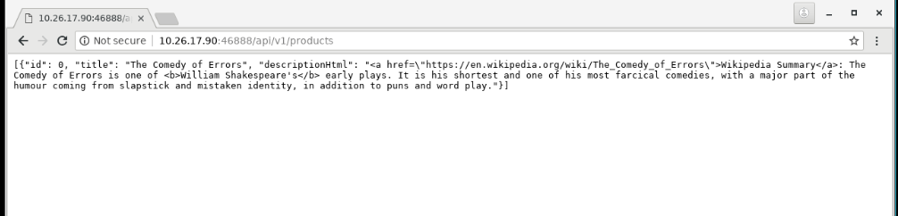

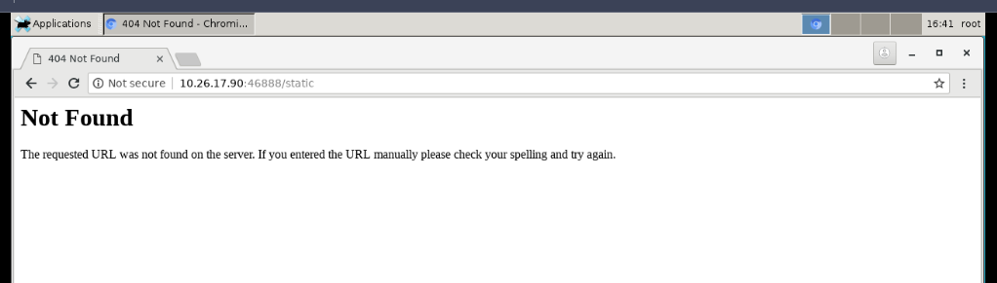

## 问题二

|  |
| --- |
| cat bookinfo/bookinfo.yaml | istioctl kube-inject -f - | kubectl apply -l app=productpage -f - |

这里的 – 具体是什么意思

## 问题三

|  |
| --- |
| [root@k8s-master-node1 ServiceMesh]# cat bookinfo/bookinfo.yaml | istioctl kube-inject -f - | kubectl apply -l app=details -f -  service/details unchanged  deployment.apps/details-v1 configured  [root@k8s-master-node1 ServiceMesh]# kubectl get pod  NAME READY STATUS RESTARTS AGE  details-v1-6c946f95d8-hk754 1/1 Running 0 2m33s  details-v1-6df75fb475-pjxcw 1/2 ImagePullBackOff 0 2m8s  productpage-v1-5ccd77cbc-mfqfp 2/2 Running 0 23m  ratings-v1-787844b448-dccrg 2/2 Running 0 14m  reviews-v1-5859666b89-8bknx 2/2 Running 0 14m |

拉去第二个镜像会出现拉取失败

## 问题四