# Rocket.chat部署手册

## 案例描述

本案例共讲述了Rocket.chat聊天系统的部署。

1. MongoDB数据库安装部署

2. NodeJS 环境安装

3. Rocket.Chat 安装部署

## 案例一、Rocket.chat聊天系统

### 案例准备

#### 1.规划节点

使用云主机CentOS7.9系统。节点规划见表1-1。

表1-1 节点规划

|  |  |  |
| --- | --- | --- |
| **IP** | **主机名** | **节点** |
| 172.30.17.15 | rocketchat | 聊天平台 |

#### 2.基础准备

使用云主机搭建rocketchat聊天系统，该案例只讲述rocketchat系统的安装。

### 案例实施

#### 1.安装编译环境

配置mongodb4.0 yum源

cat << EOF | sudo tee -a /etc/yum.repos.d/mongodb-org-4.0.repo

[mongodb-org-4.0]

name=MongoDB Repository

baseurl=https://repo.mongodb.org/yum/redhat/7/mongodb-org/4.0/x86_64/

gpgcheck=1

enabled=1

gpgkey=https://www.mongodb.org/static/pgp/server-4.0.asc

EOF

配置要通过包管理器安装node.js

yum install -y curl && curl -sL https://rpm.nodesource.com/setup_12.x | sudo bash -

安装构建工具、MongoDB、nodejs 和 graphicsmagick：

yum install -y gcc-c++ make mongodb-org nodejs

yum install -y epel-release && sudo yum install -y GraphicsMagick

使用npm安装inherits、n，并根据Rocket.Chat选择需要的node版本：

npm install -g inherits n && sudo n 12.16.1

对应node版本存在与Rocket.Chat安装包中README

cat README

This is a Meteor application bundle. It has only one external dependency:

Node.js v12.16.1. To run the application:

#### 2安装Rocket.Chat系统

解压Rocket.Chat软件包

tar -xzf rocket.chat-3.4.1.tgz -C /tmp

使用npm命令安装rocket.chat

cd /tmp/bundle/programs/server && npm install --unsafe-perm

安装完成结果显示：

{

"npm": "6.13.4",

"ares": "1.15.0",

"brotli": "1.0.7",

"cldr": "35.1",

"http_parser": "2.9.3",

"icu": "64.2",

"llhttp": "2.0.4",

"modules": "72",

"napi": "5",

"nghttp2": "1.40.0",

"node": "12.16.1",

"openssl": "1.1.1d",

"tz": "2019c",

"unicode": "12.1",

"uv": "1.34.0",

"v8": "7.8.279.23-node.31",

"zlib": "1.2.11"

}

audited 148 packages in 161.261s

3 packages are looking for funding

run `npm fund` for details

found 1 high severity vulnerability

run `npm audit fix` to fix them, or `npm audit` for details

将安装完成的bundle目录移动至/opt/目录中，添加Rocket.chat用户，设置Rocket.Chat文件夹的权限。

mv /tmp/bundle /opt/Rocket.Chat

useradd -M rocketchat && sudo usermod -L rocketchat

chown -R rocketchat:rocketchat /opt/Rocket.Chat

创建Rocket.Chat服务文件

cat << EOF |sudo tee -a /lib/systemd/system/rocketchat.service

[Unit]

Description=The Rocket.Chat server

After=network.target remote-fs.target nss-lookup.target nginx.service mongod.service

[Service]

ExecStart=/usr/local/bin/node /opt/Rocket.Chat/main.js

StandardOutput=syslog

StandardError=syslog

SyslogIdentifier=rocketchat

User=rocketchat

Environment=MONGO_URL=mongodb://localhost:27017/rocketchat?replicaSet=rs01 MONGO_OPLOG_URL=mongodb://localhost:27017/local?replicaSet=rs01 ROOT_URL=http://localhost:3000/ PORT=3000

[Install]

WantedBy=multi-user.target

EOF

使用 sudo 和您喜欢的文本编辑器打开刚刚创建的 Rocket.Chat 服务文件 ( /usr/lib/systemd/system/rocketchat.service)，并更改 ROOT_URL 环境变量以反映您要用于访问服务器的 URL（可选更改 MONGO_URL、MONGO_OPLOG_URL 和 PORT）：

MONGO_URL=mongodb://localhost:27017/rocketchat?replicaSet=rs01

MONGO_OPLOG_URL=mongodb://localhost:27017/local?replicaSet=rs01

ROOT_URL=http://your-host-name.com-as-accessed-from-internet:3000

PORT=3000

#### 3.启动服务

为 MongoDB 设置存储引擎和复制（对于版本 > 1 是必需的），并启用MongoDB 。

sed -i "s/^# engine:/engine: mmapv1/" /etc/mongod.conf

sed -i "s/^#replication:/replication: \n replSetName: rs01/" /etc/mongod.conf

systemctl enable mongod && sudo systemctl start mongod

[root@rocke-chat Rocket.Chath]# mongo --eval "printjson(rs.initiate())"

MongoDB shell version v4.0.28

connecting to: mongodb://127.0.0.1:27017/?gssapiServiceName=mongodb

Implicit session: session { "id" : UUID("c97924b6-032a-496d-b639-f354eebfa968") }

MongoDB server version: 4.0.28

{

"operationTime" : Timestamp(1656495245, 1),

"ok" : 0,

"errmsg" : "already initialized",

"code" : 23,

"codeName" : "AlreadyInitialized",

"$clusterTime" : {

"clusterTime" : Timestamp(1656495245, 1),

"signature" : {

"hash" : BinData(0,"AAAAAAAAAAAAAAAAAAAAAAAAAAA="),

"keyId" : NumberLong(0)

}

}

}

启动Rocket.Chat服务

systemctl enable rocketchat && sudo systemctl start rocketchat

查看日志信息显示结果：

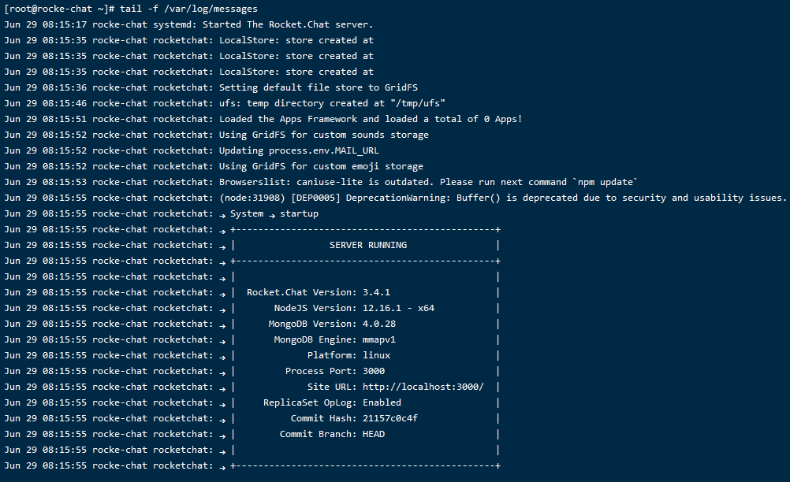

通过页面进行访问：

