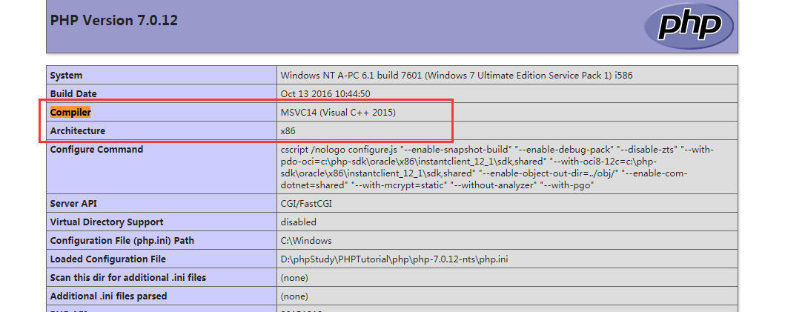
软件下载地址:
[redis软件下载]
https://www.cnblogs.com/peteremperor/p/6635767.html[连接网址]
https://github.com/MicrosoftArchive/redis/releases [下载地址]
[php-redis扩展下载]
https://segmentfault.com/a/1190000011725819

