Ex. No: 9 Threading

PROGRAM: THREAD CREATION USING PTHREAD
C PROGRAM
#include <stdio.h>
#include <stdlib.h>
#include <pthread.h>
#include <unistd.h>
void *thread_function(void *arg)
{
int i;
for(i = 1; i <= 5; i++)
{
printf("Thread Executing : %d\n", i);
sleep(1);
}
pthread_exit(NULL);
}
int main()
{
pthread_t t1, t2;
pthread_create(&t1, NULL, thread_function, NULL);
pthread_create(&t2, NULL, thread_function, NULL);
pthread_join(t1, NULL);
pthread_join(t2, NULL);
printf("All Threads Completed\n");
return 0;
}
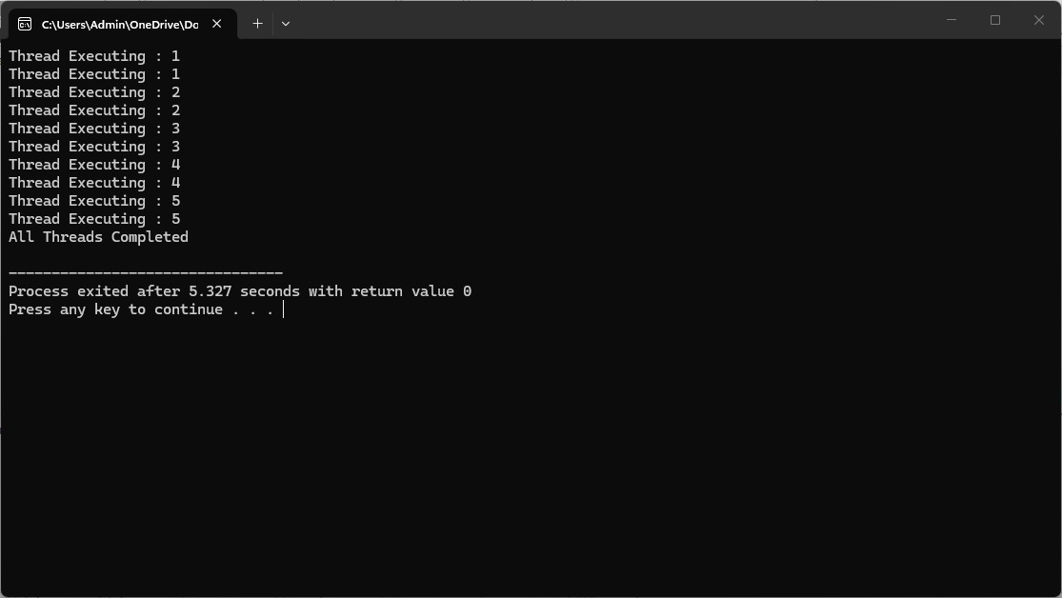
SHELL SCRIPT
#!/bin/bash
task1()
{
for i in 1 2 3 4 5
do
echo "Thread 1 : $i"
sleep 1
done
}
task2()
{
for i in 1 2 3 4 5
do
echo "Thread 2 : $i"
sleep 1
done
}
task1 &
task2 &
wait
echo "All Threads Completed"


