# Phylodynamic analysis: Netherlands, 2020-03-13

### Primary author: David Jorgensen

### Report prepared on 2020-04-05

#### On behalf of the MRC GIDA COVID-19 phylodynamics working group at Imperial College London: Lily Geidelberg, Olivia Boyd, Manon Ragonnet, David Jorgensen, Igor Siveroni, Erik Volz

## Background information

#### This is analysis is based on :

* **57 whole genomes** sampled from **within Netherlands**
* **46 whole genomes** sampled from outside of **Netherlands**
* Samples within Netherlands were collected between **2020-01-02** and **2020-03-13**

##### To add: [optional plot of sample distribution through time]

## How many are infected in Netherlands?

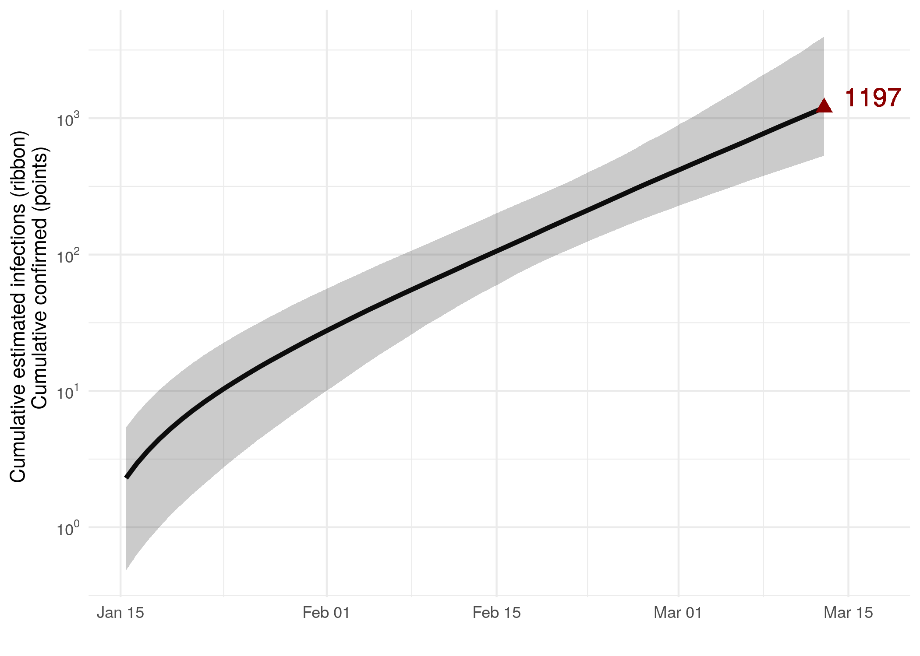

Figure 1: Cumulative estimated infections through time. Points represent reported cases in the region.

* Estimated cumulative infections at last sample (2020-03-13): **1197 [530-3961]** median [95%CI]
* Cumulative confirmed infections reported at 2020-03-13: **NA, NA, NA, NA, NA, NA, NA, NA, NA, NA, NA, NA, NA, NA, NA, NA, NA, NA, NA, NA, NA, NA, NA, NA, NA, NA, NA, NA, NA, NA, NA, NA, NA, NA, NA, NA, NA, NA, NA, NA, NA**
* Cumulative number of active infections at 2020-03-13:

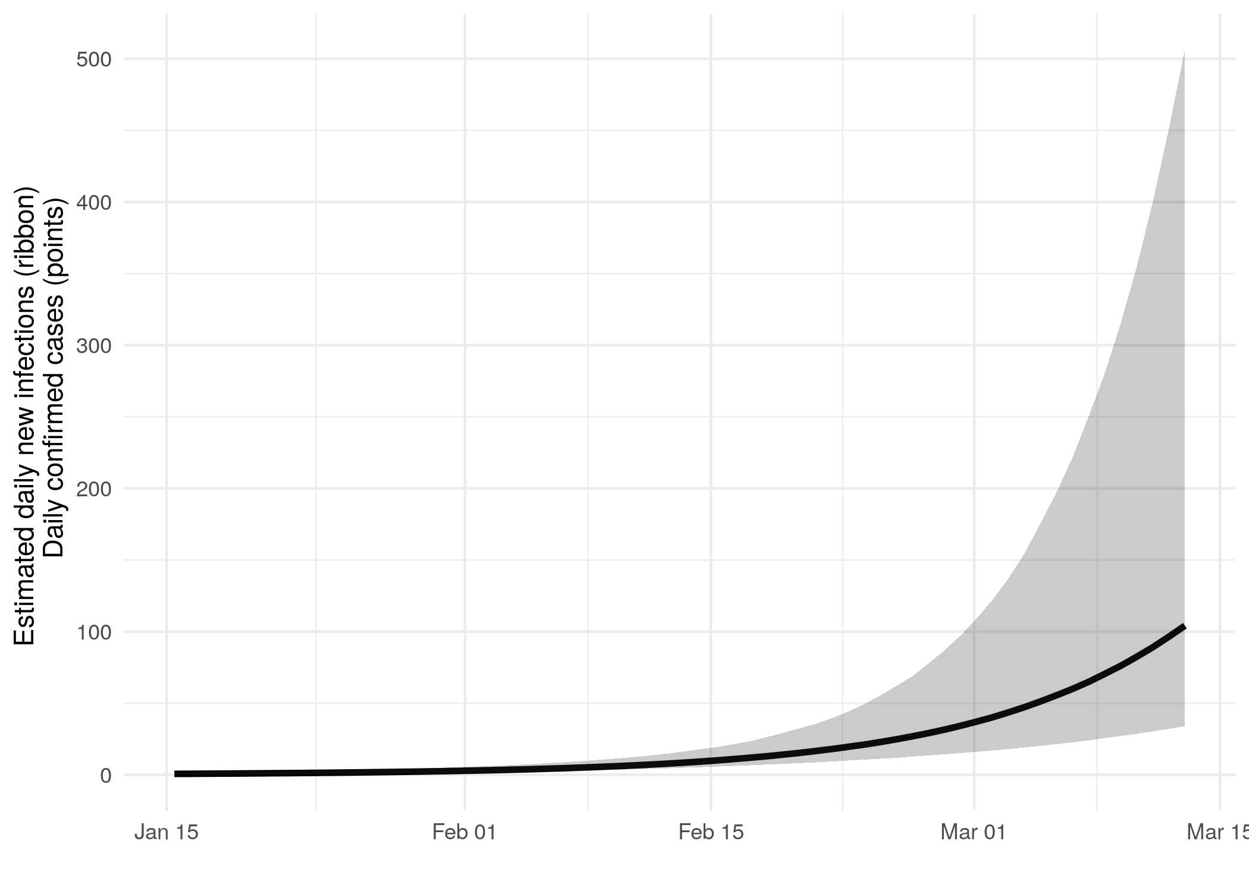

Figure 2: Daily estimated infections through time. Points represent reported cases in the region.

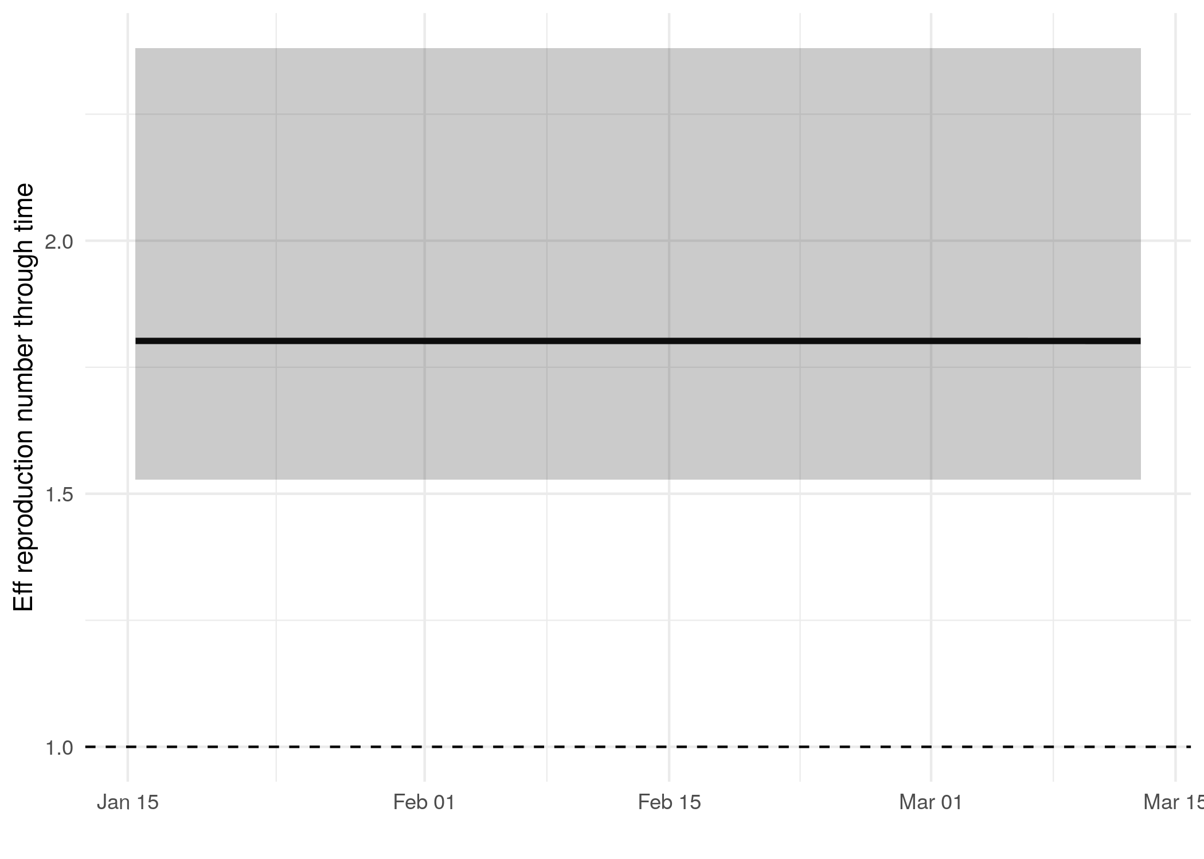

Figure 3: Reproduction number through time

Reproduction number at last sample (2020-03-13): **1.8 [1.53-2.38]** median [95% CrI]

## How quickly has the epidemic in Netherlands grown?

Table 1: Reproduction number, growth rate and doubling times

|  |  |  |  |
| --- | --- | --- | --- |
| Quantile | Reproduction number | Growth rate (per day) | Doubling time (days) |
| 50% | 1.81 | 0.0873 | 7.94 |
| 2.5% | 1.53 | 0.0594 | 4.99 |
| 97.5% | 2.4 | 0.139 | 11.7 |

## How has SARS-CoV 2 evolved in Netherlands?

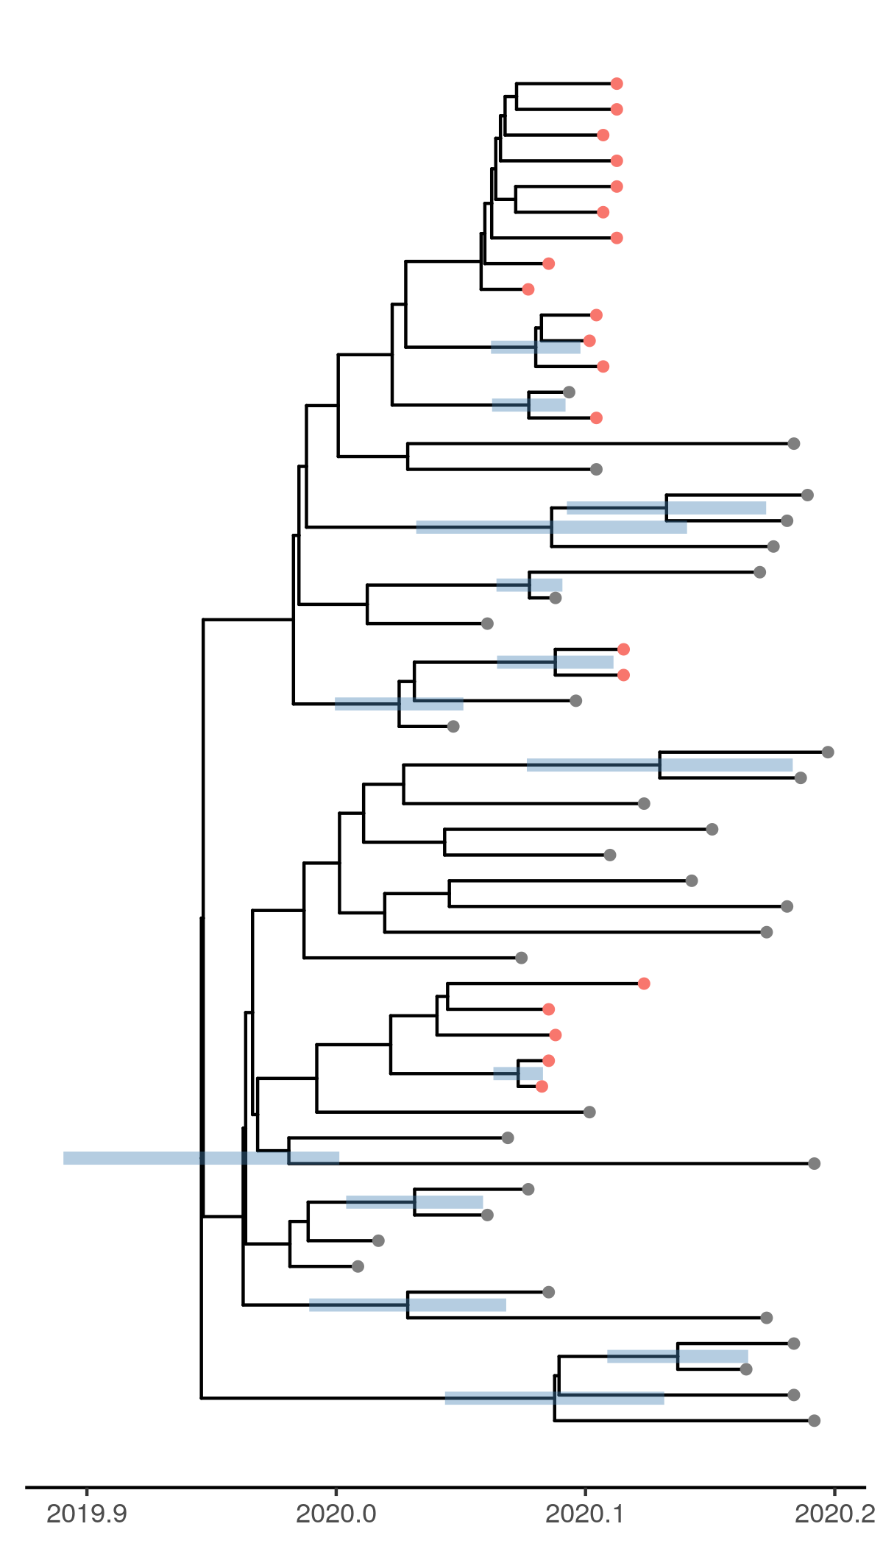

Figure 4: Time scaled phylogeny co-estimated with epidemiological parameters. The colour of the tips corresponds to location sampling; red tips were sampled from within the region, blue tips from outside

##### Molecular clock rate of evolution: **0.00121 [0.000914-0.00154]** median [95% CrI]

## Predicted cumulative infections over next 14 days (assuming exponential growth):

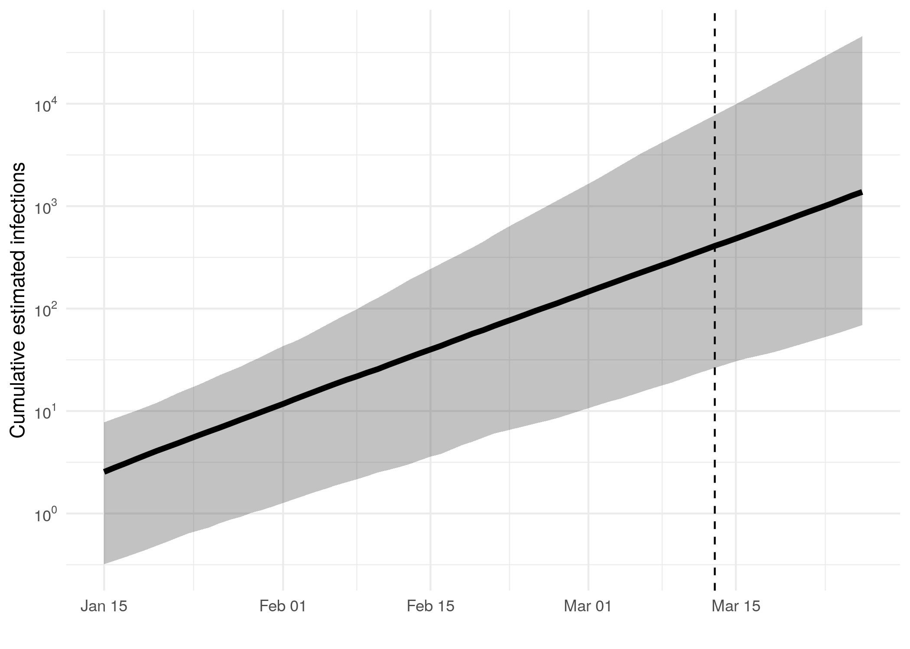

Figure 5: Cumulative estimated infections. The dashed line indicates the date of last sample in analysis. The points represent reported cases in the region.

Predicted reproduction number at 2020-03-27 (14 days after last sample): median [95% CrI] [to add!]

## Methods summary

Details on methods and priors can be [found here](http://whoinfectedwhom.org/seijr0.1.0_methods.pdf).

##### Additional notes about methods: [Insert details about any deviation from the main pipeline, like sample selection, changes to the model etc, where you retrieved other data]

Model version: seijr0.1.0

## Acknowledgements

This work was supported by the [MRC Centre for Global Infectious Disease Analysis at Imperial College London](https://www.imperial.ac.uk/mrc-global-infectious-disease-analysis).

Sequence data were provided by [GISAID](http://www.epicov.org) and [these laboratories](http://whoinfectedwhom.org/gisaid_cov2020_acknowledgement_table.xls).