Phylodynamic Analysis

# Location: Hongkong

# Most recent sample: 2020-03-14

### Primary author: Manon Ragonnet

### Report prepared on 2020-04-07

#### On behalf of the MRC GIDA COVID-19 phylodynamics working group at Imperial College London: Lily Geidelberg, Olivia Boyd, Manon Ragonnet, David Jorgensen, Igor Siveroni, Erik Volz

## Background information

#### This is analysis is based on :

* **27 whole genomes** sampled from **within Hongkong**
* **43 whole genomes** sampled from outside of **Hongkong**
* Samples within Hongkong were collected between **2020-01-21** and **2020-03-14**

##### To add: [optional plot of sample distribution through time]

## How many are infected in Hongkong?

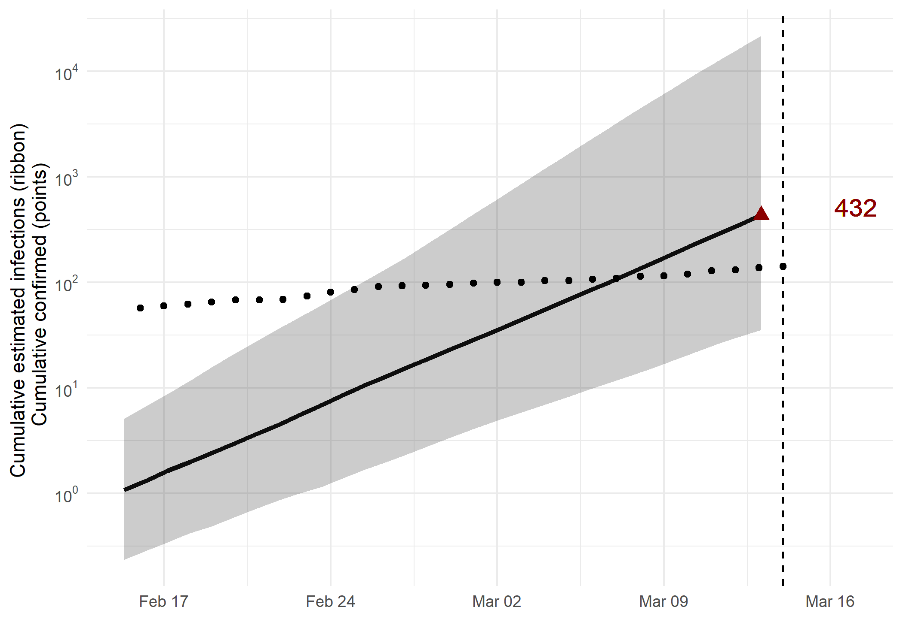

*Figure 1: Cumulative estimated infections through time. Points represent reported cases in Hongkong. The dashed line indicates the date of last sample in Hongkong in this analysis.*

* Estimated cumulative infections at last sample (2020-03-14): **432 [35-21603]** median [95%CI]
* Cumulative confirmed infections reported at 2020-03-14: **141**
* Cumulative number of active infections at 2020-03-14:

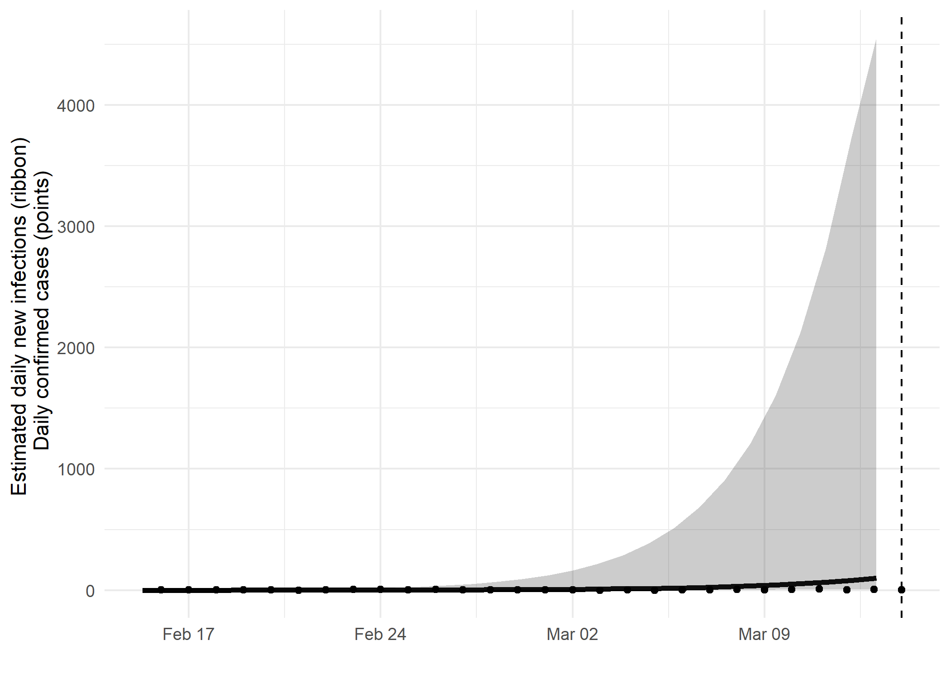

*Figure 2: Daily estimated infections through time. Points represent reported cases in Hongkong. The dashed line indicates the date of last sample in Hongkong in this analysis.*

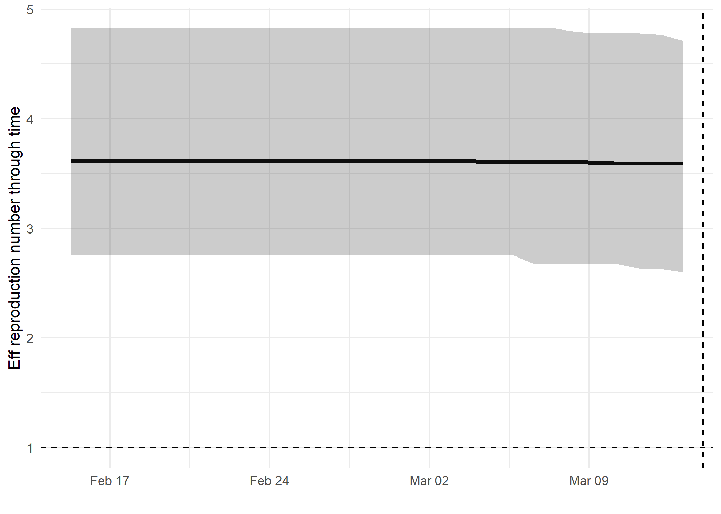

*Figure 3: Reproduction number through time. The dashed line indicates the date of last sample in Hongkong in this analysis.*

Reproduction number at last sample (2020-03-14): **3.59 [2.6-4.71]** median [95% CrI]

## How quickly has the epidemic in Hongkong grown?

Table 1: Reproduction number, growth rate and doubling times

|  |  |  |  |
| --- | --- | --- | --- |
| Quantile | Reproduction number | Growth rate (per day) | Doubling time (days) |
| 50% | 3.65 | 0.231 | 3 |
| 2.5% | 2.78 | 0.169 | 2.17 |
| 97.5% | 5.09 | 0.320 | 4.1 |

## How has SARS-CoV 2 evolved in Hongkong?

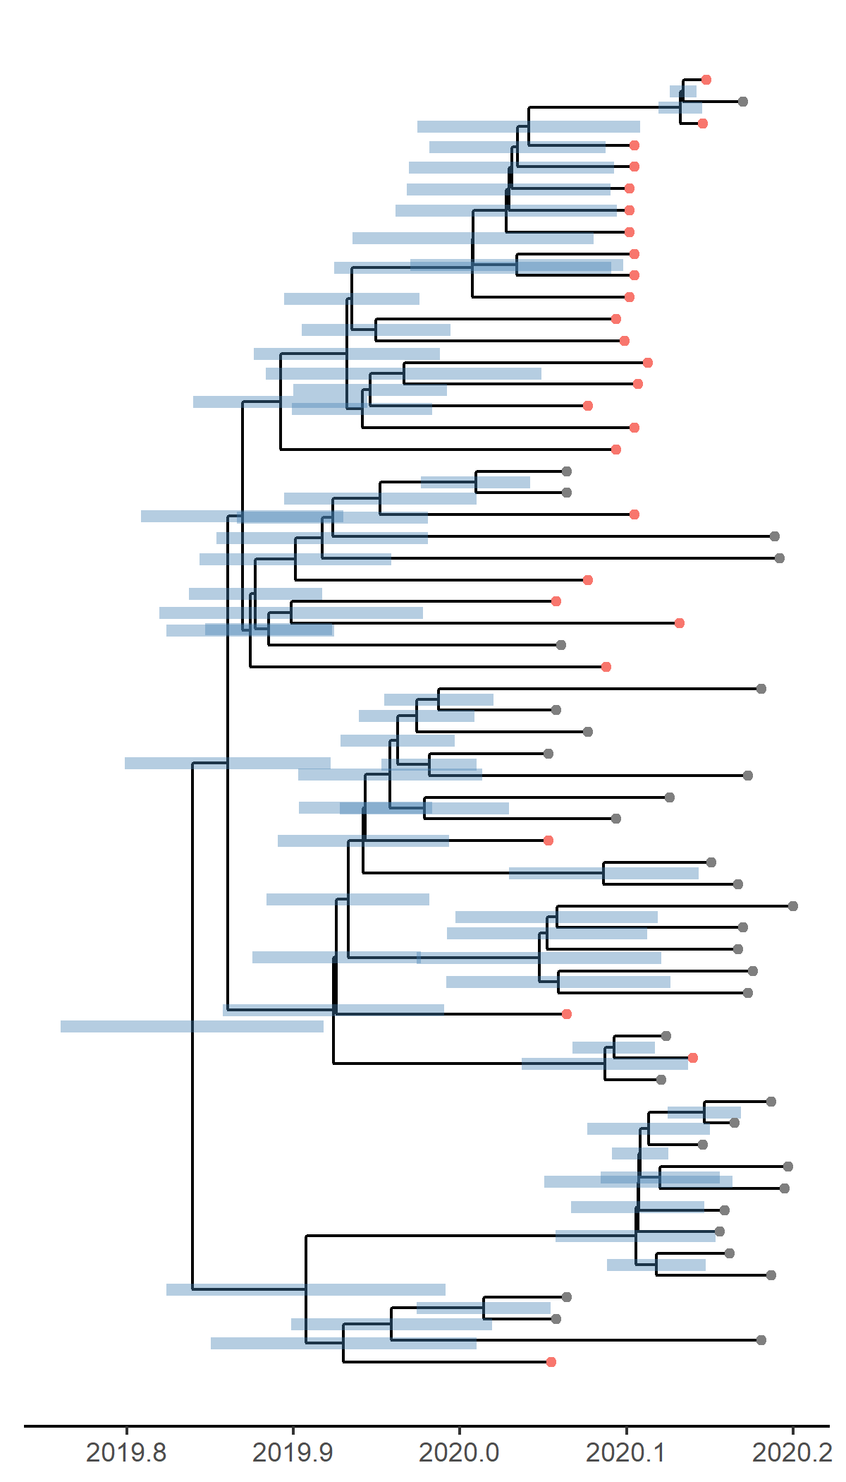

*Figure 4: Time scaled phylogeny co-estimated with epidemiological parameters. The colour of the tips corresponds to location sampling; red tips were sampled from within Hongkong, blue tips from outside.*

##### Molecular clock rate of evolution: **0.000657 [0.000511-0.000932]** median [95% CrI]

## Predicted cumulative infections over next 14 days (assuming exponential growth):

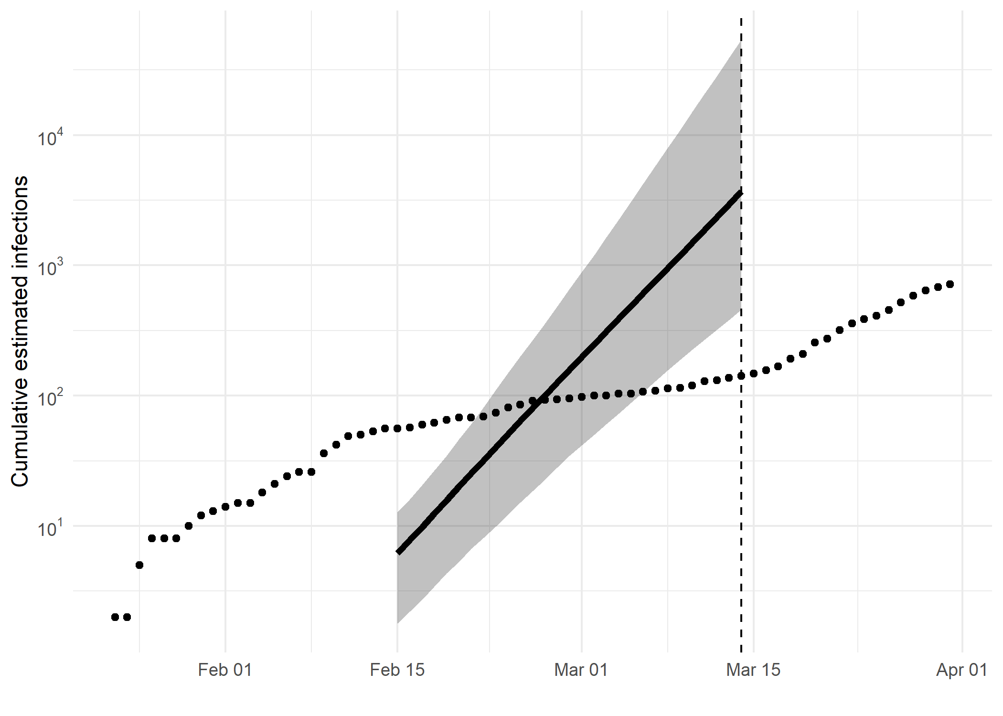

*Figure 5: Cumulative estimated infections. The dashed line indicates the date of last sample in Hongkong in this analysis. The points represent reported cases in Hongkong.*

Based on an estimated growth rate of 0.231 [0.169 - 0.320] median [95% CrI]:

We estimate cumulative number of infections at last sample (2020-03-14) as: 3700 [458 - 53686]

We estimate number of infections at 2020-03-14 (0 days after last sample) as: 3700 [458 - 53686]

## Methods summary

Details on methods and priors can be [found here](http://whoinfectedwhom.org/seijr0.1.0_methods.pdf).

Model version: seijr0.0.0

Report version: 20200407-224313-c37a4344

## Acknowledgements

This work was supported by the [MRC Centre for Global Infectious Disease Analysis at Imperial College London](https://www.imperial.ac.uk/mrc-global-infectious-disease-analysis).

Sequence data were provided by [GISAID](http://www.epicov.org) and [these laboratories](http://whoinfectedwhom.org/gisaid_cov2020_acknowledgement_table.xls).