Phylodynamic Analysis: Weifang,: 2020-02-10

April 09, 2020

### Primary author: Lily Geidelberg

### Report prepared on 2020-04-09

#### On behalf of the MRC GIDA COVID-19 phylodynamics working group at Imperial College London: Lily Geidelberg, Olivia Boyd, Manon Ragonnet, David Jorgensen, Igor Siveroni, Erik Volz

## Background information

#### This is analysis is based on :

* **20 whole genomes** sampled from **within Weifang**
* **50 whole genomes** sampled from outside of **Weifang**
* Samples within Weifang were collected between **2020-01-24** and **2020-02-10**

## How many are infected in Weifang?

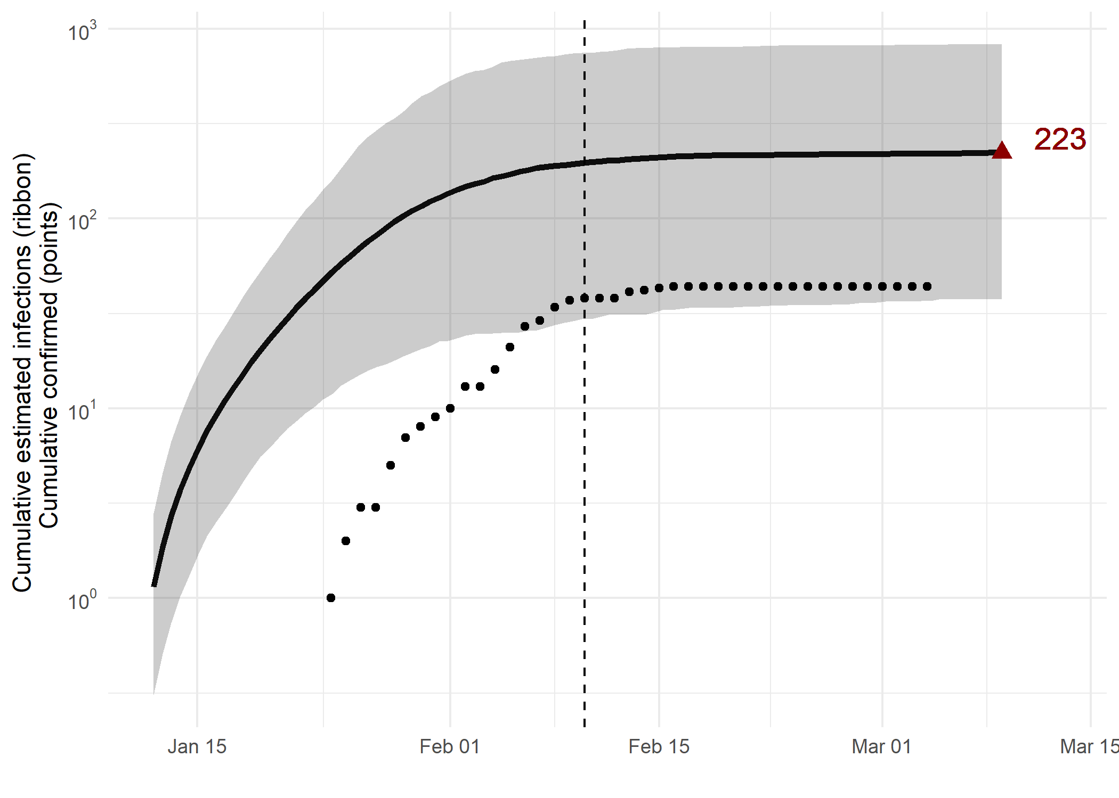

*Figure 1: Cumulative estimated infections through time. Points represent reported cases in Weifang. The dashed line indicates the date of last sample in Weifang in this analysis.*

* Estimated cumulative infections at last sample (2020-02-10): **223 [38-827]** median [95%CI]
* Cumulative confirmed infections reported at 2020-02-10: **38**

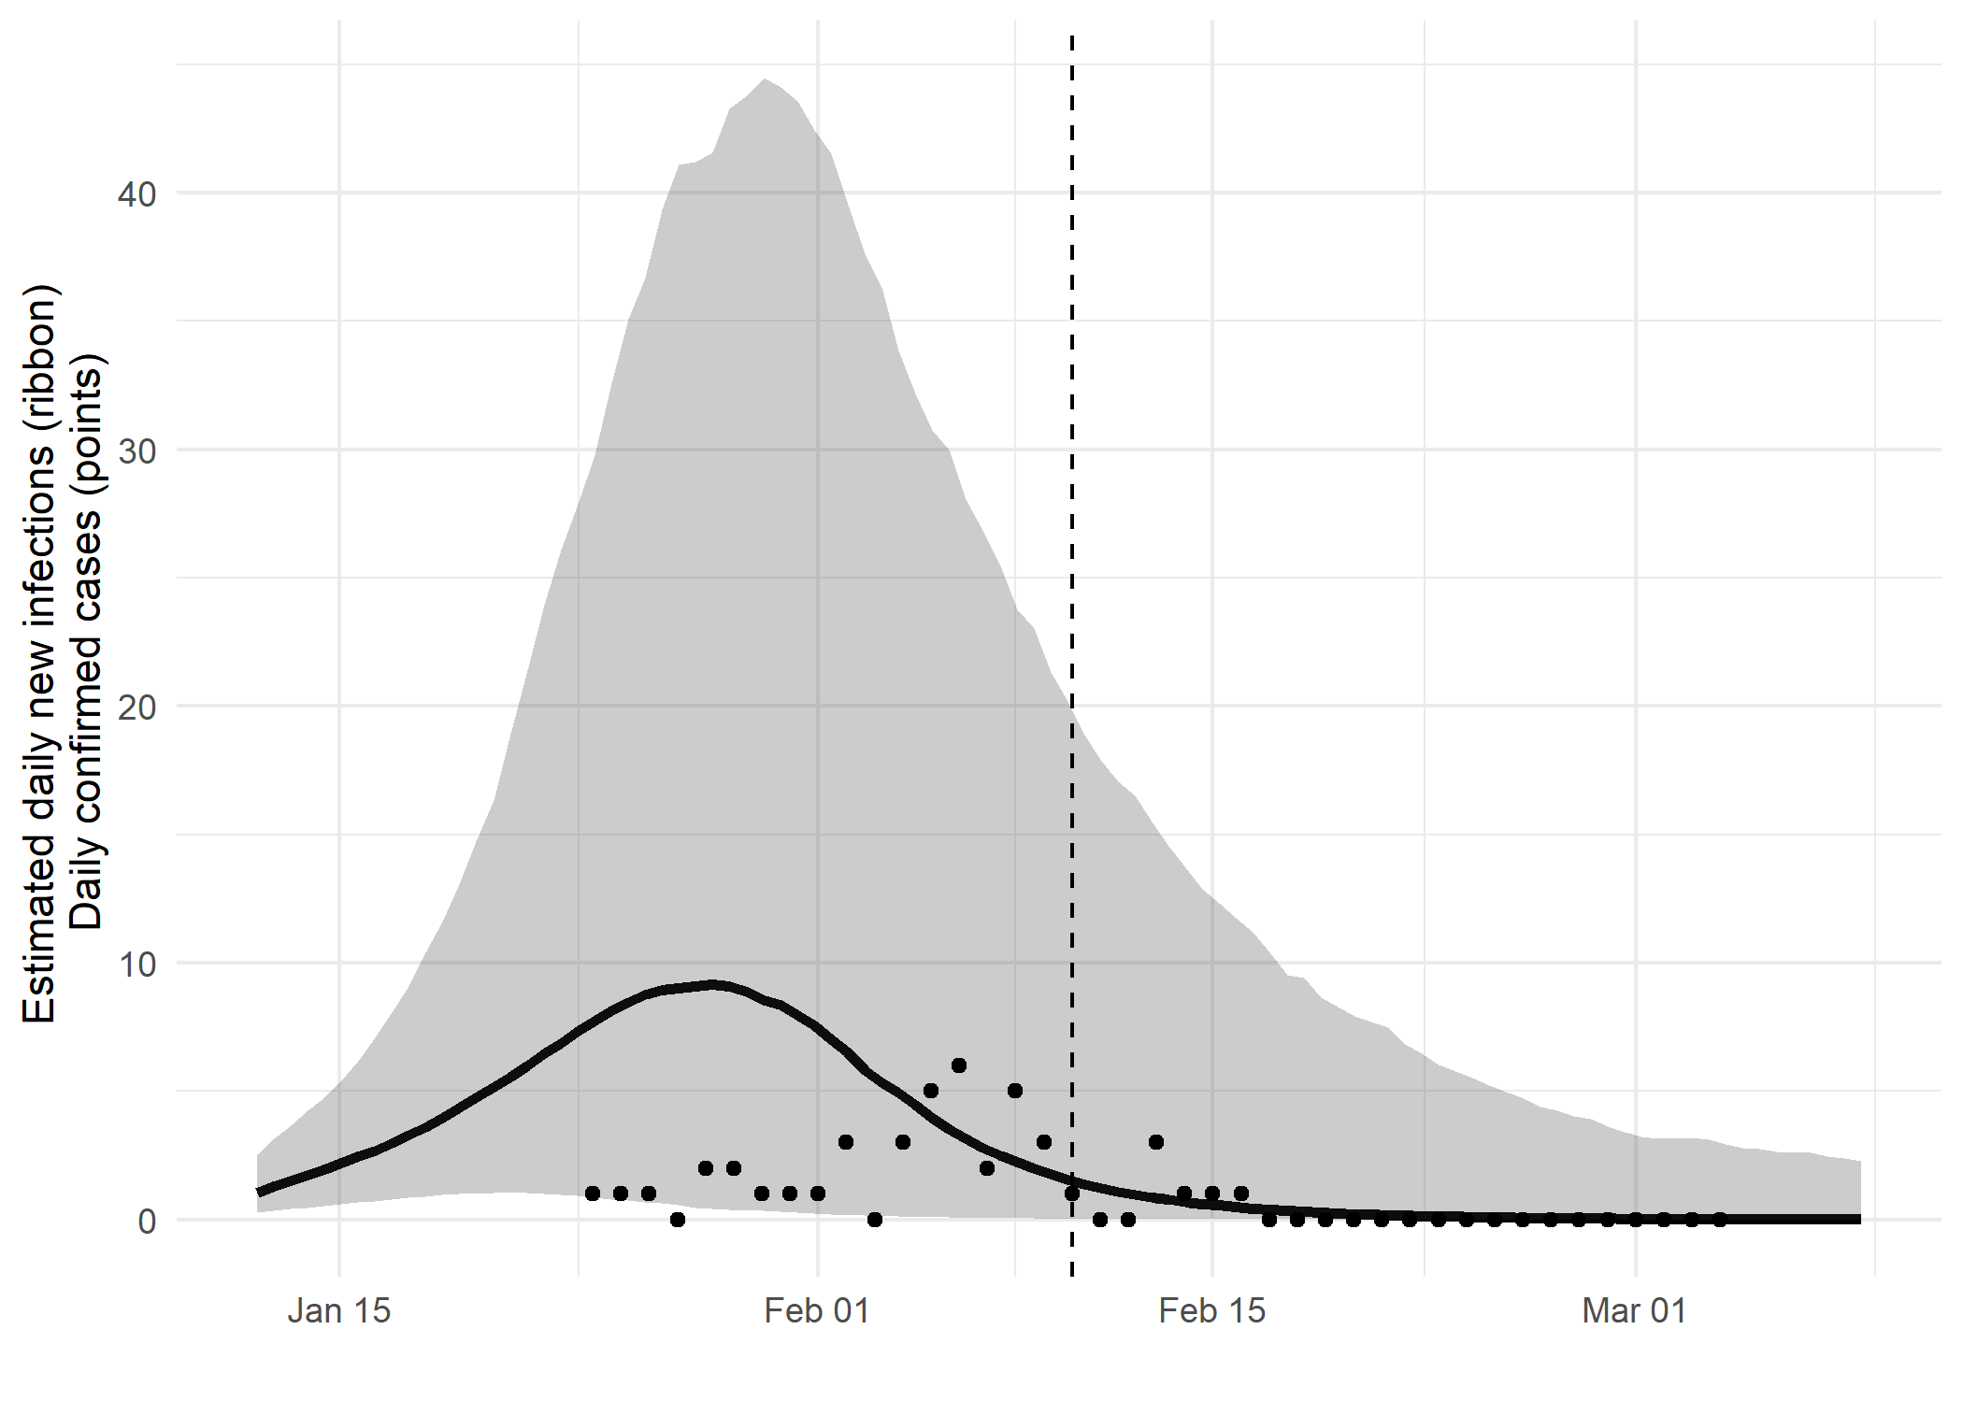

*Figure 2: Daily estimated infections through time. Points represent reported cases in Weifang. The dashed line indicates the date of last sample in Weifang in this analysis.*

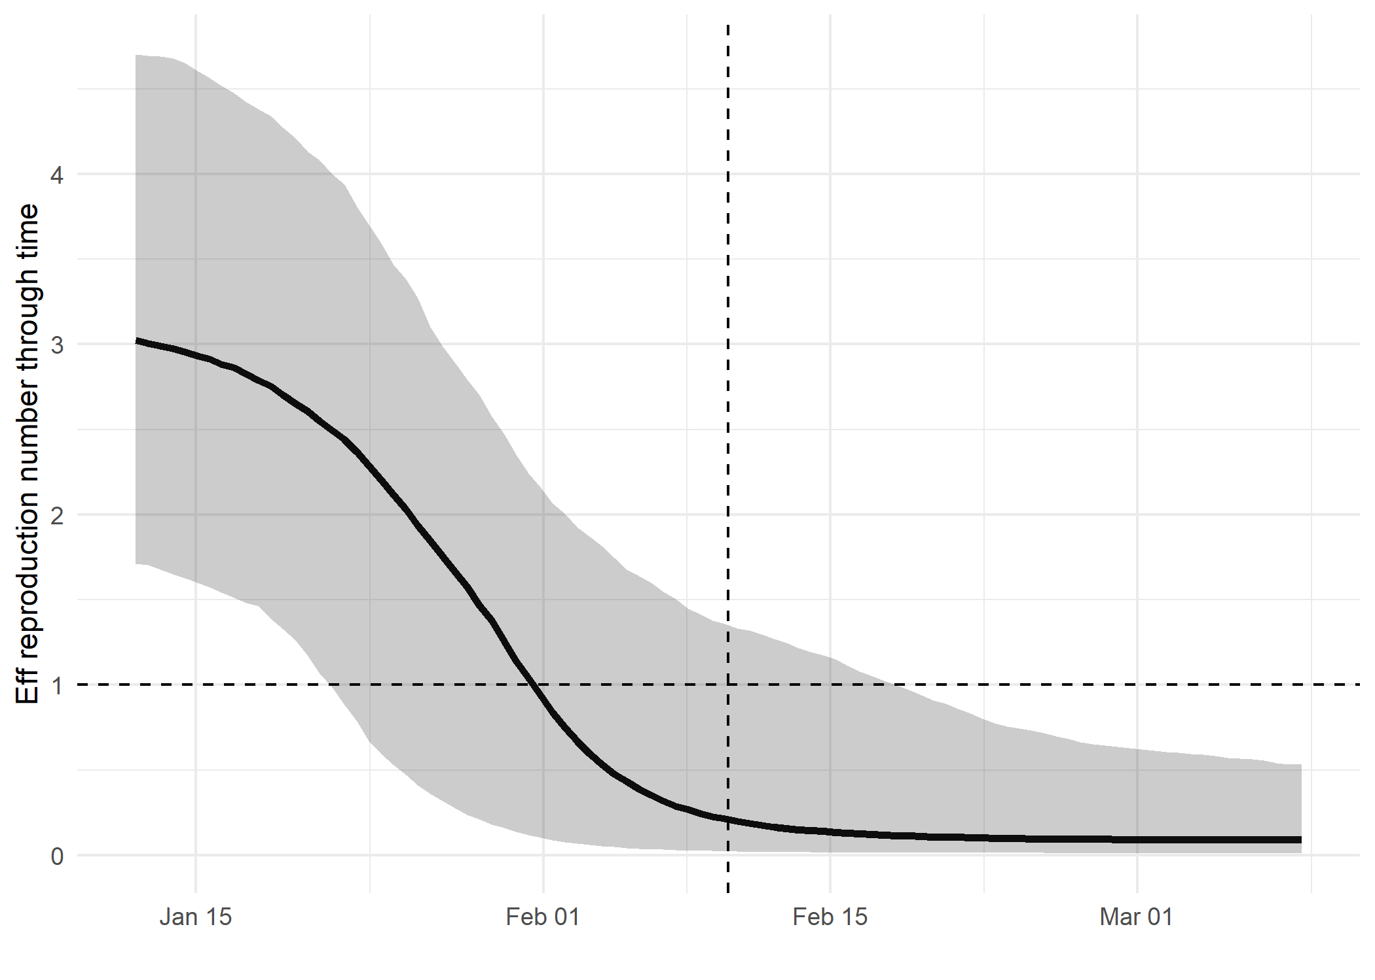

*Figure 3: Reproduction number through time. The dashed line indicates the date of last sample in Weifang in this analysis.*

Reproduction number at last sample (2020-02-10): **0.0911 [0.0129-0.532]** median [95% CrI]

## How quickly has the epidemic in Weifang grown?

Table 1: Reproduction number, growth rate and doubling times

|  |  |  |  |
| --- | --- | --- | --- |
| Quantile | Reproduction number | Growth rate (per day) | Doubling time (days) |
| 50% | 3.12 | 0.194 | 3.57 |
| 2.5% | 1.81 | 0.0871 | 2.3 |
| 97.5% | 4.79 | 0.301 | 7.96 |

## How has SARS-CoV 2 evolved in Weifang?

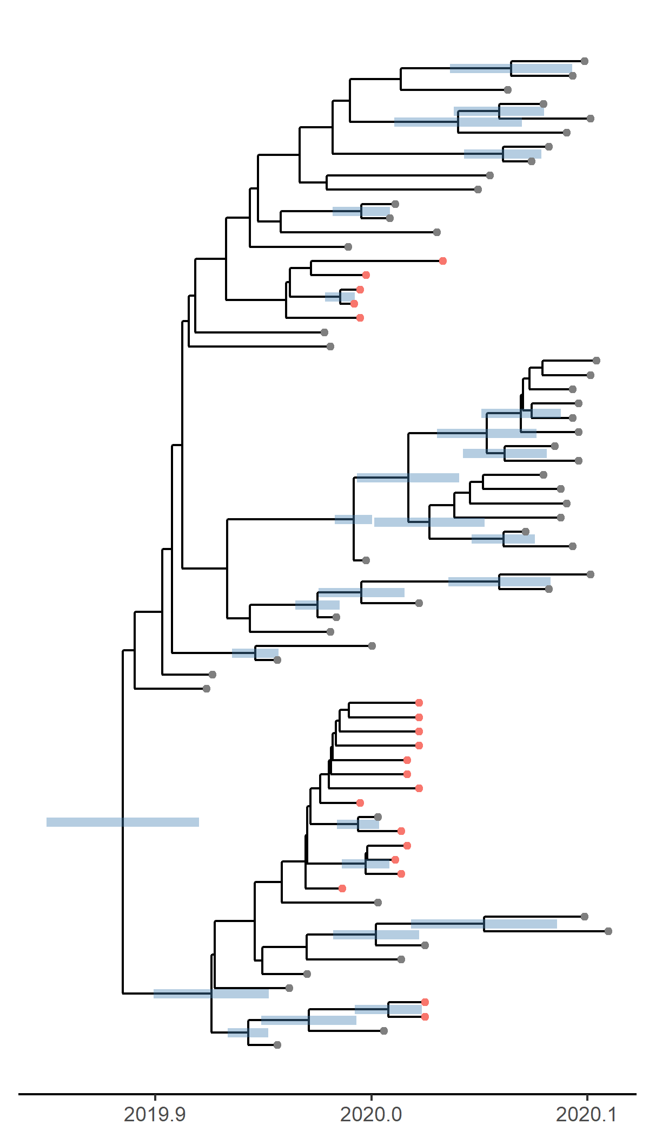

*Figure 4: Time scaled phylogeny co-estimated with epidemiological parameters. The colour of the tips corresponds to location sampling; red tips were sampled from within Weifang, blue tips from outside.*

##### Molecular clock rate of evolution: **0.0012 [0.000874-0.00163]** median [95% CrI]

## Predicted cumulative infections over next 14 days (assuming exponential growth):

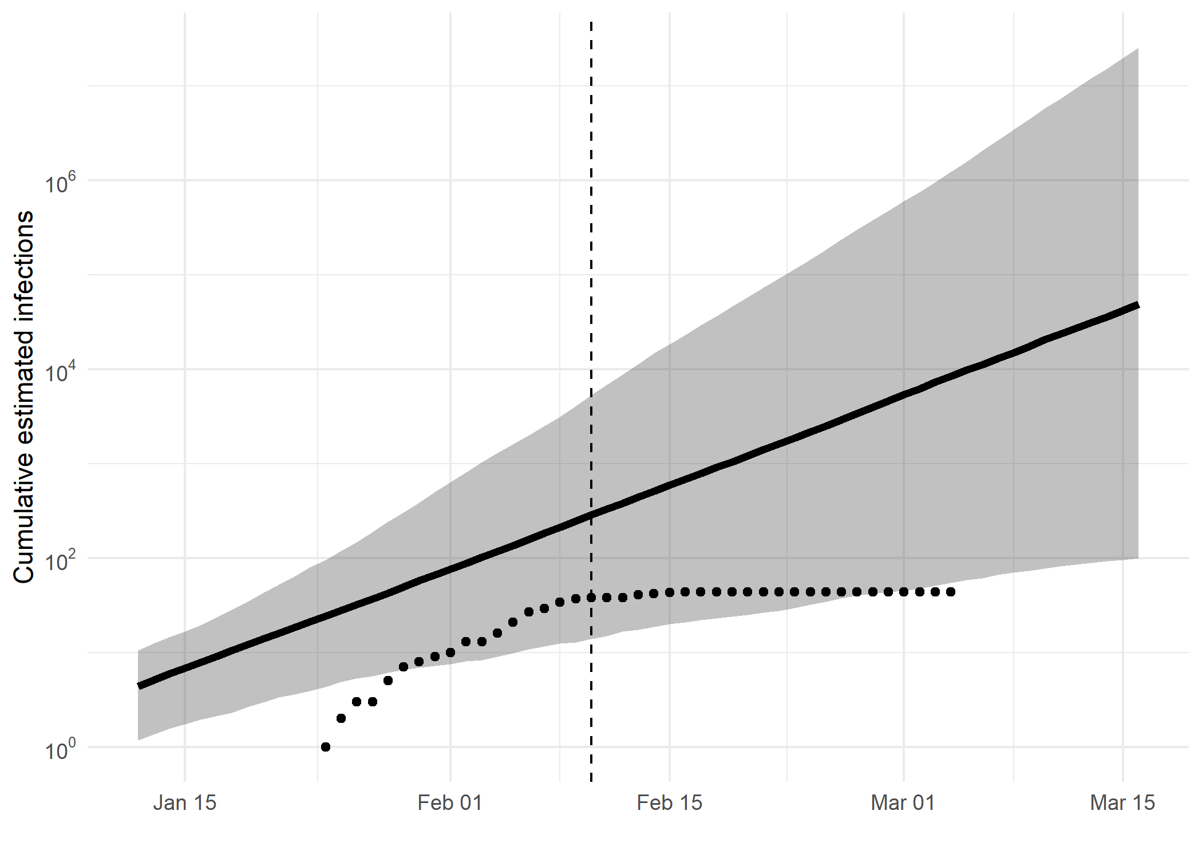

*Figure 5: Cumulative estimated infections. The dashed line indicates the date of last sample in Weifang in this analysis. The points represent reported cases in Weifang.*

Based on an estimated growth rate of 0.194 [0.0871 - 0.301] median [95% CrI]:

We estimate cumulative number of infections at last sample (2020-02-10) as: 285 [13 - 5327]

We estimate number of infections at 2020-03-16 (35 days after last sample) as: 48669 [100 - 25305030]

## Methods summary

Details on methods and priors can be [found here](http://whoinfectedwhom.org/seijr0.1.0_methods.pdf).

Model version: seijr0.0.0

Report version: 20200409-105433-91378a08

## Acknowledgements

This work was supported by the [MRC Centre for Global Infectious Disease Analysis at Imperial College London](https://www.imperial.ac.uk/mrc-global-infectious-disease-analysis).

Sequence data were provided by [GISAID](http://www.epicov.org) and [these laboratories](http://whoinfectedwhom.org/gisaid_cov2020_acknowledgement_table.xls).