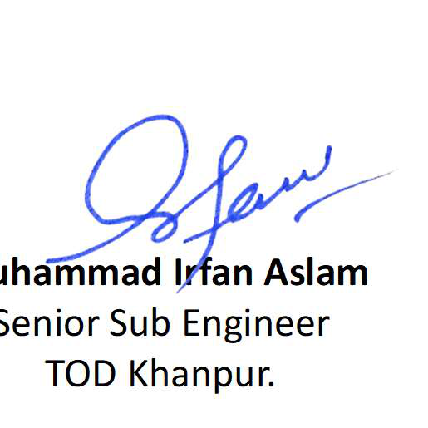
From:
Muhammad Irfan Aslam.
Senior Sub Engineer,
Tubewell & Drainage Division,
Khanpur.
To:
The Executive Engineer,
Dallas Canal Division,
Rahim Yar Khan.
Subject: REQUEST FOR ISSUANCE OF NOC From 22-12-2020 to 30-06-2021.
Respected Sir,
I respectfully state that I, Muhammad Irfan Aslam S/O Muhammad Aslam Naseem,
have served as Senior Sub Engineer during the period from 22-12-2020 to 30-06-2021 in Shear
Section, Ahmadpur Lamma Canal Division.
I require a No Demand / No Enquiry / No Draft Para / No Advance Para Certificate
(NOC) for the above-mentioned period for my departmental promotion case.
It is therefore requested that the required NOC may kindly be issued at your earliest
convenience so that I may complete my promotion documents and submit them to the Zonal
Office.
I shall be very thankful to you for this kind favour.
Muhammad Irfan Aslam
Senior Sub Engineer
TOD Khanpur.

