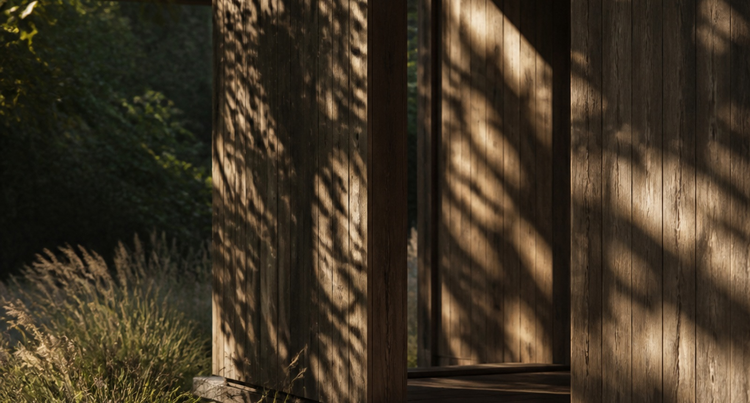
FIELD REPORT / 01
Shelter in the Shade
A field report on passive cooling at neighborhood pavilions
SITE | East Junction Pavilion | PREPARED FOR | Civic Cooling Lab

EXECUTIVE OBSERVATION
Small shade structures can reduce perceived heat without mechanical cooling when material, orientation, and airflow are designed as one system.
Field findings
- Deep roof overhangs kept occupied edges comfortable during the hottest observation window.
- Timber surfaces reduced glare, while narrow openings preserved cross-ventilation.
- Planting worked best as a cooling layer when it did not block prevailing breezes.
Practical recommendations
- Orient primary openings toward prevailing summer winds.
- Pair high-albedo paving with shaded, low-glare seating surfaces.
- Track surface temperature and dwell time during the next six-week pilot.

