**Container Scaling with Docker Swarm.**

Creating service for scaling

**Please Note:** Docker containers deployed on Docker swarm cluster can be scaled up and down to implement high availability of Docker containers. If in case any Docker container gets crashed, we can get a new one created and other containers can easily handle the load.

* Use the commands below to create a service and scale the service up and down to increase or decrease Docker containers

**docker service create -p 8080:8080 --name bootcampjocatalin/kubernetes-bootcamp:v1**

**docker service ls**

**docker service psbootcamp**

**curl localhost:8080**

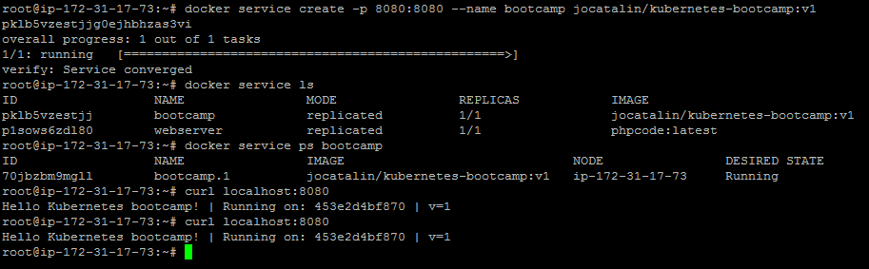

* Once the container deployed, we can scale up and down the Docker swarm service following the process shown below

**docker service scale bootcamp=3**

**docker service psbootcamp**

**curl localhost:8080**

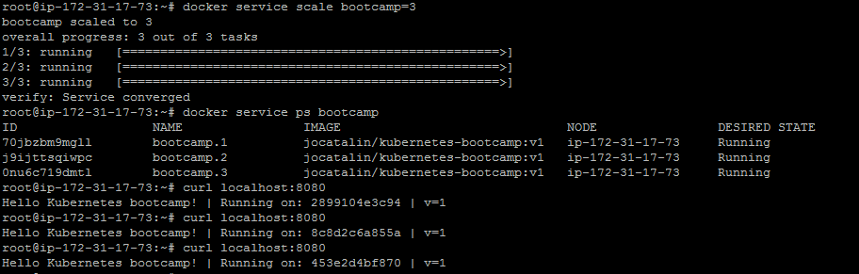

**Please Note:** In the screenshot above, we can see that when we are trying to access swarm service on 8080 port, we are getting different ids in the response. This means that our request is going to different containers in round robin manner.