**Grid Configuration Using JSON .**

This lab has mainly three subsections, namely:

2.6.1 Configuring the grid hub using JSON

2.6.2 Configuring the grid nodes using JSON

2.6.3 Pushing the code to your GitHub repositories

**Step 2.6.1:** Configuring the grid hub using JSON

1. Create JSON file for the hub which looks like

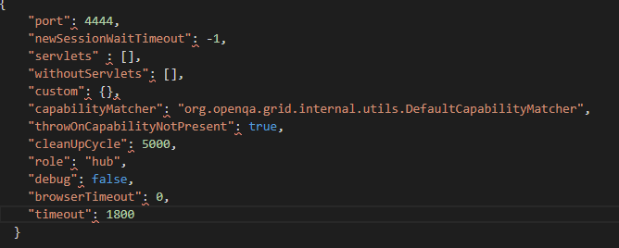

1. Save it in a folder with a valid name (example: myhub) in which we have saved Selenium standalone Server jar file
2. Go to command prompt
3. Navigate to folder structure where you have saved the Selenium standalone Server jar file
4. Type the below command in command prompt

**Java -jar selenium-server-standalone-3.141.59.jar -role hub -hubConfig myhub.json** and click on **Enter** button, which looks like

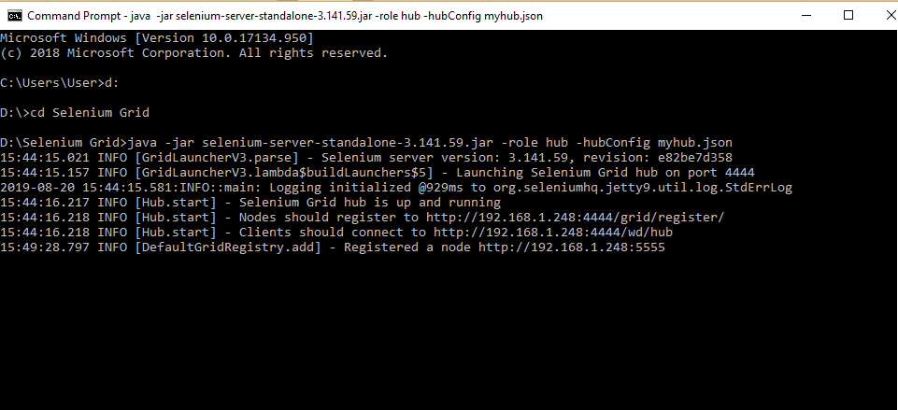

1. Open the Chrome browser
2. Enter URL as ‘http://localhost:4444/grid/console’ and click on enter
3. Grid console page is loaded as below

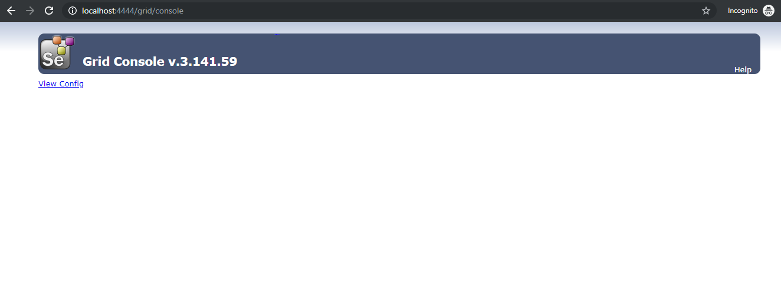

**Step 2.6.2:** Configuring the grid nodes using JSON

1. Once the Selenium Grid Hub using JSON is configured, the next step is to configure Selenium Grid nodes using JSON.
2. Create JSON file for node, which looks like:

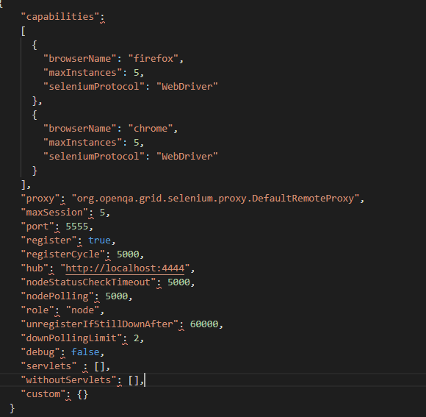

1. Save it in a folder with a valid name (example: mynode) in which we have saved Selenium standalone Server jar file
2. Open the new command prompt
3. Navigate to the folder structure where you have saved the Selenium standalone server jar file
4. Type the below command in command prompt

**java -Dwebdriver.gecko.driver="geckodriver.exe" - Dwebdriver.chrome.driver="chromedriver.exe" -jar selenium-server-standalone-3.141.59.jar -role node -nodeConfig mynodes.json**

and click on E**nter** button, which looks like

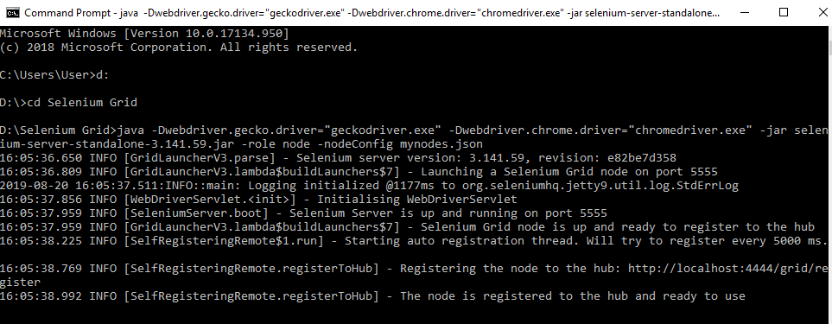

1. Open the browser
2. Enter URL as **http://localhost:4444/grid/console** and click on E**nter**
3. Grid console page is loaded, which shows **Browsers** by default

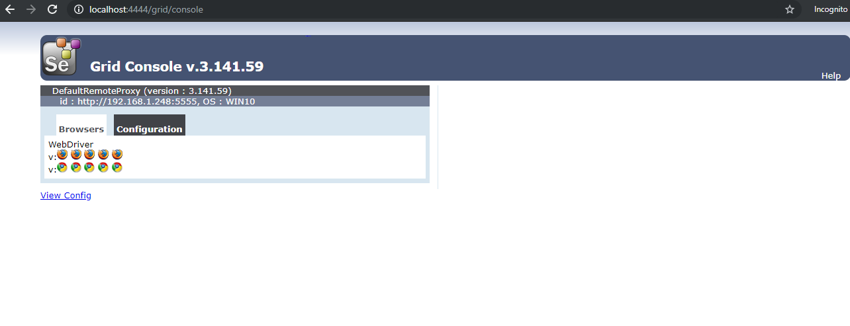

1. Click on **Configuration** which shows Configuration details

