**Create a Bucket.**

This lab has eight subsections, namely:

3.11.1 Selecting S3 from the storage of the AWS service panel

3.11.2 Verifying the button to create a bucket

3.11.3 Providing a bucket name and region

3.11.4 Entering key and value for identification and tracking the bucket

3.11.5 Blocking all the public access

3.11.6 Reviewing all parameters and creating the bucket

3.11.7 Verifying the newly created bucket on the panel of S3

3.11.8 Pushing the files to GitHub repositories

**Step 3.11.1:** Selecting S3 from the storage of the AWS service panel

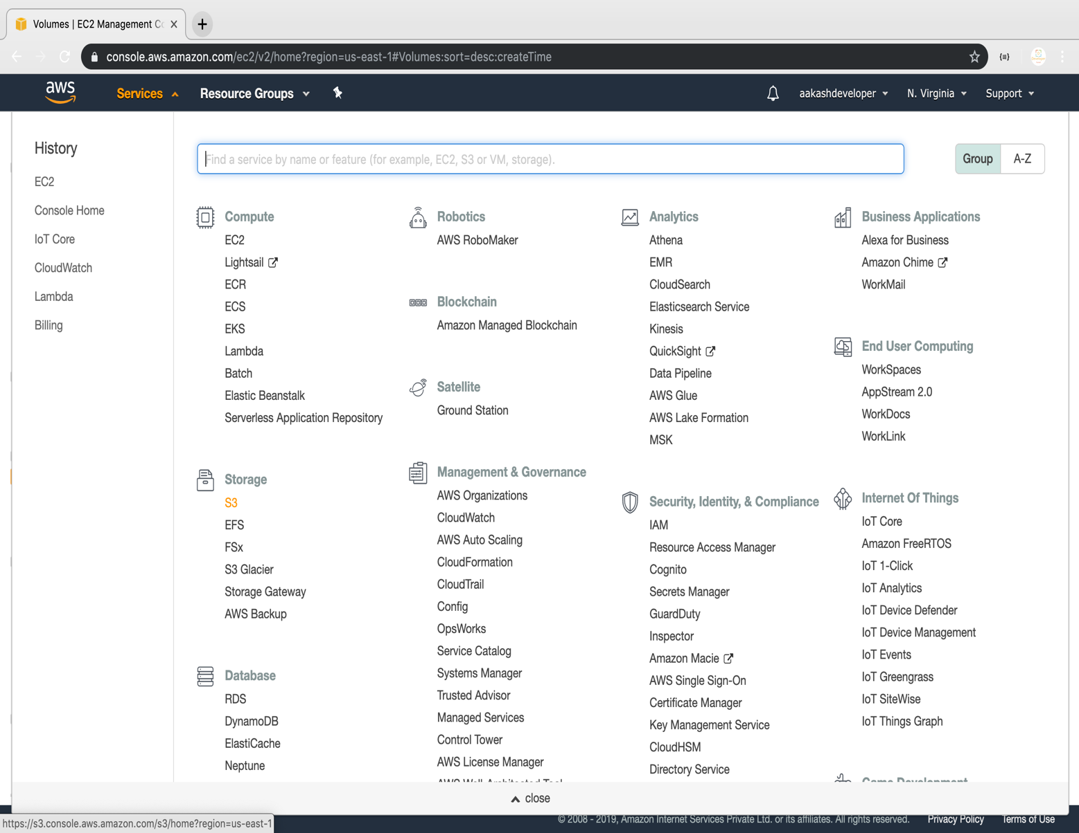

**Step 3.11..2:** Verifying the button to create a bucket

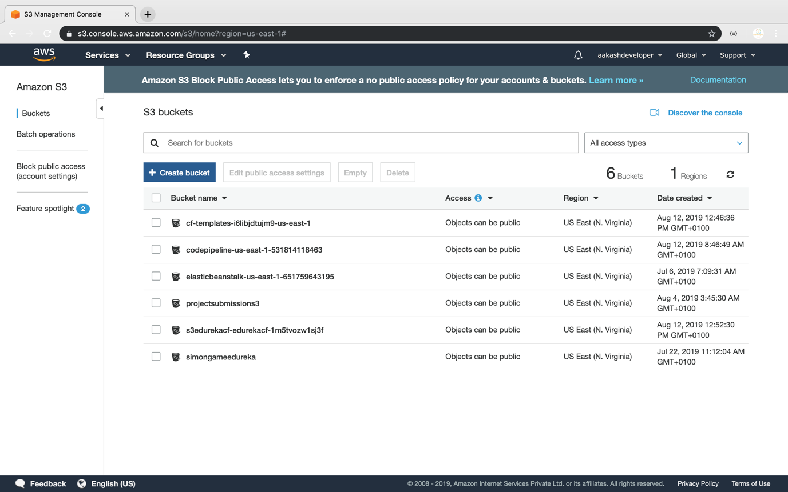

**Step 3.11.3:** Providing a bucket name and region

* Make sure that the bucket name is unique

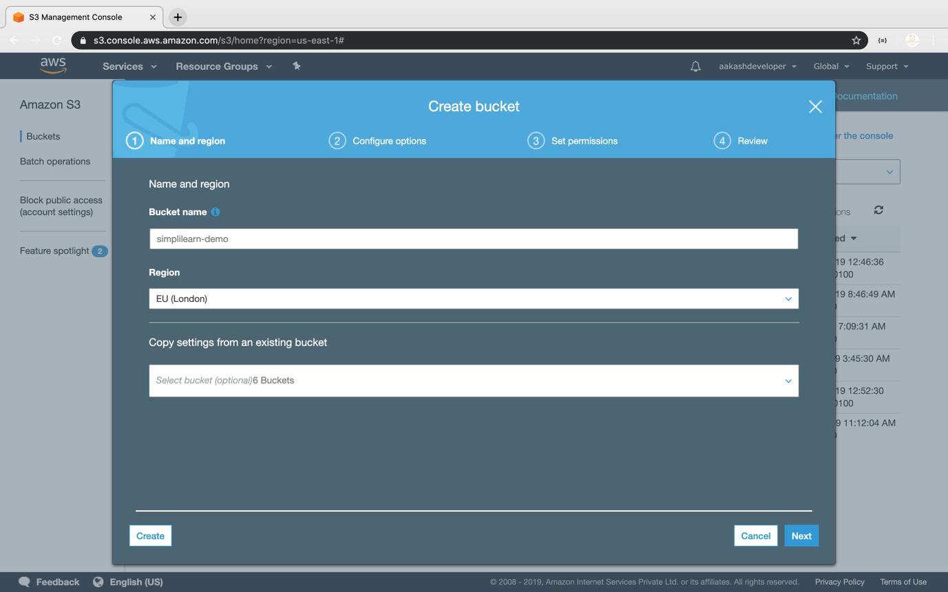

**Step 4.11.4:** Entering key and value for identification and tracking the bucket

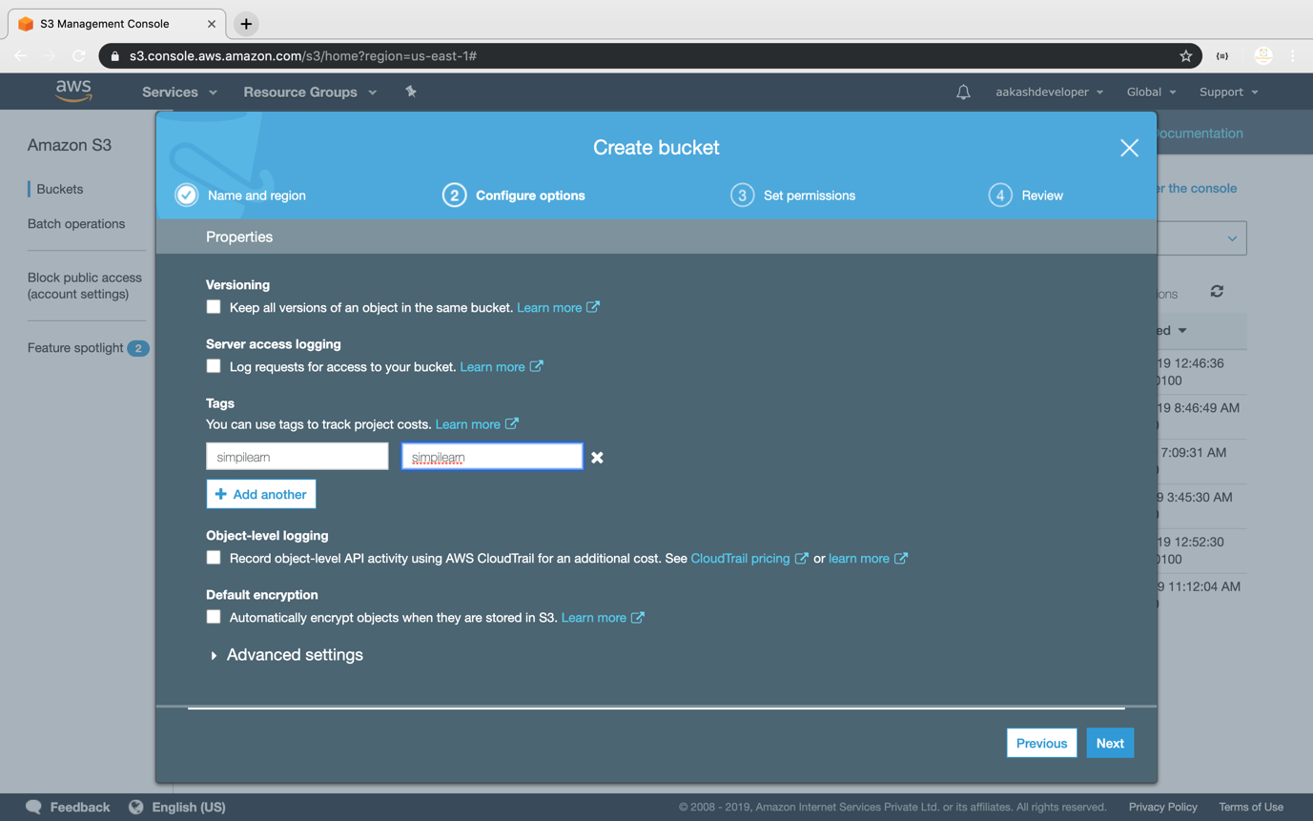

**Step 3.11.5:** Blocking all the public access

* If required, you can configure it later

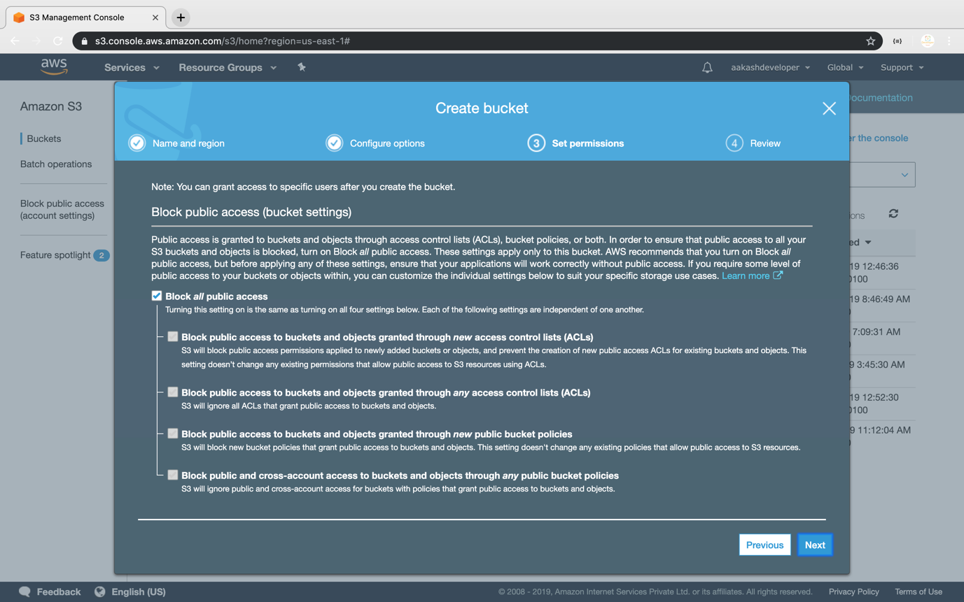

**Step 3.11.6:** Reviewing all parameters and creating the bucket

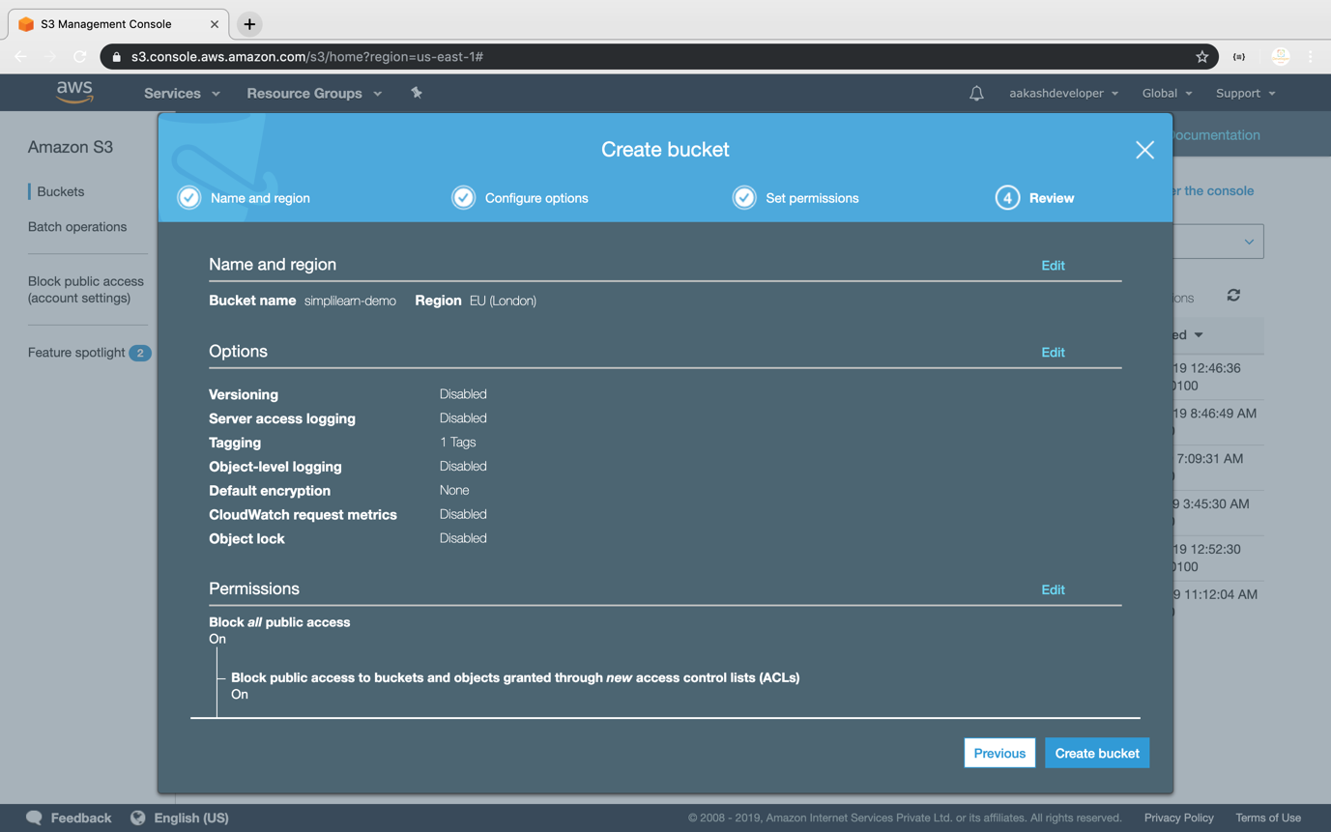

**Step 3.11.7:** Verifying the newly created bucket on the panel of S3

