**Set the Storage Class of an Object.**

This lab has three subsections, namely:

3.14.1 Selecting the bucket

3.14.2 Setting the storage class of an object

3.14.3 Pushing the files to GitHub repositories

**Step 3.14.1:** Selecting the bucket

* Select the bucket and open the list of items

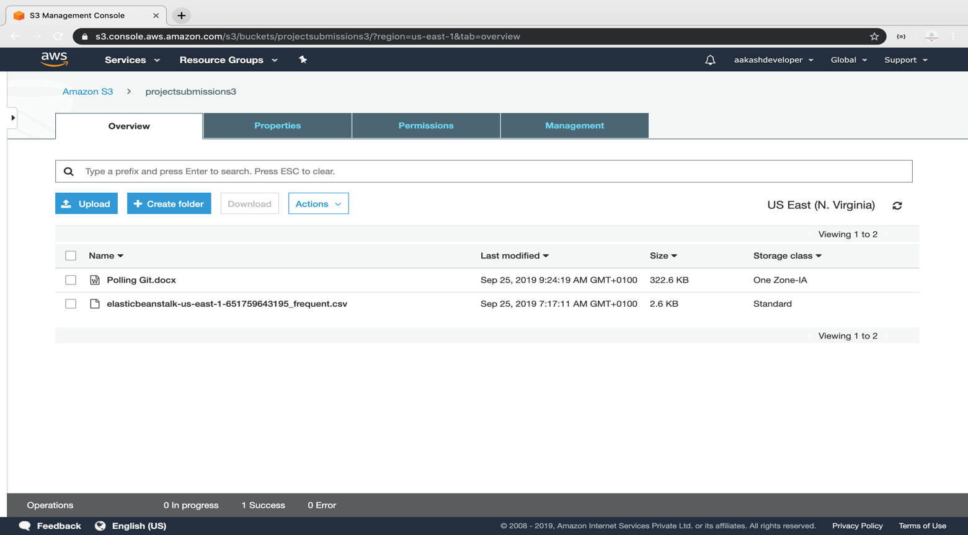

**Step 3.14.2:** Setting the storage class of an object

* Click on *Upload* and select the file and click *Next*

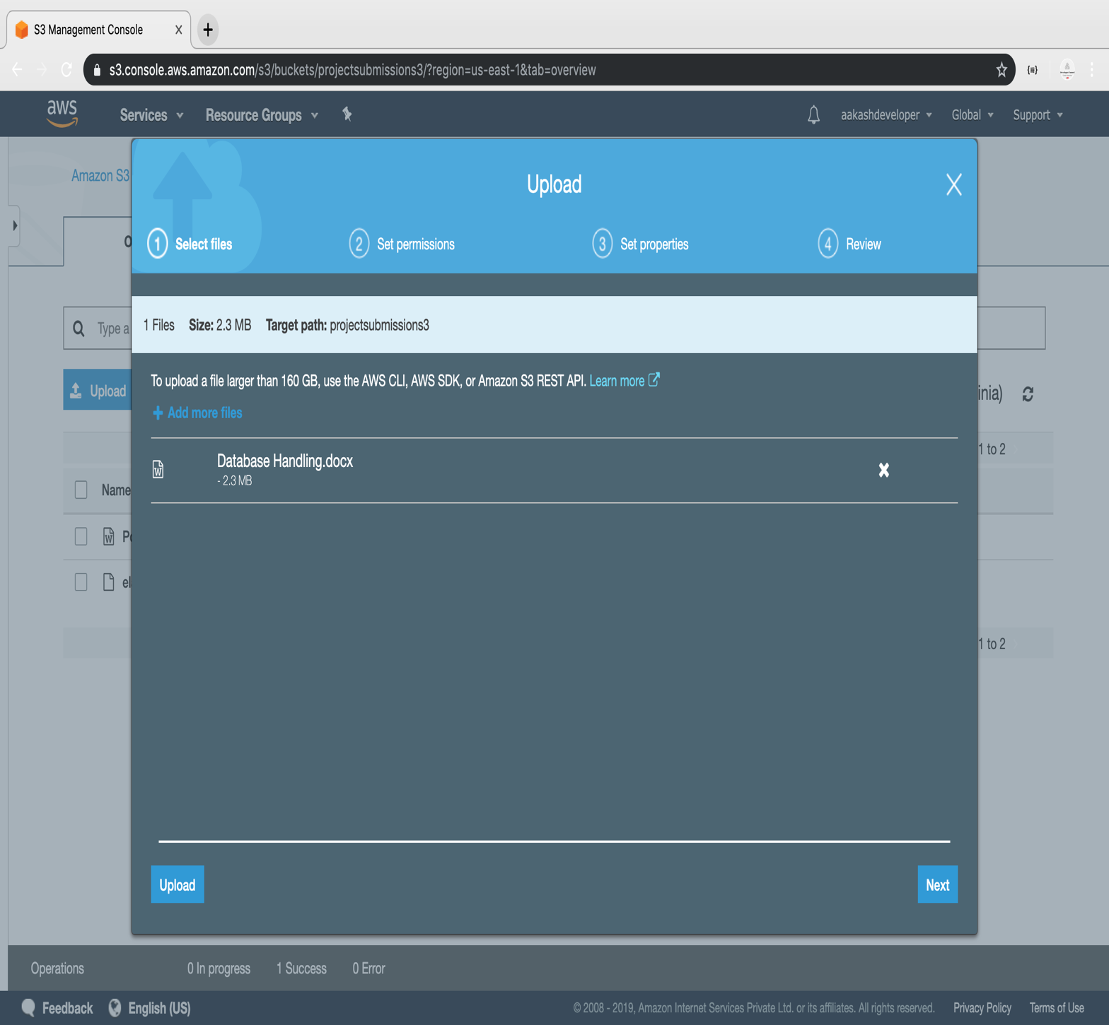

* Select the class and click *Next*

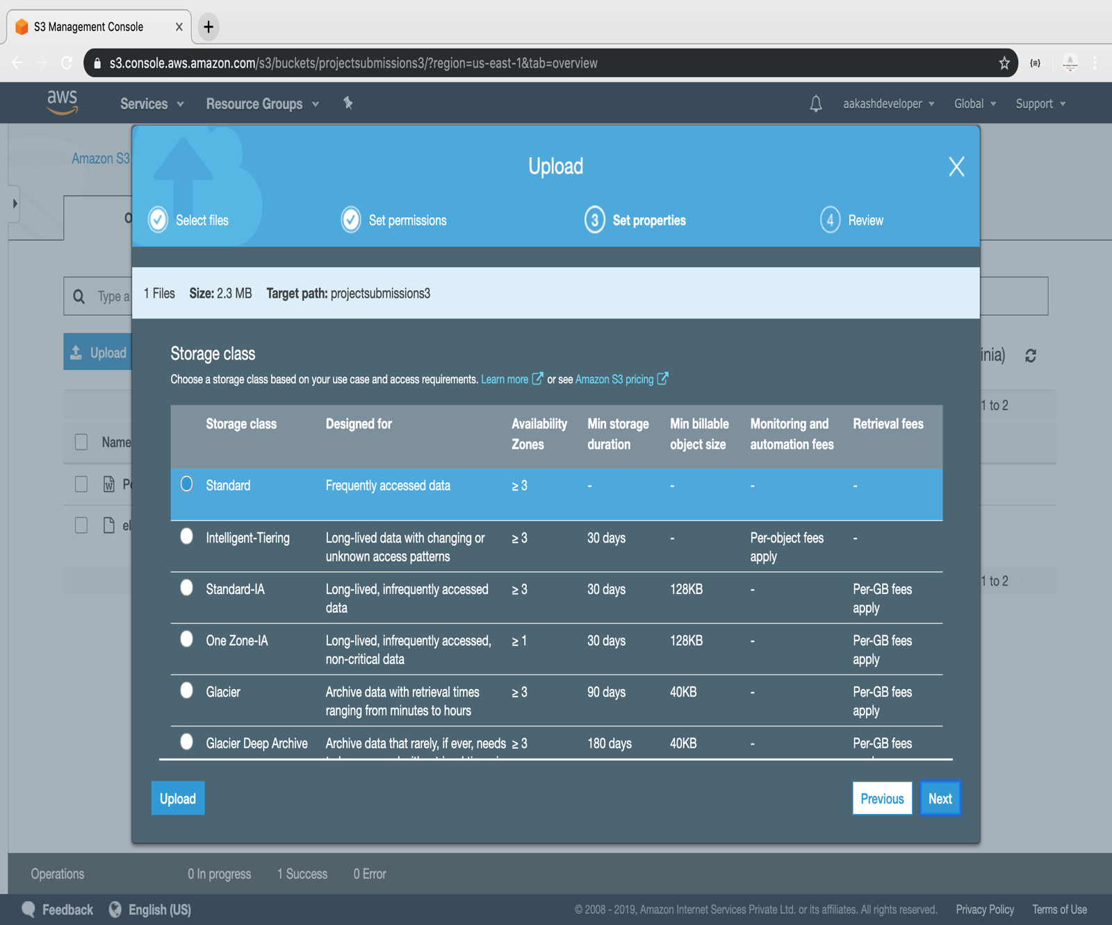

* The class will get assigned to the uploaded object

