**Create an IAM Role.**

This lab has four subsections, namely:

3.16.1 Creating an IAM role

3.16.2 Adding AWS policy to the role

3.16.3 Providing a key and a value for the role

3.16.4 Pushing the files to GitHub repositories

**Step 3.16.1:** Creating an IAM role

* In the IAM panel, click on *Roles* -> *Create role*

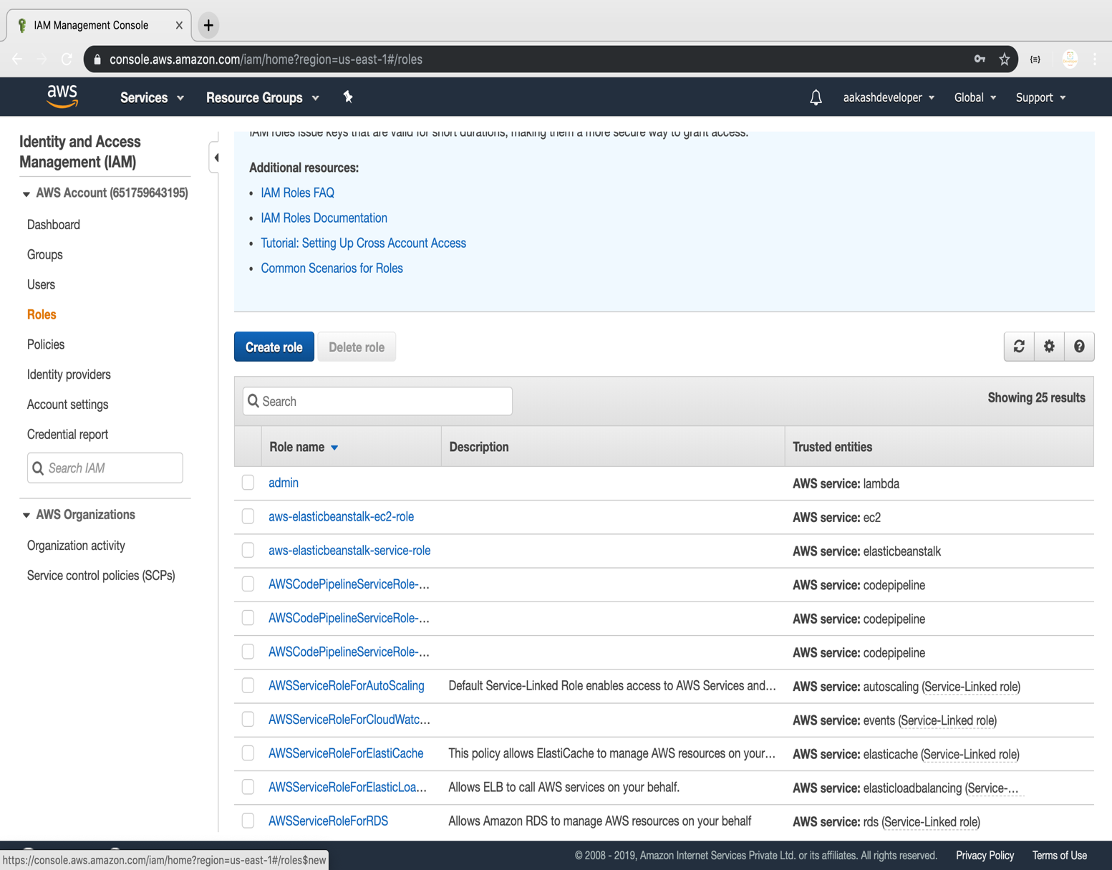

* Select the service

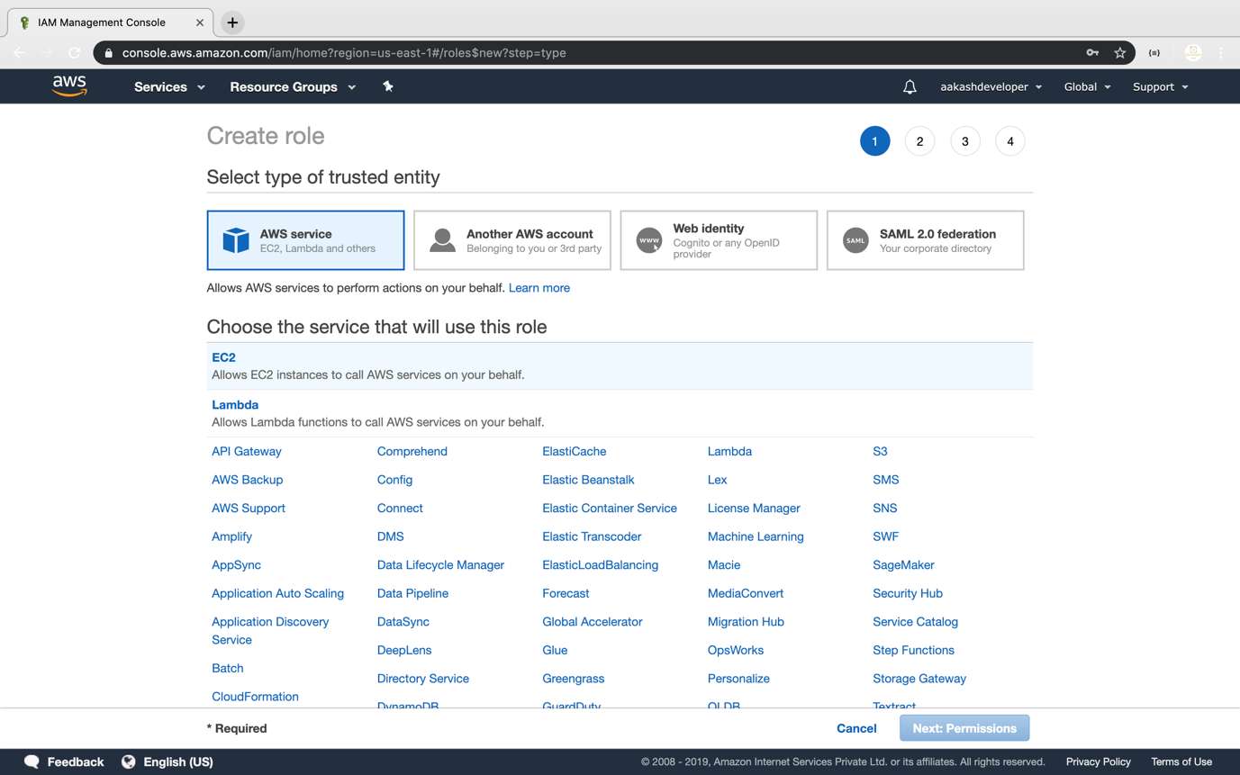

**Step 3.16.2:** Adding AWS policy to the role

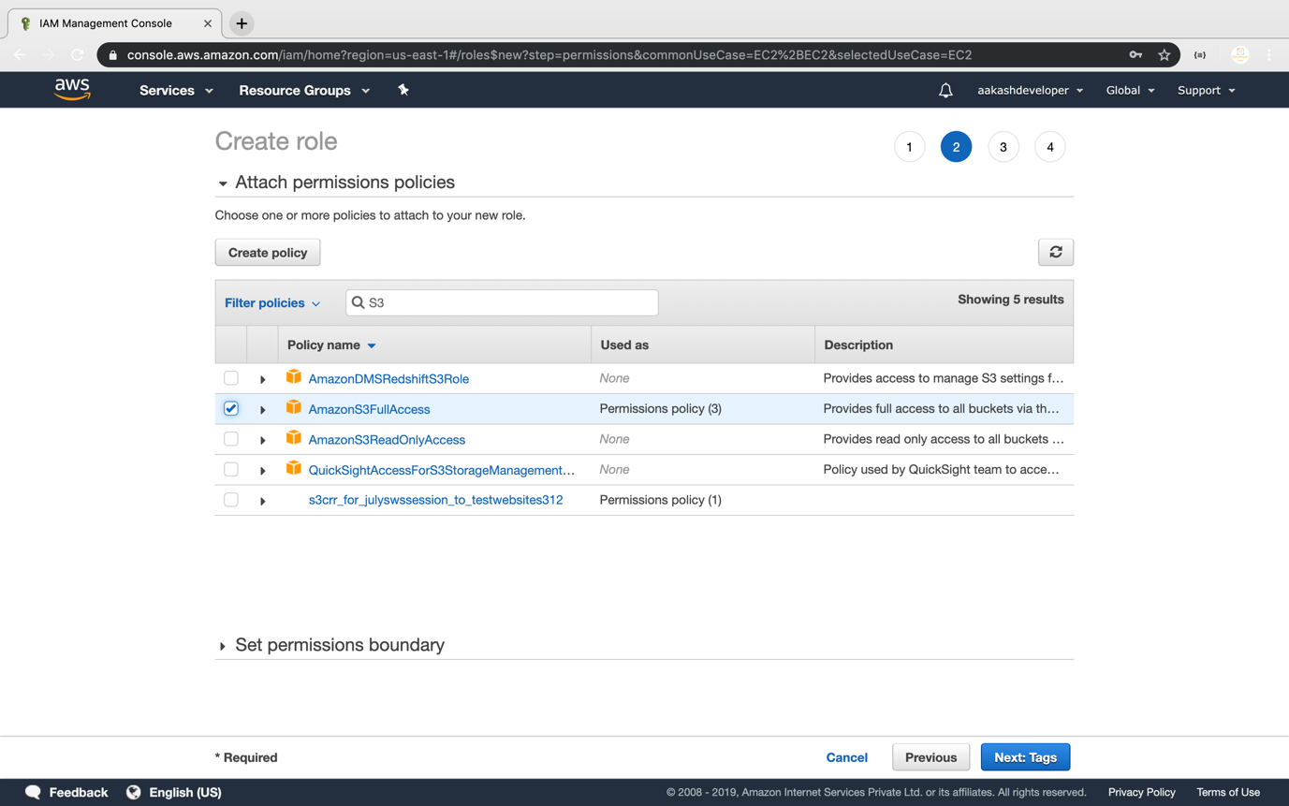

**Step 3.16.3:** Providing a key and a value for the role

* Add a key and a value to the role

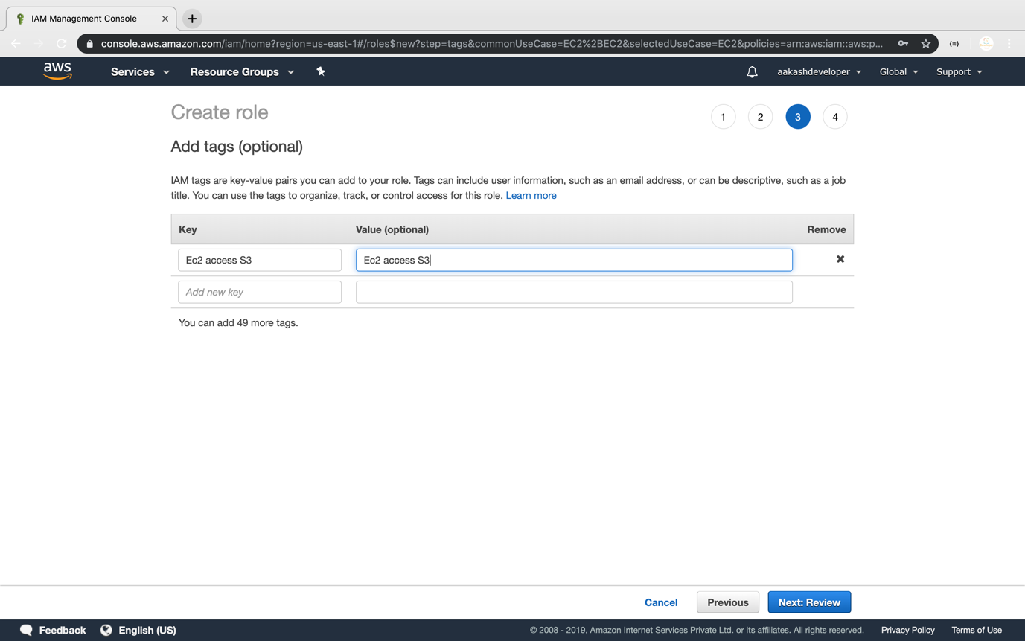

* Add a role:

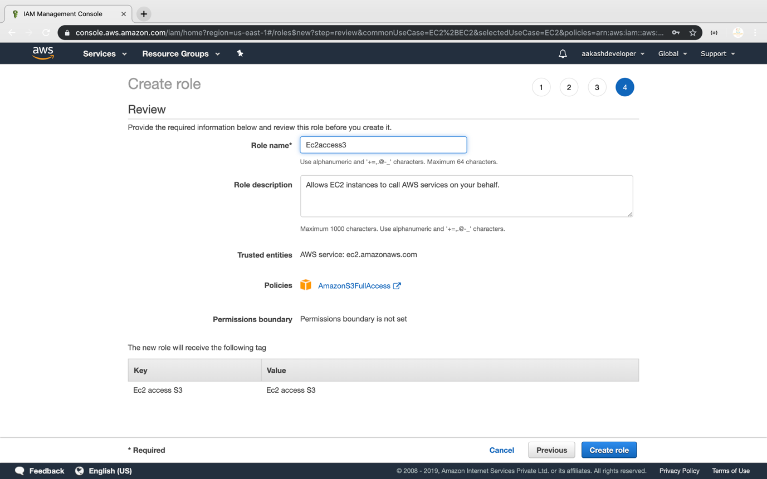

* Once the role is created, you can find it in the IAM panel

