Web Based GENERAL DISEASE PREDICTION SYSTEM (GDPS)

* Problem Statement :

The health care industries collect huge amounts of data that contain some hidden information, which is useful for making effective decisions. For providing appropriate results and making effective decisions on Data, some advanced data mining techniques are used.

In this study, an End-to-End Web-Based General Disease Prediction System (GDPS) is developed using various algorithms for predicting if the patient has a Disease or not. The System gives option to select the disease that they want to examine for (Heart, Diabetes, and Parkinson’s disease). The system uses multiple medical parameters such as age, sex, blood pressure, cholesterol, and other relevant parameters to predict the disease. The GDPS predicts the likelihood of patients having the disease they choose to enter the data for. It enables significant knowledge

E.g. Relationships between medical factors related to the disease and patterns, to be established. We have employed Logistic Regression & Support Vector Machine as the prediction algorithm. The obtained results have illustrated that the designed diagnostic system can effectively predict the risk level of the specific diseases.

Keywords: Python, Machine Learning, Logistic Regression, Support Vector Machine

* Heart Attack Overview , Symptoms , Causes, Facts & Figures

**Overview**

A type of disease that affects the heart or blood vessels. The risk of certain heart diseases may be increased by smoking, high blood pressure, high cholesterol, unhealthy diet, lack of exercise, and obesity. The most common heart disease is coronary artery disease (narrow or blocked coronary arteries), which can lead to chest pain, heart attacks, or stroke. Other heart diseases include congestive heart failure, heart rhythm problems, congenital heart disease (heart disease at birth), and endocarditis (inflamed inner layer of the heart). Also called cardiovascular disease.

**Symptoms**

Heart diseases symptoms depend on what type of heart diseases you have. Heart disease symptoms caused by abnormal heartbeats (heart arrhythmias). Signs & symptoms can include:

* Racing heartbeat (tachycardia)
* Slow heartbeat (bradycardia)
* Fluttering in your chest.
* Chest pain or discomfort.
* Dizziness
* Shortness of breath.
* Fainting (syncope) or near fainting.

**Causes**

The exact cause of Heart diseases isn't clear, but there are lots of things that can increase your risk of getting it. These are called "risk factors".

The main risk factors for Heart diseases are outlined below.

* High blood pressure
* Smoking
* High cholesterol
* Diabetes
* Inactivity
* 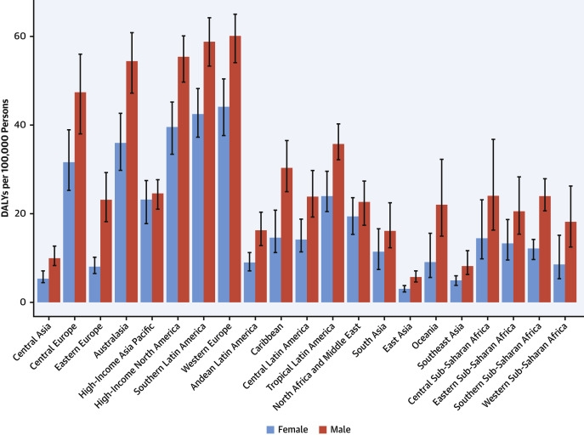Being overweight or obese

**FACTS:**

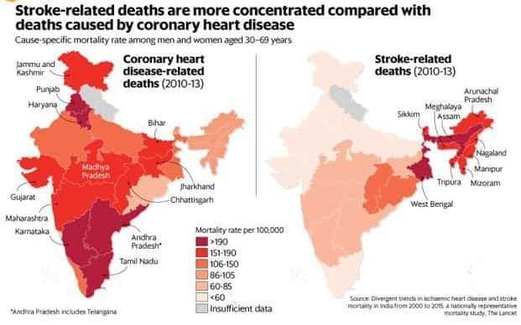

* **Cardiovascular diseases (CVDs) are the leading cause of death globally.**
* **An estimated 17.9 million people died from CVDs in 2019, representing 32% of all global deaths. Of these deaths, 85% were due to heart attack and stroke.**
* **Over three quarters of CVD deaths take place in low- and middle-income countries.**
* **Out of the 17 million premature deaths (under the age of 70) due to no communicable diseases in 2019, 38% were caused by CVDs.**

Most cardiovascular diseases can be prevented by addressing behavioral risk factors such as tobacco use, unhealthy diet and obesity, physical inactivity and harmful use of alcohol. It is important to detect cardiovascular disease as early as possible so that management with counselling and medicines can begin.

-*Sources from WHO*

* Diabetes Overview , Symptoms , Causes, Facts & Figures

**Overview**

Diabetes is a chronic disease that occurs either when the pancreas does not produce enough insulin or when the body cannot effectively use the insulin it produces. Insulin is a hormone that regulates blood sugar. Hyperglycemia, or raised blood sugar, is a common effect of uncontrolled diabetes and over time leads to serious damage to many of the body's systems, especially the nerves and blood vessels

**Types**

•**Type 2 diabetes**

Type 2 diabetes (formerly called non-insulin-dependent, or adult-onset) results from the body’s ineffective use of insulin. The majority of people with diabetes have type 2 diabetes. This type of diabetes is largely the result of excess body weight and physical inactivity.

Symptoms may be similar to those of type 1 diabetes, but are often less marked. As a result, the disease may be diagnosed several years after onset, after complications have already arisen.

Until recently, this type of diabetes was seen only in adults but it is now also occurring increasingly frequently in children.

Reduced insulin secretion and absorption leads to high glucose content in the blood.

•**Type 1 diabetes**

Type 1 diabetes (previously known as insulin-dependent, juvenile or childhood-onset) is characterized by deficient insulin production and requires daily administration of insulin. Neither the cause of Type 1 diabetes nor the means to prevent it are known.

Symptoms include excessive excretion of urine (polyuria), thirst (polydipsia), constant hunger, weight loss, vision changes, and fatigue. These symptoms may occur suddenly.

Autoimmune attack in type 1 diabetes.

•**Gestational diabetes**

Gestational diabetes is hyperglycemia with blood glucose values above normal but below those diagnostic of diabetes. Gestational diabetes occurs during pregnancy, women with gestational diabetes are at an increased risk of complications during pregnancy and at delivery. These women and possibly their children are also at increased risk of type 2 diabetes in the future. Gestational diabetes is diagnosed through prenatal screening, rather than through reported symptoms.

**Symptoms**

* + Hunger and fatigue
  + Peeing more often and being thirstier.
  + Dry mouth and itchy skin
  + Blurred vision
  + Yeast infections.
  + Slow-healing sores or cuts
  + Pain or numbness in your feet or legs

**Causes**

Diabetes mellitus is classified into **six categories:**[**type 1 diabetes**](https://en.wikipedia.org/wiki/Type_1_diabetes)**,**[**type 2 diabetes**](https://en.wikipedia.org/wiki/Type_2_diabetes)**, hybrid forms of diabetes, hyperglycemia first detected during pregnancy, "unclassified diabetes", and "other specific types”**. The "hybrid forms of diabetes" contains [slowly evolving, immune-mediated diabetes of adults](https://en.wikipedia.org/wiki/Latent_autoimmune_diabetes_of_adults) and [ketosis-prone type 2 diabetes](https://en.wikipedia.org/wiki/Ketosis-prone_diabetes). The "hyperglycemia first detected during pregnancy" contains [gestational diabetes mellitus](https://en.wikipedia.org/wiki/Gestational_diabetes_mellitus) and diabetes mellitus in pregnancy (type 1 or type 2 diabetes first diagnosed during pregnancy). The "other specific types" are a collection of a few dozen individual causes. Diabetes is a more variable disease than once thought and people may have combinations of forms. The term "diabetes", without qualification, refers to diabetes mellitus.

**Facts and Figures**

In 2019,

* Approximately **463 million adults** (20-79 years) were living with diabetes; by 2045 this will rise to **700 million**
* The proportion of **people with type 2 diabetes is increasing** in most countries
* **79%** of adults with diabetes were **living in low- and middle-income countries**
* **1 in 5** of the people who are above 65 years old have diabetes
* **1 in 2 (232 million)** people with diabetes were undiagnosed
* Diabetes caused **4.2 million deaths**
* Diabetes caused at least **USD 760 billion dollars** in health expenditure in 2019 – 10% of total spending on adults
* **More than 1.1 million children** **and adolescents** are living with type 1 diabetes
* More than **20 million live births** (1 in 6 live births) are affected by diabetes during pregnancy
* **374 million** people are at increased risk of developing type 2 diabetes
* **Total:** An estimated 34.2 million people have diabetes (10.5 percent of the U.S. population).
* **Diagnosed:** An estimated 26.9 million people of all ages have been diagnosed with diabetes (8.2 percent of the U.S. population).
  + Of the people diagnosed with diabetes, 210,000 are children and adolescents younger than age 20 years, including 187,000 with type 1 diabetes.
* **Undiagnosed:** An estimated 7.3 million adults ages 18 years or older have diabetes but are undiagnosed (21.4 percent of adults with diabetes).

View the full report: [National Diabetes Statistics Report, 2020](https://www.cdc.gov/diabetes/pdfs/data/statistics/national-diabetes-statistics-report.pdf) from the Centres for Disease Control and Prevention (CDC).

According to the American Diabetes Association’s [Economic Costs of Diabetes in the U.S.](https://care.diabetesjournals.org/content/41/5/917) the total estimated cost of diagnosed diabetes in 2017 was $327 billion, including $237 billion in direct medical costs and $90 billion in reduced productivity.

* Parkinson’s Disease Overview , Symptoms , Causes, Facts & Figures

**Definition**

Parkinson's disease (PD) is a progressive degenerative disorder of the central nervous system that primarily affects the elderly. It is named after the English· doctor, James Parkinson, who first described the disease in 1817. PD affects around 18 per 100,000 person-years and has a higher prevalence in males (Corti et aI., 2011). The degenerative symptoms of PD arise primarily from the progressive loss of dopaminergic neurons in the substantia nigra pars compacta (SNpc) of the midbrain (see figure 1) and result in motor system abnormalities such as bradykinesia, tremors, muscular rigidity and postural instability (Halliday and McCann, 2010).

[From <https://ir.library.louisville.edu/cgi/viewcontent.cgi?article=1033&context=etd> page 8]

**Parkinson's disease (PD) is a neurodegenerative disorder that affects predominately dopamine-producing (“dopaminergic”) neurons in a specific area of the brain called substantia nigra. [From** <https://www.parkinson.org/understanding-parkinsons/what-is-parkinsons> **]**

**Symptoms**

Symptoms generally develop slowly over years. The progression of symptoms is often a bit different from one person to another due to the diversity of the disease. People with PD may experience:

* Tremor, mainly at rest and described as pill rolling tremor in hands. Other forms of tremor are possible
* Bradykinesia
* Limb rigidity
* Gait and balance problems

**[From** <https://www.parkinson.org/understanding-parkinsons/what-is-parkinsons> **]**

**Causes**

The cause remains largely unknown. Although there is no cure, treatment options vary and include medications and surgery. While Parkinson’s itself is not fatal, disease complications can be serious. The Centers for Disease Control and Prevention (CDC) rated complications from PD as the 14th cause of death in the United States.

**[From** <https://www.parkinson.org/understanding-parkinsons/what-is-parkinsons> **]**

**Facts and figures(age distribution)**

<https://www.ncbi.nlm.nih.gov/pmc/articles/PMC7323575/>

In India, there have been only few published studies of Parkinson’s disease (PD) showing a wide range of prevalence. We conducted this study to determine the prevalence of PD in the rural population of Gujarat, in the western region of India.

***Methods:*** This cross-sectional descriptive study was conducted in the villages of Anand, a district of Gujarat, India, between September 2019 and February 2020. This study used a multistep approach including a screening questionnaire and video recording followed by clinical examination by a neurologist, laboratory evaluation, and brain imaging to evaluate patients with PD.

***Results:*** A total population of **18,896** was screened. The overall crude prevalence of PD was **42.3** per **100,000**, and the prevalence over the **age of 60** **was 308.9 per 100,000** which showed the trend of increasing disease prevalence with age. Their mean duration of illness was 39.3 ± 27.3 months, and more than half of patients with PD had multiple associated non-motor symptoms and nearly one-third had comorbid anxiety or depression. Environmental factors are important in the pathogenesis of PD, but there was no clear association between patients with PD and certain variables including consumption of well water, exposure to pesticides or other toxins, smoking cigarettes, and drinking alcohol or coffee in our study.

***Conclusions:*** The present study showed the current epidemiological data of PD from Gujarat, in western India. Further studies across different regions in India need to be encouraged for better understanding of PD prevalence in the Indian population.

* Dataset we’ll be working with(Hyperlinks)

[Diabetes](https://www.kaggle.com/gargmanas/pima-indians-diabetes)

[Parkinson’s disease](https://www.kaggle.com/nidaguler/parkinsons-data-set)

[Heart](https://www.kaggle.com/lykin22/heart-disease-dataset)