Agriculture Website

An Internship Report Submitted for partial fulfilment of the requirements for the Degree of Computer Science & Engineering (Artificial intelligence)

Under GIFT, AUTONOMOUS

By Manoranjan Sahoo,

Registration No: - 2301298067



2025-26

Under the guidance of

Sr. Engineer Prof.Sujana Sri

Department of Computer Science & Engineering Gandhi Institute for Technology (GIFT) Autonomous

Bhubaneswar - 752054, Odisha, India

Declaration

I Manoranjan Sahoo, hereby declare that this internship report entitled “WEB DESIGNING”, for partial fulfillment of the requirements for the Degree of Bachelor of Technology, is a bonafide record of work carried out by me and the content included in this report is true to the best of my knowledge.

Student Name: Manoranjan Sahoo

Registration no: 2301298245

Certificate of Internship Provider
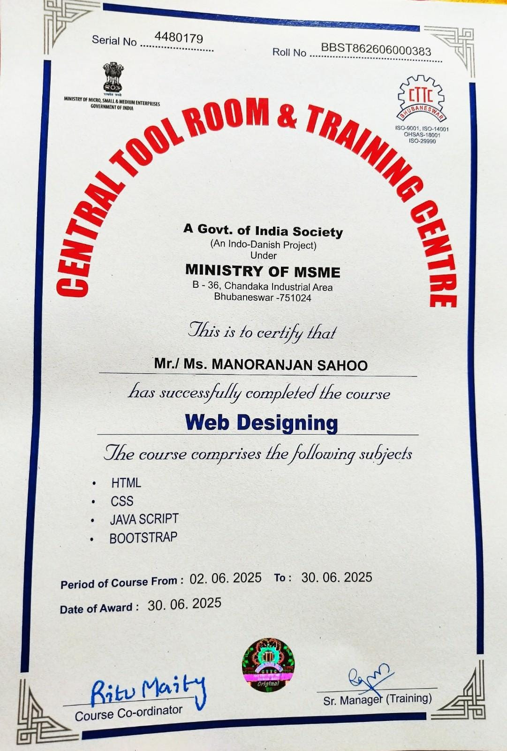

Certificate

This is to certify that the Internship report entitled “Web Designing” is a bonafide record of work done by Manoranjan sahoo (Registration No. 2301298067) under the supervision of Sr. Engineer Prof.Sujana Sri, at CTTC, in partial fulfilment of the requirements for the award of Degree of Bachelor of Technology under GIFT, AUTONOMUS.

Prof. Meenakshi Maharana Prof. Nitu Singh Internal Guide HOD

Acknowledgement

I would like to take this opportunity to thank all those people whose invaluable contributions, directly or indirectly, have made this internship a great learning experience for me.

It is my honor to express my deepest sense of gratitude and appreciation to Central Tool Room and Training Centre, and my Guide, Sr. Engineer Prof.Sujana Sri for the valuable guidance, intuitive insights and persistent efforts to complete my internship successfully.

I give my sincere thanks to Prof. Swarnananda Muduli (Internship Coordinator, Department of CSE) for giving me the opportunity and motivating me to complete the report within stipulated period of time.

I acknowledge with immense pleasure the sustained interest, encouraging attitude and constant inspiration rendered by Dr. Trilochan Sahu (Principal) and Prof. Nitu Singh (HoD,dept-Computer Science and Engineering). Their selfless inspirations have always kept us moving forward.

I am also thankful to my friends and parents for their constant encouragement.

Contents
- Introduction 1
- Internship details 2-3
- Project/Assignment Details 4-7
- Career Outcomes 8-9
- Conclusion 10
- Reference 11

Introduction

In today’s rapidly evolving technological landscape, Web Designing are at the forefront of innovation, transforming industries across the globe. With increasing demand for intelligent systems and data-driven solutions, gaining practical experience in these fields has become essential for aspiring technologists.

As part of my academic and professional development, I undertook a 45-day internship at Central Tool And Training Center, Bhubaneswar, a premier institution known for its advanced technical training and industry-oriented programs. This internship was a vital step in bridging the gap between theoretical knowledge and practical application, offering me a hands-on introduction to real- world webdesign workflows.

My motivation for choosing this internship stemmed from a growing interest in the potential of Web Designing to solve complex problems and automate intelligent decision-making. Central Tool And Training Center, structured training, expert mentorship, and opportunity to work on a live project aligned perfectly with my learning goals and career aspirations.

Key Points of My Internship:
  - Learned fundamentals and practical applications of Web Designing.
  - Worked on how html and CSS work and Javascript
  - Gained hands-on experience with tools such as javascript, html, CSS.
  - Completed mini-projects to implement Website for solving real-life problem.

Internship details

I have successfully completed my internship at the Central Tool And Training Center, Bhubaneswar, as part of the Web Designing course. Central Tool And Training Center is a Central government training institute under the Ministry of Micro, Small and Medium Enterprises (MSME), known for offering a wide range of industry-oriented training programs. These include courses in mechanical design, manufacturing, CAD/CAM, robotics, automation, and cutting-edge fields like Web Designing. Each course is designed to provide both theoretical knowledge and hands-on practical exposure to the latest technologies used in industry.

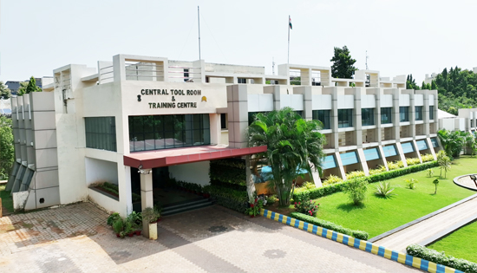

Figure 1: Image of CTTC, Bhubaneswar

As part of the WEB DESIGNING internship program, I received structured training focused on key concepts of how to design and working a website . The training covered:
  - Data preprocessing and data handling techniques
  - Supervised and unsupervised styling and working function of website
  - Model training, testing, and performance evaluation

  - Basic Natural Language Processing (NLP)
  - Project-based learning and real-world use cases

The training was conducted using html along with essential tools and libraries such as Jvascript, Css, html. I was able to apply the concepts learned through practical exercises, mini-projects, and assignments, which helped reinforce both my theoretical understanding and technical skills.

Skills Acquired:

  - HTML/CSS – Structure and styling of web pages.
  - JavaScript – Adds interactivity and client-side logic.
  - Responsive Design – Creating mobile-friendly layouts using media queries and frameworks like Bootstrap or Tailwind CSS.

The total duration of the internship was 45 days, during which I gained valuable exposure to real-time Web Designing applications and enhanced my ability to work with data-driven technologies. This internship not only strengthened my technical foundations but also increased my confidence to take on more advanced roles or academic projects in the field of Web Development.

Project/Assignment Details

Project Title & Group Name:
Agriculture Website

Objective:
The objective of this project is to design and implement a Agriculture Website that To provide farmers, agribusinesses, and agriculture enthusiasts with reliable information, innovative products, and practical solutions that enhance crop productivity, promote sustainable farming, and connect users with trusted agricultural brands—all through an easy-to-use, informative digital platform.

Tools & Technologies Used:

Code Editor

  - Visual Studio Code – Best for web or Html,css & Javascript.

Programming Language

  - HTML, CSS, JavaScript – For Design and working for Agriculture website.

Browser (For Web Version)

  - Google Chrome or Firefox – To test and view your Agriculture website .

Methodology:
The development of the Green Harvest agriculture website followed a systematic and iterative approach to ensure usability, relevance, and technical robustness. The key stages involved are:
- Requirement Analysis
  - Identified user needs including product browsing, crop guidance, and brand information.
  - Defined essential features such as product listings, video resources, multilingual support, and mobile responsiveness.
- Design Phase
  - Created wireframes and mockups for intuitive navigation and visual appeal.
  - Focused on user-friendly layouts for farmers and agri-enthusiasts.
- Development
  - Built the website using HTML, CSS, JavaScript, and optionally frameworks like React or Tailwind CSS.
  - Integrated brand-wise product filtering, modal popups, and video embedding.
- Content Integration
  - Curated product details, crop tips, and embedded YouTube videos.
  - Verified accuracy of agricultural information through trusted sources.
- Testing and Debugging
  - Conducted cross-browser and device testing to ensure functionality and performance.
  - Fixed UI, logic, and responsiveness issues.
- Deployment
  - Hosted the website on a reliable platform (e.g., GitHub Pages or Netlify).
  - Ensured SEO-friendly URLs and fast load times.
- Documentation
  - Documented code structure, features, and update instructions for maintenance and scalability.

Results:

The Green Harvest agriculture website was successfully developed and implemented in alignment with the defined objectives and methodology. The platform provides farmers and users with a seamless interface to explore agricultural products, watch informative videos, and access crop-related guidance from trusted brands.
The website delivers accurate product details, brand-based filtering, and integrated video content in a user-friendly layout. Key features like responsive design, modal popups, and Google Translate integration function smoothly across devices and browsers.
Testing was conducted using varied data inputs (e.g., different brands, video links, product categories), and the site consistently performed as expected. All functional elements—including navigation, product display, and media playback—were validated for reliability and responsiveness.
This project not only meets the requirements of a functional agriculture-focused platform but also demonstrates practical skills in web development, including UI/UX design, content integration, and responsive coding. Overall, Green Harvest fulfills its goal of supporting modern, informed, and connected farming practices through an accessible digital solution.

Code Snippets: Html code:

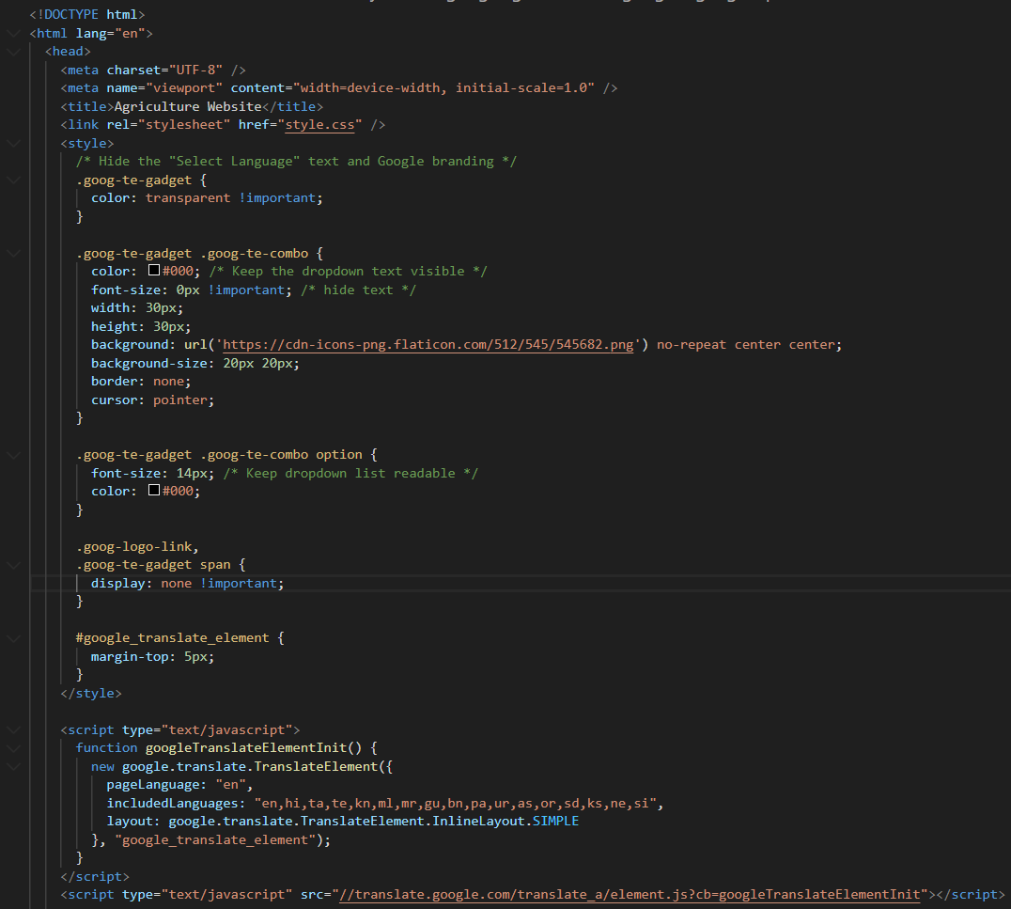

CSS code:

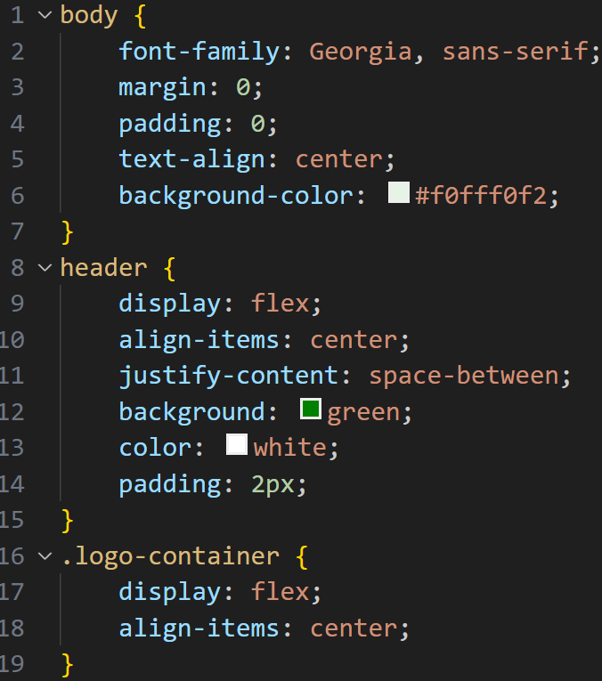

Javascript code:

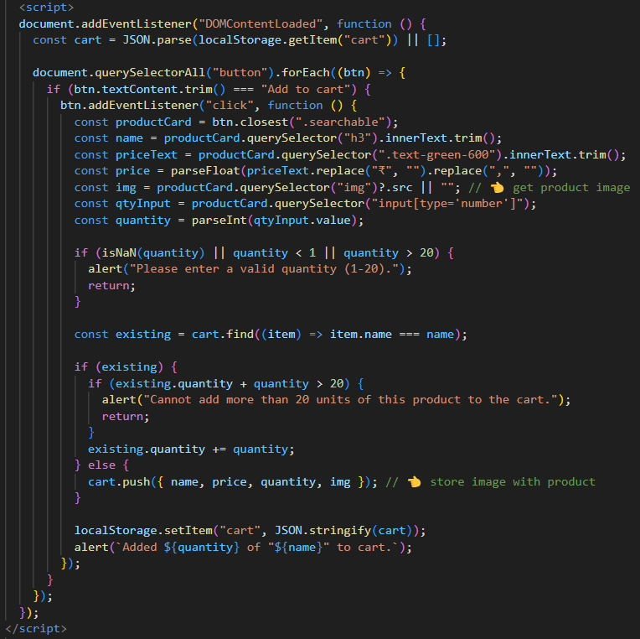

Output:

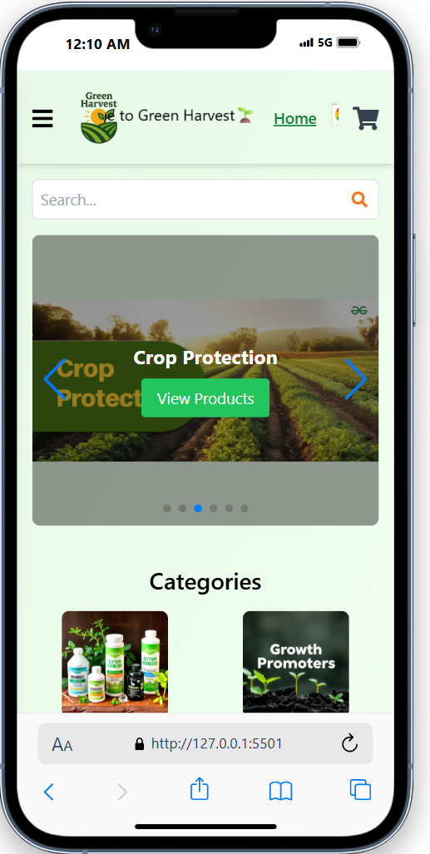

Career Outcomes

The internship at CTTC, Bhubaneswar proved to be a significant milestone in my academic and professional journey. It not only enhanced my technical knowledge in WEB DESIGNING but also played a vital role in shaping my career aspirations and long-term goals.

Through this project, I gained valuable hands-on experience with tools and technologies like HTML, CSS, JavaScript, and responsive design frameworks. These are essential in today’s digital ecosystem, especially for those aspiring to careers in web designing
Some of the key career-oriented outcomes include:
• Technical Skill Development:
I improved my front-end development skills significantly, especially in structuring content, styling responsive layouts, and integrating multimedia content like embedded videos and modals. I also practiced writing clean, modular code and became more comfortable using developer tools for debugging and testing.

• Domain Knowledge Application:
Working on an agriculture-focused platform helped me understand how technology can solve practical problems for farmers and agri-businesses. It broadened my perspective on how to design digital solutions that are accessible and useful for non-technical users.

• Project Management and Planning:
By following a structured methodology—from requirements gathering to deployment—I learned how to plan web project independently. This has prepared me for handling end-to-end projects in professional environments.

• Career Direction and Confidence:
This experience solidified my interest in pursuing a career in web designing and possibly exploring opportunities in technology for rural development or domain-specific software solutions. It has also motivated me to deepen my knowledge in modern framework Bootstrap.

• Soft Skills and Collaboration:
Documenting the project, designing with users in mind, and solving real UI/UX problems have helped strengthen my communication, critical thinking, and problem-solving skills—key traits valued in both individual and collaborative tech roles.

.

Conclusion

My 45-day internship at CTTC, Bhubaneswar was a highly enriching and transformative experience. It provided me with valuable insights into the world of Web Designing, combining both theoretical knowledge and practical application in a structured and engaging manner.

Throughout the development of the agriculture website, I had the opportunity to work hands-on with modern web technologies, apply structured development methodologies, and create a domain-specific solution tailored for agricultural users. This experience strengthened my technical competencies while also enhancing my problem-solving, design thinking, and professional communication skills.
The project has greatly contributed to my overall personal and professional development, giving me clarity and confidence in pursuing a career in web designing, especially in building impactful, real-world applications. It has laid a strong foundation for further learning and specialization in user-centric, sector-focused digital solutions.
Overall, the project was both educational and inspiring, and I consider it a significant milestone in my academic journey and a valuable step toward achieving my long-term career goals.

Reference:-

https://www.w3schools.com

https://developer.mozilla.org

https://getbootstrap.com

https://tailwindcss.com

https://support.google.com/youtube/answer/171780?hl=en

https://translate.google.com/intl/en/about/website/

https://pages.github.com

