- I delete the early_stopping for now. Because it stopst the training too early like at 16. epoch

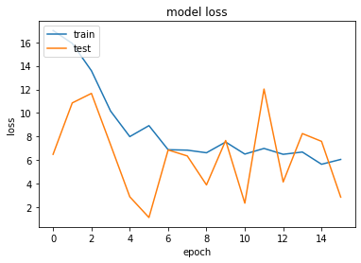
- Okk I don’t know why but my code start training with too high loss and val acc doesn’t increase. So I will start from manos’s code and do the changes step by step to see where does the problem come

Starting from the beginning.
- Manos’us code without any change (it stops at 74. Epoch and acc’s seems ok)
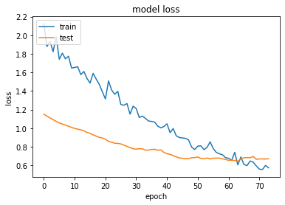
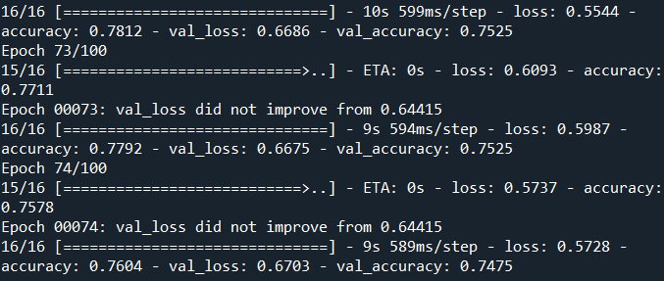
- Manos’us code without any change but with the new dataset (It doesn’t go to early stop and actually we see train and val loss still decrease so I will increase the epoch number
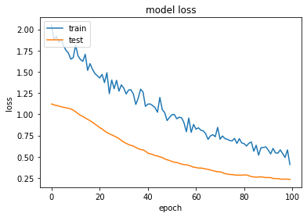
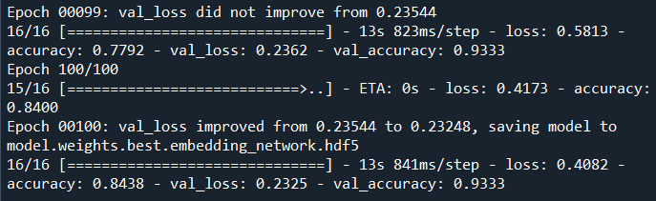

- Manos’us code with input size = 100x100 and epoch = 140

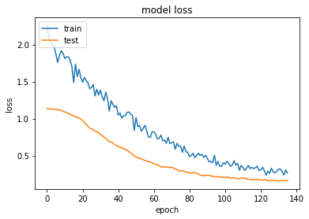
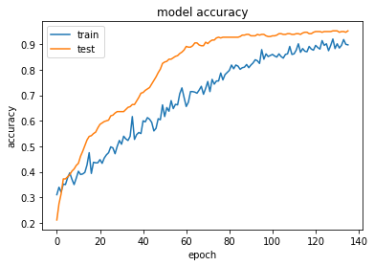

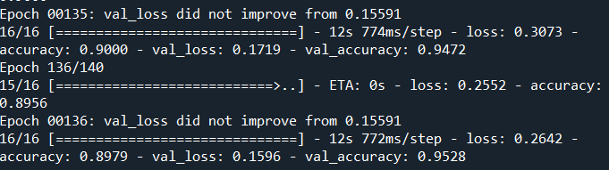

The training stops with early stop at 136 epoch. Soo 140 epoch was okk we don’t need more.

- Changing learning rate from 0.0001 to learning scheduler

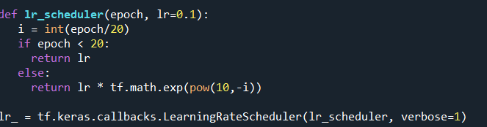
ULALAAA I did it from scratch but look the accuracy got messed up. I will use some google prepared learning scheduler :D

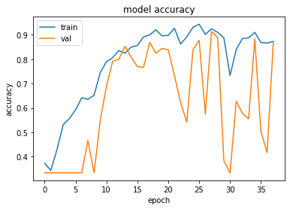

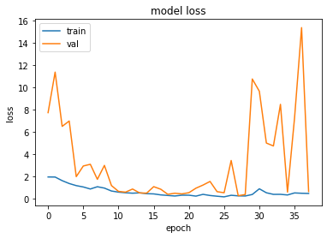

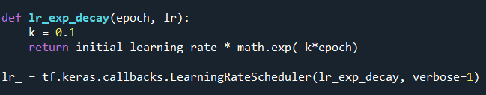

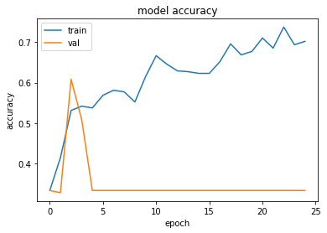
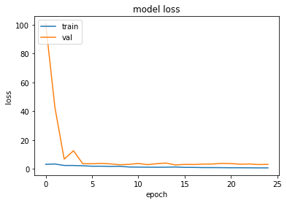

Okkkk step decay doesn’t work for us I don’t know whyyy. The possible reason:
In transfer learning, learning rate should be very very low
otherwise the weights change too much even in the first epoch... so we loose the pretrain benefits.

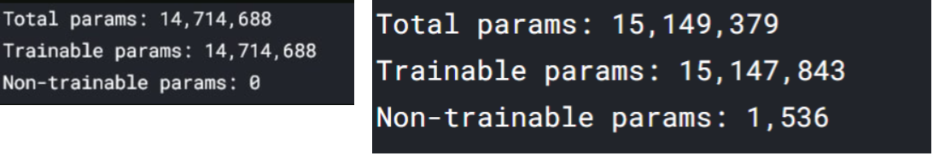
- Why do we have untrainable params after adding last 3 dense to the vgg network??

In general, all weights are trainable weights. The only built-in layer that has non-trainable weights is the BatchNormalization layer. It uses non-trainable weights to keep track of the mean and variance of its inputs during training. OKK its normal

- FINAL MODEL

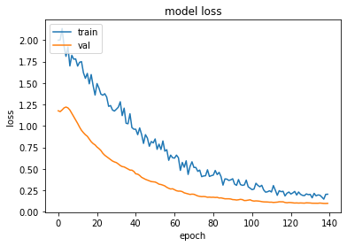

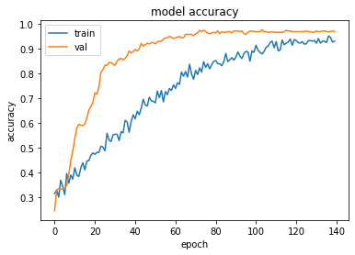
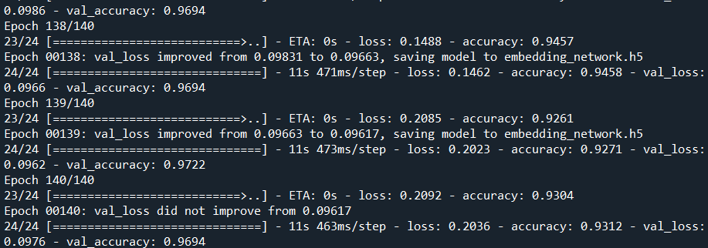

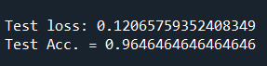

pretrain_mano_changes.py
embedding_network.h5

Additional Info I had during the experiments

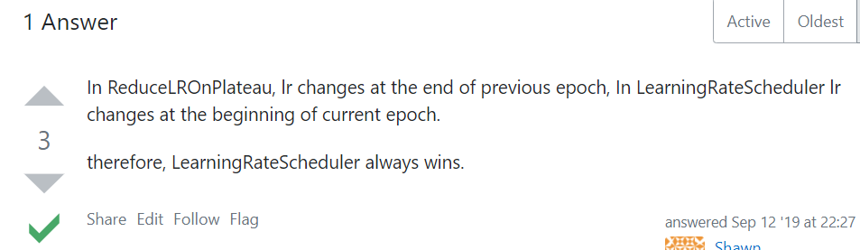

conda install h5py==2.10.0 otherwise load.model gives "AttributeError: 'str' object has no attribute 'decode' " , while Loading a Keras Saved Model

