- I delete the early_stopping for now. Because it stopst the training too early like at 16. epoch

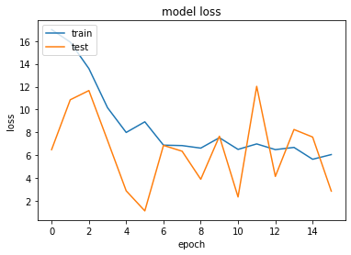
- Okk I don’t know why but my code start training with too high loss and val acc doesn’t increase. So I will start from manos’s code and do the changes step by step to see where does the problem come

Starting from the beginning.
- Manos’us code without any change (it stops at 74. Epoch and acc’s seems ok)
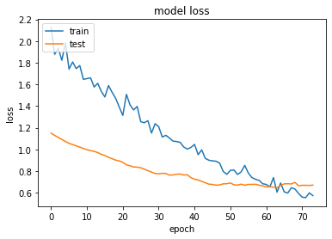
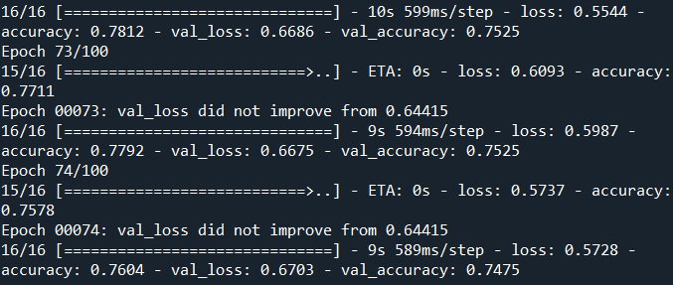
- Manos’us code without any change but with the new dataset (It doesn’t go to early stop and actually we see train and val loss still decrease so I will increase the epoch number
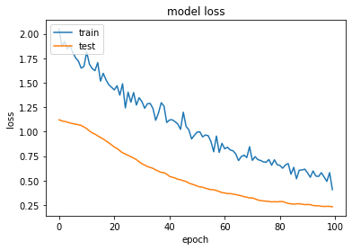
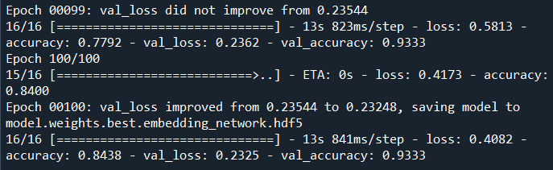

- Manos’us code with input size = 100x100 and epoch = 140

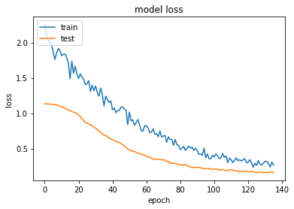
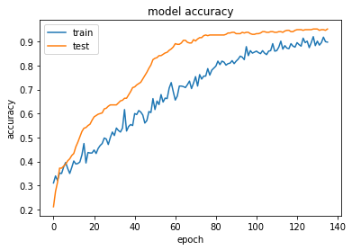

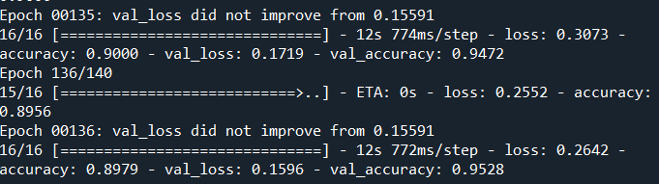

The training stops with early stop at 136 epoch. Soo 140 epoch was okk we don’t need more.

- Changing learning rate from 0.0001 to learning scheduler

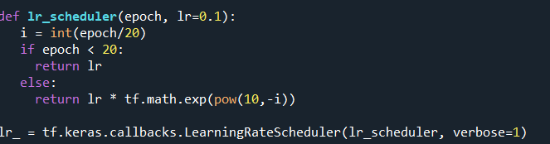
ULALAAA I did it from scratch but look the accuracy got messed up. I will use some google prepared learning scheduler :D

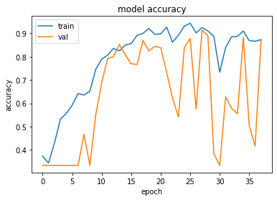

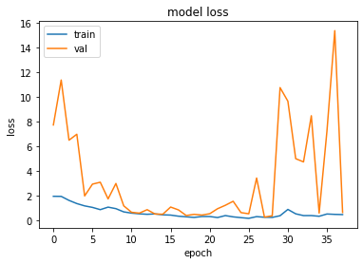

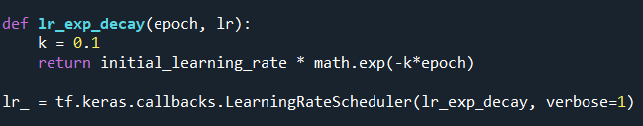

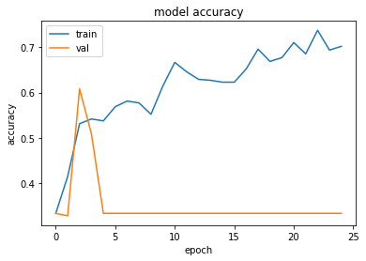
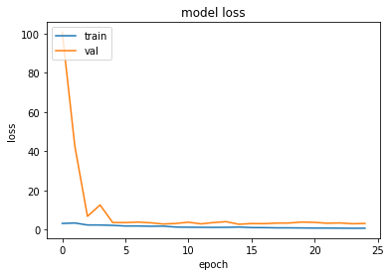

Okkkk step decay doesn’t work for us I don’t know whyyy. The possible reason:
In transfer learning, learning rate should be very very low
otherwise the weights change too much even in the first epoch... so we loose the pretrain benefits.

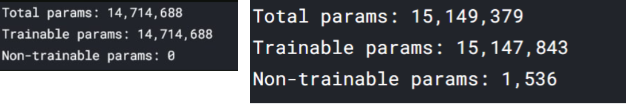
- Why do we have untrainable params after adding last 3 dense to the vgg network??

In general, all weights are trainable weights. The only built-in layer that has non-trainable weights is the BatchNormalization layer. It uses non-trainable weights to keep track of the mean and variance of its inputs during training. OKK its normal

- FINAL MODEL

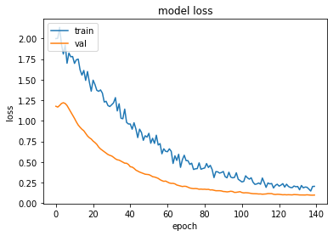

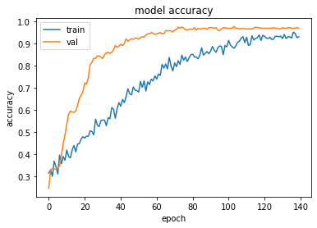
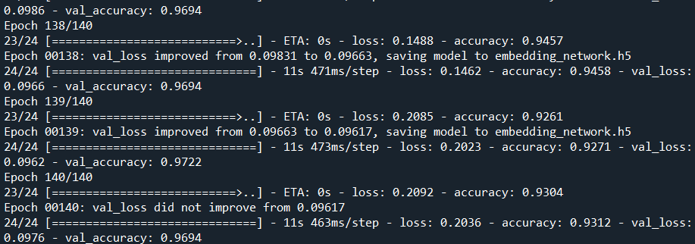

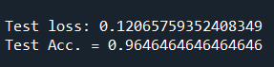

pretrain_mano_changes.py
embedding_network.h5

- Batch size experiments
16

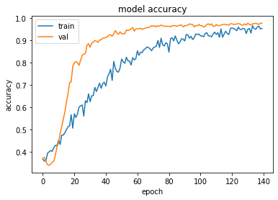

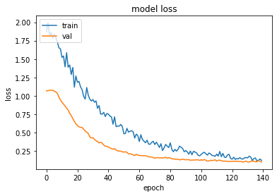
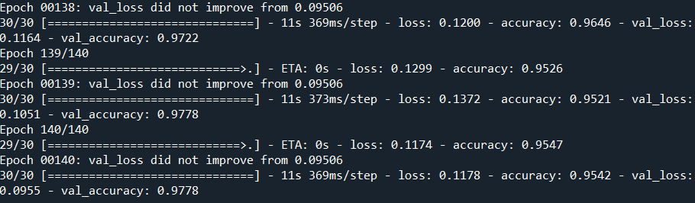
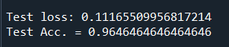

32
Gives near results with 16

64

Like a shiiit lilii
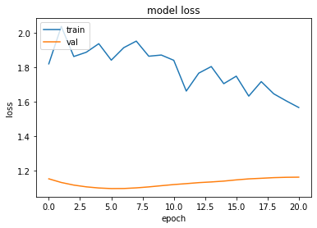
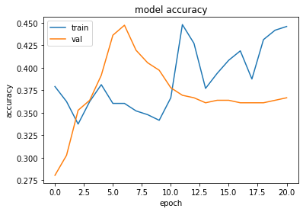
7/8 [=========================>....] - ETA: 0s - loss: 1.5816 - accuracy: 0.4330
Epoch 00021: val_loss did not improve from 1.09514
8/8 [==============================] - 13s 2s/step - loss: 1.5543 - accuracy: 0.4458 - val_loss: 1.1614 - val_accuracy: 0.3667
Questions

- Why do we have a higher validation acc than train acc?? Its very strange isn’t ?
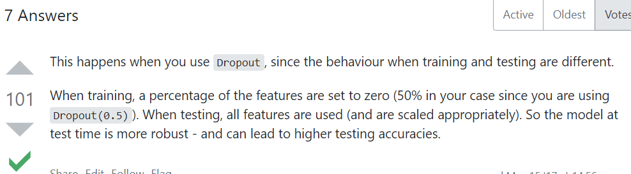

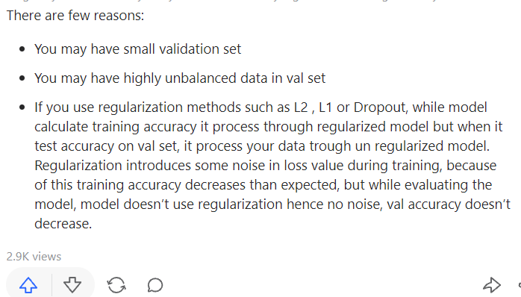

Ok its normal I believe

Additional Info I had during the experiments

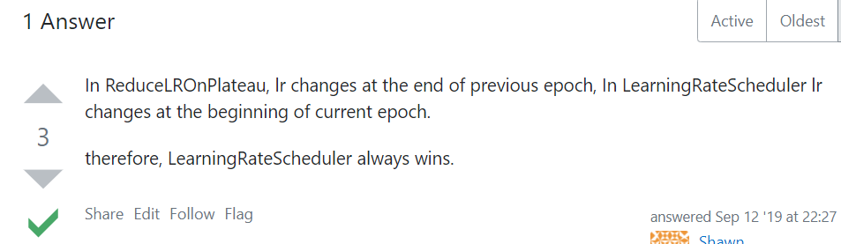

conda install h5py==2.10.0 otherwise load.model gives "AttributeError: 'str' object has no attribute 'decode' " , while Loading a Keras Saved Model

- using smaller batch sizes have been empirically shown to have faster convergence to “good” solutions. This is intuitively explained by the fact that smaller batch sizes allow the model to “start learning before having to see all the data.” The downside of using a smaller batch size is that the model is not guaranteed to converge to the global optima. It will bounce around the global optima, staying outside some ϵ-ball of the optima where ϵ depends on the ratio of the batch size to the dataset size. Therefore, under no computational constraints, it is often advised that one starts at a small batch size, reaping the benefits of faster training dynamics, and steadily grows the batch size through training, also reaping the benefits of guaranteed convergence. But this statement has its limits; we know a batch size of 1 usually works quite poorly. It is generally accepted that there is some “sweet spot” for batch size between 1 and the entire training dataset that will provide the best generalization. This “sweet spot” usually depends on the dataset and the model at question. https://medium.com/mini-distill/effect-of-batch-size-on-training-dynamics-21c14f7a716e
- https://www.tensorflow.org/install/source#gpu
- https://scikit-learn.org/stable/modules/model_evaluation.html
- https://keras.io/examples/vision/siamese_contrastive/

Batch size = 16
Learning rate = 0.00001
Deleted custom layers from the VGG architecture
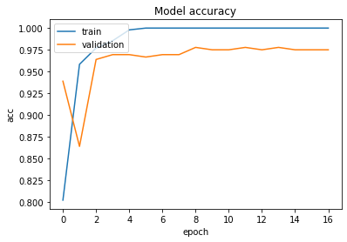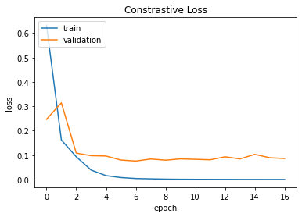
Evaluate on test data
Accuracy: 0.9797979797979798
Precision: 0.979871041065071
Recall: 0.9797979797979798
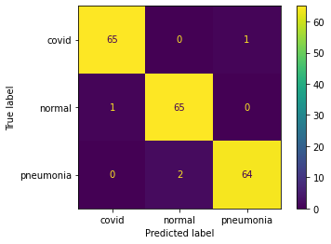

Batch size = 54
Learning rate = 0.00001
Deleted custom layers from the VGG architecture

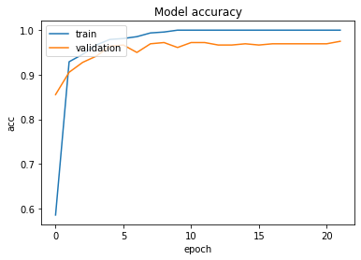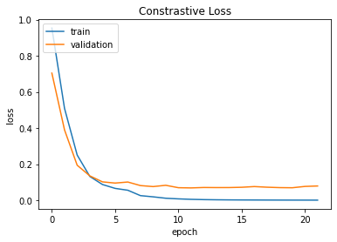

Evaluate on test data
Accuracy: 0.9696969696969697
Precision: 0.970291146761735
Recall: 0.9696969696969697

