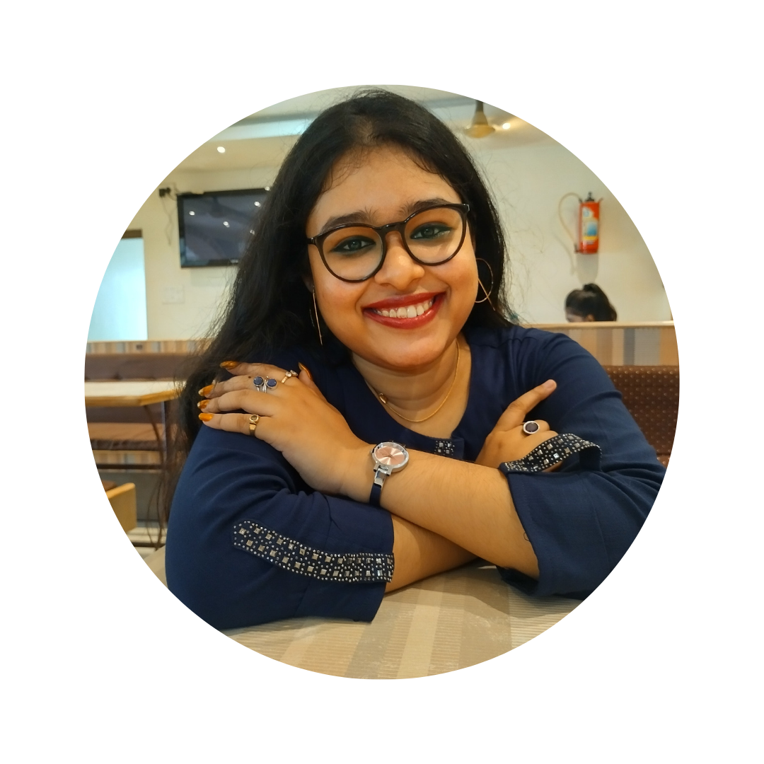
Manoswita Bose Cohgan
Cell: 9874334534
Email: simabose12@gmail.com
ABOUT ME
Career Objective
A lifelong learner passionate about research in the field of bionetworks, machine learning, and artificial intelligence. A detail-oriented individual seeking a challenging position in a company to launch a career and build a valuable skillset.
Personal Details
Father’s name – Goutam Kumar Bose
Mother’s name – Sima Bose
Date of Birth – 25/01/2001
Gender – Female
Languages known – English, Bengali, Hindi, French

Address – 2F/A, Surya Narayan Complex, 67, West Ghosh Para Road, Bhatpara, North 24 Parganas - 743123.
Professional Experience:-
- Internship

Name of Company | Duration | Project Title | Deliverables
MyCaptain | 2 months | Social Media Intern | Leveraging established and emerging social media channels, expanding reach and engagement.

- Projects

- Community Analysis in Social Media Networks
- Bio-network Analysis

- Computer Proficiency

- Proficient in C, Python, Java, and MySQL
- Intermediate knowledge of Cloud Computing, Cyber Security, Digital Electronics, Networking, and Software Engineering and Modelling

- Interests and Hobbies

- Passionate about Content Writing, Ghost-writing, Blogging, Traveling, Reading, Learning, and Storytelling.
- Keen interest in Graphic Designing, Public Speaking, Music and Craftwork.

- Activities and Achievements

- Published in 15+ anthologies
- Attended workshops in Creative Writing, Digital Marketing, Social Media Content Creation, Psychology, and Graphic Designing
- Certified in ‘Power Python’ by Ludifu
- Certified in ‘Power BI’ by Ludifu
- Certified in ‘Digital Power’ by Ludifu
- Certified in ‘Network Security’ by TubeStudy
- Certified in ‘C#’ by TubeStudy
- Certified in ‘Java Programming’ by TubeStudy

ABOUT ME
Academic Qualifications

Qualification | Name of School / College | Board / University | Year of Passing | Marks (in %) / CGPA
Bachelor of Computer Applications | Amity Institute of Information and Technology, Kolkata | Amity University, Kolkata | 2023 | 8.57  (till Sem-III)
12th | St. Joseph’s Convent, Chandannagar | Indian School Certificate | 2019 | 89%
10th | St. Joseph’s Convent, Chandannagar | Indian Certificate of Secondary Education | 2017 | 97%

I, Manoswita Bose, student of Amity University, Kolkata, hereby solemnly affirm and declare that what is stated, is true to the best of my knowledge.
Date 31-05-2022
Place Kolkata

Signature

