Manotej Meka

Dr. Ross

Project 3 Report

1. Mean Face and the 25 eigen values faces

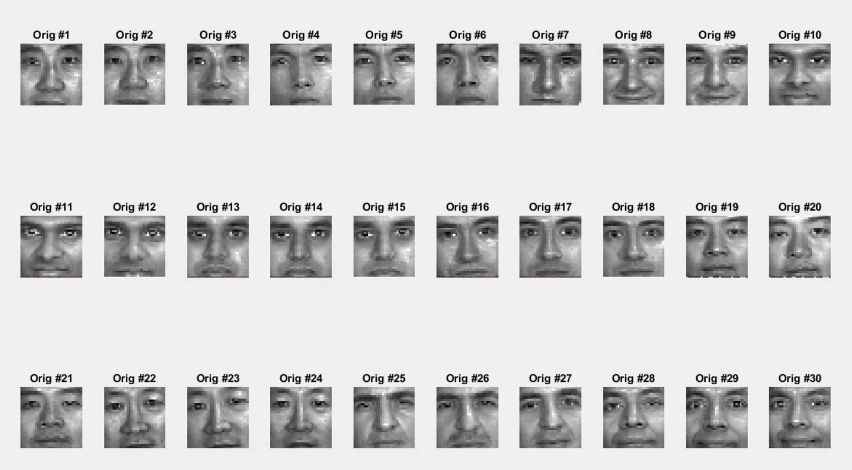

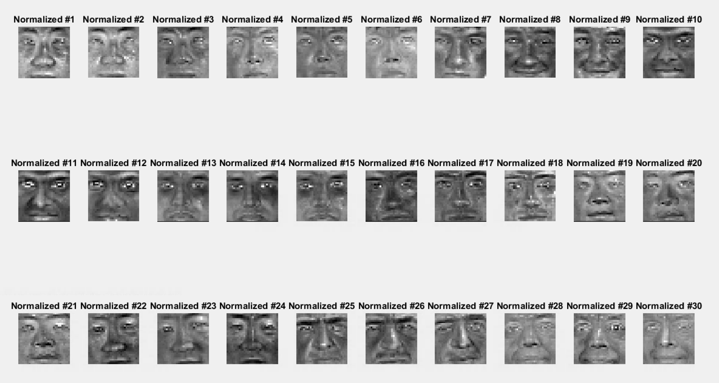

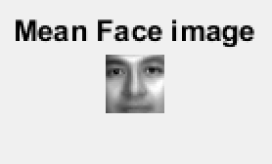

1. Top 25 feature vector faces

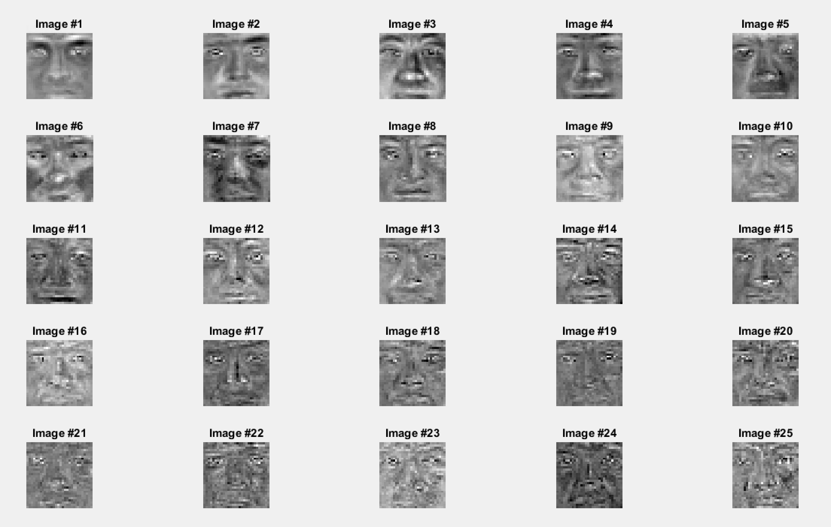

1. ROC, Gen and Imp

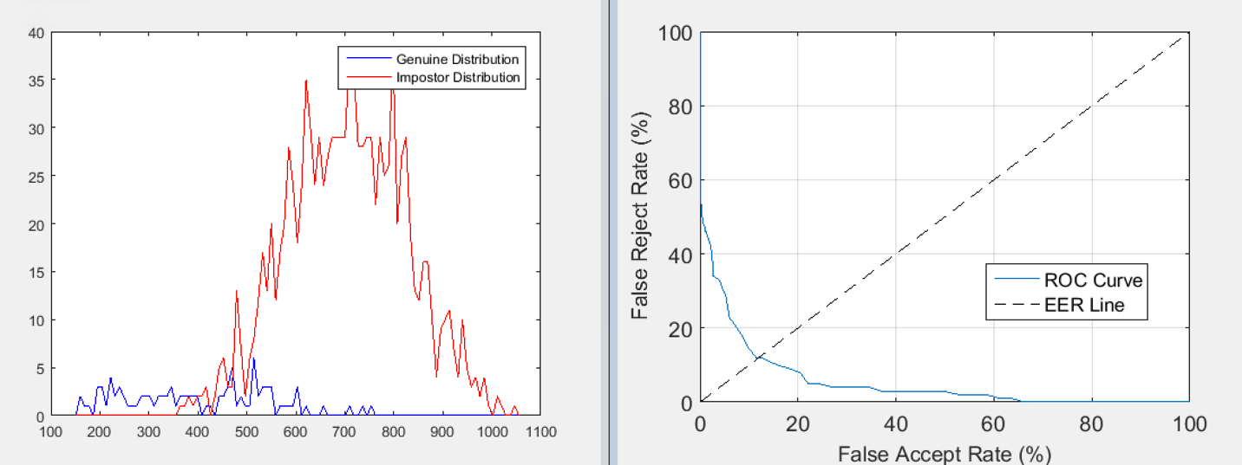

1. Top 20 feature vector faces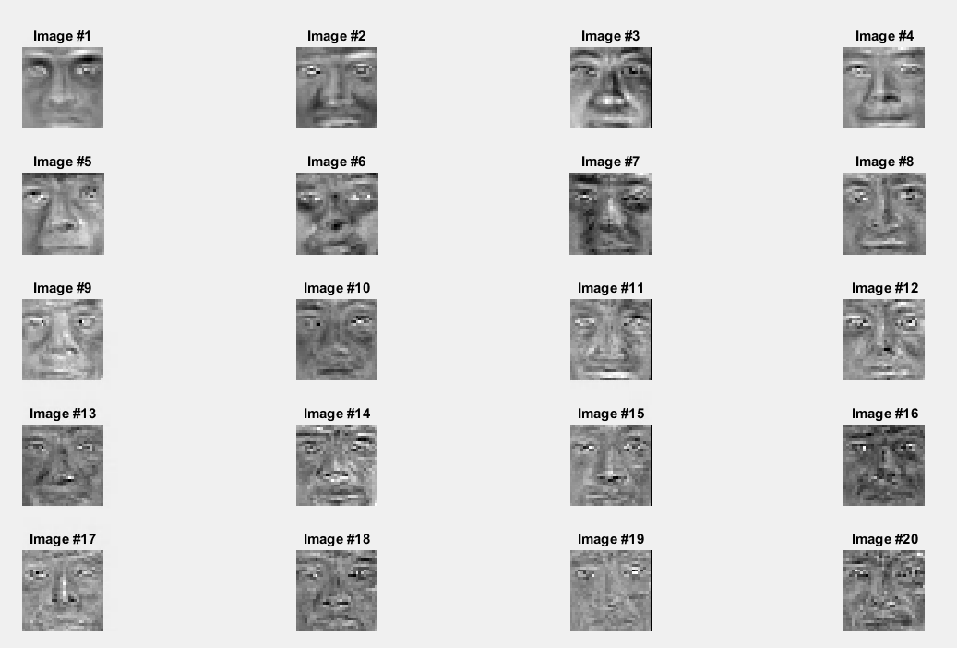

ROC, Gen and Imp of 20

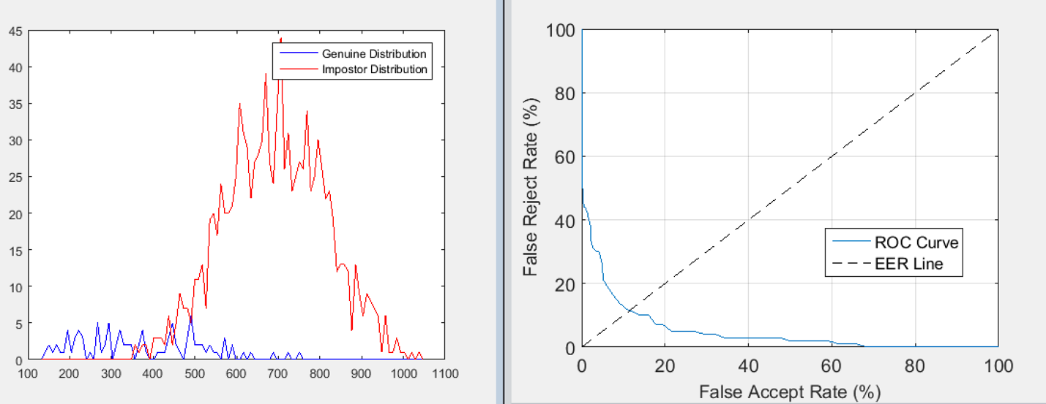

Top 15 feature vector faces

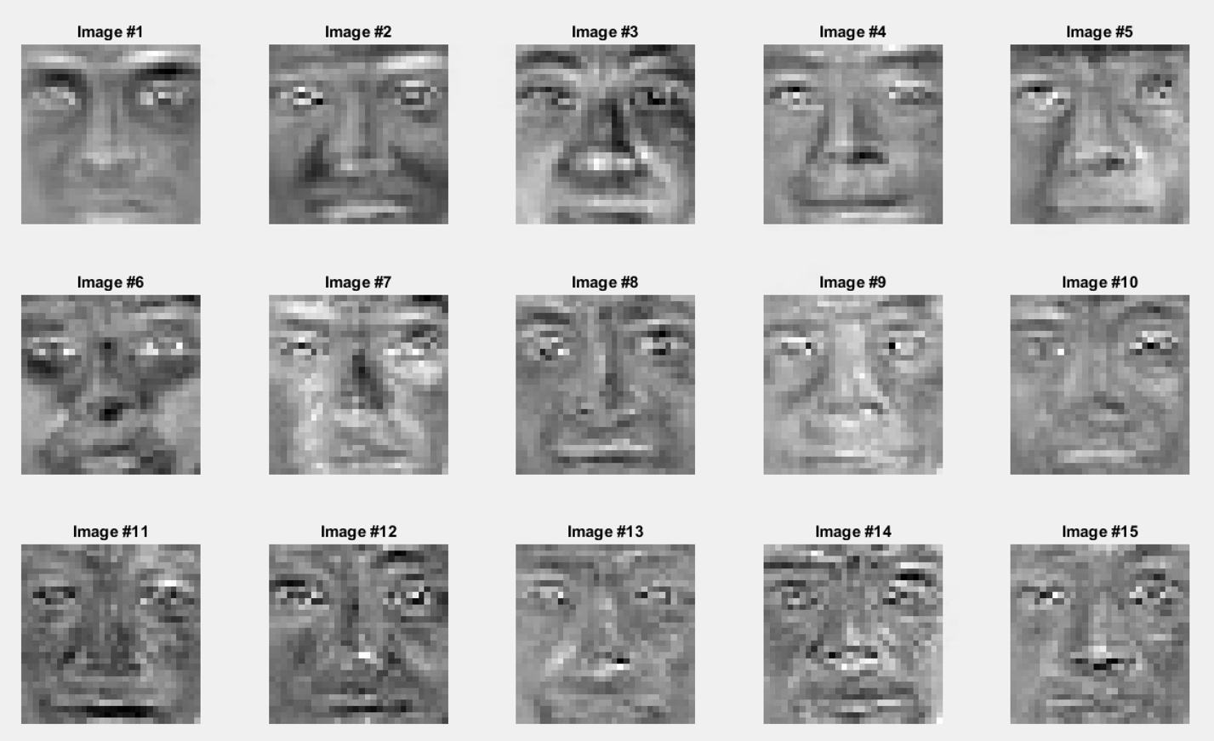

ROC, Gen and Imp for 15

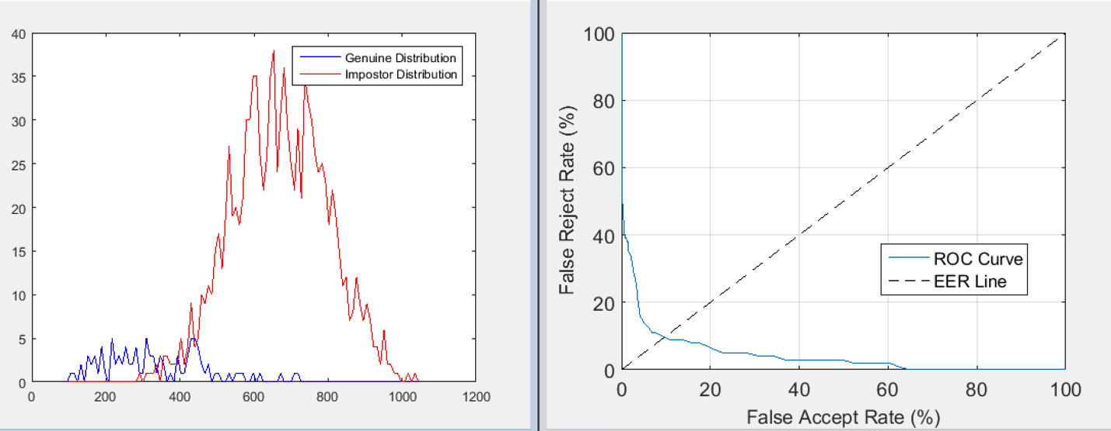

Top 10 feature vector faces

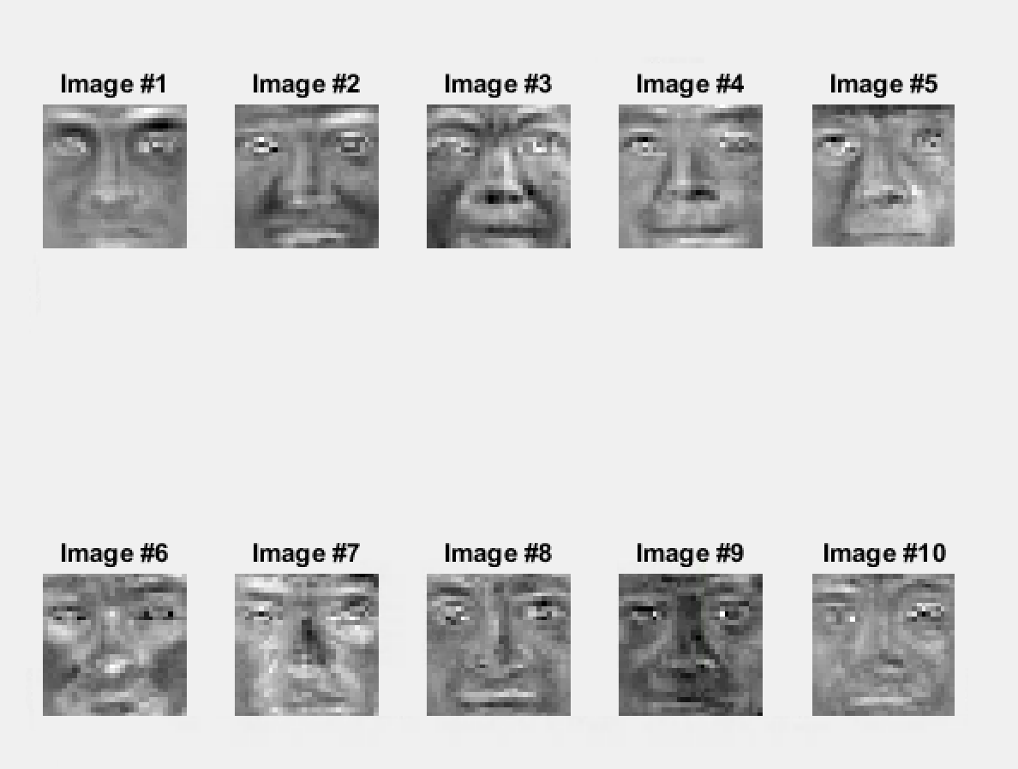

ROC, Gen and Imp for 10

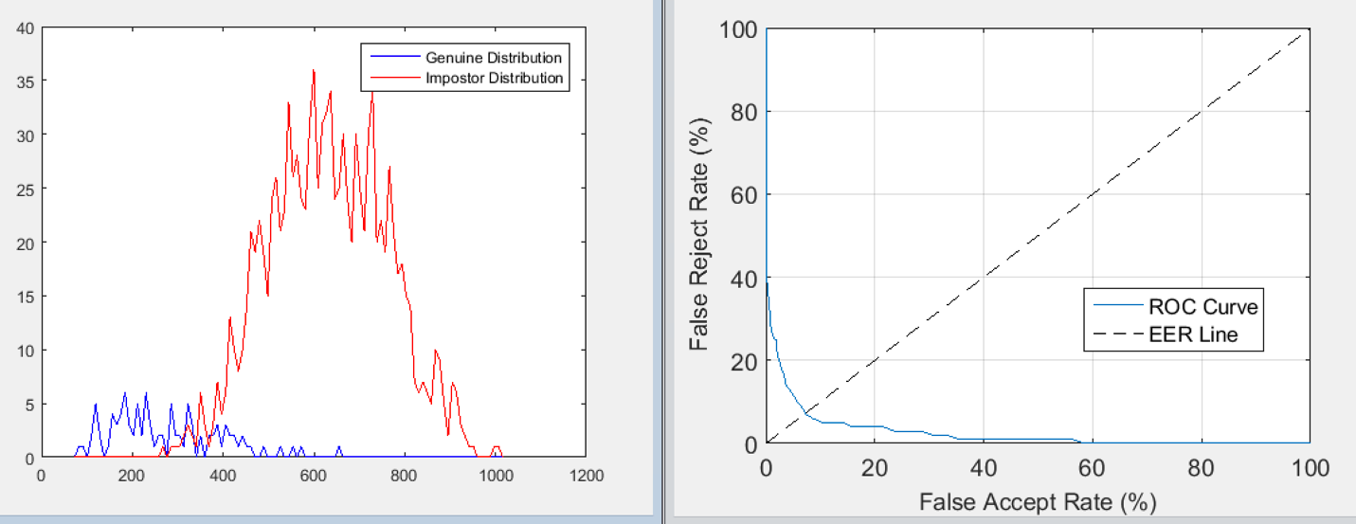

Top 5 feature face vector

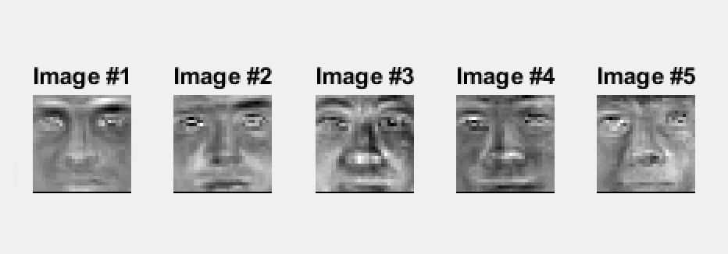

ROC, Gen, Imo for 5

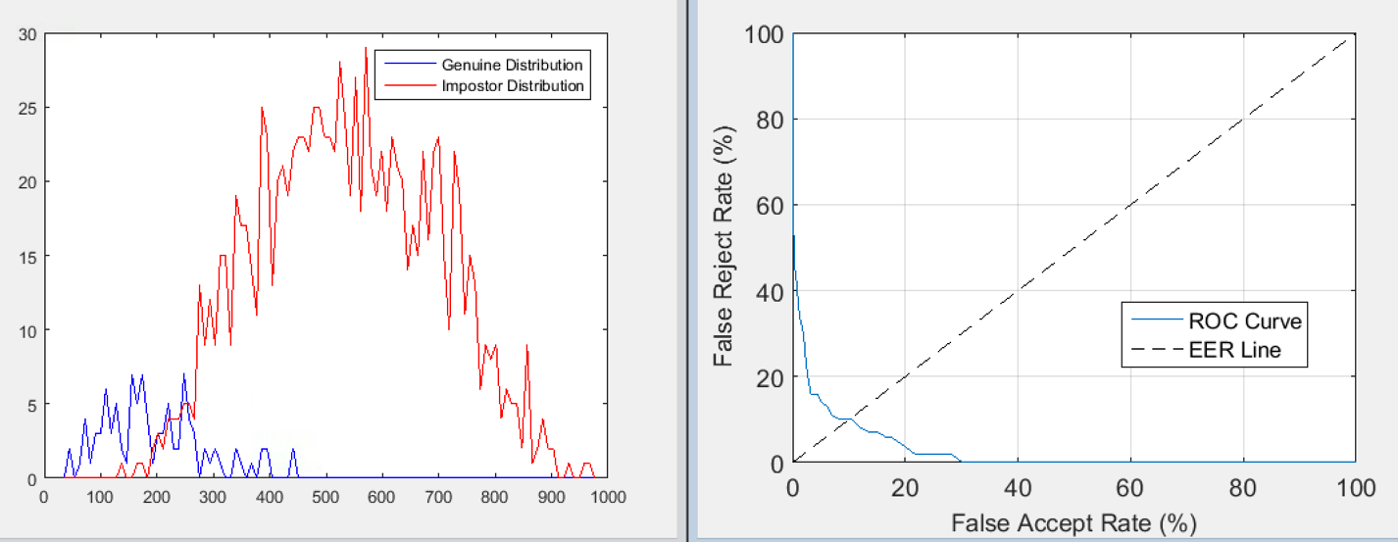

According to the ROC curves of all the different samples you can see that as less Eigen-faces are chosen the ROC curve got closer/ tighter to the 0 mark for the FAR and FRR. The reason the FAR and FRR were closer is because with less amount of samples there is less discrepancy and less variation between the images and the mean face. This is why they are closer together.

1. My faces

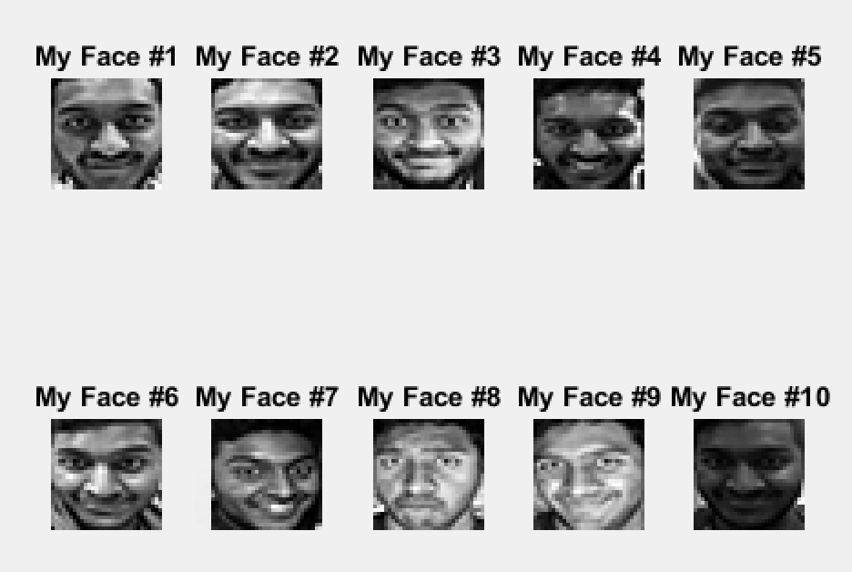

My faces genuine histogram

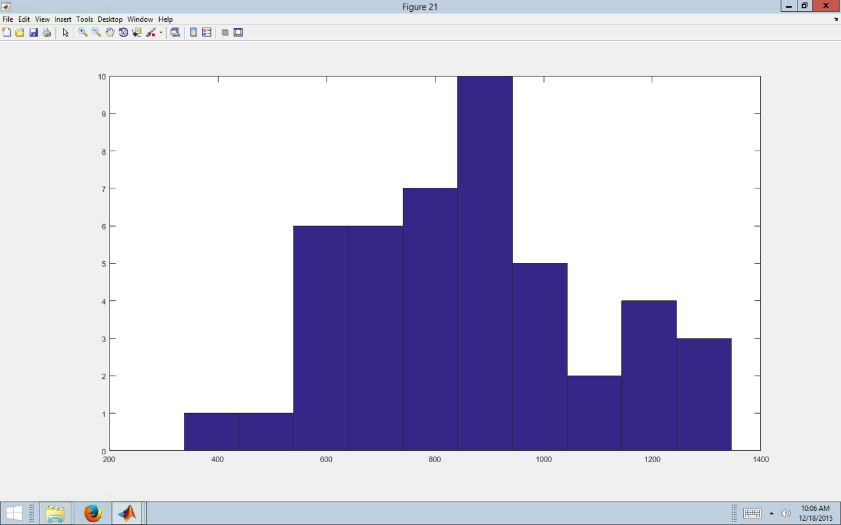

The accuracy of the face matcher worked well. As you can see form the above histogram most of the faces are towards the middle to the left mostly. This tells us that the face matcher worked well but not perfectly. The reason the face matcher was not able to work perfectly or close to perfectly is because as you can see in my images most of them have many facial expression, has different poses and mainly the pictures are not a perfect square they have to be compressed and forced into 30x30 grid which resulted in distortion of the image.