https://lh3.googleusercontent.com/URRxI1-Tvth7CpiarC2TdDVP65V6DohEU-LpaFLhL-nuHJVWtrdZR0OZLJuYQbiM7PuDWAzZIIta-mB9egJbBtPBt5iJJbQvUbHQiBtOXzMu1dI--bX92l-6uuw9blrBplTvtMu8fLAUhFuEvchvr8Q

ARCHITECTURE

***Travel Package Purchase PREDICTION***

***September 2, 2022***

***Written by othmane Zoubairi***

CONTENTS

**DOCUMENT VERSION CONTROL 1**

2 **ABSTRACT**  2

1. **INTRODUCTION** 2

**1.1 WHY THIS LOW-LEVEL DESIGN DOCUMENT?**

**1.2 SCOPE** 4 **2) TECHNICAL SPECIFICATIONS** 5 **2.1 DATASET OVERVIEW** 3

**2.2 PREDICTING Travel Package Purchase PROBABILITY** 3

**2.3 LOGGING** 4

**3) TECHNOLOGY STACK** 4

**4) PROPOSED SOLUTION** 4

**5) WORKFLOW** 5

1 | P a g e

**DOCUMENT VERSION CONTROL**

|  |  |  |  |
| --- | --- | --- | --- |
| Date Issued | Versions | Description | Author |
| 13/07/2022 | 1.0.1 | First Draft | Othmane zoubairi |
| 23/07/2022 | 1.0.2 | Added Technical  specifications | Othmane zoubairi |
| 20/08/2022 | 1.0.3 | Added Technology  stack, Proposed  solution and  Workflow | Othmane zoubairi |
|  |  |  |  |

2 | P a g e

**ABSTRACT**

**The Travel company is now planning to launch a new product i.e. Wellness Tourism Package. Wellness Tourism is defined as Travel that allows the traveler to maintain, enhance or kick-start a healthy lifestyle, and support or increase one's sense of well-being. However, this time company wants to harness the available data of existing and potential customers to make the marketing expenditure more efficient.**

**With the help of Data Science and Machine learning  technology, I developed an application, which allows a Travel Company to determine the probability Of Package Purchase faster.**

**1) Introduction**

1.1 Why this Low-Level Design Document?

**The goal of LLD or a Low-level design document is to give an  internal logical design of the actual program code for the  Concrete Compressive Strength Prediction System. LLD  describes the class diagrams with the methods and relations  between classes and program specs. It describes the modules  so that the programmer can directly code the program from the  document.**

1.2 Scope

**Low-level design (LLD) is a component level design process  that follows a step-by-step refinement process. This process  can be used for designing data structures, required software  architecture, source code and ultimately, performance  algorithms. Overall, the data organization may be defined during  requirement analysis and then defined during data design work.**

3 | P a g e

**2) Technical Specifications**

**2.1 Dataset Overview**

**For training and testing the model, I used the public set  available in Ineuron intership :**

URL – https://raw.githubusercontent.com/manotti22/Travel-Package-Prediction-Projekt/main/TourismData.csv

Dataset Attributes:

Customer details:[¶](https://www.kaggle.com/code/dscodingp19/travel-package-purchase-prediction" \l "Customer-details:" \t "_self)

1. **CustomerID: Unique customer ID**
2. **Age: Age of customer**
3. **TypeofContact: How customer was contacted (Company Invited or Self Inquiry)**
4. **CityTier: City tier depends on the development of a city, population, facilities, and living standards.**
5. **Occupation: Occupation of customer**
6. **Gender: Gender of customer**
7. **NumberOfPersonVisiting: Total number of persons planning to take the trip with the customer**
8. **PreferredPropertyStar: Preferred hotel property rating by customer**
9. **MaritalStatus: Marital status of customer**
10. **NumberOfTrips: Average number of trips in a year by customer**
11. **Passport: The customer has a passport or not (0: No, 1: Yes)**
12. **OwnCar: Whether the customers own a car or not (0: No, 1: Yes)**
13. **NumberOfChildrenVisiting: Total number of children with age less than 5 planning to take the trip with the customer**
14. **Designation: Designation of the customer in the current organization**
15. **MonthlyIncome: Gross monthly income of the customer**

**Label Column ;**

1. **ProdTaken: Whether the customer has purchased a package or not (0: No, 1: Yes)**

**2.2 Predicting Travel Package Purchase**

**The web application must be loaded properly for the users  without any technical glitches like server timeouts.**

**• It must display the input fields and the “Predict” button to  the users who accessed the application and allow the user  to enter the values with respect to the attributes of the  customer.**

**• The user gives the required information.**

**• Then the application should be able to predict the  probability of Package Purchase based on the information given by the  user about the customer**.

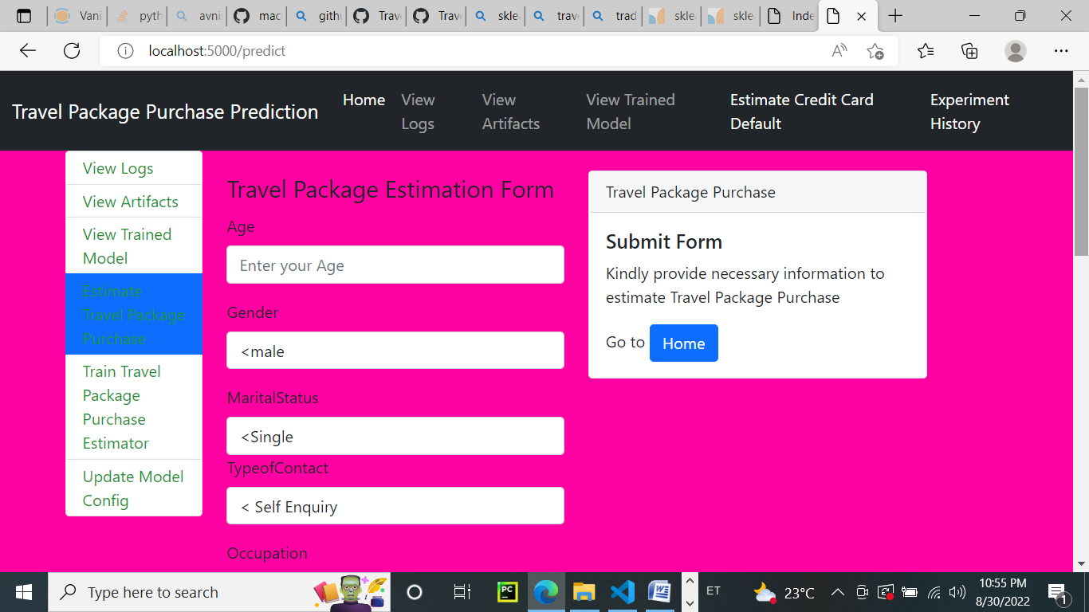

4 | P a g e

2.3 Logging

**We should be able to log every activity done by the user.**

**• The system should be able to log every step in the program  flow and in every Time .**

**• System should not be hung even after using so many  loggings.**

**• Logging makes debugging much easier, like we can  directly go to that specific line of code, having bugs.**

**• In this project, logs will be written in the files**

**• “Travel\_logs.” and the “deployment\_logs.” respectively.**

**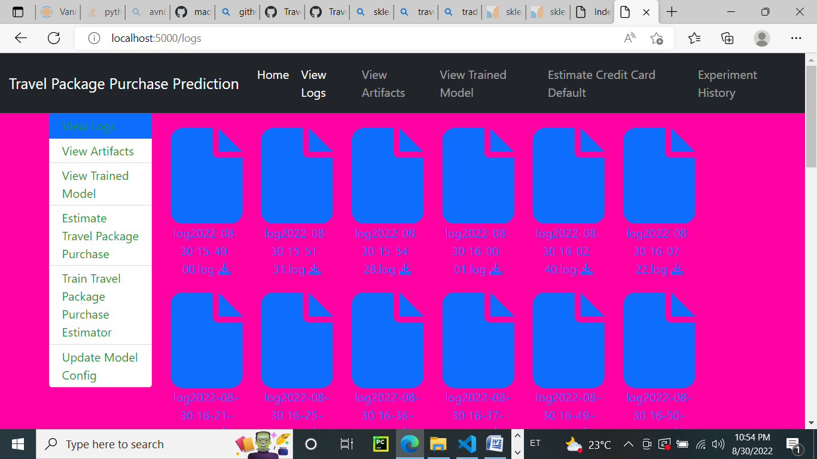**

1. **Technology stack**

|  |  |
| --- | --- |
| Front-end | HTML with CSS styling |
| Back-end | Python version 3.7,  Flask version 2.0.1 |
| Deployment | Heroku, gunicorn version  20.1.0 |

1. **Proposed solution**

**The solution proposed here is a web application, which takes  the details of the customer and those details will be taken by a  machine learning model in the backend, which will then predict the probability of Package Purchase and display it on the front-end page of  the user.**

**4)- Workflow**

**-🡪 START DATA -🡪 INGESTION DATA**

**-🡪 Data validation-🡪MODEL Transformation**

**-🡪 Model Trainer -🡪Model EVALUATION**

**-🡪BEST MODEL-🡪 MODEL Pusher**

**-🡪DEPLOYMENT-🡪 APPLICATION START**

**-🡪PREDICT PROBABILITY OF PURCHASE -🡪 END**