https://lh3.googleusercontent.com/URRxI1-Tvth7CpiarC2TdDVP65V6DohEU-LpaFLhL-nuHJVWtrdZR0OZLJuYQbiM7PuDWAzZIIta-mB9egJbBtPBt5iJJbQvUbHQiBtOXzMu1dI--bX92l-6uuw9blrBplTvtMu8fLAUhFuEvchvr8Q

ARCHITECTURE ***CREDIT CARD DEFAULT PROBABILITY PREDICTION***

***August 21, 2022***

***Written by othmane Zoubairi***

CONTENTS

**DOCUMENT VERSION CONTROL**

2 **ABSTRACT** 3

1. **INTRODUCTION** 4

**1.1 WHY THIS LOW-LEVEL DESIGN DOCUMENT?** 4

**1.2 SCOPE** 4 **2) TECHNICAL SPECIFICATIONS** 5 **2.1 DATASET OVERVIEW** 5

**2.2 PREDICTING CREDIT CARD DEFAULT PROBABILITY** 6

**2.3 LOGGING** 6

**3) TECHNOLOGY STACK** 7

**4) PROPOSED SOLUTION** 7

**5) WORKFLOW** 8

1 | P a g e

**DOCUMENT VERSION CONTROL**

|  |  |  |  |
| --- | --- | --- | --- |
| Date Issued | Versions | Description | Author |
| 18/07/2022 | 1.0.1 | First Draft | Othmane zoubairi |
| 29/07/2022 | 1.0.2 | Added Technical  specifications | Othmane zoubairi |
| 20/08/2022 | 1.0.3 | Added Technology  stack, Proposed  solution and  Workflow | Othmane zoubairi |
|  |  |  |  |

2 | P a g e

**ABSTRACT**

**Financial threats are displaying a trend in the credit risk  of commercial banks as the incredible improvement in  the financial industry has arisen. In this way, one of the  biggest threats faces by commercial banks is the risk  prediction of credit clients. The goal is to predict the  probability of credit default based on the credit card  owner's characteristics and payment history.**

**With the help of Data Science and Machine learning  technology, I developed an application, which allows a banker to determine the probability Of Default in just a  few second**

**1) Introduction**

1.1 Why this Low-Level Design Document?

**The goal of LLD or a Low-level design document is to give an  internal logical design of the actual program code for the  Concrete Compressive Strength Prediction System. LLD  describes the class diagrams with the methods and relations  between classes and program specs. It describes the modules  so that the programmer can directly code the program from the  document.**

1.2 Scope

**Low-level design (LLD) is a component level design process  that follows a step-by-step refinement process. This process  can be used for designing data structures, required software  architecture, source code and ultimately, performance  algorithms. Overall, the data organization may be defined during  requirement analysis and then defined during data design work.**

4 | P a g e 

**2) Technical Specifications**

2.1 Dataset Overview

**For training and testing the model, I used the public data set  available in Kaggle, “Default of Credit Card Clients Dataset” by  UCI.**

URL - https://www.kaggle.com/datasets/uciml/default-of credit-card-clients-dataset

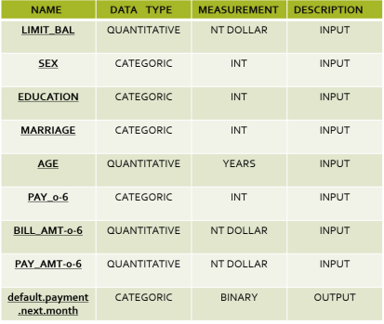5 | P a g e 

2.2 Predicting Credit card default probability

**The web application must be loaded properly for the users  without any technical glitches like server timeouts.**

**• It must display the input fields and the “Predict” button to  the users who accessed the application and allow the user  to enter the values with respect to the attributes of the  customer.**

**• The user gives the required information.**

**• Then the application should be able to predict the  probability of default based on the information given by the  user about the customer**.

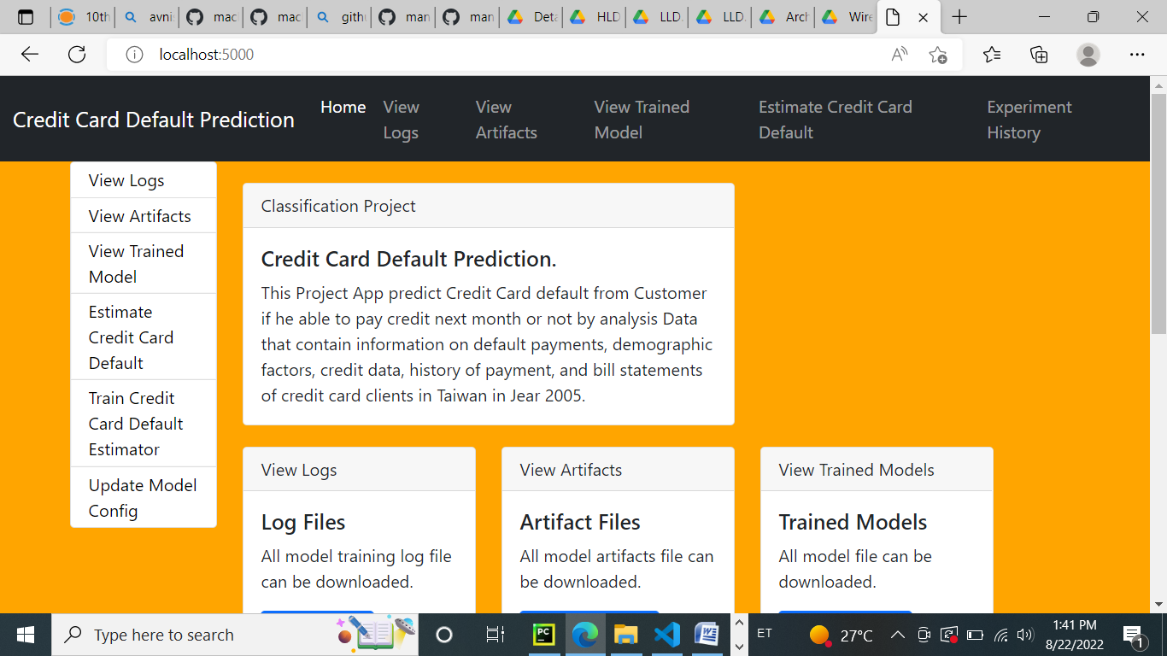

2.3 Logging

**We should be able to log every activity done by the user.**

**• The system should be able to log every step in the program  flow.**

**• System should not be hung even after using so many  loggings.**

**• Logging makes debugging much easier, like we can  directly go to that specific line of code, having bugs. • In this project, logs will be written in the files**

**• “development_logs.log” and the “deployment_logs.log” respectively.**

1. **Technology stack**

|  |  |
| --- | --- |
| Front-end | HTML with CSS styling |
| Back-end | Python version 3.7,  Flask version 2.0.1 |
| Deployment | Heroku, gunicorn version  20.1.0 |

1. **Proposed solution**

**The solution proposed here is a web application, which takes  the details of the customer and those details will be taken by a  machine learning model in the backend, which will then predict the probability of default and display it on the front-end page of  the user.**

1. **Workflow**

**START DATA -🡪 INGESTION DATA**

**-🡪 Data validation-🡪MODEL Transformation**

**-🡪 Model Trainer -🡪Model EVALUATION**

**-🡪BEST MODEL-🡪 MODEL Pusher**

**-🡪DEPLOYMENT-🡪 APPLICATION START**

**-🡪INPUT FROM USER**

**-🡪PREDICT PROBABILITY OF DEFAULT -🡪 END**