WIREFRAME DOCUMENT **CREDIT CARD DEFAULT PROBABILITY PREDICTION**

***August 21, 2022***

***Written BY OTHMANE ZOUBAIRI***

**ABOUT THE USER**

**INTERFACE IN THE WEB APPLICATION:**

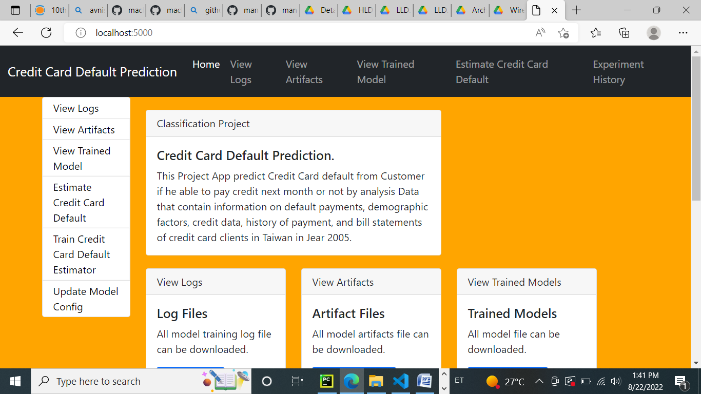

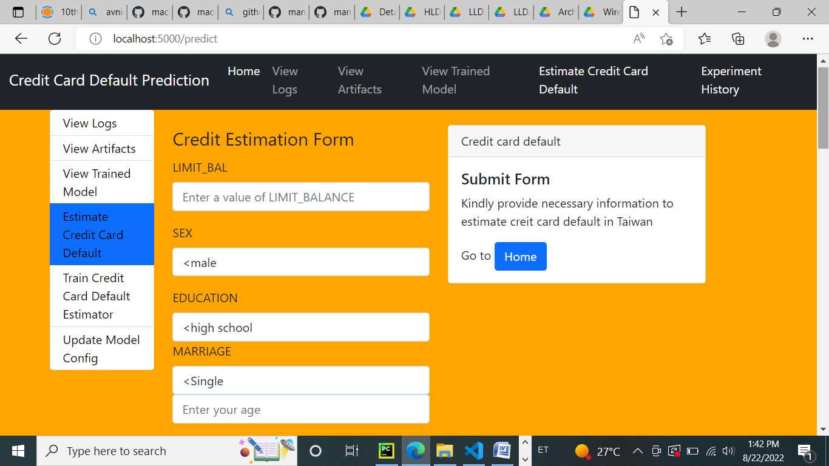

**I designed an user interface, in which a user can**

**use  the app like homepage with different folder :**

* **logs folder with time stemp to observe every predict action**
* **trainer model folder to save a best model**
* **experiments folder with limit that you want to display and run your pipeline**
* **artifacts folder to save alle data ingestion steps with time stemp**
* **They Estimate Credit Default is used for**
* **prediction of the probability of default in the backend and  displays it on the front-end page of the user.**

**• The entire web page and the format is designed using a template folder with different html files.**

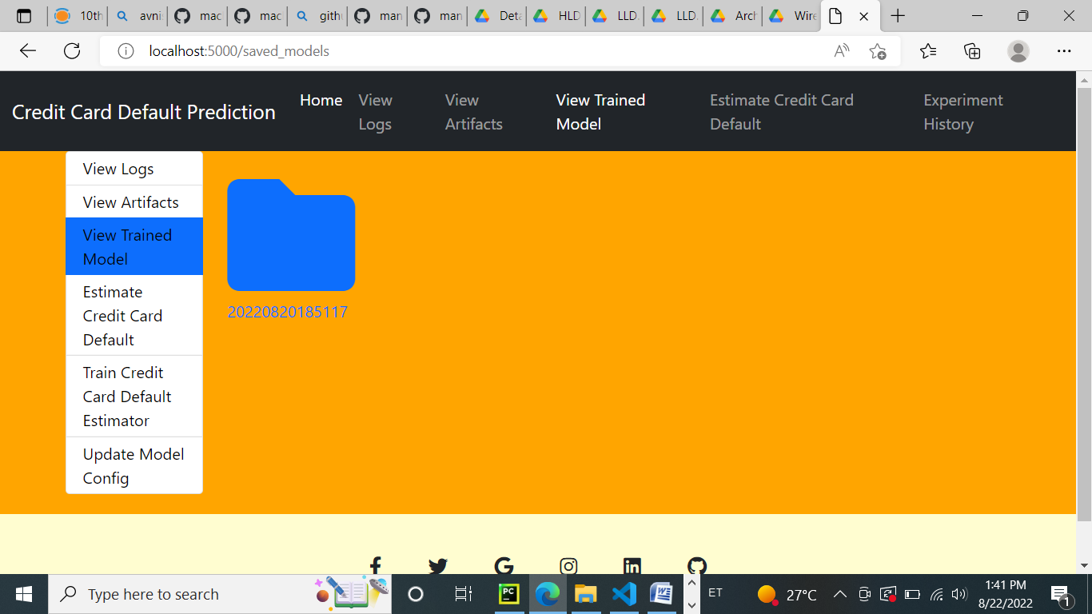



1 | P a g e

2 | P a g e

