

WIREFRAME DOCUMENT

***Restaurant Rating PREDICTION***

***JANUARY 23, 2023***

***Written SOFANA BENOUTIQ & OTHMANE ZOUBAIRI***

**ABOUT THE USER**

**INTERFACE IN THE WEB APPLICATION:**

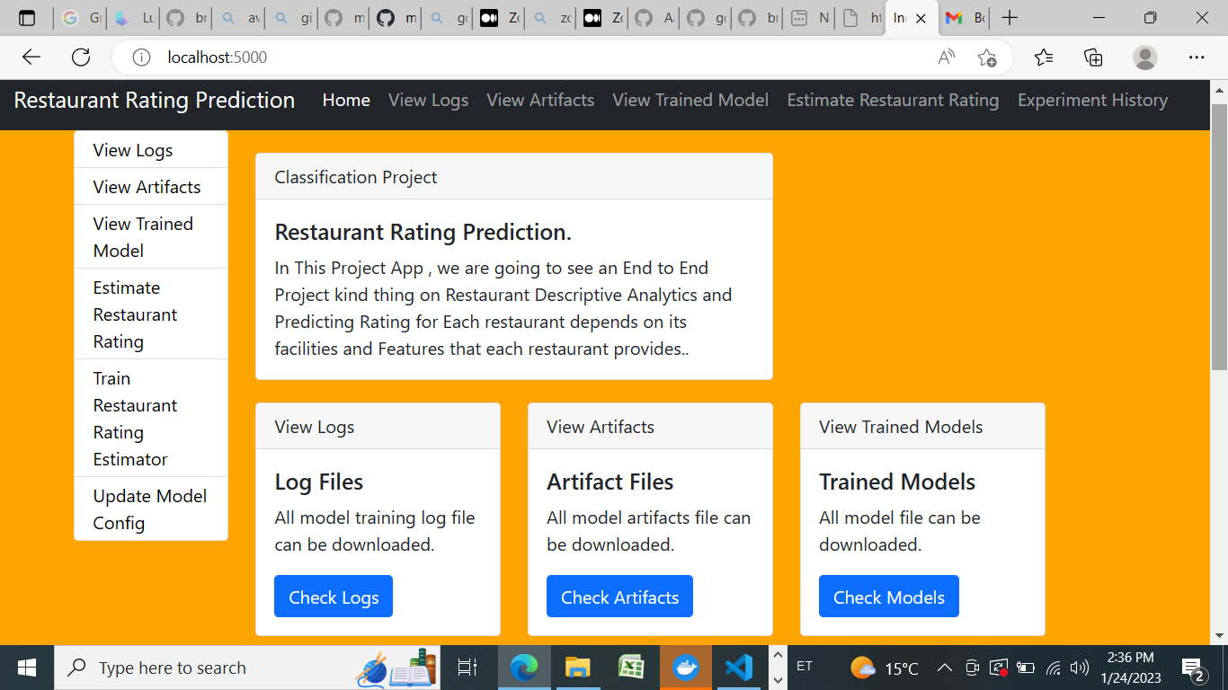

**I designed an user interface, in which a user can**

**use  the app like homepage with different folder :**

* **logs folder with time stemp to observe every predict action**
* **trainer model folder to save a best model**
* **experiments folder with limit that you want to display and run your pipeline**
* **artifacts folder to save alle data ingestion steps with time stemp**
* **They Estimate Package Prediction is used for**

**prediction of the probability of Restaurant Rating Prediction in the backend and  displays it on the front-end page of the user**

**• The entire web page and the format is designed using a template folder with different html files.**

**Logs with timestamp:**

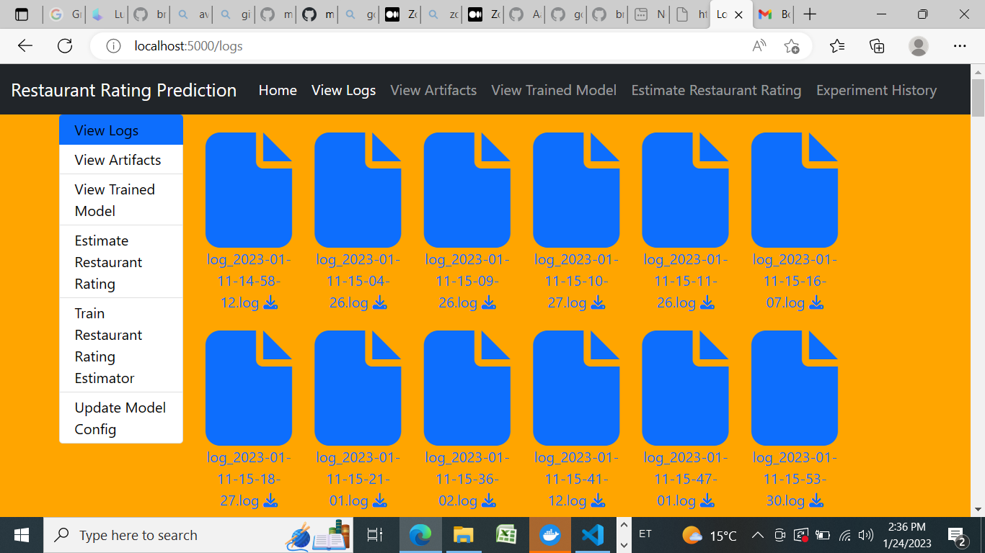

**Artifact Folder for data Ingestion;**

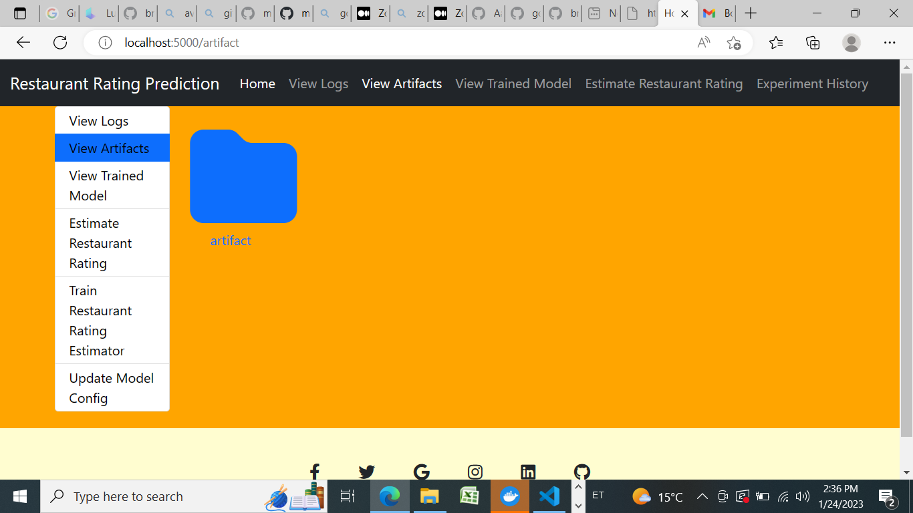**Prediction Folder :**

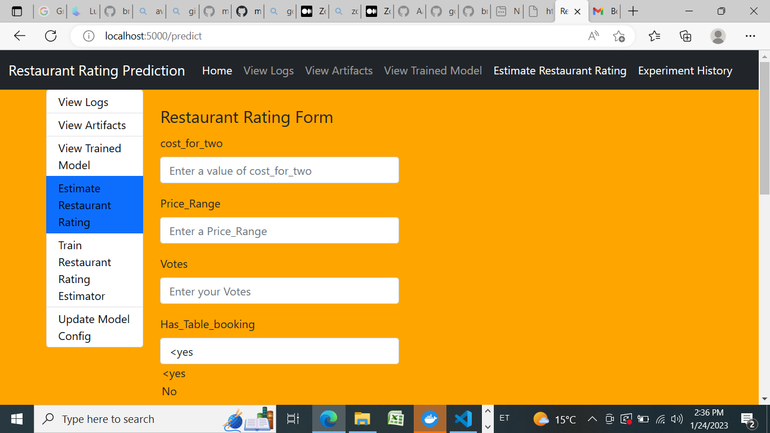

**Experiment Folder with Ranning Status ;**

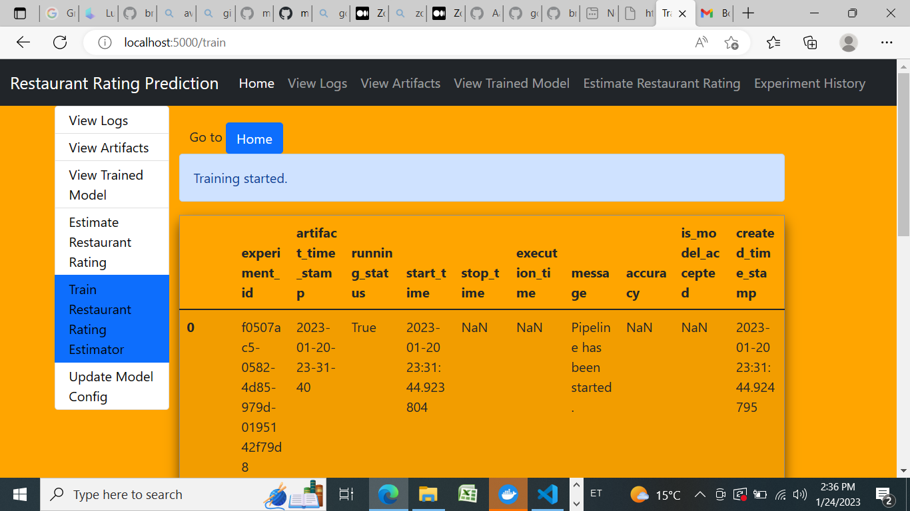

**Update Model in Json Format :**



