Couplers
KNX Association

Table of Contents
1 Couplers 3
2 Operation Modes of the TP-TP Coupler 4
2.1 TP-TP Coupler – Old and New Design 4
2.2 Parameters of Line and Backbone Couplers 6
2.2.1 Parameter: “Check Filter Table?” 7
2.2.2 Parameter: “On Error in Filter Table…” 7
2.2.3 Parameter: “Main Group 14/15” 8
2.2.4 Parameter: “Repetition if Transmission Error on Main Line” or “Repetition if Transmission Error on Line” 8
2.3 Parameters of Line Repeaters 9
2.4 Routing 10
2.4.1 Routing for Physically Addressed Telegrams 10
2.4.2 Example: Routing Physically Addressed Telegrams in the Line Coupler 11
2.4.3 Routing for Group Telegrams (Destination address is Group Address) 13
2.4.4 Example: Telegram Transmission “Step by Step” 14
2.5 Telegram Structure for Downloading of Couplers 16
2.6 Automatic filter table 16
2.6.1 Current best practices for visualizations 17
3 Couplers for Different Media: Media Couplers 18
3.1 The TP-IP Router 18
3.2 Individual addresses of IP Routers 19
3.3 IP Router as Backbone Coupler 20
3.4 IP Router as Line Coupler 21
3.5 IP Router as Line and Backbone Coupler 22
3.6 IP Router as Backbone/Network Coupler 23
3.7 Network Settings 23
3.8 Parameters of the IP Router 24
4 Supplementary Information / Informative Appendix 25
4.1 Couplers for Powerline Installations 25
4.1.1 Structure of the TP-PL Media Coupler 25
4.1.2 Filter Table 26
4.1.3 Parameters 26
4.1.4 Commissioning of Devices 27
4.2 Couplers for RF Installations 27

Couplers
Couplers (not to be confused with bus coupling devices) are system devices which enable a hierarchical structure of the KNX system. Couplers transfer data between electrically independent parts of a KNX installation.

Couplers reduce telegram traffic throughout the installation with the help of filter tables. Filter tables are automatically calculated by ETS in the background.

Filter tables are transferred into each coupler via Download Download application. If ETS has determined a change for a filter table, it resets the GRP tick and thus signals that a transfer to the coupler has become necessary.

The exact designation of a coupler depends on its location within the KNX hierarchy and the supported media.
- Line couplers (LC) connect a TP line with a TP main line
- Backbone couplers (BC) connect a TP main line with the TP backbone line
- PL media couplers link a PL line with a TP main line
- RF media couplers link an RF lines with a TP main line
- KNXnet/IP routers link a TP line or a TP area with an Ethernet LAN. With several KNXnet/IP routers, several KNX lines, areas or even complete installations can be linked via Ethernet LAN
A basic distinction must be made between couplers and interfaces. Interfaces (in contrast to couplers) are devices that link a KNX installation with other technical equipment. They are not fully integrated into the KNX installation and do not have a filter table. Instead such devices have a table that assigns group telegrams to elements of the other system. Interfaces are frequently also designated as gateways. Some examples of interfaces/gateways are:
- Telecontrol/Teleswitch (analogue telephone interface)
- DP/KNX link, interlinking of PROFIBUS-DP and KNX
- Radio Frequency gateway of the Insta group
- LAN/ISDN gateways
- Many visualisation programs also contain a gateway function

Operation Modes of the TP-TP Coupler
Couplers for TP can be used as Backbone coupler (BC), line coupler (LC), Line repeater (LR) and as Segment coupler (SC). The assigned individual address determines the operation mode of the coupler.

Operation Mode Coupler as | Individual address |  |  | Example
 | Area | Line | Device
Backbone coupler | 1…15 | 0 | 0 | 3.0.0
Line coupler | 1…15 | 1…15 | 0 | 3.2.0
Line repeater | 1…15 | 1…15 | 1…255 | 3.2.64
Segment coupler | >= 0 | 1…15 | 1…255 | 0.5.240

TP-TP Coupler – Old and New Design
During the course of the development of semiconductor technology, the first generation coupler was replaced by a new variant in June 2003. A distinction is therefore made in some sections between the “old” and “new” coupler. As the old coupler type has been used in a large number of installations, it is a good idea to outline its characteristics.

Old design (before 2003) | New design (from 2003)
Two microcontrollers | One common controller
Two transmission modules (R/L/C) | Two transmission modules (electronic)
4 Kbyte static “dual-ported“ SRAM, buffered against voltage failure for more than 10 years via a lithium battery  Upper memory area (3.5 KiB):  Filter table for 28,672 group addresses (main groups 14/15 do not have any place)  Lower memory area (0.5 KiB):  Telegram buffer for 20 telegrams, each 23 bytes long with a flag byte before the telegram and a status byte after the telegram. Each buffer of 10 telegrams is reserved for each direction. | Memory for the filter table is implemented as a non-volatile flash memory so that buffering via a battery is not necessary.
Energy supply via secondary line (data rail) | Energy supply via primary line or secondary line
DIN rail mounted device, 4 modules wide | DIN rail mounted device, 2 modules wide
Connection of secondary line:  Data rail via spring-loaded contacts on the rear of the device.  Connection of primary line:  Bus terminal on the front of the coupler. | Connection of both lines via bus terminals on the front of the device.
Main groups: 0 to 15,  main groups 14/15 without individual filtering | Main groups: 0 to 31,  for compatibility reasons frequently main groups 14/15 without individual filtering (depending on manufacturer and device)

Parameters of Line and Backbone Couplers
Figure 1 shows the parameters of a coupler of the older design. Two parameters are omitted for the new coupler (Figure 2), the rest is identical.

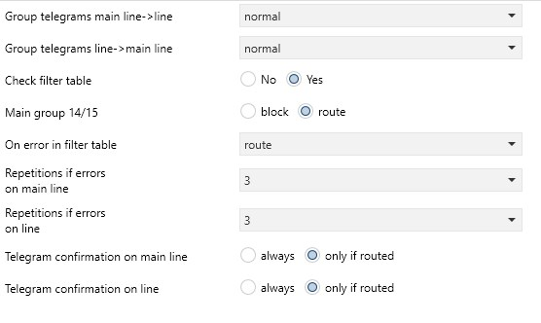
Figure 1: Parameters of couplers of the old design

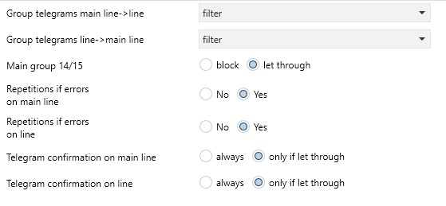
Figure 2 : Parameters of a new coupler
Parameter: “Group Telegrams”
The filter behaviour can be modified with the first two parameters “Group telegram …”
It can be set separately for both directions:
- normal (or filter): Filter table is used, telegrams are routed selectively
- route: All group telegrams are routed
- block: Group telegrams are not routed
The default is “normal (or filter)”. The settings “route” and “block” should only be used for diagnostics purposes or during the commissioning phase.
Even if e.g. a visualisation is used, the couplers can work with a filter function. ETS can calculate the filter tables correctly if a dummy application with the visualised group addresses is configured in the line of the visualisation PC. Some visualisation packages automatically maintain a dummy application in the ETS project with the addresses that have been used.

Parameter: “Check Filter Table?”
A test algorithm is activated via this parameter. It checks the filter table for data loss through the evaluation of check sums. The following options can be set:

- YES – The filter table is checked cyclically for errors
- NO – The filter table is not checked
With the new type of coupler, the parameter ‘Check filter table’ is always set internally and can therefore no longer be configured.

Parameter: “On Error in Filter Table…”
(only for the old type of coupler):
If the coupler establishes a defect in the filter table, the setting of the parameter “On Error in Filter Table” determines the behaviour:

- route Bus load increases, installation continues to function, fault remains
undetected
- block Malfunction of the installation, fault becomes apparent
- ignore Coupler behaves according to the first two parameters “Group
Telegrams…”, fault does not become apparent or only very late

For the new type of couplers, this parameter is always set internally to “route”.

Parameter: “Main Group 14/15”
Entries for all the group addresses of main groups 14 and 15 did not originally fit in the filter table memory. They cannot be filtered by address but only be routed or blocked “collectively”.
- route – both main groups are routed in both directions
- block – both main groups are blocked in both directions
If main groups 14 and 15 are used, they should only be used for internal line functions and the parameter should be set to “block”. The bus load would be increased unnecessarily in the setting “route”.

Parameter: “Repetition if Transmission Error on Main Line” or “Repetition if Transmission Error on Line”
These parameters control the repetition process if there is no acknowledgement or only a negative acknowledgement on the corresponding line. The following options can be set:
- none, 1, 2, 3 or
- yes/no for the new type of coupler
The last two parameters “Telegram confirmation on main line” and “Telegram confirmation on line” determine the acknowledgement process for received telegrams:
- only if routing – the telegram is only acknowledged if it is routed by the coupler
- always – all received telegrams are acknowledged

These parameters should only be modified in specific cases as the following examples show:
- A visualisation PC is connected to the main line via a data interface. The filter tables of the line coupler are active and the filtering is set in such a way that the telegrams for the visualisation can reach the main line. If telegrams which only address the visualisation are now routed to the main line, the IACK is missing for the line coupler and the telegrams are repeated e.g. three times which leads to a high bus load on the main line. This can be remedied by:
- Changing the parameter “Telegram confirmation on main line” to “always” for all line couplers so that all the couplers respond and the telegram is not repeated or
- Changing the parameter “Repetitions if transmission errors on main line” to “none” for all couplers so that the telegram is likewise not repeated. The disadvantage is that telegrams are lost if transmission errors actually occur or the input buffers of the couplers are full and send “busy”. This option is however the only one available if there is only one line coupler present.
- A visualisation PC is connected to a secondary line via a data interface. The filter tables of the line coupler are active and the filtering is set in such a way that the telegrams for the visualisation reach the line. If telegrams which only address the visualisation are now routed to the line, the IACK is missing for the line coupler and the telegrams are repeated e.g. three times which leads to a high bus load on the line. This can be remedied by:
- Changing the parameter “Repetitions if transmission errors on line” is set to “none” for the coupler; the telegram is therefore not repeated. The disadvantage is that telegrams are lost if transmission errors actually occur.

Parameters of Line Repeaters
If a TP-TP coupler is used as a line repeater, it receives a device number from 1 onwards (not 0 as this is reserved for LC/BC). By this, the coupler application will know that it shall operate as repeater.

A special “Line repeater” application can also be selected as an option, in which only two parameters can be set for programming the individual address and the sending of group telegrams. The line coupler/backbone coupler application can however also be used as the individual address has priority over the operation mode.

As the ETS program does not make a distinction between different line segments, it is not able to create a filter table for the line repeater. The repeater therefore routes all group telegrams. Telegrams with physical destination addresses are also generally routed.

Therefore only two of the previously described parameters of the TP coupler are of significance:
- Repetitions if transmission errors on primary line segment (“line”)
- Repetitions if transmission errors on secondary line segment (“segment”)

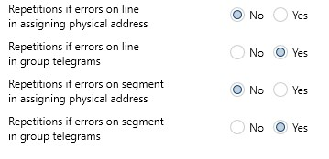
Figure 3: Parameters of TP line repeater application
- Repetitions if transmission errors on (primary) line (segment) when assigning individual address address: yes/no
- Repetitions if transmission errors on (primary) line (segment) in group telegrams: yes/no
- Repetitions if transmission errors on (secondary) line segment when assigning individual address: yes/no
- Repetitions if transmission errors on (secondary) line segment in group telegrams: yes/no
The default values should normally be set as shown in Figure 3.

Routing
Once a coupler is put into operation, there are five possible ways in which the coupler can respond on reception of a telegram:
- If the telegram is acknowledged:
- telegram is routed unchanged (TEL_ROUT_UN)
- telegram is routed and the routing counter is reduced by 1 (TEL_ROUT_DEC)
- telegram is intended for the coupler itself in order to change internal data (TEL_INT) ) and is not routed
- telegram is ignored (TEL_IGN_AK)
- If the telegram is not acknowledged:
- telegram is ignored without an acknowledgement (TEL_IGN_NOAK)

Routing for Physically Addressed Telegrams
In the KNX Basic Course, you have learnt how a line coupler can reduce the bus load in the system by filtering group telegrams.

Couplers carry out further filtering however almost invisibly by filtering physically addressed telegrams.
This means telegrams whose destination is an individual address.
These telegrams occur typically during the transmission of device data from ETS to a bus device.

To put it simply, a coupler only routes those physical telegrams where
- the sender address in the telegram is plausible and
- the destination address in the topology makes routing necessary

Example: Routing Physically Addressed Telegrams in the Line Coupler
The following example shows the routing algorithm of physically addressed telegrams in the line coupler in detail.

Legend:
- Physical destination address of destination device: A.B.C
- A = Area in which target device is located
- B = Line in which target device is located
- C = Device number of target device in the line
- Individual address of the line coupler: X.Y.0 (zero)
- X = Area in which line coupler is located
- Y = Line in which line coupler is located
- 0 = Device number of line coupler (always zero)
Main line to line:
Figure 4: Routing with “destination address is individual address” – Main line to line
Line to main line:
Figure 5: Routing with “destination address is individual address” – Line to main line

Routing for Group Telegrams (Destination address is Group Address)
Prerequisite: filter table is set for both directions.

Example: line coupler, whereby:
- GT = Group address of the telegram
- FT = Filter table
- RC = Routing counter

Figure 6: Routing of group telegrams

Example: Telegram Transmission “Step by Step”
Abbreviations used:
- BC = Backbone coupler
- LC = Line coupler
- LR = Line repeater
- RC = Routing counter
- DVC = Bus device
- PS/CH = Power supply / choke
Figure 7: Telegram transmission “step by step”

Using the KNX installation represented above, telegram transmission across lines will be clarified "step by step". It is a prerequisite that the installation has been properly designed and has been put into operation. The couplers take into account their filter table.

- Start:
The 1-fold pushbutton with individual address 1.1.65 sends a telegram to the group address 5/88.
- End:
The telegram is received by 1-fold switch actuator 15.15.127 which then returns a reply telegram (ACK).
The actuator switches its output according to the transferred group object value.

The result of using telegram filtering is that telegrams are only passed to lines that really require them. Telegrams are not routed to places where they have no effect. The advantage of this is that the bus load in the installation is reduced.

Line repeaters do not filter. They should therefore not be used in the planning of a new KNX installation but only in the extension of an existing one.

The routing counter has the benefit that even when the installation has faulty wiring (loop formation with couplers), a telegram circulates in the loop a maximum of six times. The installation is not blocked! On the other hand, the routing counter has the effect that a telegram can only pass through a maximum of six couplers.

As a result, line repeaters may not be connected in series.

Telegram Structure for Downloading of Couplers
For the download of filter tables, couplers are addressed by ETS with other telegram types (APCIs) than normal devices.

Automatic filter table
The filter tables are generated by ETS automatically in the background.
They are transferred to the line/backbone coupler with “Download Application”.

Before the actual “Download”, it is possible to check the virtual filter tables. This can be done by clicking with the right-mouse button on the line/backbone coupler and by clicking on “Preview Filter Table”.
The latest downloaded filter table from the coupler’s memory can be read out via the context-sensitive menu “Device info (with group communication)”.
Since ETS6.3.0 it is not possible anymore to manually insert group addresses into the filter table of new ETS projects. Manual alterations can lead to security risks and a reduced project overview. The automated management ensures a better accuracy, security and project clarity.

Existing ETS projects with manual filter tables can still be edited in ETS, but a deprecation message will be displayed under the Sidebar properties and a warning dialog will appear when opening the project.

Current best practices for visualizations

Instead of directly manipulating filter tables, users are encouraged to consider the following options:

1. Use Bus Interfaces:

- The bus interfaces are modeled in ETS, therefore one can drag and drop the required group addresses to the respective interfaces, an example of which is illustrated below, after which the group addresses are automatically added to the Filter table of the respective couplers.

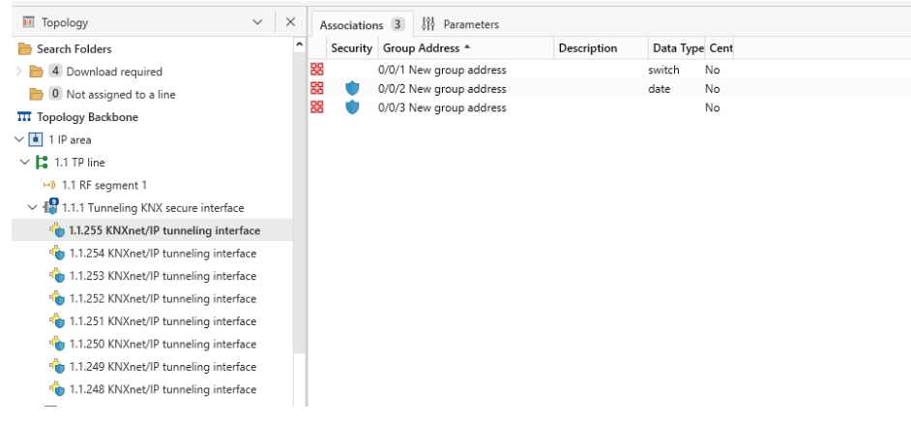
Figure 8: Drag and drop group address to bus interface

2. Use of a Dummy Device:
- Add one or more dummy devices to the line where the visualization system is connected.
- Configure the device parameters to include the required group objects.
- Assign the necessary group addresses to facilitate communication.

Couplers for Different Media: Media Couplers
A KNX project can contain different communication media. The system devices for coupling the various media are media couplers.

For example, there are media couplers for linking TP subsystems with
- IP subsystems
- Powerline subsystems (see informative appendix / KNX Basic Course documentation)
- RF subsystems (see informative appendix / KNX Basic Course documentation)

The TP-IP Router
The TP Ethernet media coupler, otherwise known as the KNXnet/IP router or IP router for short, is widely used:
- IP routers link TP lines with Ethernet data networks
- IP routers link TP lines together over the data network:
Main and/or backbone lines are supplied with a large bandwith over Ethernet and IP.
- IP routers offer an IP interface for access to the bus – not only for ETS – and replace the USB interfaces that are otherwise used.
Figure 9: IP Router
The connection to the KNX TP is established via a bus connector. The link to the data network (IP via 10BaseT) is carried out via an RJ45 socket.

For its operation, the IP router may also require AC/DC 24 V (manufacturer-specific) which is supplied via a second connector.

The IP router uses the KNXnet/IP standard defined by KNX Association. This standard specifies how KNX telegrams must be sent via an IP network so that KNX telegrams between lines can be routed via an IP network and the bus can also be accessed from a PC.
The IP router can be used as a line coupler and backbone coupler, both in existing KNX networks and new KNX networks. It also contains filter tables which enable specific bus telegrams from or to the bus line to be blocked or passed through and therefore contributes to a reduction in the bus load. The filter table is created automatically by the ETS program during the parameterisation and commissioning of the installation.

An overview of the features of the IP router:
- Simple interface connection to higher-order systems through the use of the Internet protocol (IP)
- Direct access to the KNX installation (KNXnet/IP tunnelling) from any point in the IP network
- Rapid communication between KNX lines, KNX areas and systems (KNXnet/IP routing)
- Communication across buildings and properties (networking of properties)
- Filtering and routing of telegrams according to
- individual address
- group address
- LED displays for
- Readiness for operation
- TP communication
- IP communication
- Simple configuration with ETS without any plug-ins
- Simple interface connection of visualisation systems

Individual addresses of IP Routers
IP routers can adopt the function of both backbone couplers and line couplers.

An IP router can in principle be used as a line coupler or as a backbone coupler. The individual address has the format x.y.0, with x=1...15, y=1...15.

The individual addresses for IP routers have the same format as classic TP/TP line/backbone couplers.

Careful planning and assignment of the individual address is more significant for IP routers than for classic line/backbone couplers as main line(s) and backbone line can lie on the same medium (Ethernet)! What is physically tangible in pure TP installations as a bus cable, is somewhat abstract in the IP installation and only determined by the individual address.

IP Router as Backbone Coupler
Figure 10: IP router as a backbone coupler

Caution:
If an IP router is used as a backbone coupler with the individual address B.0.0 (B=1...15) e.g. 2.0.0, no other IP routers may be used topologically “below” this IP router i.e. with an individual address B.L.0 (L=1...15) e.g. 2.1.0.

Therefore:
If there is an IP router as backbone coupler for an area, no IP routers may be used as a line coupler in this area!

The reason for this is that IP main lines and IP backbone lines in the IP network – as for TP – are not separated from each other but are both operated on the same medium (Ethernet).

IP Router as Line Coupler

Figure 11: IP router as a line coupler
If an IP router is used as a line coupler (e.g. 1.2.0), no IP routers with the associated backbone coupler address (e.g. 1.0.0) may be used “above” this device in the system (see explanation in section 3.3).

IP Router as Line and Backbone Coupler
Figure 12: IP router as backbone and line coupler
If an IP router is used as a line coupler (e.g. 1.2.0), it is not possible for an IP router with the associated backbone coupler address (e.g. 1.0.0) to be used “above” in the system (see explanation in section 3.3).

IP Router as Backbone/Network Coupler
With the IP router, even existing installations with possibly identical group addresses may be linked. The IP router here is functioning as a combined backbone/network coupler.

Figure 13: IP router as backbone/network coupler

Network Settings
On the IP side, the IP router requires an IP address for communication. This IP address can be assigned automatically via a DHCP service or defined manually. DHCP is the abbreviation for “Dynamic Host Configuration Protocol“ and the name for an Internet or LAN service which “dynamically” assigns IP addresses to network devices “on request”.
The IP address must always be set manually if there is no DHCP service available in the network.

Parameters of the IP Router
The parameters of the IP router are self-explanatory and underneath therefore only a general overview is given:
- Parameter group “General”
It is possible to assign a device name to the IP router here. This name is used to more easily find the device in the network. It is also possible via this name to connect together separate installations which use the same group addresses internally.
- Parameter groups “Routing Bus → KNXnet/IP” and “Routing KNXnet/IP → Bus”
As with the TP coupler, the filter behaviour and the telegram acknowledgement of the IP router is set via these parameters.
- Parameter group “IP configuration”
Used for setting IP data such as IP addresses, subnet masks.

Supplementary Information / Informative Appendix

Couplers for Powerline Installations
To keep the number of telegrams as low as possible in large KNX Powerline installations, it is necessary to divide the installation up into several KNX areas. Each PL area receives its own domain address and is isolated from the total installation with band-stop filters. The individual PL areas are interfaced via PL backbone couplers. These correspond to the media coupler PL-TP in their structure and function but a data cable is connected instead of the primary line. It has an internal power supply that can be used to power the TP side, but an additional choke must then be used. The same specifications apply for the data cable as for a TP backbone line.
Telegrams that cross different areas are routed selectively via the data cable to the corresponding PL areas. At first different devices existed for the tasks of coupling Powerline areas and media coupling. However, the two functionalities have meanwhile been combined in one device called system coupler.

Structure of the TP-PL Media Coupler
The PL media coupler is a DIN rail mounted device. It contains a Powerline repeater, a TP bus coupler with a special BCU and a power supply for supplying up to five TP devices.
The secondary side of the device is connected to PL while the primary side is always connected to TP. On the TP side, it operates either as a line coupler or a backbone coupler while on the PL side it also functions as a repeater.
The connection of Powernet KNX is carried out via screw terminals while KNX-TP bus is connected via the black/red bus connector.
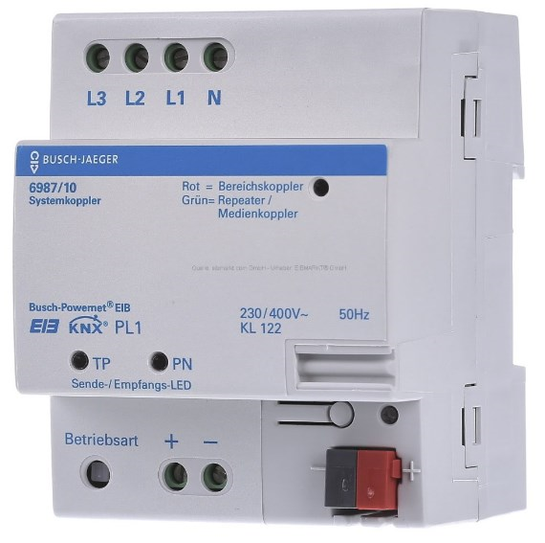
Figure 14: TP-PL media coupler
The media coupler has a red LED and a programming button for assigning the individual address. The operation mode is set via a local push button and indicated via a two-colour LED. It also has a send/receive LED for each side. They flash green briefly when a telegram is received and red when a telegram is sent.
The device is configured in the Powerline line with the device number 0. As the system coupler functions simultaneously as a repeater, no further repeaters may be installed on the line. Due to the repeater functionality, the same recommendations apply as for the repeater.

If the destination address is a group address, a search is made in the filter table depending on the parameterisation. If the destination address is an individual address, the telegram is filtered with the help if its own individual address.
The same happens when a telegram reaches the TP-BCU. A decision is then likewise made in the network layer as to whether it is routed to the repeater via the PEI.

If a telegram cannot be sent because the bus is busy, it is stored temporarily in the RAM of the telegram buffer. A maximum of 255 telegrams can be buffered.

Filter Table
The media coupler uses a filter table to route the telegrams that have a group address as destination address. This filter table is created by the ETS program and should be loaded into the media coupler via TP-KNX. All group addresses up to 7FFF are contained in the filter table i.e. main group 14 and 15 are also accommodated. The filter table is located in the EEPROM of the media coupler. A battery is therefore not required.

Parameters
The operation mode of the media coupler is set via the parameter “Device function” with the options of media coupler or Powerline backbone coupler.
The second parameter “Telegram confirmation for routed telegrams on TP side” influences the acknowledgement behaviour. It is permanently set to “yes”. A third parameter “Repetitions if transmission errors on TP (1...6)” indicates for the TP side how often the telegram should be repeated if the ACK is missing (IACK): 1,2,3,4,5 or 6.

The media coupler also has configurable parameters by means of which the filter behaviour of group telegrams can be modified.
It can be set separately for both directions:
- filter – Filter table is used, telegrams are routed selectively
- route – All telegrams with group addresses are routed
- block – All telegrams with group addresses are blocked
Finally, it is possible to set whether system broadcast telegrams should be routed by the coupler.

Commissioning of Devices
The data interface must always be inserted in the same medium as the device that is to be programmed. It is currently not possible to commission devices across different media.
The following functions can however be carried out across media using ETS:
- Switching the programming LED of the bus coupling unit or mains coupler ON/OFF
- Reading the individual address (on the PL side, only one programming LED may be switched on) - the system ID is not transmitted to the TP side
- Sending group address
- Reading device info

Couplers for RF Installations
Detailed information about KNX-RF and different media couplers can be found in the documentation about the KNX Basic Course in the section “KNX RF”.

Figure 15: Topology of KNX RF

To find additional details about the Segment coupler, kindly refer to the Topology chapter of the Basic course.
The assignment of the two TP connections is solved differently by the manufacturers: imprints “Primary Line” or “Main Line” correspond to the upper segment while “Secondary Line” or “Line” correspond to the lower segment.
Is also designated a system coupler

