Flags
KNX Association

Table of Contents
1 Flags 3
1.1 Setting the Flags 3
1.1.1 Example: Setting a Flag in Buildings View 3
1.1.2 Example: Simultaneous Setting of Flags at Several Objects 4
1.2 The Communication Flag ‘C’ 5
1.2.1 Example of a Communication Flag 6
1.3 The Write Flag ‘W’ 7
1.4 The Transmit Flag ‘T’ 8
1.4.1 Example of a Transmit Flag 9
1.5 The Read Flag ‘R’ 10
1.5.1 Principle Sequence of a Read Request 11
1.5.2 Special Features of Read Flags 11
1.6 The Update Flag 12
1.7 Example of the Interaction of Read and Update Flag 13
1.8 The Read on Init Flag ‘I’ 15

Flags
Each group object has five to six communication flags. These flags control the communication possibilities of an object with the bus.

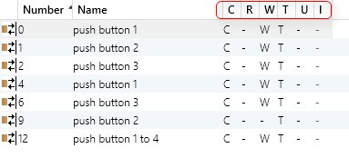
Figure 1: Flags

Setting the Flags
In most cases, flags are preset by the manufacturers. However, if the configuration extends beyond basic functions, adaptations must be carried out.

Flag settings can take place in Buildings/Functions view, in Group Addresses view and in the Topology view at the objects of the devices. Flags can be set at individual objects or simultaneously set and deleted at several objects.

Example: Setting a Flag in Buildings View
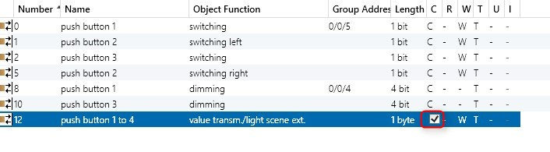
Figure 2: Setting a flag in Buildings view

Example: Simultaneous Setting of Flags at Several Objects
In order to set or delete flags at several objects simultaneously, the relevant objects must be marked (Shift+click or Ctrl+click) and the setting is carried out in the object properties in the sidebar.

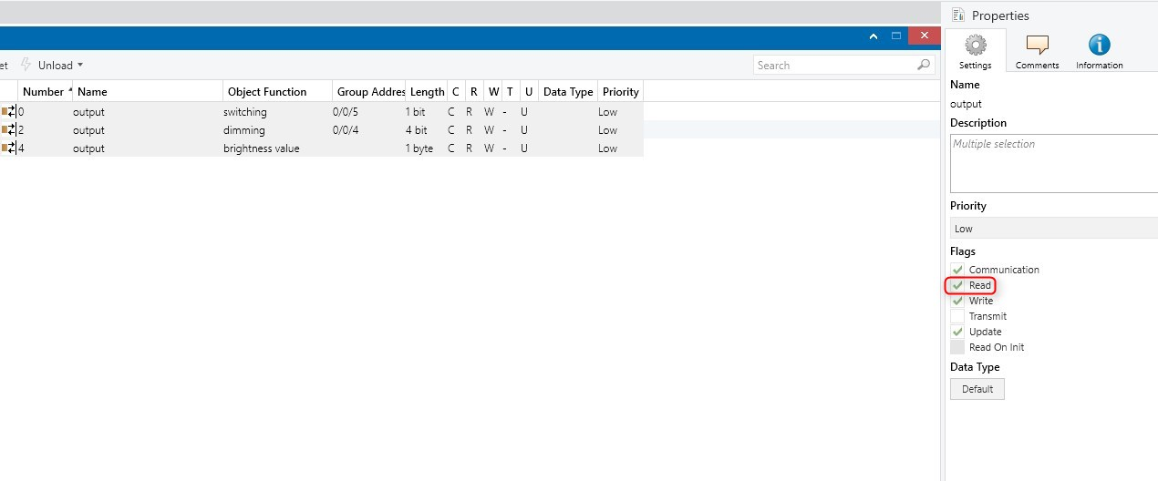
Figure 3: Example of setting several flags in the sidebar

The Communication Flag ‘C’
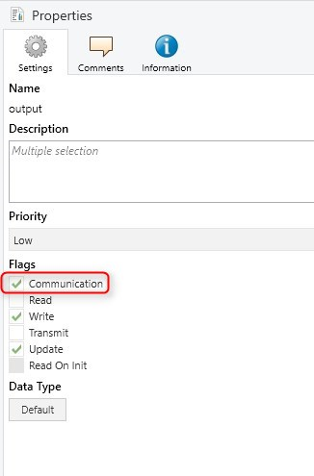
Figure 4: Communication flag "C"
The communication flag is the “master switch” for communication and is set by default at all the group objects. If this flag is not set, the object cannot send or receive telegrams.

Note:
If this object is linked to a group address, an acknowledgement is also sent when the communication flag has been deleted!

Example of a Communication Flag

The communication flag is very helpful for diagnostics. If you're troubleshooting a logic module with many objects linked to group addresses, you can unset the flag on specific objects to temporarily exclude them - without deleting or unlinking them. This lets you isolate and test parts of the logic step by step. Just make sure to reactivate the Communication flag afterward.

The Write Flag ‘W’

If the write flag is set, the value of a group object can be overwritten via the bus by group telegrams.

Typical applications:
- An actuator can only be switched via group telegrams if the write flag is set at its switch object.
- An LED on a push button can only react to group telegrams if the write flag is set at its LED object.

The write flag is set by default for all switch objects, value objects on dimming actuators as well as many push button objects (e.g. for the update of TOGGLE functions).

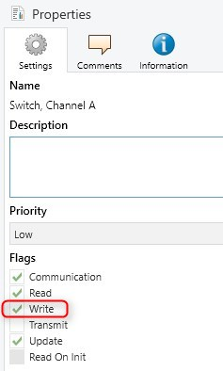
Figure 6: The Write Flag ‘W’

The Transmit Flag ‘T’
If the transmit flag is set, a group object can transmit changes in its value on the bus by triggering group telegrams to the sending group address.

The object value can be changed e.g. by a push button action, a change in temperature or the receipt of a group telegram.

The transmit flag is set for sensors by default and in most cases also for status objects of actuators.

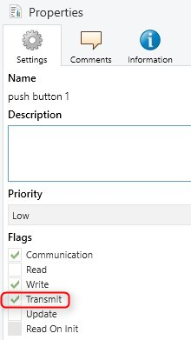
Figure 7: The Transmit Flag ‘T’

Example of a Transmit Flag
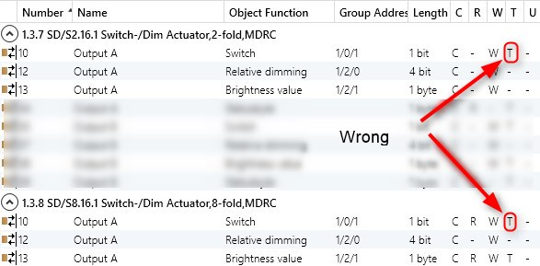

Figure 8: Example: Specific transmit flag configurations can trigger telegram chain reactions
In the example, two dimming actuators are switched in parallel. The transmit flag has been set for both dimming actuators at the combined switch/status object.
In this configuration, this results in both actuators sending a telegram to 1/0/1 after each update of the switching status. The other actuator receives the telegram and sends an update telegram. Result: A chain reaction of update telegrams. The bus is put under a heavy load and the actuators possibly no longer react.

The Read Flag ‘R’
The read flag enables the object value to be read out via read telegram.
This function is required for visualisation, light scenes etc. to query the current object status.

More precisely: If the read telegram is set at an object, the bus device responds to a read request telegram with a response telegram to the sending group address of the object. If the read flag is deleted, there is no response.

The read flag is not set by default in most cases. The flag is set by many manufacturers for status objects.

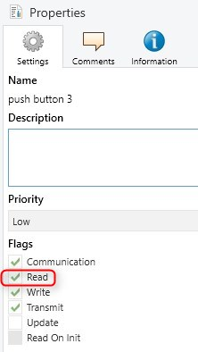
Figure 9: The Read flag "R"

Principle Sequence of a Read Request
The following example represents the sequence of a read request:
- by a visualisation (1.1.255)
- at the status object (read flag set here) of a switch actuator (1.1.1)
- via the group address 3/2/1 (status of lamp 1):
Tel. no. | Source | Source address | Target | Target address | Telegram type | Info (useful data)
1 | Visualisation | 1.1.255 | Status of lamp 1 | 3/2/1 | Read
2 | Switch actuator | 1.1.1 | Status of lamp 1 | 3/2/1 | Response | 0 or 1

Special Features of Read Flags
Some specific features should be noted when using read flags:
- The read flag should only be set at the bus device which is to respond.
- The read flag is only set once for each group address.
- If the read flag has been set for a group address at several objects, a read request would trigger several response telegrams. Different status values could be answered shortly after each other. The effects on the reading devices would then be hard to predict.
- The group address that is used to read out the object status must be placed at the transmission point of the bus device that should be read out as the sending group address is only used as a destination in the response telegram (see following example).

Example – The group address for the read request would be 3/1/6:

Incorrect:
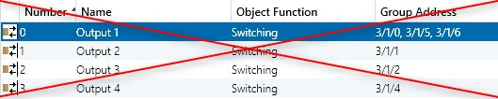
Figure 10: Incorrect: Group 3/1/6 for read request is not the sending address in this case

Correct:
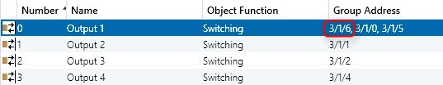
Figure 11: Correct: Group 3/1/6 for read request is the sending address

The Update Flag
The update flag adopts a special role: it controls whether the received response telegrams should be ignored or whether the received value should be transferred to the group object.

If the update flag is set, a response telegram of a read procedure is interpreted as a ‘normal’ write telegram i.e. the value of the group object is changed by the response telegram.

If it is deleted, response telegrams are ignored.

Update flags can only be deleted from system 2 bus couplers onwards.

In the case of system 1 bus couplers, the update flag is always set. Devices with BCU1 do not distinguish between response telegrams and “normal” write telegrams. They therefore change their object status as a result of read/response sequences!
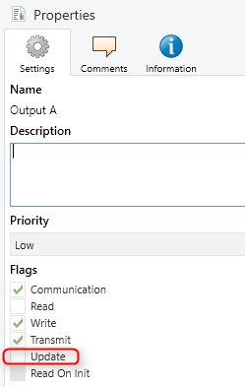
Figure 12: The Update Flag

Example of the Interaction of Read and Update Flag
The following example clarifies the interaction of read and update flags.

Project:
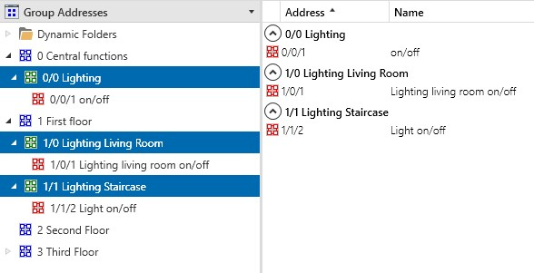
Figure 13: Group address structure
Figure 14: Group content: 1/0/1 – First floor lighting in living room ON/OFF
Figure 15: Group content: 1/1/2 – First floor lighting in staircase ON/OFF
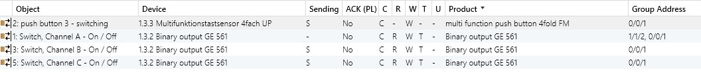
Figure 16: Group content: 0/0/1 – Central functions lighting all ON/OFF

Sample sequence:
- The multifunction push button (1.3.3) with lightscene module sends a read request to group 1/1/2 to query a switching state.
- The read flag is set and the actuator 1.3.2 reacts with a response telegram.
- Instead of 1/1/2, the group address of the central function 0/0/1 “Lighting ON/OFF” is incorrectly set at the sending point. The actuator therefore sends its response to 0/0/1 instead of 1/1/2!
- Result: A read request at 1/1/2 now leads to the lighting being switched on or off throughout the building (using the living room and staircase as an example) (depending on the switching state of the queried actuator)!

Sequence in detail:
- Multifunction push button sends a read telegram to 1/1/2
- Actuator 1.3.2 sends a response telegram to sending group address 0/0/1 with useful data “ON” or “OFF”.
- All other bus devices “listen to” the response telegram.
- All objects
- in which the update flag is set
- and which carry the address 0/0/1,
now interpret the response telegram precisely as a “normal” write telegram and adopt the useful data i.e. “ON” or “OFF”.
- The relevant actuator channels are switched.

Note:
If the configuration is incorrect, read requests can trigger (unintentional) switching actions!

The Read on Init Flag ‘I’
In addition to the flags (CRWTU) described above, system B devices (with mask versions $07B0 and $17B0) also offer a Read on Init flag (called “I” flag).

If the Read on Init flag is set for one or more group objects, the device automatically triggers read telegrams to the sending group addresses after bus voltage failure and recovery.

The ‘I’ flag is not set by default in most cases.

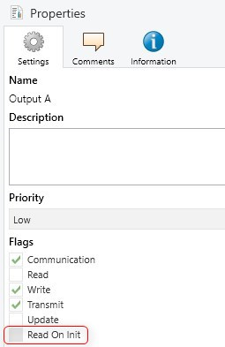
Figure 17: The Read on Init Flag
Usually, a delay can be set in the parameters for triggering read telegrams. If many ‘I‘ flags are set in an installation, the delays for all the relevant device should be set carefully and of varying duration. Otherwise it could cause a high bus load if a large number of devices send their read requests “simultaneously” after bus voltage recovery.

