ETS Apps
KNX Association

Table of Contents
1 Introduction 3
1.1 Definition 3
1.2 Description 4
2 System requirements 5
3 Licensing 5
4 Examples of ETS Apps 6
4.1 Introduction 6
4.2 Device Reader 6
4.2.1 Reading out the property of a device 7
4.2.2 Reading out the memory of a device 9
4.3 Compare Device 11
4.4 Device Templates 14

NOTE: THIS CHAPTER IS INTENDED AS AN INFORMATIVE APPENDIX TO THE ADVANCED COURSE

Introduction
For more than 3 decades now and on a worldwide scale, numerous automation projects have been realized with KNX, ranging from private, single-family homes to the networking of office building floors and even entire airports. This high variety in project types requires the continuous development of new approaches on how one deals with the project at hand and its handling in ETS, the tool in which these projects and their structures are created, edited, configured and managed.

In many cases, whether the projects needs to be edited simultaneously by several persons or because of the sheer number of KNX devices used, the project designer will desire special functions for his projects or for certain devices.

It is for this reason that KNX has opted to allow KNX manufacturers to extend the functional scope of ETS by special programs; these use interfaces available in ETS specifically available for such extensions. Two types of extensions are distinguished:

Definition
- An ETS Plug-in: A plug-in is a product-related extension, made available by the manufacturer of the respective device, allowing a device specific configuration or commissioning, deviating from the standard ETS design and configuration. Plug-ins can be called via the Parameters tab at the bottom of the list view in the Building window.
- An ETS App: An App is an extension to the standard functional scope of ETS, not limited to a specific device. ETS Apps are normally not by default included in the ETS software as shipped to the customer.
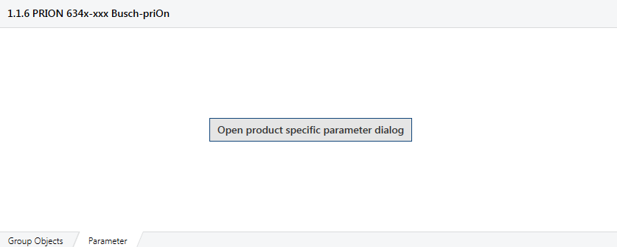
Figure 1: Example of an ETS plug-in

Description
Everyone may in the meanwhile be familiar with Apps for smart phones or tablet computers: these are software applications extending the functionality of the before-said devices.
In most cases, the ETS program will offer all functionality necessary for users wishing to design and configure KNX projects. In this way, the entry barriers for newcomers into the ETS are kept low. However, as in the case for smartphones, some users may want additional functionality on top of the standard software package.

Thanks to the concept of ETS Apps, ETS can be customized to individual needs while maintaining the KNX “one tool” approach. Especially KNX experts will profit from the transparency and faster programming offered by extra functionality in the form of ETS Apps.

KNX members have the possibility to offer ETS Apps, tailored to the needs and features of their products and/or specific markets.
As also ETS Apps are part of the KNX Licensing Scheme, they are at least sold via the MyKNX platform. This moreover has the additional advantage that the ETS user can see all available ETS Apps at a glance.
Prior to the use in ETS, KNX manufacturers must submit their developed ETS Apps to a semi-automatic validation at KNX, to check the proper use of the ETS App interface. Such validated Apps are signed by KNX: without this signature, Apps cannot be offered in MyKNX.

System requirements
In order to use ETS Apps, the following requirements have to be met:
- An installed and operational ETS software.
- An installed ETS Professional, Home or Lite license. ETS Apps cannot be run in a Demo environment.
- Each ETS App requires a specific license. This license can be obtained via MyKNX.

Licensing
Each individual ETS App always requires a separate license. Without an ETS license, an ETS App can still be installed but cannot be run.

In order to get hold of a license of an ETS App, you need to log in to your MyKNX account. Select the menu Shop on top and select afterwards the submenu ETS Apps. You will now be able to select the KNX ETS App of your choice within the different App categories.

Please note that some of the App extensions have to be extra installed: these are marked with a download icon in the “Products” menu of your MyKNX account once you have bought them.

If this download icon is missing, the App functionality is already contained in the ETS software and thus does not need to be extra installed. The functionality only needs to be released by an appropriate license.

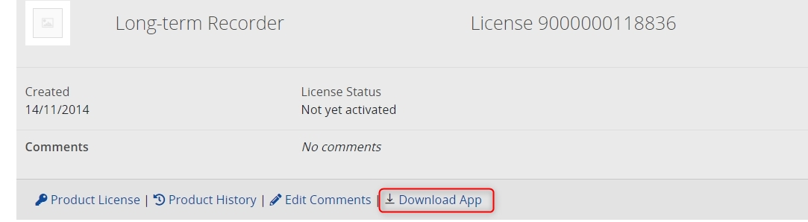
Figure 2: ETS App “Long-term Recorder” which needs to be extra installed

Further information with regard to ETS6 Licensing can be found in our help centre: https://support.knx.org/hc/en-us/articles/7393992314770-ETS6-App-licensing

Examples of ETS Apps

Introduction
Underneath only a selection of ETS Apps is described, all of them are Apps offered by KNX Association itself. For more information on available Apps and their functionality, please consult the KNX help centre.

Device Reader
With the help of the standard ETS, one can easily manipulate parameters in the application software of KNX devices and thus realize the desired functionality. Even at a later stage, these parameters can again be adapted in ETS to new user needs.
Situations may however occur where system integrators have to dig deeper into devices. An unknown bus component may for instance unexpectedly surface when reconstructing an existing KNX installation. In such cases, the ETS App Device Reader can be used to directly read out the memory of devices, in this way providing the user with data that are more helpful and hopefully information that resolves matters at hand.

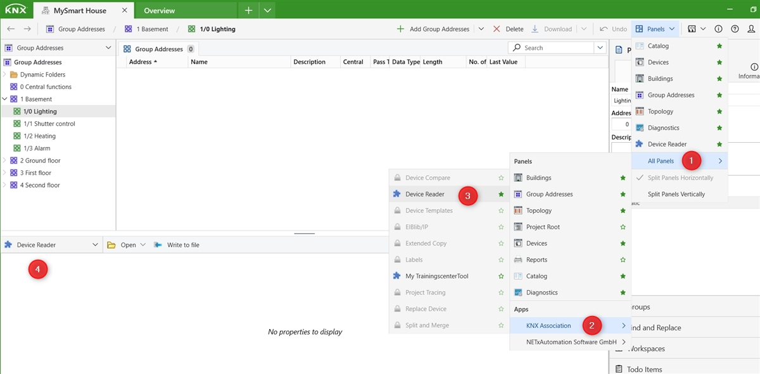
Figure 3: App Device Reader

You can open the Device Reader App by selecting the Device Reader panel. The Device Reader gives the system integrator the possibility to read out properties of interface objects or the memory of a certain KNX device.

You can read out the properties or memory of a specific device by entering the individual address of the corresponding device (“open from device”).

In the case where you have exported the file via the function in the Device Reader, it is moreover possible to open a properties file (*.knxprop file) or a memory dump (*.s19 file) and this by selecting the Option “Open from file”

Reading out the property of a device
Some KNX system profiles allow storing data in data structures called properties of interface objects, which have been standardized system wide (“device object”) or for a specific class of devices (e.g. dimming actuators).
Such properties can be read out for KNX devices complying with certain system profiles (e.g., System 2, 7…): the data can then be interpreted without the need to know the device’s internal memory structure or storage location of the data.
For manufacturer specific extensions there is however also a manufacturer specific range of KNX interface objects and properties.

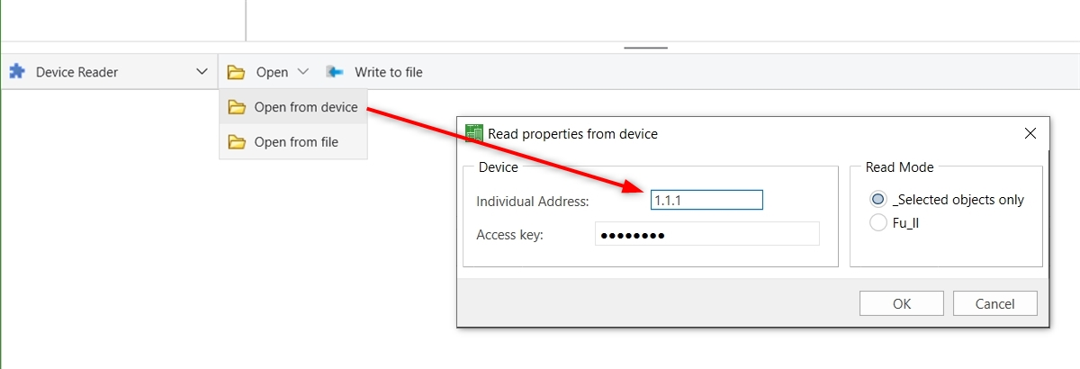
Figure 4: Read properties from device

Individual Address: | Enter the individual address of the device, of which you want to read out the properties
Access key: | In this field, the default BCU Key needs to be entered or the correct BCU Key as previously entered in the Details menu of the corresponding project in the ETS Dashboard. Some KNX device profiles do not support a BCU Key.
Read Mode: selected objects only | This will only read out the properties of an interface object, when selecting it individually in the left panel this reading approach is slower
Read Mode: Full | This will read out all properties of all available interface objects in one go, hence you will not need to select each object one by one in order to read them this reading approach is faster

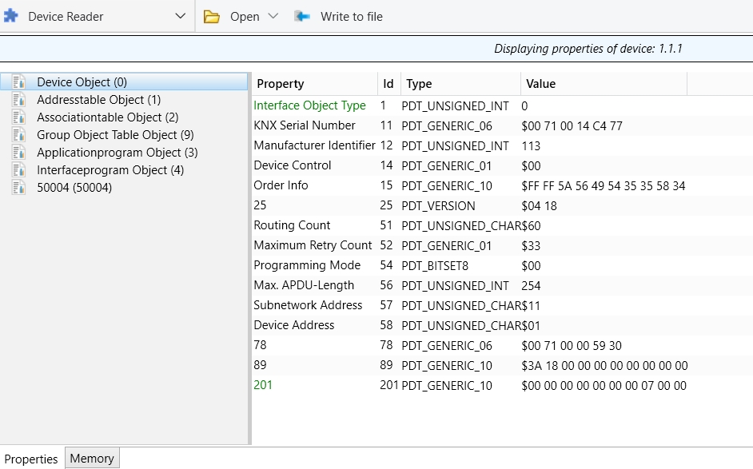
Figure 5: Example of property read

The values of some of the properties can be changed in the Properties container (of the device Reader, however not in the device!). The result of a property read can then be written to a file, of which the extension is *.knxprop. These properties can be analyzed and edited in a text editor and can afterwards again be opened in the Device Reader.

Reading out the memory of a device

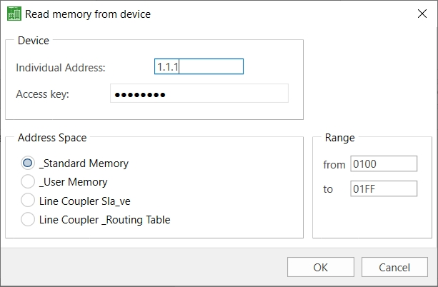
Figure 6: Read memory from device

Individual Address: | Enter the individual address of the device, of which you want to read out the memory
Access key: | In this field, the default BCU Key needs to be entered or the correct BCU Key as previously entered in the Details menu of the corresponding project in the ETS Dashboard. Some KNX device profiles do not support a BCU Key.
Address Space: | Standard Memory, others are User Memory, Line Coupler Slave, Line Coupler Routing Table
Range: | You can specify the memory block that shall be read out by entering the memory range.  Default value: 0100 to 01FF

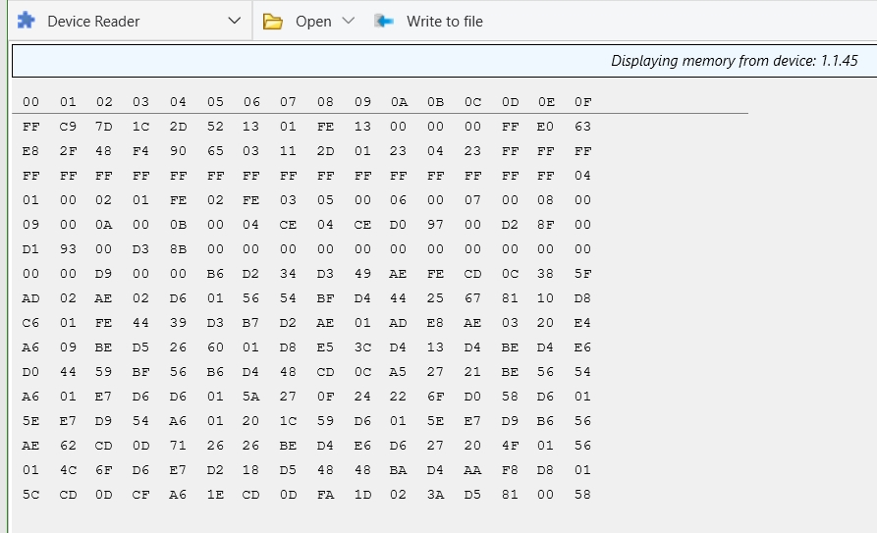

Figure 7: Example of memory read of a system 1 device -> individual address 1.1.45

The result of a memory read can be written to a file, of which the extension is *.s19, *.s28 or *.s37 file. The result can be analyzed and edited in a text editor and can afterwards be opened again in the Device Reader.

Compare Device
The App “Compare Device” enables the system integrator to compare the available data in the ETS project to the individual devices in the installation. In this way, the current state as loaded in the installation can be compared with the expected state as contained in the ETS project.

Hence, the user has the possibility to check whether the project is still up to date. Rather than guessing, he can know exactly which changes have been made in the ETS project or in the installation.

The dissimilarities in device configurations are shown.

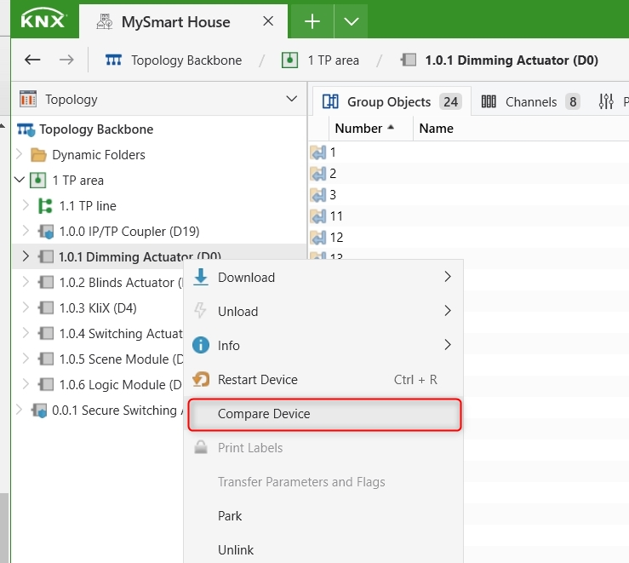
Figure 8: Select Compare Device via context sensitive menu

Select the device(s), for which you want to perform a “Compare device” in the “Buildings”, “Devices”, or “Topology” view. The function can be called via the context-sensitive menu.
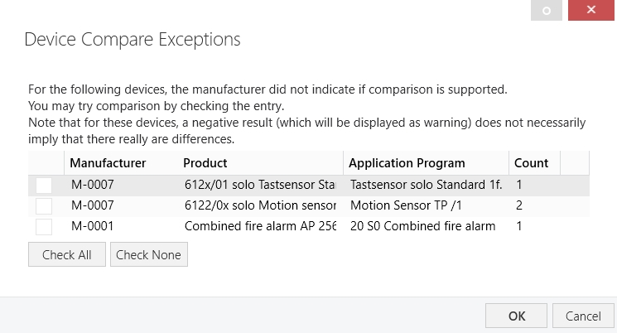
Figure 9: Device Compare Exceptions

‘Check All’ if you want for all products that a comparison is made between the current state as in the installation and the expected state as stored in the ETS project, or you only select the device(s) concerned.

For some of the listed products the manufacturer may not have indicated whether comparison is supported or not: this result of the comparison may therefore not in all cases be reliable.

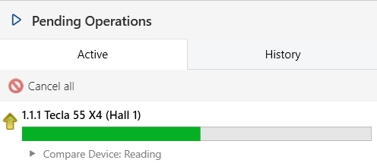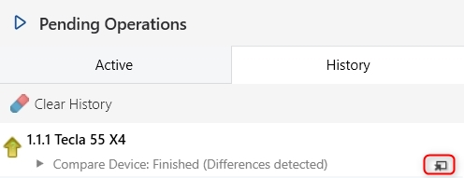

Figure 10: Comparison Process

You will see the Compare Device reading progress in the navigation bar of your project. Select the small arrow in the right bottom corner of the Pending Operations container to see the result of the comparison between selected Device(s) and Installation.

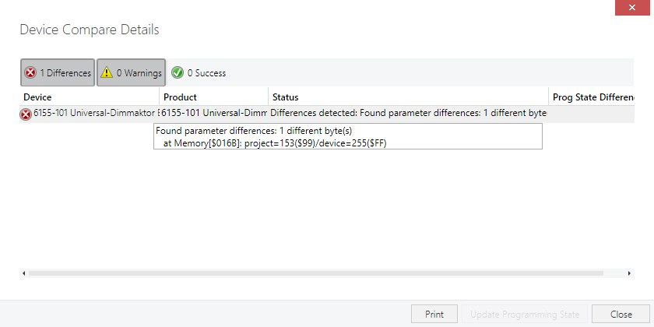
Figure 11: Device Compare Details

The outcome of a comparison process in the above figure shows that there is only 1 difference. When analyzing the differences detected by ETS, the ETS indicates that it has found a parameter difference at Memory address [$016B]. The parameter value for this device is programmed as 255 ($FF), where the parameter value in the ETS project is set to 153 ($99). This dissimilarity in device configuration has to be further investigated.

Further analysis of the parameter settings reveals that the initial brightness value is 60% although in the device itself this value has been set to 100% (255 or $FF). A simple calculation shows that 60% equals 153 (60/100 * 255 = 153)

Note: If a warning is displayed this does not necessarily mean that there is a difference.

Device Templates
In practice, parameterizing KNX devices can be very time-consuming. If you need devices with particular parameter settings more than once, it is possible to have these configured products available for further use afterwards. With the ETS App “My Product Templates” such ready-made devices can be added to a favorite’s list.

A big advantage is that these product templates then also become available for other projects - like from the Online Catalog – but then fully pre-configured. System integrators who repeatedly integrate similar functions can save a lot of time and effort with this ETS App.

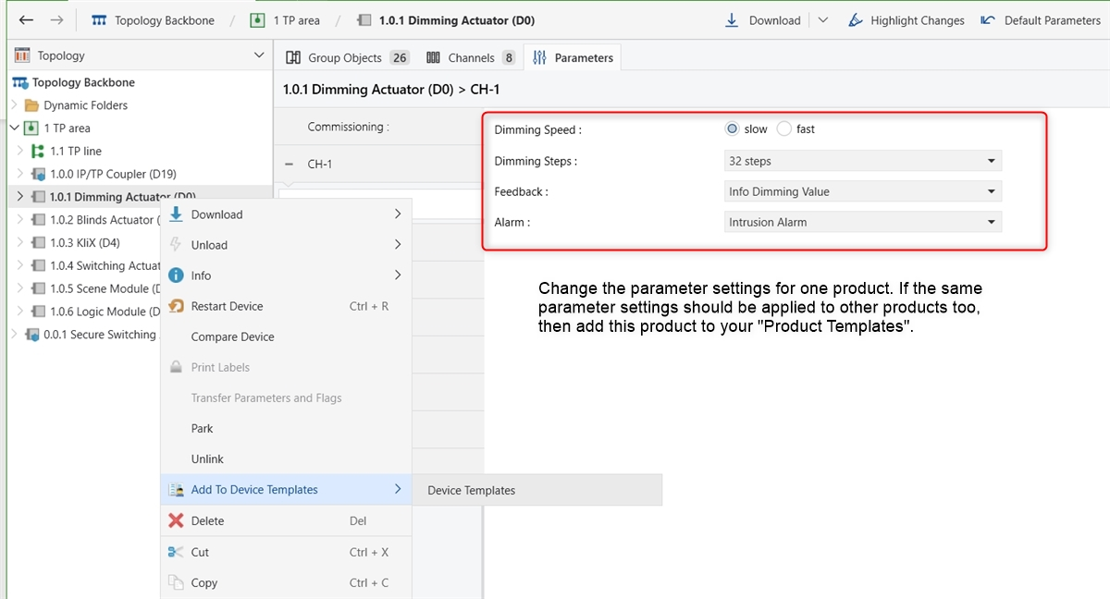
Figure 12: Adding product to Device Templates

If a template with the same parameter settings already exists, ETS will display a warning and will cancel the process of adding the template.

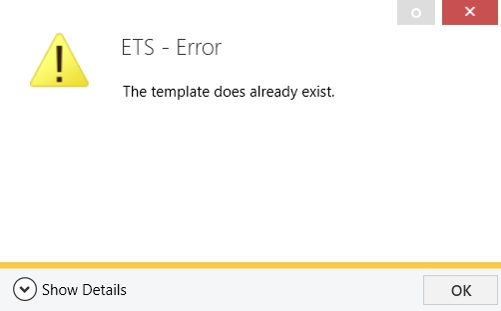
Figure 13: Template already exists

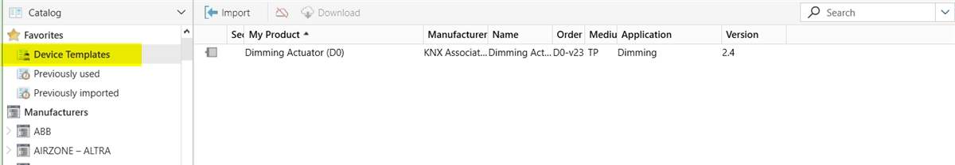

Figure 14: Location of My Device Templates

The Device templates can be found in the Favorites menu of the Catalog panel. It is even possible to import or export a product template as a *.knxtempl file. This is handy if different system integrators are working with the same set of pre-configured parameter settings.

Note: Deleting a product template does not mean that the corresponding products are deleted from the project.

Not supported in ETS3. Only ETS4.1 or higher. System requirements for ETS4/ETS5/ETS6 and ETS Apps are identical.

