Fail-safe Planning
KNX Association

Table of Contents
1 General 3
2 Software Measures 3
2.1 Cyclical Telegrams for Monitoring 3
2.2 Parameterisation of a Weather Station 4
2.3 Priority of a Telegram 5
2.4 Behaviour after Bus Voltage Recovery 6
2.5 Bus Voltage Monitoring 7
3 Steps to a safe KNX installation 8
3.1 Distributed System with Controllers 8
3.2 Logic Modules and Visualisation in connection with Couplers 8
3.3 Multi-channel Switch Actuators 9
3.4 Benefits of Line Couplers 10
3.5 Power Supply 10
3.6 Backup Power Supply on Voltage Failure 10
3.7 Redundant Layout of Power Supplies 11
3.8 Power Supplies with Diagnostic Function 13
4 Practical example 14
4.1 Cyclical Monitoring of 2 Lines using a Controller 14

NOTE: This chapter is intended as an informative appendix to the ADVANCED COURSE.

General
Many KNX systems that are installed nowadays fulfil security-related functions. If these types of applications are required, software and hardware measures should be taken into account to make the KNX system fail-safe.
Examples of these types of requirements include:
- Alarm functions
- Monitoring systems (windows, doors, …)
- Intruder and anti-theft alarm systems
- Remote signalling (telephone, web, …)
- Fire detectors
- Water detectors
- Control of devices and applications whose failure could lead to consequential damages (wind sensors for shutters, rain sensors for skylights, central disconnection of the water in unused buildings …)

Software Measures
To implement functions, there are actuators, sensors and controllers available which the integrator must link together. During normal operation, telegrams are transmitted dependent on events. If an event occurs, a telegram is generated and sent to the bus system. If the sensor should no longer be in operation, it is possible to stop generating telegrams which cause an action to be carried out. In the worst case, an “important” telegram may be lost. To prevent this, it is possible to detect the failure of a telegram and to signal in succession that a fault has occurred in the transmission.

Cyclical Telegrams for Monitoring
For safety-related reasons, it can be advisable to repeat telegrams at cyclic intervals to guarantee that the output device is set to a defined switch position if the transmitting device fails. A function that occurs frequently in KNX systems is the wind or rain alarm. The method of operation of a wind sensor is described in the following section by way of illustration.
The information that there is no wind (logic “0”) is transferred cyclically by the sensor. If the shutter actuator does not receive a safety telegram within a defined period, the shutter is moved into the safety position and any move, stop and step commands are only carried out if the wind sensor has sent the telegram “No wind present”. It should be noted that only the information “No wind” i.e. logic “0” should be repeated cyclically in the KNX system. The majority of shutter actuators carry out a movement command on receipt of the telegram “Wind present” (“logic 1”). If this telegram is also transmitted cyclically, it could lead to damage of the drive motors in the worst case.
When configuring this type of cyclical monitoring, it should always be ensured that the monitoring time on the actuator side is selected as approx. three times as long as the cycle time of the sensor. Generally, telegrams which are sent cyclically should not be sent at very short intervals as this would lead to an unnecessarily high bus load. Normally, it can be assumed that the new state will be sent immediately, if there is a change in the state at the sensor.

Parameterisation of a Weather Station
The following diagrams show an example of the parameterisation of a conventional wind sensor which is connected to the binary input (Channel A) of a KNX weather station.
Due to this parameterisation, the input sends the sensor state on the bus with a cyclic period of 5 minutes.

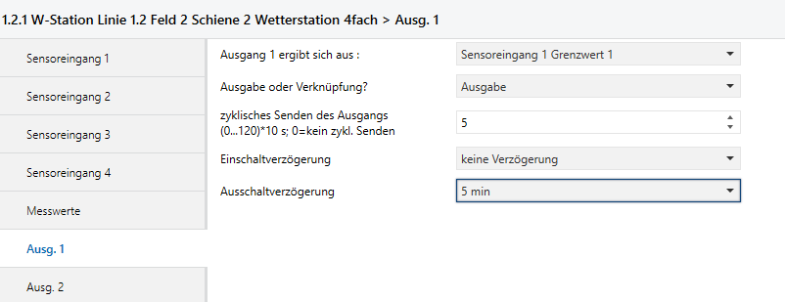
Figure 1: ETS screenshot of a weather station (e.g. Sensor input 1, limit value 1, wind (54km/h), output 1 cyclical 50s / 5min delayed)

The shutter actuator must now be configured so that the shutter moves into the safety position if the information (“No wind present” (logic 0)) is not received within 15 minutes.

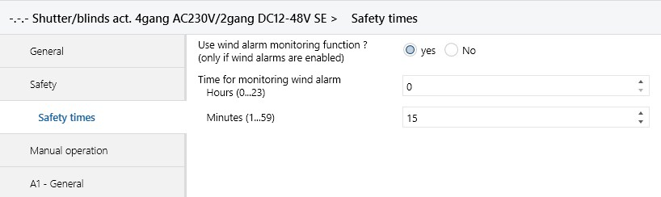
Figure 2: ETS screenshot of a shutter actuator

The previously described method of operation can also of course be implemented using switch actuators or controllers. The sensor or controller which can send a telegram cyclically must be configured so that it always triggers a time switch or staircase function in the output device, so that it does not change its state. If information is lost because for example the power supply of a primary line fails, the output object changes its state. This method can be used to check from a central position whether voltage has been applied to all the line segments of a KNX system. A device must be installed in each segment which sends cyclical telegrams and a device must be installed at a central point which evaluates this information.

Figure 3: Sensor repeats cyclically
In event-controlled, decentralised systems, the majority of safety functions are based on cyclically transmitted telegrams whose transmission is monitored at another location.

Priority of a Telegram
A further step in enabling telegrams to be sent as quickly as possible is the setting of priorities at the group object. Normally, these are set by the manufacturer. The priority of the sending telegrams of an object can be adapted individually on three levels with ETS as required.

The following priority levels are available:
- Low operational priority
- High operational priority
- Alarm
- System (used by ETS during the download)
The following diagram indicates a weather station in which object 1 (Output Safety 2) has been set to ‘Alarm’ priority. This setting means that primarily several logic “0” are sent in the control field of the telegram and the telegram prevails immediately and without a delay against a device with an auto or normal priority. It should however be noted that you should not set a large number of telegrams on the same priority level if they could possibly be sent at the same time.
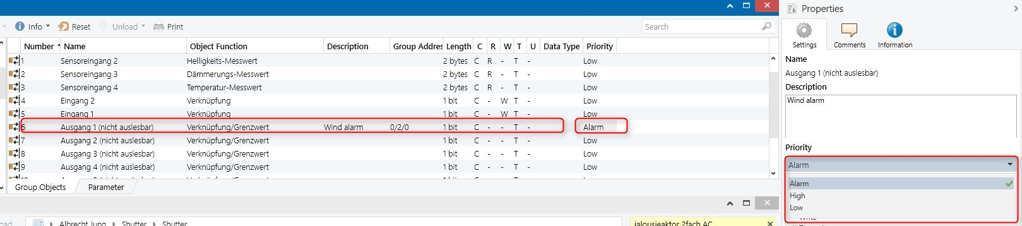
Figure 4: Priority of a telegram

Control field  7 6 5 4 3 2 1 0  1 0 R 1 P1 P0 0 0 | Repeat flag  0 Repetition  1 Normal | P1 P2 Priority  0 0 System telegram  1 0 Alarm  0 1 High  1 1 Low

Figure 5: TP1 telegram

Behaviour after Bus Voltage Recovery
The start-up behaviour of a KNX installation after voltage failure must be planned and checked no later than the handover stage. In most cases, it can be assumed that switch actuators retain their state after bus voltage recovery or switch off the outputs. For many devices, the “Status after voltage recovery” can be set in the device parameters. In particular, if irrigation systems, pump control systems or device controllers which cause very high operating costs are implemented using KNX, the start-up behaviour must be verified and become a part of the acceptance report.

Bus Voltage Monitoring
It is possible to install a conventional time relay in parallel to the KNX power supply to establish a voltage failure. Controllers, setpoint values and other states in an installation can thus be reset to the initial state. The time relay switches with a delay (after approx. 30 sec) and the contact is linked with a channel of a KNX binary input. This binary input sends to a group address which reports a power failure and creates defined basic states. The following diagram represents the schematic configuration of this type of system.

Figure 6: The installation of a conventional time relay in parallel to the power cable of the KNX power supply
Newer power supplies offer diagnostic functions. With these devices, a start-up initialisation can be carried out directly via group objects. More about this topic in the chapter “Power Supplies with Diagnostic Functions” below.

If there is a request to transfer defined data to different group addresses on voltage recovery, a controller can be used which is able to trigger a telegram and to send defined data to group addresses on receipt of this initialisation telegram.
In this example, an initialisation telegram triggers the sending of data to different group addresses:
Figure 7: Trigger in response to a telegram

Steps to a safe KNX installation

Distributed System with Controllers
Each bus device has its own authorisation and its own microprocessor. If a bus device fails, all the other bus devices function without any interference. This applies to all direct connections (e.g. sensor – actuator). If logic modules are used however between the input device and the output device, the failure of this device means that data transfer cannot take place.

Figure 8: Distributed system with controllers

The above should be noted in particular if the lighting can for example only be switched via scene modules.
To be able to switch the lighting on and off after the failure of the scene module, it is advisable to assign a central ON/OFF function for the room to at least one sensor and to allocate this group address to the respective actuators.

Logic Modules and Visualisation in connection with Couplers
In KNX systems that extend over several rooms, it is advisable to distribute the controllers i.e. to position several modules. The fault tolerance is thereby increased. It also relieves the load from the filter tables and the telegram traffic across the lines and areas is reduced to a minimum.
If a visualisation program is present in a KNX system, it can take over logic functions and sequence control in many cases. Products are also available which can be freely programmed and possibly contain logic functions. As regards operational reliability, it is not a good idea to link functions from different zones in one device as a failure of the PC or central control system leads to there no longer being any functions throughout the KNX system.
In any case, it is advisable to connect the PC on which the visualisation is installed to a UPS. In general, however a control option should always be provided next to the PC to ensure emergency operation. This can take the form of a switch sensor or panel units for example.

Multi-channel Switch Actuators
When costing KNX systems, multi-channel switch actuators are being installed with increasing frequency. These devices appear perhaps to be a good idea in most cases as regards project costs but a possible disruption of the device means that several loads can no longer be controlled in the event of a fault. This fact should also be considered when planning a KNX system. If however output devices are used with many channels, the allocation should be distributed so that on failure of a device, complete areas of a building or entire rooms are not affected by the malfunction. (See example).

The light strips are often placed on the switch actuators in sequence:

Switch actuator 1 | Channel A | Room 1 | Door light strip
Switch actuator 1 | Channel B | Room 1 | Window light strip
Switch actuator 2 | Channel A | Room 2 | Door light strip
Switch actuator 2 | Channel B | Room 2 | Window light strip
Table 1: Room function based on the actuator

A failure of switch actuator 1 or 2 would mean that it would not be possible to switch any loads throughout the room. The operational reliability is improved if the switching groups of a room or an area are distributed among many actuators.

Distribution of the room function spanning the actuator:

Switch actuator 1 | Channel A | Room 1 | Door light strip
Switch actuator 2 | Channel A | Room 1 | Window light strip
Switch actuator 1 | Channel B | Room 2 | Door light strip
Switch actuator 2 | Channel B | Room 2 | Window light strip
Table 2: Room function spanning the actuator

If one of the two actuators should now have a malfunction, it does indeed affect both rooms but at least one light strip per room would always remain functional.

Benefits of Line Couplers
The more line couplers are installed in a system, the better the structure and reliability of the entire installation. The basic requirement is of course the proper commissioning of the filter tables to reduce the total number of telegrams in the KNX system and to avoid repeat telegrams. The fastest possible information transfer is thus guaranteed.
The failure safety is considerably improved by the electrical isolation of the line segments via line couplers. Short-circuits, overvoltage and other signal defects can thus be limited to line segments. To avoid the build-up of telegrams via controllers (telegrams circulating via logic modules due to faulty programming) or repeat telegrams, the filter tables should be loaded correctly into the couplers and configured.

Power Supply
A 640 mA power supply offers the opportunity in most cases to supply more than one line segment with power. It must however be noted that 2 line segments can no longer be operated if this power supply fails.

Backup Power Supply on Voltage Failure
To guarantee the operation of a line segment for a certain period without the 230 V power supply, there are two possibilities:
- Use of power supplies with battery connection which can buffer the KNX system for a certain period even in the event of a complete power failure. Depending on the capacity and voltage, it is moreover possible to control an alarm siren with a flashing light via a switch actuator with floating contacts. (See the “Security Technology” chapter).
- Sometimes bus devices require a separate power supply.
These include built-in panels, PCs with a visualisation system running on them or telephone dialling devices which are connected to telecommunication systems. The request is often made that it should also be possible to send signals in the event of a mains failure. The KNX power supply can be maintained e.g. via an uninterruptible power supply (UPS) for a certain period.
Other 230V devices can of course also be connected via the USP such as telephone dialling devices, telephone systems and power supplies for 24V binary inputs which are often used to monitor window contacts.

If several line couplers are installed in a KNX system, each segment should also be buffered. If a monitoring system is implemented with KNX, it is advisable to connect all the sensors and actuators required for the alarm signalling to a buffered line segment. This segment can be separated from the rest of the system with a line coupler. This generates a saving as only one line segment must be buffered.

Redundant Layout of Power Supplies
Standard KNX power supplies (PSU, Power Supply Unit) are primarily used to supply bus segments (lines or line segments) centrally. This means that a PSU is installed per line. If the bus voltage supply should be designed as redundant, two power supplies can be installed per line. The distance between 2 Power Supply Units in one line is specified by the manufacturer. The data sheet contains the information as to whether the manufacturer permits this operation mode.
A further possibility of the redundant layout is the use of DPSU (Decentralised Power Supply Unit). A maximum of 8 DPSUs can be distributed on a line. DPSUs are particularly intended for the supply of small installations with a few devices but can also be combined with a central power supply. In each case, the data sheets of the manufacturers must be taken into account. The maximum short-circuit current produced on a line may not exceed 3A.

Cable length | Power supply type
 | Decentralized power supply with number of power-feeding devices with decentralized bus supply |  |  | Central power supply
Number of DPSUs | 1 | 2 | 3…8
Max. total cable length | 350 m | 700 m | 1000 m | 1000 m
Max. distance between two bus devices | 350 m | 700 m | 700 m | 700 m
Max. distance between non-power feeding device and power supply | 350 m | 350 m | 350 m | 350 m
Minimum distance between two power supply units |  |  |  | As specified by the manufacturer

Table 3: Decentralised and central power supplies
Since very recently, devices are available which combine two electrically isolated power supplies in one housing. A central redundancy can be implemented with these types of devices.

Figure 9: Redundant power supply

It should be noted that if one power supply fails, the remaining power supplies must supply the required bus current. The bus supply must also be dimensioned accordingly. A further variant of making a fail-safe connection of the KNX power supply is the use of several standard power supplies with a separate KNX choke.

Figure 10: Redundant power supply with separate choke

When planning a redundant bus supply, the 230V supply must also be taken into account. If e.g. two power supplies provide redundant power to a line, they should be fed by different external conductors which are fused independently, if possible in different subdistribution boards.

Power Supplies with Diagnostic Function
For the early detection of problems with the bus voltage supply, some manufacturers offer power supplies with a diagnostics function. These devices have a bus coupler and can send telegrams on the bus. Typical diagnoses are e.g. the early detection of voltage dips, overcurrent or excess temperature. If these diagnoses are monitored, problems can possibly be detected before the voltage supply fails. If there is a bus voltage failure, the system must be frequently brought to a defined state after voltage recovery. (See 2.3 “Behaviour after Bus Voltage Failure”) Power supplies with an integrated diagnostic function frequently report the voltage recovery with a time delay or send their status cyclically so that defined recovery procedures can be implemented.
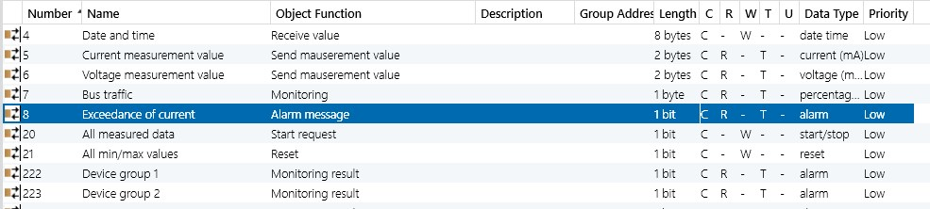

Figure 11: Power supply with diagnostic function

Practical example

Cyclical Monitoring of 2 Lines using a Controller
Configure a KNX system with 2 lines and a main line.
A device which is able to send cyclical telegrams is installed in each of the two secondary lines. An output device (actuator, LED, display, visualisation...) should be installed on the main line of the system which indicates whether bus voltage is present in line 1 or 2. You require a controller whose application enables time switch operation.
Integrate a wind sensor into your system which acts on shutter actuators. This should move the shutter to the end position when the limit value is exceeded.
The information of the cyclic wind telegram should also be represented on the main line on the output device.
Consider whether it is a good idea to place the cyclical information at an OR gate and to signal at one channel of an output device. Which problems could arise?

