HVAC Control with KNX
KNX Association

Table of Contents
1 General 4
1.1 Foreword 4
1.1.1 Requirements to the climatic control system 6
1.1.2 Energy Certificate 6
1.2 Planning the Heating System 9
1.3 Function and Type of Heating Components 13
1.3.1 Type of Heating 13
1.3.2 Heating Curve 15
1.3.3 Capacity of the Heating Elements 18
1.4 Commissioning the Heating System 21
2 Integration of the Heating into the Building Management System 21
2.1 Individual Room Control 23
2.1.1 Principle of Individual Room Control 23
2.1.2 Types of Control 23
2.1.3 Components of Individual Room Control 25
2.2 KNX Connection to Heating or Cooling Systems 32
2.2.1 Connection via DDC Gateway or Conventional Actuators 32
2.2.2 Connection via a KNX Gateway 32
2.2.3 Connection via an External Heating Controller 35
3 Fan Coil 37
3.1 Introduction 37
3.1.1 Technical Structure 38
3.1.2 Design Variants 39
3.2 KNX Integration 42
3.2.1 Fans 42
3.2.2 Operating Modes 43
3.2.3 Sensors 43
4 Integrating air conditioning systems 44
4.1 Introduction 44
4.2 Technical Design 44
4.3 Integration in KNX 45
4.3.1 Proprietary Protocol 45
4.3.2 Gateway to an open Automation Protocol 45
4.3.3 Unidirectional Communication 46
4.3.4 Bidirectional Communication 46
4.4 Regulation cf. § 2.1.3.1 47
5 Ventilation 49
5.1 Introduction 49
5.2 Technical Design 49
5.3 Integration with KNX 52
6 Physical Sensors 54
6.1 General 54
6.2 Weather condition sensors 54
6.2.1 Temperature sensor 54
6.2.2 Brightness sensor 55
6.2.3 Wind sensor 56
6.2.4 Precipitation sensor 57
6.2.5 Solar radiation sensor 57
6.2.6 Combined device, Weather station 58
6.3 Air quality sensors 59
6.3.1 Terms and definitions 59
6.3.2 CO₂ concentration sensor 59
6.3.3 Humidity sensor 60

NOTE: THIS CHAPTER IS INTENDED AS AN INFORMATIVE APPENDIX TO THE ADVANCED COURSE

General

Foreword
The correct room temperature (type of room, usage time) affects our well-being. The requirements may vary depending on the location and the individual. Room temperatures of 16 °C -18 °C may be sufficient for the kitchen and bedroom but we require a cosy warm temperature of 21 °C for the living room and even 22 °C in the bathroom.
A feeling of well-being is extremely important in our private lives and working environment. Comfortable temperatures are therefore vital for our health and well-being since we spend up to 95% of our time inside buildings.
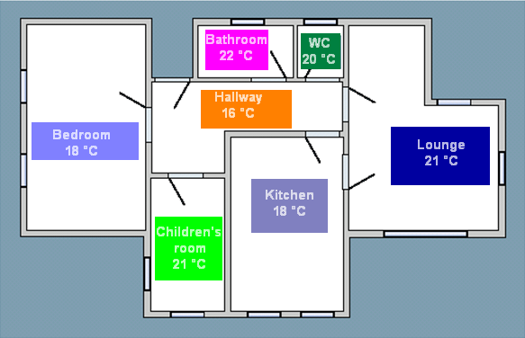
Figure 1: Temperatures according to room usage
Also all other premises that we use (public buildings, workplace) should have a temperature appropriate for the location and activity. People feel uncomfortable if the temperature control system of the body (the skin) is put under strain e.g. due to excessively low or high air and wall temperatures, considerable air movement, excessively low or high air humidity.

Note: A feeling of comfort is experienced if air temperature, movement, humidity and wall temperatures are in a balanced ratio to the activity and clothing of the person. Comfort and well-being are also favourably influenced by the cleanness of the air and a low sound level in the room.

In private households in Germany, approx. 70% of the energy consumed is used for heating and hot water. Calculated on the energy consumption of the entire country, 30% of the total energy alone is used for heating and hot water.
An effective use of energy with an increased level of comfort must nowadays be the goal from an economic and environmental point of view. A modern building system should therefore concentrate on the proper control of heating, ventilation and air conditioning systems.
The aim when planning a heating or air conditioning system must be to achieve the required level of convenience and comfort with the lowest use of energy. It is therefore necessary to plan the systems in detail, thereby considering the local possibilities and the use of intelligent control systems.
KNX offers corresponding components for the various control options:
- Individual room control
- Heating and cooling circuit control
- Boiler control

In the light of energy savings, the significance of individual room control or the integration of the heating system has increased. With demand-based individual room control, savings of 5-10% can be achieved. This of course depends on the individual user behaviour. If the user now already closes the conventional thermostat valve when opening a window, the savings are very low. If however the user wishes the convector to heat despite an open window, savings with individual room control with window contacts are a great deal higher. Even if the heating would continue over night or during the weekend (even with an open window) without the respective rooms being used, the savings could be significant. Demand-based control for the entire installation is the optimum situation. It is not only a question of regulating the flow rates at the radiators or heating coils via control valves but also of influencing the heat generation. Only the right amount of thermal energy to regulate the temperature in the building is produced. Circulating pumps are only switched on when required and do not run permanently. It is difficult to give a precise percentage value of the savings gained, as many different factors have an influence on the result. These include the structural conditions such as the insulation of the roof, the walls and the design of the windows etc. The highest possible saving on the KNX control side can be achieved if only demand-based heating or cooling is generated through the integration of different sensors and time switches as well as the communication between the room and the heating/cooling.
The term ‘climatic control system” in the underneath text denotes a dual temperature control system, which can – depending on the requirement – either heat and/or cool.

Requirements to the climatic control system
Already in the nineties minimum requirements were laid down for central heating in national regulations for the control of the heat supply and electric valves, e.g.
- Temperature controlled (outside temperature or other applicable reference variables)
- Time controlled
In the mean while, requirements have again been extended. Compared to standards – of which many exist in the area of the energetic evaluation of buildings – regulations are requirements that are fixed by the lawmaker and thus are binding. In some European countries the energy saving targets were considerably lowered in the last years (e.g. up to 30%).
These regulations are in the end all based on international standards, which were in turn the result of political activities, e.g.:

- EN 15232
- EN ISO 13789:1999-10
- EN 832:2003-06
- ….

Although the earlier regulations were required by law, the energy saving targets were relatively easy to fulfil. Since not only in Europe politics has increased its focus on CO₂ reduction, this has an immediate impact on regulations.

The regulations clearly lay down that the energetic targets for larger buildings need to be higher than those of smaller.

Fact: in case of new buildings or even in the case of extensive renovation, the targets can only be achieved thanks to building automation, especially when one wants to achieve a certain differentiation in the heat/cool distribution (e.g. per room) in these buildings.

Energy Certificate

A result of the before-said regulations is in the end the energy certificate of a building, of which the German version is shown underneath. The way such a certificate is established can however be highly complex, hence not explained below.

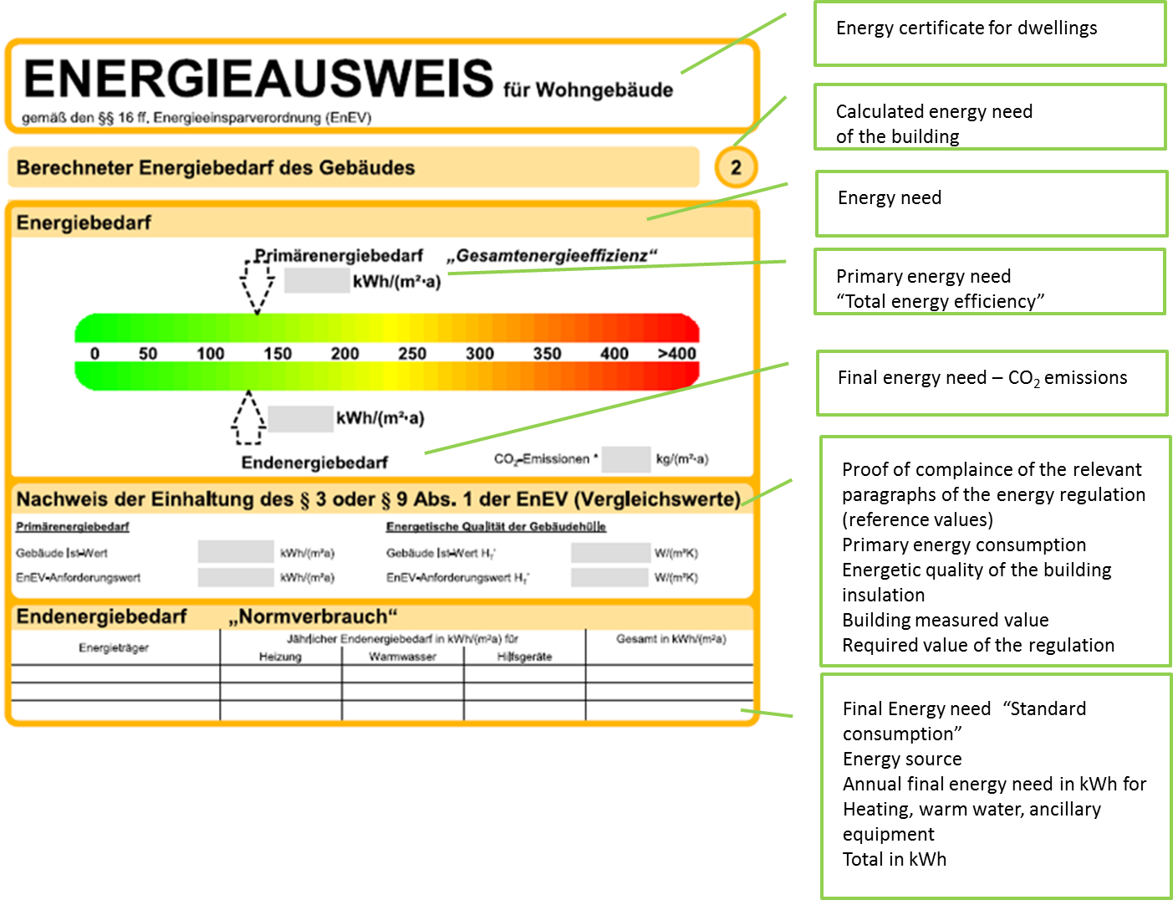
Figure 2: Final energy need in Energy Certificate (Example Germany – Energy Saving Regulation 2007)
The underneath graphics shows reference values for the final energy need according to the type of building, again taking the example of Germany and according to the local Energy Saving Regulation from 2007. Newer versions of the regulations cause the reference values to shift increasingly to the left!
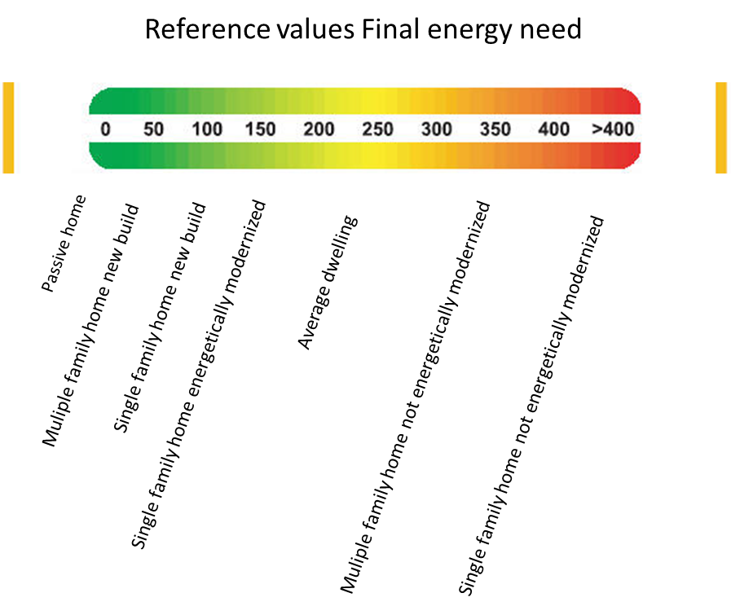

Figure 3: Reference values for final energy need (Example Germany – Energy Saving Regulation 2007)

The conclusion relevant for us out of all this data is quite simple:
It is no longer imaginable not to foresee any automation technology in new buildings, not even in renovations.

Planning the Heating System
The planning of the heating system is generally carried out by specialist heating engineers under certain criteria.
- Type of heating – selected by the customer (according to the type of primary energy)
- Heating curve – dependent on the type of heating and location
- Capacity of the heating elements – building type (W/m²), room temperature costs
- Heating control - costs
An important selection criterion is the price of the primary energy which is available at the installation site. It is less the current price that is considered and more the price development of the last few years and the prognosis for the next few years. The investment costs and operational costs for the system must however also be noted when selecting the type of primary energy (e.g. a storage room, oil tanks, oil pumps and corresponding control technology for fuel oil). The diagram below shows a comparison between the different energy types.
Source: Federal Statistic Office Germany
Measured values
Measured values
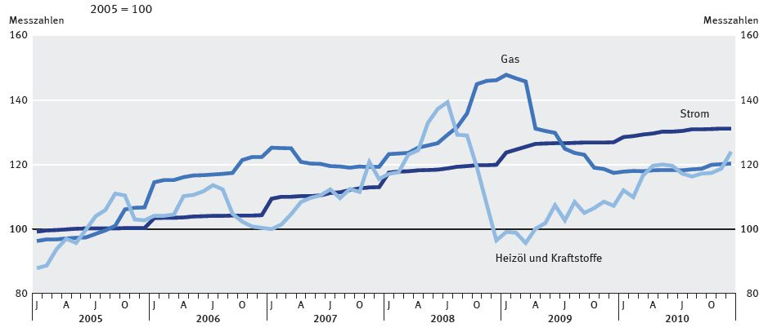
Electricity
Gas
Heating oil and fuel
Figure 4: Price development of fossil fuels compared to electricity with 2005 as reference

As further example from Germany, an absolute price comparison between gas (yellow), electricity (blue) and oil (red) – source (http://www.energieagentur.nrw.de).

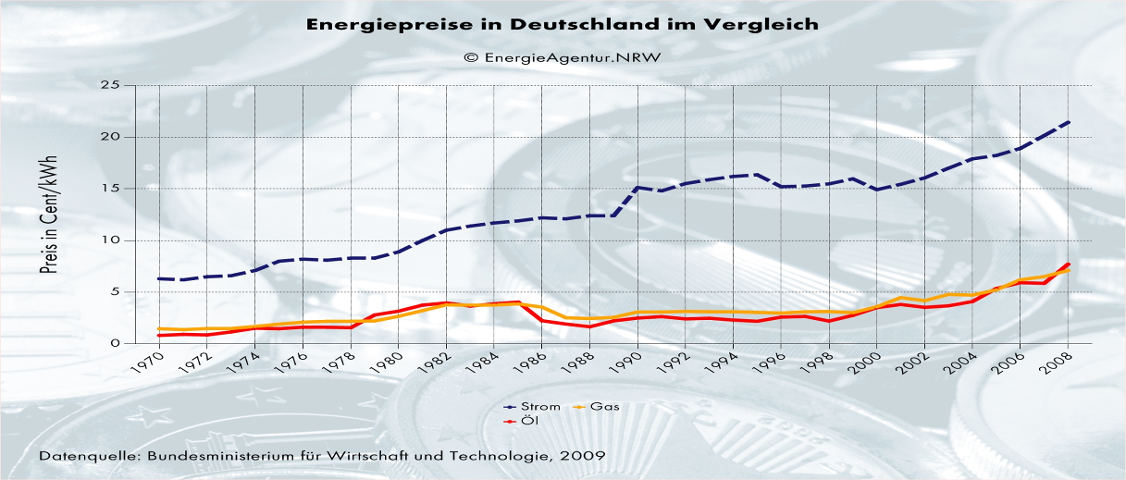
Figure 5: absolute energy price development electricity/oil/gas 1970-2008
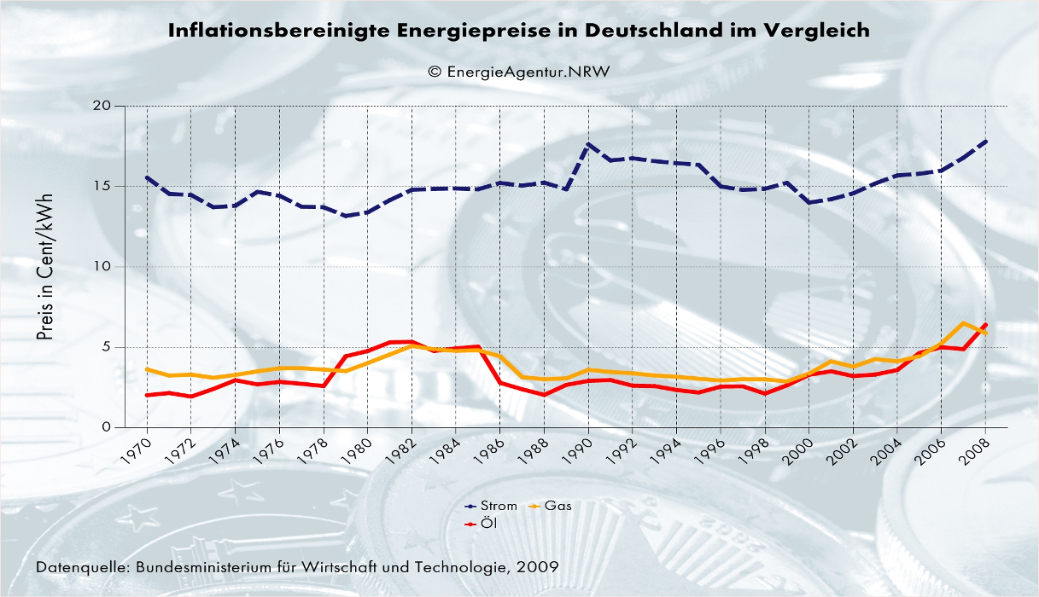
Figure 6: Energy price development electricity/oil/gas not taking into account inflation

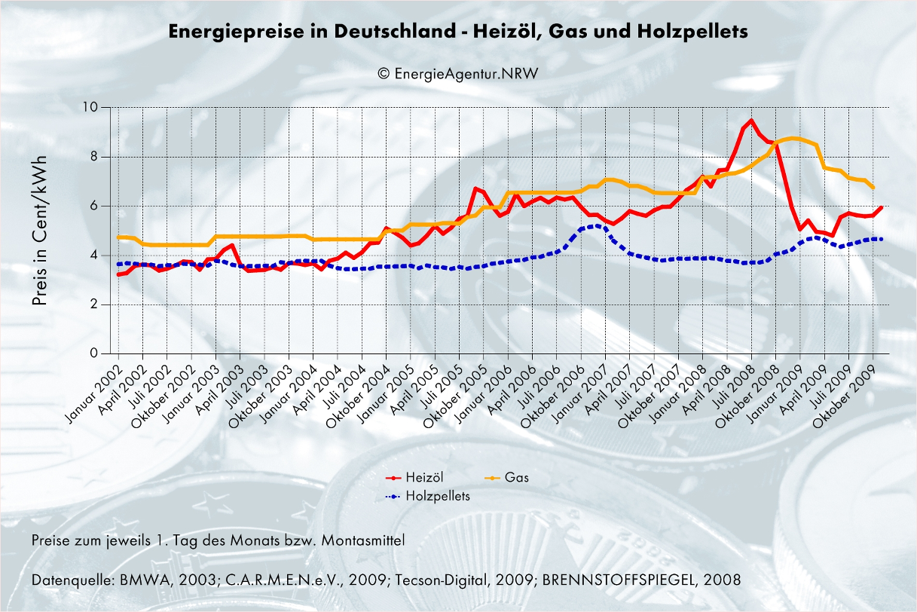
Figure 7: Energy price development oil (red)/gas (orange) compared to wood pellets (blue), 2002 - 2009

The comparison of the individual types of primary energy is carried out via the calorific value.

Table 1
Fuel oil | 10.0 | kWh/l
City gas | 4.5 | kWh/m³
Natural gas L | 9.0 | kWh/m³
Natural gas H | 10.5 | kWh/m³
Crushed coke | 8.0 | kWh/kg
Brown coal briquettes | 5.5 | kWh/kg
Brown coal coke | 8.0 | kWh/kg

The structure of a heating system consists of the following components
- Heat generation
- Heat transfer
- Heat consumption

Figure 8: Example of a single boiler system with domestic hot water storage, a direct heating circuit and two variable temperature heating circuits
The following abbreviations are used for the designation of the individual components.

Table 2
Pumps/valves |  | Temperature sensors
PHP | Primary heating pump | ET | External temperature sensor
HWP | Domestic hot water pump | BTS | Temperature sensor (boiler)
HWRP | Domestic hot water return pump | HWTS | Temperature sensor (domestic hot water)
SHP | Secondary heating pump | FTS | Temperature sensor (flow)
MV | Mixing valve | RTS | Temperature sensor (return)

Figure 9: Explanation of the abbreviations of Figure 8

Function and Type of Heating Components

Type of Heating
The type of heating is generally defined by the clients or planner.
- Related to the type of heating
- Low temperature set for all conventional heating (max. flow temperature of 75°C)
- Minimum temperature is used for underfloor heating and/or for heat pumps or solar panels (max. flow temperature of 50°C)
- Related to the generation of energy
- Type of primary energy
- Related to the number of energy sources
- Single boiler systems with/without hot water storage
- Multiple boiler systems with/without hot water storage
- Related to the heating elements

Table 3
Type | Area of application | Reaction | Comments | Type of control | Diagram
Hot water convector heating | Residential and functional buildings | Quick | Flow temp.: 35-70 °C | Continuous (0-10 V or 3-step) | 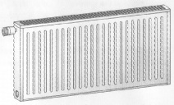
Underfloor heating | Residential and functional buildings | Slow (6-8h) | Flow temp.: 30-45 °C Additional fuse must be provided for protection against excessively high temperatures | Continuous (0-10 V or 3-step) | 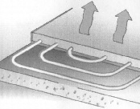
Hot water fan heating | Industrial plants | Quick | Flow temperature should be the same as the boiler temperature (≥ 60°C) | Single- and multi-level (2-step) | 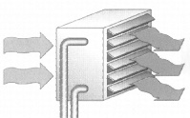
Electric convector | Rooms that are rarely used | Medium to slow | Can be basic heating | Single- and multi-level | 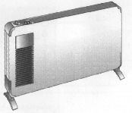
Electric fan heating | Rooms that are rarely used | Very quick | As additional heating | Single- and multi-level | 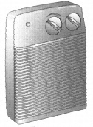
Night storage heating | Residential and functional buildings | Stores during the night, heats during the day | Various types | Single- and multi-level | 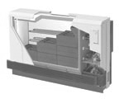
Figure 10: Heating types

It is possible to combine these heating types. The two-level heating (basic and additional heating) is an example of this. The basic level can be underfloor heating (slow) and the additional level can be hot water convector heating (quick). The reaction time during the warm-up stage is visibly shortened.

Heating Curve
When planning the heating system, the average minimum external temperature is used as a starting point. This temperature has been defined for all the locations in tables (e.g. Climate data for Germany) and is –14°C for Berlin for example. This means that the maximum flow temperature of the heating system is defined for Berlin at an external temperature of –14°C.
Table 4
Figure 11: Climate data of selected locations
The characteristics field of the heating curve is produced from the temperature value and the selected heating system (high, low or minimum temperature).
Designation of the heating system:
High temperature system: e.g. gravity heating (no longer for new systems according to the regulations)
Low temperature system: e.g. conventional heating system
Minimum temperature system: e.g. underfloor heating
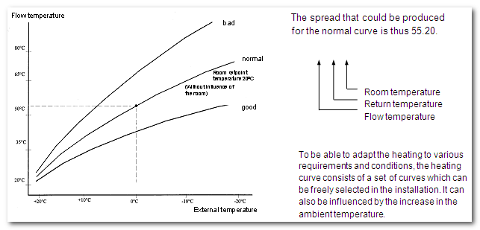
Figure 12: Heating curve with standard characteristics field
The lowest flow temperature is produced from the required room temperature when the heating is switched off in the summer. The highest flow temperature is determined by the type of heating system (low temperature, minimum temperature). In practice, the flow temperature in the lower range is increased slightly so that there is a temperature differential between the heater and the room. The following options are available (depending on the manufacturer) to adapt the heating curve to the conditions and usage of the building:
- Modification of the rate of rise ⇒ Modification of max. flow temperature
- Parallel adjustment ⇒ Modification of min. and max. flow temp.
- Ambient temperature ⇒ Increase in min. flow temperature
(constant flow temperature via a range of the external temperature)
Note: If values of the heating curve are required for the parameterisation of devices, they should be queried in writing from the heating engineer. These settings must be documented.
Figure 13: Modification of the rate of rise

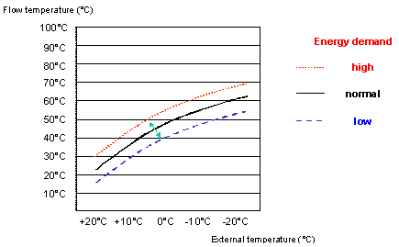
Figure 14: Adjustment of the heating curve

Figure 15: Ambient temperature

Capacity of the Heating Elements
Depending on the type of building (old building, new building, low-energy house…) and type of room, there are formulae and tables for producing the size or capacity of the heating elements.
Rule of thumb: 100-120 W per m² (room height of 2.60m, 2 external walls, no large window surface)
Special requirements should also be considered (e.g. rapid reaction time in the warm-up phase). Since specific setpoint temperatures are provided depending on the room usage, a table is produced with the heating capacity of the heaters.

Note: A reduction in the room temperature by 1°K causes an energy saving of 6%!
Figure 16: Example of the heating capacity of a duplex heater with an overall height of 500 mm (information from the manufacturer)

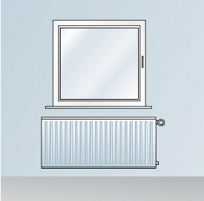 | To achieve a uniform distribution of heat in the room, the heater should be placed in the coldest place. This is under the window in most cases. The heater should at least be as wide as the window.  Note: All the pipes of the wiring system should be carefully and sufficiently insulated. In well-insulated buildings, pipes without sufficient insulation can already heat up the rooms (when the angle-type valve is closed). Closed-loop control is then no longer possible.  Caution: When using a room temperature controller, no additional unregulated heating systems may be located in the room! | 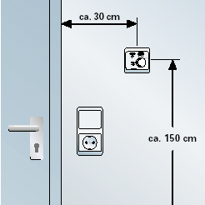
Figure 17: Installation of the heaters and temperature sensors
Heating Control
Various control systems are possible here. The necessary fail-safe circuits (e.g. for the boiler) are not taken into account as they must be guaranteed by the device manufacturers.
Let us look at typical circuits for a hot water system with a single energy source (compare with Diagram 3):
- Control options according to sensors
Table 6
Control option | Comment
Control dependent on room temperature | Disadvantage is that other rooms are dependent on the reference room
Individual room temperature control | Each room is controlled individually
Control dependent on external temperature | Disadvantage is that you have no information about the building temperature
External temperature and control value of room temperature | Advisable if other rooms are used like the reference room
External temperature and control via the spread | Heat requirement is detected
- Control options according to actuators
Table 7
Control option | Comment
Direct heating circuit | Heat requirement can only be regulated by switching the secondary heating pump on/off
Mixed circuit | Heat requirement can only be regulated by opening/closing the mixing valve and via the boiler circuit when there is a lack of heat
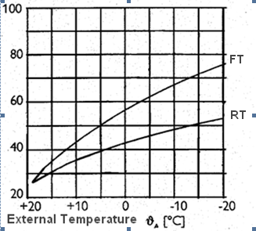
Figure 18: Heating curve for control via the spread
Example: Control via the spread (flow/return sensor)
When the installation has the correct layout, the setpoint room temperature is achieved if a return temperature of approx. 42°C is set e.g. at an external temperature of 0°C and a flow temperature of approx. 58°C. A deviation in the return temperature leads to an adjustment of the setpoint flow temperature.

The ideal type of control is achieved if the heat requirement of a room influences the operation of the heat source.
In a rented or owner-occupied flat, the user can achieve an energy saving using KNX individual room control without intervening in the heating system. No real problems arise. This is particularly suitable for installations with a central heat source.
It is advisable in detached houses to combine the KNX individual room control with the heating circuit and boiler control. In this case, only the heat that is needed is generated. It is then necessary to use boiler and mixed circuit controllers with KNX capability (heating manufacturers: Viessmann, Buderus, Stiebel-Eltron).

Commissioning the Heating System
The commissioning of the heating system is generally carried out by the heating engineer. Particular attention should be paid to the hydraulic adjustment of the system so that a control system can function without any problems.
Checking the function: All the heating elements must warm up to the same level when the valves are open.
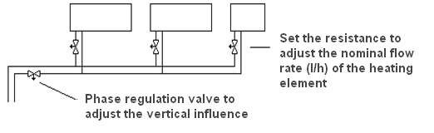
Figure 19: Hydraulic adjustment
Note: Even the best control system cannot adjust bad hydraulics.

Integration of the Heating into the Building Management System
If the heating should be integrated in the building management system (here specifically KNX), various solutions are available:
- Individual room control
- Heating system control (with and without influence from a boiler)
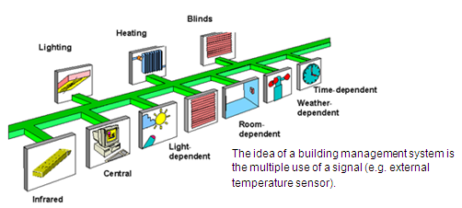
Figure 20: Integration of functions
The aim of this integration is increased comfort and effective use of energy.

The areas of application of the control systems are as follows:
Table 8
 | Individual room control | Heating systems without direct boiler connection | Heating systems with boiler control
Applications | No intervention necessary in the heating system, only changing valve elements | For installations with mixing valves in the heating circuits without direct access to the boiler via a KNX gateway | For installations with direct access to the boiler via KNX
Principle | Opening/closing of load circuits (rate regulation) | Mixing and control of load circuits, increase and reduction of flow temperature via analogue and/or digital input signals | Boiler control and mixing of load circuits
Cost reduction by decrease in energy consumption | Dependent on the room usage (little use – more savings)  No influence from the boiler | Considerable savings for installations with storage capacity as only the required energy is taken from the tank and thus long operating times | Large reduction as the complex installation is controlled at the optimum level  No heat requirement = boiler OFF
Cost of purchase | Low | Medium | High
Device example | Individual room thermostat, heating actuator + electrothermal drive or electromotive drive | Central control unit or via analogue/digital inputs or outputs in a PLC e.g. with proprietary sensor or sensor with KNX capability,  mixed circuit controller  (e.g. shutter actuator + mixing valve),  pump control  (e.g. switch actuator + pump)  0-10 V interface  (increase or reduce boiler temperature) | Manufacturer-specific gateways for the specific installation type

Individual Room Control
The individual room control system can be implemented relatively simply by the electrical installer as only a small amount of specialist knowledge of the heating industry is required.
It is possible to distinguish between 2 types of individual room control:
- 2-step control
- continuous control (3-step control)
In our examples, we are starting with hot water convector heating.

Principle of Individual Room Control
The control system consists of a room thermostat and a valve drive. The valve drive influences the heating valve of the heater or phase. The heating system must only have a direct heating circuit. There should also be an option for displaying the temperature.
A room thermostat measures the current temperature (current room temperature) and compares it with the predefined setpoint. The control value is calculated (e.g. as a percentage or ON/OFF commands) from the differential of the current and setpoint temperature using the set control algorithm. The control value indicates the heating or cooling capacity that should be supplied to the system.
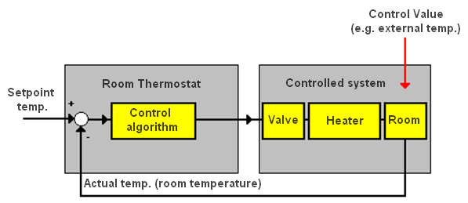
Figure 21: Control system

Types of Control

Two-step Control
This is the simplest type of control. A control value is not calculated. The controller switches on or off. The room temperature oscillates around the setpoint temperature (hysteresis value).
Example: Setpoint 30 °C, hysteresis 1 Heating switches on at 29 °C and switches off at 31 °C.
The continually fluctuating room temperature is a disadvantage of this extremely simple control system. This leads to an overshooting of the temperature because the valve drive requires approx. 3 minutes until it is fully closed. The heater also continues to supply heat to the room even once the water has stopped flowing.
When the heating is switched on, the system behaves as if it has a time delay. Slow heating or cooling systems cannot be controlled via two-step control as it can lead to an extreme overshoot and therefore a considerable loss of comfort.
Figure 22: Measuring diagram of individual room controller in two-step application (here setpoint temperature and negative hysteresis)
Room temperature – heating actuator – thermoelectric controller (or switch actuator) – valve drive. For pulse width modulation and two-step control, the room thermostat triggers a switch actuator which in turn opens or closes the valve drive. This combination is more cost-effective than the continuous valve drive. If there are several heaters in a room, this combination has even multiple cost benefits compared to continuous control as several thermoelectric valve drives can be triggered by one actuator channel.

PI Control
A control algorithm is used which creates the control value. An attempt is made to adapt the room temperature to the setpoint temperature without causing any oscillation.
Figure 23: Measuring diagram of an individual room controller with switching PI application

Components of Individual Room Control

Room Thermostat
The intelligent element in this system is the room thermostat. Room thermostats mostly have 4 operating modes, which differentiate between 4 temperature levels in heating and cooling mode. Three of the four operating modes are part of the normal operating mode: in comfort mode, the highest temperature level (e.g. 21 °C in the living room) is selected for heating and the lowest temperature level for cooling (e.g. 24 °C). In standby mode, the setpoint temperature is slightly reduced for heating (e.g. to 19 °C). If the thermostat is in cooling mode, the setpoint temperature is raised accordingly (e.g. to 26 °C). This operating mode has been conceived for short absences. The room can be quickly heated up (or cooled down) according to the needs. During night operation (also referred to as economy or energy saving mode), a further reduction (adjustable value) is done for the heating (or an increase for cooling). In a fourth operating mode (also referred to as frost/heat protection), the setpoint temperature is reduced to e.g. 7 °C if a window is opened. It is not advisable to switch off the heating system completely as the pipes for the heating could freeze in the winter. The protection mode has the highest priority for room thermostats i.e. if frost mode is active, it is not possible to switch to another operating mode. The protection mode can be caused by: opening of a window or setting the thermostat in permanent protection mode manually or via a time switch. In order to switch back to normal operating mode, the protection mode must be deactivated (e.g. closing of the window).

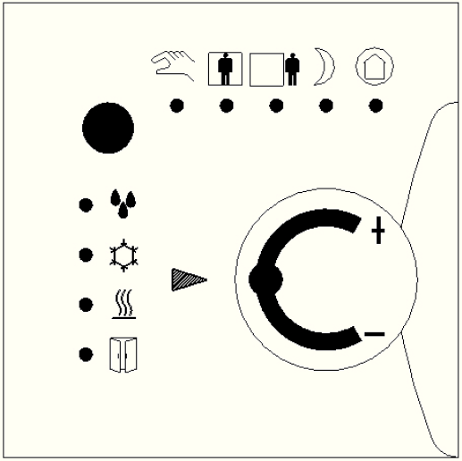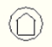
Comfort
Pre-Comfort
Economy
Building Protection
Manual operating mode
Dew Point Alarm
Cooling active
Heating active
Open Window
Multifunctional
button
Adjustment Set Point
Figure 24: Standard Heating Regulator/Operating and Indication elements
Historically various functional blocks and data point types were developed for the adjustment of the operating mode. While in the beginning three of four individual one bit objects were used, the DPT 20.102 has now become quite common, as the 5 different operating options can be set by one group address (8 bit object). The 8 bit mode is moreover easier to set, as it only has two priorities (high = protection mode; low = normal mode), compared to the 3 times 1 bit modes. In normal mode, all 3 settings have the same priority and can be changed by one single telegram.
Table 9: Table of priorities in the 3 times 1 bit functional block (x = setting has no reaction)
 |  | KNX objects
Operating mode | Frost protection | Night reduction | Comfort
Frost/heat protection | 1 | x | x
Comfort | 0 | x | 1
Night | 0 | 1 | 0
Standby | 0 | 0 | 0

Table 10: Table of priorities in 8 bit mode (DPT 20.102)
Operating Mode | Value of KNX Object | Remark
Building Protection | 4 | Higher prioritized than 0-3
Economy | 3
Precomfort | 2
Comfort | 1
Automatic | 0 | In this setting, the thermostat can be controlled e.g. by a separate clock object.
Figure 25: Room thermostat and the various mode settings
The room thermostat can be controlled externally (via KNX) or locally (multi-functional button) and in this way set into the different operating modes. The current mode is indicated by LEDs or symbols.
The exact manual operation is manufacturer specific as left open in the KNX Standard.
Room thermostats sometimes have extensive parameters: they can for instance be set as 2-step or continuous controllers.

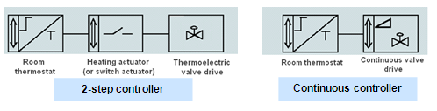

Figure 26: Controlled systems for 2-step and continuous controller
2-step heating is frequently used in connection with underfloor heating. Underfloor heating is a very slow system. It takes a long time to heat up a room (up to several hours). To shorten the warming-up phase, a rapid heating system (e.g. hot water convector heating) is used in addition.

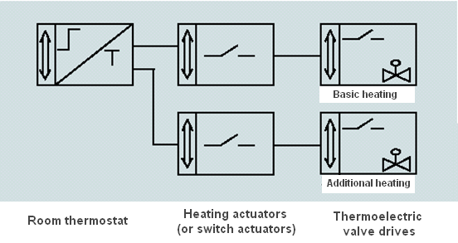

Figure 27: Controlled system for 2-step heating
The cooling function has a second operating mode. It is used in connection with the heating to achieve a constant room temperature. When using the cooling mode, the occurrence of condensed water on the cooling surfaces (dew point) should be noted.
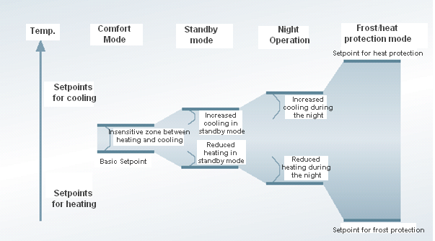
Figure 28: Simplified representation of the setpoints for heating and cooling
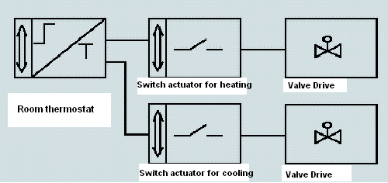
Figure 29: Controlled system for heating and cooling

Actuator – Variant 1 (Switch Actuator)
A switch or heating actuator can be used as an actuator in connection with one/several thermoelectric valve drives. A cost-effective hardware variant is thereby produced if more than one hot water convector per room needs to be switched.
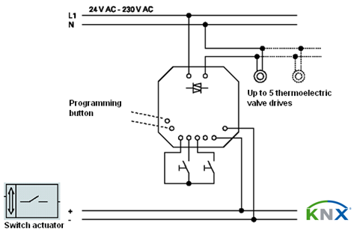
Figure 30: Example of a heating actuator

Note: In the case of low supply voltages (e.g. 24 V), the reaction times of the thermoelectric elements and their respective cable lengths must be observed.

Switching applications must be selected for the room thermostat. The operating time of the thermoelectric drive should be noted for the cyclic time of the switching control value.

Actuator – Variant 2 (Continuous Controller)
As final control element, a linear, motor operated KNX valve is used. In the room thermostat, a continuous application needs to be selected.
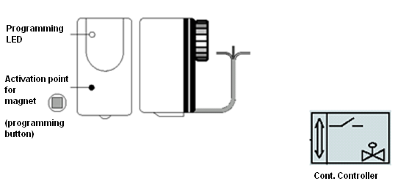
Figure 31: Block diagram of a linear valve

Table 11: Advantages and disadvantages of continuous and thermoelectric valve drives
Valve drive | Advantage | Disadvantage
Continuous | Connection only via the bus  Status display or control value can be read in detail  Very precise control | Only one valve can be controlled  Higher current loading on bus line  High costs
Thermoelectric | Status display  Low costs  No high bus load  Several valves per actuator channel  Noise-free with electronic actuator | Additional power supply required  Higher installation costs

Further Elements
The basic elements of individual room control are the room thermostat and the actuator as described above. To be able to improve the effectiveness of the circuit, further elements can be integrated.

Table 12
Element | Effect (for example)
Time switch | Timed control of the operating modes of the controller
Window contacts via binary input or push button interface | Control of frost protection mode
Display | Display of temperature values and selection of new setpoint temperature
PIR (motion detector) | Control of comfort mode
Logic | Logical connection of input signals

KNX Connection to Heating or Cooling Systems

Connection via DDC Gateway or Conventional Actuators
In large functional buildings, a so-called management level should be used.
This management level checks and visualises all the processes in the building and links various bus systems together if required. Apart from KNX, DDC systems (Direct Digital Control), special security systems, lift control and entry systems can also be used for example.
These systems then interface the management level via gateways (linking elements between the various bus systems).
The management system preselects e.g. the basic setpoint temperature for the room thermostat. This information is then converted into a KNX telegram by the gateway. It may be important for the boiler system (e.g. controlled via DDC) to receive information about the current and setpoint temperatures or the control values of the individual rooms. The gateways are then generally made available when creating the management level and configured so that only the information flow must be matched.
Alternatively, the connection can be implemented via analogue actuators. The temperature is then divided into sections to form threshold values. These values are then issued in analogue voltage. A digital output is frequently integrated in parallel. This output gives a command to the heating system as to whether heating or cooling is required, depending on the information provided by the room thermostat. If a “1” is set here for example, the digital output is enabled and the heating system starts to heat. The temperature for heating is derived from the voltage issued by the analogue actuator.

Digital and analogue inputs
and
outputs
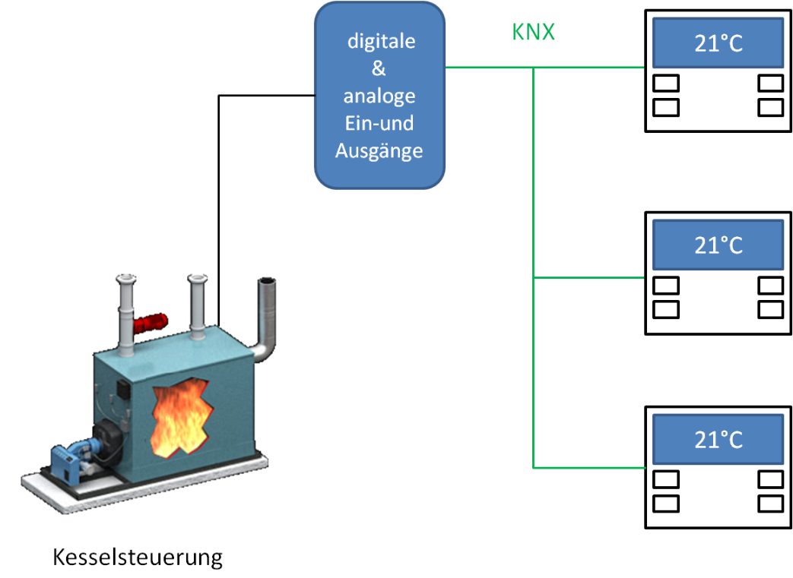
Boiler control
Figure 32: Conventional connection via actuator and sensor technology

Connection via a KNX Gateway
The most elegant solution compared to the coupling of DDC and KNX is a universal implementation of building automation with only one bus technology, that of KNX. For this purpose, controller components in bus technology or with bus interface are offered by various heating manufacturers. These solutions have the benefit of being standard applications. This type of connection is widely used in functional buildings or private residences. Individual room control with transfer of the setpoint value (1 byte) to the heating/boiler control or a request for heating (1 bit) is used in this case.

Circulating pump 1 bit
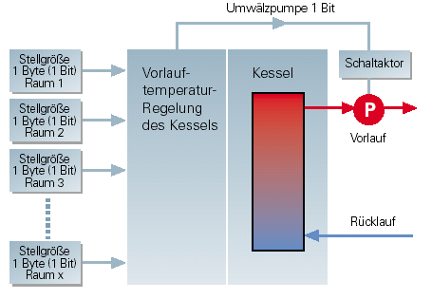

Boiler

Flow temperature

Boiler control
Return
Flow
Control value
1 byte (1 bit)
Room x
Control value
1 byte (1 bit)
Room 2
Control value
1 byte (1 bit)
Room 2
Switch act.
Control value
1 byte (1 bit)
Room 1
Figure 33: Requirement for individual room control

The connection can be implemented for example via an external interface which translates the internal, manufacturer-specific bus into KNX via a gateway. This is not an unusual method as a considerable number of HVAC manufacturers allow their installations to communicate via proprietary bus systems.
A more widespread solution in this market is internal plug-in cards which function as an extension module in the respective installation and make a connection available to KNX. In both versions, the heating is integrated into ETS as a device.

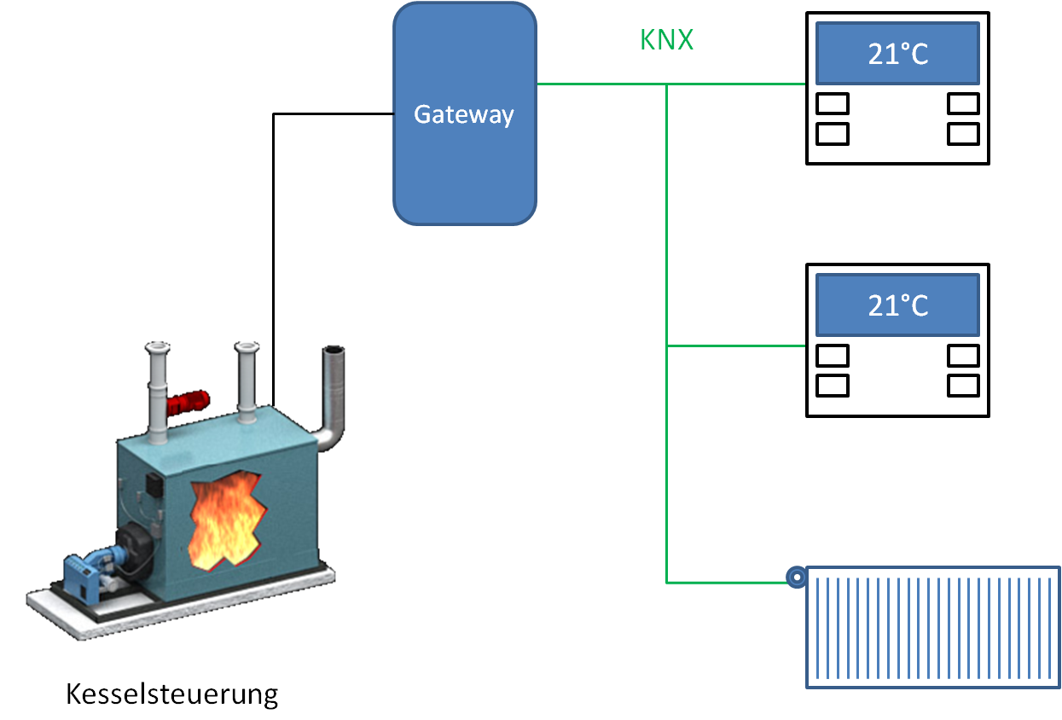
Boiler control
Figure 34: Connection via a KNX gateway

Connection via an External Heating Controller
A further approach is the option of controlling the heating via a central unit. There are two philosophies available on the market. One option is to connect room temperature sensors, control valves etc. to the control unit via KNX. This means that a KNX room thermostat or a temperature sensor sends its information to the control unit where it is processed and a reaction is triggered. In the case of heating control, a signal can be sent to the control valves and the flow temperature of the boiler can also be influenced via an analogue and/or digital output. It is also possible to switch the circulating pumps on or off as well as opening or closing mixing valves. It is also possible to control different heating circuits and to integrate temperature sensors for flow and return.

Analogue +
digital I/O
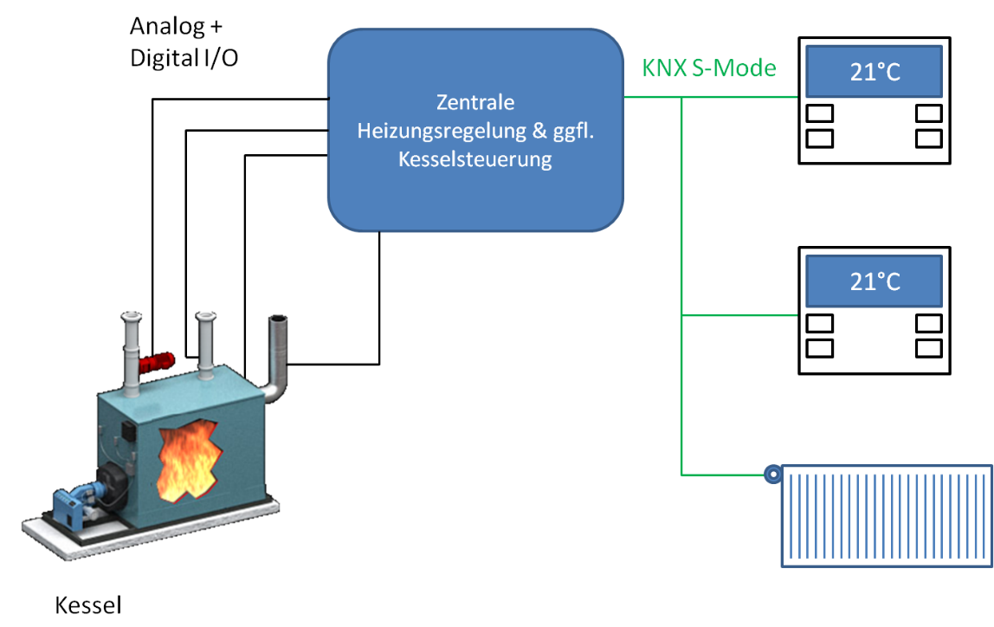

Central heating control and boiler control if applicable
KNX S mode
Boiler
Figure 35: Connection via an external central controller

An alternative solution is the connection of manufacturer-specific sensors to the control unit which are not configured or commissioned via ETS. They can use e.g. the specified KNX transfer media such as TP or RF. The commissioning process that is used in this case is called LTE mode (Logical Tag Extended). This principle functions without using a PC and thus requires no special KNX knowledge and is therefore also suitable for HVAC installers or remote PC installers. For commissioning purposes, only the devices which should communicate with each other are grouped together in a logical connection or in zones via the hardware. After the programming, they then automatically exchange the date and formats which have already been defined by the manufacturer. In most cases, the function is assigned as device-specific or can be set e.g. via on-screen menus and the control mode can be modified. The communication in the direction of the boiler behaves as previously described via digital and/or analogue outputs etc. Instead of the LTE mode, the devices can also be configured and programmed as usual via the S mode and ETS.

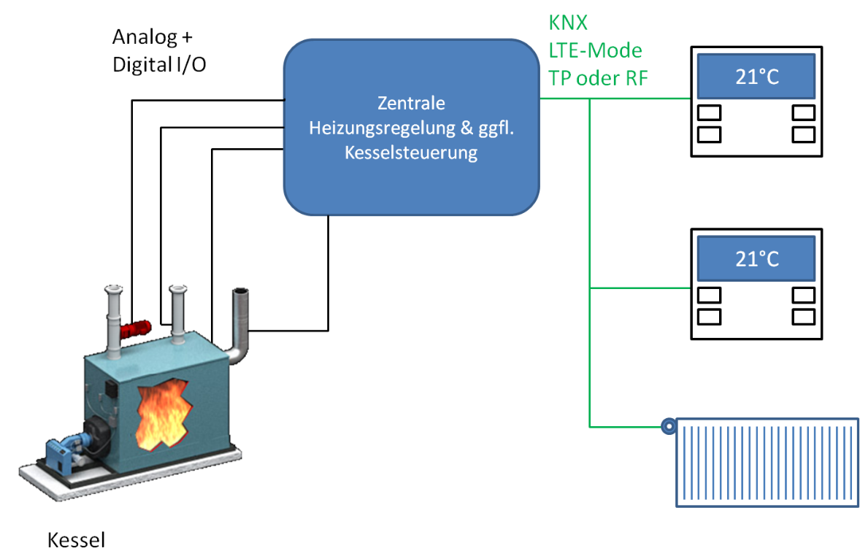
Boiler
Analogue +
digital I/O
KNX LTE mode
TP or RF

Central heating control and boiler control if applicable
Figure 36: Connection via an external central controller using LTE mode

Fan Coil

Introduction
The term ‘fan coil’ implies a blower convector which is typically used for cooling rooms. There are also areas of application in which the fan coil unit is also used for heating or ventilation. Conventionally, a fan coil unit consists of a heater or cooling battery (coil) and a fan. The cooling or heating capacity required in the respective room is however produced centrally. It is then routed through the building via pipe systems and accessed by each unit when required.

In general, one fan coil unit is installed per room and takes over the required temperature control. One benefit of this technology is the rapid availability of heat energy or cooling capacity. This technology is therefore widespread in hotels or office buildings for example. It is controlled via a room thermostat using the control processes that have already been described.

Fan coil convectors are available in different styles e.g. as wall-mounted or ceiling-mounted devices as well as for insertion in floor boxes.

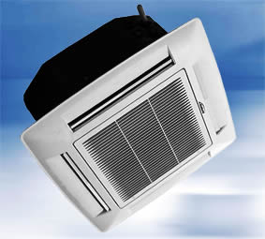
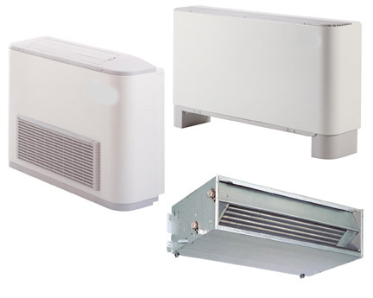

Figure 37: Fan coil styles: Source www.tca.ch, www.wolf-heiztechnik.ch

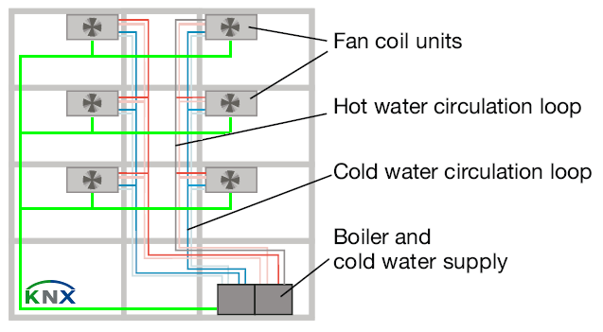

Fan coil units

Hot water circulation pipe

Cold water circulation pipe

Heat generator and cold water supply
Figure 38: Fan coil schematic

Technical Structure
The basis of the system is that a heated or cooled transfer medium (mostly water) is routed through a battery. Behind this battery is a fan which blows the air through the battery and then directs it into the room in order to warm it up or cool it down. While the air flows through the battery (batteries), the appropriate temperature is applied.

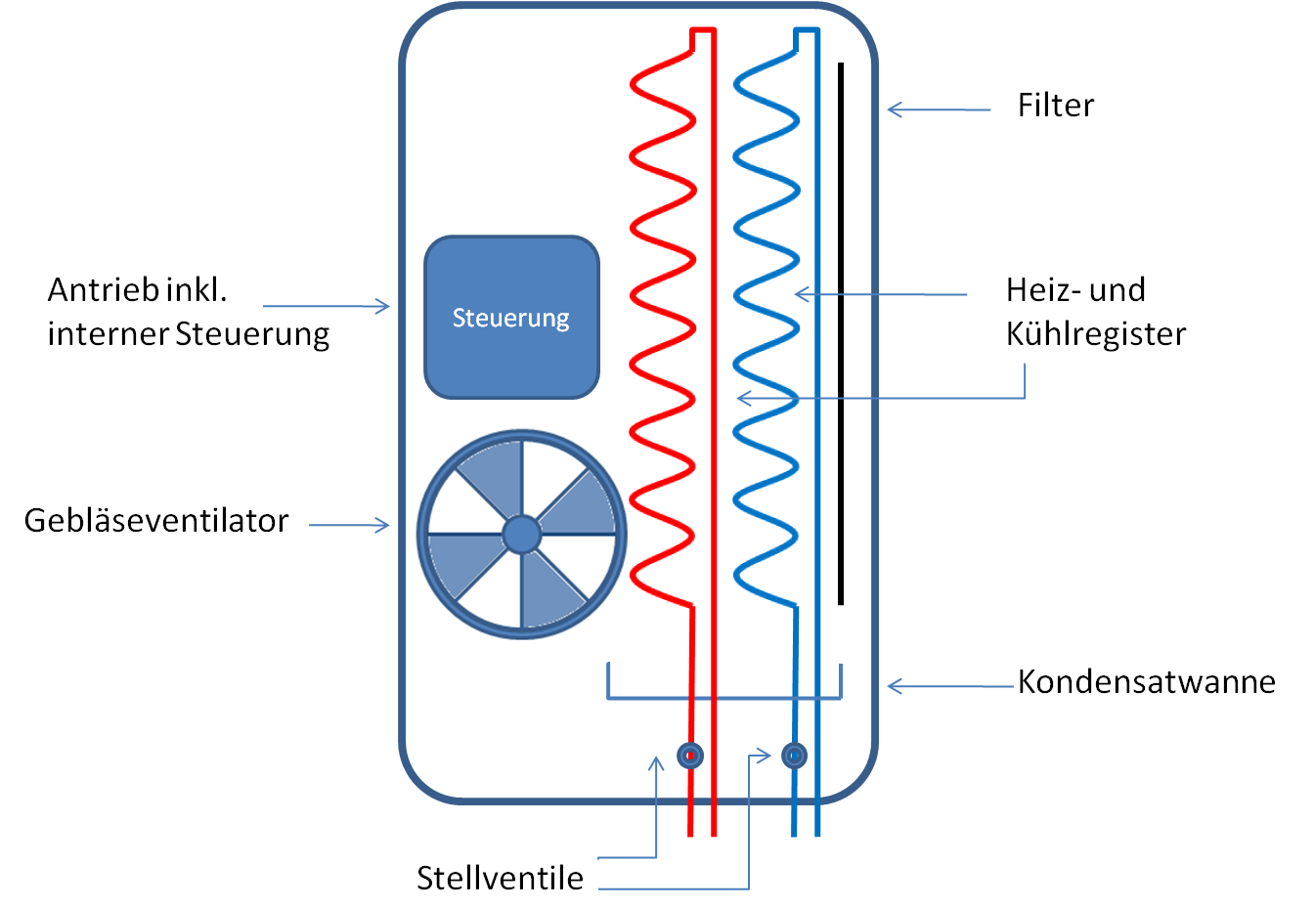

Controller
Drive incl. internal controller
Blower
Control valves
Heating and cooling battery
Condensate tray
Figure 39: Structure of a fan coil unit
In addition to the basic components, there is generally a collection container for any condensed water that may occur in the fan coil unit (caused by cooling) or a filter to remove any existing particles or pollutants from the air.

Design Variants
Fan coil units are available in different versions. Their mode of operation is shown below:

4-pipe system
If a room should be cooled, the control valve on the cooling circuit (blue) is opened and the carrier medium can circulate through the battery. The fan starts running in parallel and begins to blow air through the battery. The air is then let in via the corresponding temperature exchange and directed into the room.

The system behaves in a similar way in heating mode. The “cooling” control valve is closed and the “heating” control valve is opened. The other medium then circulates through the heater battery (red) and the air that is flowing through is heated.

There are therefore two fully independent circuits.

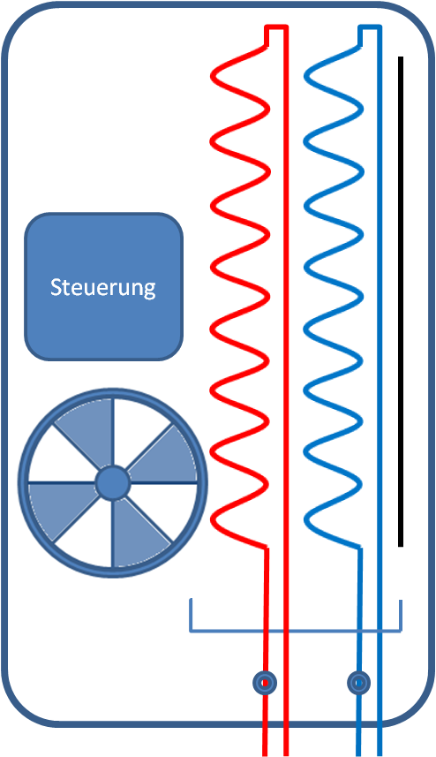

Controller
Figure 40: Structure of the 4-pipe FCU version

3-pipe system

In principle, the 3-pipe system functions in the same way as the 4-pipe system. The most basic difference is the recirculation of the two transfer media via one pipe. The supply of the two batteries for heating and cooling is separate as described previously.

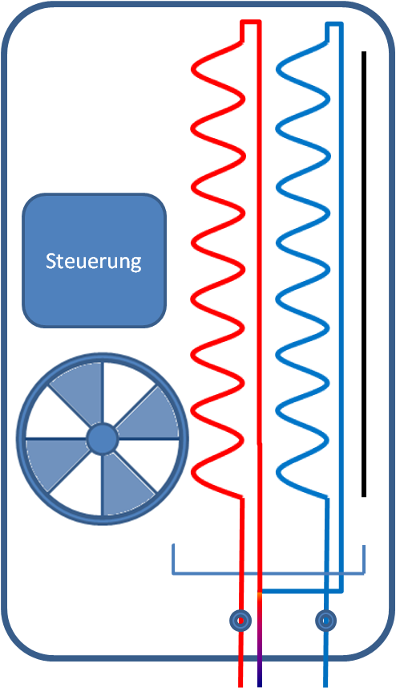

Controller
Figure 41: Structure of the 3-pipe FCU version

2-pipe system

The basic structure of a 2-pipe system is the same as the other two variants. We still require a battery for the medium to circulate through and a fan to let the air flow through the battery. Only one battery however is used in this variant. The heated or cooled medium is conducted through this battery and the air is thus warmed or cooled. Depending on the season, the fan coil unit can be used for heating or cooling.

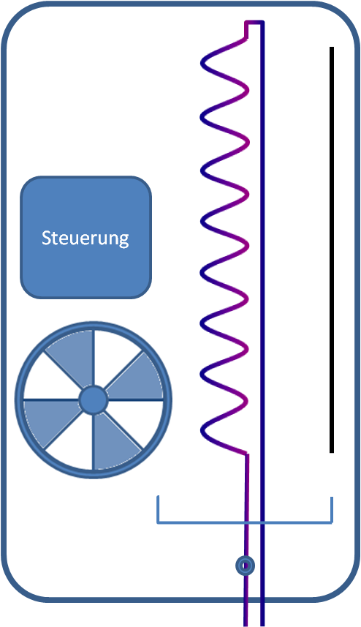

Controller
Figure 42: Structure of the 2-pipe FCU version

There is a further modification of this variant which is found more frequently on the market with an electrical booster heater integrated in the fan coil unit. Only the cooled medium then circulates through the battery and the air is heated via the heating system.

KNX Integration
As fan coil units usually do not have an integrated KNX interface, each unit requires a fan coil actuator for activation. These actuators have different connection options which enable the individual components to be linked.
This includes e.g. the triggering of the fan which can be switched on at different speeds and the speed can also be increased. In this case, the actuator can adopt the function of a conventional step switch. Alternatively, several actuators have the option of activating the fan continuously.

The fan(s) can also be electrothermal or electromotive. They can be triggered via 2-step control or via switching or continuous PI control. The majority of actuators have a further load contact as mentioned in the 2-pipe variant which enables an electric booster heater to be connected. Binary inputs are also integrated in the actuator to monitor the condensate tray or to query a window contact for example.

If the room thermostat establishes that the current measured temperature in the room is too high or too low based on its setpoint temperature, it sends a command to the fan coil unit. The fan coil actuator then decides how the required valve is moved (opened or closed) based on the telegram/sent control value and at which speed the fan is switched.

Fans
The speed control of the connected fan can be set in two different ways in the parameters depending on its technical design.
In the example here, the fan has three speeds. If the fan requires a coil for each speed, it must be connected according to the following model.

Table 13: Fan coil model with a coil for each speed
Fan | Actuator | Output 1 | Output 2 | Output 3
OFF |  | 0 | 0 | 0
Speed 1 |  | 1 | 0 | 0
Speed 2 |  | 0 | 1 | 0
Speed 3 |  | 0 | 0 | 1

The actuator will never switch on two speeds at the same time to prevent the fan being damaged. An adjustable delay between the speeds is automatically maintained.

If the fan should have a coil, the model that was previously described is not applied but the fan is switched on gradually.

Table 14: Fan coil model with one coil all speeds
Fan | Actuator | Output 1 | Output 2 | Output 3
OFF |  | 0 | 0 | 0
Speed 1 |  | 1 | 0 | 0
Speed 2 |  | 1 | 1 | 0
Speed 3 |  | 1 | 1 | 1

Operating Modes
Fan coil controllers can be operated in different operating modes in the same way as described for individual room control for the other variants. These modes include:

- Comfort mode
- Standby mode
- Night reduction
- Frost/heat protection

The toggling between the operating modes is implemented via communication objects. As already seen in individual room control, a basic temperature can be set with an insensitive zone between heating and cooling. Reference is also made to the temperature increase or reduction.

Sensors
Sensors such as presence detectors, time switches, room thermostats, humidity sensors, window contacts or sensors for condensed water as well as binary inputs which influence the control can either communicate via KNX directly with the fan coil actuator via group addresses or alternatively sensors can be connected directly to the actuator. This depends on the respective device i.e. whether it is just an actuator or an integrated control unit.

Integrating air conditioning systems

Introduction

Because of the use of KNX across different applications and its high level of integration, one needs to certainly also familiarize oneself with the connection of air conditioners to KNX systems. This is especially relevant in climate zones where temperatures are higher and heating is less of an issue. However, the need for air conditioning may also arise in glass buildings, where room temperatures can increase significantly during the summer. In buildings that house both heating and air conditioning systems, you often find that these systems are managed separately, sometimes even by different people. In order to avoid conflicting approaches in such a situation, it is highly useful to integrate all components into a KNX system. By doing so, you can avoid that the air conditioning system cools while the heating at the same time tries to keep the temperature level constant by simultaneously heating the room.

Technical Design
Fundamentally speaking, an air conditioning system is made up of various components. Basically, it consists of a cooling medium that circulates through a circuit in varying aggregate states. A compressor will draw in the gaseous medium and liquefy it in the condenser. The liquefaction of the cooling medium will result in the creation of heat, which is released to the environment. This heat will have to be evacuated, either with the help of a ventilator or through the process of convection. Then the liquid medium is passed through a valve to the evaporator. Here the aggregate state will again change, this time to a gaseous state. During this process, the medium will again extract the temperature from the surrounding air. This will result in a cooling of the temperature, which will then be pumped into the room via a ventilation system, as exemplified below.

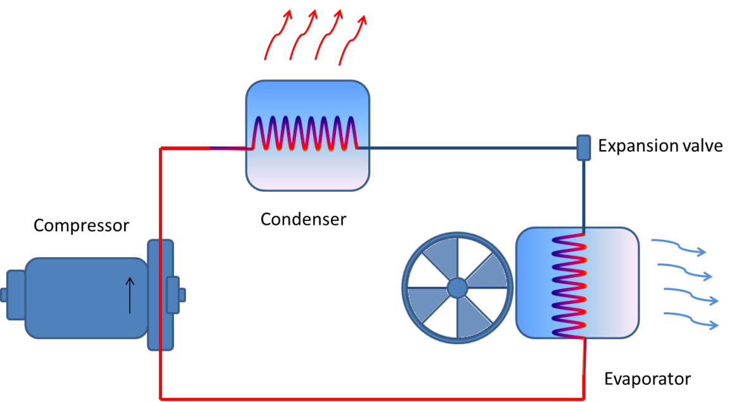
Figure 43: Technical design of an air conditioner

Integration in KNX
As it is often the case in the world of KNX, the market offers different integration approaches. The model and make of the air conditioner are decisive here. Either the air conditioner communicates via a proprietary protocol or via a common interoperable automation standard: this will determine the layout of the gateway towards KNX. A further differentiating factor is the type of communication. This can either be unidirectional or bidirectional.

Proprietary Protocol
In case the air conditioner is equipped with a proprietary interface (depending on make), the integration will be done via a purpose built gateway. This will be necessary because the structure of the telegram and its message is not published and consequently is not available. Without this background information it will be very difficult or even impossible to realize the integration. The gateway is therefore shipped with an application including communication objects, parameter settings, etc.

Gateway to an open Automation Protocol

Should the air conditioner, however, be equipped with an open standard (i.e. BACnet) there is the possibility to integrate it via a universal gateway. In this way, the gateway constitutes a device in the KNX system. Furthermore, an application is needed in order to connect the components of the different automation systems. In this way you can realize an integration of the KNX side via the ETS and the classic mechanisms (i.e. parameterization, implementation, etc.). Besides this, you will usually need a further program with which the non-KNX side can be parameterized and programmed.

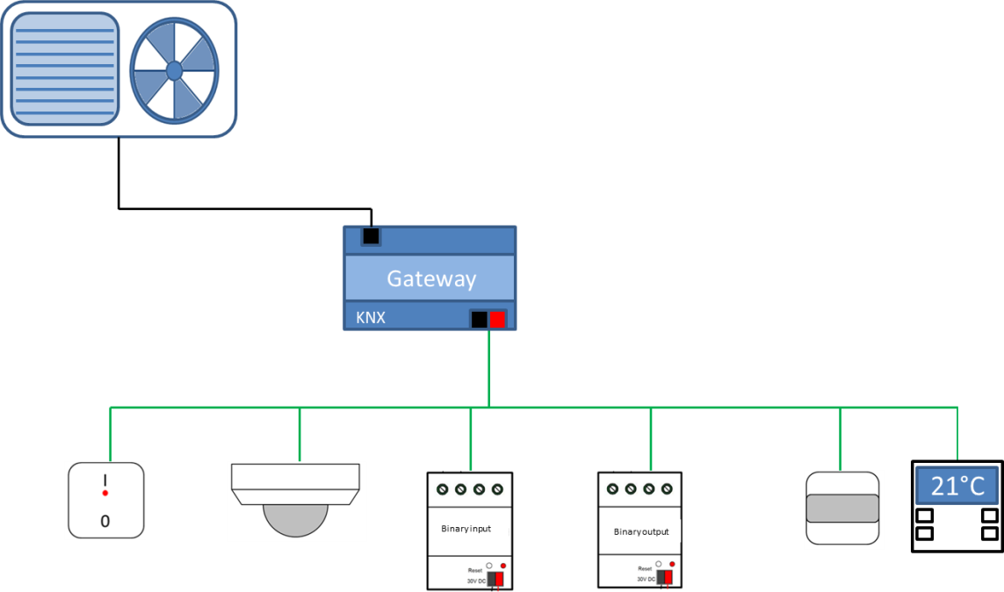
Figure 44: Integration of Air conditioner via Gateway

As air conditioners currently on the market are not always natively equipped with a KNX interface, it is useful to consider the used type of communication.

    - Unidirectional Communication

With unidirectional communication you only have the option of communicating to the air conditioner. This solution does not allow an information flow back towards KNX. Consequently, you have the possibility of setting the temperature or the number of rotations of your fan, however you will not receive any confirmation of this action on KNX.

    - Bidirectional Communication

In the case of bidirectional communication, you can both send and receive telegrams from either direction. Thus you will also have the possibility to influence the performance, that is to say the actual operation of the air conditioner, as well as the possibility to receive feedback from the device. This type of integration has the advantage of gathering, processing and logging process and operation information centrally. This can even go so far as registering error indications, which can in turn lead to a consecutive reaction or the sending of an error message.

The implementation of the integration can be realized with the following media:

- Infrared
- Twisted Pair
- Ethernet/IP
- RS232
- RS485
- …

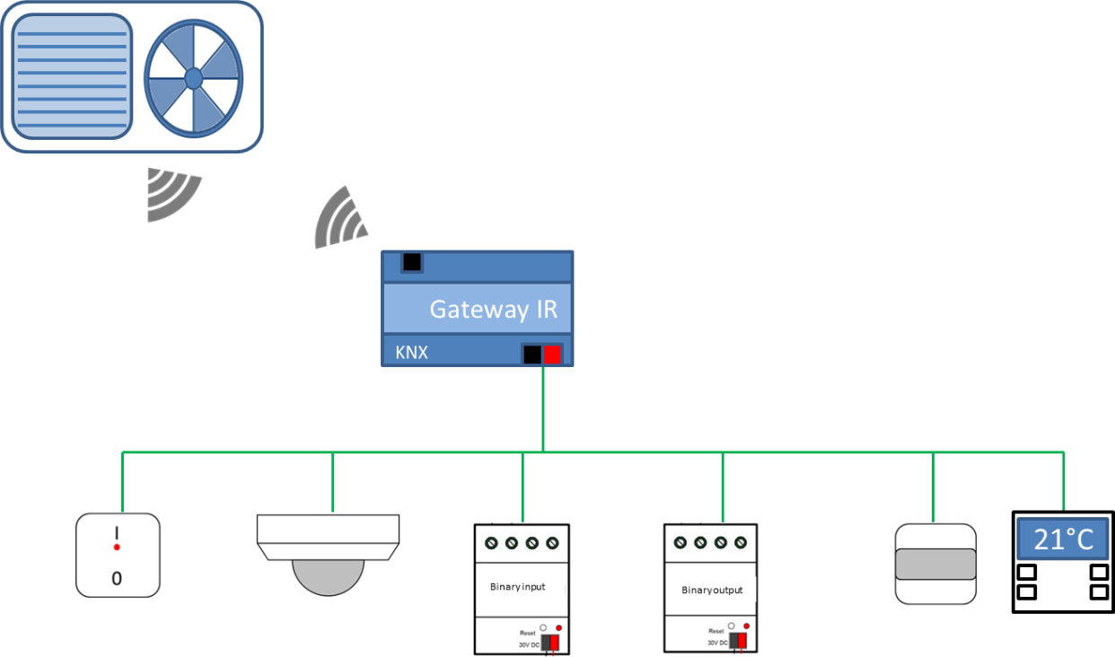
Figure 45: Integration of Air Conditioner via IR-Gateway

Regulation cf. § 2.1.3.1
The control of an air conditioner follows the philosophy that is applied for room temperature regulation as already explained above (cf. §2.1.3.1). Consequently, it is also possible to set the operating mode via an object (DPT 20.105). In order to establish the regulation you will need, as seen previously, two components: a room temperature sensor with a regulator and a valve. The valve is in this case the interface to the air conditioner.
You can both regulate and monitor the temperature with the room temperature regulator via KNX. The room temperature regulator will in turn decide, based on a comparison between the set and actual temperature, whether to heat or whether to cool. For example, this would mean that if your target temperature is set to 19°C and the actual temperature is 23°C, the valve opening of the air conditioner would be increased, while the valve opening of the heating system (if applicable) would be decreased. The room temperature regulator thus automatically regulates the conditioning in both directions. There is also the possibility of switching between the two directions via a communication object, linked to a switch of a push-button, a clock timer or similar.

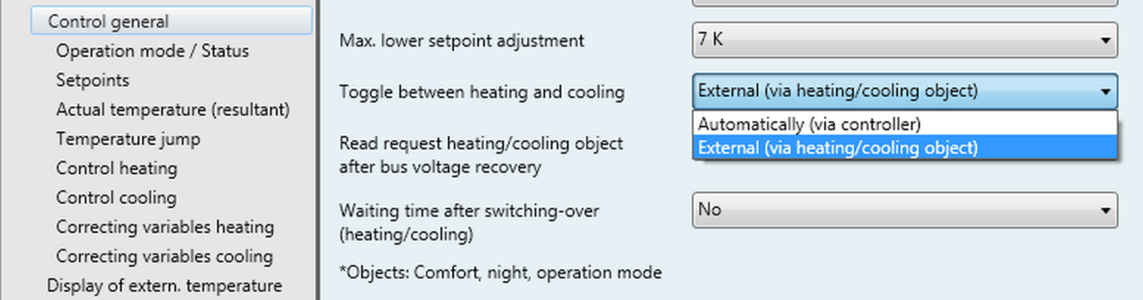
Figure 46: Parameter Switching between Heating/Cooling

Alternatively, the control mechanism can also be centralized. In this case, a KNX control mechanism will be integrated, which takes over the calculation of the variables, as well as the actual opening and closing of the valves. This structure can be composed of one central and several subunits/centrals. The outputs and functions are implemented in the same way as for the integration of a boiler (cf. § 2.2.3), with the difference that the variables, switch commands, etc. activate a cooling process rather than a heating process.

Certain air conditioners are equipped with an integrated temperature regulator. In such cases, the mode can be changed externally via KNX. This solution needs the following information: Heating, cooling, etc. and the current actual temperature. Via KNX you can also regulate the fan speed, turn on the device, switch on the motion of the slats or send an error message. The appropriate function can be triggered by different sensors. The only condition for this is either to have the same KNX DPT-type or a conversion via a logic function.
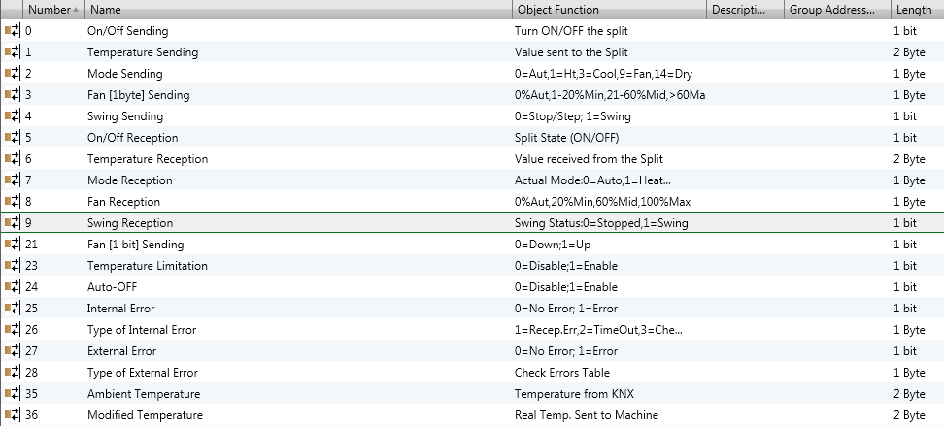
Figure 47: Communication objects KNX Gateway

Ventilation

Introduction
Due to increased requirements in terms of energy saving, new buildings have amongst others become more and more air tight. This is done to minimize the loss of energy. When buildings are built in this way, it becomes necessary to pay more attention to their controlled aeration and de-aeration. Owing to the way the building is constructed, natural ventilation is minimal, if not non-existent. This in turn requires paying special attention to air quality. If this is disregarded it can lead to subsequent damage to humans and buildings, in particular through the spreading of fungi, spores and bacteria. Through the use of an automated ventilation system one can set a number of goals, including not exceeding a set CO²-emission value, humidity, temperature, etc.

Technical Design
In principle, a ventilation system can be configured in different ways. One possibility is an actively controlled aeration and de-aeration, possibly configured with waste heat recovery and bypass. In such a case, fresh air will be blown into the building/rooms via a central ventilation station. On the other hand, the “used” air would, in turn, be extracted and evacuated. Should the ventilation system be equipped with waste heat recovery, a cross-flow heat exchanger would extract the temperature from the evacuated air and use it in order to condition the “fresh” air. This would in turn lower energy consumption. With such a system the internal energy surplus generated through lighting, computers, etc. can be reused for heating purposes.
As this process is intended to keep the heat in the building as long as possible it is mainly used during colder periods. There is always the possibility that the recuperated energy (incl. internal energy surplus) is insufficient to meet the heating demand. In such a case, the temperature can be increased via a heat pump or an electric reheating damper. However, during the summer, when evacuating the heat the recuperation procedure will have to be bypassed. A bypass will be installed in the system in order to achieve this.
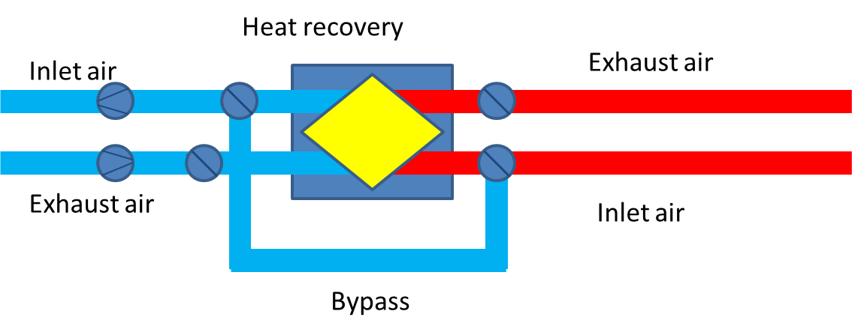
Figure 48: Air Conditioner with Waste Heat Recovery

In warmer climates, the system can be conceived alternatively so that the introduced cooling energy remains in the building as long as possible. Here the afore-mentioned principle is exactly reversed. Indeed, here there is also a central unit that takes over the controlled aeration and de-aeration in order to achieve the desired air quality or room temperature. However, the “used” air together with the stored cooling energy (and if applicable, the humidity) will condition the incoming air via a recuperation mechanism. During this process the warmer incoming air will be conditioned via the difference with the colder outflowing air and consequently cool down. If, for example, an incoming air temperature of 30°C is merged with an outflowing temperature of 21°C, the incoming air temperature can be decreased (i.e. to 25°C ). With the incoming air temperature now reduced to 25°C, the additional energy source only needs to decrease the temperature from 25°C to 21°C instead of from 30° to 21°C. The cooling process for the remaining temperature difference will be achieved via further downstream cooling units. An additionally implemented feature one might find is a bypass, which can be used, for example, for night-time cooling. Here, for example, if an exterior temperature falls below a certain temperature threshold, this cool air can be blown into a building, in which the temperature is too high, without much energy use. Hereby, the building would thus be cooled naturally, that is to say without prior conditioning of the air, since it already has the necessary temperature.

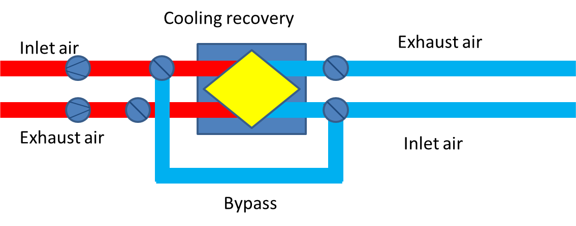
Figure 49: Diagram Air Conditioner with Cooling Recovery

Alternatively, there is also the option of natural ventilation without the use of systems engineering. Here, the process of ventilation and/or cooling will be ensured by the manual “opening” and “closing” of windows or skylights. This “regulation” can also be automated. For this, the relevant openings will be equipped and controlled with motor drives.
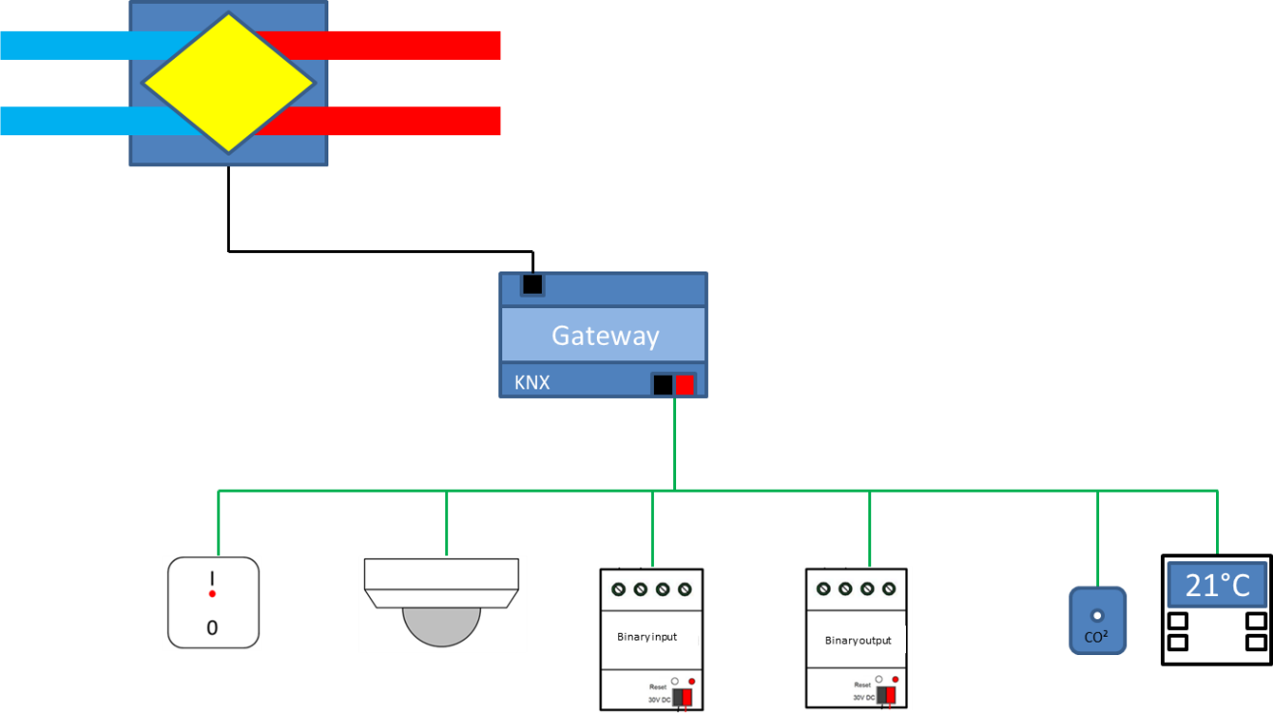
Figure 50: Diagram Integration via Gateway

Integration with KNX
Ideally, the integration with KNX can be realized via a Gateway. Thus, a ventilation system is used, which is integrated and controlled in the KNX system. The procedure is the same as with a heating boiler or an air conditioning system. When no Gateway is available, the devices will often be equipped with digital/analogue in- and outputs. These can be used to influence the operation.

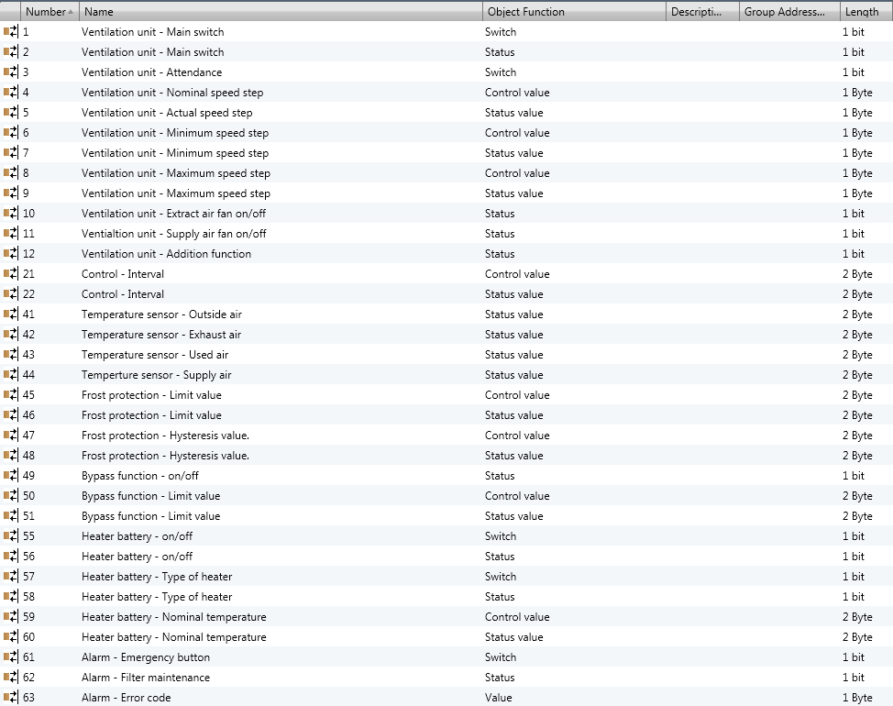
Figure 51: Communication objects natural mechanic ventilation

With natural ventilation, the natural night-time cooling is amongst others used to lower the temperature level. As before, the closing and opening of windows and skylights will assure air ventilation. The reactions and drive movements depend on the input from e.g. weather related data or process related data from a weather station or comparable sensors.

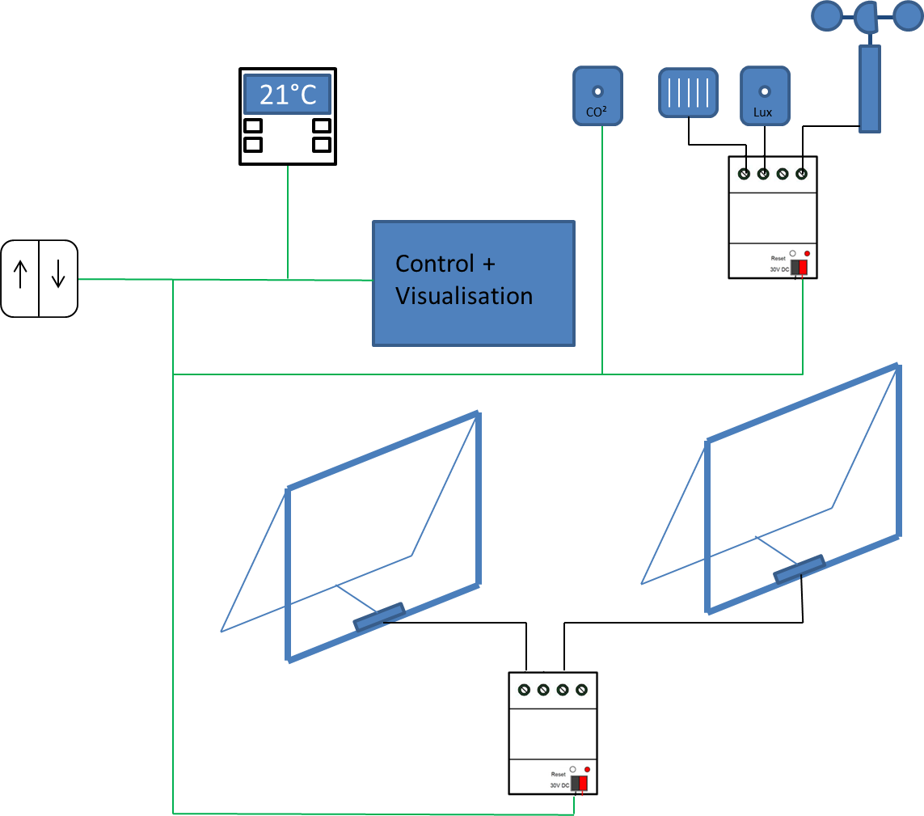
Figure 52: Diagram Natural Mechanic Ventilation

Physical Sensors

General
A sensor is a device that measures a physical quantity and converts it into a signal readable by an observer or by an instrument. For example, in a mercury-in-glass thermometer the expansion and contraction of a liquid determines the temperature indicated on a calibrated glass tube. A thermocouple converts temperature to an output voltage readable by a voltmeter. For accuracy, most sensors are calibrated against known standards.
The term physical sensor is used to describe the category of sensors that measure physical phenomena, such as weather conditions (i.e. temperature, brightness and/or position of the sun, precipitation, wind, solar radiation) or air quality (i.e. CO₂ concentration, humidity, etc.).
Most of the KNX sensors include functions that make them powerful measuring devices. These can be GPS functions, measurement calibration, hysteresis definition, logical functions, timing functions, value recording, sending threshold and/or alarm values, etc.

Weather condition sensors

Temperature sensor
The most common Physical sensor is the temperature sensor. It is widely used either as a standalone device, or integrated in other types of sensors (e.g. push buttons or brightness sensors). It measures the current temperature value and transmits it to the bus. The sensitivity can vary according to its use. A temperature sensor in a chemical process shall be more accurate (even a sensitivity of 0.01K can be required) than a temperature sensor used in a residential building.
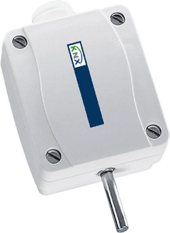
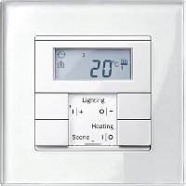
Figure 53: Standalone temperature sensor and integrated temperature sensor in a push button device

Temperature sensors need to be calibrated before their first use and therefore in most application programs a calibration option is available, allowing the user to define the deviation of the sensor against an external standard temperature sensor.
Temperature is transmitted using a 2 byte Group Object with encoding 9.001, DPT_Value_Temp or 9.002, DPT_Value_Tempd. These have a resolution of 0,01 °C or 0,01 K respectively.

Figure 54: Group Object in ETS for reading the current value of the temperature

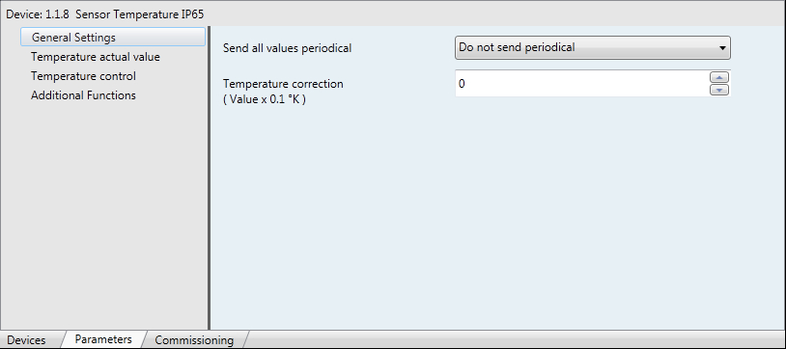
Figure 55: Setting the deviation of the temperature sensor in ETS

Brightness sensor
A brightness sensor is also a widely used device, which senses the current brightness value of an area and transmits it to the bus. This type of devices is mostly used for switching or dimming lighting circuits in order to create an ambient living environment, but also to save energy costs. There is a large variety of brightness sensors. They can be classified according to their use, i.e. external or internal. Moreover, there are brightness sensors that not only detect the brightness value, but also the position of the sun. This function might be very useful when controlling the blinds of the facades of a building or the angle of solar trackers, resulting in either proper shading and heating control or higher energy production of solar panels.
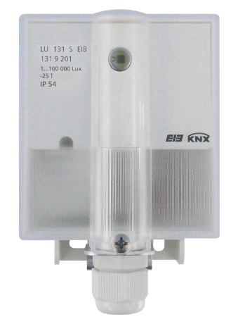
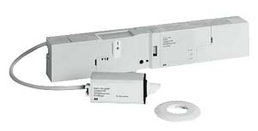
Figure 56: Brightness sensor for external use and internal use

The brightness value is measured and expressed in lux and is transmitted using a 2 byte Group Object with encoding 9.004, DPT_Value_Lux, which has a resolution of 0,01 Lux.
Figure 57: Group Object in ETS for reading the current brightness value
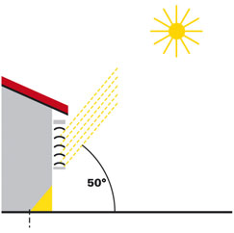
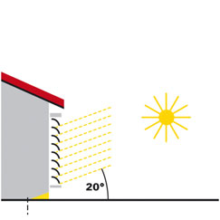
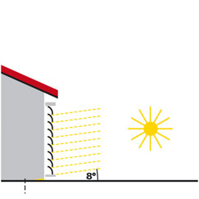
Figure 58: Blind control according to sun position

Wind sensor
This measurement instrument, which is actually one of the main components of a meteorological station, has as a major role to measure the speed of the wind and transfer it to the bus for further processing.
There are two different types of KNX wind sensors. The first type is the ‘Cup Anemometer’, which comes in the form of the classical housing of a conventional wind sensor but includes a BCU for the connection to the bus. The second type is the ‘Compact housing’ similar to other sensors: this type has the advantage of low risk of damage because of the lack of moving parts. Both housing types may be delivered with their individual heating system in order to prevent them from freezing during cold days. For this purpose, an ancillary voltage is needed, which can be fed by the ancillary voltage output of a KNX power supply.

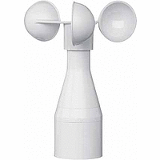
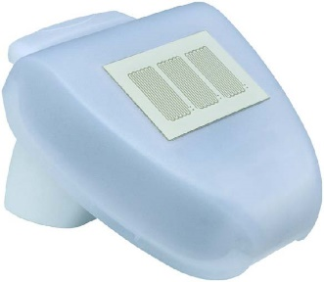
Figure 59: 'Cup Anemometer' and a 'Compact housing' wind sensor

The wind speed value is measured and expressed in meters per second and is transmitted using a 2 byte Group Object with encoding 9.005, DPT_Value_Wsp, which has a resolution of 0,01 m/s.

Figure 60: A typical Group Object in ETS for reading the current wind speed value

Precipitation sensor
A precipitation sensor - also known as rain sensor - senses the precipitation and transmits the value to the bus for further processing. This sensor can be used in conjunction with blind actuators to prevent canvas of sun shading from getting wet and destroyed or even with an irrigation system to switch it off for saving water.

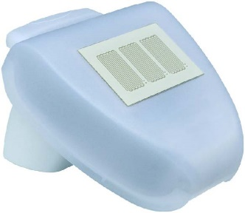
Figure 61: A common rain sensor

The precipitation detection is usually transmitted using a 1 bit Group Object. Since there is no standard Datapoint type for rain indication, the 1.005, DPT_Alarm is used.

Figure 62: A typical Group Object in ETS for reading the detection of precipitation

Solar radiation sensor
The solar radiation sensor measures the sun intensity as amount of heat.
The current radiation is measured in watts per square metre and the most common use is to calculate the energy input to an area, especially for installed solar panels. With this, it is possible to calculate and use the produced energy during a defined period of time.
There are two different types of solar radiation sensors; the ‘Compact sensor’, which is a compact device including the sensor in its housing and the ‘Modular Sensor’, which is a sensor unit, either for DIN rail or wall mounting, with an external probe.
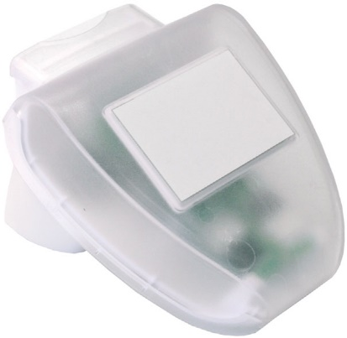
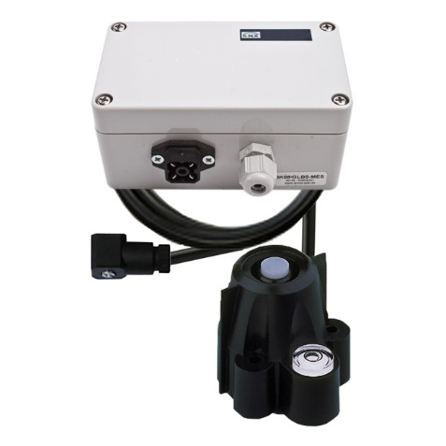
Figure 63: A compact solar radiation sensor and a classical sensor with external probe

The solar radiation value is measured and expressed in watt per square meter and is transmitted using a 2 byte Group Object with encoding 9.022, DPT_PowerDensity, which has a resolution of 0,01 W/m².

Figure 64: A typical Group Object in ETS for reading the current solar radiation value

Combined device, Weather station
The term ‘Weather station’ is often used by manufacturers in order to describe the combination of at least three different measurement options of physical phenomena into one single device. A weather station includes the same measuring options of separate physical sensors but has as big advantage the integration of several sensors into one device.
There are three different types of weather stations; the ‘Cup weather station, the ‘Compact weather station’ and the ‘Modular weather station’. In the case of ‘Modular weather station’, several PT1000 sensors can be connected.

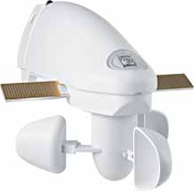
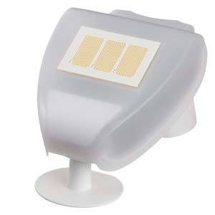
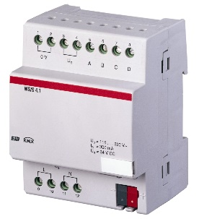
Figure 65: Cup weather station, Compact weather station and Modular weather station

Air quality sensors

Terms and definitions
Various terms that are used to indicate moisture levels are given in the table below:

Table 15: Terms to indicate moisture levels, source: http://www.engineersgarage.com
S.No | Term | Definition | Unit
1 | Absolute Humidity  (Vapor Concentration) | Ratio of mass (vapour) to volume. | grams/m³
2 | Mixing Ratio OR Mass Ratio | Ratio of mass (vapour) to mass (dry gas) | grams/m³
3 | Relative Humidity | Ratio of mass (vapour) to mass (saturated vapour) OR ratio of current vapor pressure to saturation vapor pressure. | %
4 | Specific Humidity | Ratio of mass (vapour) to total mass. | %
5 | Dew Point | Temperature (above 0°C) at which the water vapor in a gas condenses to liquid water | °C
6 | Frost Point | Temperature (below 0°C) at which the water vapor in a gas condenses to ice
7 | Volume Ratio | Ratio of partial pressure (vapour) to partial pressure (dry gas) | % by volume
8 | PPM by Volume | Ratio of volume (vapour) X 10⁶ to volume (dry gas) | PPM_{V}
9 | PPM by Weight | PPM_{V} X | PPM_{W}

CO₂ concentration sensor
A CO₂ concentration sensor measures the concentration of CO₂ in a room and transmits it to the bus. It can also receive an external CO₂ value via the bus and process it with its own data to calculate an overall value (mixed value, e. g. room average). Measuring CO₂ concentration can be very useful in crowded areas, where the CO₂ concentration can reach very high limits and ventilation needs to be activated on in order to refresh the air.
The CO₂ concentration value is measured and expressed in parts per million and is transmitted using a 2 byte Group Object with encoding 9.008, DPT_Value_AirQuality, which has a resolution of 0,01 ppm.

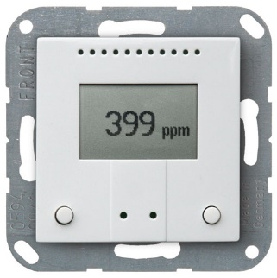
Figure 66: CO₂ concentration sensor
Figure 67: A typical Group Object in ETS for reading the current CO₂ concentration value

Humidity sensor
A humidity sensor, which consists of a thermometer and a hygrometer, measures temperature and humidity and calculates the dew point. Actually, humidity measurement determines the amount of water vapor present in a gas. This can be a gas mixture, such as air, or a pure gas, such as nitrogen or argon. The amount of water vapor in air can affect human comfort as well as many industrial manufacturing processes. The presence of water vapor also influences various physical, chemical, and biological processes. Humidity measurement in industry is critical because it may affect the business cost of the product and the health and safety of the staff. Hence, humidity sensing is very important, especially in control systems for industrial processes and for ensuring human comfort. For domestic applications, humidity control is used to ensure proper living environment in buildings and to indicate moisture levels in the environment.
The KNX humidity sensors can also receive external measured values via the bus and process them with own data to calculate an overall temperature and air humidity (mixed values).

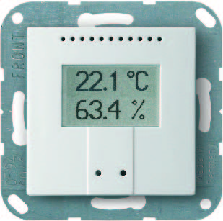
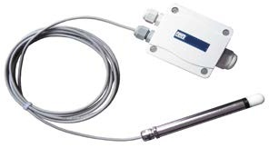
Figure 68: Humidity sensors for indoor and outdoor use

The humidity value is measured and expressed in percentage and is transmitted using a 2 byte Group Object with encoding 9.007, DPT_Value_Humidity, which has a resolution of 0,01 %.

Figure 69: A typical Group Object in ETS for reading the current value of the humidity

